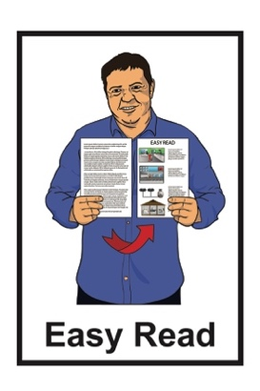
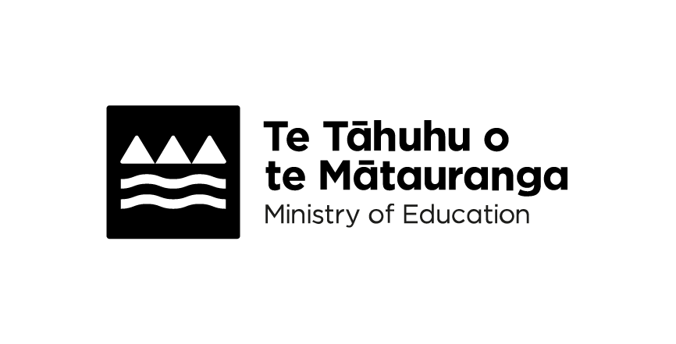

Learning in the first 6 months

of school
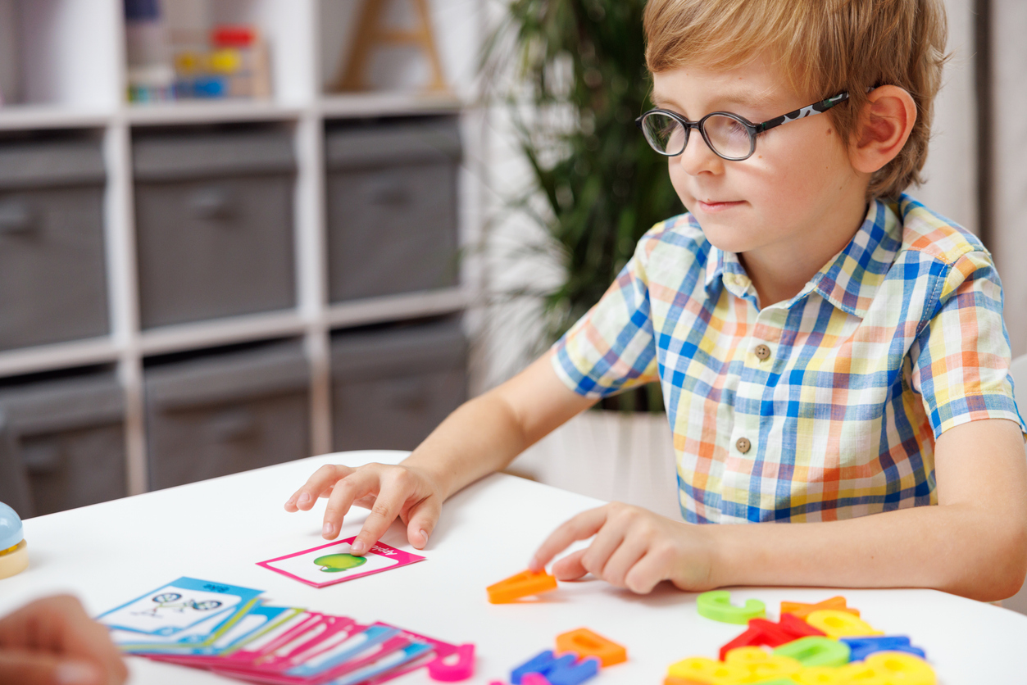

Published: November 2026

About this Easy Read

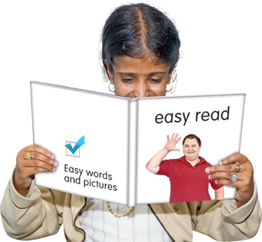
This Easy Read is from Te Tāhuhu o te Mātauranga Ministry of Education.

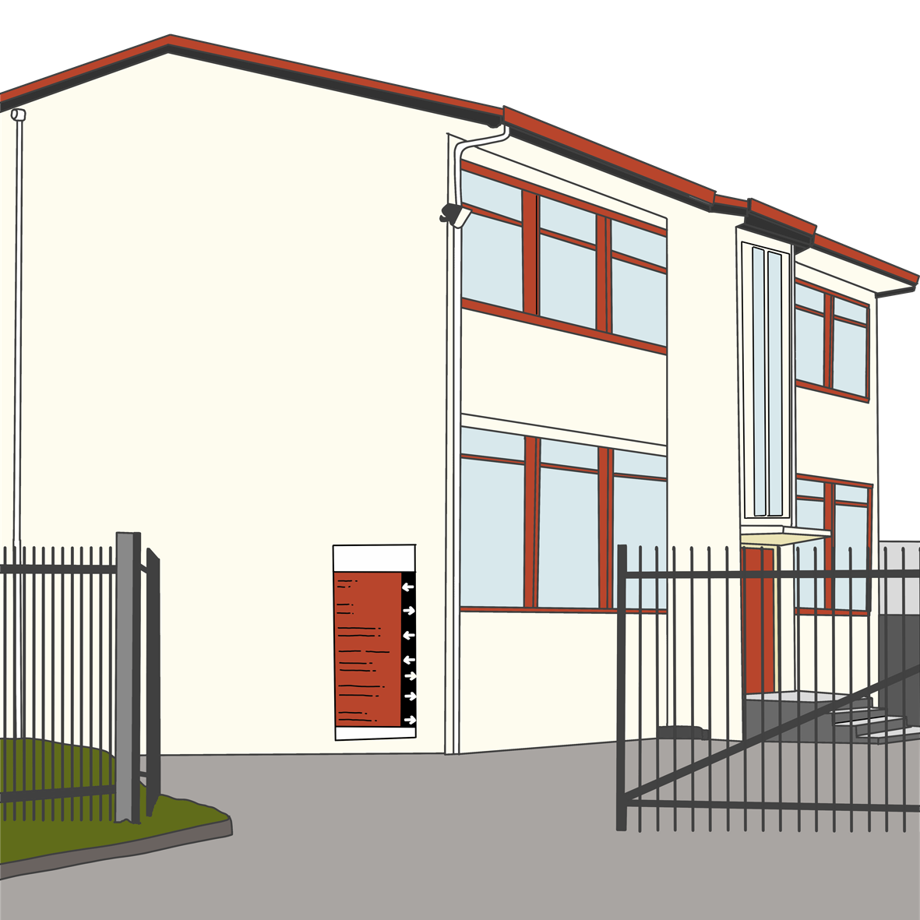
Te Tāhuhu o te Mātauranga Ministry of Education is the part of the Government in charge of schools in Aotearoa New Zealand.

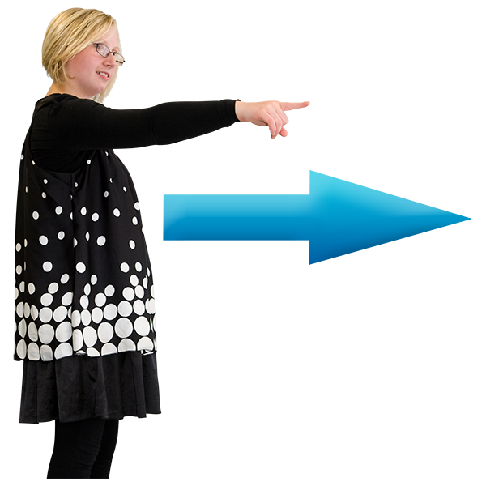
Where it says we / us this means
the Ministry of Education.

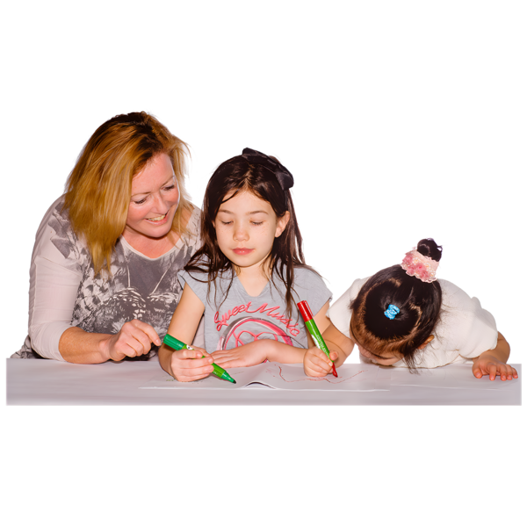
This Easy Read is about what your child will learn in their first 6 months at school.

Starting school

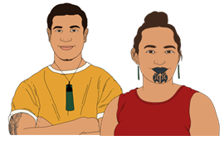
Starting school is a big thing to happen for:
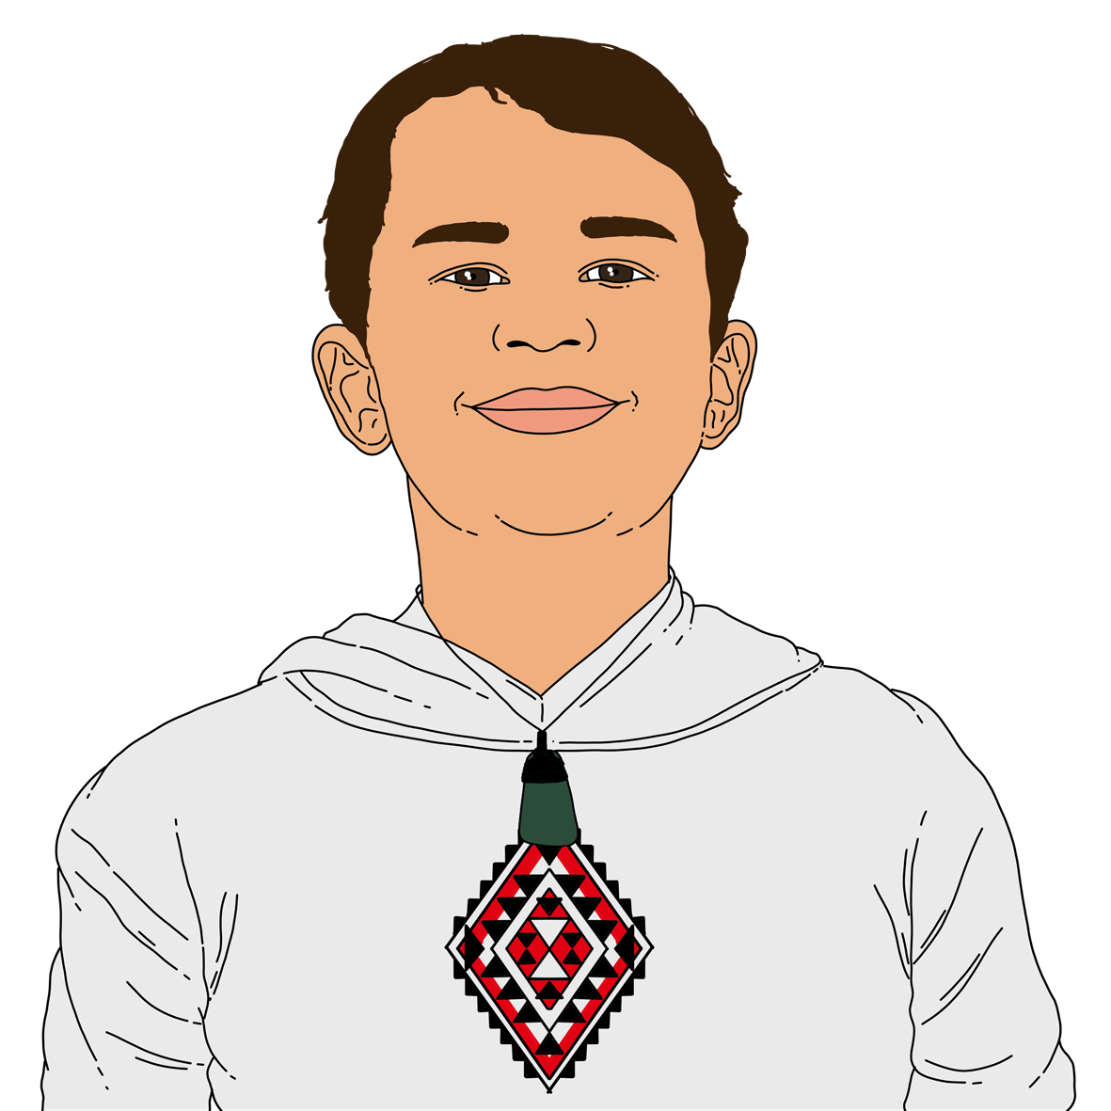
you
your child.

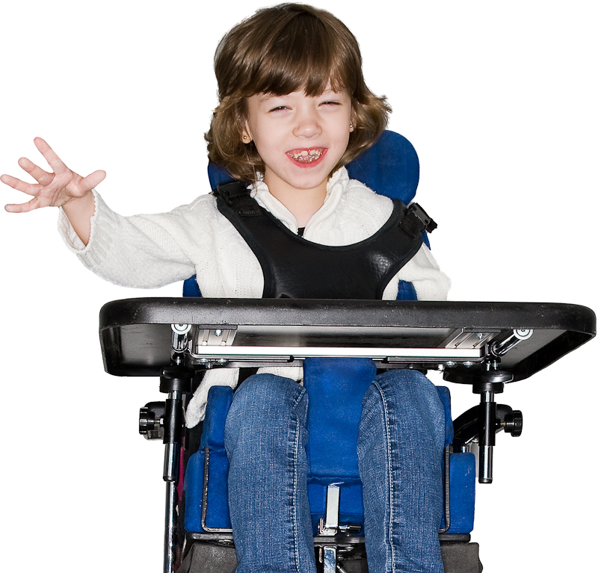
We know children in their first year of school are excited to learn.

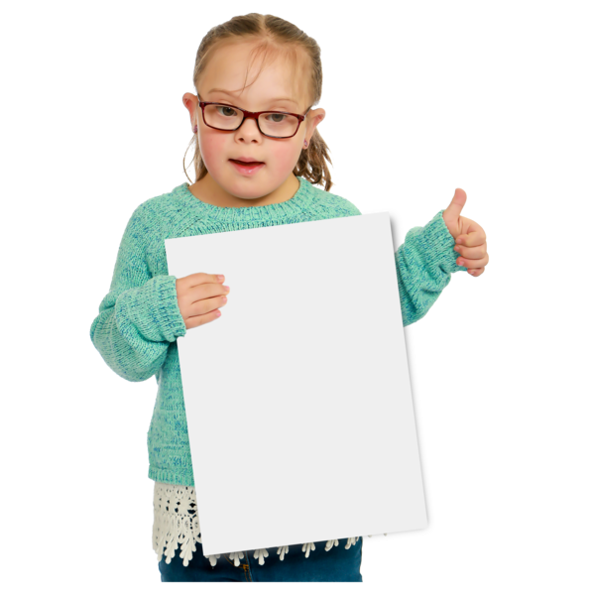
Children want to do well in everything they do.

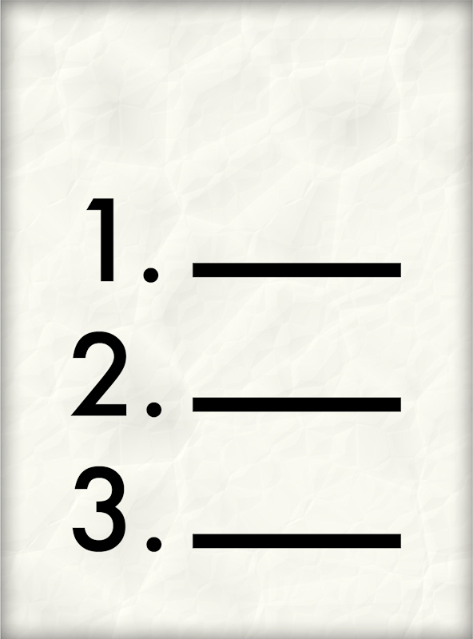
Your child will be supported to start learning by the:
New Zealand Curriculum
Te Marautanga o Aotearoa.
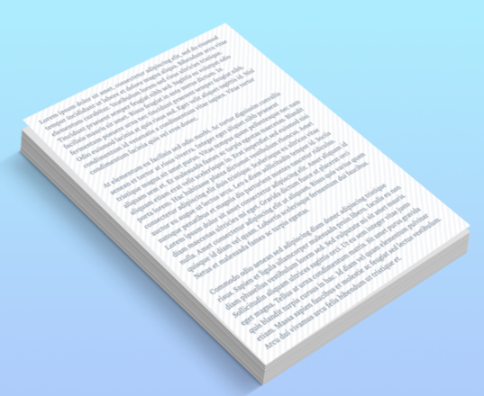
A curriculum is a document that says what your child will learn at school.

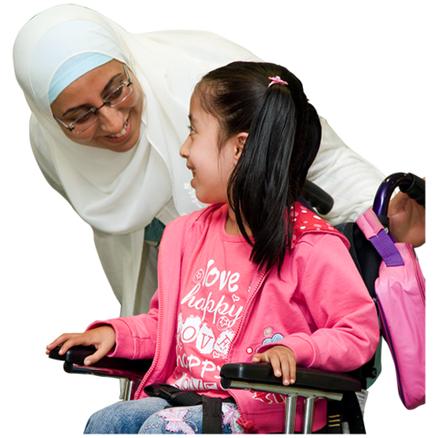
You can support your child too.

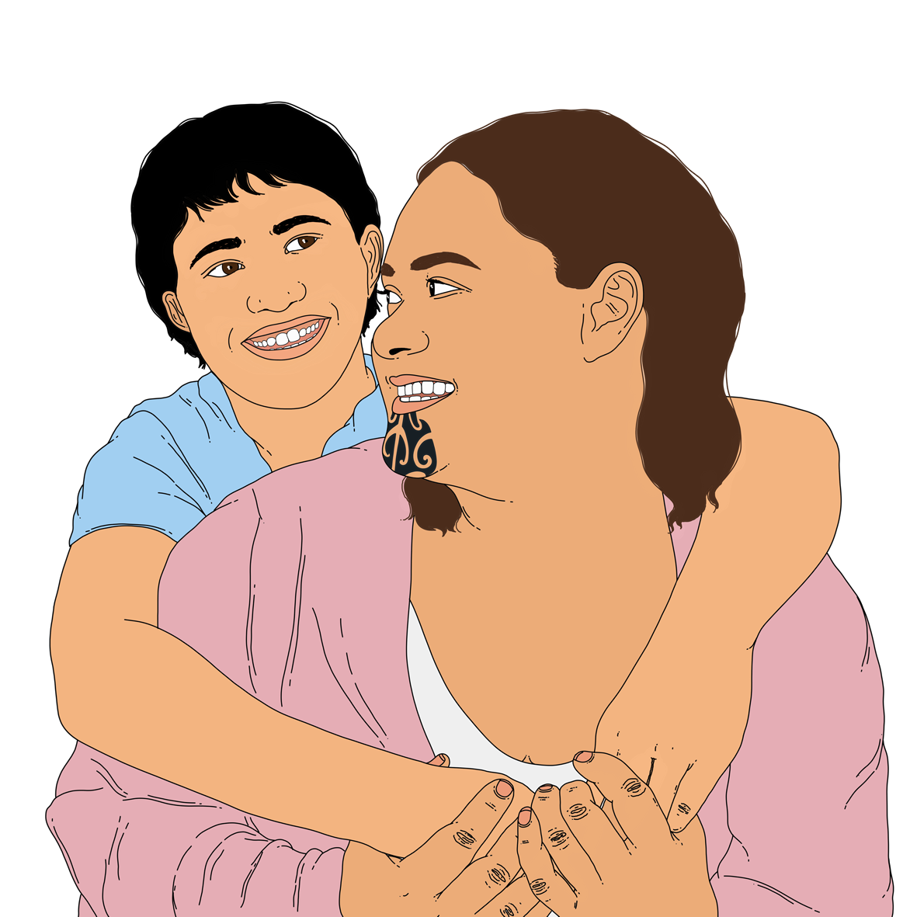
When they come home you can ask them questions like:
how was your day at school?
what did you enjoy most about school today?

English / Te Reo Rangatira

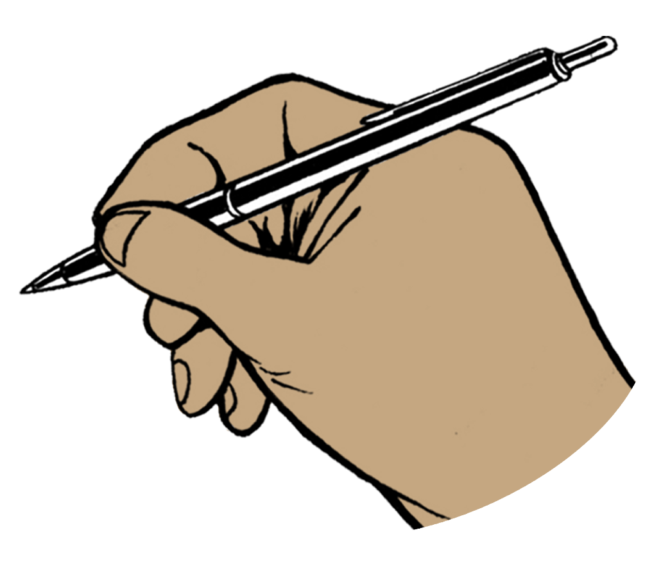
English / Te Reo Rangatira is about your child learning:
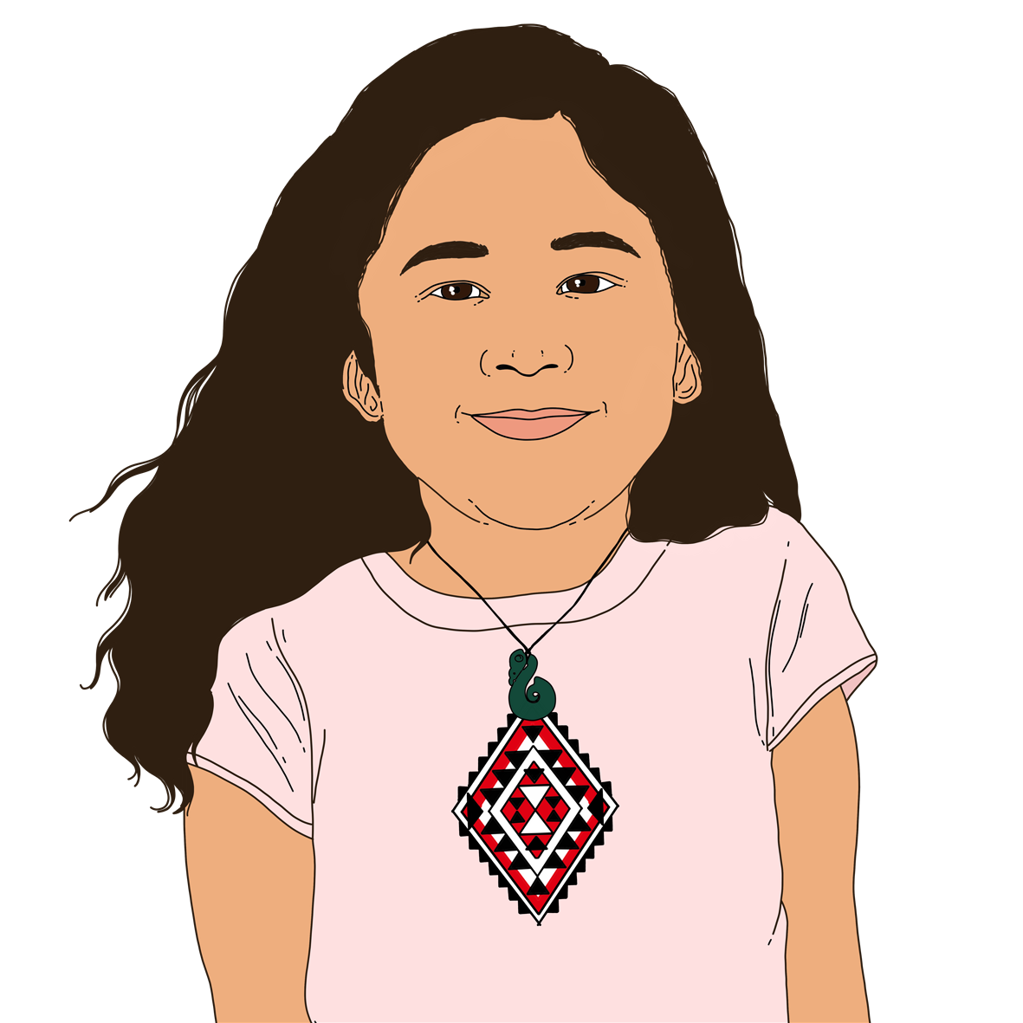
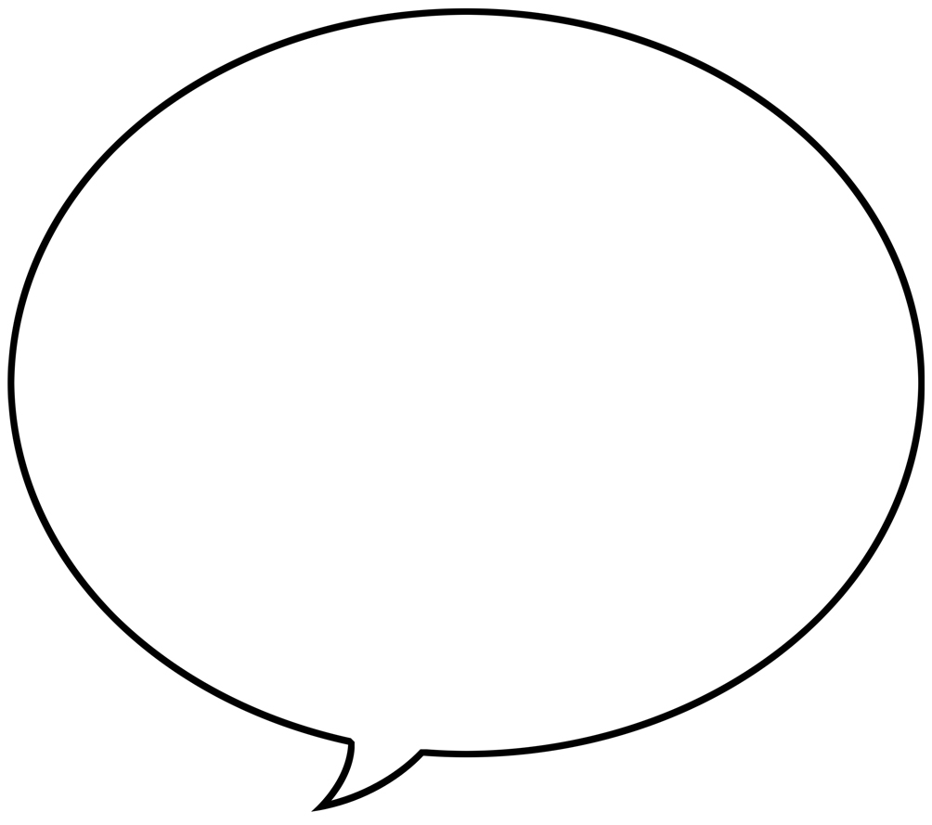
handwriting
to read by matching letters to sounds.

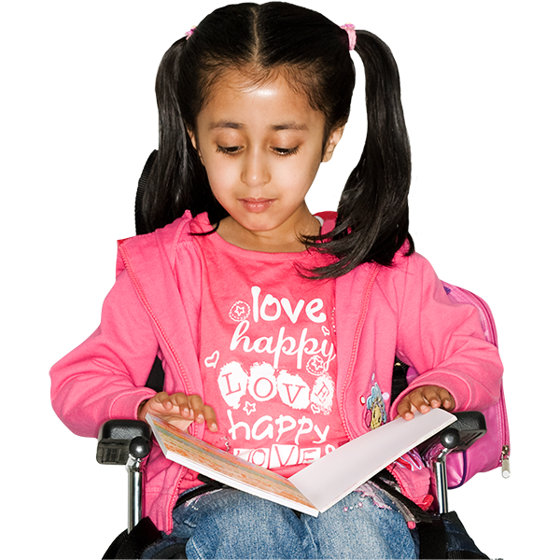
Your child will bring books home to practise what they have learned in class.


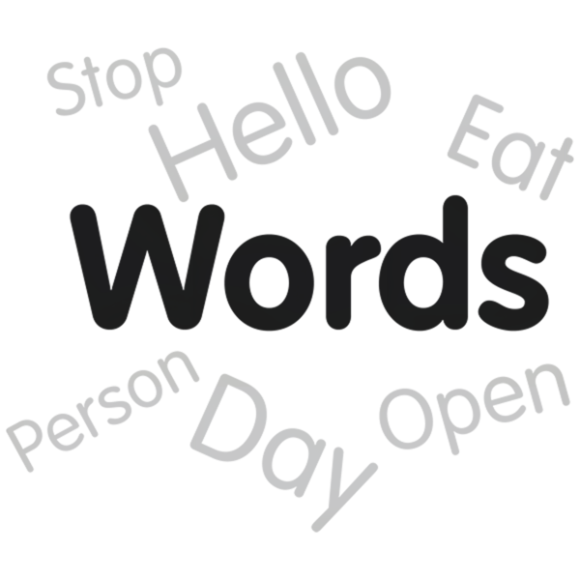
This will support them to remember how to do these skills.

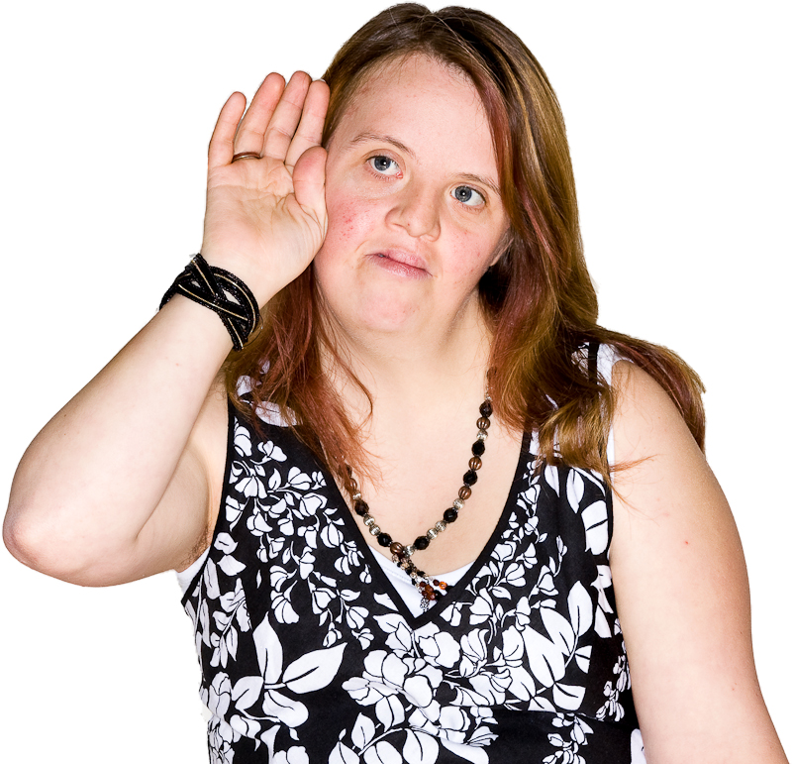
Your child will do a phonics check when they have been at school for 20 weeks.

Here a phonics check is a test to find out if a child:
hears sounds
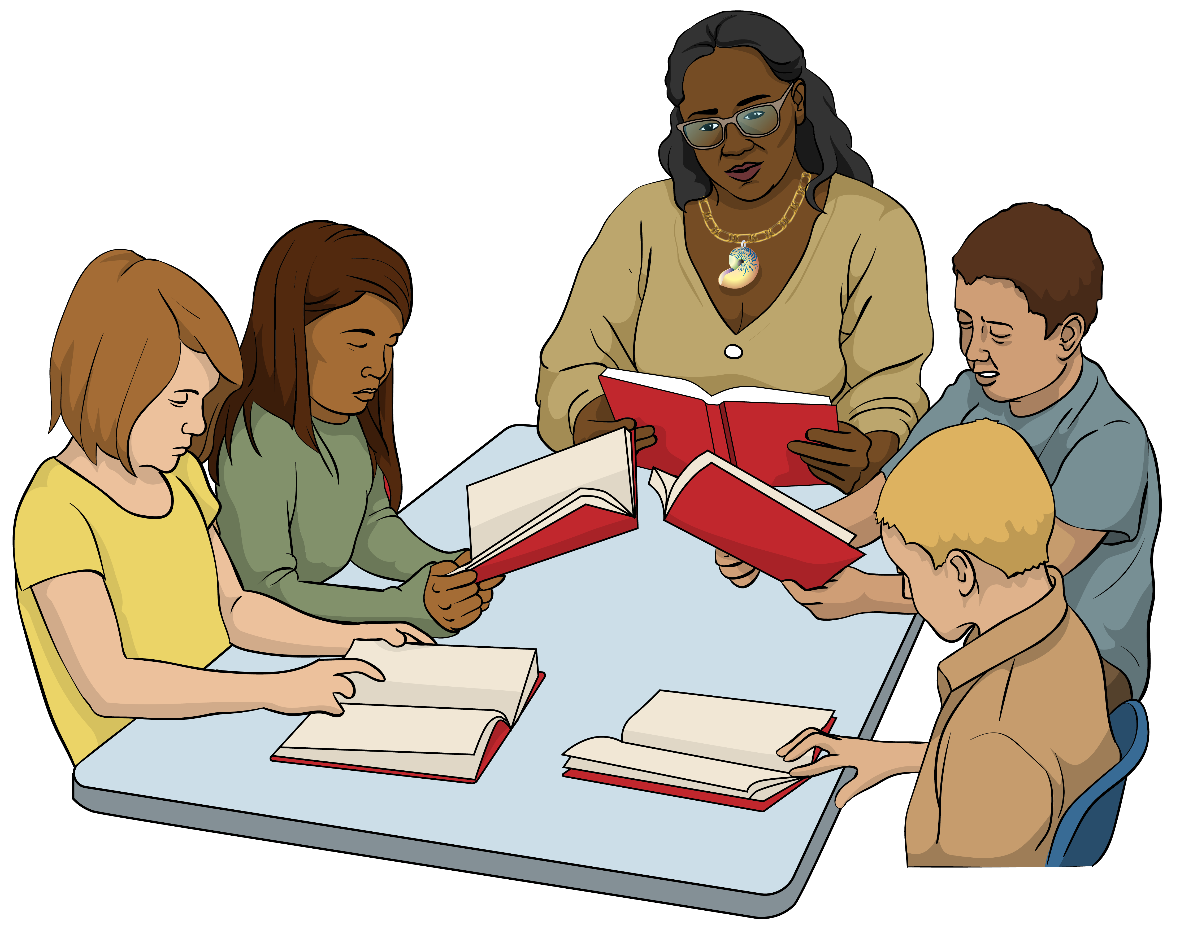
knows what the sounds are.

The test includes reading words.

The phonics check:
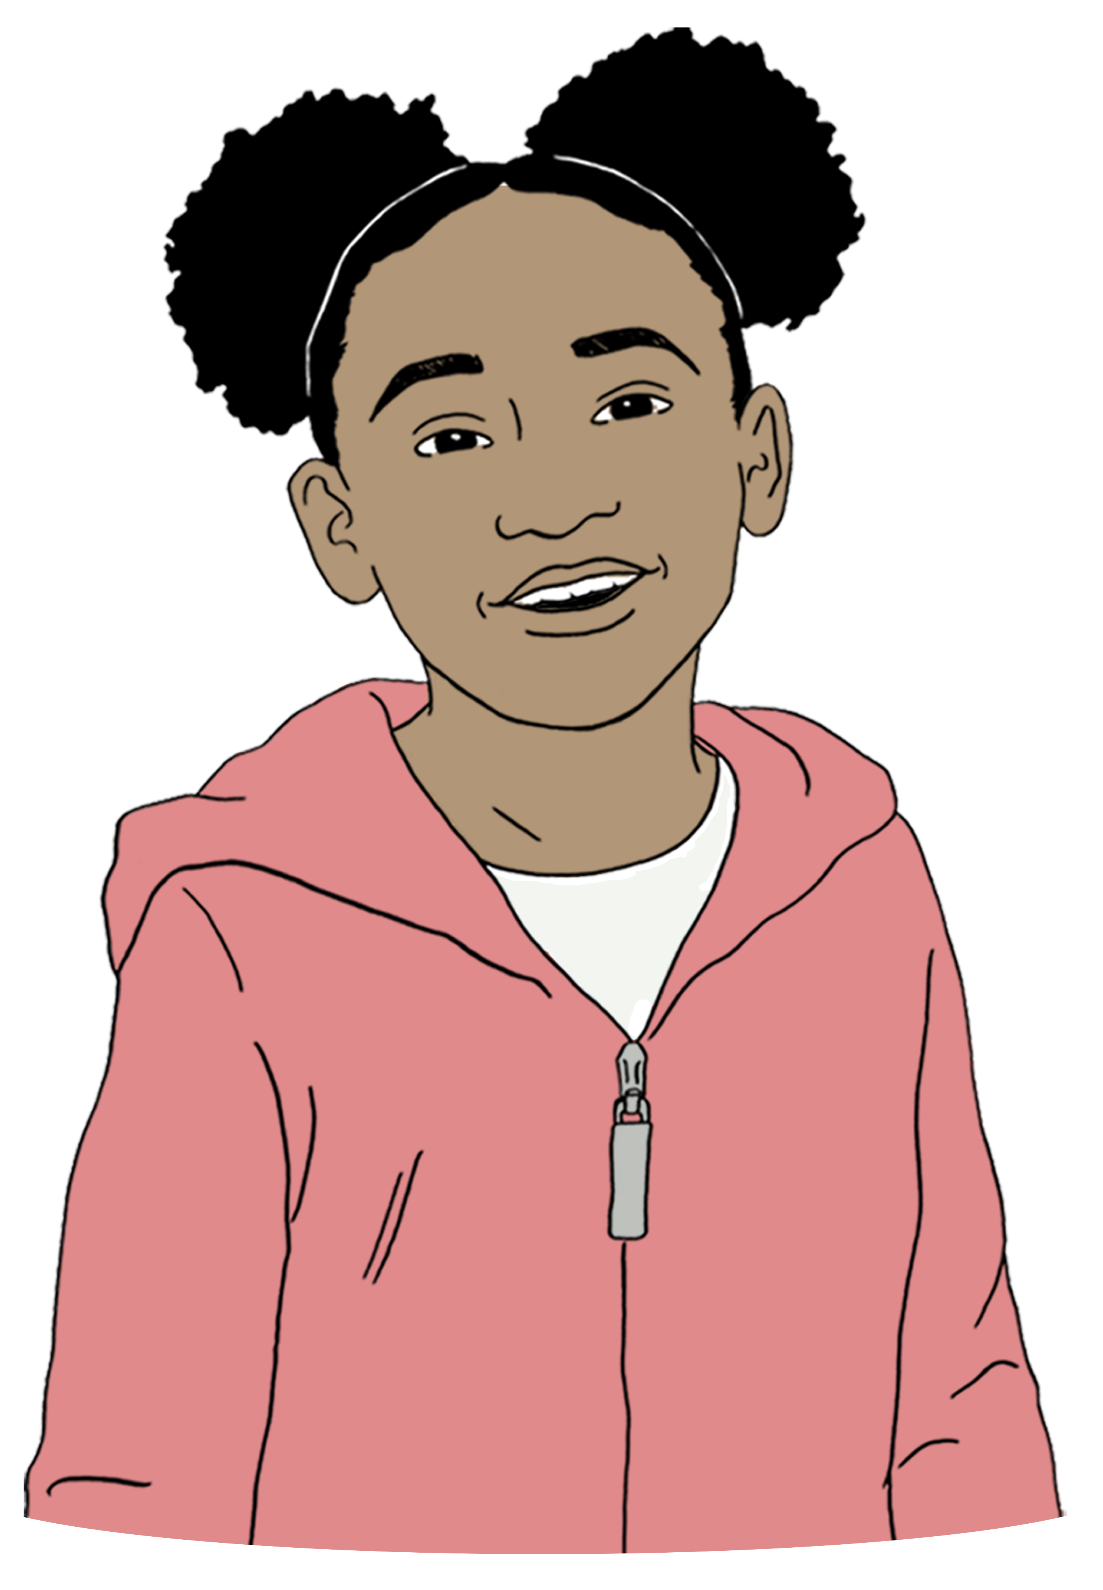

is done by the teacher of the child
checks if the child can figure out sounds when reading words.

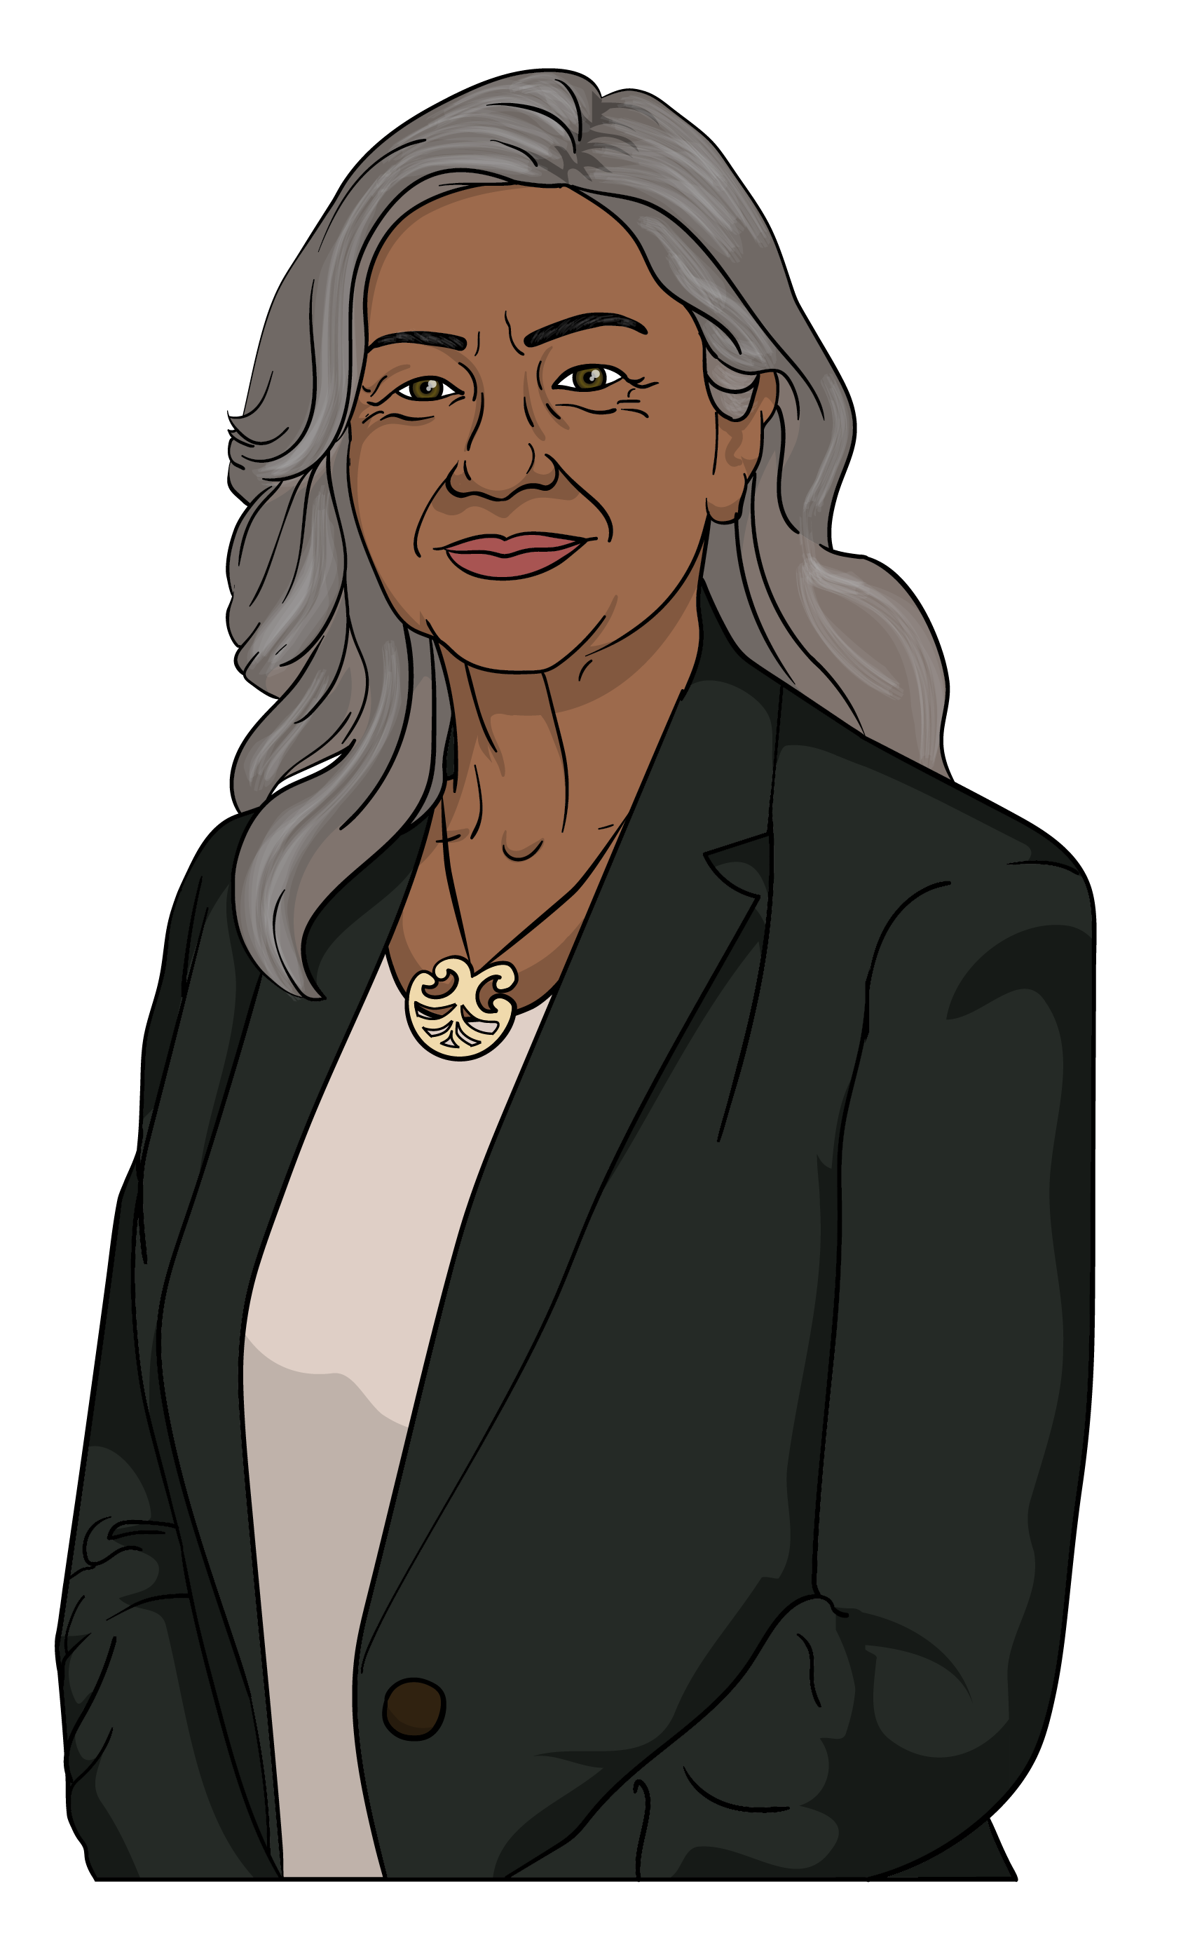
A mokopuna / child who is learning
te reo Māori / the Māori language will be given Te Mōhiohio Oro by their kaiako / teacher.

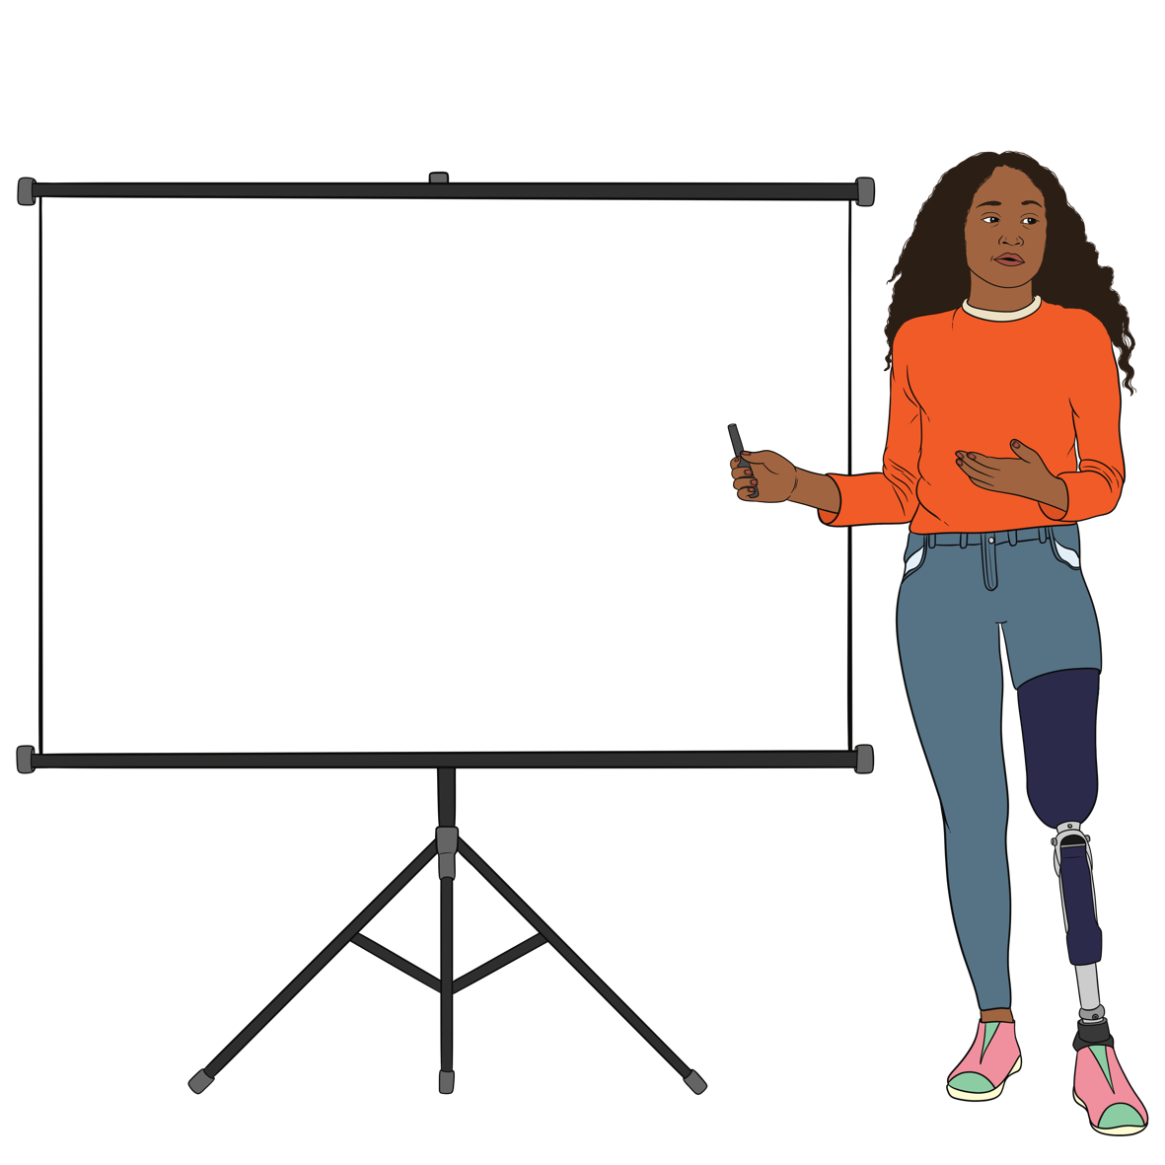
Te Mōhiohio Oro is a phonics check done in te reo Māori / the Māori language.
Kia ora


How your child is doing will be checked using:
the phonics check
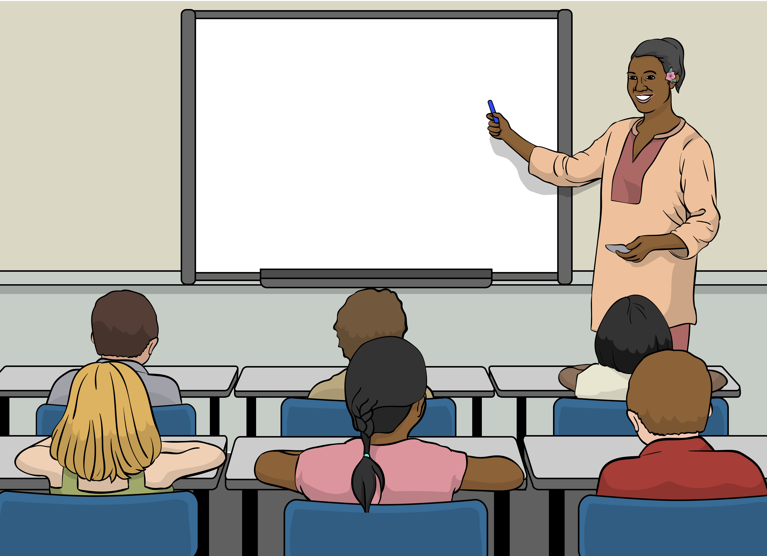
what the teacher sees your child doing in class.

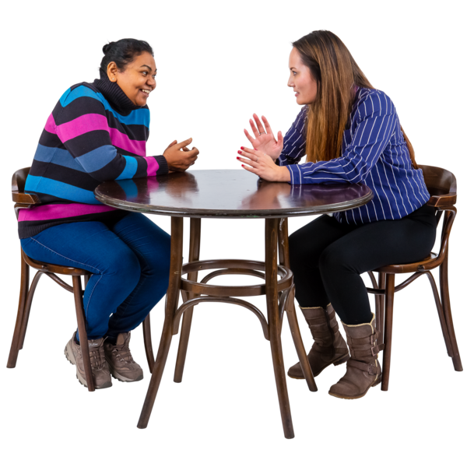
You will be told how your child is doing every step of the way.

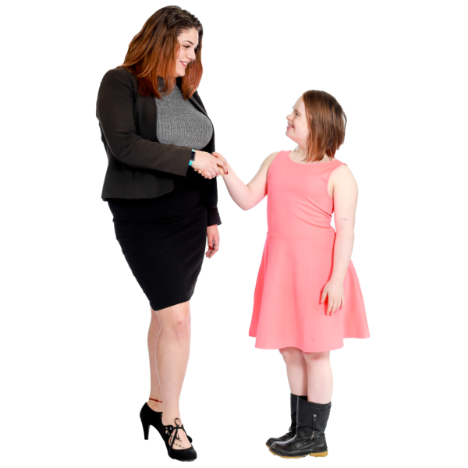
The phonics check is a good way to:
celebrate how your child is doing
work out if your child needs support.

Maths / Pāngarau
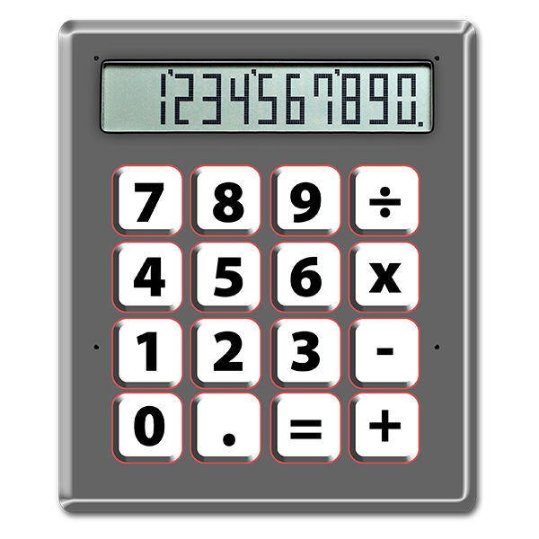

Your child will start to learn
maths / pāngarau in the first 6 months of school.

Maths / pāngarau includes things like:
1 2 3 4 5
6 7 8 9 10
numbers

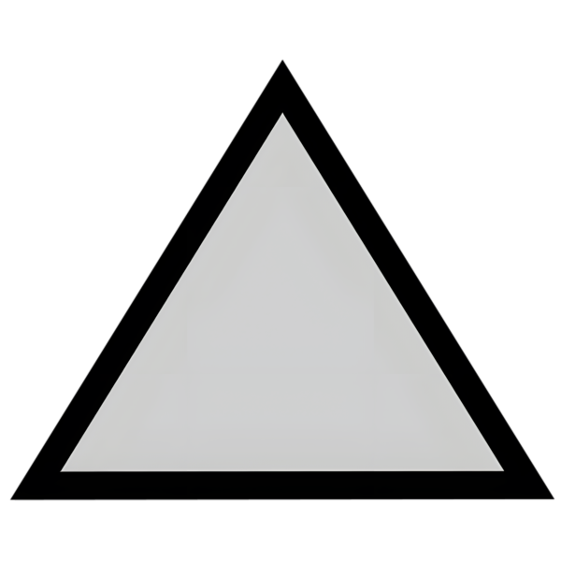
geometry / shapes
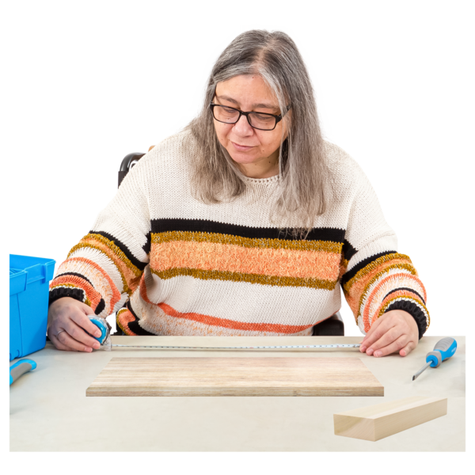
algebra which is how numbers are put together
measurements which is how big things are.

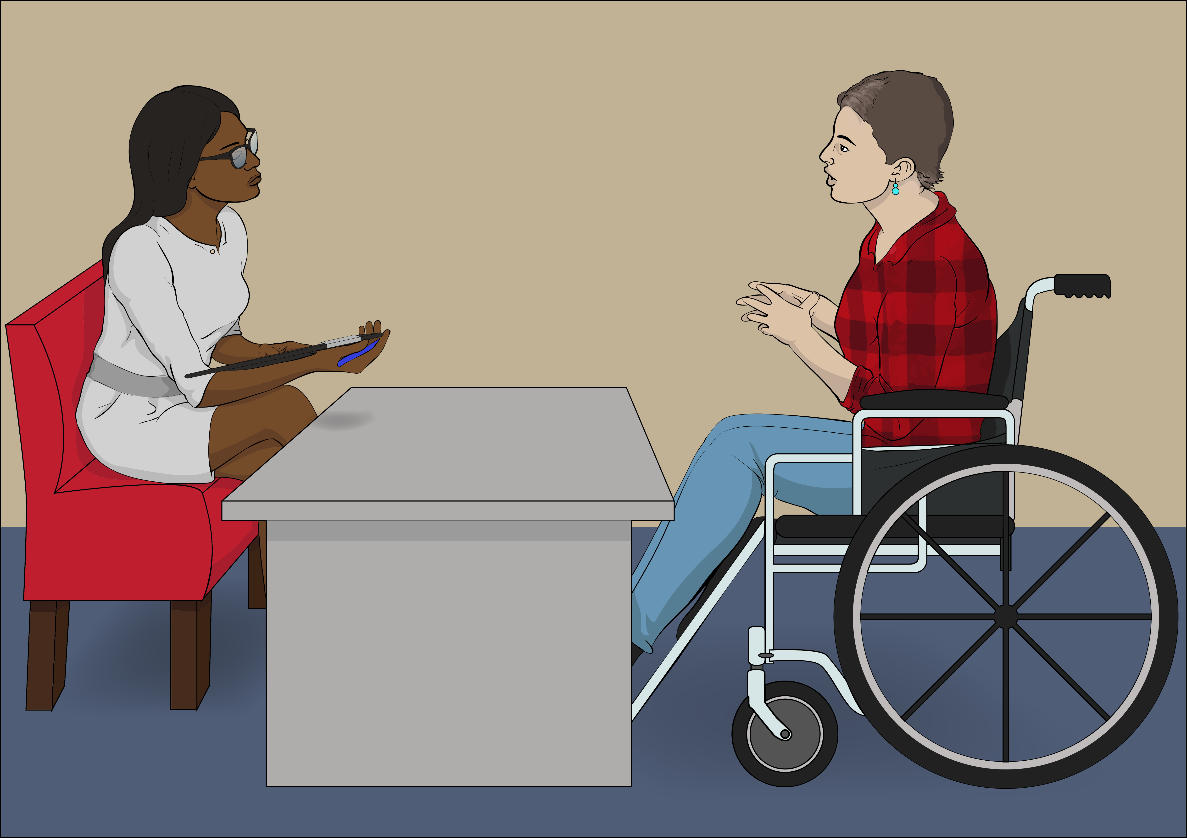
The teacher will tell you how your child is doing in maths / pāngarau.

More information


You can find more information about the first 6 months of school at this website:

https://tinyurl.com/4x5dzh5p
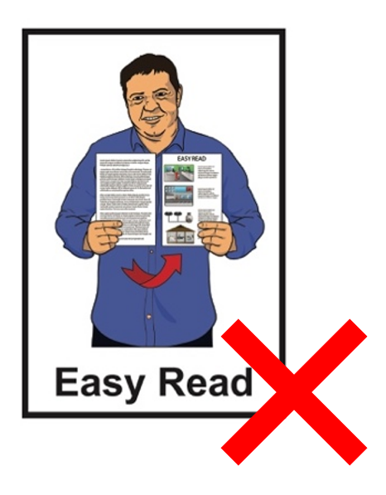

This website is not in Easy Read.

You can also talk to your child’s teacher

This information has been written by Te Tāhuhu o te Mātauranga Ministry of Education.

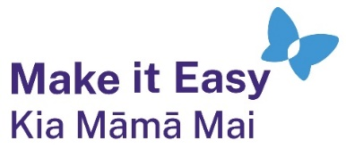
It has been translated into Easy Read by the Make it Easy Kia Māmā Mai service of People First New Zealand Ngā Tāngata Tuatahi.

The ideas in this document are not the ideas of People First New Zealand Ngā Tāngata Tuatahi.

All images used in this Easy Read document are subject to copyright rules and cannot be used without permission.


Make it Easy uses images from:

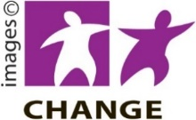
- Photosymbols

- Change Images


- Huriana Kopeke-Te Aho

- SGC Image Works

- T Wood

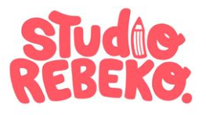
- Studio Rebeko

- Inga Kramer.

