Consistency Accountability Statement: Education (School Boards) Amendment Regulations 2026 made under sections 638 and 639 of the Education and Training Act 2020
Agency responsible | Ministry of Education
Portfolio | Education
Date finalised | 23/09/2026
Statement of Review
I confirm that the Ministry of Education has assessed the above legislation for consistency with the principles of responsible regulation as set out in section 9 of the Regulatory Standards Act 2025.
This assessment identified the following inconsistencies with the principles of responsible regulation:
Relevant principle of responsible regulation | Relevant sections in legislation
Good law making, s 9(i): the importance of consulting, to the extent that is reasonably practicable, the persons or representatives of the persons that the responsible agency considers will be directly and materially affected by the legislation
Summary of inconsistency
Because there was no consultation about the regulation changes, the proposed regulation changes are inconsistent with s 9(i) of the Regulatory Standards Act 2025, which outlines the importance of consulting, to the extent that is reasonably practicable, the persons or representatives of the persons that the responsible agency considers will be directly and materially affected by the legislation.

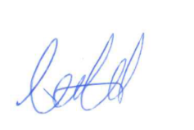

Clare Old
Senior Policy Manager, Curriculum and Digital Policy
Ministry of Education

