Practice Guide – Managing Not Located and Not Sighted cases (updated 5 October 2026)
Information for Attendance Service Providers (ASPs)

Purpose: The guide outlines the required actions, decision points, and recording requirements in AS-CMS before applying a Not Located flag.

This guide also explains the terms Not Located and Not Sighted and provides guidance on when a Not Located case should also be recorded as Not Sighted.

- Not Located – reasonable efforts have not successfully located or contacted the ākonga and/or their whānau; or
- Not Sighted – Contact may have been made with whānau or other parties, but you have been unable to verify the ākonga’s whereabouts or confirm that they are safe and well.

Scope:

This guidance applies to ASPs managing cases where:
- Contact details are missing, unknown or outdated, or
- An ākonga and/or their whānau cannot be contacted or located despite reasonable efforts, or
- The ākonga has not been sighted or their whereabouts have not been verified despite contact with whānau or other parties, and there are concerns about their wellbeing or current place of residence.

Key Principles:
- The Not Located flag provides visibility of children and young people whose whereabouts or welfare have not been confirmed after reasonable efforts have been undertaken.
- The same flag may be used for both Not Located and Not Sighted situations; however, the evidence, actions and decision-making requirements are different and must be assessed separately given the different circumstances.
- Providers must complete the relevant checklist and record all locating and verification activities in AS-CMS before applying the flag.
- While the same AS-CMS flag may be applied in both Not Located and Not Sighted cases, the required actions and evidence differ. Refer to the detailed checklists later in this guidance (see page 5) for the specific steps and criteria that must be completed in case notes before applying the flag.
- The flag supports ongoing monitoring, follow-up activity, information requests and escalation pathways where appropriate.
- Applying the flag does not mean work on the case stops, ongoing monitoring is still required.

2) “Not Located” is a flag, not a closure reason
- Apply the Not Located flag when you have been unable to locate the ākonga or whānau after reasonable efforts, or when the ākonga has not been sighted and their whereabouts have not been satisfactorily verified despite reasonable enquiries.
- Ensure the requirements of the relevant Not Located and/or Not Sighted checklist have been completed before applying the flag.
- The flag provides visibility of the issue at catchment, regional and national level, but it does not mean work on the case stops.
- Continue appropriate follow-up, including monthly Information Requests, ongoing locating or verification activities, engagement with other agencies and referral to an attendance multi-agency forum where available.
- Do not close a case because you cannot locate the child or because the child has not been sighted. Close a case only when a valid closure reason applies (for example, the student has an approved exemption or has moved overseas).
3) Retain ownership until transfer or closure criteria are met
Maintain ownership of the case until one of the following conditions is met:
- The case meets the criteria for closure, or
- The case needs to be reallocated because
  - The ākonga enrols at a school outside your catchment area, allowing the case to be reallocated to the new provider, or
  - A confirmed address outside your catchment area is obtained, allowing the case to be allocated to CIT for reassignment to the appropriate provider
  - Remember to follow the reallocation process including a handover meeting with the new provider before reallocating.

Not Located workflow: expected steps and timeframes
This diagram summarises the typical pathway for cases where a student or whānau cannot be located. It shows the expected sequencing of contact attempts and information checks, and the key decision points during the early stage of the case, including when to apply the Not Located flag.

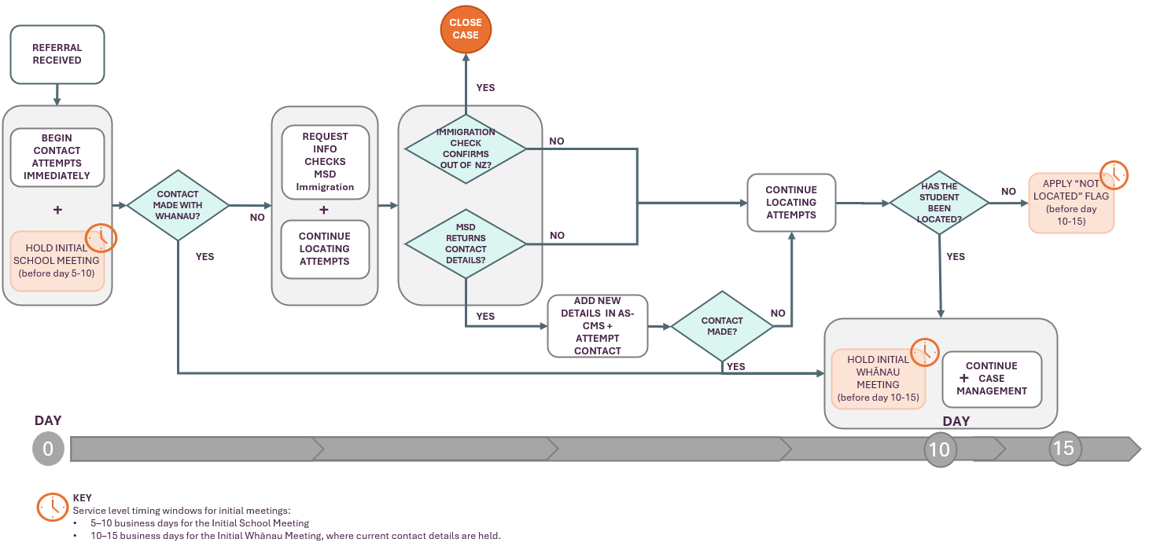

Not sighted workflow: expected steps and timeframes
This diagram summarises the typical pathway for cases where a student has not been sighted.
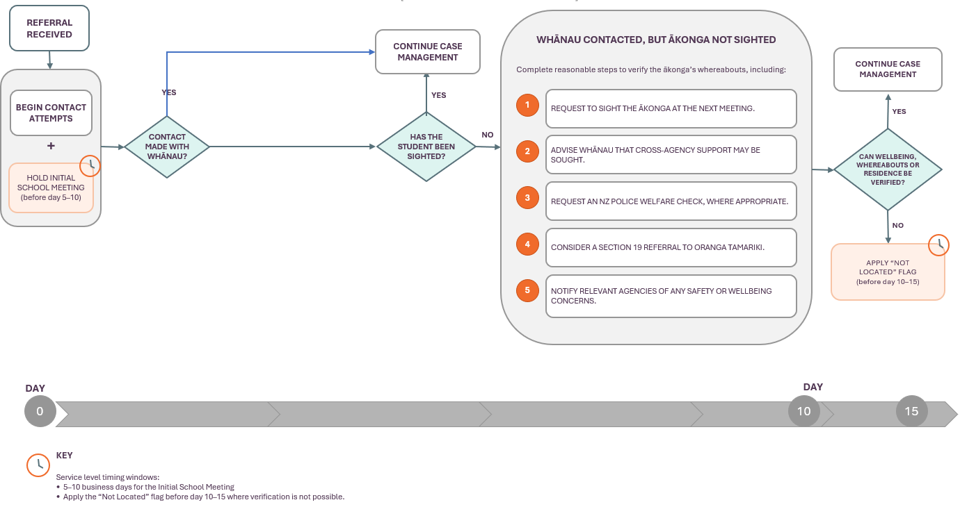

What we mean by business days
Throughout this guidance, a number of activities are expected to occur within specified timeframes to support Attendance Service Level Agreements (SLAs), such as Initial School Meetings, Initial Whānau Meetings, contact attempts, and follow-up activities. Unless otherwise stated, these timeframes are measured in business days.
For Attendance Service SLAs, business days:
- Include weekdays (Monday-Friday), school holidays, and regional public holidays.
- Exclude weekends and national public holidays.
This applies to all SLA measures including Initial School Meetings and Initial Whānau Meetings.
If contact details are not current you must document all efforts to find updated contact details and locate the student and caregivers. Service level reporting allows for a percentage of cases to miss the service level due to these factors.

Step-by-step workflow
- Begin contact attempts as soon as the referral is received and record all activity in AS-CMS.
- Hold the Initial School Meeting as early as possible and record it using the correct Initial School Meeting event subject.
- Use the Initial School Meeting to confirm contact details and identify any additional information the school may hold. See here for further guidance on initial school meetings.
Remember: The Initial School Meeting is still required even if whānau cannot be contacted.
Step 2: Use Info Requests early
When an ākonga becomes unenrolled, the Ministry's CIT receives the referral, completes initial checks, and assigns the case to an ASP. CIT also manages Information Requests to agencies such as MSD and Immigration New Zealand.
If initial contact attempts are unsuccessful, submit Information Requests through AS-CMS as early as possible. These requests can be used to:
- Check whether MSD holds updated contact details for the student or whānau.
- Determine through Immigration New Zealand whether the student has left New Zealand.
Do not wait until later in the case to submit Information Requests, as agency responses can take time to be received and actioned.
For guidance on common scenarios and how to interpret Information Request results, refer to the Guidance for common scenarios

Step 3: What providers are expected to do before a not located flag is used (Day 0–10)
Complete the relevant checklist before applying a Not Located flag.
If the ākonga and whānau cannot be located
- Contacting any previous provider or case manager.
- Carry out information requests with MSD and Immigration
- Checking with the current, last known, or previous school.
- Contacting known family members, friends, or other contacts.
- Speaking with neighbours where appropriate.
- Using whānau networks, iwi/marae, churches, sports clubs, health workers
- Refer to an Attendance Multi Agency Forum (where available)
- Requesting information under section 66C of the Oranga Tamariki Act where appropriate. This allows you to engage with other agencies and community groups to request information, including contact details.

If the whānau has been contacted but the ākonga has not been sighted
- Requesting to sight the ākonga at the next meeting as this is critical in ensuring the right supports are in place to address attendance barriers.
- Advising whānau that you may seek support from other government agencies as you are concerned for the welfare of the child
- Contacting NZ Police to carry out a welfare check
- Consider a Section 19 Family Group Conference Referral to Oranga Tamariki
- Notifying appropriate agencies of any concerns for the ākonga’s safety or wellbeing e.g. Oranga Tamariki or NZ Police

Important: For Not Sighted cases, ASCMS case notes must begin with:
"Not Sighted: [Explain why you have concerns]
This helps distinguish Not Sighted from Not Located activity, enabling the national team to be able to pull information from case records until future functionality changes can be made in ASCMS.

It’s important to remember that if you have any concerns about an ākonga’s safety or wellbeing, you should raise these immediately with the appropriate agencies. It’s also important to vary the days and times of your visits, as repeatedly attending at the same time may mean you are visiting when the whānau are routinely away from home. You should also remain alert to any signs that raise doubts about whether the ākonga is living at the address, as these may indicate the need for further enquiries to confirm their whereabouts and circumstances.

TI
Step 4: Apply the “Not Located” flag
Apply the Not Located flag when:
- The relevant Not Located or Not Sighted checklist has been completed.
- Reasonable efforts to locate the ākonga or verify their whereabouts have been unsuccessful.
- All available contact information has been checked, and the Initial School Meeting has been used to confirm whether the school holds any additional information.
- Information Requests to both MSD and Immigration NZ have been completed within the previous 28 days.
If either Information Request is more than 28 days old, submit a new request before applying the flag. Alongside provider case management activities, you should submit the Information Request every 28 days to CIT if the student is not located or sighted.
The Not Located flag provides system visibility of students whose whereabouts have not been confirmed. It is a monitoring tool, not a closure reason.

Step 5: After Not Located flag is set
Retain ownership of the case and continue follow-up case management activities, including:
- Ongoing efforts to locate or sight the ākonga.
- Information Requests to MSD and Immigration NZ monthly.
- Engagement with multi-agency forums where available. Use Section66C and engagement with other agencies if you do not have an available forum
- Monitoring enrolment and attendance information.
- Reviewing AS-CMS case history and reporting tools to track progress.

Requesting information under section 66C of the Oranga Tamariki Act
Section 66C of the Oranga Tamariki Act may be used to request information that will assist in locating ākonga and in supporting them back into attendance and educational engagement.
Information Sharing Request Template – Agency to Agency
Record the request in AS-CMS by adding a Case Comment containing the term "S66C". Refer to the related guidance below for further information on when and how section 66C requests can be used.
Related guidance
- Oranga Tamariki: – use this guidance for more information on when section 66C may be used, who information can be requested from, and what to include in a request.
- Oranga Tamariki: – use this page to access the section 66C request forms for requesting information from an agency or from Oranga Tamariki.
- Privacy Commissioner: – use this guidance for an overview of section 66C, including when information may be shared or requested for child wellbeing and safety purposes.
Step 6: Remove the Not Located flag when circumstances change
Remove the Not Located flag when:
- The ākonga or whānau is located and current contact details are available.
- The ākonga's whereabouts have been confirmed.
- Immigration NZ confirms the ākonga has left New Zealand.
- The ākonga enrols at a new school.
- The case meets valid closure criteria.
Important: If a case is being closed because the child has turned 16 or their eligibility has expired and they remain unlocated, leave the Not Located flag in place. If you are closing the case because you have confirmed that the child has enrolled out of scope, is deceased, is residing in a Youth Justice or OT Residence or is confirmed to be overseas (as part of valid closure reasons), please remove the flag before closing the case. For further information on closing cases, please refer to the guidance.

Recording expectations (AS-CMS)
To ensure accurate reporting and case management:
- Record Initial School Meetings and Initial Whānau Meetings as Events using the correct Subject.
- Do not change the Subject of Initial Meeting Events, as this will affect reporting.
- Update AS-CMS Contacts when new contact details are obtained.
- Record significant locating, verification, and follow-up activities in the case record
- Apply the Contact Details Not Current flag when contact information has been confirmed as outdated.
For Not Sighted cases, ASCMS case notes must have the format "Not Sighted: [Explain why you have concerns]

- Where a Not Located flag is applied due to the ākonga and whānau not being located, record this clearly in the ASCMS case notes.

- Check the Notifications tab in AS-CMS regularly. Notifications will advise when a Not Located ākonga has enrolled at school, allowing the Not Located flag to be removed and the case to be closed where appropriate.

- The safety and wellbeing of the ākonga should always be the priority. If you have any concerns, make a Report of Concern as soon as possible. You do not need to wait until the third visit to take this step.

Key reminders
- Record mandatory meetings as Events using the appropriate Subject from the dropdown list provided.
- Use Information Requests early and repeat them every month
- Update contact records when new information becomes available.
- Record key actions so case activity is visible and auditable.
- Not Located is a monitoring flag, not a closure reason.

For further detail on recording in AS-CMS refer to the Practice Guide Recording for reporting and the Quick reference guides for providers.

Safety & privacy reminders
- Follow the Privacy Act: you may speak with people who can help (for example neighbours or community contacts) but share only what is necessary and appropriate.
If you have welfare/safety concerns, notify Oranga Tamariki or NZ Police and update AS-CMS accordingly. For further guidance on this see: Referring to Oranga Tamariki

Misconceptions to correct
- Cases staying open longer do not affect your performance metrics: there are no KPIs/service levels associated with how long cases remain open.
- Not Located is not a closure reason: only close cases when closure criteria are met.

Appendix A: Worked Example

The examples below illustrate how the Not Located and Not Sighted pathways may be applied in practice.

Example 1: Not Located

Scenario: A NEN referral is received with an outdated phone number and last known address. Attempts to contact the whānau are unsuccessful.

Day 0
- Case manager begins contact attempts immediately and records activity in AS-CMS.
- Information Requests are submitted to MSD and Immigration NZ.
- Initial School Meeting is scheduled.

Day 3-4
- Initial School Meeting is held and recorded as an Event.
- The school confirms it does not hold any updated contact information.
- The provider obtains any known family, community, or agency contacts that may assist.

Day 5-10
- The provider completes the Not Located checklist, including:
  - Contacting previous schools and known contacts.
  - Making enquiries through family, friends, neighbours, agencies, and community networks.
  - Using multi-agency forums where available.
  - Considering section 66C requests and/or a Report of Concern where appropriate.
- Information Request responses are reviewed and any new contact details followed up.

Day 10
- The student and whānau remain uncontactable despite reasonable efforts.
- MSD and Immigration NZ Information Requests have been completed within the previous 28 days.
- The provider applies the Not Located flag.

Outcome
- The student's whereabouts remain unknown.
- The Not Located flag provides visibility for ongoing monitoring and reporting.
- The case remains open and active.

Ongoing follow-up

The provider:
- Retains ownership of the case.
- Continues locating efforts.
- Repeats Information Requests every month as required.
- Continues using multi-agency forums and community networks where appropriate.

Example 2: Not Sighted

Scenario: A NEN referral is received, and the provider successfully contacts the whānau. The whānau advises that the student is living at home, but the student is not present and has not been sighted after three visits.

Day 0-5
- Case manager contacts the whānau and records the interaction in AS-CMS.
- An Initial Whānau Meeting is arranged.
- Initial School Meeting takes place
- Information Requests are submitted if additional verification is required.

Day 5
- The provider meets with the whānau but the student is not present.
- The provider requests that the student be present at a follow-up meeting.

Day 7-10
- A follow-up meeting is arranged; however, the student is still not sighted.
The provider advises the whānau that additional steps may be required to confirm the ākonga's wellbeing and whereabouts if they are not sighted.
- Additional steps are taken to verify the student's whereabouts, including welfare and safety enquiries where appropriate.

Day 10
- The student's whereabouts have still not been satisfactorily verified.
- The Not Sighted checklist has been completed.
- The provider applies the Not Located flag and clearly records in a case comment in AS-CMS that the flag relates to a Not Sighted situation.

Outcome
- Contact has been made with the whānau, but the student has not been sighted.
- The Not Located flag provides visibility that the student's whereabouts remain unverified.
- The case remains open while further verification activities continue.

Ongoing follow-up

The provider:
- Continues efforts to verify the student's whereabouts.
- Undertakes welfare checks where appropriate.
- Contacts Police where there are concerns for the student's safety or wellbeing.
- Retains ownership of the case until the student is sighted, located, transferred, or the case meets closure criteria.

