Otaika Valley School
New Enrolment Scheme

Overview – what is changing?
The Ministry of Education regularly monitors enrolment patterns, population growth and anticipated school roll changes across the Tai Tokerau region. As part of this monitoring and regular review, we now consider an enrolment scheme is necessary for Otaika Valley School. It means we can ensure we are making best use of educational facilities across the wider Otaika Valley area.
The new enrolment scheme will have a home zone, like other schools with enrolment schemes in the area. Children that live within this area will have entitlement to enrol at Otaika Valley School. The home zone area is shown on the map below and described here:
Otaika Valley School (#1068)
Proposed Draft Enrolment Scheme
Commencement date: 1 January 2027

The guidelines for development and operation of enrolment schemes are issued under Schedule 20, Clause 3 (3) of the Education and Training Act 2020 for the purpose of describing the basis on which the Secretary’s powers in relation to enrolment schemes will be exercised.
Home Zone
All students who live within the home zone described below shall be eligible to enrol at the school.
The Home Zone includes addresses on both sides of the boundary roads mentioned in the description, and all no-exit roads off the boundary roads are included in the zone unless otherwise stated.

Zone Years 1-6
Starting at Hewlett Road (not included in-zone), the zone travels north on State Highway 1 (SH1), including properties on both sides of the highway. The zone travels down Springfield Road until the intersection with Salmon Road (not included in-zone).
The zone continues north along SH1, then travels down Mangapai Road until it meets the intersection with McAlister Road (McAlister Road and Ormandy Road addresses not included in-zone).
The zone continues north along SH1, including Marusumi Road and Maungakaramea Road up to and including 410 Mangakaramea Road. Portland Road is in-zone until the intersection with Old Stone Road (not included in-zone).

Continuing north along SH1 the zone then travels along Loop Road and Otaika Valley Road until it reaches the Cemetery Road intersection (Cemetery Road not included; Jersey Lane included in-zone).
The zone continues north along SH1 and finishes at Toetoe Road (included in-zone).

Zone Years 7-8
Starting at Hewlett Road (not included in-zone), the zone travels north on State Highway 1 (SH1), including properties on both sides of the highway. The zone travels down Springfield Road until the intersection with Salmon Road (not included in-zone).
The zone continues north along SH1, then travels down Mangapai Road until it meets the intersection with McAlister Road (McAlister Road and Ormandy Road addresses not included in-zone).
The zone continues north along SH1 and travels down Marusumi Road, Tikorangi Road, and Portland Road to include all addresses in Portland. Maungakaramea Road up to and including 410 Mangakaramea Road is also in-zone.
Continuing north along SH1 the zone then travels along Loop Road and Otaika Valley Road until it reaches the Cemetery Road intersection (Cemetery Road not included; Jersey Lane included in-zone).
The zone continues north along SH1 and finishes at Toetoe Road (included in-zone).

Section 75 of the Education and Training Act 2020 states that

“the Secretary may authorise an enrolment scheme to permit a student to enrol at the school as if the student lived in the home zone of the school if, -

(b) in the case of a new enrolment scheme, the student,

1. lives outside of the home zone of the new enrolment scheme; and
2. has a sibling who is enrolled at the school at the time that the new enrolment scheme is implemented.”

Special Programmes
This priority category is not applicable at this school because the school does not run a Special programme approved by the Secretary.
Out of Zone Enrolments
Each year the Board of Trustees will determine the number of places which are likely to be available in the following year for the enrolment of students who live outside the home zone. The Board will publish this information by public notice in a medium appropriate to the area served by the school. The notice will indicate how applications are to be made and will specify a date by which all applications must be received.
Applications for enrolments will be processed in the following order of priority:
First Priority
This priority is not applicable at this school because the school does not run a special programme approved by the Secretary for Education.
Second Priority
will be given to applicants who are siblings of current students.
Third Priority
will be given to applicants who are siblings of former students.
Fourth Priority
will be given to any applicant who is a child of a former student of the school.
Fifth Priority
will be given to any applicant who is either a child of an employee of the board of the school or a child of a member of the board of the school.
Sixth Priority
will be given to all other applicants.

If there are more applicants in the second, third, fourth, fifth or sixth priority groups than there are places available, selection within the priority group will be by ballot conducted in accordance with instructions by the Secretary, under Schedule 20, Clause 3 (1) of the Education and Training Act 2020. Parents will be informed of the date of any ballot by public notice in a medium appropriate to the area served by the school.
Applicants seeking second or third priority status may be required to give proof of a sibling relationship.

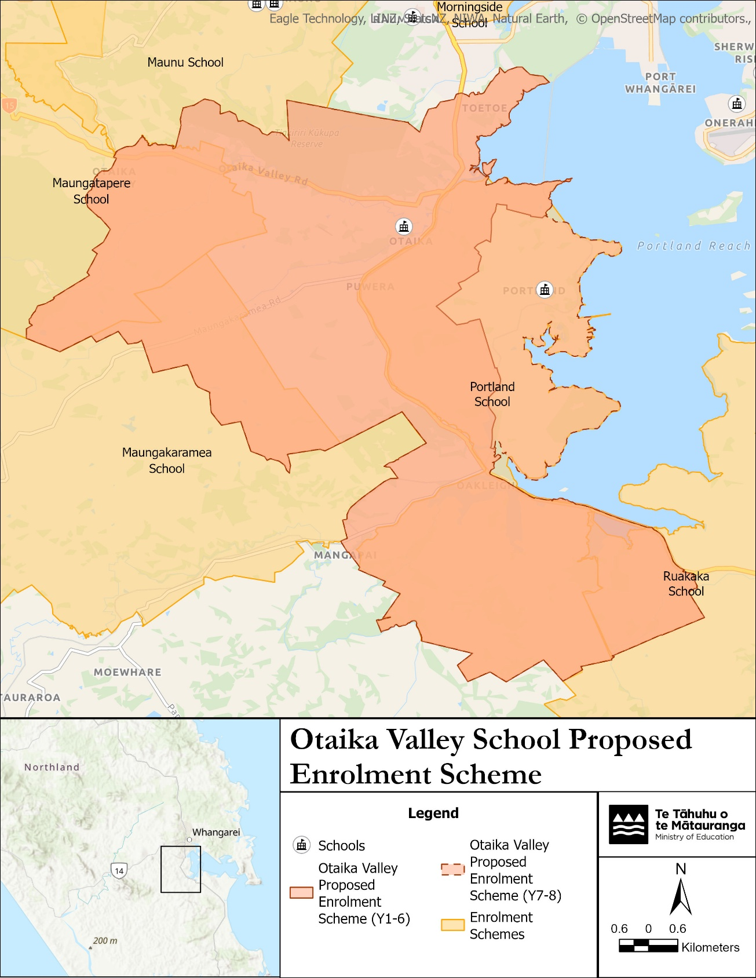

What does this mean for my family?
Any student currently enrolled at Otaika Valley School will not be impacted by the new enrolment scheme. All students enrolled (and attending school) will be entitled to continue attending Otaika Valley School.
The amendment of the enrolment scheme and home zone will affect some enrolments starting at the beginning of Term 1 202X. This includes current families who have a younger sibling looking to enrol at Otaika Valley School starting on 1 January 202X (the commencement date) or later. The flowchart below will help you assess your indicative eligibility to enrol after the commencement date.
Does your child (enrolling in 2027 or later) live within the enrolment scheme home zone? (check map for reference)
In zone enrolment
YES

NO
Out of zone enrolment
(if places available)

YES
Does your child (enrolling in 2027 or later) live outside of the zone?

Consultation process and timeline
The Ministry of Education is currently undertaking consultation about the proposed changes and new enrolment schemes. You can have your say by:
Completing the survey at https://consultation.education.govt.nz/ on the Otaika Valley School consultation page.

Emailing taitokerau.enrolmentschemes@education.govt.nz if you have further questions or comments.
Consultation will run 2 November to 12 December 2026. The Ministry will consider all feedback and liaise with the Karetu School Board before making a final decision. The new scheme and changes will come into effect for enrolments after the commencement date.

