Kawakawa Primary School
New Enrolment Scheme

Overview – what is changing?
The Ministry of Education regularly monitors enrolment patterns, population growth and anticipated school roll changes across the Tai Tokerau region. As part of this monitoring and regular review, we now consider an enrolment scheme is necessary for Kawakawa Primary School. It means we can ensure we are making best use of educational facilities across the wider Kawakawa area.
The new enrolment scheme will have a home zone, like other schools with enrolment schemes in the area. Children that live within this area will have entitlement to enrol at Kawakawa Primary School. The home zone area is shown on the map below and described here:
Kawakawa Primary School (1033)
Proposed Draft Enrolment Scheme
Commencement date: 1 January 2027

The guidelines for development and operation of enrolment schemes are issued under Schedule 20, Clause 3 (3) of the Education and Training Act 2020 for the purpose of describing the basis on which the Secretary’s powers in relation to enrolment schemes will be exercised.
Home Zone
All students who live within the home zone described below shall be eligible to enrol at the school.
The Home Zone includes addresses on both sides of the boundary roads mentioned in the description, and all no-exit roads off the boundary roads are included in the zone unless otherwise stated.
The zone starts on Paihia Road at the turnoff for 501 Pahia Road A/B/C/D (included) and travels south through the intersection with Waikare Road (excluded) and Doel Road (included) and into Kawakawa township.
The zone turns left onto Ruapekapeka Road and follows it south. After 584 Ruapekapeka Road/at the northern end of Ruapekapeka Historic Reserve, the zone travels left overland to State Highway 1 to include 4554 State Highway 1. The zone travels north up State Highway 1, through Kawakawa township, and west towards Moerewa. At the intersection with Saies Road (included), the zone travels north overland to join Hupara Road at 55 A/B Hupara Road (included).
The zone turns left onto McIntyre Road and travels north up to the McDonald Road intersection (included). From here, the zone travels north-east overland to join at the intersection between Whangae Road (included) and Oromahoe Road (excluded). The zone travels south down Whangae Road to the intersection with McIntyre Road. The zone travels east overland to the starting point on Paihia Road.

Section 75 of the Education and Training Act 2020 states that

“the Secretary may authorise an enrolment scheme to permit a student to enrol at the school as if the student lived in the home zone of the school if, -

(b) in the case of a new enrolment scheme, the student,

1. lives outside of the home zone of the new enrolment scheme; and
2. has a sibling who is enrolled at the school at the time that the new enrolment scheme is implemented.”

Special Programmes
The school operates the following special programme:
Immersion Unit Rau Kumara, Rau Tangata (Max Roll 120 students)
- Consisting of 6 akomanga; Ngā Kākano (NE-Y1), Ngā Rau Rito (Y1-Y2), Ngā Rau Tupuranga (Y2-4), Ngā Rau Puawai (Y4-5), Ngā Rau Mahuri (Y5-6) and Ngā Rau Rangatira (Y6-8).
- Instruction in the Rau Kumara, Rau Tangata akomanga is between 50-80% te reo Māori (Māori Immmersion Level 2) with Te Reo Māori used in all subjects throughout the day. Pupils entering these classes must be able to speak and learn in Māori, and have a willingness to grow as a reo Māori speaker and learner. They must also be prepared to participate in kaupapa Māori and kapa haka.
Being part of our Rau Kumara, Rau Tangata akomanga requires commitment from both whānau and students which is outlined below;
Attendance.
- Rau Kumara Rau Tangata requires at least 90% REGULAR school attendance. This means no more than 5 days of absences each term, with the exception of māuiuitanga, attending huimate, and justified kaupapa.
Whānau Commitment.
- Learning in both te reo Māori and English requires whānau support and commitment to using te reo within the home. Whānau are encouraged to, if not currently doing so, use this as an opportunity to start their own reo Māori journey.
Entry Requirements.
- Preference will be given to new tauira that come from Kohanga Reo, Kura Kaupapa Māori, Kura ā-Iwi, or those showing that they have te reo i te kainga.
Kapa haka commitments.
- Ngā Huiarau o Kawakawa kapa haka sessions are compulsory for all Year 4–8 students. These involve after-school practices as well as weekend wānanga.
- Ngā Rau o Kawakawa kapa haka sessions are compulsory for all Year 2–8 students. Training takes place during the school day, with occasional weekend wānanga scheduled as needed.
Upholding the principles of our reo rua whānau will ensure a students placement within it.

Out of Zone Enrolments
Each year the Board of Trustees will determine the number of places which are likely to be available in the following year for the enrolment of students who live outside the home zone. The Board will publish this information by public notice in a medium appropriate to the area served by the school. The notice will indicate how applications are to be made and will specify a date by which all applications must be received.
Applications for enrolments will be processed in the following order of priority:
First Priority
must be given to students who have been accepted for enrolment in the following special programme run by the school and approved by the Secretary of Education up to the maximum roll set for the programme
- Immersion Unit Rau Kumara, Rau Tangata
Second Priority
will be given to applicants who are siblings of current students.
Third Priority
will be given to applicants who are siblings of former students.
Fourth Priority
will be given to any applicant who is a child of a former student of the school.
Fifth Priority
will be given to any applicant who is either a child of an employee of the board of the school or a child of a member of the board of the school.
Sixth Priority
will be given to all other applicants.

If there are more applicants in the second, third, fourth, fifth or sixth priority groups than there are places available, selection within the priority group will be by ballot conducted in accordance with instructions by the Secretary, under Schedule 20, Clause 3 (1) of the Education and Training Act 2020. Parents will be informed of the date of any ballot by public notice in a medium appropriate to the area served by the school.
Applicants seeking second or third priority status may be required to give proof of a sibling relationship.
See maps below.
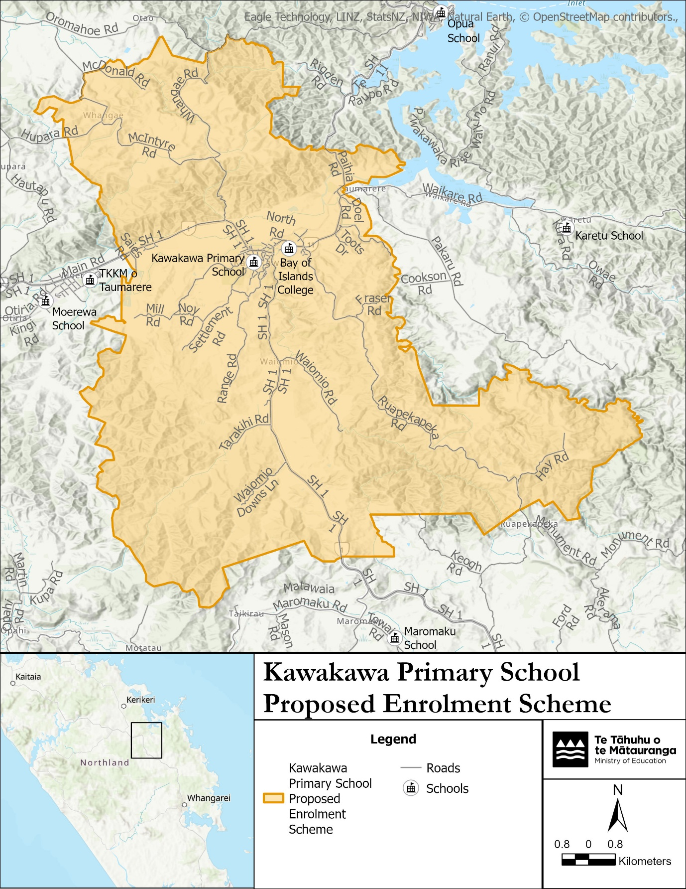

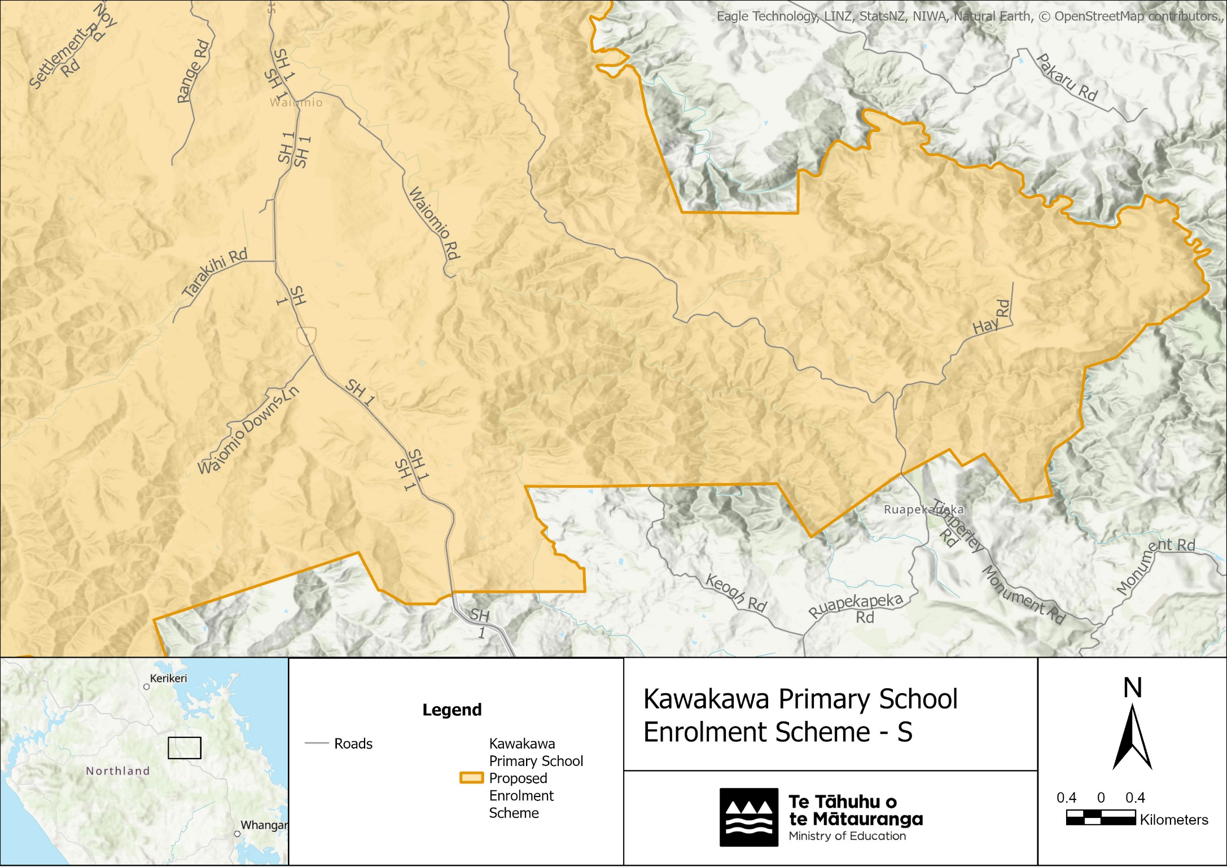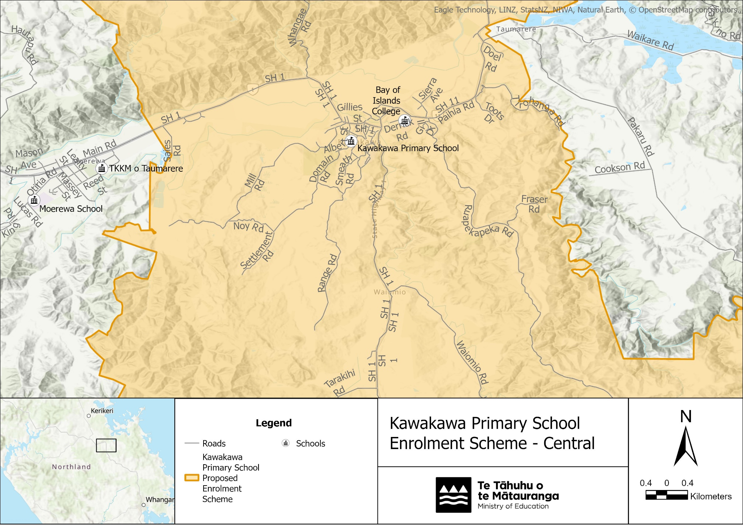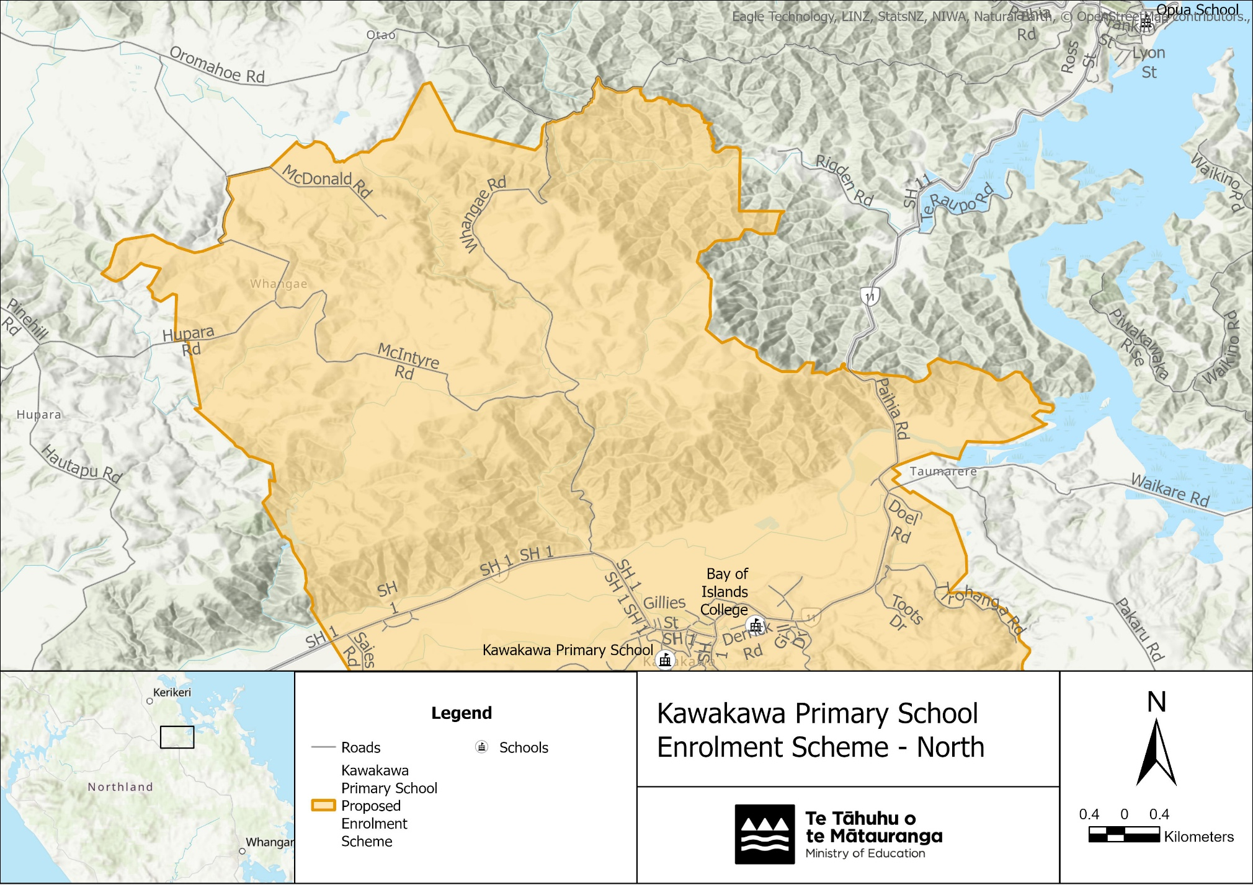
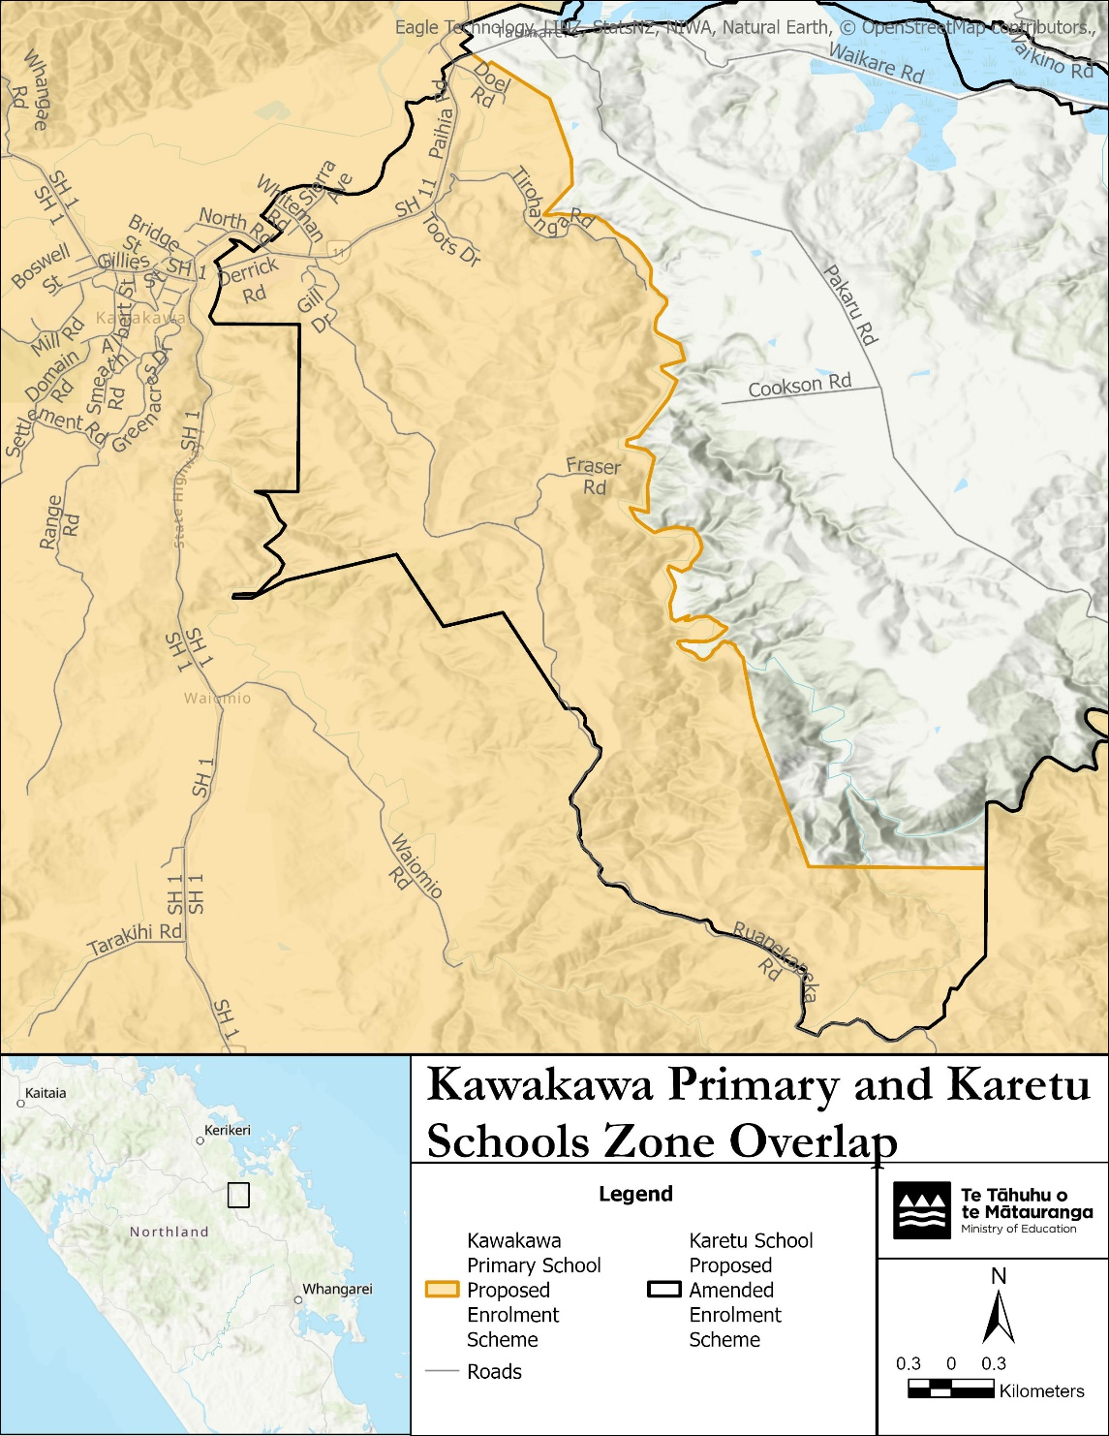
What does this mean for my family?
Any student currently enrolled at Kawakawa Primary School will not be impacted by the new enrolment scheme. All students enrolled (and attending school) will be entitled to continue attending Kawakawa Primary School.
The amendment of the enrolment scheme and home zone will affect some enrolments starting at the beginning of Term 1 2027. This includes current families who have a younger sibling looking to enrol at Kawakawa Primary School starting on 1 January 2027 (the commencement date) or later. The flowchart below will help you assess your indicative eligibility to enrol after the commencement date.
Does your child (enrolling in 2027 or later) live within the enrolment scheme home zone? (check map for reference)
In zone enrolment
YES

NO
Out of zone enrolment
(if places available)

YES
Does your child (enrolling in 2027 or later) live outside of the zone?

Consultation process and timeline
The Ministry of Education is currently undertaking consultation about the proposed changes and new enrolment schemes. You can have your say by:
Completing the survey at https://consultation.education.govt.nz/ on the Kawakawa Primary School consultation page.

Emailing taitokerau.enrolmentschemes@education.govt.nz if you have further questions or comments.
Consultation will run 2 November 2026 to 12 December 2026. The Ministry will consider all feedback and liaise with the Kawakawa Primary School Board before making a final decision. The new scheme and changes will come into effect for enrolments after the commencement date.

