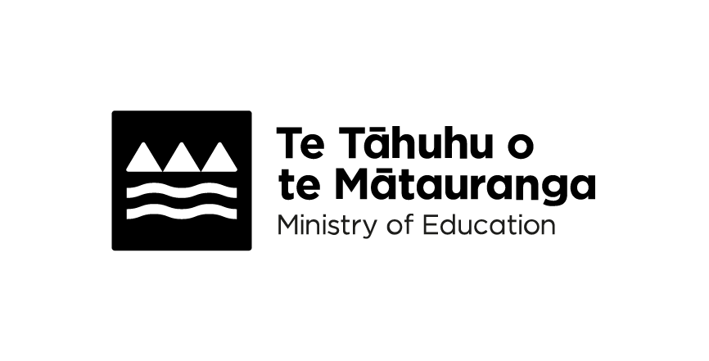
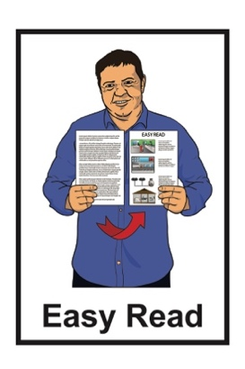
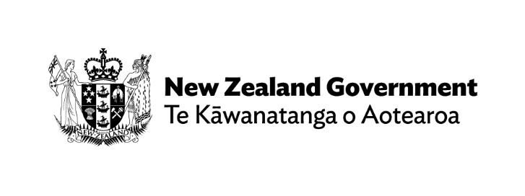

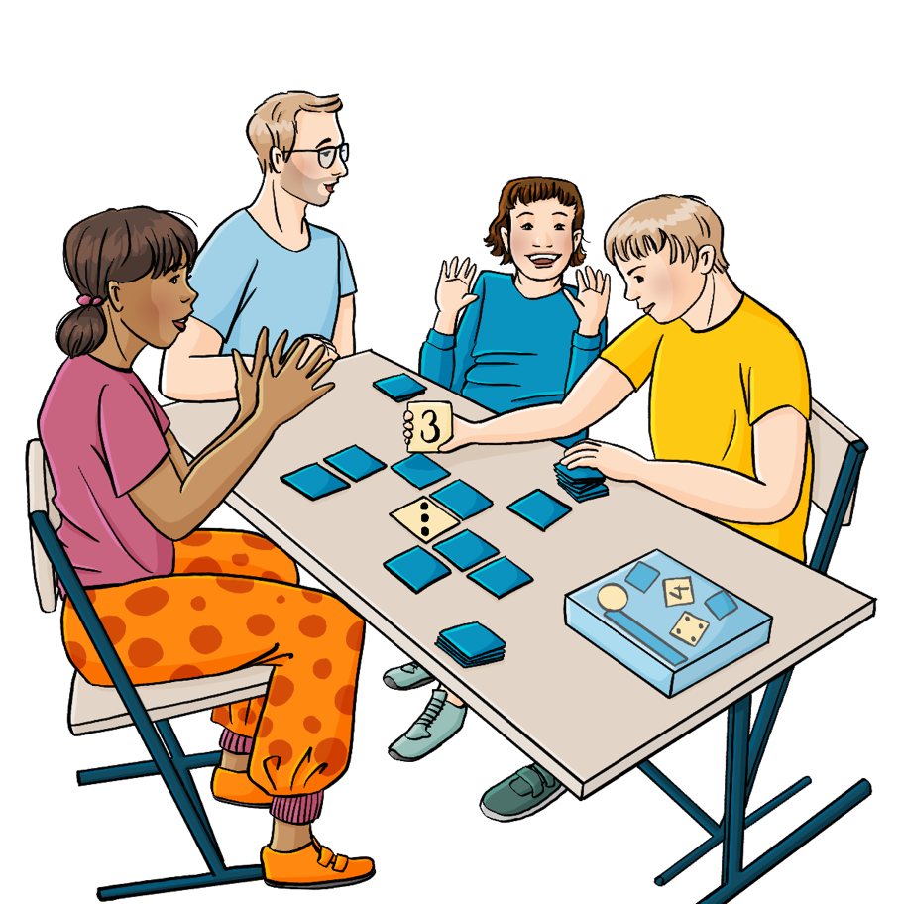
Help shape the future of
your school

Published: September 2026

What you will find in here


Page number:

What this Easy Read is about 2


Your ideas are important 4

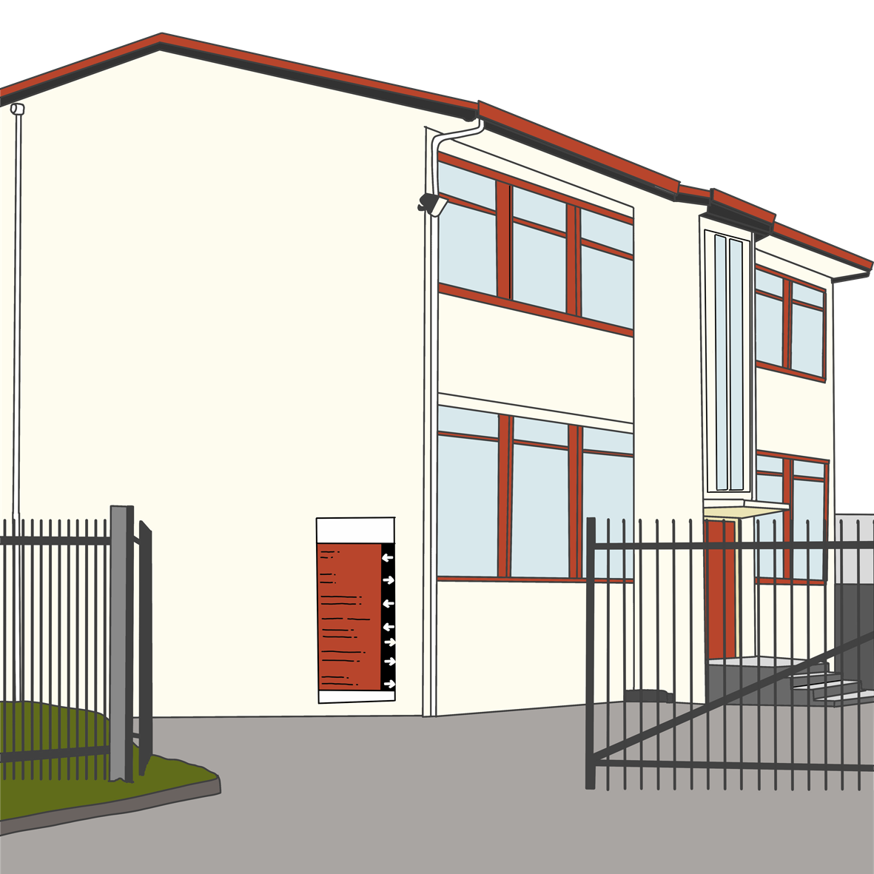
What schools have to do 6

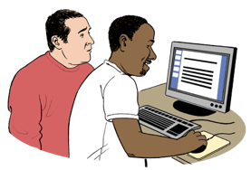
What you can expect from
your school 14


Where to find more information 16

What this Easy Read is about

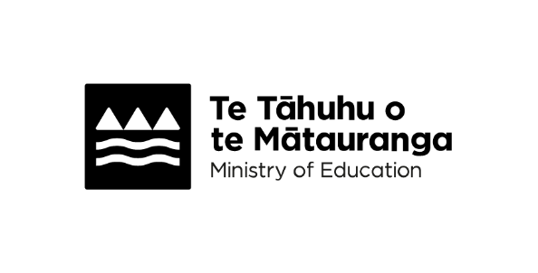
This Easy Read is from Te Tāhuhu o te Mātauranga Ministry of Education.

Te Tāhuhu o te Mātauranga Ministry of Education is the part of the Government in charge of schools in Aotearoa New Zealand.


This Easy Read is about what schools need to do to:
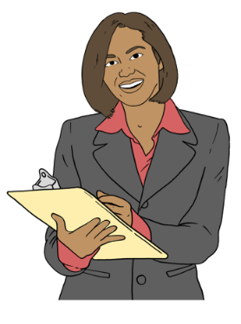
plan how they will do things
monitor / check how things are going.

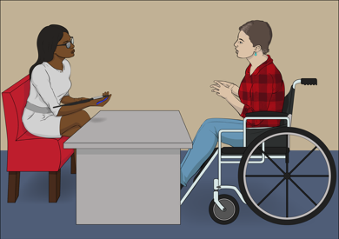
This Easy Read also has information about how you can have a say about your school.

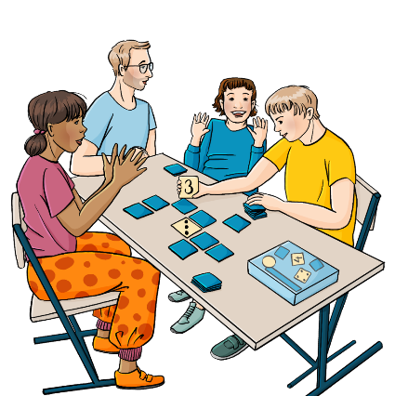
Your ideas can help your school to be a place where everyone can do well.

Your ideas are important

Schools need to work with everyone in their community when they make plans.

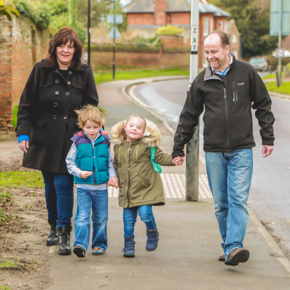
Here community is everyone who has something to do with the school like:
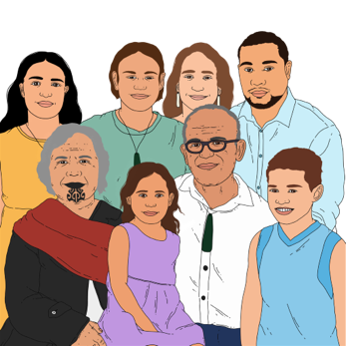
students
parents
whānau / families.


Working with their community supports schools to set goals that:
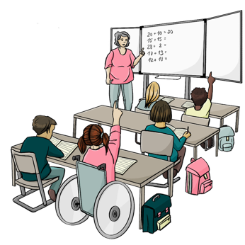
meet the needs of all their students
give all students the best chance to do well at school.

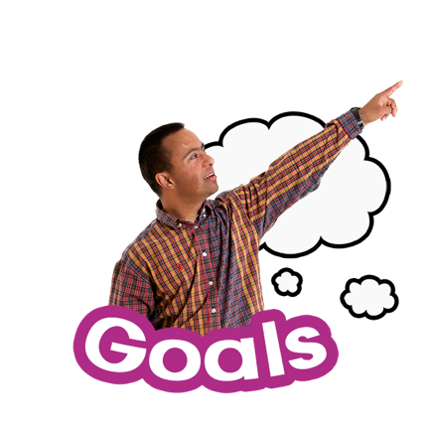
Here goals are:
things that the school wants to make happen
how the school wants things to be.


Your ideas can be part of making school better for everyone.

What schools have to do

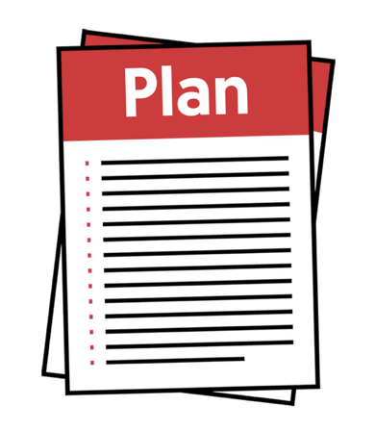
Schools need to write:
long-term plans
annual plans.


Here long-term plans say what
goals the school will work towards over the next few years.

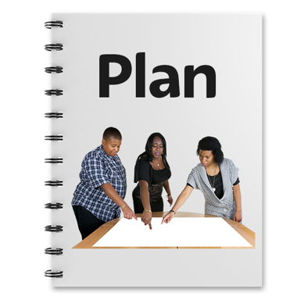
Here annual plans have details about what the school will do in the coming year.

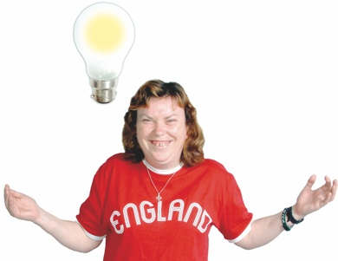
Schools should write these plans using:
ideas from their community
their data.


Here data is information schools have about their students like how well students have done on their tests.
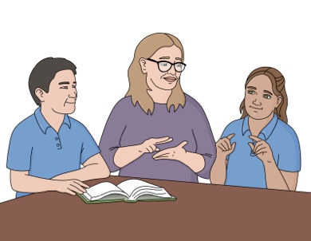

Schools must make sure every student can do as well as possible.

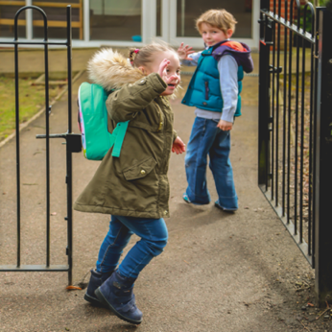
Schools must also do what they can to make sure all students come to school every day.


Schools must use good
aromatawai / assessment information to check how students are doing with their learning.


Here aromatawai / assessment means checking how students are doing using things like tests.

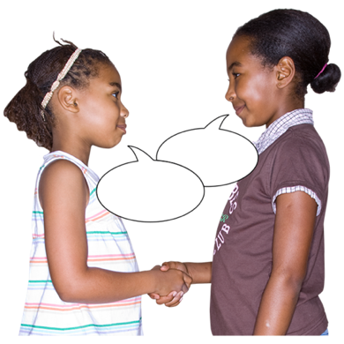
Schools must be places students are safe:
physically / in their bodies

emotionally / in their feelings.
Rights

Schools must take care of the rights their students have.

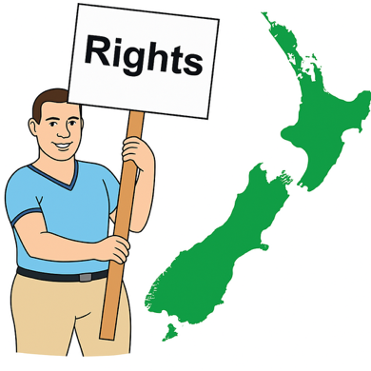
Rights are things everyone should:
have
be able to do.

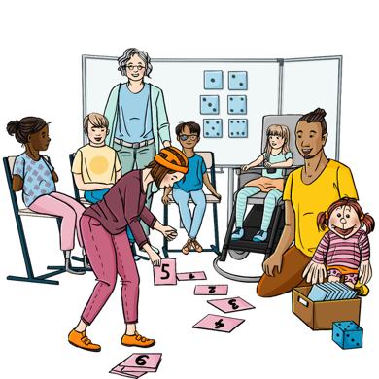
Rights are things like:
having a safe place to learn
being able to take part in
learning at your school.


Schools must do everything they can to stop things like:
bullying
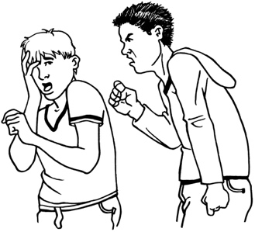

discrimination
racism.


Bullying is when someone is
treated in a bad way by another person / group of people.

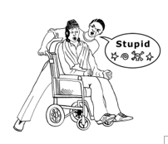
Bullying can be things like:
saying nasty things to
you / about you
- hitting / kicking / pushing you.


Discrimination is when people are treated unfairly because of things like:

how old they are
being a boy / girl / someone of another gender
being disabled.


Racism means nasty / unfair treatment of someone because of:
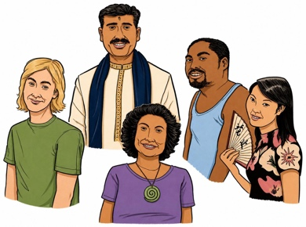
where they come from
- their language
- their skin colour.
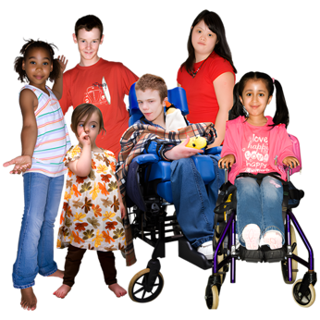

Schools must be inclusive of students with different needs.


Inclusive means everyone can:
take part
feel like they belong.
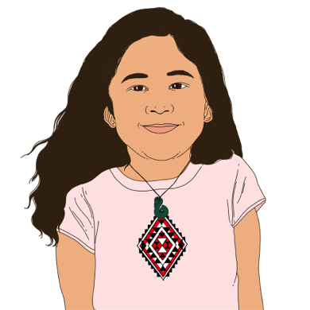

Schools need to work to make sure Māori students have a fair chance to do as well as other students.

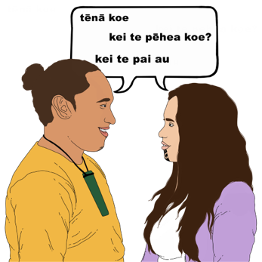
Schools should do everything they can so students can learn in te reo Māori / the Māori language.


Schools should think about
cultural diversity when they decide about:
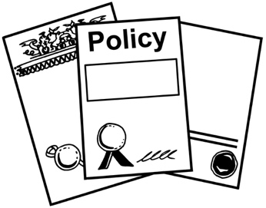
policies / rules
how they do things.

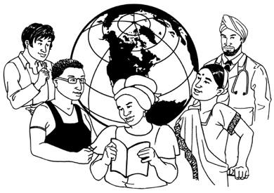
Here cultural diversity means people in Aotearoa New Zealand:
come from many different cultures
have different needs because of their culture.

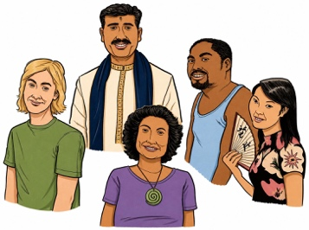
Culture is a way of:
thinking that a group shares
doing things as a group.
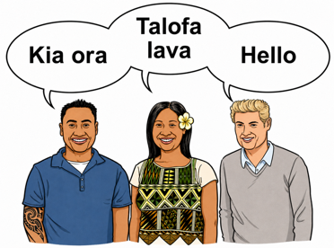

There are many different cultures in
Aotearoa New Zealand.
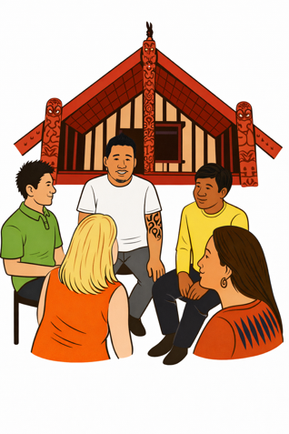

Some examples of the different cultures are:
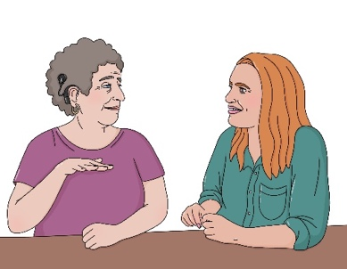
Māori culture
Pacifica culture
Deaf culture.

What you can expect from your school

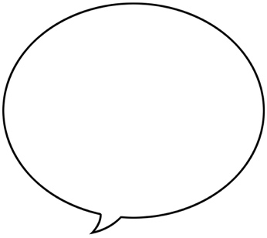

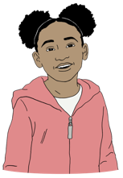
Your school will want to talk to you about what is:
working well for your child
not working well
important for your child.

This will help the school know what goals they should set.

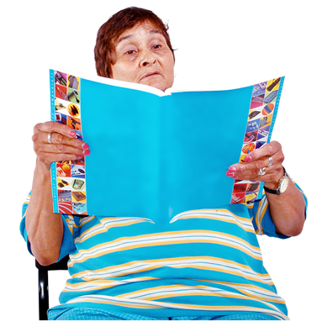
The school should make sure its plans are shown to all:
parents
students.

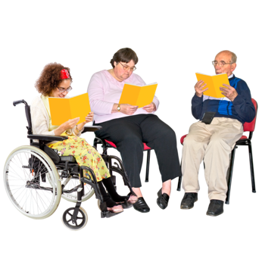
The plans should be:
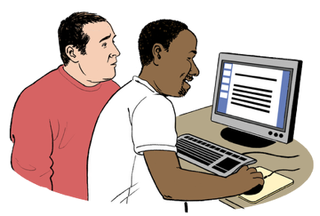
written in a way that is easy to understand
put online.

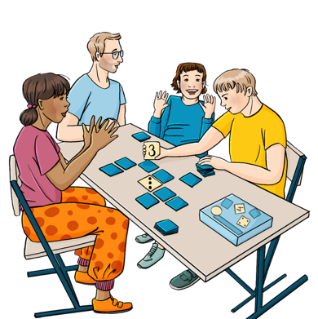
Every year your school should tell you about the difference they are making for their students in:
learning
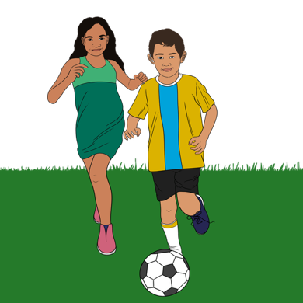
wellbeing.

Wellbeing means things like:
how we feel about ourselves
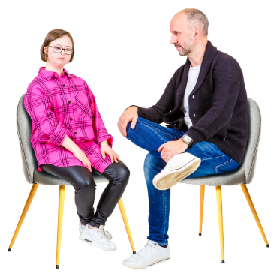
looking after our bodies with good food and exercise
getting support when we are feeling sad or worried.

Where to find more information

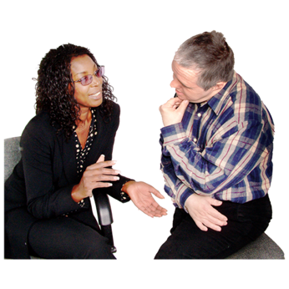
You can find out more about how your school makes plans by talking to someone from your school like:
a teacher
the principal
someone from the School Board.

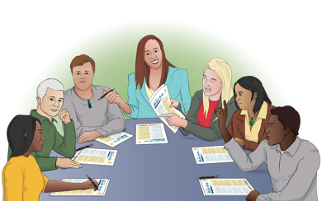
The School Board is the group of people who run a school.

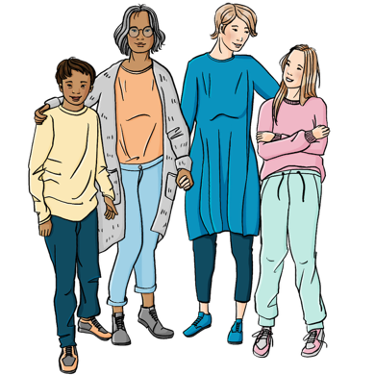
People on the School Board can include:
parents
a teacher
people from the commmunity.
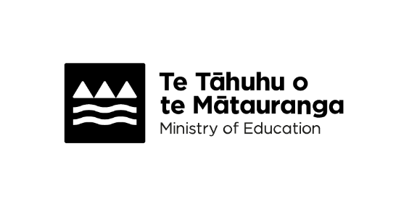
You can go to the Ministry of Education website to find out more about what schools have to do for:
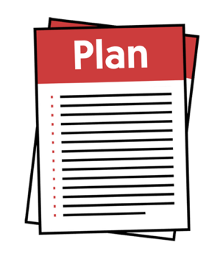
planning
reporting / telling people how they are doing.


You can click this link to get to the Ministry of Education website:

https://tinyurl.com/4ra2pzjr
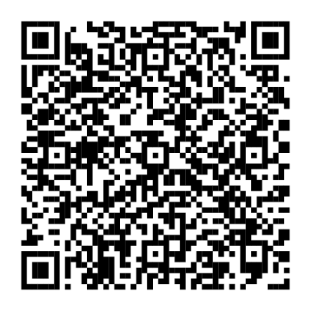

You can also scan this QR code to get to the Ministry of Education website.

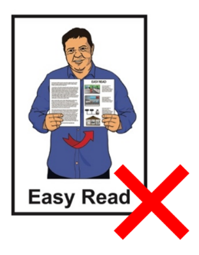
The website is not in Easy Read.

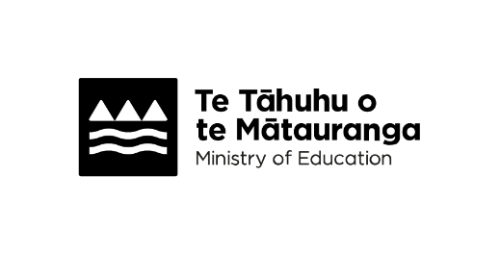
This information has been written by Te Tāhuhu
o te Mātauranga Ministry of Education.

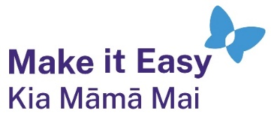
It has been translated into Easy Read by the Make it Easy Kia Māmā Mai service of People First New Zealand Ngā Tāngata Tuatahi.
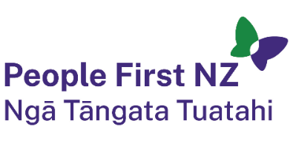
The ideas in this document are not the ideas of People First New Zealand Ngā Tāngata Tuatahi.

All images used in this Easy Read document are subject to copyright rules and cannot be used without permission.


Make it Easy uses images from:


- Photosymbols

- Change Images


- Huriana Kopeke-Te Aho
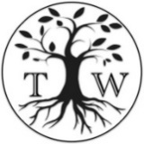
- SGC Image Works

- T Wood

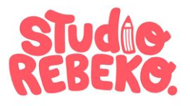
- Studio Rebeko

- Inga Kramer.

