Frequently Asked Questions: Ongoing Resourcing Scheme – Changes to Streamlined Early Intervention Very High (EIVH) digital and downloadable application forms
Apply for the Ongoing Resourcing Scheme - Ministry of Education

Background
How did the streamlined EIVH ORS application form come about?
The streamlined application was introduced in 2011 to better meet the needs of those tamariki who clearly had very high needs. These applications are specific to each criterion (one through four) and can be completed from the age of four years and six months.
These forms are streamlined to reduce the time needed to complete the application and specifically for tamariki who obviously have very severe needs and clearly meet the very high ORS criteria and when applicants can easily and succinctly describe their needs.
The EIVH streamlined application was designed to shorten the application and decision-making process.

What has changed?
- The digital application form has been launched and the most current downloadable application forms will be available on the Ministry webpages.
- Apply using the digital application form available via Education Sector Logon (ESL), or, if you do not have an ESL, complete one of the forms on the webpages Apply for the Ongoing Resourcing Scheme - Ministry of Education
- The applications have a character/page limit. Please ensure you write clearly and succinctly. The competencies for each section have not changed.
- Additional information about digital applications is available here: Request Learning Support | Applications & Online Systems
- The guideline documents on the website have been updated and reorganised. The information is not ‘different’ and the overall process of application to the ORS has not changed.
- Language on all ORS application forms has been revised to reflect plain language and ensure consistency of messaging. Some words and headings may look different however the same information is still required.

Why is this changing?
EIVH streamlined applications
Applications have become less succinct. Often applications are more than twice as long as they should be.
The practice around the use of the EIVH streamlined application form has changed over time. Many practitioners are using the streamlined form for all Early Childhood applications for Very High ORS applications. There will be children who meet the ORS very high criterion, but their applications require more comprehensive and detailed information to clearly illustrate their very high needs to the verifiers, in this case a full form should be used.
Given the length and complexity of the information we are seeing in the streamlined applications, we know that the full form should be used. When the full form is not used for complex tamariki there can be gaps in the information about the competencies, leading to declined applications.
Most applications for Very High ORS should be on the full form. The streamlined EIVH form should be the exception.
Lengthy applications have an impact on assessment and decision-making timelines. When used wrongly they can result in lengthier wait times as a decline on a streamlined EIVH form means that a new full form will be required if a review of the decision is needed.
Placing a character/page limit on applications will support applicant decision making when choosing the correct application pathway. That is – are the needs of the tamaiti ongoing and very severe, can they be expressed succinctly and clearly?
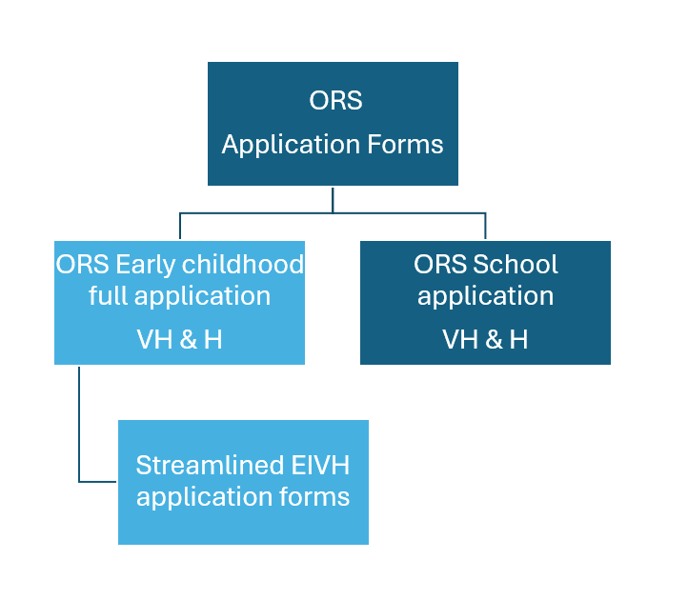
What’s happening with guidance and application forms?
The guidance forms on the website has been revised to ensure that it is up to date. The language used is plain, consistent, and restructured to make sure it is accessible.
We have also updated the application forms. We have revised the language to ensure that it is plain and clear and removed the guidance from the application form. This is also to ensure guidance has consistency of message and there is one source of truth.
For the EIVH streamlined applications, there are character/page limits on the form as well as limiting the information able to be put into each box.
Full Early Childhood application forms can be used to complete applications for both High and Very High ORS, especially for those Very High ORS students whose needs are complex and not easily understood.
The streamlined EIVH forms should only be used for those tamariki whose needs are obviously at the Very High level and can be clearly and succinctly conveyed in the application. They should be the exception and in most cases the use of a full form is best practice.

Difference between Early Intervention ORS application forms
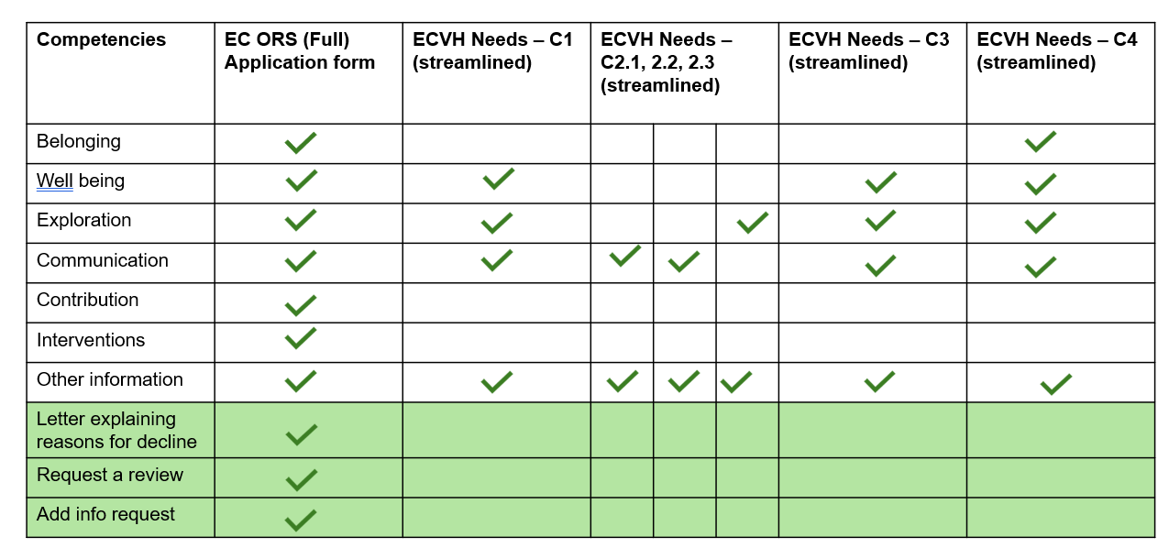

Key points for noting when using the streamlined EIVH form:
- If the information provided in the streamlined application does not clearly show a child meets ORS at the very high level the verifiers may approve ORS at the high level. This will only happen if there is enough information to demonstrate their needs are at the high level. A letter will be sent to the educator; however, it will not explain the verifiers’ decision because the EIVH application was brought in to reduce information and speed up processes.
- When the information provided in the streamlined application form doesn’t indicate a child meets ORS at either the very high or high level the child will not be ORS verified and an email letter will be sent to the educator. The letter won’t include the reasons for the decision.
- The educator will need to discuss the decision with the parent and ensure that they have a copy of the letter.
- When the applicants continue to be of the belief that the needs of the child are at the very high level please reapply using a full Early Childhood ORS application form.
- EIVH streamlined applications have a character/ page limit. This is stated on the application form for EIVH streamlined forms. The page limit is for the total pages of the application which includes the front and end pages that don’t have a page number.
- There are no changes to criteria or any steps in the application and decision-making process.
What are good practice expectations?
Applicants’ managers (internal and external) will continue to review the applications before they are submitted to ensure: they are appropriate, on the right application form, processes for decision making have been used and information is clear and no inappropriately shared information is included.
Downloaded Application Forms
The most current application forms from the website will be used, noting that from time to time we will amend application forms.
Please do not change the formatting. You do not need to provide headings and other editing features for these applications.
Some of the functions of Word are not available when the page numbers are restricted. Please download a copy of form and save it.
Updated guidance on the website is used to support the writing of applications.
The Assurance and Eligibility Team will continue to make changes to the information on the website, to support users and ensure that the information is up to date, accessible and that the language is plain and clear.
The Assurance and Eligibility Team will continue to manage application queries and expectations with external providers.
To manage wait times for assessment and practice expectations, the Assurance and Eligibility Team will send back incomplete application forms and applications that contain excessive information - those that are beyond the page limits.
Clear and succinct applications from applicants who know tamariki well will support timely consideration and robust decision making.
Please note when using the Streamlined EI VH Application Form
Once downloaded from the Ministry of Education website, Enable Editing in the yellow banner will need to be selected. Each header has their character limit stated. If copying and pasting, please note if you go over the character limit, the text box will not expand, and information will be cut off. Due to limitations of the restrictions, spelling and grammar check, autosave, right click function and undo button are unable to be used. Extra attachments will only be accepted for criteria 2.1, 2.2 and 2.3. Remember information is to be clear, succinct and does not require repetition.
If you are unable to provide sufficient information to clearly illustrate the tamaiti meets ORS Very High within the maximum number of pages, please consider completing a full Early Childhood application form.

