Consistency Accountability Statement: Education (School Planning and Reporting) Amendment Regulations 2026

Agency responsible | Ministry of Education
Portfolio | Education
Date finalised | 2 September 2026
Identification number | REG- 2239
Statement of Review
I confirm that the Ministry of Education has assessed the above legislation, and the process for developing it, for consistency with the principles of responsible regulation as set out in section 9 of the Regulatory Standards Act 2025.
This assessment identified no inconsistencies with the principles of responsible regulation.
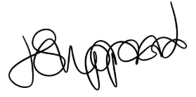
Jacqueline Sheppard
Senior Policy Manager
Te Pou Kaupapahere | Policy
Ministry of Education

