Information for Attendance Service Providers

Practice Guide – Managing cases moving catchment

Purpose
This practice guide explains what to do when an ākonga with an open attendance case moves into another Attendance Service catchment. It supports consistent decisions about whether a case should be transferred to another provider, allocated to CIT, or retained while further locating activity continues.

This guide focuses on practice expectations. For step-by-step instructions on reallocating a case in AS-CMS, use the AS-CMS Quick Reference Guides for Providers.

Key message
A case should move to a new catchment only when there is enough confirmed information to support the transfer. Confirmed information means more than being told that the ākonga may have moved or may enrol somewhere else. Before a case is transferred, there should be enough information to support the transfer pathway, including confirmed enrolment, confirmed residence in another catchment, or agreement from another provider to accept the case.
In practice, this means:
- if the ākonga is enrolled at a school in another catchment, you can reallocate the case directly to the new provider in that catchment after appropriate preparation and handover
- if the ākonga is not enrolled but has a confirmed address in another catchment, you should update the case record and allocate the case to CIT so it can be reassigned
- if the ākonga may have moved but there is no confirmed address or enrolment, you should retain the case and continue locating activity.

In some situations, another provider may also be better placed to support the ākonga, for example because they are already supporting siblings or whānau members. This should only happen where the receiving provider has agreed to accept the case. The case should be allocated to CIT with a clear note explaining which provider should receive it and why.

Moving catchment is not a close reason. The case should remain open unless a valid closure reason has been met.

Key principles
When making decisions about moving catchment, you should:
- base the decision on confirmed information
- keep the case open while transfer decisions are being worked through
- transfer the case through the appropriate pathway
- make sure the case record is up to date before transfer, including contacts, case comments, events, barriers, plans, services, and supports where relevant
- support continuity through a warm handover
- record the reason for the transfer clearly
- do not reallocate based only on an expected move or intended enrolment.

Checking enrolment and catchment information
Before reallocating a case, use the enrolment and catchment information in AS-CMS to determine which pathway applies.
You should check:
- the Currently Enrolled field in the Student Details section of the case, immediately under the status bar. This field will show Y if the ākonga is currently enrolled, or N if they are not currently enrolled.
- the Details tab on the case to see whether the case is showing as out of catchment, and to view current school catchment and new provider information where available.
- the Enrolment History tab where you need to confirm current and previous enrolment information.
- the Daily Attendance tab as a supporting check, noting that attendance data may sometimes appear before ENROL has been updated.

When the ākonga enrols at a school in another catchment

What this means
If the ākonga enrols at a school in another catchment, the case should move to the provider for the new catchment.
You may become aware that the enrolment has changed because you receive an in-app notification. The case will also show an Out of Catchment alert.
Use the enrolment and catchment information in AS-CMS to confirm that this is the correct pathway before reallocating the case.

What you should do
Before reallocating the case, you should:
- confirm the ākonga is currently enrolled at a school in another catchment
- check the relevant enrolment and catchment information in AS-CMS
- update the case record, including recent case activity, contacts, barriers, plans, services, and supports where relevant
- contact the receiving provider and arrange a handover
- record the handover in AS-CMS, including what was discussed
- reallocate the case directly to the receiving provider.

The handover should give the receiving provider enough information to continue supporting the ākonga and whānau without repeating work unnecessarily.

When the ākonga is not enrolled but has a confirmed address in another catchment

What this means
If the ākonga is not enrolled, but you have a confirmed address in another catchment, the case should move through CIT so it can be assigned to the appropriate provider.
This pathway applies when there is enough confirmed address information to identify the new catchment, but the ākonga is not currently enrolled at a school.
Use the address and catchment information available to you to confirm that this is the correct pathway before allocating the case to CIT.

What counts as a confirmed address
A confirmed address should give you reasonable assurance that the ākonga is living in the new catchment.
A confirmed address may come from sources such as:
- whānau
- an MSD information request
- a school
- another agency or professional source
- another reliable source that provides enough information to identify the new catchment.
If the information is unclear, or there is reason to believe the ākonga may not be living at the address provided, continue locating activity before allocating the case to CIT.
Where an address has been provided, record the source of that information clearly on the case. This is especially important where the address has come from an information request, another agency, or another professional source.

What you should do
Before allocating the case to CIT, you should:
- confirm the ākonga is not currently enrolled
- confirm the new address is in another catchment
- ensure that the information gives reasonable assurance that the ākonga is living at that address
- update the case contacts with the new address and any other relevant contact details
- record the source of the address information
- identify the provider for the new catchment
- update the case record, including recent case activity, barriers, plans, services, and supports where relevant
- contact the receiving provider and arrange a handover
- record the handover in AS-CMS, including what was discussed
- allocate the case to CIT with a clear note identifying the provider the case should go to.
The note to CIT should include the confirmed address, the source of the address information, the intended receiving provider, and whether a handover has taken place.
The handover should give the receiving provider enough information to continue supporting the ākonga and whānau without repeating work unnecessarily.

When the ākonga may have moved but there is no confirmed address

What this means
Sometimes you may have information that suggests the ākonga has moved to another catchment, but you do not yet have a confirmed address or confirmed enrolment.
This information can help guide your locating activity, but it is not enough to reallocate the case or allocate it to CIT. The case should stay with you while you continue attempts to locate the ākonga.
The same approach applies if you are told that the ākonga is expected to move or enrol in another catchment, but this has not yet been confirmed. Record the information as unconfirmed, continue locating activity and information checks where needed, and check AS-CMS for updated enrolment or address information.

What you should do
You should:
- retain responsibility for the case while the location is being confirmed
- record what you have been told, including whether the information is confirmed or unconfirmed
- continue reasonable efforts to locate the ākonga and whānau
- check whether there is any updated information from previous schools, known contacts, agencies, community networks, or other relevant sources
- complete or repeat information requests where appropriate
- update the case record as new information becomes available
- use the Not Located flag if the criteria are met
- keep the case open unless a valid close reason has separately been met.

If you later confirm that the ākonga is enrolled at a school in another catchment, follow the pathway for reallocating directly to the receiving provider.
If you later confirm that the ākonga is not enrolled but has a confirmed address in another catchment, follow the pathway for allocating the case to CIT.

When another provider has agreed to support the ākonga
In some situations, another provider may be better placed to support the ākonga, for example because they are already supporting siblings or whānau members.
This pathway should only be used where the receiving provider has agreed to accept the case.

Before allocating the case to CIT, you should:
- confirm that the receiving provider has agreed to accept the case
- record why the transfer is appropriate
- update the case record, including recent case activity, contacts, barriers, plans, services, and supports where relevant
- arrange and record a handover with the receiving provider
- allocate the case to CIT with a clear note identifying which provider the case should go to and why.
The note to CIT should clearly explain the agreed receiving provider and the reason for the transfer.

Handover expectations
When a case is moving to another provider, you should contact the receiving provider and arrange a handover meeting before the case is reallocated to that provider or to CIT.
The purpose of the handover is to support continuity for the ākonga and whānau. It should give the receiving provider enough information to understand the case history, current circumstances, barriers identified and supports already in place.
The handover should cover:
- why the case is moving catchment
- whether the transfer is based on confirmed enrolment, a confirmed address, or provider agreement
- what has happened so far and what support has been provided
- who is involved with the ākonga and whānau
- current contact details
- barriers that have been identified
- plans, services, referrals, or supports in place
- any risks, safety concerns, or urgent follow-up needs.

You should record the handover in AS-CMS, including who was involved, the date of the handover, what was discussed, and any key information the receiving provider needs to be aware of.
The handover does not replace the receiving provider’s own case management activity. It supports a clear transfer of responsibility so the receiving provider can continue support without repeating work unnecessarily.

Recording expectations
Before a case moves, make sure the case record is up to date.
This includes updating relevant:
- contacts and address details
- case comments
- events
- barriers
- plans
- services
- information request outcomes.

Where the ākonga is not enrolled but has a confirmed address in another catchment, the note to CIT should include:
- the intended receiving provider
- the reason the case should go to that provider
- the source of any confirmed address information, where relevant
- confirmation that the receiving provider has been contacted and that a handover has taken place.
Free-text recording should be professional, factual, and respectful. It should help another provider understand the case if they read the record later.

Initial meetings and reporting expectations after transfer
When a case moves from one provider to another, the receiving provider needs to check the case record and handover information to confirm which initial meetings have already taken place and which meetings are still required.
Initial meeting expectations relate to each new referral or notification, not just to the AS-CMS case record. When a school makes a CA referral or creates a NEN in ENROL, that action creates a case in AS-CMS. If the case is later transferred between providers, the receiving provider is responsible for completing any initial meetings required for that referral type (CA or NEN).

For CA cases where the ākonga is enrolled, the receiving provider must complete both the initial school meeting and the initial student / whānau meeting after transfer.
For NEN cases, the receiving provider must complete the initial student / whānau meeting after transfer. The receiving provider is only required to complete the initial school meeting if it has not already been completed and recorded by the transferring provider for the same referral.
If the case has closed and a later referral is made for the same ākonga, the required initial meetings apply again for the new referral. This applies even if AS-CMS reopens the previous case rather than creating a new case.

NEN case transferred to another provider
For NEN cases, the transferring provider is expected to complete the initial school meeting and initial student / whānau meeting before transfer.

After transfer, the receiving provider must complete the initial student / whānau meeting. The receiving provider is only required to complete the initial school meeting if it has not already been completed and recorded by the transferring provider for the same referral.

Provider | Initial School Meeting | Initial Student / Whānau meeting | Expectations
transferring provider |  |  | Initial School Meeting and Initial Student / Whānau Meeting should be held before transferring.  Details of the meetings should be recorded on the case.
receiving provider | If required |  | Initial School Meeting is not required if it has already been held and recorded by the transferring provider (for the same referral).  Initial Student / Whānau meeting is required  Details of the meetings should be recorded on the case.

The receiving provider’s Initial Student / Whānau Meeting is required because the provider needs to establish a relationship with the ākonga and whānau, understand their current circumstances, and agree next steps.

CA case transferred to another provider – student is enrolled
For CA cases where the ākonga is enrolled, the receiving provider must complete both initial meetings after transfer.
Provider | Initial School Meeting | Initial Student / Whānau meeting | Expectations
transferring provider |  |  | Initial School Meeting and Initial Student / Whānau Meeting should be held before transferring.  Details of the meetings are recorded on the case.
receiving provider |  |  | Initial School Meeting is required  Initial Student / Whānau meeting is required

These meetings help the receiving provider establish relationships, gather and share relevant case background, understand the current attendance context, and agree how support will continue. This supports a student-centric approach and continuity of case management.

Recording expectations
Initial meetings should be recorded in AS-CMS using the correct meeting type, so they are reflected in reporting. See Recording for Reporting and Keeping records of how you manage cases for further details. Where the receiving provider is expected to hold an initial meeting after transfer, that meeting should be recorded as an initial meeting.

After the receiving provider has held initial meetings
After the case has moved, the receiving provider uses the initial meetings to understand the current situation and agree how support should continue.

For a NEN case where the ākonga has enrolled in the new catchment, the receiving provider should meet with the new school and whānau. The provider and school should agree whether the case can move into Transition, or whether further Attendance Service support is needed.

If further support is needed, the school should submit a CA request. This will convert the case to a CA case so active case management can continue.

For a CA case where the ākonga is enrolled in the new catchment, the receiving provider should meet with the new school and whānau. The provider and school should agree whether the case should move into Transition or remain open for active case management.

For more information about when and how to move a case into Transition, see Moving a case to Transition.

When not to reallocate
You should not reallocate a case where:

- there is information that the ākonga may be in another area, but no confirmed address
- enrolment in another catchment is expected but not confirmed
- whānau have said they may move, but no new address is confirmed
- another provider may be better placed to support the ākonga, but you have not yet contacted that provider, completed a handover, and confirmed they agree to accept the case
- the handover meeting has not taken place
In these situations, retain the case and continue locating or case management activity until there is confirmed enrolment, a confirmed address, or an agreed transfer pathway with another provider.

Moving catchment and closing cases
A case should not be closed because the student is moving catchment. A case should only be closed where a valid close reason has been met. See Practice Guide – Closing Cases.
The case should be transferred where there is confirmed enrolment or a confirmed address in another catchment, or another provider has agreed to receive the case.

Figure 1: Moving catchment: transfer pathway check
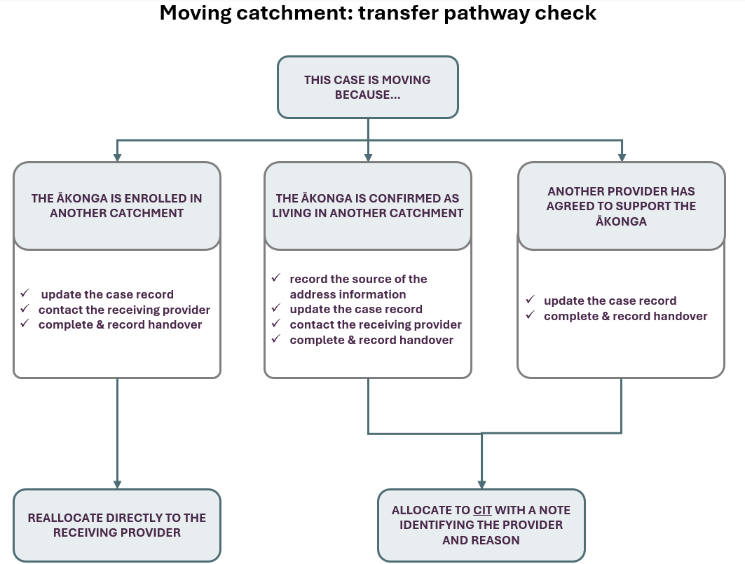

Related guidance
- AS-CMS guidance for common scenarios
- AS-CMS Quick Reference Guides for Providers
- Practice Guide – Managing Not Located cases
- Practice Guide – Keeping records of how you manage cases
- Practice Guide – Closing cases

Appendix: Worked Examples
These examples are illustrative only. They show common situations and one possible sequence of actions. The right response will depend on the information available and the needs of the ākonga and whānau.

Example 1: Ākonga enrols at a school in another catchment
- An ākonga has an open NEN case and later enrols at a school in another catchment.
- You receive an in-app notification that the enrolment status has changed.
- The case also shows an Out of Catchment alert.
- You check AS-CMS and confirm that the ākonga is currently enrolled at a school in another catchment.
Actions before transfer:
- check the relevant enrolment and catchment information in AS-CMS
- update key case information, including contacts, barriers, plans, services, events, and case comments where relevant
- contact the receiving provider and arrange a handover
- record the handover in AS-CMS, including what was discussed and any agreed handover actions
- reallocate the case directly to the receiving provider.

Recording information on the case:
The handover may be recorded as a meeting/event, with the discussion captured in the description. You may also add a case comment if this helps make the transfer decision clear on the case record.

Example note/meeting description:
“Ākonga is now enrolled at [school name], which is in [catchment/provider] catchment. Handover completed with [receiving provider/contact] on [date]. Discussed current engagement, known barriers, supports in place, and relevant case history. Case reallocated to [receiving provider].”

Example 2: Ākonga is not enrolled, but a new address is confirmed in another catchment
- An ākonga has an open NEN case.
- Whānau have not been contactable using the details already on the case.
- An information request returns a new address in another catchment.
You check AS-CMS and confirm that the ākonga is not currently enrolled. You use the confirmed address to identify the new catchment and the provider for that catchment.

Actions before allocating to CIT:
- update the case contacts with the new address and any other relevant contact details
- identify the provider for the new catchment – using the Catchment Map
- update key case information, including barriers, plans, services, events, and case comments
- contact the receiving provider and arrange a handover
- record the handover in AS-CMS, including what was discussed
- allocate the case to CIT with a clear note identifying the provider the case should go to.

Recording information on the case:
The handover may be recorded as a meeting/event, with the discussion captured in the description.
Example note/meeting description:
Ākonga is not currently enrolled. New address confirmed through [source, e.g. MSD information request]. Address is in [catchment/provider] catchment. Handover completed with [receiving provider/contact] on [date]. Discussed current engagement, known barriers, supports in place and relevant case history. Case allocated to CIT for reassignment to [receiving provider].

You need to add a note for CIT that clearly identifies the intended receiving provider and why the case should go to that provider. Without this information, CIT may not have enough context to assign the case as intended.

Example note to CIT:
Confirmed address is [address/suburb], which is in [catchment/provider] catchment. Address information came from [source]. Handover completed. Please allocate case to [receiving provider].

Example 3: Ākonga may have moved, but there is no confirmed address
- An ākonga has an open NEN case.
- A previous school, whānau contact, or another source tells you that the ākonga may have moved to another area, but no confirmed address is available.
- You have been unable to reach the ākonga or whānau at the address in AS-CMS.
- The ākonga is not currently enrolled.

This information can help guide your locating activity, but it is not enough to reallocate the case or allocate it to CIT.

Actions while confirming location:
- record what you have been told, including who provided the information
- clearly note that the address or location is not confirmed
- retain responsibility for the case while the location is being confirmed
- continue efforts to locate the ākonga and whānau, including information checks and other appropriate avenues
- check with previous schools, known contacts, agencies, community networks, or other relevant sources
- update the case record as new information becomes available
- use the Not Located flag if the criteria are met
- do not reallocate the case unless enrolment or address information is confirmed, or another agreed transfer pathway applies.

Recording information on the case:
This information may be recorded as a case comment, with any follow-up actions recorded as tasks or other appropriate case activity.
Example comment
[Source/contact] advised that whānau may have moved to [area/town], but no confirmed address is available. Ākonga is not currently enrolled. Information recorded as unconfirmed. Case retained while locating activity continues. Next steps: complete/update information checks, follow up with known contacts and previous school, and update the case record if address or enrolment information is confirmed.

Important:
Do not allocate the case to CIT based only on an unconfirmed location. The case should stay with you until there is enough confirmed information to support transfer, or until a valid close reason has separately been met.

