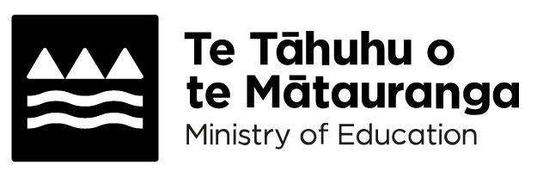
Learning in the first 6 months of school
Adapted in 2026 by Accessible Formats Service,
Blind Low Vision NZ, Auckland
Transcriber's Note: The logo at the top of the page is: Te Tāhuhu o te Mātauranga–Ministry of Education

Learning in the first 6 months of school

Starting school is a big milestone for both you and your child.
We know children in their first year of school are excited to learn. They want to do well in everything they experience.
Find out what you can expect your child to learn in their first 6 months at school.
The New Zealand Curriculum and Te Marautanga o Aotearoa are here to ensure a smooth and enriching transition from day 1.
After school, ask your child | tamaiti:
- how their day was, and
- what they enjoyed most.

English and Te Reo Rangatira
Your child will be doing handwriting and learning to read by matching letters to sounds.
Expect them to bring books home to practice what they've learned in class, reinforcing their skills.
At 20 weeks of schooling, your child will do a phonics check or Te Mōhiohio Oro with their kaiako | teacher. This assesses mokopuna | children's ability to hear and distinguish correct sounds. This involves reading a range of words.
Te Mōhiohio Oro is the first phonics check of Hihira Weteoro, a suite of phonics checks specifically created for te reo Māori learners.
Information from the phonics check combined with teacher observations will provide a clear picture of your child's progress, and you'll be kept informed every step of the way.
The phonics check and Hihira Weteoro provide opportunities to celebrate their progress and achievement while identifying any support that may be required to help our mokopuna | children progress and achieve as expected.

Maths and Pāngarau
Your child | tamaiti will also be learning the 6-month sequence in the first phase | tūārere of learning for Maths and Pāngarau.
Your child | tamaiti will start learning many foundational and exciting maths concepts in number, algebra, geometry and measurement.
Just like they do for the English and Te Reo Rangatira learning area, your child's | tamaiti teacher | kaiako will let you know how your child | tamaiti is progressing in Maths and Pāngarau.

More information
There is also a video about what your child will be learning in the first 6 months of school: https://vimeo.com/1069434747 or short url: https://tinyurl.com/28b7en8m
For more information visit: https://www.education.govt.nz/parents-and-caregivers/schools-year-0-13/parent-portal/guide-for-the-new-zealand-curriculum-years-0-to-8/first-6-months-at-school/learning-in-the-first-6-months-of-school or shortened URL: https://tinyurl.com/4x5dzh5p
End of Learning in the first 6 months of school

