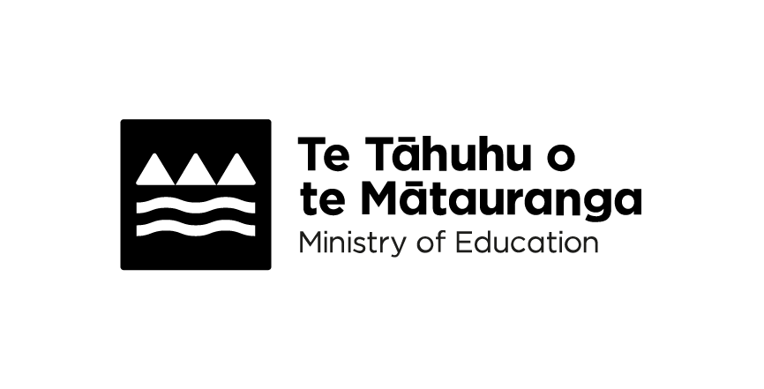
Mathematics and Statistics in Year 1
Adapted in 2026 by Accessible Formats Service,
Blind Low Vision NZ, Auckland
Transcriber's Note: The logo at the top of the page is
Te Tāhuhu o te Mātauranga Ministry of Education.

Mathematics and Statistics in Year 1
During the first 3 years at school, the goal is for children to thrive in environments rich in Maths.

What your child will learn in Maths
Every day, your child is learning about and using maths ideas like:
- Counting
- Measuring
- Sorting
- Patterns
- Numbers
- Shapes
- Size
- position.
You can help them by:
- noticing patterns, shapes, sizes, and numbers wherever you are
- including maths ideas in their play, interests, and everyday activities.
Good maths skills and a positive view of themselves as maths learners will help your child in the future. Encourage your child to use the maths vocabulary they learn in class.

Number

Ideas to help at home
With your child, you could:
- find numbers around your home and neighbourhood, like clocks, letterboxes, speed signs
- count forwards and backwards, microwave, clocks, fingers and toes, letterboxes, action rhymes, signs
- do sums using small numbers of objects, for example "we have 2 marbles, let's get 3 more, how many do we have now?"
- make up number stories, for example "you have 2 brothers and 2 sisters. There are 4 of them."
- bake, talk to your child about the recipe and ingredients using words like, "how many?" "how much?" And, "more", for example, count how many teaspoons of baking soda are needed, how many cups of flour and how many muffin cases.

Your child is learning to:
- count in 1s, 2s, and 10s forwards and backwards up to 20, then up to 100
- count up to 30 in te reo Māori
- recognise, read, write, and compare numbers up to at least 100, use place value to show numbers (17 is 1 10s and 7 1s) and use terms like "first", "second", "third"
- make smaller groups in different ways using 20 objects, like 10 and 10, 11 and 9, or 15 and 5
- develop addition and subtraction skills by joining and separating groups of up to 20 objects and finding the difference between groups by counting
- learn basic addition facts up to 10 and their subtraction facts (6+4 = 10, 4+6 = 10, 10−4 = 6, 10−6 = 4), including doubles and halves
- develop multiplication and division ideas by using equal groups or counting, like making 3 groups of 3 blocks and counting all the blocks
- talk about, draw and use materials to show fractions, such as finding halves and quarters of small groups of objects or shapes.

Words your child will be learning
Words include:
- digit
- equal group
- equal part
- forwards, backwards
- fraction, half, quarter, whole
- regroup
- set
- sum, difference
- tally.

Algebra

Ideas to help at home
With your child, you could:
- create patterns with everyday objects. Use blocks, beads, shells or toys to make and extend patterns (red-blue-red-blue or big-small-big-small). Ask your child to predict "what comes next?"
- play "what's missing?" games. Line up a few toys or objects, then remove 1 while your child closes their eyes. Ask them to identify what's missing, helping them understand the concept of unknown values.
Your child is learning to:
- solve simple number problems using addition and subtraction, like filling in the missing number: 3+X = 7
- check if number sentences are true or false, like 4+2 = 7
- copy, continue, and make repeating patterns using 3 things (like colours, shapes, or actions)
- spot what's missing in a pattern, like: red, green, blue, red, X, blue.

Words your child will be learning
Words include:
- changed, unchanged
- element
- equation
- number sentence
- repeating pattern
- true, false
- unit of repeat.

Measurement

Ideas to help at home
With your child, you could:
- use string, blocks, or shoes to compare the length of objects around the house. Ask, "Which is longer?" or "Can we measure both with the same piece of string?"
- let children hold 2 items (for example, an apple and a potato) and ask, "Which feels heavier?", use kitchen scales if available
- use cups or containers during bath time or cooking. Ask, "Which holds more water?" or "Can we fill this using the same cup each time?"
- talk about time during the day and look at your family calendar to visualise days, weeks, months.
Your child is learning to:
- compare objects by their size, weight and how much they can hold, and decide which object is longer, heavier, or holds more
- order the days of the week and understand when things happen in their daily routine, using words like "morning", "afternoon", and "night"
- tell the time to the hour using "o'clock".

Words your child will be learning
Words include:
- capacity
- day, week, month, year
- tomorrow, yesterday, next, last
- days of the week
- distance
- far
- near
- close
- earlier, later
- heavier, longer, shorter
- hour, minute, second
- morning, afternoon, evening, midday, noon, midnight
- o'clock
- starting point, end point
- weight.

Geometry

Ideas to help at home
With your child, you could:
- build with blocks and talk about shapes, describe the shapes you're using (cubes, rectangles) and discuss concepts like "on top of", "beside" or "under" to develop spatial awareness
- read picture books that emphasise positional language and movement, for example, "Scatter Cat", "Bears in the Night", "We're Going on a Moa Hunt"
- go on a shape hunt around your house or neighbourhood, look for circles, squares, triangles and rectangles in your environment and talk about their properties
- cut sandwiches into different shapes, make triangles, squares or rectangles and talk about how the pieces look different but are still the same amount of food.
Your child is learning to:
- name and sort different shapes like triangles, circles, squares, and 3D shapes like cubes, cylinders, and spheres
- predict and check how to make a big shape using smaller shapes, like using a square and a triangle to make a house shape
- flip, slide, and turn 2D shapes to create fun patterns
- follow simple directions, for example, "go to the right of the door" or "find your red ball on the shelf above the books"
- use pictures, diagrams, or stories to help describe where things are.

Words your child will be learning
Words include:
- map
- middle, centre
- 2D shape
- 3D or solid shape
- cube, cylinder, sphere
- slide
- rectangle.

Statistics

Ideas to help at home
With your child, you could:
- gather leaves, rocks, or pinecones during a walk, then sort them by different attributes, count how many are in each category
- ask a question like "What's your favourite fruit?" and collect answers from a few family members or friends
- look at the chart together and ask questions like "How many people chose bananas?" or "Which fruit was the most popular?"
- ask questions like "Which fruit do people like the most?" to help your child think about the data.
Your child is learning to:
- ask simple questions and collect information with a few possible answers, like "What is your favourite colour?"
- sort answers into groups and identify if they are more or less popular or favourite
- record information using tally marks, for example (|||) for 3 people
- make simple graphs or charts to show the information
- talk about what the graph or chart shows, using the topic and how many people chose each answer
- answer questions about the graph, like which group has the most or least.

Words your child will be learning
Words include:
- category
- data
- frequency
- most, least
- picture graph.

Resource
Resource Maths Year 1 at home: https://tinyurl.com/2vr9mbax
The resource may not be accessible.
For more information, visit https://www.education.govt.nz/parents-and-caregivers/schools-year-0-13/parent-portal/guide-for-the-new-zealand-curriculum-years-0-to-8/year-1-new-zealand-curriculum/mathematics-and-statistics-in-year-1 or shortened url: https://tinyurl.com/kwbfcnr7
End of Mathematics and Statistics in Year 1

