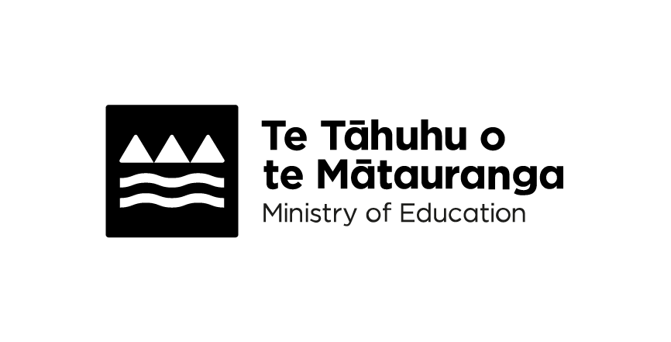
Hihira Weteoro | Phonics Checks
Adapted in 2026 by Accessible Formats Service,
Blind Low Vision NZ, Auckland
Transcriber's Note: The logo at the top of the page is
Te Tāhuhu o te Mātauranga Ministry of Education.

Hihira Weteoro | Phonics Checks
All children in their first year of kura | school will have an opportunity to complete a Hihira Weteoro | Phonics Checks. This helps kaiako | teachers understand how well a child is progressing with learning to read.

What is phonics
Phonics is the relationship between letters and sounds.
In te reo Māori, letters and sounds are consistent meaning that the spelling generally reflects the way you say the sounds.
Mokopuna | children are taught how to:
- recognise the sounds that letters show
- recognise combinations of letters that show one sound (such as "wh")
- blend these sounds together to make words.

Why it's important
Phonics is an essential part of learning to read—children use it to work out new words they do not yet know how to read.
Learning how to blend sounds helps beginner readers to read words accurately, setting them up for future reading success.

About Hihira Weteoro | Phonics Checks
Hihira Weteoro | Phonics Checks is the name for the checks to understand how your child is progressing in phonics and word recognition in te reo Māori.
Hihira Weteoro | checks Phonics Checks will be done after 20 weeks, 40 weeks and again at 55 weeks.
The 20-week phonics check | Te Mōhiohio Oro involves mokopuna children listening to pairings of sounds to determine if the sounds are the same or different.
The 40-week phonics check | Te Mōhiohio Pūriki involves mokopuna children identifying lowercase letters of the Māori alphabet by sound, name or giving a word that starts with the letter. It also confirms the sounds, and their correct use of short and long vowel sounds and consonants.
The 55-week phonics check | Te Mōhiohio Arapū involves mokopuna children assessing both upper and lowercase letters and high frequency words. Te Mōhiohio Arapū | the 55-week phonics check involves mokopuna children listening to words in sentences and writing them down.

When Hihira Weteoro | Phonics Checks starts
From the beginning of 2026, kura | schools are required to start using Hihira Weteoro | Phonics Checks. The only exception is kura | schools that are run by a specified
kura | school board. These kura | schools are still able to use Hihira Weteoro | Phonics Checks, but it is not a requirement in 2026. If your mokopuna | child has recently started kura | school or will start during 2026, ask their kaiako | teachers or tumuaki | principals whether they are using Hihira Weteoro | Phonics Checks.

Finding out the results
The kaiako | teacher or the tumuaki | principal will also be best placed to let you know what you can expect in terms of a report on your child's Hihira Weteoro aromatawai | Phonics Checks assessment tasks.
We will automatically collect the results to build a picture of how well the education system is working for our beginning readers.

Why we introduced Hihira Weteoro Phonics Checks
In 2024, Te Reo Matatini wāhanga ako (learning te reo Māori as your first language) was updated through changes to Te Marautanga o Aotearoa curriculum. The curriculum was expanded to include Rangaranga Reo ā-Tā (structure literacy in te reo Māori), a component specifically related to learning to read and write in te reo Māori.
This work to raise achievement includes the introduction of Hihira Weteoro aromatawai | Phonics Checks tasks for those ākonga | learners learning through te reo Māori.
Having a check that all schools and kura complete will help us know how well the education system is working for our youngest learners.

Tip

Help your child with their phonics
- Incorporate phonics into daily conversations. For example, when cooking, you can ask your child what sounds the ingredients start with.
- Sound sorting: create a set of pictures or objects that start with different sounds. Have your child sort them into groups based on their beginning sounds.
- Word building: use magnetic letters or letter tiles to build simple words and ask your children to sound them out.
- Play snap with letter cards matching pairs of letters and saying the correct sounds.
You'll find slides to help your mokopuna recognise letters and sounds by looking at pictures and words:
Practising sounds and letters in the first 6 months: https://tinyurl.com/3bhb8t5b
Practising sounds and letters—Tau | Year 1: https://tinyurl.com/3r2fn9t8
To find out more, visit https://www.education.govt.nz/parents-and-caregivers/schools-year-0-13/parent-portal/hihira-weteoro or shortened URL https://tinyurl.com/4z7cjx5p
End of Hihira Weteoro | Phonics Checks

