Risk Management Planning Tool

This planning tool is designed to help you carry out a security audit at your school. It will help you create a risk management plan that
addresses your schools security needs, ranks those needs and helps you plan your response.

Read it alongside our Security in your school: A guide to implementing and managing effective security systems, which we developed in
response to requests from schools seeking comprehensive, school- specific security information.

Your school is likely to get the best results by reading the Security in your school guide in advance and reviewing the incidents recorded in
your school security incident log. (see Security in your school, page 5 for more information about incident logs).

Why prepare a security risk management plan?
- Good security measures will benefit your school by:
- reducing vandalism and theft
- reducing the cost of vandalism and theft
- creating a safer school environment (helping to increase pride in the school and encourage positive perceptions in the wider
community).

Each school has different experiences of school security and faces different security issues.

Your risk management plan will help your school assess and identify security risks that are particular to your school, and implement new or improved security measures. It will also provide direction for future
improvements and expenditure.

Review your risk management plan annually or sooner if new security issues begin to affect your school.

If your school already has an existing security policy, use this risk management planning tool to help review and update that policy.
Schools without a security policy will find this planning process helps them to create one.
What does this planning tool cover?

This planning tool is a five-step process:

Step |  | Questions
1. | Environmental Scan | What are the risk factors in the external  environment that may impact your school, staff and students?
2. | Existing security measures | Survey and record:  - what current security measures exist in your school?  - why were they implemented?  - what has been the cost to the school?  - how successful have they been?
3. | Identify  security risks | - What do you consider to be security risks  in each security layer?  - Why are they considered a risk?
4. | Create a plan to deal with urgent  security risks | - What risks need urgent attention now and  how will that be done?  - what will be the cost to the school?  - how successful have they been?
5. | Create an action  planand timeline | - What operational improvements can be  made now, easily and with minimal cost?  - What risks will need to have a response or remedy programmed for future action?  - Who will be responsible?  - How will the risk be managed until the work can be done?  - How will we know that it has been  successful?

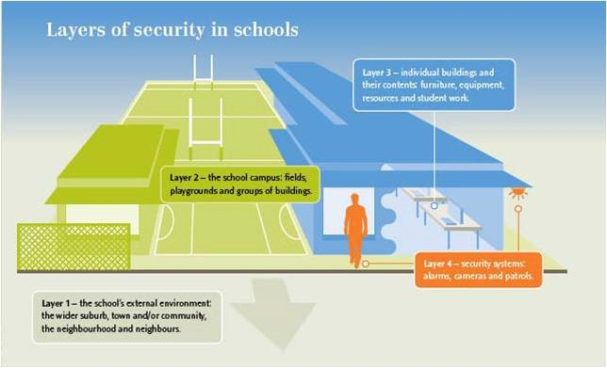Further information and assistance

The Ministry of Education’s Security in your school guide is an important
companion piece to this planning tool. The guide contains information and advice for schools and signposts further information and useful
downloads.

You may wish to consult your local crime prevention officer during the planning process and / or involve the school and community.

If you require a professional security audit, contact your Ministry network facilitator, who may have a list of security consultants in your area.

A draft specification security audit and an example of a completed security report are available at www.education.govt.nz

Steps 2-3 are structured around the four layers of school security discussed in the Security in your school guide, page 3.

Step 1: Environmental Scan
Use the space below to list risk factors in the external environment that may impact your school, staff and students. Risk factors may relate to:
- the physical environment ( the town, suburb or isolated location)
- the economic environment ( the current economy, major employers)
- the social environment (local rates of employment, education and levels of income).

Your local crime prevention officer may be useful when completing this environmental scan.

External factor / risk | Why this is considered a risk? | Has anything been done to date to mitigate the risk?
 |  |  | +
 |  |  | +
 |  |  | +
 |  |  | +
 |  |  | +
 |  |  | +

Step 2: Identify exist ing security measures in each security layer of your school

Existing measure | Why was it implemented? | Cost per annum | Has it been successful? How do you know?
Layer 1: External Environment
 |  |  |  | +
 |  |  |  | +
Layer 2: Inside the school edge
 |  |  |  | +
 |  |  |  | +
Layer 3: Buildings and contents
 |  |  |  | +
 |  |  |  | +
Layer 4: Security systems
 |  |  |  | +
 |  |  |  | +

Step 3: Identify areas or aspects of your school you consider to be a security risk

Area / aspect | Why is it considered a risk? | Does it need urgent attention? (Urgent  attention is needed for things that happen a lot and / or impact on student / school safety)
Layer 1: External environment / school boundary - use your environmental scan (step 1)
 |  |  | +
Layer 2: Inside the school edge
 |  |  | +
Layer 3: Buildings and contents
 |  |  | +
Layer 4: Security systems
 |  |  | +

Step 4: Plan to manage security risks needing urgent attention

Area of security risk requiring urgent attention  ( copy from Step 3 worksheets) | Improvements: How can you remove, reduce or remedy the security risk, and by when?  Include additional resources needed, and who is responsible for what. | Contingencies: Until the  security risk is remedied, how will you manage the risk?  Identify all actions and people involved, and any associated costs (if known). | Costs involved | How will you know when you are successful?
Layer 1: External Environment / school boundary
 |  |  |  |  | +
Layer 2: Inside the school edge
 |  |  |  |  | +
Layer 3: Buildings and contents
 |  |  |  |  | +
Layer 4: Security systems
 |  |  |  |  | +

Step 5: Timeline / action plan

Area of improvement ( copy from Step 4) | When will this work take place? | Who is responsible for this area of improvement?  (internal / external personnel) | How will it be monitored? | When will it be reviewed?
 |  |  |  |  | +
 |  |  |  |  | +
 |  |  |  |  | +
 |  |  |  |  | +
 |  |  |  |  | +
 |  |  |  |  | +

