Healthy habits for learning:
Resources for schools and ECEs
Purpose
This toolkit is for early learning services and schools to work alongside communities, whānau and ākonga to encourage healthy winter habits and support regular attendance. The resources give you practical, easy-to-use information about preventing illness, managing common health issues, and supporting ākonga to return to learning as soon as they are well enough.
The health-related guidance included in this toolkit draws on advice and resources from Health New Zealand and their partner agencies.
Resources
Topic | Audience | Description | Type | Link
Knowing if a child is well enough to be at school | Schools | Information to help school leaders and whanau understand when it is okay for a child to still be at school and when an unwell child should be at home. | Webpage | Knowing if a child is well enough to be at school - Health NZ
Coughs and colds | Early Learning Services and Schools | Advice on coughs and cold in children to share with whānau. | Web guidance and videos | Cough In Children - KidsHealth  Colds In Children - KidsHealth
Hygiene | Early Learning Services and Schools | Simple things you can do to stop the spread of infectious diseases and illnesses. | Posters | Stay Clean As – HealthEd  Wash your hands for 20 seconds and dry thoroughly – HealthEd
Infectious diseases | Early Learning Services & Schools | Information to support decisions on when a child or adult should be excluded from the facility. | Poster | Infectious diseases - Health NZ
Eczema | Early Learning Services and Schools | Information about recognising and managing eczema which can flare up or worsen during winter due to dry, cold conditions. | Webpage | Eczema | Healthify  Eczema In Children | KidsHealth New Zealand's Trusted Voice On Children's Health  Eczema | Pūmau
Scabies | Early Learning Services and Schools | Information about the treatment and prevention of scabies. | Infographic | Scabies Infographic – HealthED
Ventilation | Early Learning Services and Schools | Good ventilation removes virus and bacterial particles in the air, reducing the risk of infection from airborne illnesses. | Web guidance and posters | Ventilation in Early Learning Services - MoE  Ventilation in Schools - MoE
Managing infectious diseases | Early Learning Services and Schools | A guide for ECEs and schools on infectious disease preparedness. | PDF | Infectious-disease-outbreak-preparedness-in-schools-and-ECEs.pdf
Supporting ākonga with ongoing health needs
We know some ākonga have ongoing or additional health needs, and that schools and whānau will continue to make decisions based on individual circumstances and medical advice.
If ākonga are experiencing ongoing health-related absences, we encourage schools to work with whānau to understand what support may help them stay connected to learning and return when they are well enough.
Support may include:
- flexible return-to-school approaches
- wellbeing or health planning
- additional learning support
- connection with health or specialist services where appropriate.
Schools and kura should continue to work alongside whānau and follow medical advice when supporting students with ongoing or complex health needs.
School High Health Needs Fund
The School High Health Needs Fund (SHHNF) is available when children or young people have high health needs that require care and support for more than 6 weeks. The funding contributes to employing a teacher aide or support person. For more details, see here.
Regional health schools
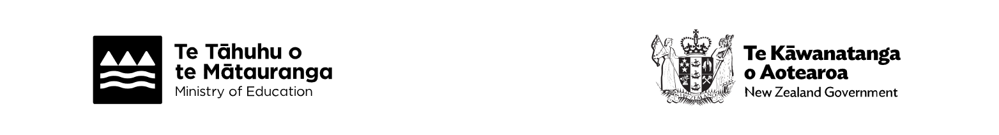
If a child can't attend their local school for health reasons, they may be able to get help from a regional health school. These schools provide short-term education support until a child can return to their regular school. For more information, see here.

