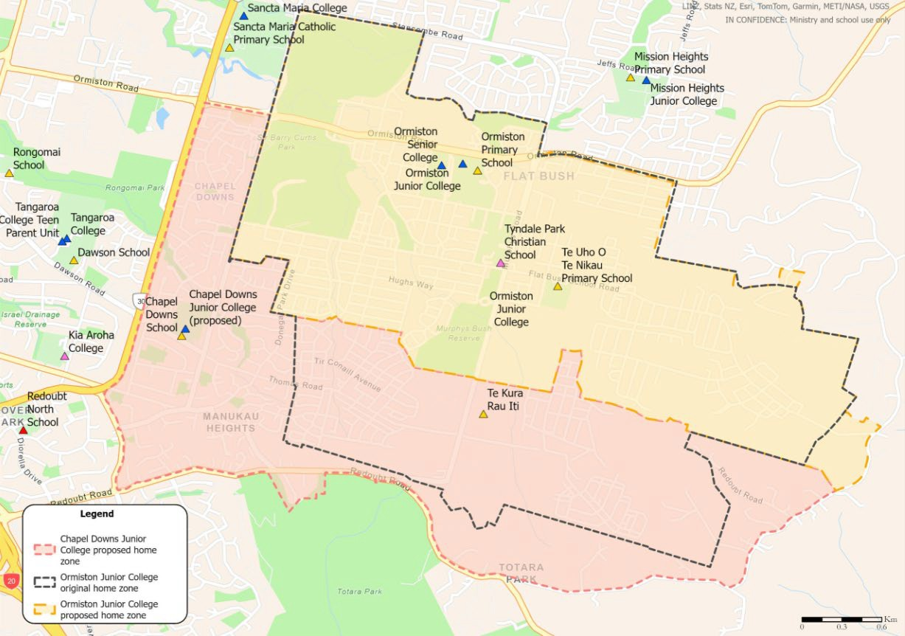

CHAPEL DOWNS JUNIOR COLLEGE MAP (THREE ZONES)

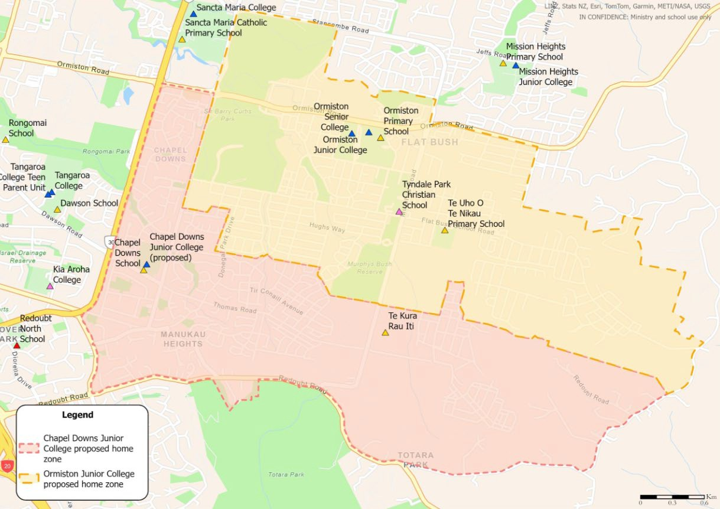

CHAPEL DOWNS JUNIOR COLLEGE MAP (TWO ZONES)

