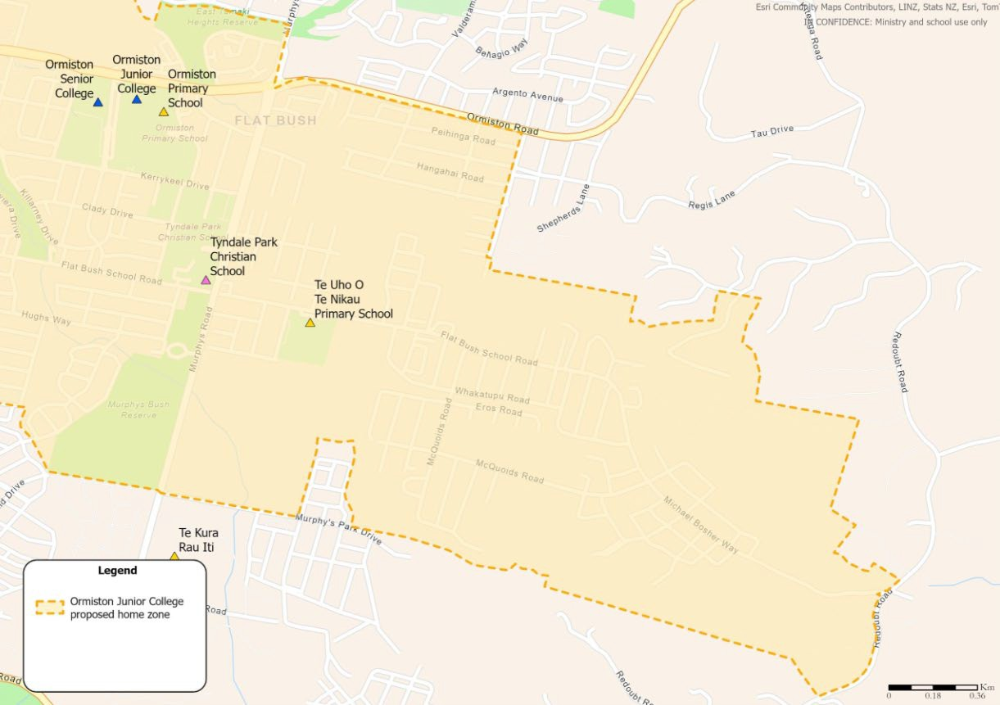

ORMISTON JUNIOR COLLEGE MAP (EAST)

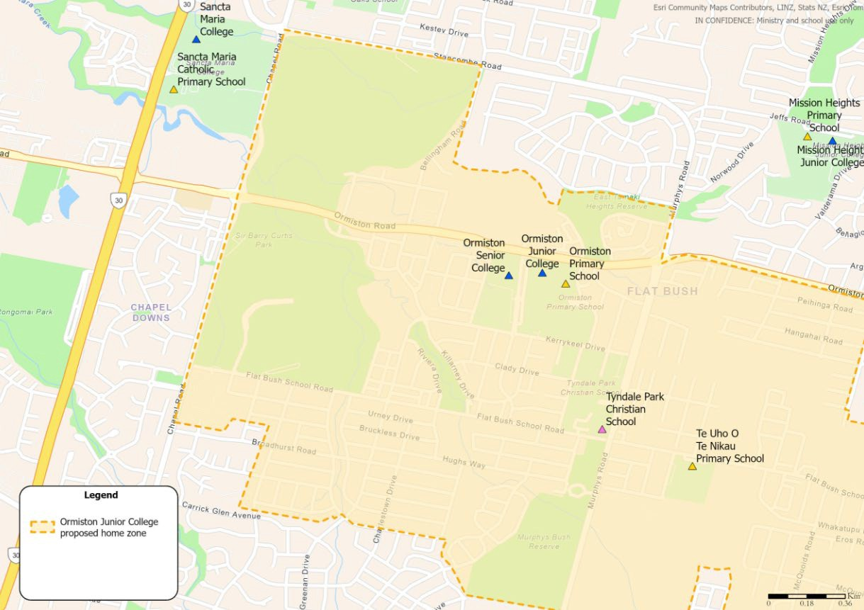

ORMISTON JUNIOR COLLEGE MAP (WEST)

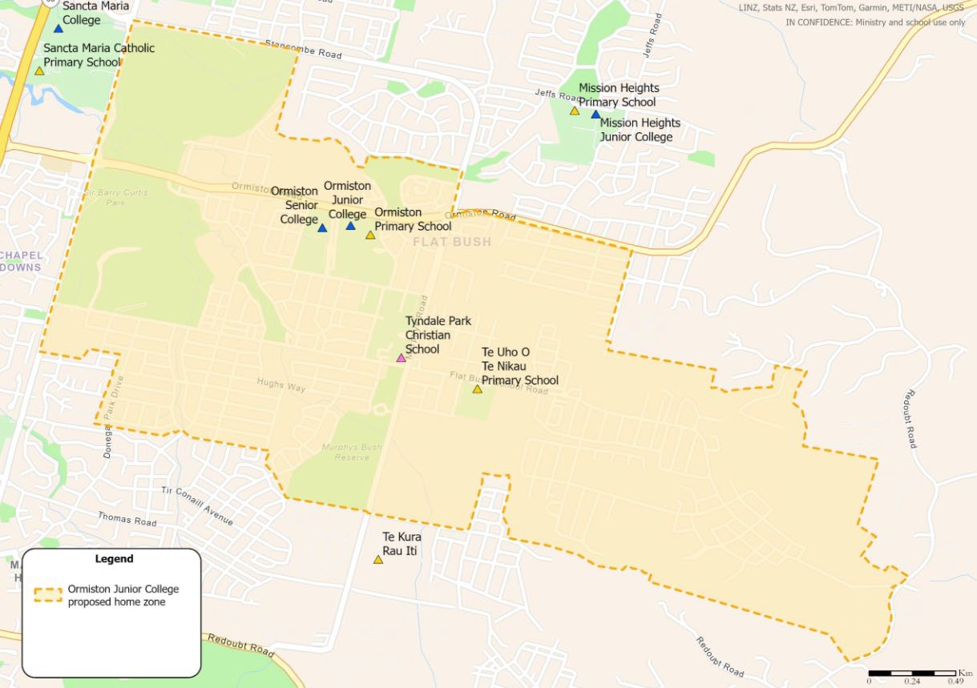

ORMISTON JUNIOR COLLEGE MAP

