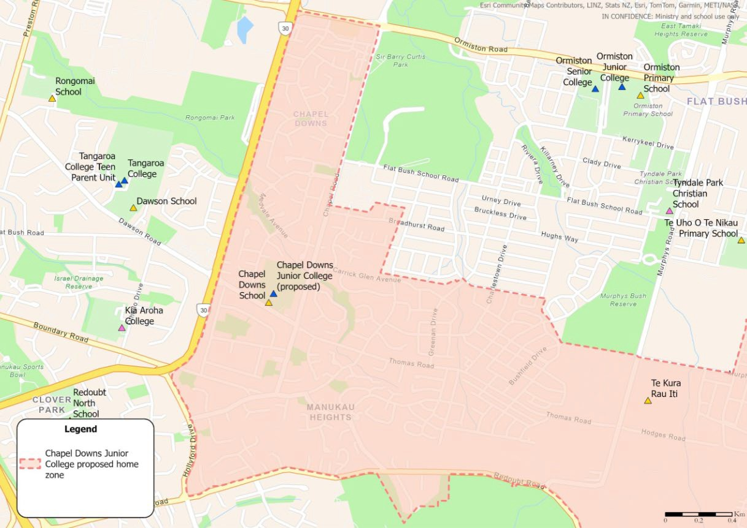
[UNCLASSIFIED]

CHAPEL DOWNS JUNIOR COLLEGE MAP (WEST)

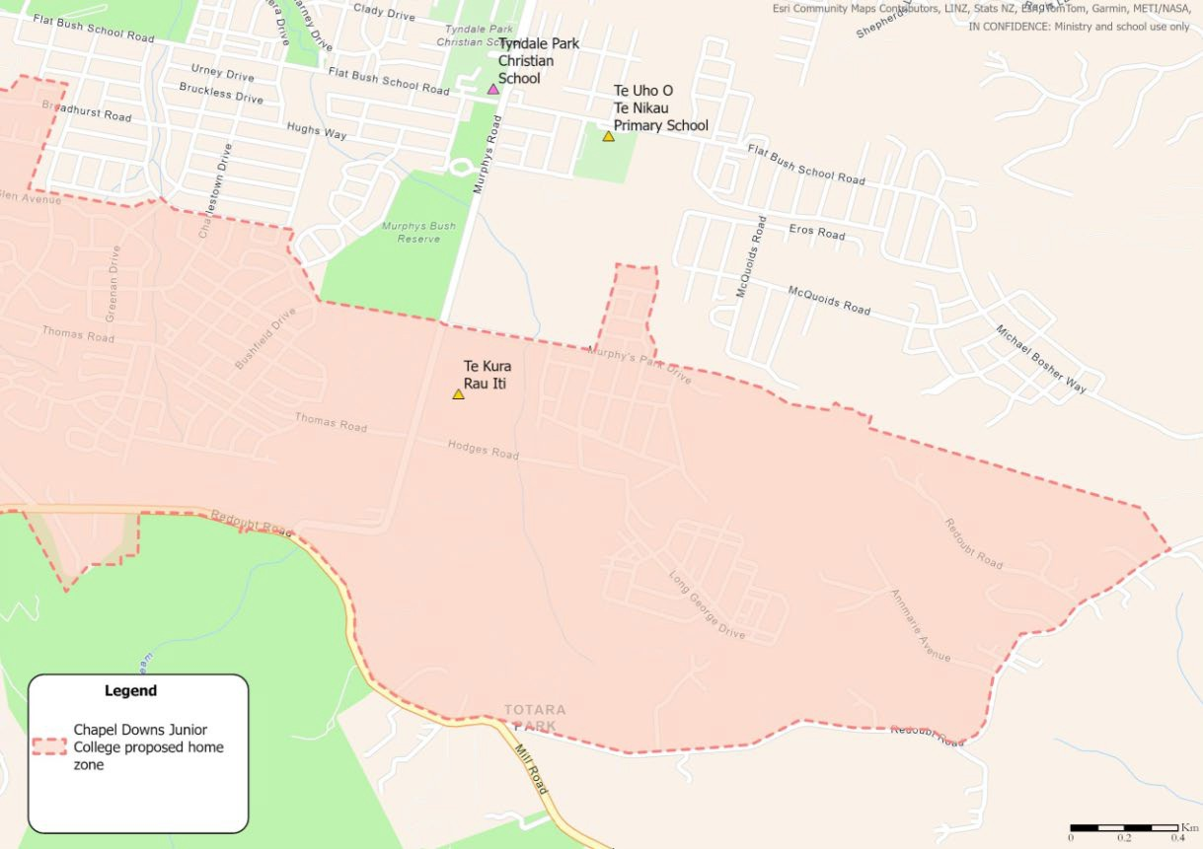
[UNCLASSIFIED]

CHAPEL DOWNS JUNIOR COLLEGE MAP (EAST)

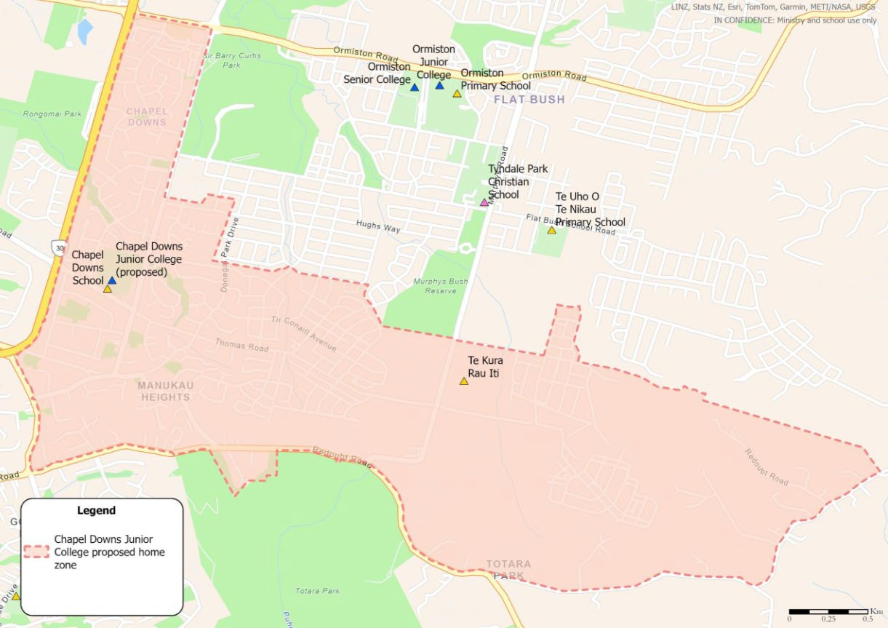
[UNCLASSIFIED]

CHAPEL DOWNS JUNIOR COLLEGE MAP

[UNCLASSIFIED]

