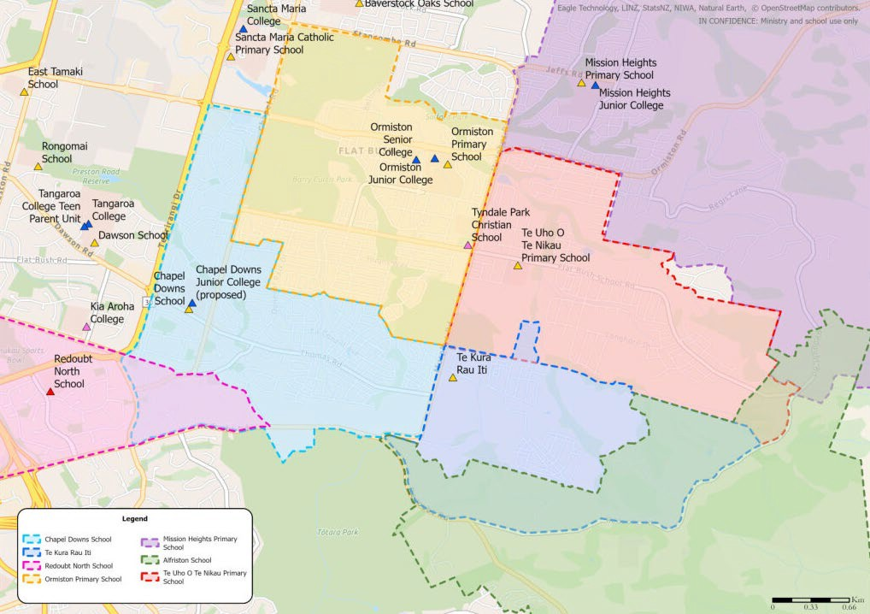

PRIMARY SCHOOL MAPS

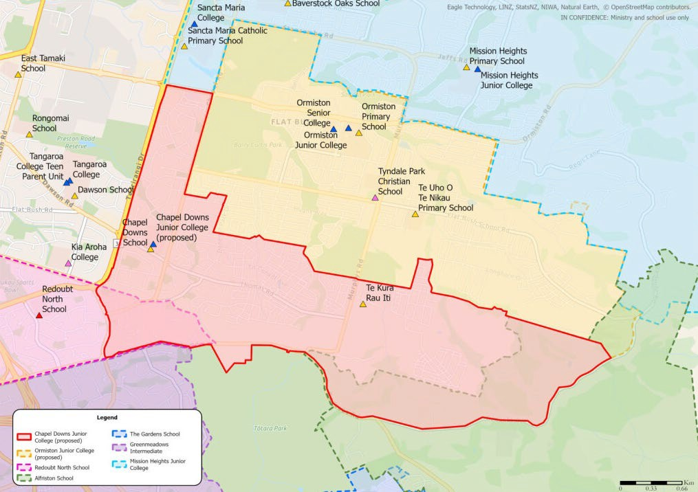

JUNIOR SCHOOL MAPS

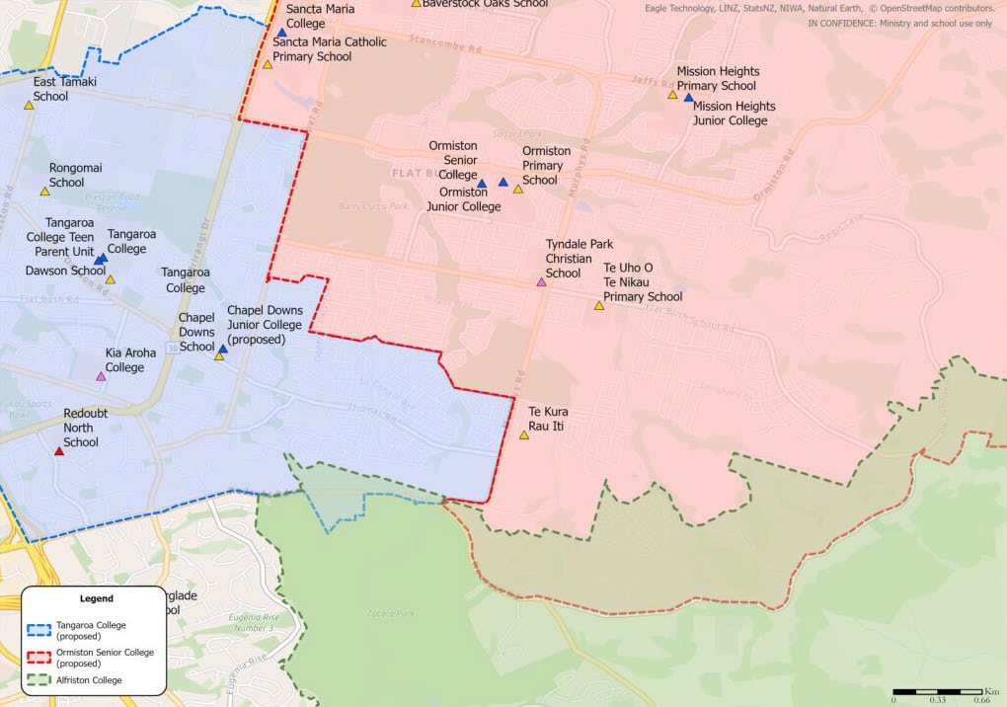

SENIOR SCHOOL MAPS

