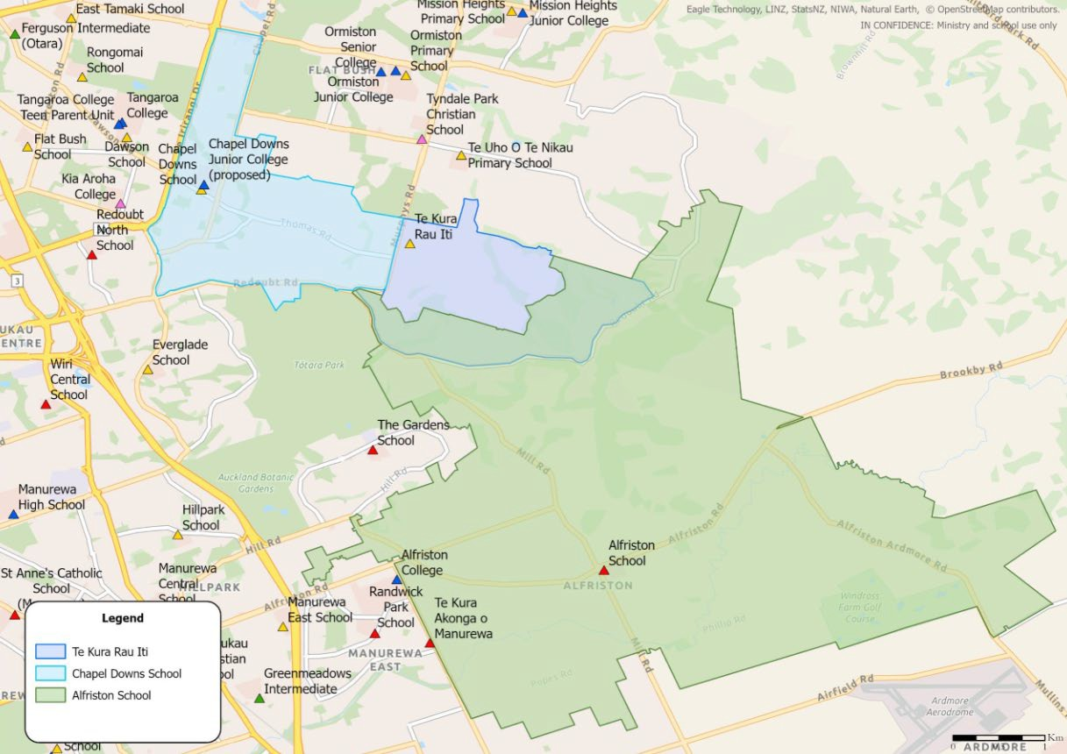

ALFRISTON SCHOOL OVERLAP WITH TE KURA RAU ITI

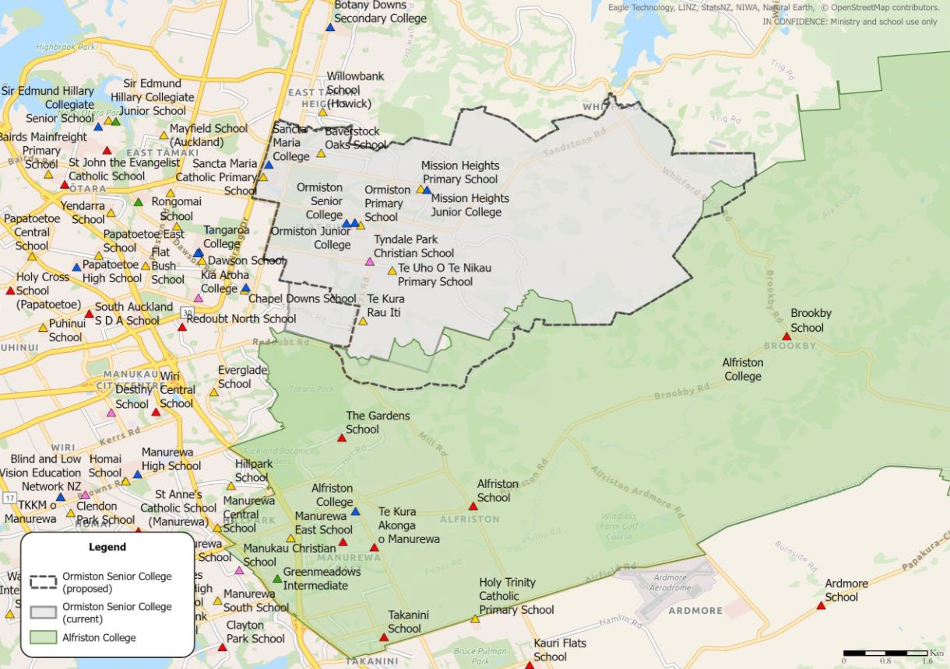

ALFRISTON COLLEGE OVERLAP WITH ORMISTON SENIOR

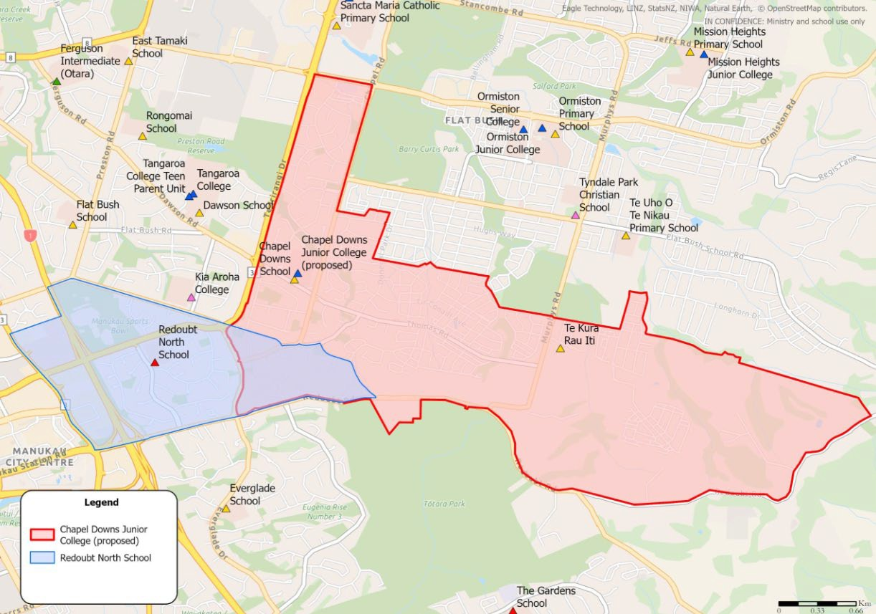

REDOUBT NORTH SCHOOL OVERLAP WITH CHAPEL DOWNS JUNIOR
COLLLEGE

