When using this template please update all information between [ ]

[Provider / Organisation Name]
[Street Address]
[Suburb]
[City / Region]
[Postcode]
Phone: [Provider phone number]
Email: [Provider email address]

Date: [DD Month YYYY]

[Parent / Legal Guardian Name]
[Street Address]
[Suburb]
[City / Region]
[Postcode]

Kia ora [Name of parent / legal guardian],
I have written to you on [three] prior occasions, [date 1], [date2], [date3] and have made several further attempts to support the improvement of [child’s name] attendance. However, [child’s name] continues to be absent from school at an unacceptable level.
Under Section 36 of the Education and Training Act 2020, students enrolled at a registered school must attend whenever the school is open. Continued non-attendance may result in prosecution under Section 244 of the Act. Attached to this letter is a copy of Sections 36 and 244 for your reference.
This letter is to formally advise you that the Ministry of Education’s prosecutions team is now considering whether prosecution is appropriate in your case.
My focus remains the same. I want to provide you with the support needed to get [child name] attending school regularly. I continue to be keen to listen without judgement and understand your situation so we can create a plan to help.
Please call me on [phone number] or email [email address] so we can get started.
For more information on this process, please check the Ministry of Education website.
Prosecution and Warnings Policy 2025.pdf

Nga mihi,
[Provider signature]

Legal information
Under Section 36 of the Education and Training Act 2020, students enrolled at a registered school must attend whenever the school is open. Continued non‑attendance may result in prosecution under Section 244 of the Act.
Included below is a copy of Sections 36 and 244 for your reference.

Education and Training Act 2020 - Key Sections

Section 36
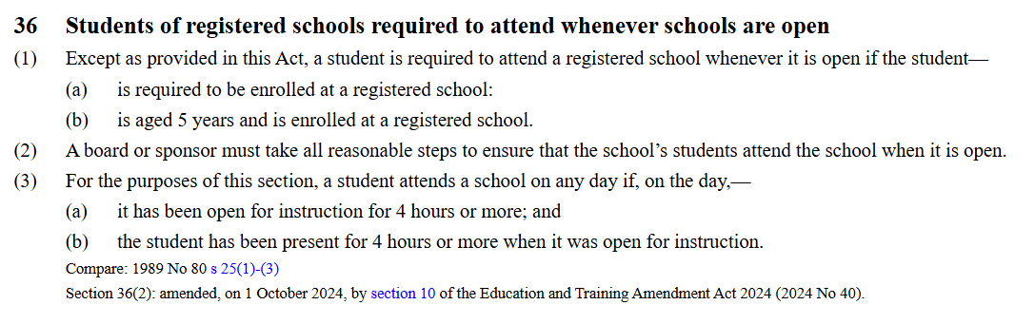Source: https://www.legislation.govt.nz/act/public/2020/0038/latest/LMS171382.html

Section 244
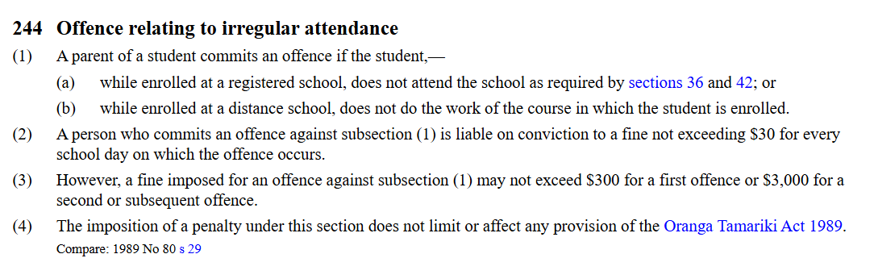Source: https://www.legislation.govt.nz/act/public/2020/0038/latest/LMS176221.html

