When using this template please update all information between [ ]

[Provider / Organisation Name]
[Street Address]
[Suburb]
[City / Region]
[Postcode]
Phone: [Provider phone number]
Email: [Provider email address]

Date: [DD Month YYYY]

[Parent / Legal Guardian Name]
[Street Address]
[Suburb]
[City / Region]
[Postcode]

Kia ora [Name of parent / legal guardian],
I wrote to you on [date] and have made several further attempts to contact you with offers of support. You have not contacted me yet. This is my [second] formal letter regarding [child’s full name] continued non-enrolment at a registered school.
My focus is to provide you with the support needed to get [child name] enrolled and attending school. Without enrolment it is possible that legal action could follow which we want to avoid for you and [child name]. You’ll find more information on your legal obligations below.
Our service is here to support. We work with schools, and have relationships with community groups, government agencies and other organisations that we can access to support you and [child name].
I am [name], your [kaimahi | case manager] at our Service. I am keen to listen without judgement and understand your situation so we can create a plan to help.
Please call me on [phone number] or email [email address] so we can get started.
Nga mihi,
[Provider signature]

Legal information
Under Section 35 of the Education and Training Act 2020, you are legally required to enrol [child’s first name] at a registered school unless an exemption has been granted. Based on our records, [child’s first name] does not appear to have an exemption.
If enrolment is not confirmed, the Ministry of Education’s Prosecution Unit can choose to investigate and prosecute under Section 243 of the Act.
Included below is a copy of Sections 35 and 243 for your reference.

Education and Training Act 2020 - Key Sections

Section 35
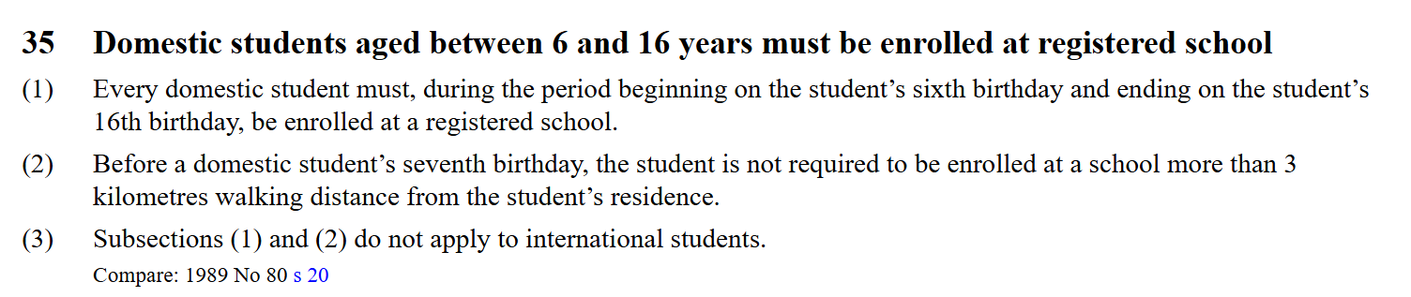
Source: https://www.legislation.govt.nz/act/public/2020/0038/latest/LMS204312.html

Section 243
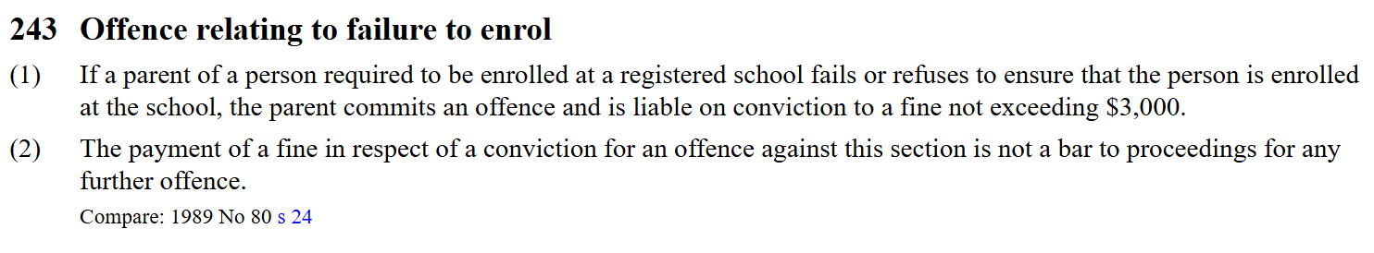
Source: https://www.legislation.govt.nz/act/public/2020/0038/latest/LMS176215.html

