When using this template please update all information between [ ]

[Provider / Organisation Name]
[Street Address]
[Suburb]
[City / Region]
[Postcode]
Phone: [Provider phone number]
Email: [Provider email address]

Date: [DD Month YYYY]

[Parent / Legal Guardian Name]
[Street Address]
[Suburb]
[City / Region]
[Postcode]

Kia ora [Name of parent / legal guardian],
I wrote to you on [date] and have made several further attempts to support the improvement of [child’s name] attendance. This is my [second] formal letter.
However, [child’s name] continues to be absent from school at an unacceptable level. For more information about when children should attend school please see the Ministry’s webpage: Student attendance guide - Ministry of Education
My focus is to provide you with the support needed to get [child name] attending school regularly. As you know, you have a legal obligation to ensure your child attends school. You’ll find more information on your legal obligations below. Without improvement it is possible that legal action could follow.
Our service is here to support. We work with schools, and have relationships with community groups, government agencies and other organisations that we can access to support you and [child name].
I am [name], your [kaimahi | case manager] at our [insert name of Attendance Service.] My focus remains the same. I am keen to listen without judgement and learn more about your situation so we can create a plan that works.
Please call me on [phone number] or email [email address] so we can get started.
Ngā mihi,
[Provider signature or name]
[Role / Position]
[Attendance Service Name]

Legal information
Under Section 36 of the Education and Training Act 2020, students enrolled at a registered school must attend whenever the school is open. Continued non‑attendance may result in prosecution under Section 244 of the Act.
Included below is a copy of Sections 36 and 244 for your reference.

Education and Training Act 2020 - Key Sections

Section 36
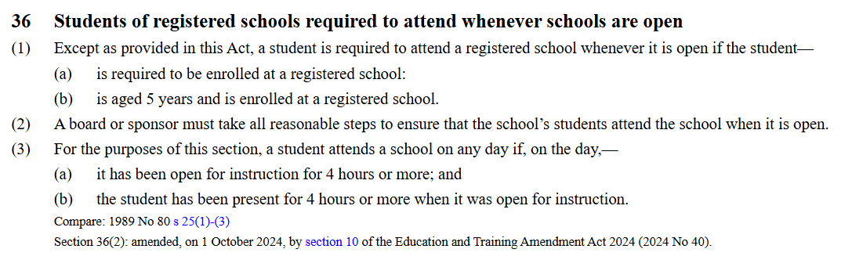Source: https://www.legislation.govt.nz/act/public/2020/0038/latest/LMS171382.html

Section 244
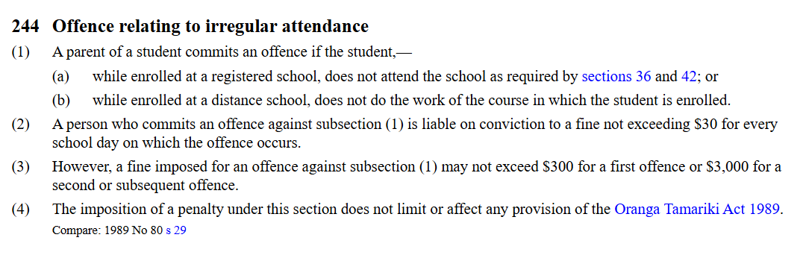Source: https://www.legislation.govt.nz/act/public/2020/0038/latest/LMS176221.html

