When using this template please update all information between [ ]

[Provider / Organisation Name]
[Street Address]
[Suburb]
[City / Region]
[Postcode]
Phone: [Provider phone number]
Email: [Provider email address]

Date: [DD Month YYYY]

[Parent / Legal Guardian Name]
[Street Address]
[Suburb]
[City / Region]
[Postcode]

Kia ora [Name of parent / legal guardian],
We all want the best for our tamariki and understand that a good start in life supports a good future. Going to school every day is one of the best predictors of a positive future for our tamariki. I also understand that life can get busy and challenging. Getting your tamariki to school can become difficult at times, and you may be facing a variety of challenges that make this difficult.
However, [insert child’s name] is still not attending school at an acceptable level. For more information about when children should attend school, please see the Ministry’s webpage: Student attendance guide – Ministry of Education
Our service is here to support. We work with schools, and we have relationships with community groups, government agencies and other organisations that we can access to work through the challenges that are stopping your child from attending school regularly.
We have been in touch several times to offer / provide support. Unfortunately, we’re not seeing any ongoing improvements in attendance. I must therefore remind you that you are legally required to ensure that [child’s name] attends school regularly. You’ll find more information on your legal obligations below.
I am [name], your [kaimahi | case manager] at [insert name of Attendance Service]. I would like us to talk so we can make sure you’re getting the support you both need.
I am keen to listen without judgement and understand your situation, so we can personalise the service you receive. This might involve one‑on‑one time with your child or with you, help accessing services and supports you’re entitled to, sharing what’s worked for others in a similar situation, or something different.
Please call me on [phone number] or email me at [email address] so we can get started.
Ngā mihi,
[Provider signature or name]
[Role / Position]
[Attendance Service Name]

Legal information
Under Section 36 of the Education and Training Act 2020, students enrolled at a registered school must attend whenever the school is open. Continued non‑attendance may result in prosecution under Section 244 of the Act.
Included below is a copy of Sections 36 and 244 for your reference.

Education and Training Act 2020 - Key Sections

Section 36
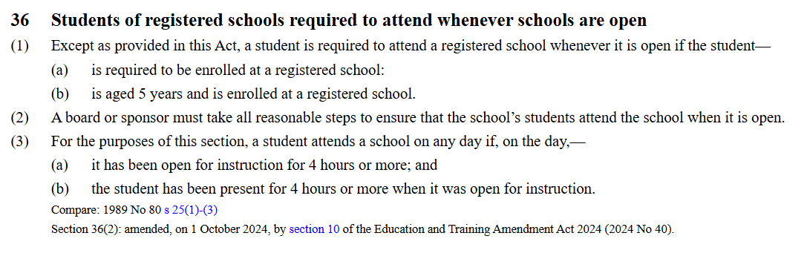Source: https://www.legislation.govt.nz/act/public/2020/0038/latest/LMS171382.html

Section 244
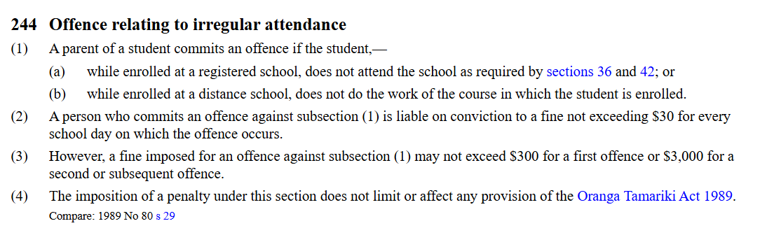Source: https://www.legislation.govt.nz/act/public/2020/0038/latest/LMS176221.html

