When using this template please update all information between [ ]

[Provider / Organisation Name]
[Street Address]
[Suburb]
[City / Region]
[Postcode]
Phone: [Provider phone number]
Email: [Provider email address]

Date: [DD Month YYYY]

[Parent / Legal Guardian Name]
[Street Address]
[Suburb]
[City / Region]
[Postcode]

Kia ora [Name of parent / legal guardian],
We all want the best for our tamariki and understand that a good start in life supports a good future. Going to school every day is one of the best predictors of a positive future for our tamariki. I also understand that life can get busy and challenging. Getting your tamariki to school can become difficult at times, and you may be facing a variety of challenges that make this difficult. [child’s first name] is not enrolled and attending school, and with the information we have at the moment they should be.
Our service has tried to get in touch several times. This is a formal letter letting you know more about your legal requirement to have your child enrolled and attending school and to introduce the service that we offer. You’ll find more information on your legal obligations below.
Our service is here to support. We work with schools, and have relationships with community groups, government agencies and other organisations that we can access to support you and [child name].
I would like to get started working on a plan together. I am [name] a [kaimahi | case managers] at our Service. I am keen to listen without judgement and understand your situation so we can create a plan to help. This might involve one on one time with your child or you, help accessing services and supports your entitled to, sharing what’s worked for others in a situation similar to your own, or something different.
Please call me on [phone number] or email [email address] so we can get started.
Nga mihi,
[Provider signature]

Legal information
Under Section 35 of the Education and Training Act 2020, you are legally required to enrol [child’s first name] at a registered school unless an exemption has been granted. Based on our records, [child’s first name] does not appear to have an exemption.
If enrolment is not confirmed, the Ministry of Education’s Prosecution Unit can choose to investigate and prosecute under Section 243 of the Act.
Included below is a copy of Sections 35 and 243 for your reference.

Education and Training Act 2020 - Key Sections

Section 35
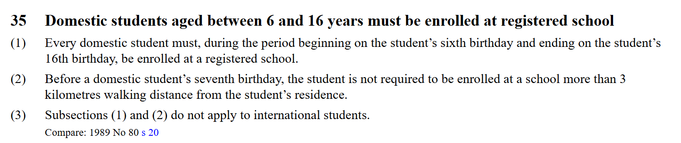
Source: https://www.legislation.govt.nz/act/public/2020/0038/latest/LMS204312.html

Section 243
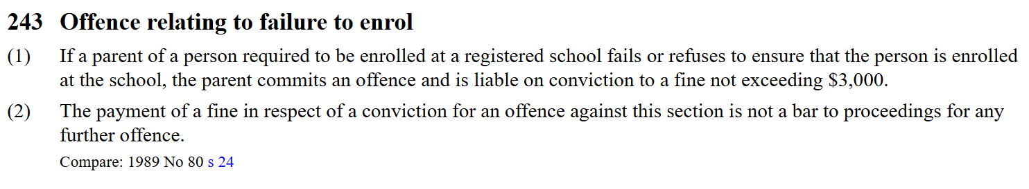
Source: https://www.legislation.govt.nz/act/public/2020/0038/latest/LMS176215.html

