Initial Diagnostic Assessment for Year 9 and new ELLs in Years 9-13
A quick-reference info sheet for secondary teachers assessing English Language Learners (ELLs).

1. Who needs to be assessed?
• All Year 9 ELLs listed on ENROL, including those with ceased funding.
• NZ-born bilingual students returning from overseas.
• Newly arrived migrants and former refugee learners.
• Long-term international fee-paying students.

2. What the assessment should include
• Listening & Speaking assessment.
• Vocabulary (e.g.The Updated Vocabulary Levels Test (UVLT).
• Reading - using ELL appropriate tools (e.g. Indicator, AssessEP).
• Independent writing sample matched to likely ELLP stage.

3. Understanding learner backgrounds
• Group 1: New to New Zealand – likely need targeted ESOL support (Foundation–Stage 4).
• Group 2: NZ-born/long-term residents – strong oral fluency but may have academic literacy gaps.

4. ESOL vs Learning Support
• ESOL = language acquisition needs.
• Learning Support = cognitive or literacy-based needs.
• Some learners require both; collaborate with SENCO and RTLB.
• Use a Bilingual Assessment where language barriers complicate identification.

5. ESOL funding eligibility – Quick Guide
• Funding based on ELLP total score (L+S+R+W).
• A “ceased” status does not always mean maximum terms reached.
• Check Column P in ENROL and reassess eligibility.

6. When ESOL funding has ceased
• Continue supporting based on need, not funding status.
• Many Year 9 learners still require literacy support even if funding ended.

7. Foundation Stage learners
• Delay formal assessment; begin with oral, phonological awareness.
• Use relationship-based, individual assessment.

Using ENROL to Identify and Support English Language Learners (ELLs)



ENROL is the Ministry of Education’s student enrolment register and the fastest tool to
Identify learners who may require ESOL assessment and support. The report is called
‘English language learners at my school’.

1. Understanding the ENROL Report
• Active: students currently receiving ESOL funding.
• Ceased: funding has stopped; Check Column P for clarification.
2. Start-of-Year Data Check
At the beginning of Term 1, Year 9 students listed as ‘ceased’ should be reassessed to determine whether a) they are eligible for further ESOL funding or b) need further ESOL support.
3. Learners NOT Included in ENROL
• new migrant or former refugee students enrolling for the first time in NZ
• international students
• learners never previously identified for ESOL funding
4. School Processes and Responsibilities
TICs/HODs of ESOL should request the current ENROL report from enrolment staff. Review data each term to guide assessment, ESOL placement, and progress tracking.
5. How ENROL Supports Effective ESOL Practice
• Identify new ELLs quickly
• Plan for Year 7 & 9 transitions by requesting feeder-school ENROL data (Oct–Nov)
• Build learner profiles using ELLP data
• Share information with teachers, deans, and literacy coordinators
• Link learner data to NCEA literacy/numeracy progress
All Year 9 ELLs should be assessed for co-requisite readiness. Benchmark: high ELLP Stage 3 to Stage 4 in reading and writing.
Assessment Administration Checklist: Responsibilities and Practical Considerations Use this table and the checklist that follows to ensure all practical aspects of the assessment process are prepared and managed effectively.

Focus Area | Key Guidance
Initial assessment of ELLs | Managed by an ESOL specialist teacher. Support may come from other teachers, language assistants, or teacher aides as needed.
Consistency and moderation | HOD or TIC of ESOL oversees marking to ensure consistency and alignment with ELLP. Moderation of reading and writing assessments is essential for reliable outcomes.
Familiarity with ELLP | ESOL staff must understand ELLP matrices to assess accurately, track progress, inform teaching, and apply for Ministry ESOL funding ELLP support hub
Use of ELLP and ELIP exemplars | Teachers should use exemplars and models from ELLP and ELIP to guide accurate assessment judgments  ELLP & Pathway overview
Digital record-keeping | Schools are encouraged to use digital platforms for storing assessment results to improve organisation, accessibility, and long-term tracking.
Planning for scale | The number of students needing assessment at the start of the year can range from 10 to several hundred. Schools must plan for time, staffing, space, and marking logistics.
Consistency of assessment conditions | All students should complete assessments under the same conditions to ensure fairness and reliability. Even small changes (e.g., reducing time by 5 minutes) can affect performance.
Equal time allocation | Every student must receive the same amount of time for each assessment.
Consistent instructions and materials | Instructions and resources should be identical across all assessment groups to maintain fairness.
Formal test conditions | Assessments must be supervised, with no collaboration or communication between students, and conducted in a quiet environment to support focus and equity.
Use of AI | AI may support translation for learner profiles or initial communication with Foundation Stage ELLP students. It must not be used for vocabulary, reading, or writing assessments.

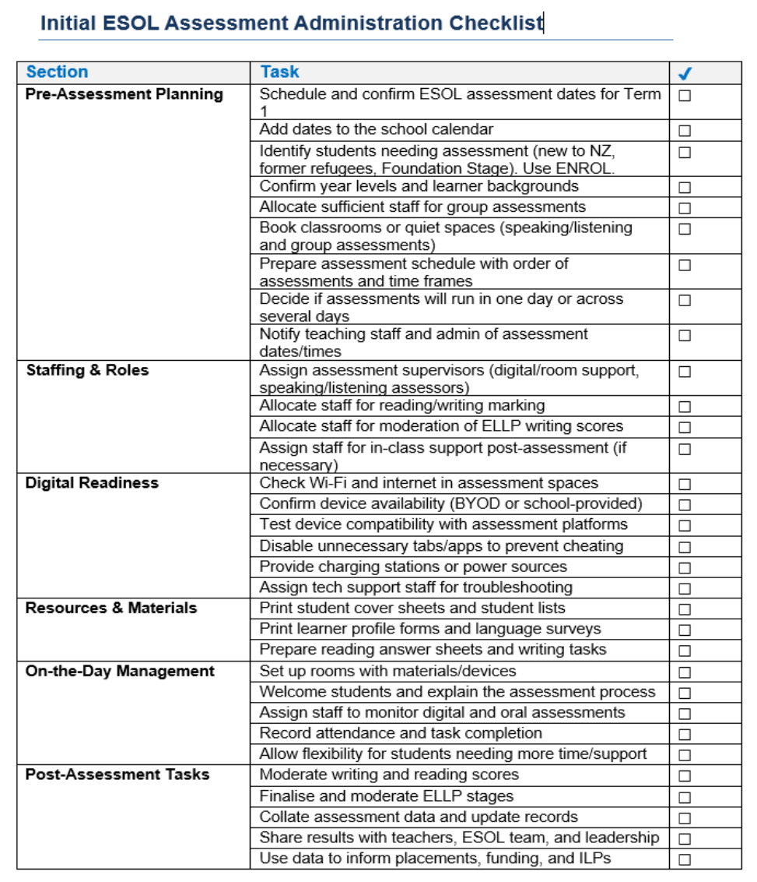

More detailed general guidance and support for initial assessment:

Order of assessment
Managing the different assessment tasks for a large group of learners at the beginning of Term 1 will be challenging. Ideally, it is best if you follow this order, with the listening and speaking assessments conducted at the beginning of the assessment process, however, it is not always possible to do this.

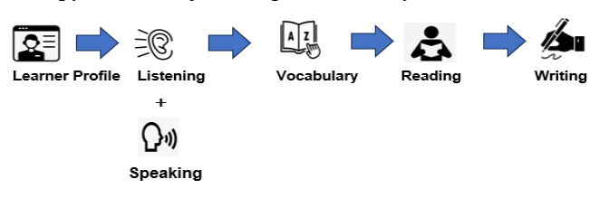

There is not a one-size-fits-all model that will work in all schools and it may take a couple of assessment periods to find the model that works best. Most likely the number of students to be assessed in Term 1 will be the deciding factor.

Who should have an initial assessment?
Initial ESOL assessment helps identify English language learning needs and inform placement and support. It should be completed as soon as practicable after enrolment, ideally within the first 2–3 weeks. Assessment provides a snapshot only; decisions about ELLP levels should draw on multiple sources, including classroom observations and ongoing assessment.

Table 1: Determining Which Students Need an Initial ESOL Assessment
Student Group | Notes | When | Rationale
All Year 9 students on ENROL report | Include those who ceased ESOL funding, completed maximum terms, or previously identified as needing support. | Within first 2–3 weeks of school year or 2 weeks of enrolment. | Prompt assessment informs class placement and ESOL/literacy support.
New former refugee students (Y9–13) | Allow time to settle; start with oral/writing sample. | Initial sample within 2 weeks; full assessment over 6–8 weeks. | Likely at early ELLP stages; need intensive ESOL support in a supportive environment.
New migrant students (Y9–13) or NZ-born ELLs returning from overseas | May not appear on ENROL; range from Foundation to Stage 3 ELLP. | Within 2 weeks of enrolment (ideally 2–3 weeks for timetable confirmation). | Early assessment aids placement and identifies support needs; some may need reception programmes before full assessment.
International fee-paying students (Y9–11) | Long-term students should have offshore assessment; short-term students usually exempt. | On arrival for long-term students. | Confirms proficiency, guides placement, and identifies additional needs.

Assessment considerations for Foundation Stage Learners
It is important not to rush into formal assessment with students with very limited English language proficiency as they need time to settle into the school environment, and teachers need time to build a rapport and create opportunities for one-on-one assessment in a supportive context.

Who are the Foundation Stage ELLs - it is important to recognise that there is considerable variation in the learner profiles of students at Foundation Stage which needs to be explored and understood, but the learners who are likely to fit this profile will be:

- Migrants and former refugee students who have newly arrived in New Zealand.
- NZ born ELLs who typically enrol in Year 1 at primary school but spend several years in their parents’ homeland. They return to NZ at upper primary with stronger first language proficiency, but limited English.

Table 2: Examples of learners at Foundation Stage ELLP and suggested approaches

Learner Profile | Assessment Approach
Former refugee – Zinat  Dari speaker, limited literacy due to interrupted schooling, limited information about their experiences before arrival in NZ. | Build trust first; do not rush assessment. Begin with oral language and phonological/phonemic awareness (letters, sounds, blends). May be appropriate to use trauma-informed strategies.
NZ-born – Austin  Year 10, first language Mandarin, spent Years 2–8 overseas, returned mid-Year 9. | Stong literacy skills in his first language, which is an advantage.  Assess phonological/phonemic awareness and first 500–1000 English words. Conduct informal L1 literacy check with bilingual support to inform planning.

Table 3: Initial Assessment Checklist for Foundation Stage ELLs (Years 9–13)
Step | Actions
Gather Background Information | • Review enrolment documents (especially important for former refugee students).  • Collect background details through conversations with:  – Parents or caregivers  – Red Cross or other support agencies (for former refugee students)  • Complete the short Language Survey as a starting point.
Prepare for Initial Assessment | • Use Foundation Stage descriptors from the ELLP or English Language Learning Pathways resource to make initial judgments.  • Begin with a Speaking and Listening Assessment.  • Be guided by the results of the oral language assessment before proceeding further.

Using initial assessment data to inform placement and support

After completing the initial assessment and determining the ELLP stage (using the ELLP Pathway or matrices), use this data to guide class placement and ESOL support planning.

Table 4: Key considerations for placement and support
Consideration | Action
Prioritise ELLP Stage | Use a learner’s ELLP stage as the main factor for class placement decisions.
ESOL Support | • ESOL support is essential, not optional for learners at Foundation to Stage 3.  • Communicate the rationale to students and parents, linking it to NCEA Level 1 Literacy and long-term success.
Support Beyond Funding | • Provide ESOL support for students who have not met the literacy benchmarks, even if funding has ceased.  • Focus on student need, not funding status.
Additional Literacy or Academic Pathways | • For students at initial ELLP stages, consider extra literacy programmes or alternative pathways.  • Discuss decisions collaboratively with the student, family, and key staff (e.g., year-level dean).

Stage 4 ELLP – Why Ongoing Support Matters
Stage 4 learners can access the curriculum and communicate fluently across all four language domains. However, as students progress through Phases 4 and 5 of the curriculum, academic content becomes increasingly abstract and vocabulary more academic. Even high-achieving ELLs may have a significantly smaller vocabulary than native speakers (~5,000 vs 13,000 words). Continued ESOL support, tracking, and consideration of EAP pathways (Level 3–4) are often necessary to meet benchmarks such as University Entrance Literacy (UE Lit).

Additional literacy / academic pathways

The English Language and the English for Academic Purposes unit standards offer an additional literacy pathway for learners who will require targeted ESOL support from Year 9 to Year 13. The EL unit standards are available to Year 9 and 10 learners with the school’s consent.

The chart shows how these standards can be used as building blocks towards the NCEA Literacy co-requisites, as well as University Entrance literacy requirements. It also shows the relationship between the EL and EAP unit standards and the English Language Learning Progressions (ELLP) stages and the Common European Framework of Reference for Languages (CEFR).

