
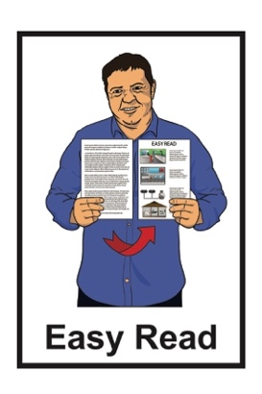

Settlement between IHC, the Minister and the Ministry of Education


Published: December 2025

What this Easy Read is about

This Easy Read is from the Ministry of Education.


The Ministry of Education is the part of Government in charge of the education system.

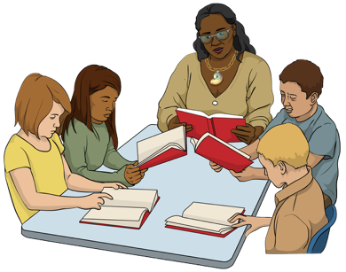
The education system is all the places people learn like:
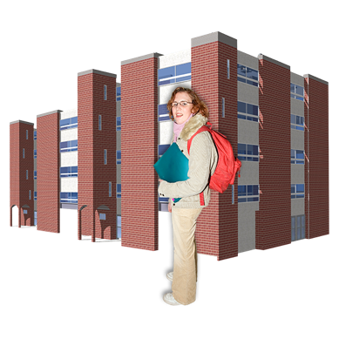
preschools / kindergartens
schools
tertiary education like polytechs.

When you see we / us / our in this Easy Read it means the Ministry of Education.

This Easy Read is about a settlement between:
the Ministry of Education
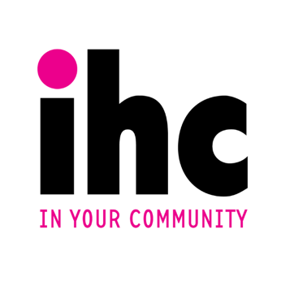
the Minister of Education
IHC.


A settlement is a legal agreement
made in court that:
ends a conflict / disagreement
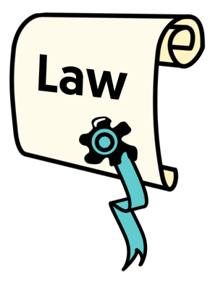
says what each side must do to put things right.

Legal means something to do with the law.
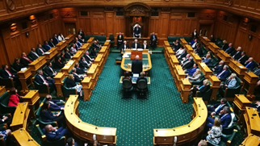
The Minister of Education is:
part of the Government
in charge of the Ministry of Education.
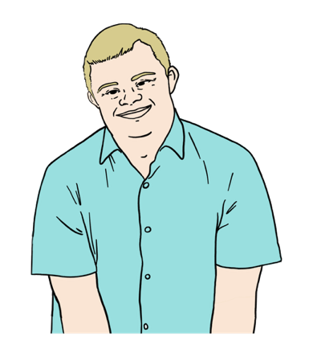

IHC is an organisation that works for people with learning / intellectual disabilities.

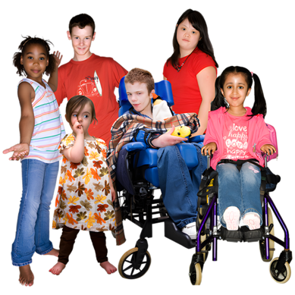
The settlement will make the Aotearoa New Zealand education system work better for disabled students.


This Easy Read has information about:
the Framework for Action
being part of a stakeholder group.
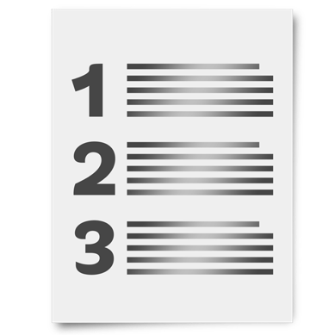
The Framework for Action says the things we will do to make the education system better for disabled students.
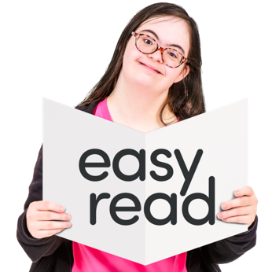

In this Easy Read the Framework for Action will be called the framework.

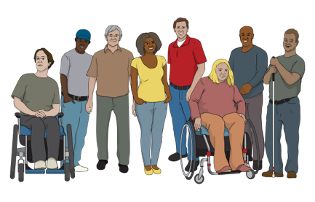
Here the stakeholder group is a group of people who:
have experience with:
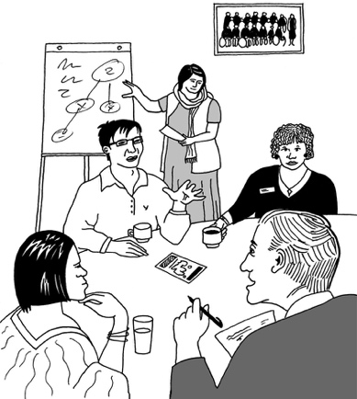
- disability
- education
give us advice about our work on the framework.

Framework for Action


This settlement is to sort out a complaint IHC made under the Human Rights Act.


Making a complaint means telling someone:

there is a problem
you want them to do something to put it right.

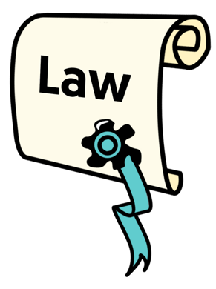
The Human Rights Act is a law about the things every person
should:
have
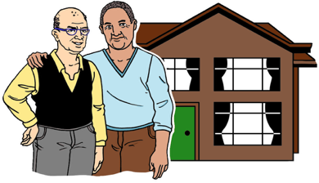
be able to do.

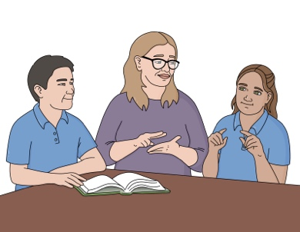
Human rights are things like:
having a safe place to live
getting the education you need.

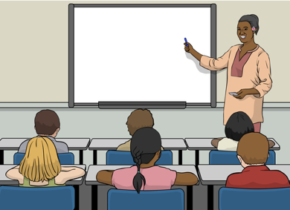
IHC said that some things in the education system:
are discrimination
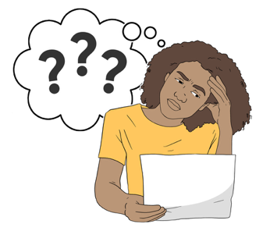
cause disabled students to get less education than non-disabled students.

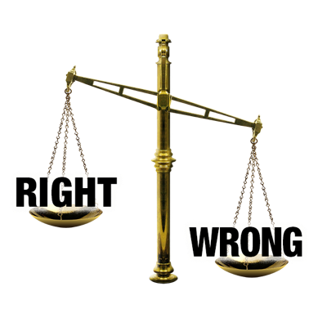
Discrimination is when people are treated unfairly because of things about them like:

how old they are
if they are disabled.

IHC has written the framework to get rid of some of the barriers for disabled students in the education system.


Barriers are things that make it harder to do the things you need / want to do.

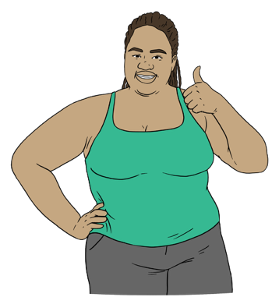
We have promised to do the things in the framework.


The framework says we have to investigate things about the education system like how we:

collect information about disabled students
report / share information about disabled students.

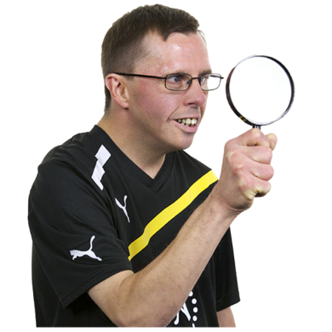
Here investigate means looking closely at things to see:
what is happening
how they could be made better.

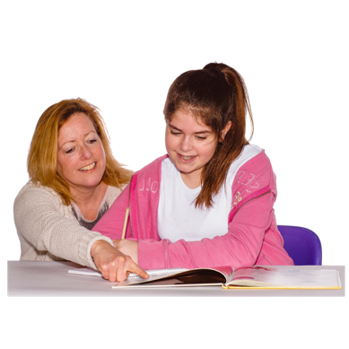
The framework also says we have to investigate how easy it is for students to get the specialist support services they need.

Here specialist support services
are people who have training to support disabled students with their learning like:
speech–language therapists
vision or hearing experts.

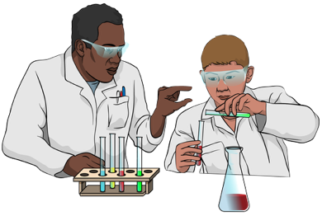
We also have to investigate:
if the things we teach:
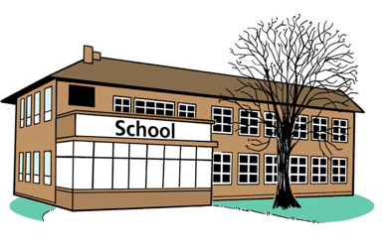
- work for all students
- let all students be included
how accessible our schools are.
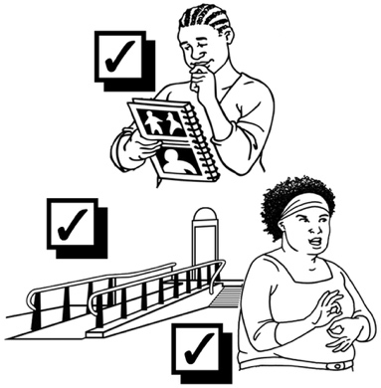

Accessible means something works well for disabled people.


You can find Easy Read information about the framework at:

https://tinyurl.com/ef8v35ks

Being part of the stakeholder group


The stakeholder group will:
share ideas about our work on the framework
give us feedback.

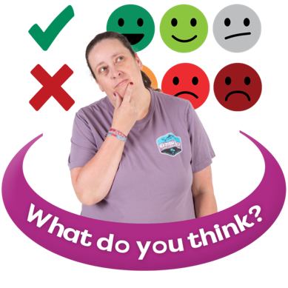
Feedback is when you tell someone what they:
are doing well
could do better.

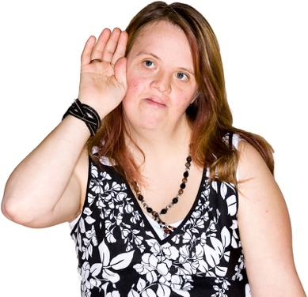
We will work with the stakeholder group to make sure we are listening to the lived experiences of disabled people.

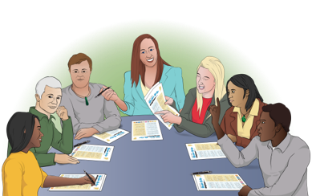
The stakeholder group will have
6 to 8 members.


2 members will be from IHC.

1 of the members from IHC will be the chair of the group.

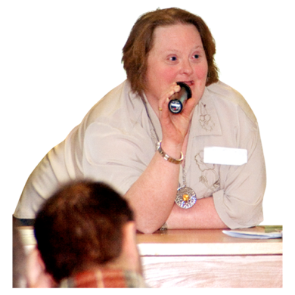
The chair:
leads meetings
speaks for the group.

We are looking for people to be part of the stakeholder group:
who have been through the education system in Aotearoa New Zealand
and
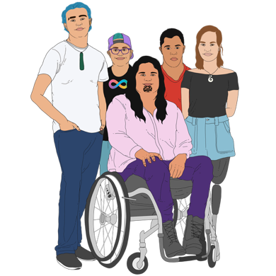
who are:
- disabled
- tangata whaikaha Māori.


We are also looking for people who have:
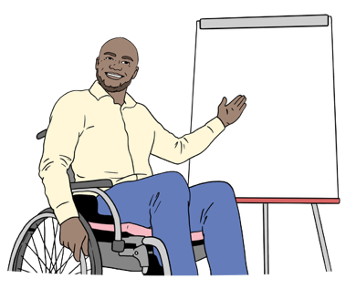
supported a disabled person through their education
worked in the education system.

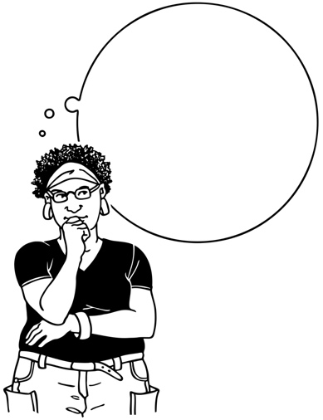
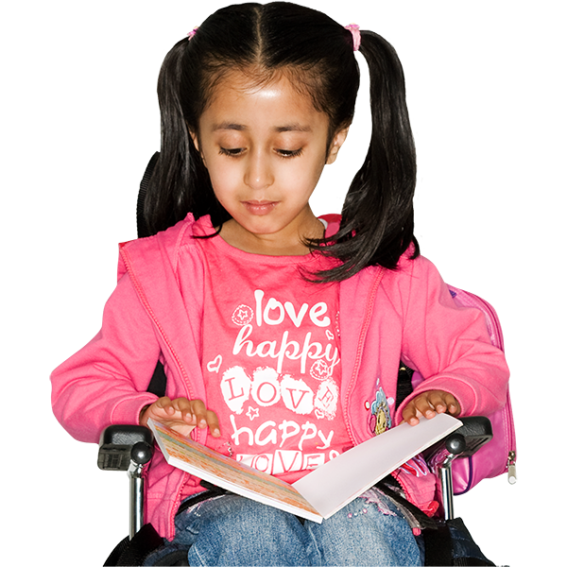
Members of the stakeholder group should understand what:
is important to disabled students
barriers there are for disabled students.



The stakeholder group will run for at least 6 years.


Members will be part of the group for at least 3 years.

The group will meet 3 times each year.

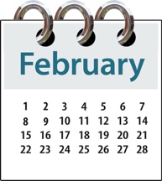
Meetings will probably be in:
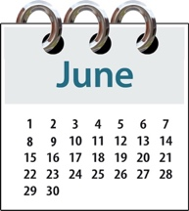
February
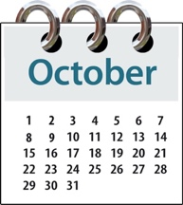
June
October.


We will pay members who do not already work for us for their:
time
travel costs.

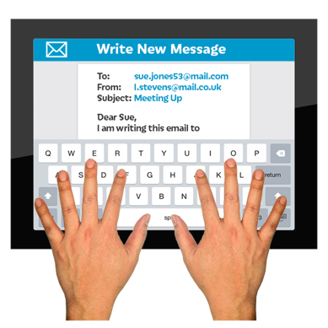
You can apply to be a member of the stakeholder group by filling out an expression of interest form before
11 January 2026.


Here an expression of interest is a formal way to say:
you would like to be part of the stakeholder group
why you would be a good person to have in the stakeholder group.

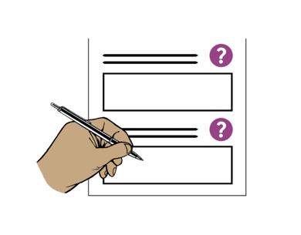
You can find the Easy Read expression of interest form at:

https://tinyurl.com/3v3famn3

You can also fill out an expression of interest form online at:

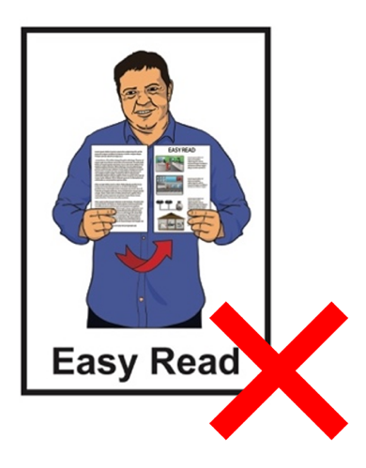
https://tinyurl.com/2t7cuz7u

The online form is not in Easy Read.

Contact us

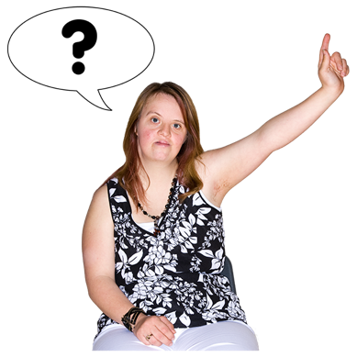
You can contact us if you have questions about the:
framework
stakeholder group.

You can email us at:

enquiries.national@education.govt.nz

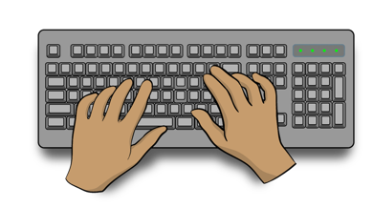
When you email please write
IHC Settlement Agreement in the subject line.

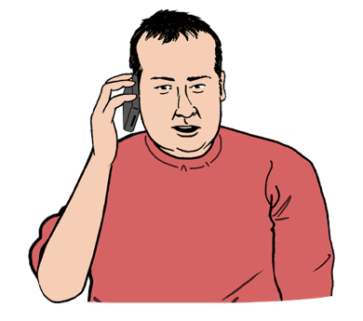
You can phone us on:

0800 4711 711


You can only phone us if you are in Aotearoa New Zealand.

You can phone us:
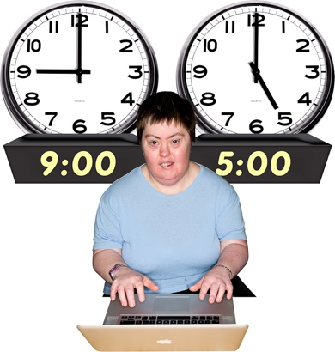
from
- 9 am
to
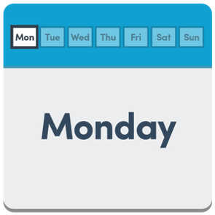
- 5 pm
on
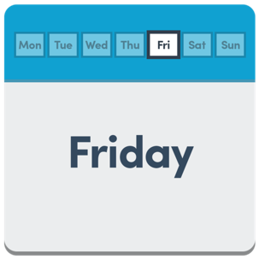
- Monday
to
- Friday.


It does not cost money to phone us.


If you find it hard to use the phone the New Zealand Relay service is for people who are:

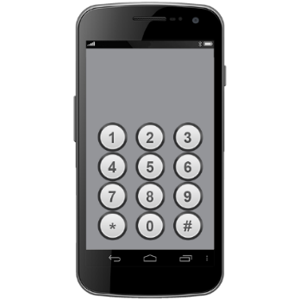
- Deaf / hard of hearing

- deafblind

- speech impaired / find it hard to talk.


You can find out more about the New Zealand Relay service at:

www.nzrelay.co.nz

This information has been written by Te Tāhuhu o te Mātauranga Ministry of Education.

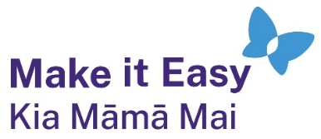
It has been translated into Easy Read by the Make it Easy Kia Māmā Mai service of People First New Zealand Ngā Tāngata Tuatahi.
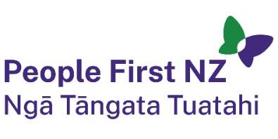
The ideas in this document are not the ideas of People First New Zealand Ngā Tāngata Tuatahi.

All images used in this Easy Read document are subject to copyright rules and cannot be used without permission.


Make it Easy uses images from:

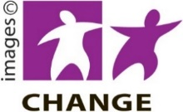
- Photosymbols

- Change Images

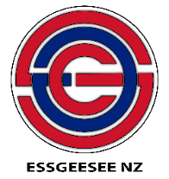
- Huriana Kopeke-Te Aho
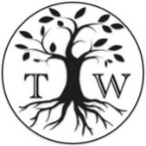
- SGC Image Works

- T Wood

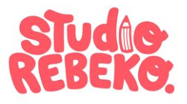
- Studio Rebeko

- Inga Kramer.

