Summary of our Attendance Management Plan -Template
This template is intended to support schools to create a summary of your attendance plan to share with your community.
In line with the government's target of 80% of students regularly attending school by 2030. |  |  |  |  | Our school uses the Stepped Attendance Response (STAR) to guide when and how we respond to absences.  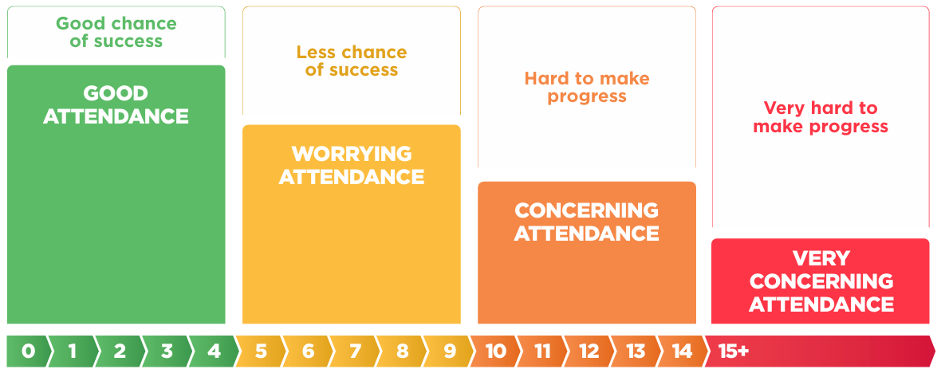
We’re currently at  __% Regular attendance  by Term X, YEAR |  | Our school has a target of __% Regular attendance  in Term X, YEAR
Our Attendance Management Plan sets out  - Why attendance is a priority for our school  - Legal requirements about attendance  - Our expectations of students, parents and our school staff  This includes  - How we manage attendance in our school  - How we identify concerning attendance  - How we respond to absences at different thresholds  - How we monitor and review the impact of our actions  - How we give the Board assurance that the school is managing attendance effectively |  |  |  |  |  | If your child is regularly attending,  you can expect | If your child has some absences,  you can expect | If your child has many absences,  you can expect | If your child has a lot of absences,  you can expect
 |  |  |  |  |  | We will stay in regular contact with you about your child’s attendance.  We will follow up to find out the reason when they aren’t at school. | We will work with you to identify any barriers to attendance.  We may provide support to help them catch up and stay on track. | We will work with you to develop a plan to support their attendance and learning.  We may seek support of the Attendance Service or other agencies to remove barriers to attendance. | We will continue to work with you to implement the plan to support their attendance and learning.  We will seek support of the Attendance Service or other agencies to support their return to school.

“Regular attendance” means attending more than 90% of a term, or 9 days in a fortnight

