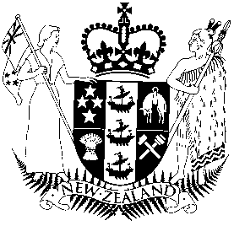

New Zealand Qualifications Authority (NZQA) | Mana Tohu Mātauranga o Aotearoa

Board Member Position Description
Appointed by | Minister of Education
Term | Up to 3 years with potential for reappointment
Remuneration | $22,680 per annum

About NZQA | Mana Tohu Mātauranga o Aotearoa
The New Zealand Qualifications Authority’s (NZQA) services span the secondary and tertiary education sectors. NZQA manages the New Zealand Qualifications and Credentials Framework (NZQCF), administers the National Certificate of Educational Achievement (NCEA) for secondary school students and is responsible for the quality assurance of tertiary education providers (except for universities). It is also the Administrator of the Education (Pastoral Care of Tertiary and International Learners) Code of Practice 2021, provides a service for recognition of overseas qualifications, and has a number of other international responsibilities. More information on its function can be found on NZQA’s website: https://www2.nzqa.govt.nz/about-us/why-we-are-here/our-responsibilities/

Role of the Board and its members
The Board’s governance role involves setting the strategic direction for NZQA to ensure that the entity performs its functions in line with the Government’s policies and priorities, and that NZQA makes sound fiscal decisions. In setting this direction the Board needs to consider the priorities in the Minister’s Letter of Expectations, the Enduring Letter of Expectations for Crown Entities, and other communication from Ministers.

The Board is responsible for assurance over NZQA’s performance against its strategic direction and for issuing a three-yearly Statement of Intent and an annual Statement of Performance Expectations. NZQA must report on its performance against these in quarterly reports to the Minister and in its Annual report which is tabled in Parliament.

Members of the Board are accountable to the Minister in respect to their collective and individual duties and responsibilities. As a Board member you are expected to support the work of the Board as directed by the Chair (or deputy Chair) by:

- contributing your specific areas of expertise as they relate to the governance of NZQA
- supporting other Board members and working in a collective and collaborative manner
- participating in or leading sub-committees or projects
- maintaining current knowledge of the education sector, environmental factors, emerging risks and challenges and government direction, and
- maintaining political neutrality and the confidence of the Minister.

Relevant legislation
The Education and Training Act 2020 also sets out the functions of NZQA in Section 433 which can be found at the following link:
https://www.legislation.govt.nz/act/public/2020/0038/latest/LMS172270.html

The main sections of the Act which uphold Te Tiriti o Waitangi are listed at this link:
https://www.legislation.govt.nz/act/public/2020/0038/latest/LMS280244.html

As set out in the Public Service Act 2020 the Board must preserve, protect, and nurture the spirit of service to the community (s13), and is responsible for ensuring NZQA upholds Public Service principles (s12), which are:
- political neutrality
- providing free and frank advice
- making merit-based appointments
- fostering a culture of open government, and
- promoting stewardship of the public service – the long term capability of its people, institutional knowledge, systems and processes, assets, and the legislation agencies administer.
The rules for governance, operation, and accountability of Crown entities are set out in the Crown Entities Act 2004.

Skills, experience and attributes of the Board
To help the Board succeed in its roles and functions, it should collectively have:

- strong governance experience
- executive leadership experience, a strategic outlook, and the ability to lead through change
- strong financial capability and acumen, and commercial experience
- a detailed understanding of the machinery of government including the role of Crown Agents
- knowledge of te reo Māori, tikanga Māori, Mātauranga Māori, and Te Tiriti o Waitangi, and
- an ability to build robust, collaborative relationships in complex environments.

Workload, remuneration and term of appointment
The expected workload for members is approximately 30 days per year on meeting attendance and other Board business. The Board meets around 11 times a year. In addition, a member may sit on one of the Board’s subcommittees: Risk and Assurance (four to six times a year), People and Culture (three times a year) and Information Systems (four times a year).

Board members receive a fee of $22,680 per annum. This is set and reviewed in accordance with the Cabinet Fees Framework which can be found here:
https://www.dpmc.govt.nz/sites/default/files/2025-09/co-25-2-cabinet-fees-framework-v3.pdf

All members are paid out of NZQA’s funds for reasonable and actual allowances for travelling and other expenses relating to performing their duties and responsibilities as Board members.

Appointments are for terms of up to three years. Members may be considered for reappointment when their term expires.

Resignation or removal from office
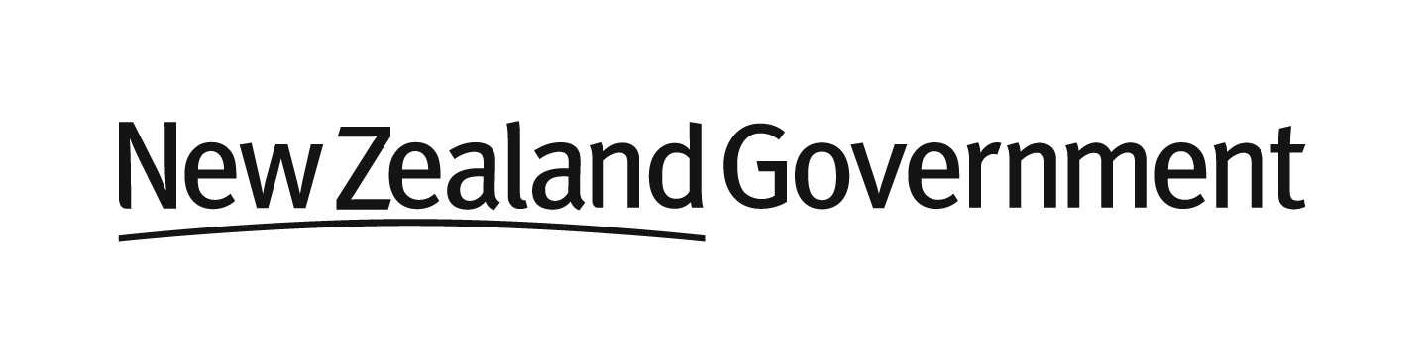
A member may, at any time, resign from office by notifying the Minister and the Board Chair in writing. Any member, including the Chair, may be removed by the Minister by written notice.

