\


Education New Zealand | Manapou ki te Ao
Board Member Position Description
Appointed by | Minister of Education
Term | Up to 3 years with potential for reappointment
Remuneration | $16,800 per annum

About Education New Zealand | Manapou ki te Ao (ENZ)
ENZ is the New Zealand government agency responsible for helping realise the social, cultural and economic benefits of international education. It is a Crown Agent under the Crown Entities Act 2004 and is governed by a board which is accountable for the performance of the entity to the Minister of Education (the Minister). ENZ is monitored by the Ministry of Education which provides an independent view of the performance of the entity to the Minister.

The operating environment
The Government has ambitious growth plans for international education which are a priority for the Board, and which are reflected in key planning and strategy documents including the International Education Going for Growth Plan.

ENZ’s strategic direction is also driven by the International Education Strategy 2022-2030 (the Strategy). This sets the goals of delivering an excellent education and student experience, ensuring that international education is sustainable and resilient, and that students are provided with relevant skills and connections as global citizens.

Role of the board and its members
The Board’s governance role involves setting the strategic direction for ENZ to ensure that the entity performs its functions in line with the Government’s policies and priorities, and that ENZ makes sound fiscal decisions. In setting this direction the Board needs to consider the priorities in the Minister’s Letter of Expectations, the Enduring Letter of Expectations for Crown Entities, and other communication from Ministers.

The Board is responsible for assurance over ENZ’s performance against its strategic direction and for issuing a three-yearly Statement of Intent and an annual Statement of Performance Expectations. ENZ must report on its performance against these in quarterly reports to the Minister and in its annual report which is tabled in Parliament.

The Chair of the Board retains the primary accountability for the performance of the entity and the board. As a board member, you are expected to support the work of the Board as directed by the Chair by:
- contributing your specific areas of expertise as they relate to the governance of ENZ,
- supporting other board members and working in a collective and collaborative manner,
- participating in or leading sub-committees or projects,
- maintaining current knowledge of the sectors ENZ operates in, environmental factors, emerging risks and challenges and government direction, and
- maintaining political neutrality and the confidence of the Minister.

Relevant legislation
The Education and Training Act 2020 sets out the functions of ENZ in Section 511 which is included as Appendix 1 and can be found at the following link:
https://www.legislation.govt.nz/act/public/2020/0038/latest/LMS172420.html

As set out in the Public Service Act 2020 the Board must preserve, protect, and nurture the spirit of service to the community (s13), and is responsible for ensuring ENZ upholds Public Service principles (s12), which are:
- political neutrality
- providing free and frank advice
- making merit-based appointments
- fostering a culture of open government, and
- promoting stewardship of the public service – the long-term capability of its people, institutional knowledge, systems and processes, assets, and the legislation agencies administer.
The rules for governance, operation, and accountability of Crown entities are set out in the Crown Entities Act 2004.

Skills, experience, and attributes of the board
To help the Board succeed in its roles and functions, it should collectively have:
- strong governance experience
- strong financial capability, and acumen, and commercial experience
- a detailed understanding of the machinery of government including the role of Crown Agents
- an understanding of the operating context for education in New Zealand
- an understanding of overseas markets and international relations.
- knowledge of te reo Māori, tikanga Māori, Mātauranga Māori, and Te Tiriti o Waitangi, and
- an ability to build robust, collaborative relationships in complex environments.

Workload, remuneration and term of appointment
The expected workload for board members is approximately 30 days per year to attend meetings and other board business. ENZ’s board meets around ten times a year. Board members receive a fee of $16,800 per annum. This is set and reviewed in accordance with CO (25) 2: Cabinet Fees Framework for members appointed to bodies in which the Crown has an interest | Department of the Prime Minister and Cabinet (DPMC). This fee is currently being reviewed.

All board members are paid out of ENZ’s funds for reasonable and actual allowances for travelling and other expenses relating to performing their duties and responsibilities as board members. Appointments are for up to three years and all members may be considered for reappointment when their term expires.

Resignation or removal from office
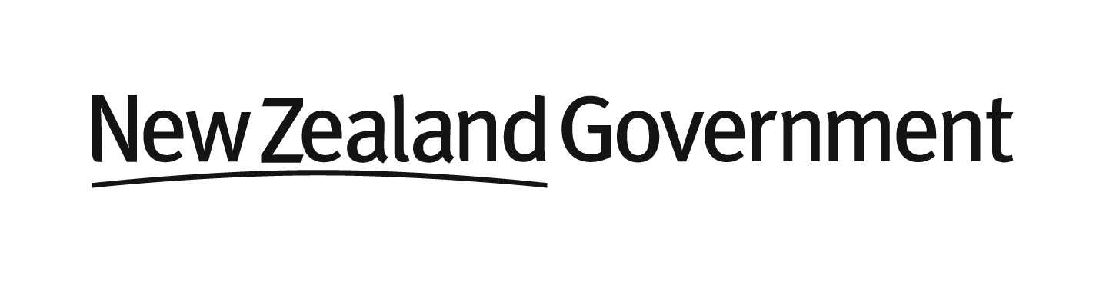
A member may resign from office by notifying the Minister and the Chair in writing, and any member may be removed by the Minister by written notice.

