TWO WEEK SAMPLE MENU – 2025 TERM 4 PRICING
Week 1
 | MONDAY  RĀHINA |  | TUESDAY  RĀTŪ | WEDNESDAY  RĀAPA | THURSDAY  RĀPARE | FRIDAY  RĀMERE | Average Daily Lunch Cost*
Lunch  Meal | 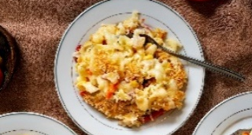  Mac n Cheese |  | Chicken Burger Wrap  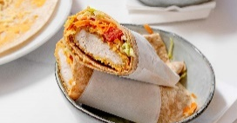  (side included) | Cottage Pie  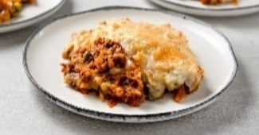 | Ham & Cheese Salad Sandwich  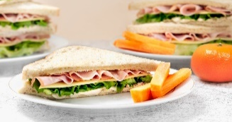  (side included) | Chicken Rice Bowl  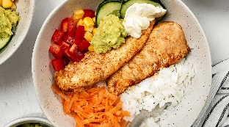
Cost*/Lunch  Y 0-3 | $0.93 |  | $1.40 | $1.00 | $1.26 | $1.74 | $1.27
Y 4-8 | $1.12 |  | $2.39 | $1.20 | $2.05 | $2.17 | $1.79
Y 9+ | $1.40 |  | $2.39 | $1.51 | $2.72 | $2.49 | $2.10
Week 2
Lunch  Meal |  | Spaghetti and Meatballs  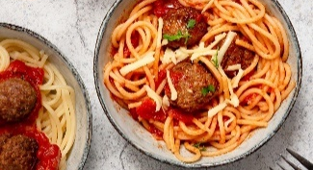 | Ham Salad Wrap  (side included)  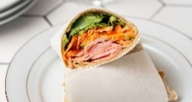 | Butter Chicken  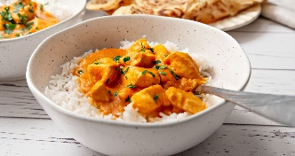 | Egg Sandwich  (side included)  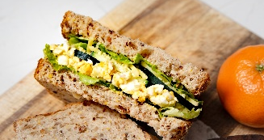 | Lasagne Style Pasta Bake  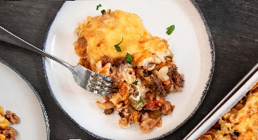
Cost*/Lunch  Y 0-3 | $1.11 |  | $1.52 | $0.92 | $1.34 | $1.01 | $1.18
Y 4-8 | $1.45 |  | $2.40 | $1.20 | $2.32 | $1.27 | $1.73
Y 9+ | $1.81 |  | $2.62 | $1.48 | $2.76 | $1.53 | $2.04

* Cost as per Gilmours Pantry Product Pricelist, 29 September 2025
Butchery & Produce pricing based on average Term 3, 2025 prices

