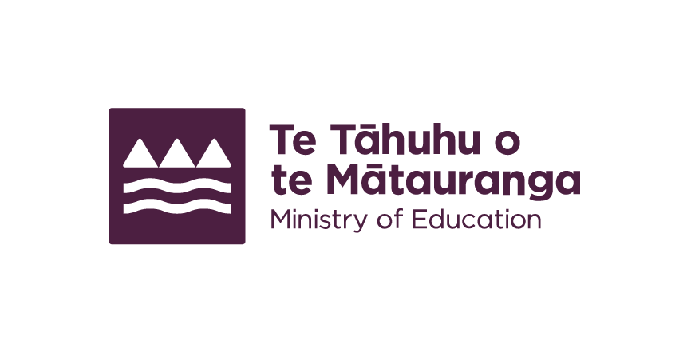
Interpreters for Deaf parents
Find an interpreter to help you communicate with your child's school.

What support is available
Ministry of Education-funded New Zealand Sign Language (NZSL) interpreters are available for Deaf parents to help you be involved in your child's education.
If your child is attending a state or state-integrated school or kura, we fund NZSL interpreters to go with you to:
- school enrolment meetings;
- formal parent-teacher meetings;
- support plan meetings;
- prizegivings and special assemblies;
- any other meetings with school staff where any aspect of your child's education is being discussed.
There is no charge to you or to the school for NZSL interpreters for these meetings and special events.

How to access this support
We fund a third-party provider, Wordsworth Interpreting, to provide NZSL interpreter services so you can engage with your child's school. Visit Wordsworth Interpreting's website to make a booking.
https://www.wordsworth.nz/booking
End of: Interpreters for Deaf parents
This Large Print document is adapted by Blind Citizens NZ from the standard document provided by the Ministry of Education

