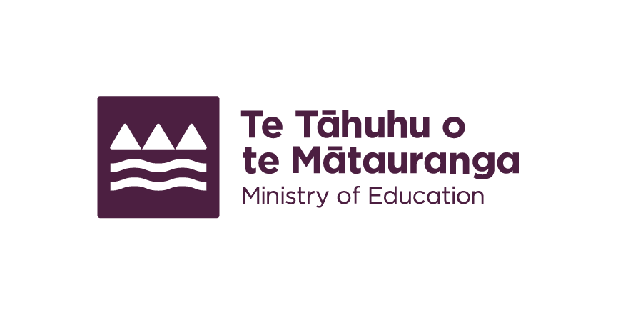
Development map for New Zealand Sign Language in Education
We are making improvements to a development map for promoting and maintaining the use of New Zealand Sign Language (NZSL) in education.
The development map aligns with the NSZL Board's strategy for the long-term promotion and maintenance of NZSL.

Recommendations of the Chief Ombudsman
We are reviewing our development map in response to recommendations from the Chief Ombudsman.

The ombudsman recommends that we:
- revise our development map within 12 months;
- provide quarterly reports to the Ombudsman.

Revising the development map
Recommended revisions include:
- adding a clear and coordinated roadmap under each goal to show how we will meet it;
- consulting with key stakeholders about meeting the goals in the development map.

Quarterly progress reports
Recommendations include:
- a summary of our progress of the review and revision of the development map;
- a summary of our communication with key stakeholders in relation to the review;
- a plan to publish and report against our redeveloped strategy for progressing access to NZSL in education.
We accepted all recommendations in January 2024.

End of: Development map for New Zealand Sign Language in Education
This Large Print document is adapted by Blind Citizens NZ from the standard document provided by the Ministry of Education

