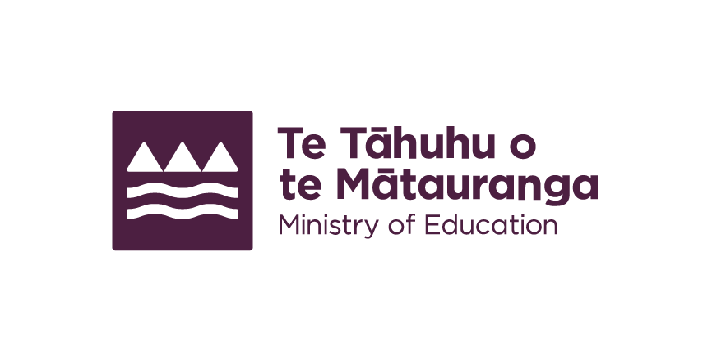
Support with education for children who are Deaf or hard of hearing
Children who are Deaf or hard of hearing can get support with their education until they leave school.

Definition of Deaf and hard of hearing
Children who are Deaf or hard of hearing have long term or permanent hearing loss. This could be in 1 or both ears and includes auditory neuropathy disorder. We can provide support from identification of hearing loss until the end of school.

Identifying a need for support
Hearing screening checks are available to all newborn babies to identify hearing loss early. If your child didn't have a newborn hearing check and you are concerned about their hearing, talk to your doctor. We work with families to provide supports once a need is identified.
Well Child Tamariki Ora checks are free for all children from 6 weeks up to 5 years of age.
https://www.education.govt.nz/parents-and-caregivers/early-learning/health-safety-and-wellbeing/health-services-young-children (https://tinyurl.com/49advnfj)
For older children, talk to your child's doctor or healthcare provider to access support.
https://www.education.govt.nz/parents-and-caregivers/schools-year-0-13/learning-support/supporting-your-child-if-they-need-extra-help-their-learning (https://tinyurl.com/4b2vvnbx)

Available support
Support works across the system to tailor an approach depending on the needs of the child.

Advisers on Deaf children
We employ advisers on Deaf children (AoDC). They work alongside children identified as Deaf or hard of hearing and their whānau | families from birth until year 3 of school. They can also work with older children.
AoDC work together with families and educators to find the best ways to support your child. They provide ongoing advice and guidance on communication, language development and learning through early childhood and into school.
Once your child is enrolled in early learning, the AoDC may also request support from Ko Taku Reo | Deaf Education New Zealand. Ko Taku Reo provide education and specialist services for children who are Deaf and hard of hearing (DHH). Services include:
- Resource Teachers of the Deaf
- New Zealand Sign Language (NZSL) Tutors
- Specialist schools.
https://www.education.govt.nz/parents-and-caregivers/schools-year-0-13/learning-support/specialist-schools#for-children-who-are-deaf-and-hard-of-hearing-4 (https://tinyurl.com/3y9jwmhe)
AoDC work together with a range of other agencies including:
- Deaf Aotearoa First Signs
- Health New Zealand | Te Whatu Ora
- Cochlear Implant Programmes.

Resources
https://deafchildren.org.nz/parents/the-family-book/
https://www.learnnzsl.nz/

More information
http://deaf.org.nz/
http://www.firstsigns.co.nz/
http://www.deafchildren.org.nz/

Contact
To request support for your child, phone or email your regional office.
https://www.education.govt.nz/our-work/about-us/contact-us/regional-offices (https://tinyurl.com/2rtynfur)
End of: Support with education for children who are Deaf or hard of hearing
This Large Print document is adapted by Blind Citizens NZ from the standard document provided by the Ministry of Education

