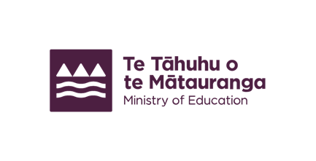
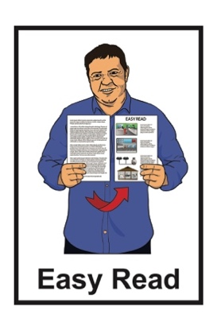

Support with education for children who are Deaf or hard of hearing
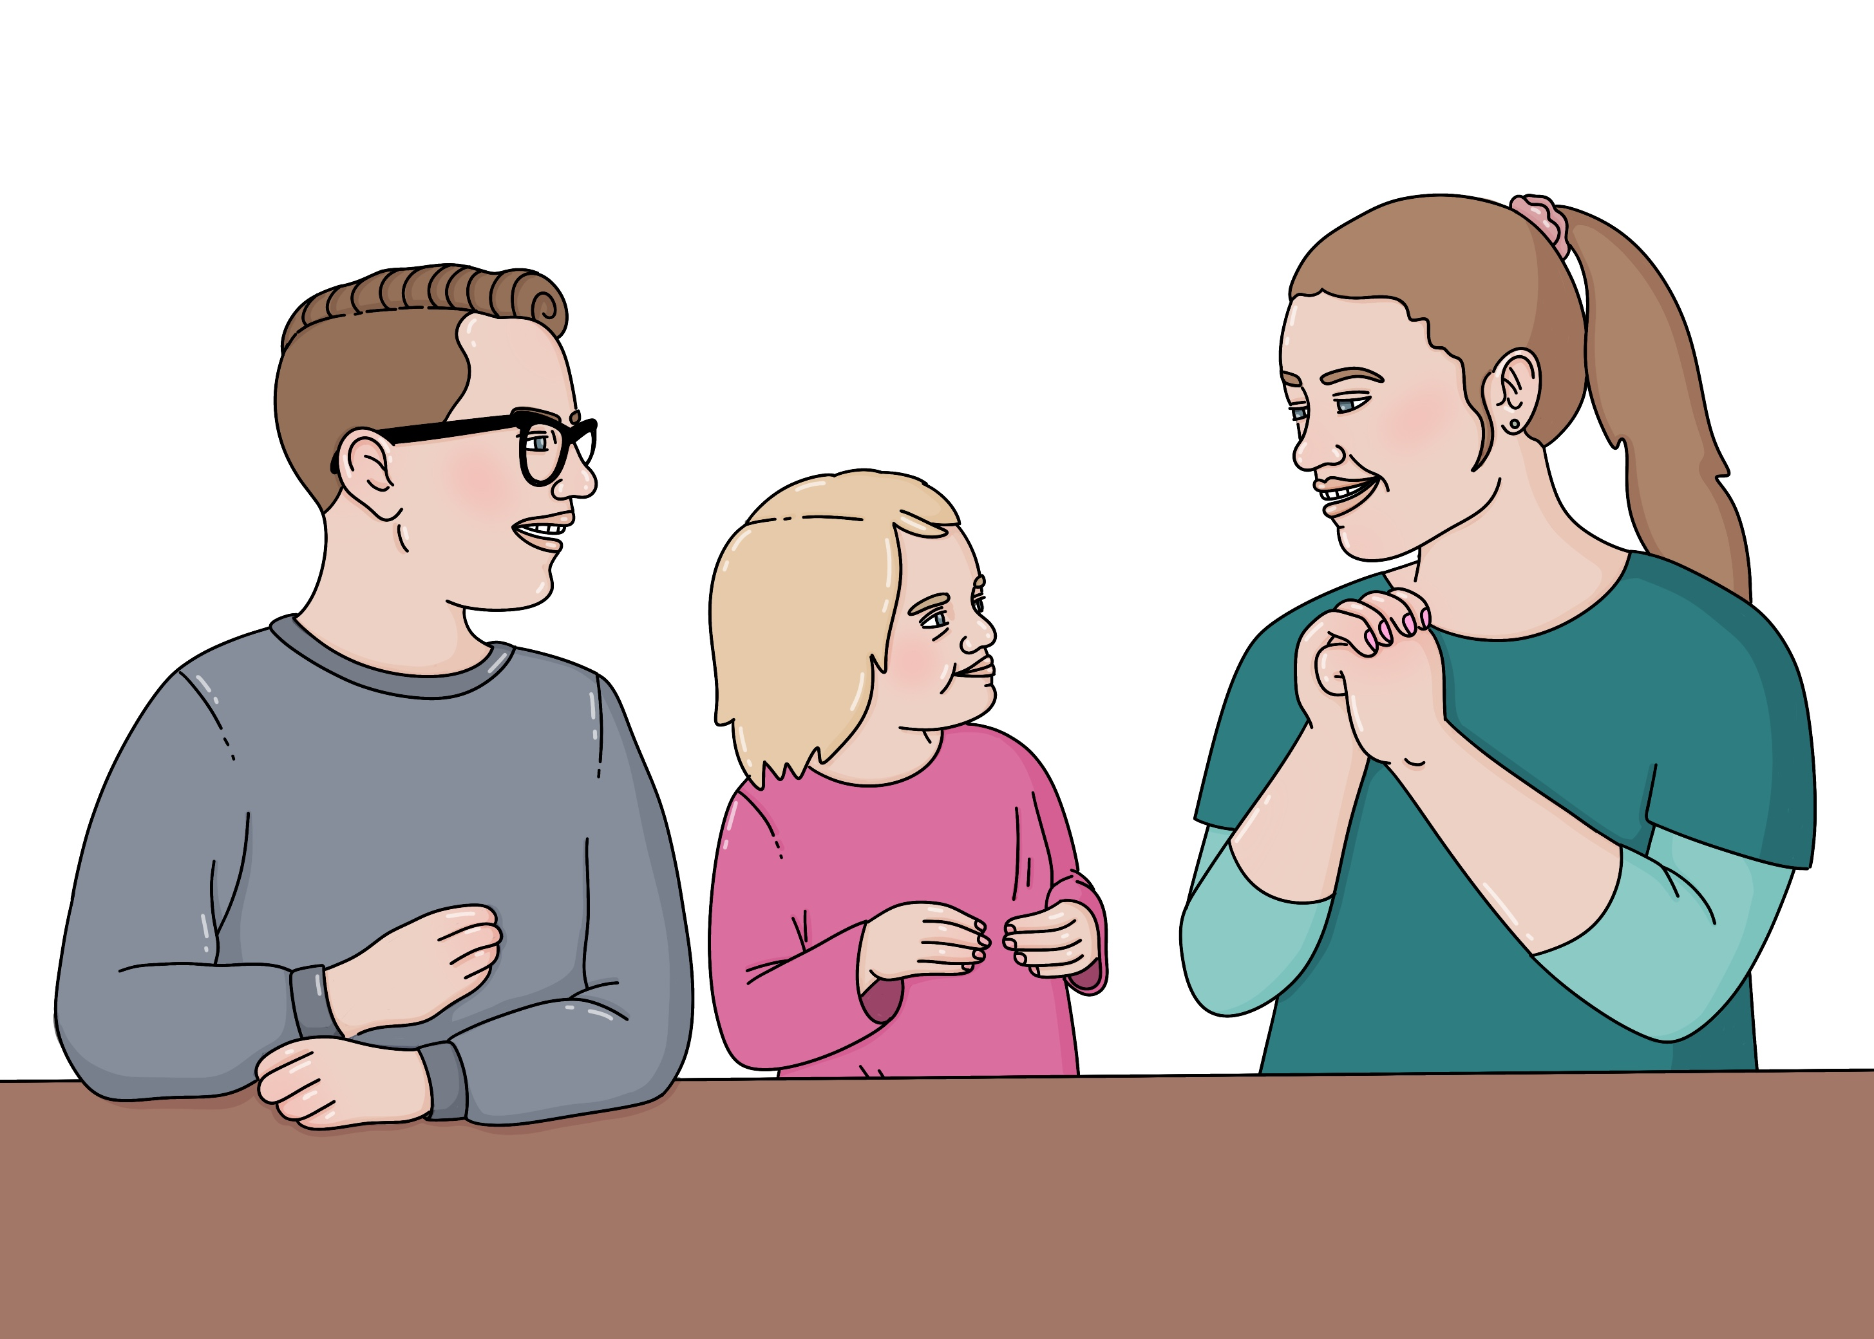

Published: September 2025

About this Easy Read

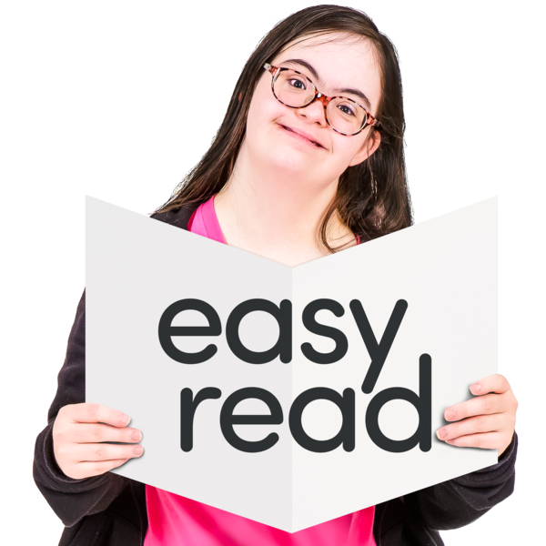
This Easy Read is about the support children can get at school if they are:
Deaf
hard of hearing.

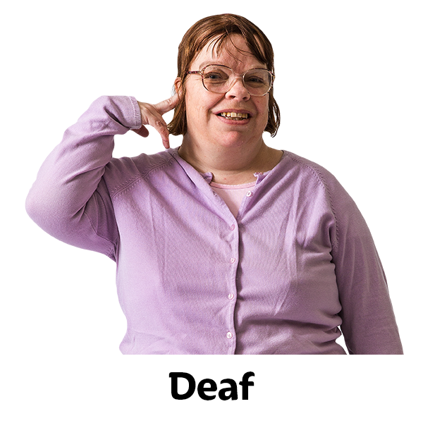
Being Deaf / hard of hearing means you have hearing loss.

Hearing loss means you cannot hear as much as other people.

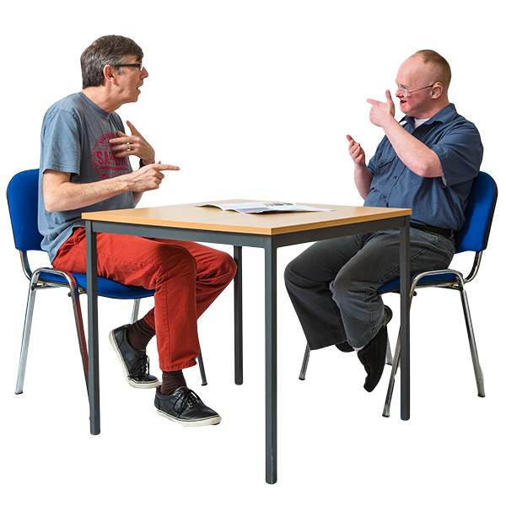
Being Deaf / hard of hearing means your hearing loss lasts:
a long time
forever.
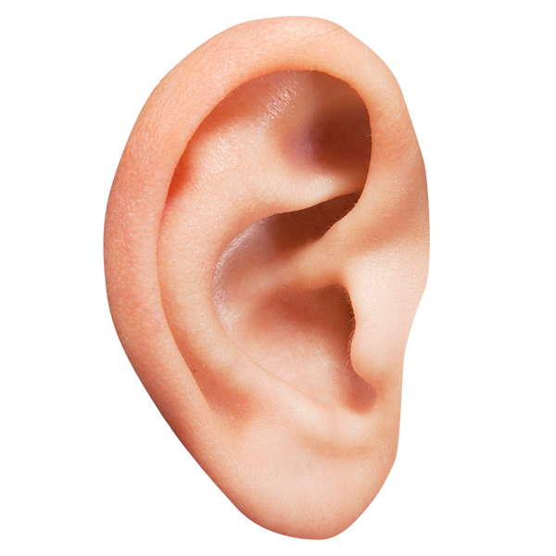

Being Deaf / hard of hearing also includes people who have auditory neuropathy disorder.

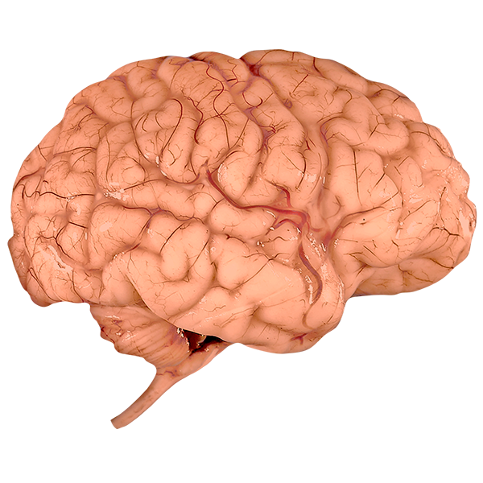

Auditory neuropathy disorder is when:
your ears can hear sound
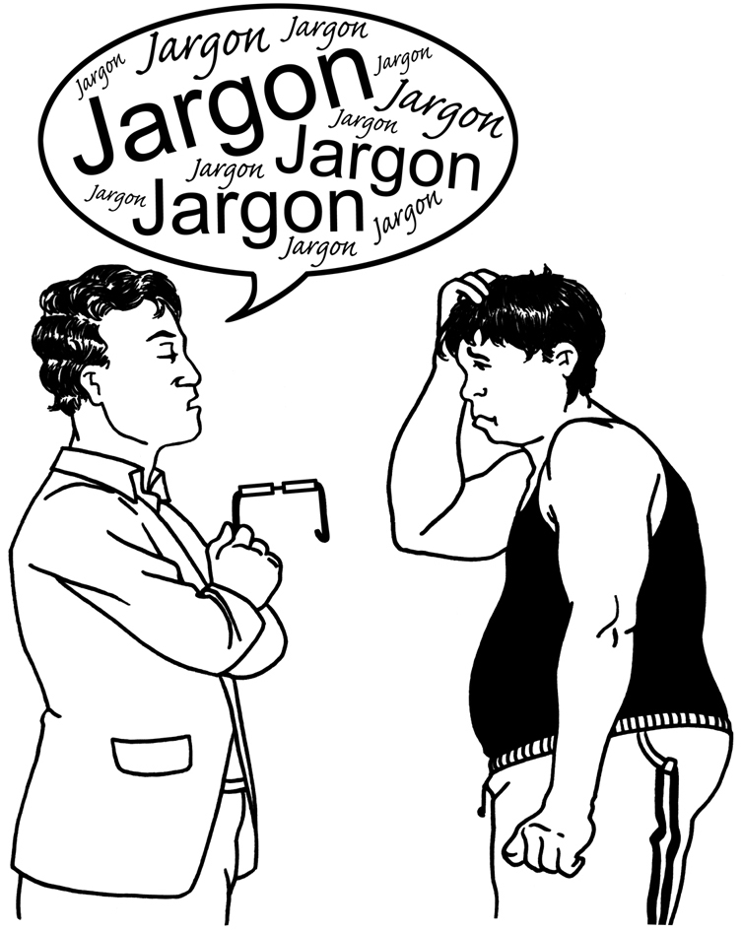
the messages from your ears do not get to your brain.

This can make it hard to understand other people when they talk to you.


People can be Deaf / hard of hearing in:
1 ear
both ears.

This Easy Read is from the Ministry of Education.

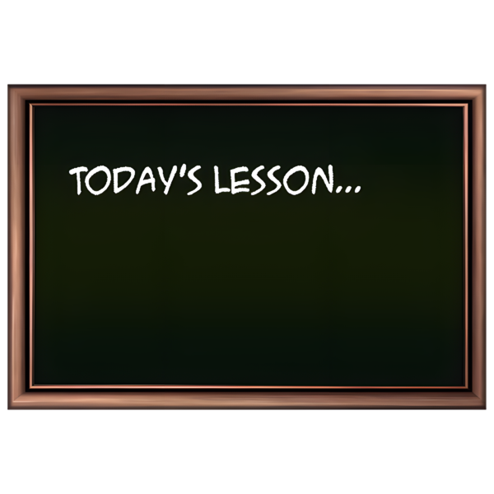
The Ministry of Education is the part of the Government in charge of schools in Aotearoa New Zealand.

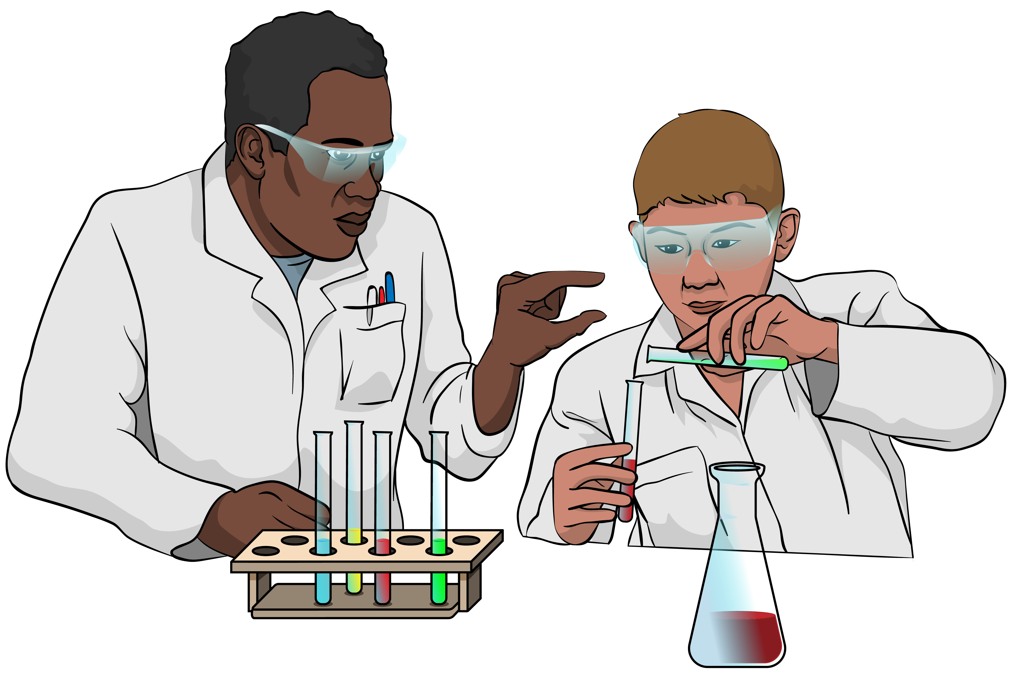
The Ministry of Education does
things like:
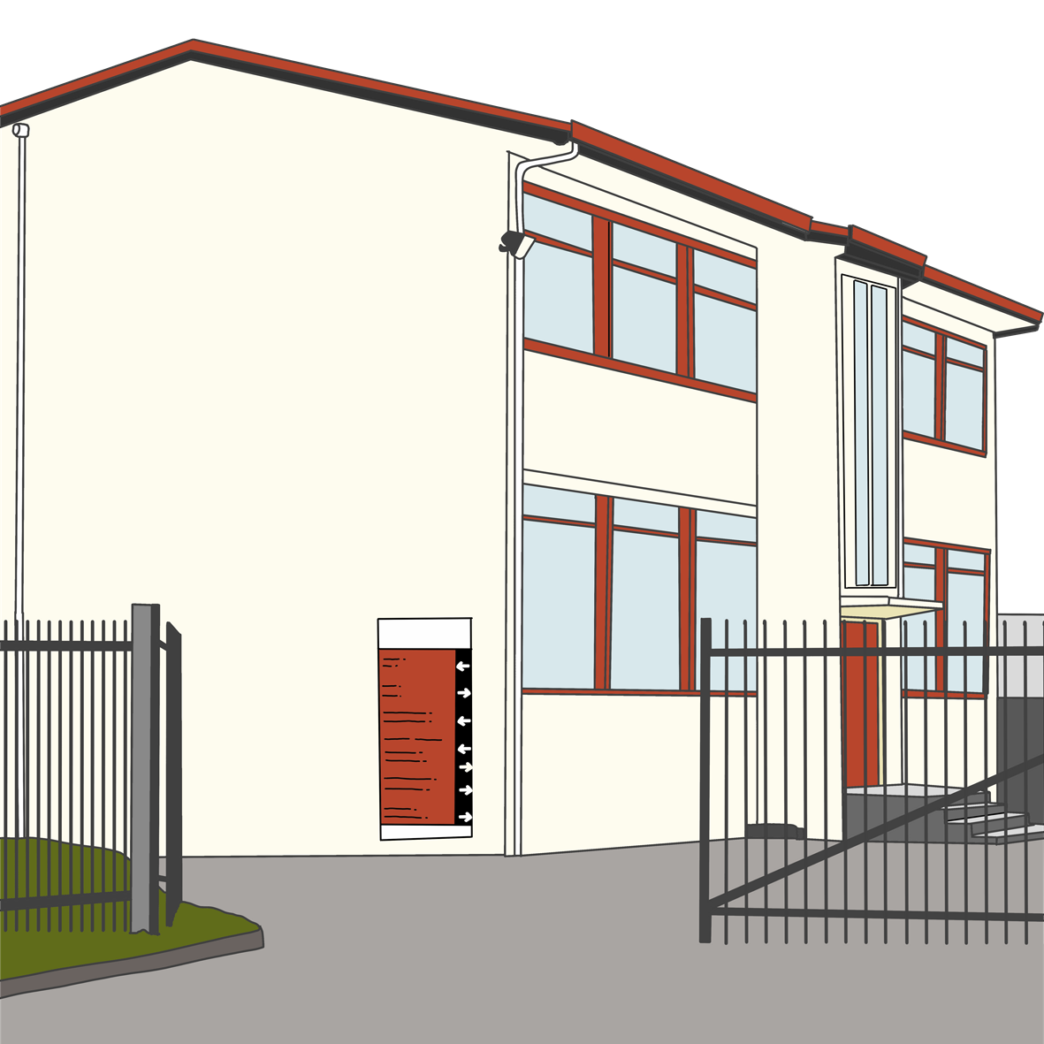
deciding what schools should teach
supporting children who need extra support with their learning
building new classrooms.

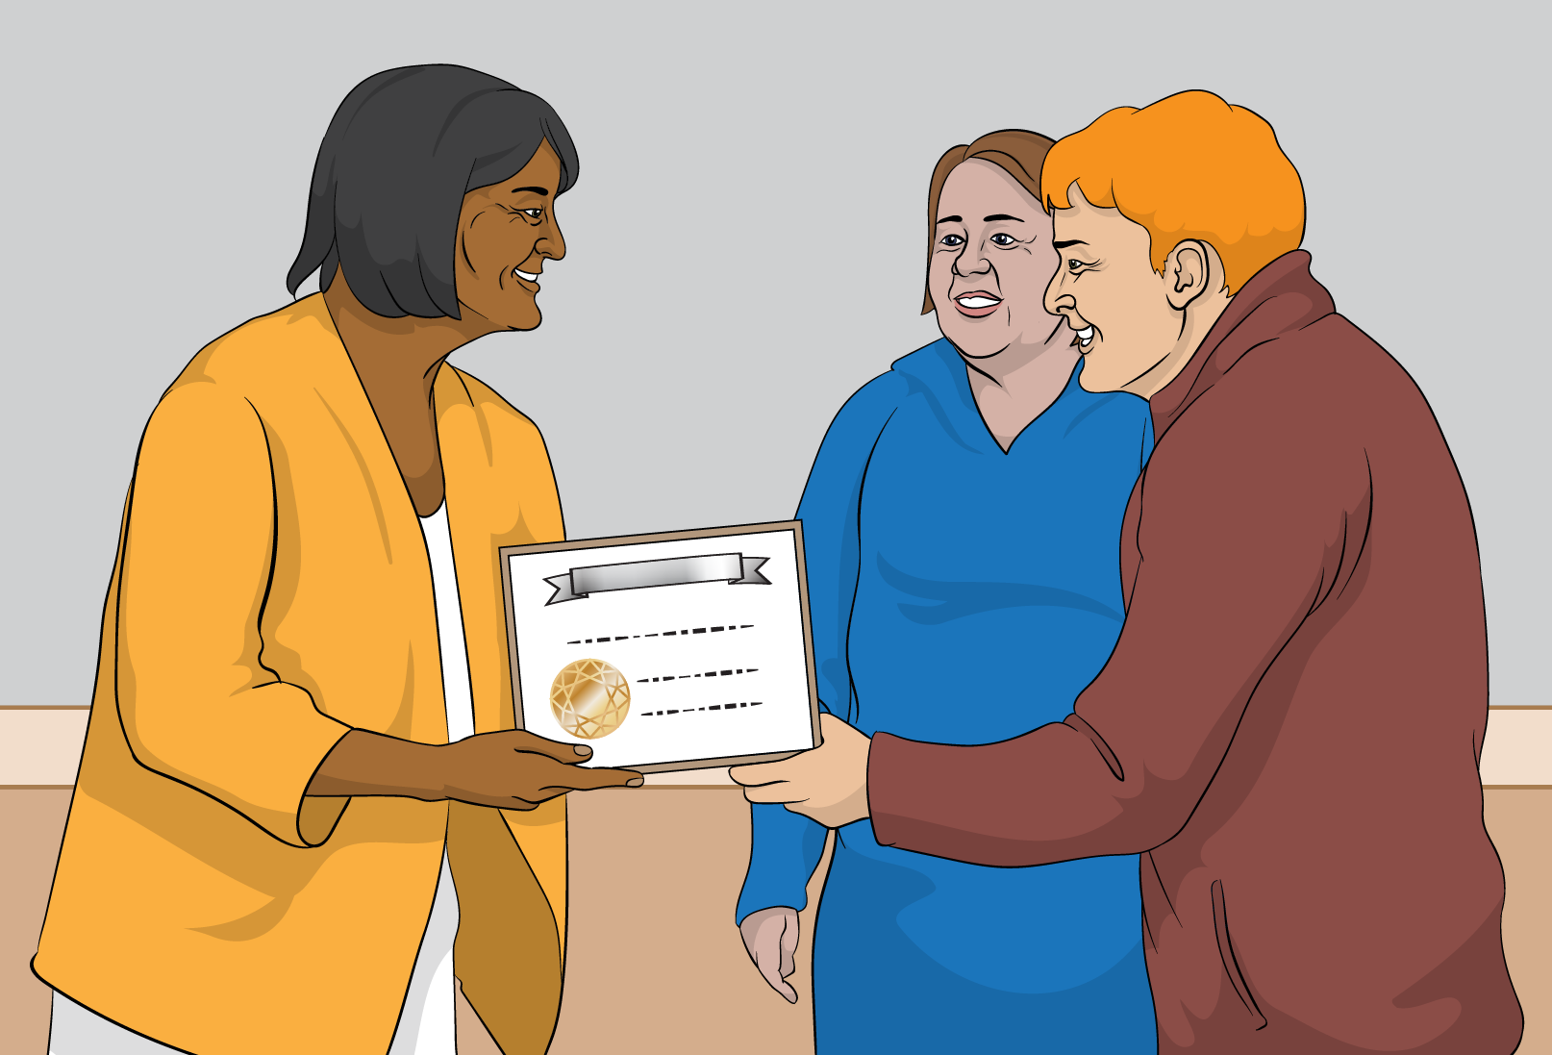
Children who are Deaf / hard of hearing can get support until they leave school.

Working out if a child needs support

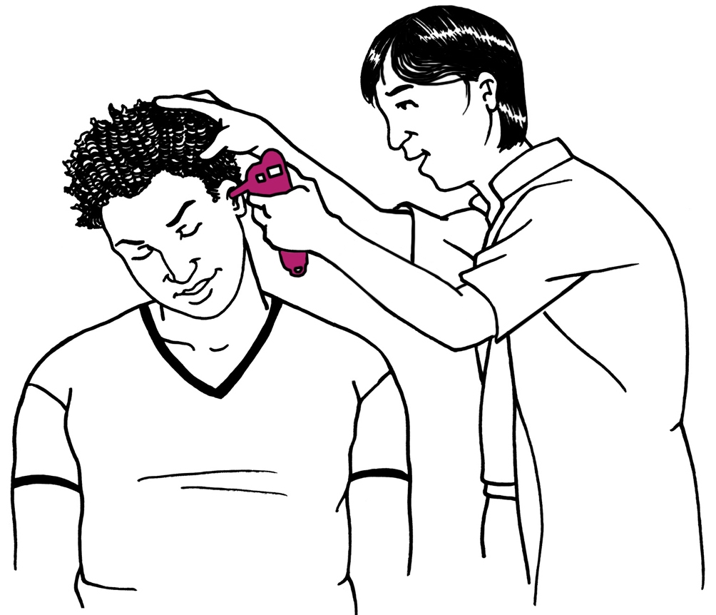
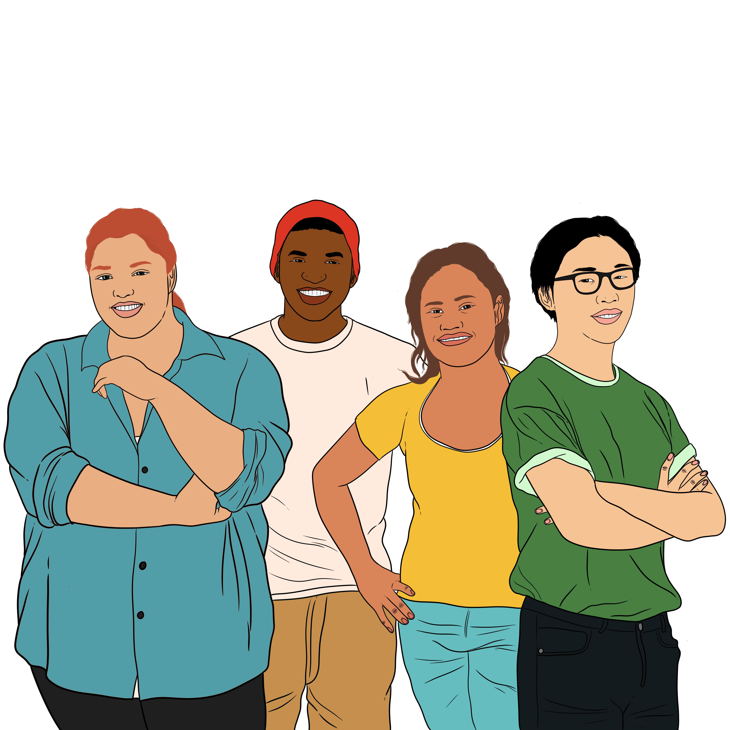
The Ministry of Education provides support to work out if a child has hearing loss.

Your child can get this support until they leave school.

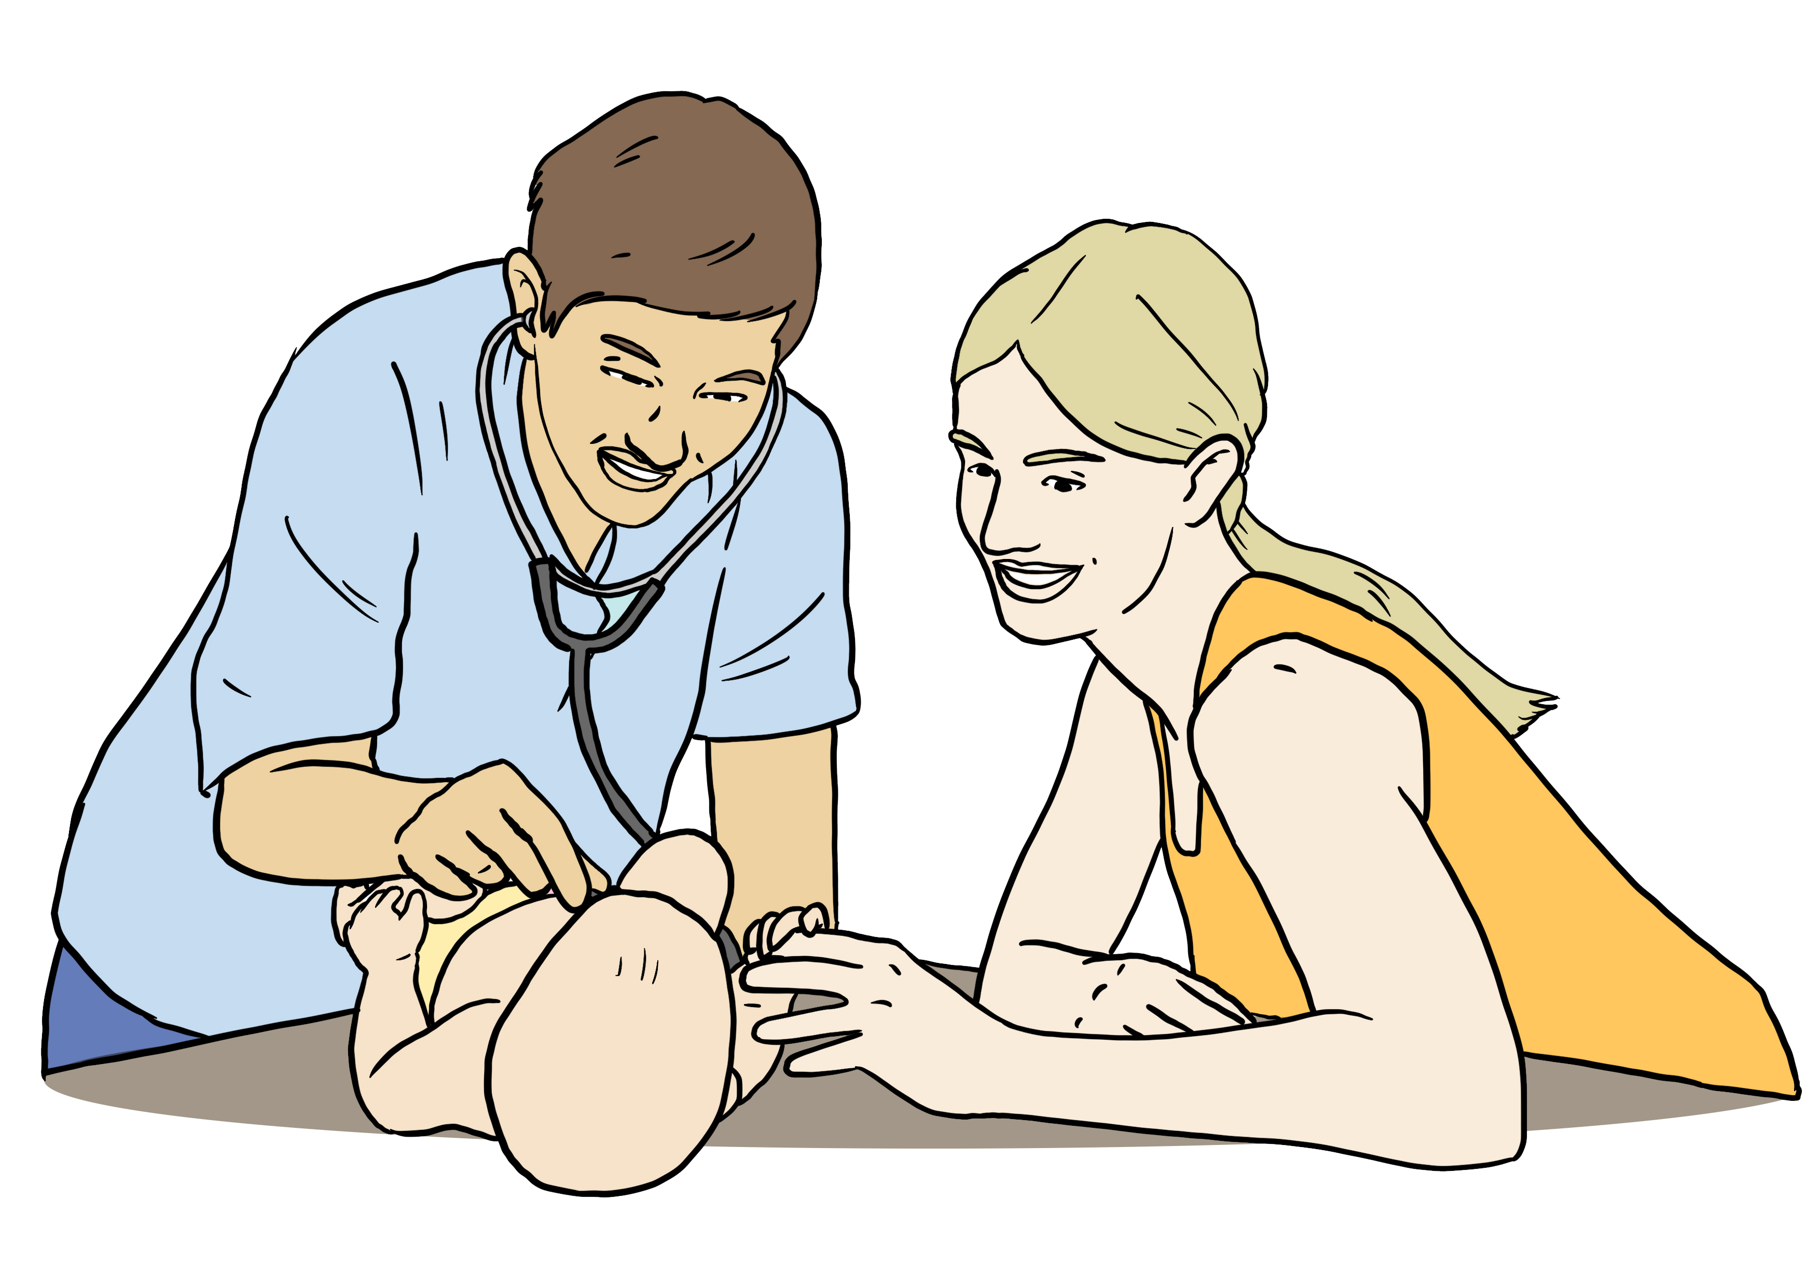
All babies can get a hearing screening check soon after they are born.
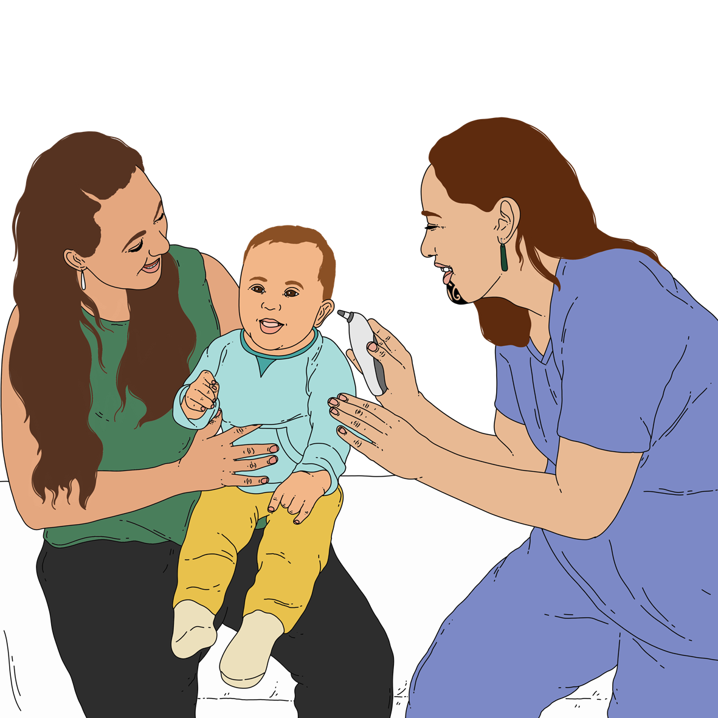

A hearing screening check is a test that checks how well someone can hear.

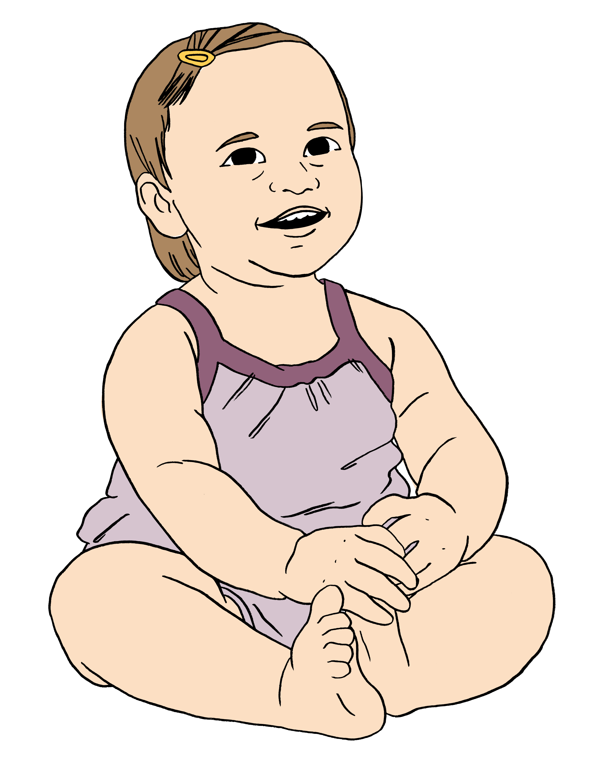
Doing hearing screening checks on babies means we can work out who needs support with hearing early.

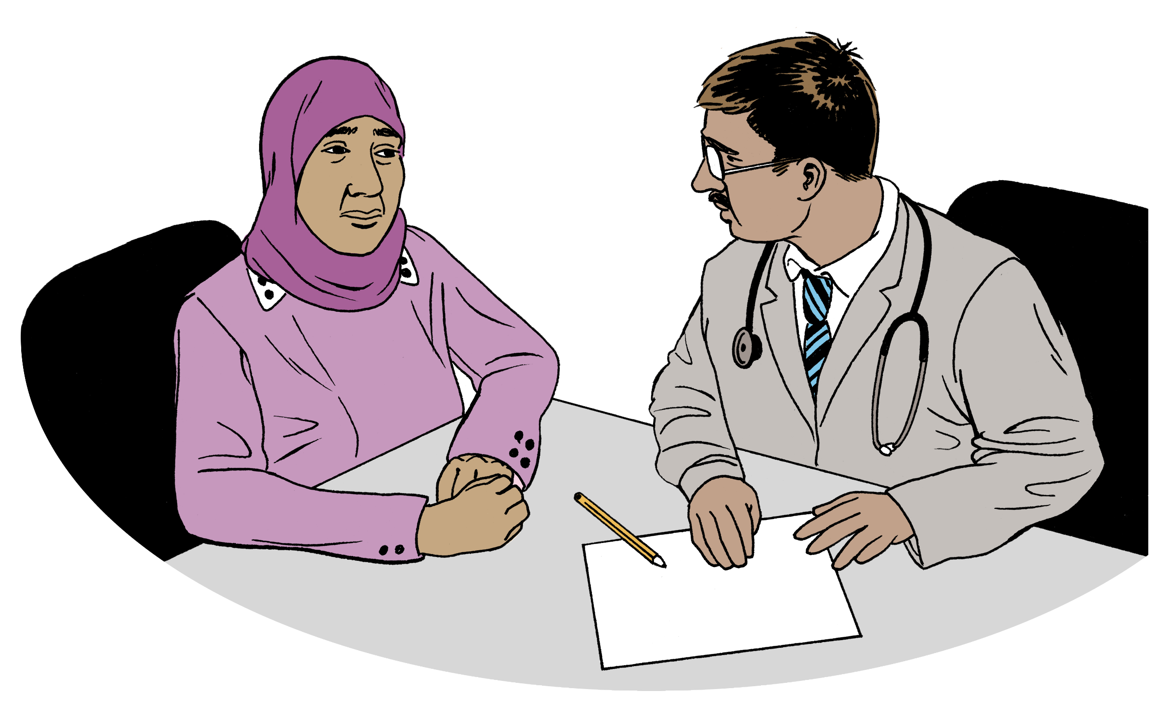
Talk to your doctor if:
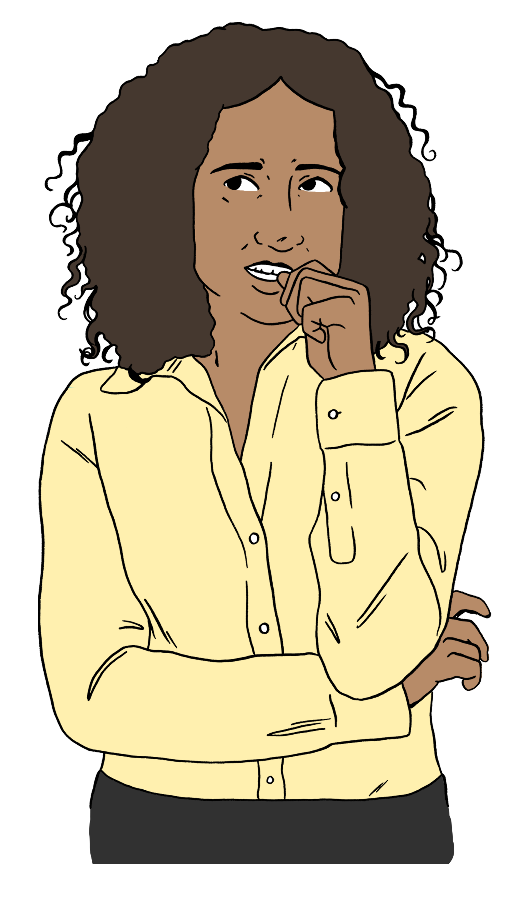
your child did not have a hearing screening check when they were a baby
you are worried about their hearing.


The Ministry of Education will work with you to support your child when the hearing screening check shows they are Deaf / hard of hearing.
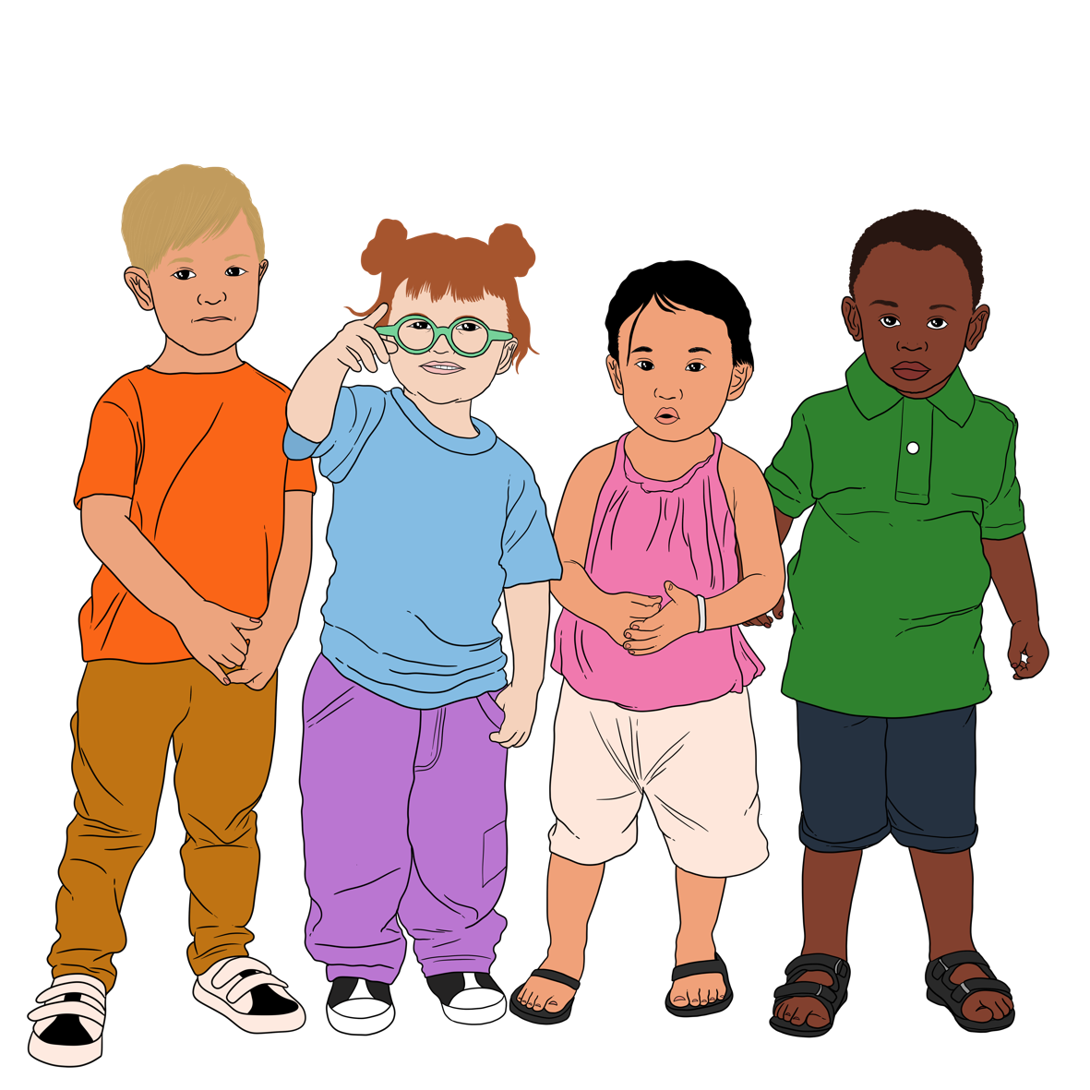

The hearing screening check is free when your child is 6 weeks to 5 years old.

It is done by a Well Child Tamariki Ora service like Plunket.


You can find out more on this website:

https://tinyurl.com/49advnfj

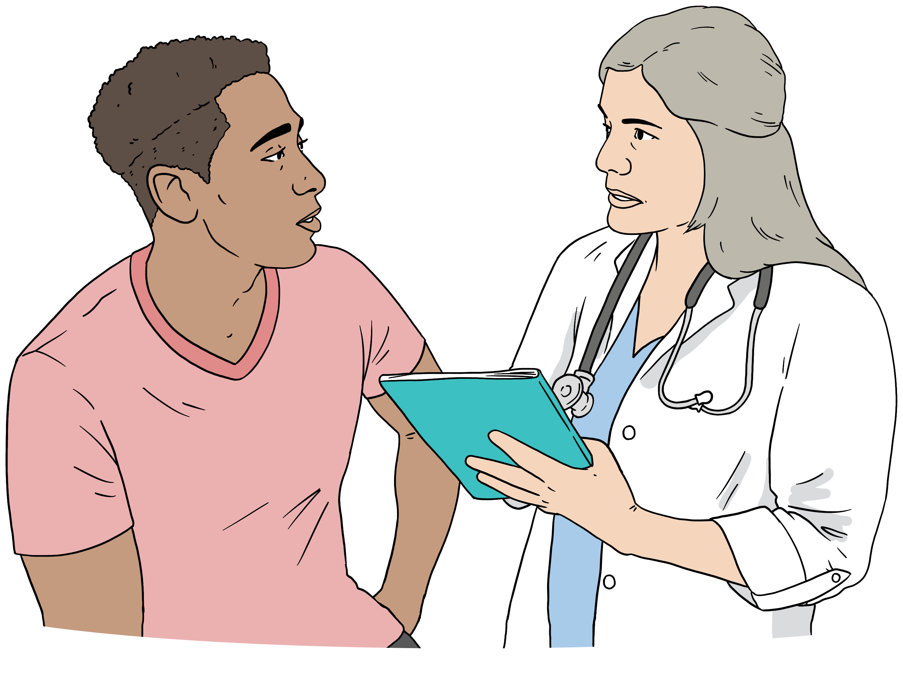
Talk to your doctor about how to get a hearing screening check if your child is over 5 years old.

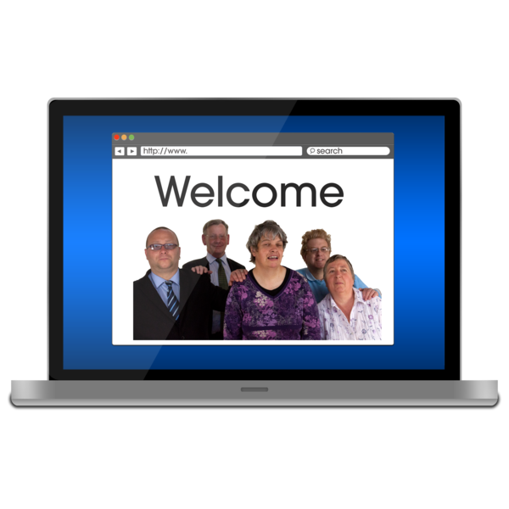
You can find out more on this website:

https://tinyurl.com/4b2vvnbx
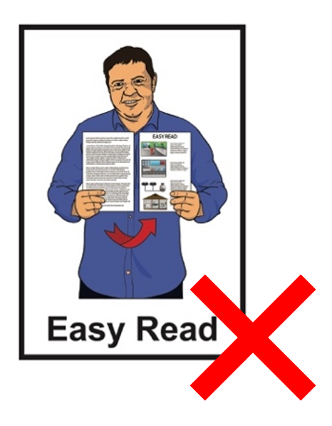

The websites in this section are not in Easy Read.

What support can my child get?

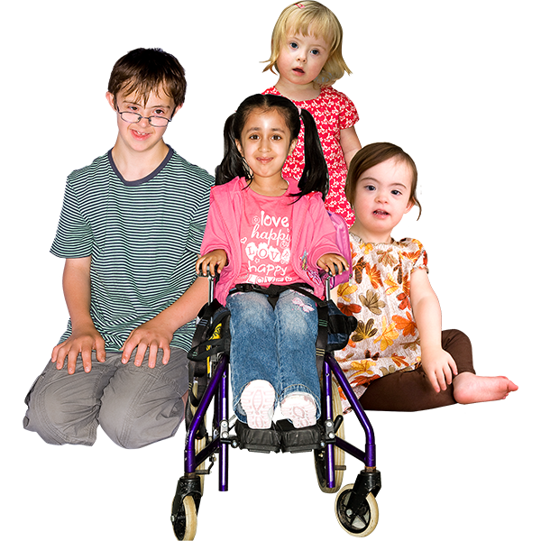
Different children have different needs.

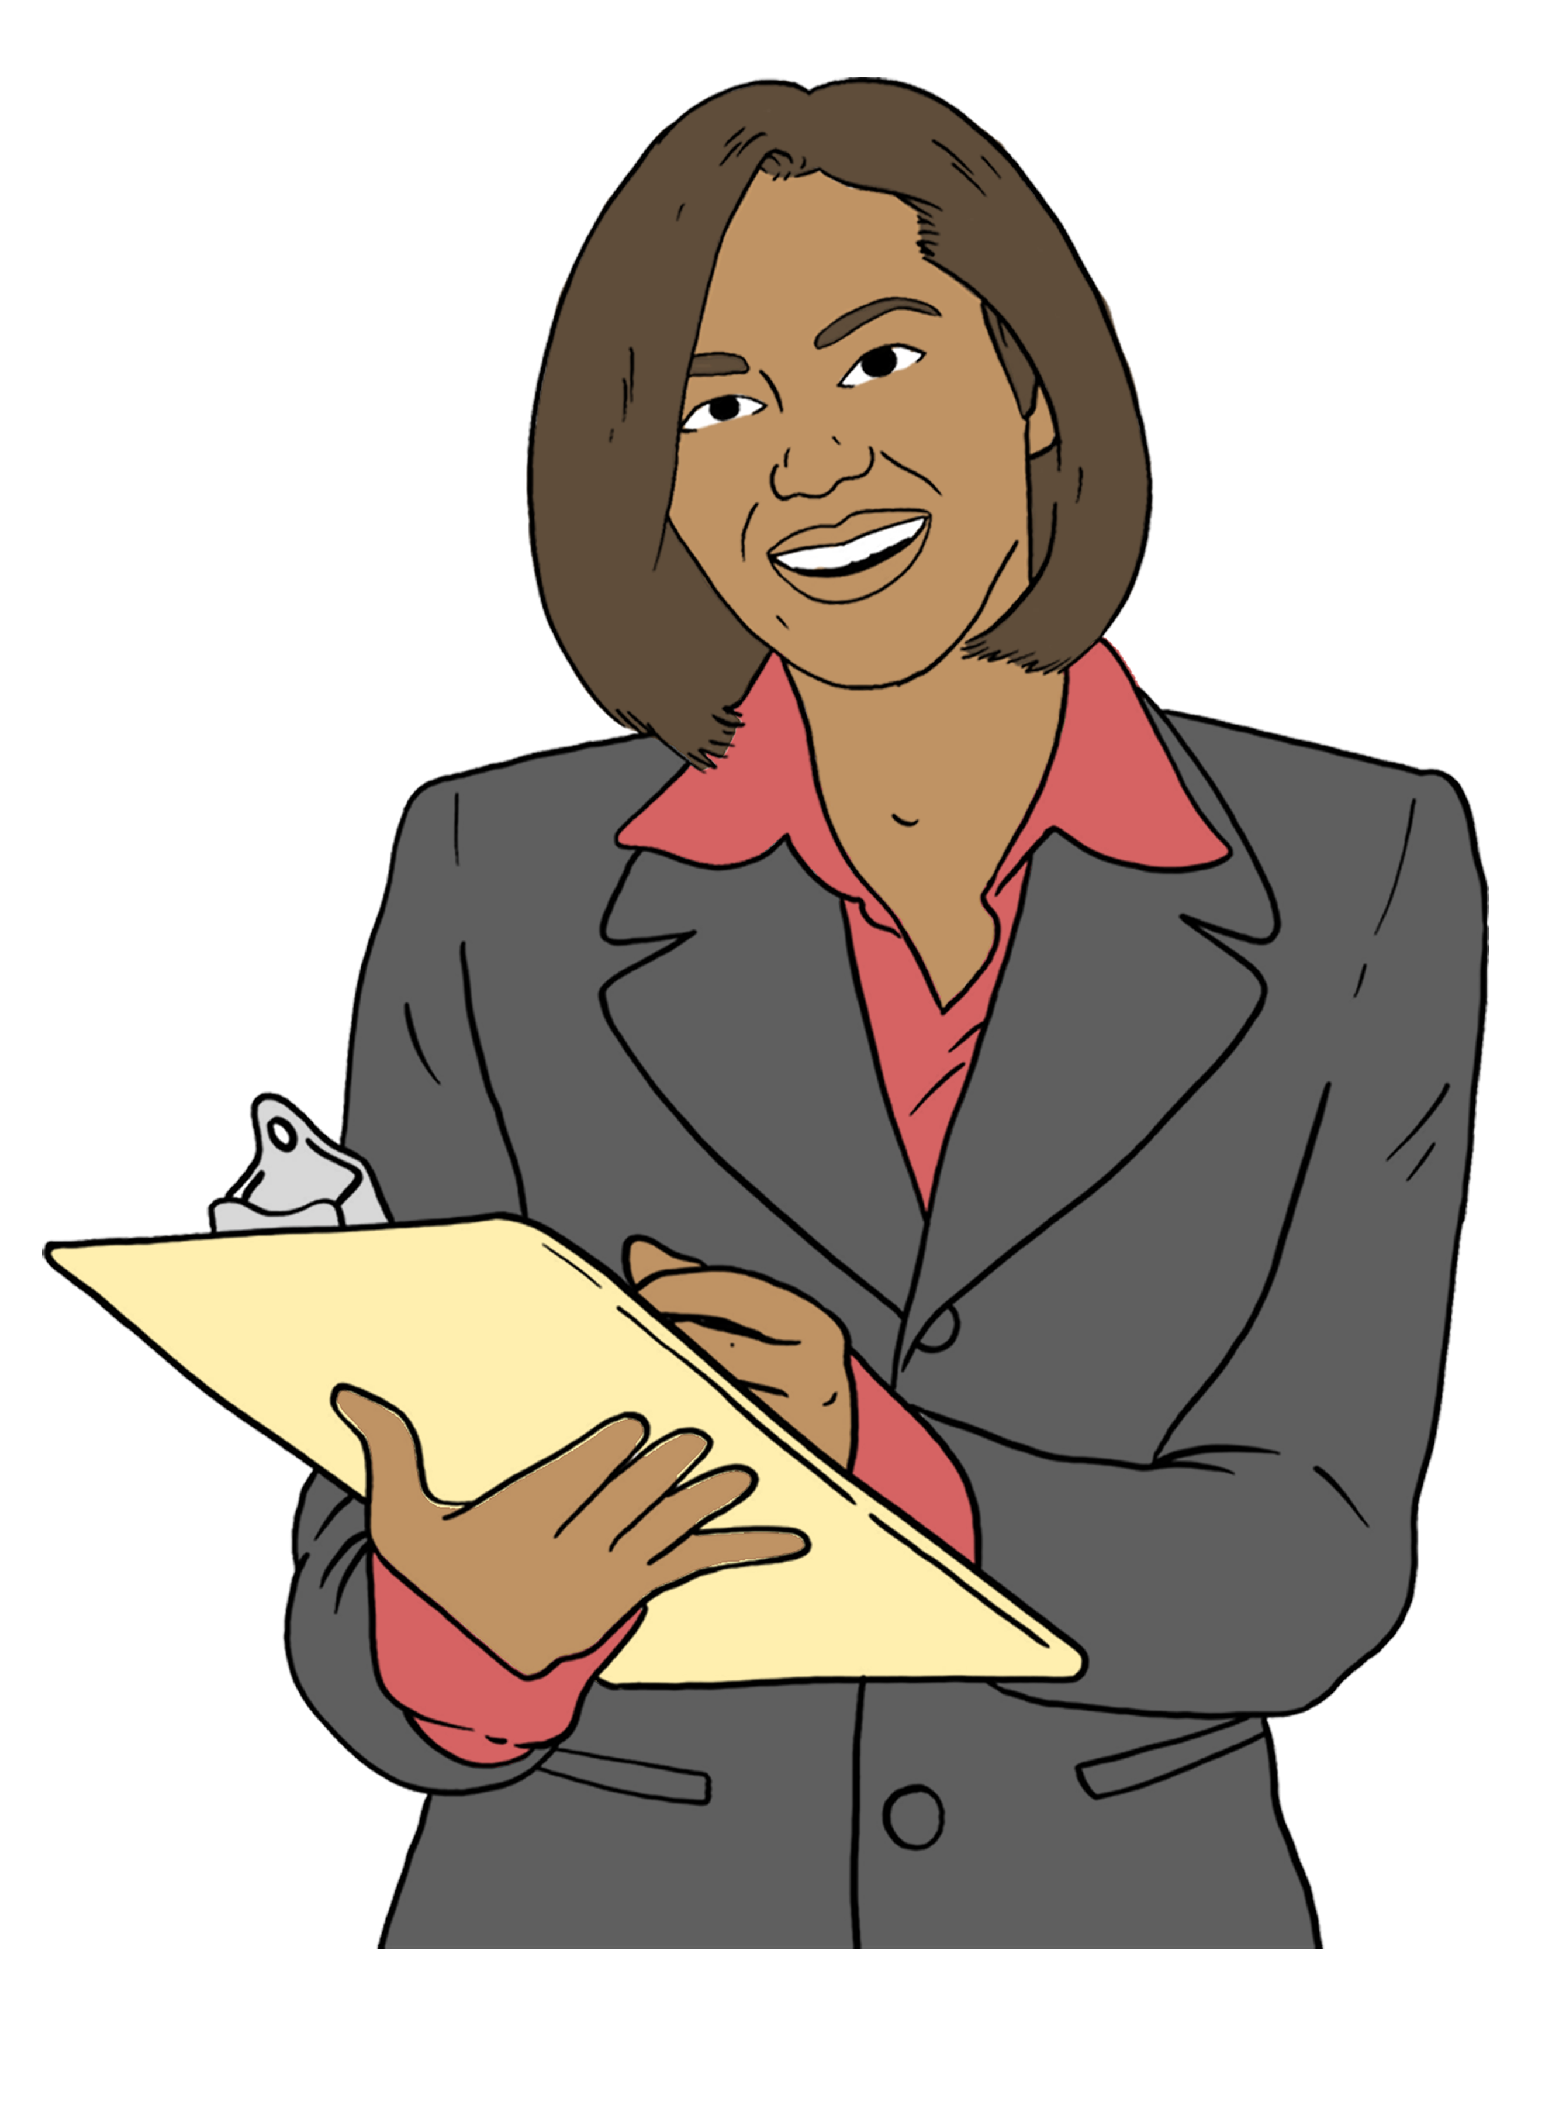
The Ministry of Education will make sure your child gets the support they need.

The Ministry of Education has Advisors on Deaf Children.
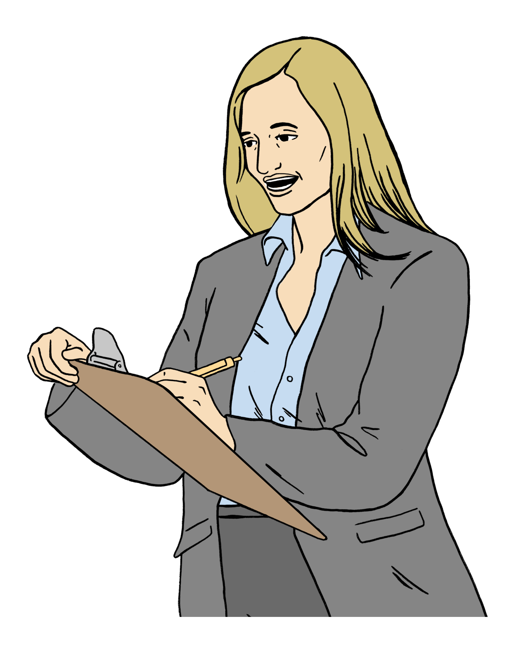

The Ministry of Education sometimes calls Advisors on Deaf Children AoDC for short.

AoDC work with:
children who are Deaf / hard of hearing
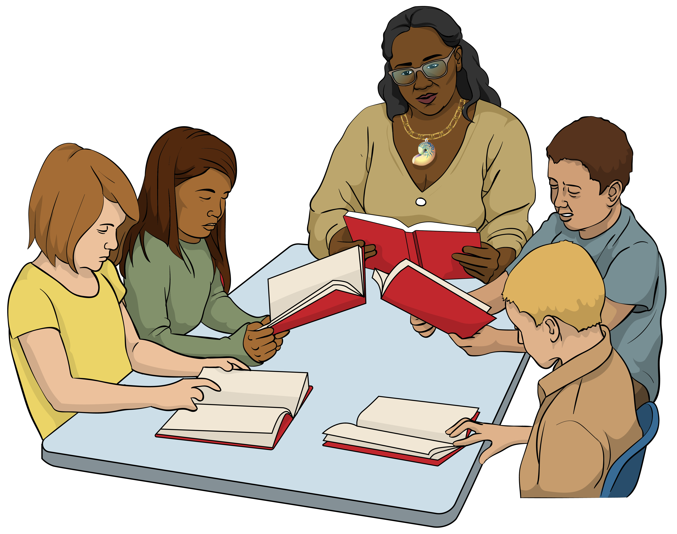
their whānau / families
their teachers.

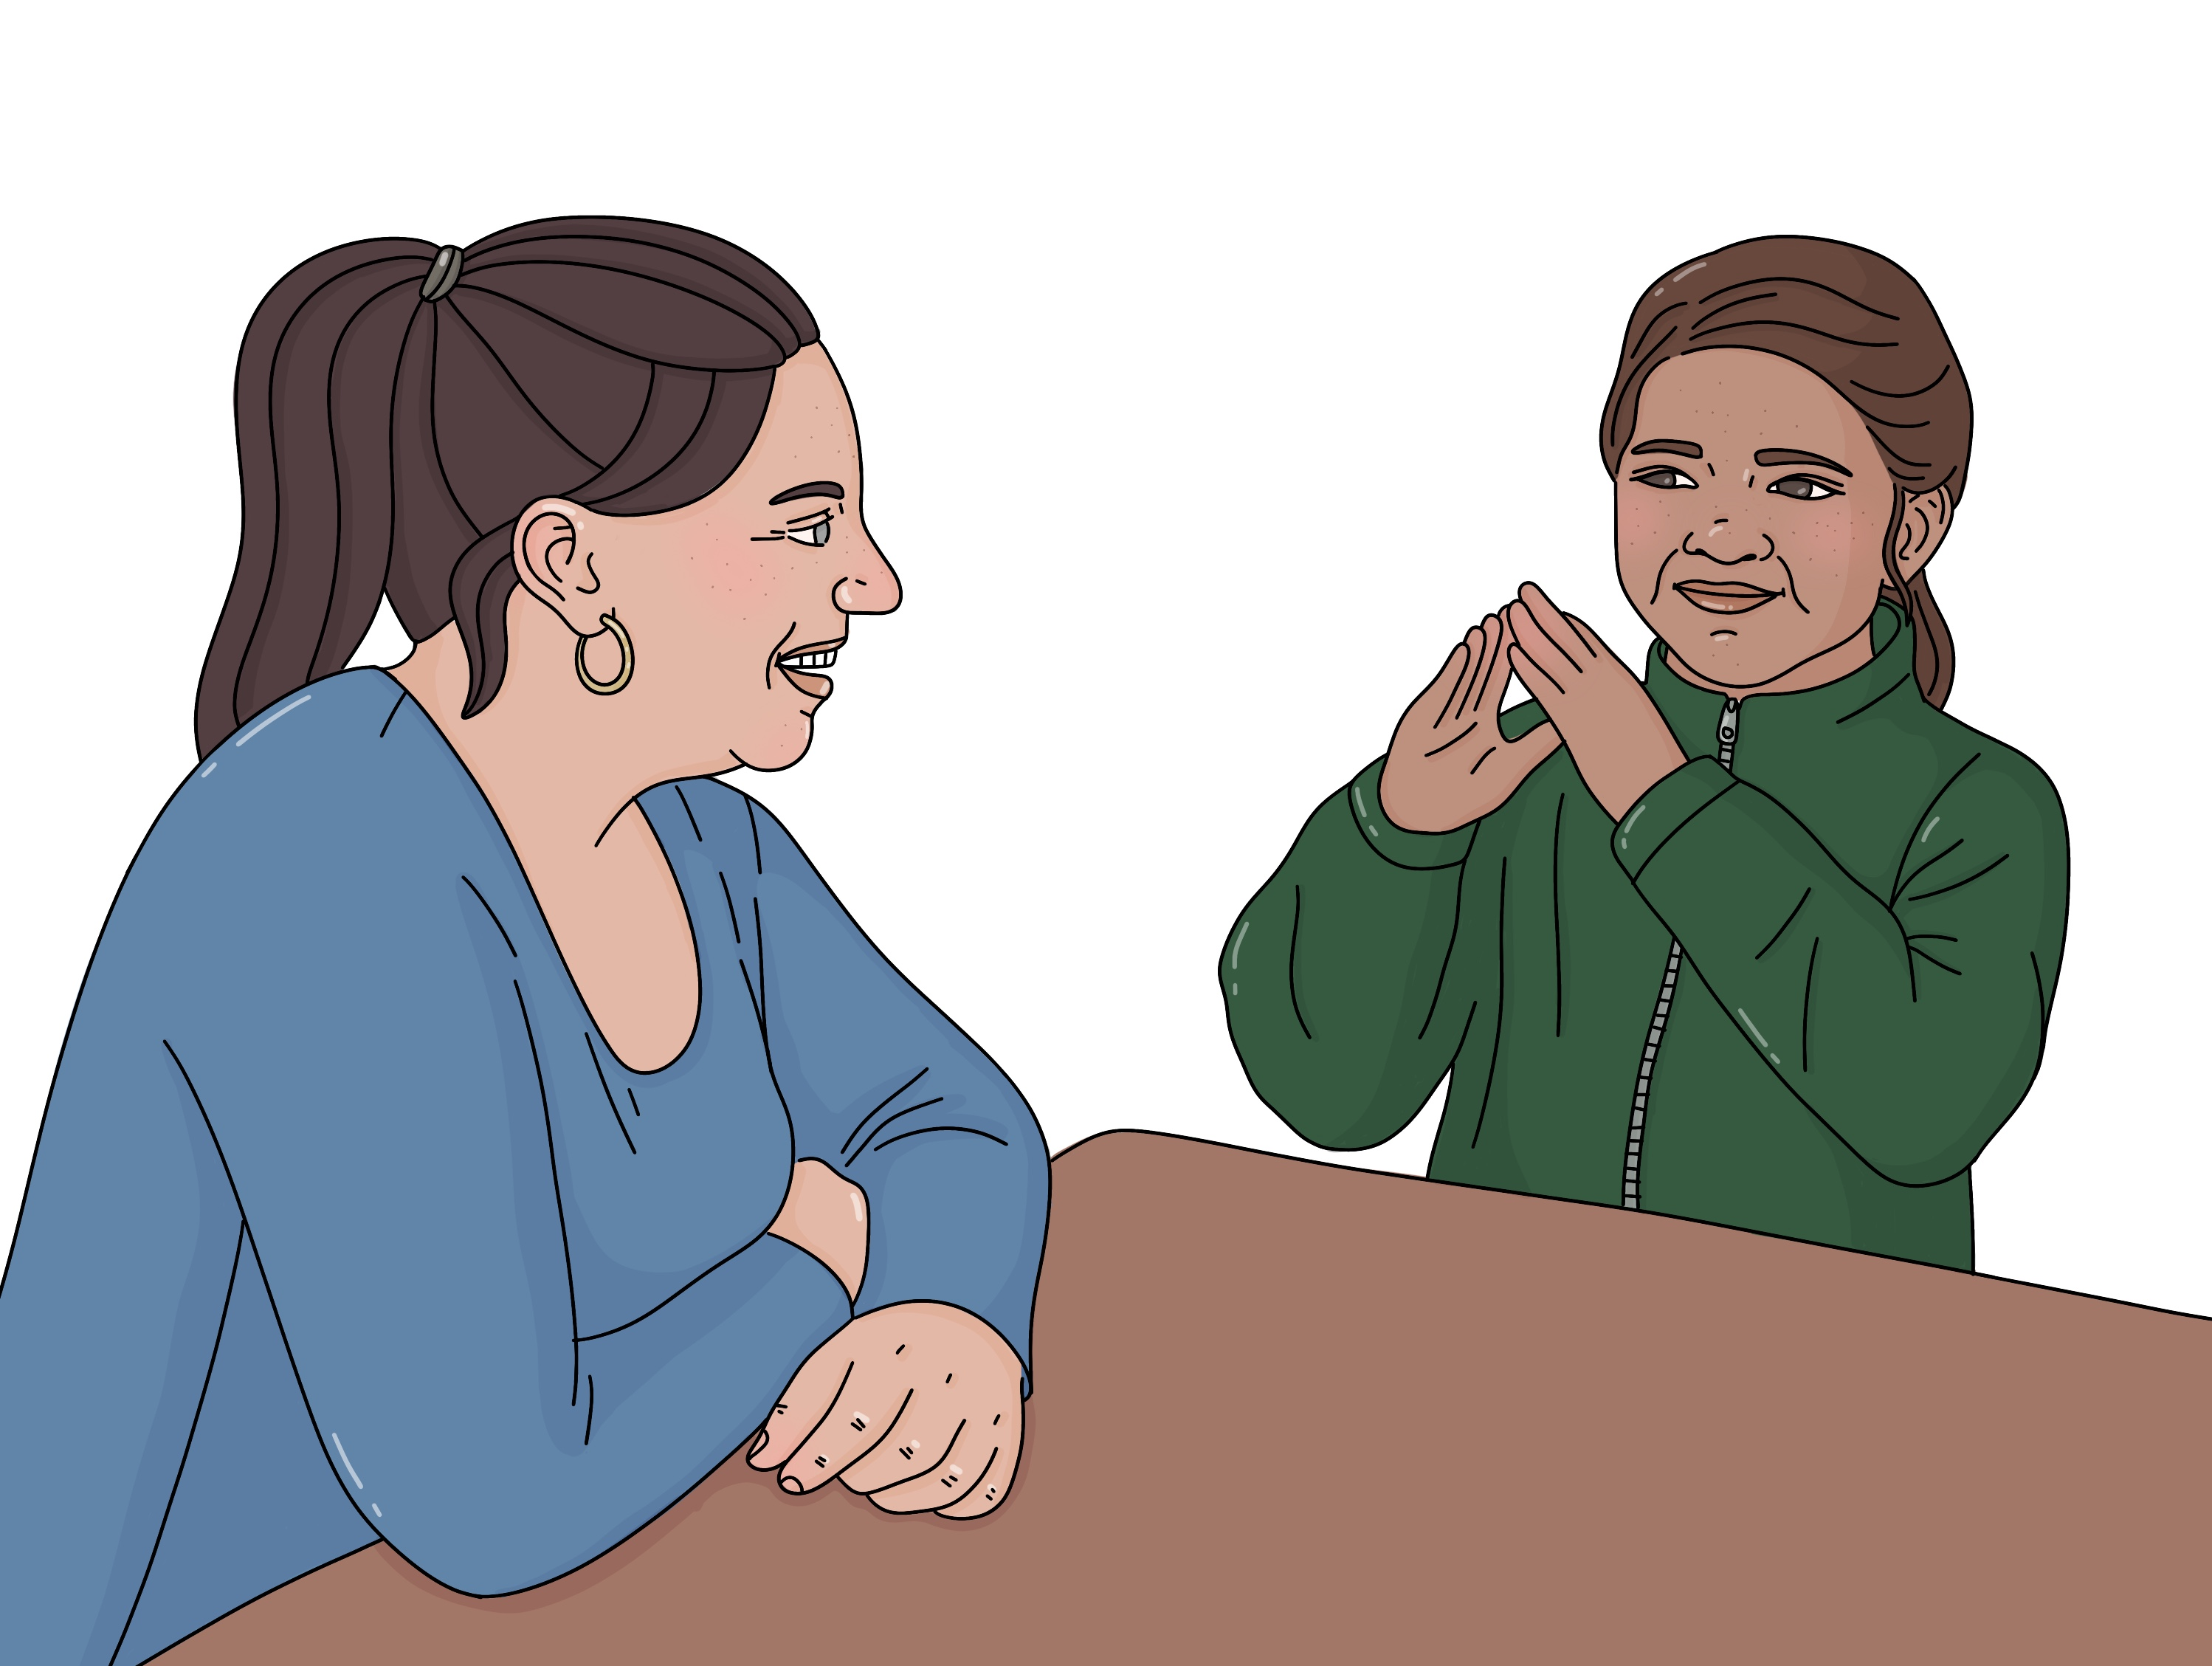
Advisors on Deaf Children will work out how to support your child with things like:
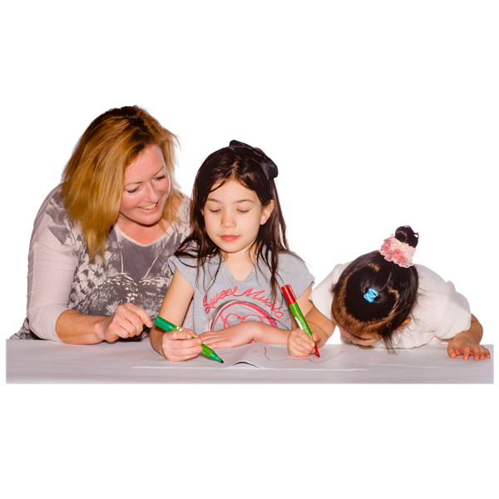
communicating
learning language
learning:
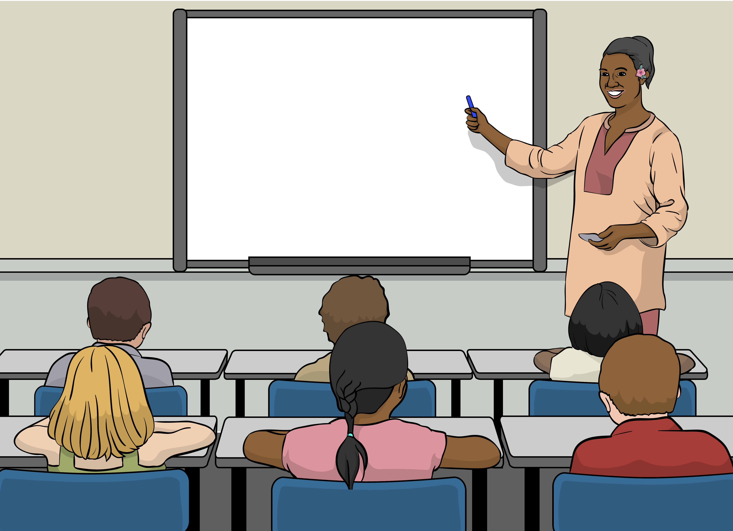
- in early childhood education
- at school.

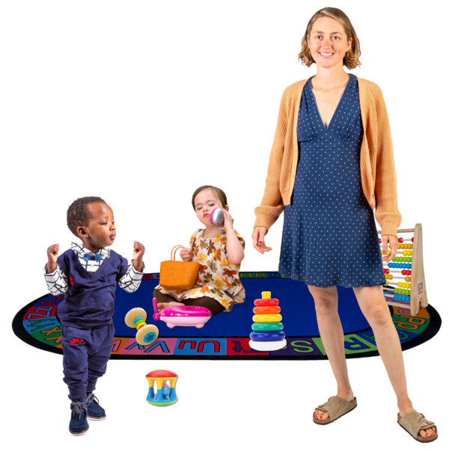
Early childhood education means places children go to learn before they start school like:
kindy
preschool.

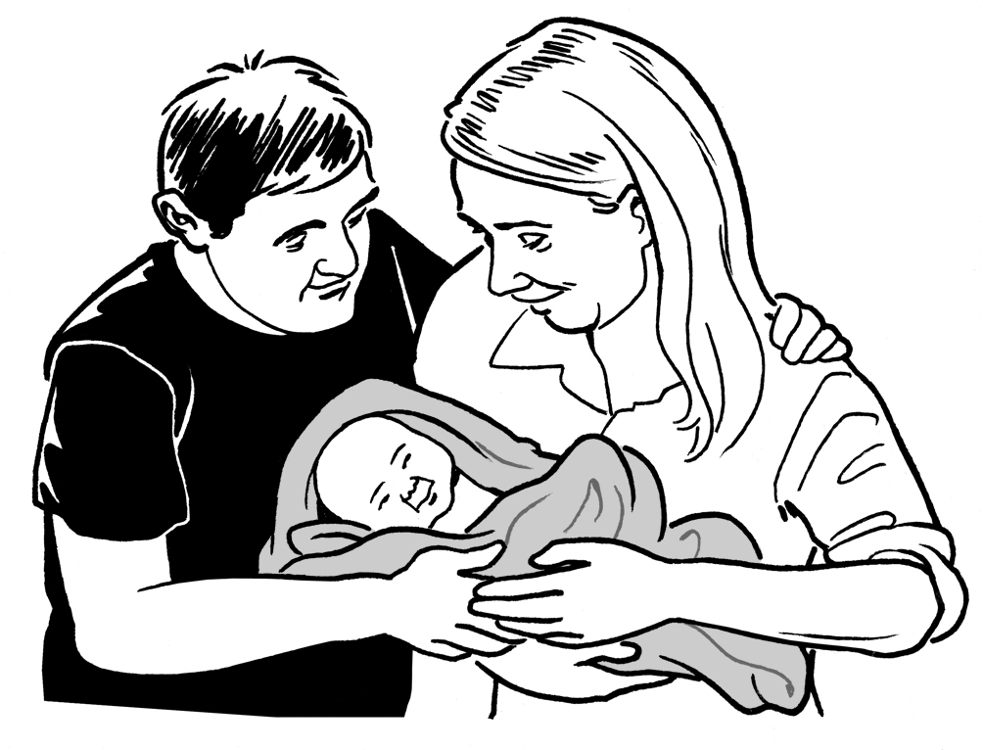
AoDC work with children who are Deaf / hard of hearing:
from when they are born
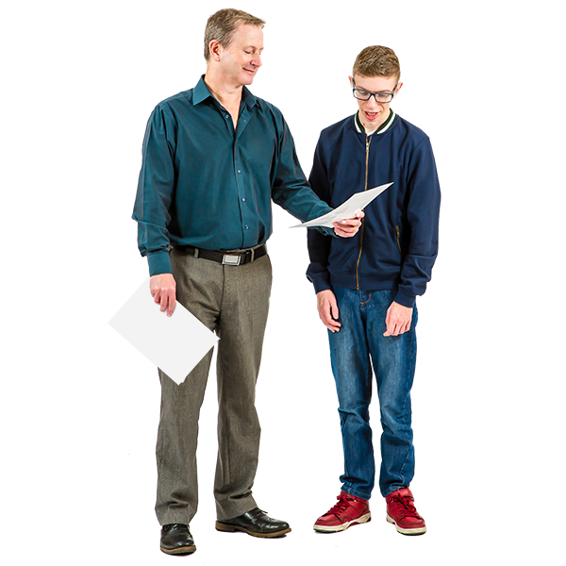
until they are in Year 3 at school.

AoDC can also work with older children.

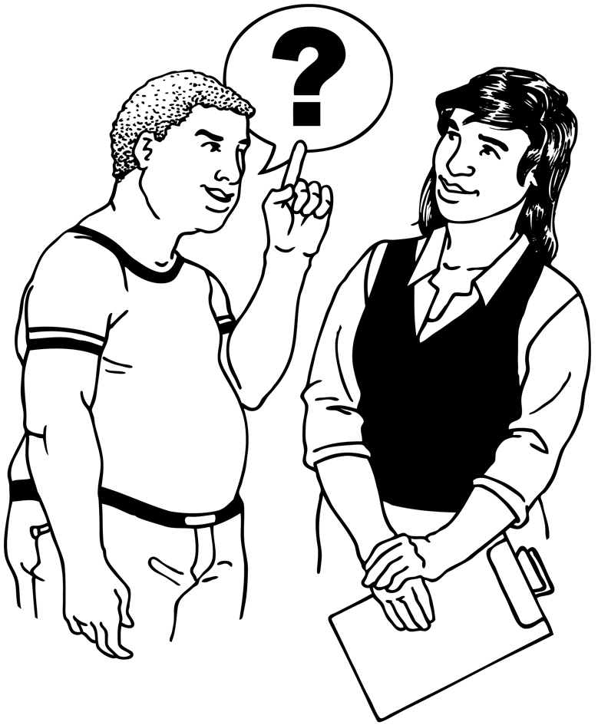
When your child starts early childhood education the AoDC might ask Ko Taku Reo | Deaf Education New Zealand for support.
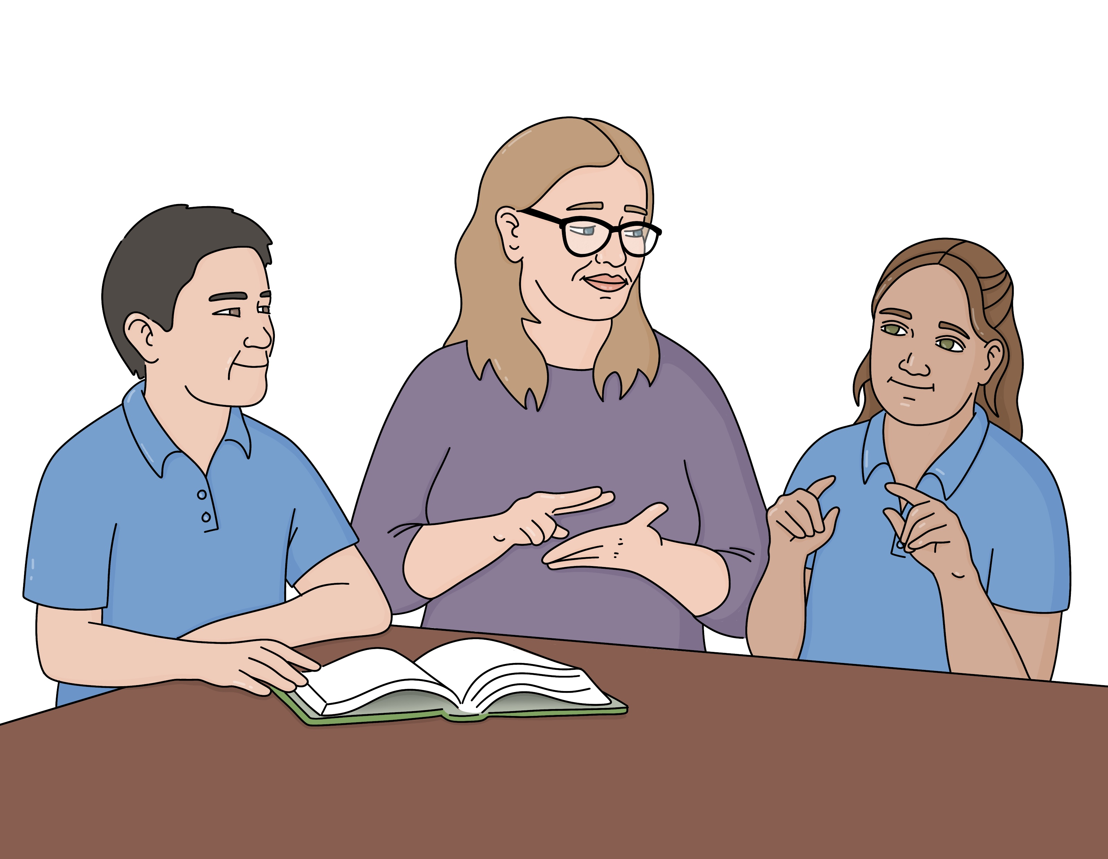
Ko Taku Reo | Deaf Education
New Zealand is in charge of supporting children who are Deaf / hard of hearing with learning.

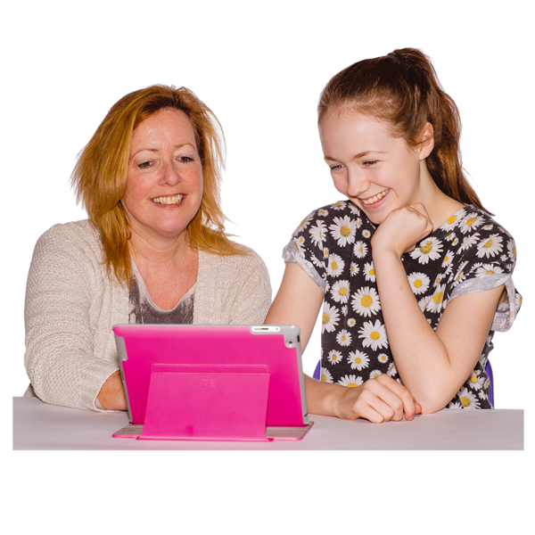
Ko Taku Reo | Deaf Education New Zealand provides support like:
Resource Teachers of the Deaf
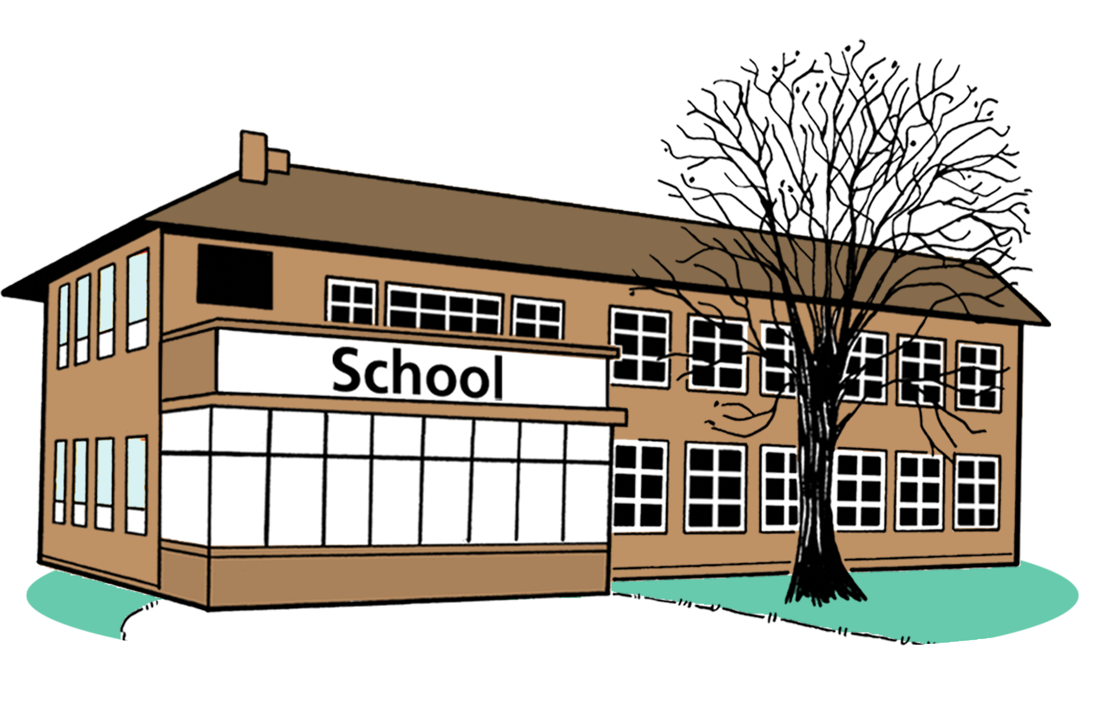
New Zealand Sign Language tutors
specialist schools.

Resource Teachers of the Deaf support children who:
are Deaf / hard of hearing
go to mainstream schools.

Here a mainstream school means a school that is not only for children who are Deaf / hard of hearing.
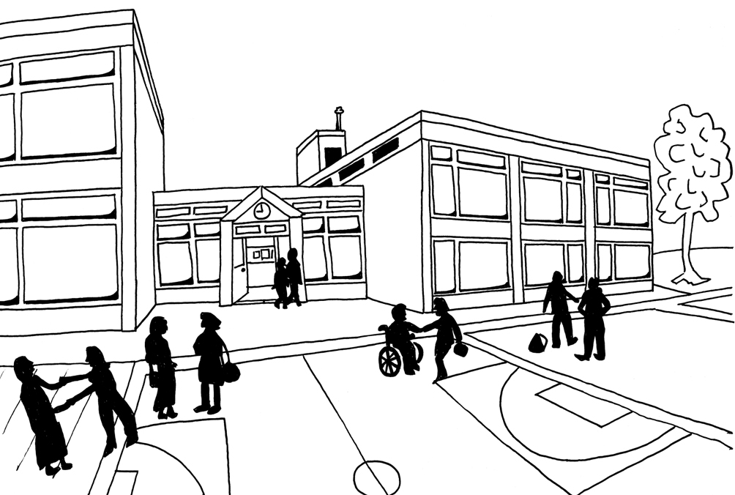

All children can go to a mainstream school.
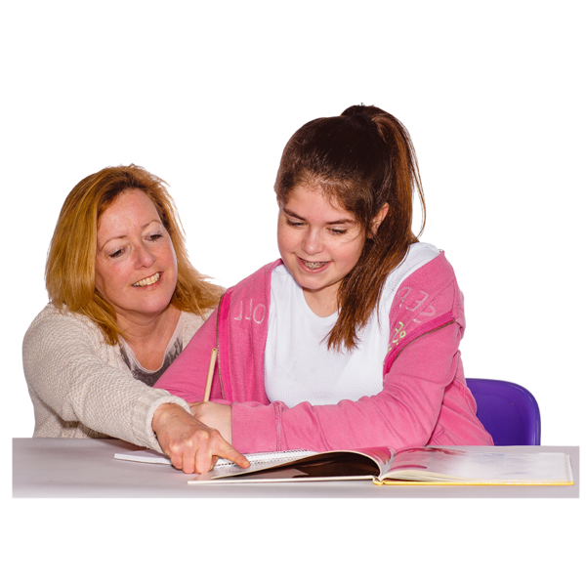

Resource Teachers of the Deaf can do things like:
teach your child
support the classroom teacher to teach your child.

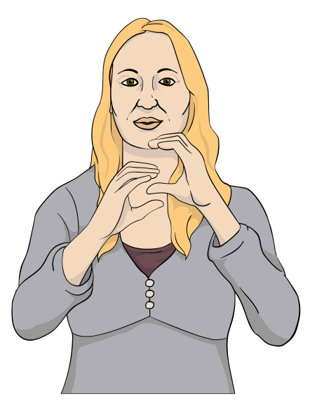
New Zealand Sign Language
tutors teach New Zealand Sign Language to Deaf children.

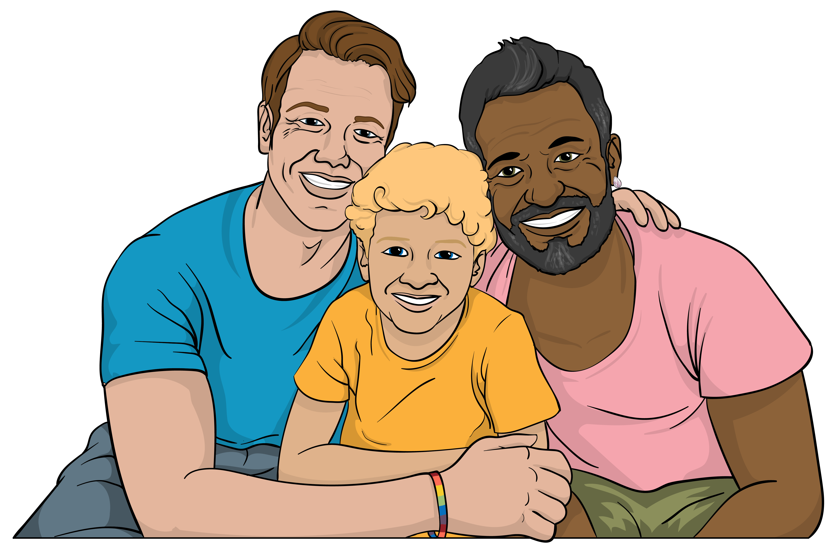
They also support:
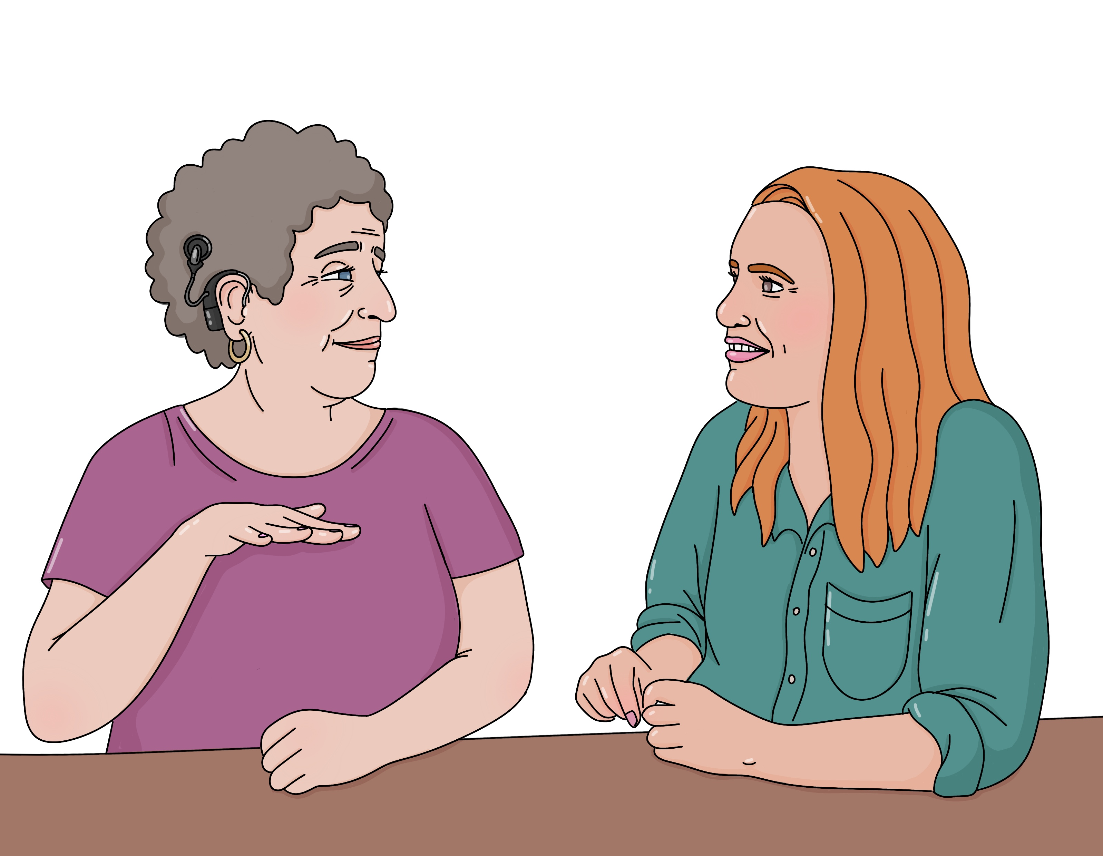
the whānau / families of Deaf children to get better at New Zealand Sign Language
teachers of Deaf children to get better at New Zealand Sign Language.

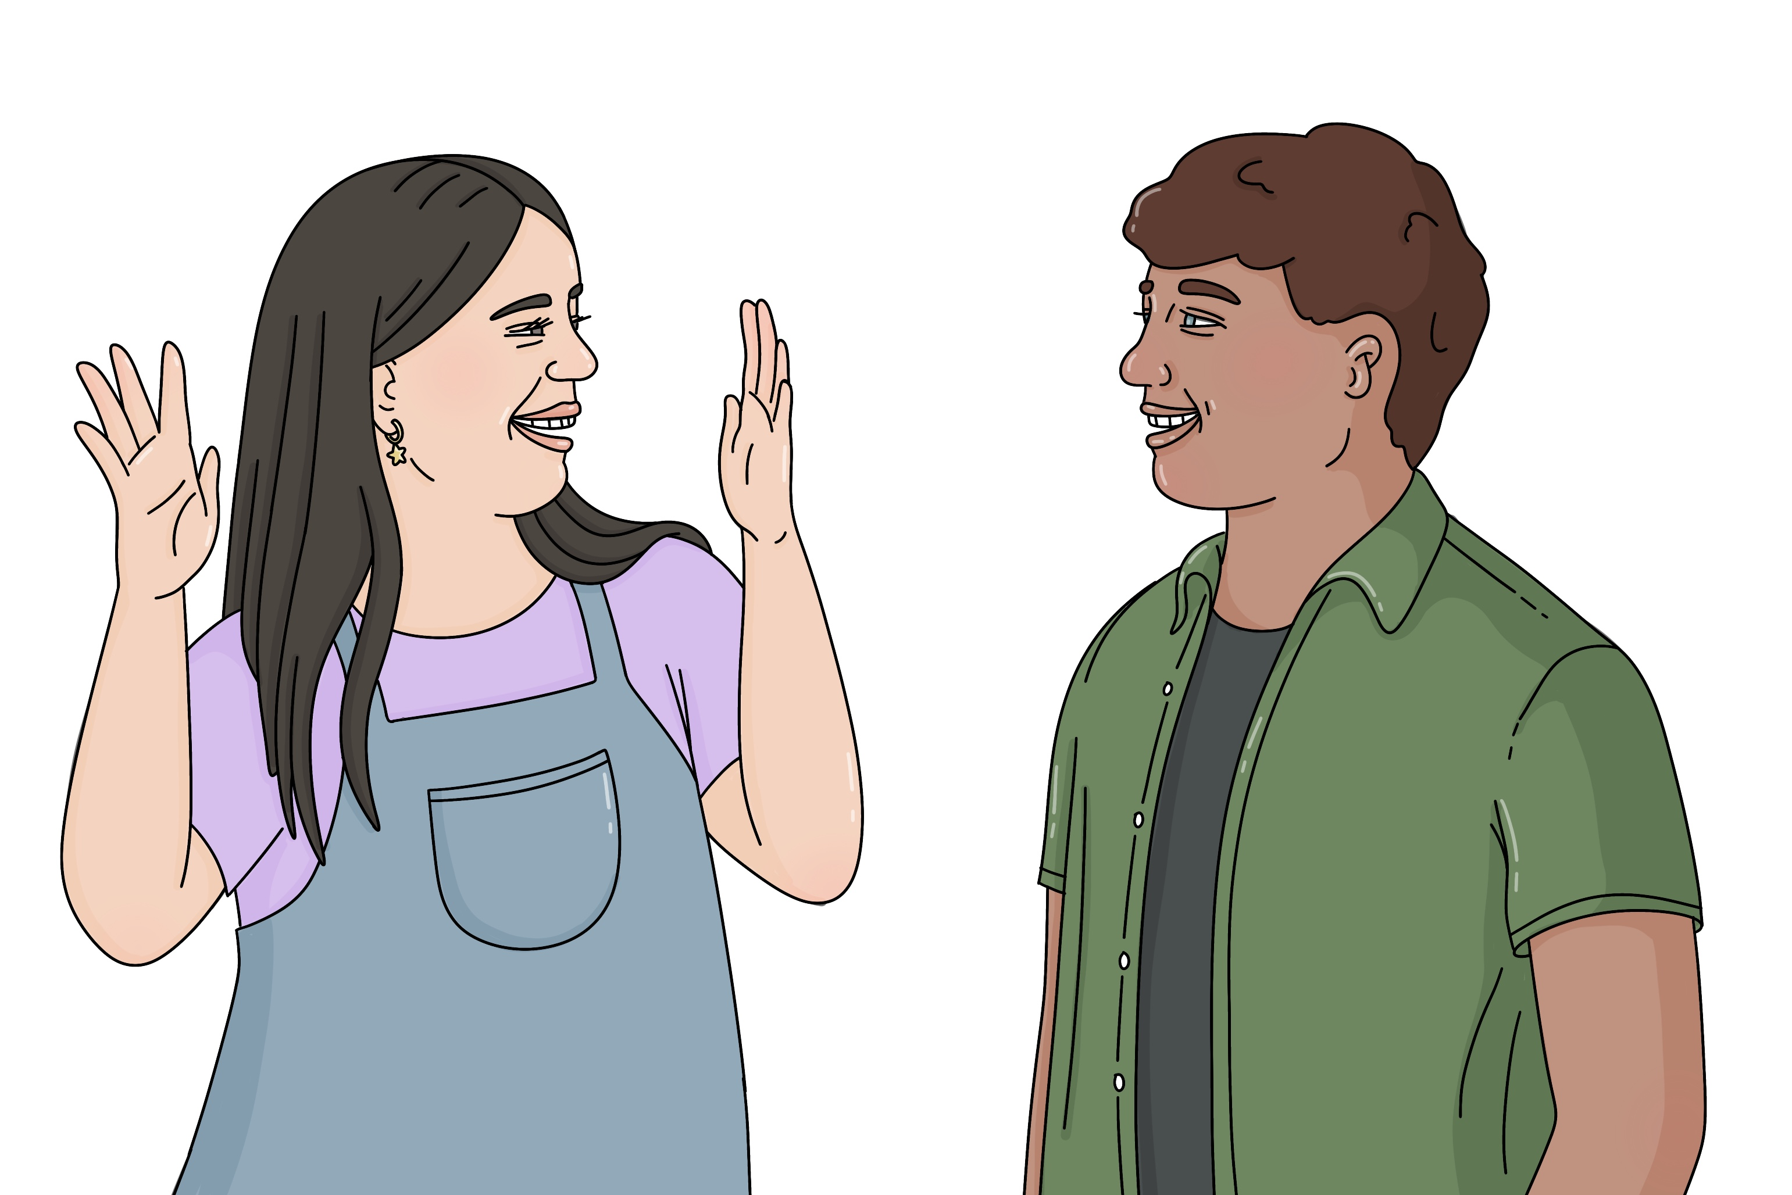
In this Easy Read we call New Zealand Sign Language NZSL for short.

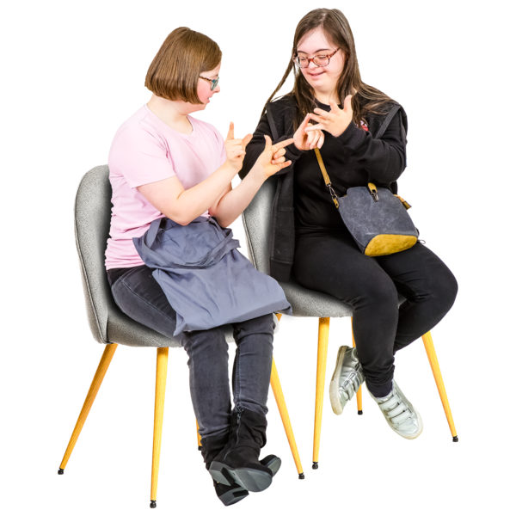
Here specialist schools are
schools for Deaf students.

The teachers at specialist schools know how to teach Deaf children.

Sometimes children at specialist schools will go to mainstream
classes with support from the specialist school.


The AoDC will also work with other services like:
Deaf Aotearoa First Signs
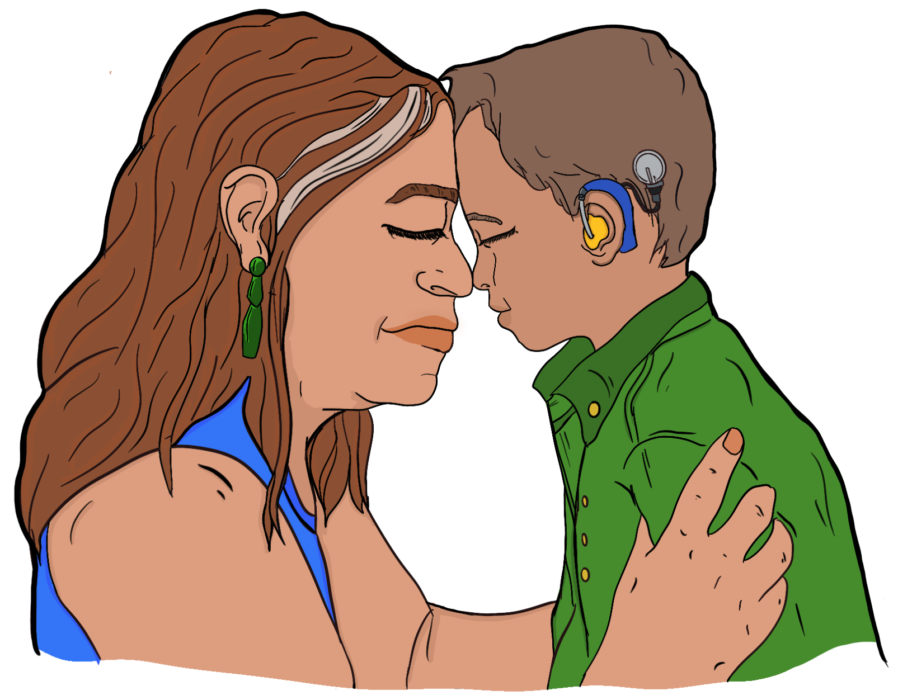
Health New Zealand | Te Whatu Ora
cochlear implant programmes.

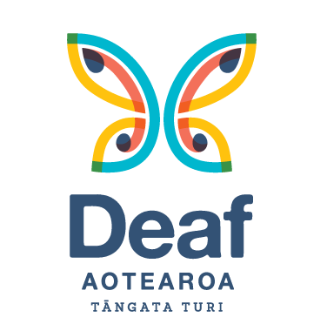
Deaf Aotearoa provides support for all Deaf people in Aotearoa New Zealand.

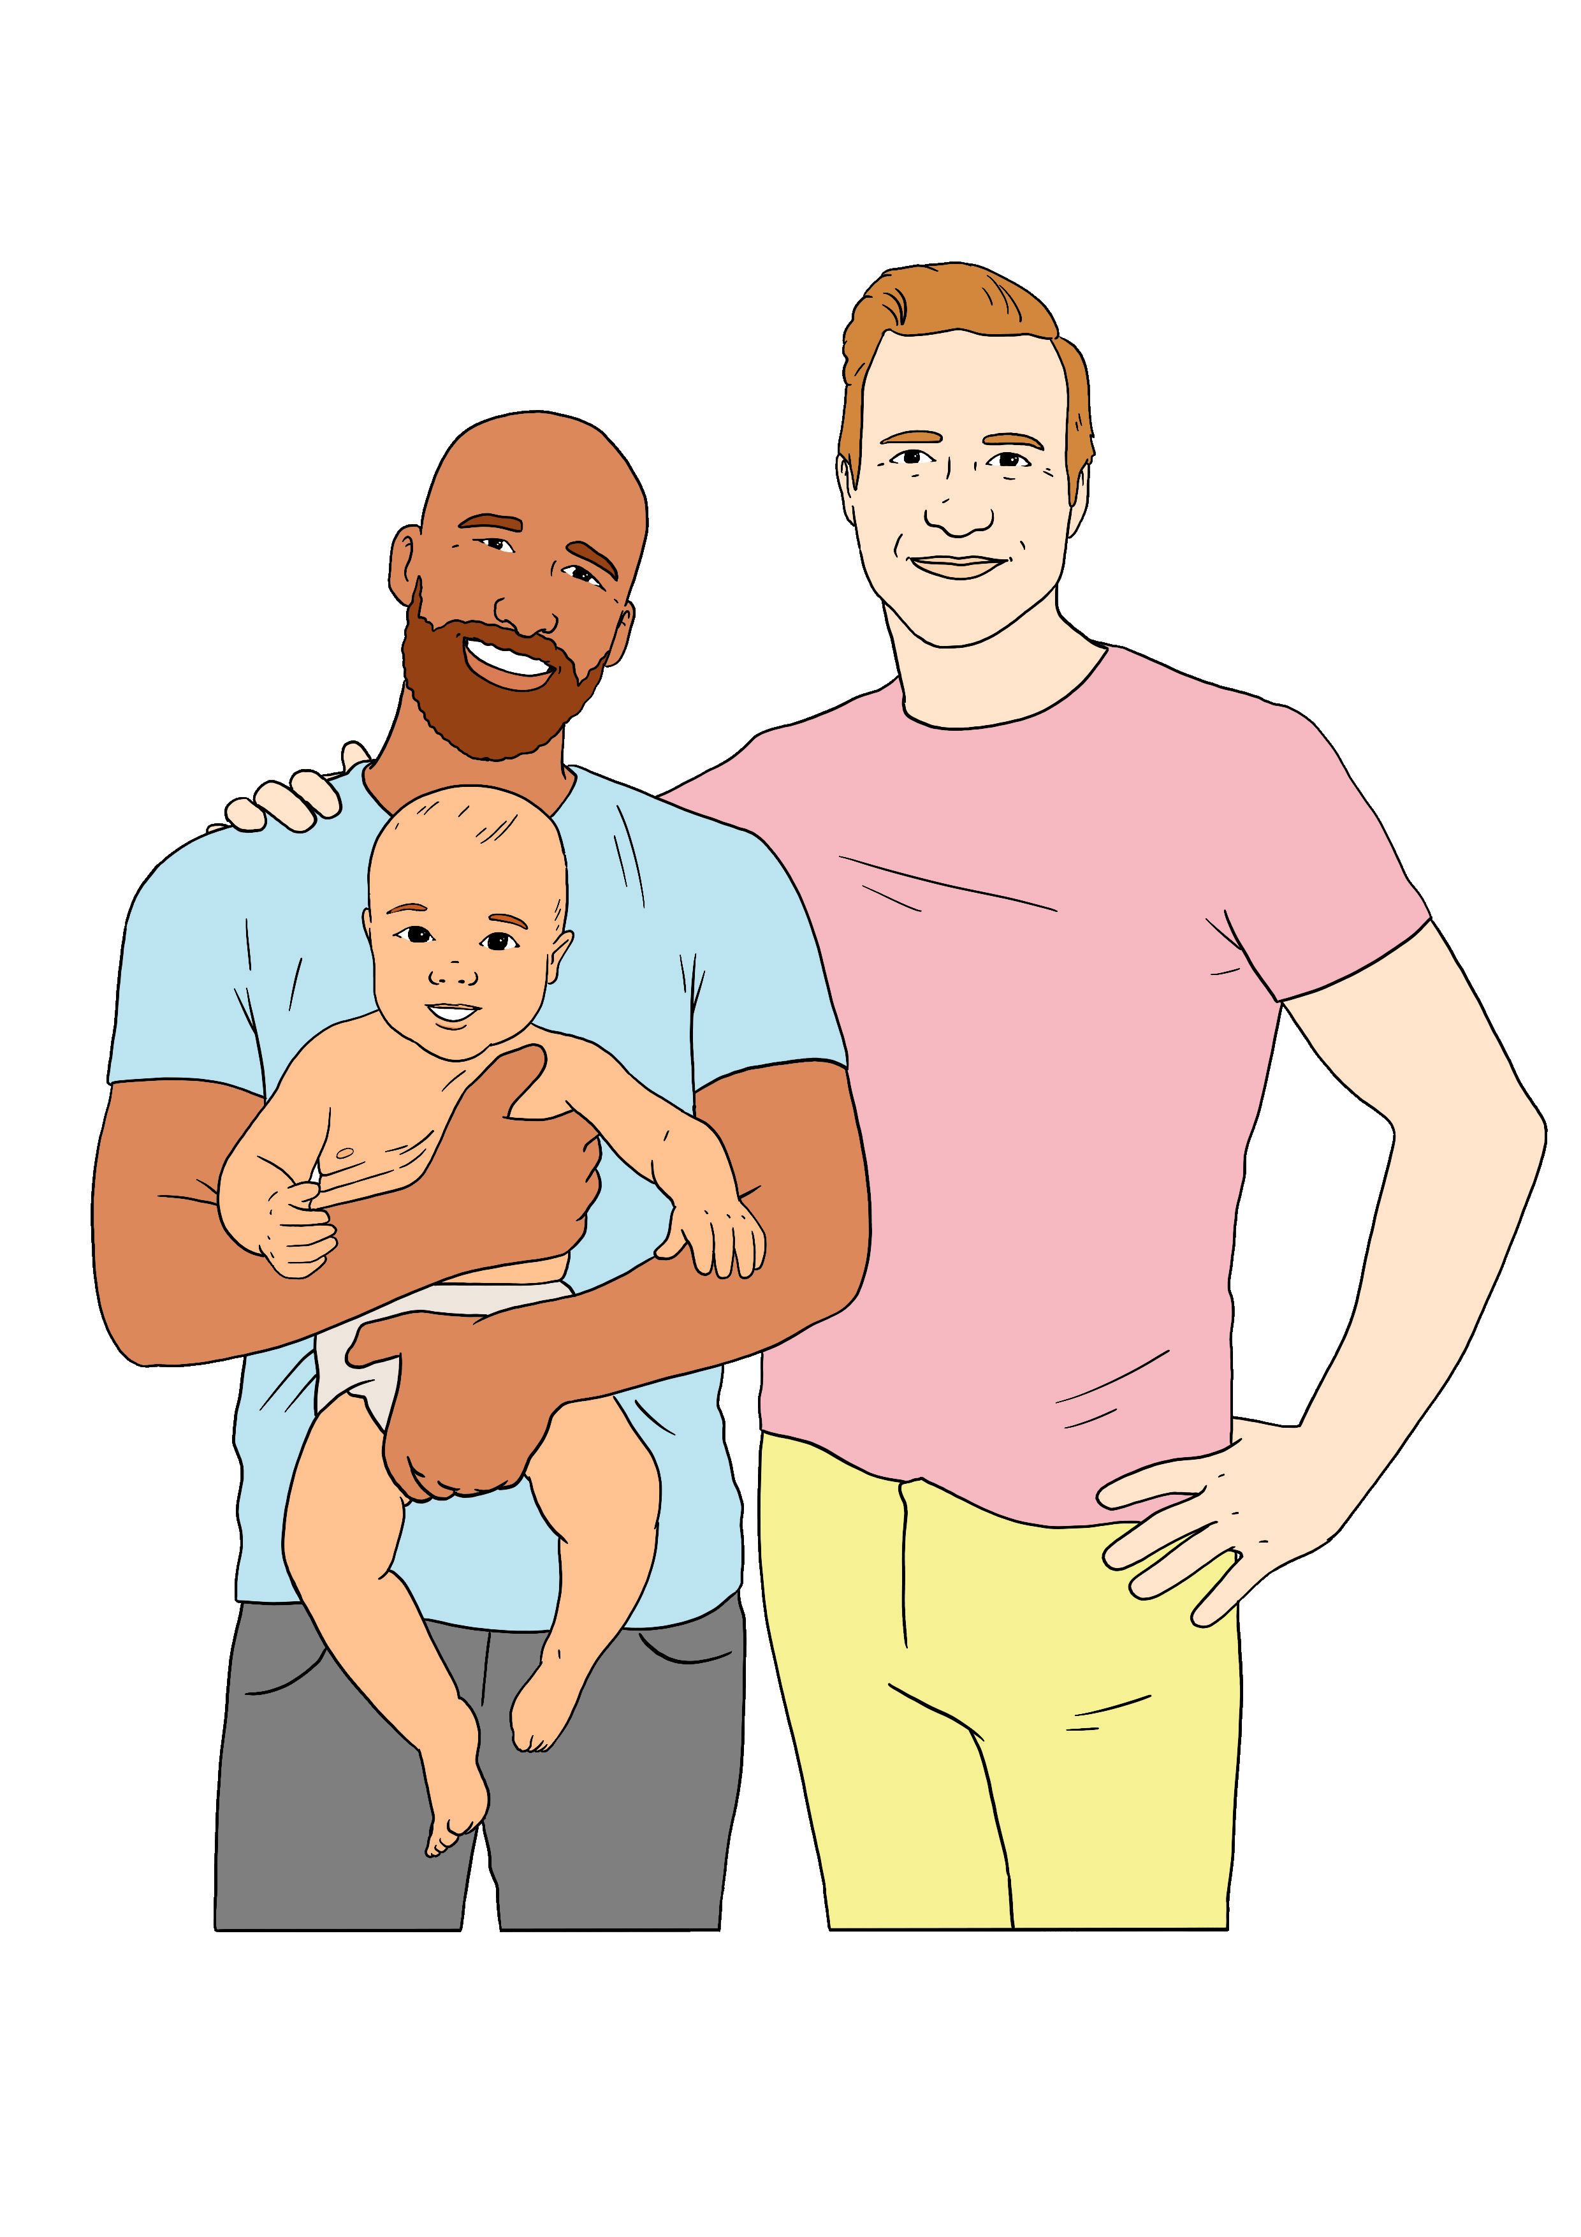
Deaf Aotearoa First Signs supports:
Deaf / hard of hearing children aged 0 to 5
their whānau / families.

Deaf Aotearoa First Signs provides support with things like:
learning NZSL
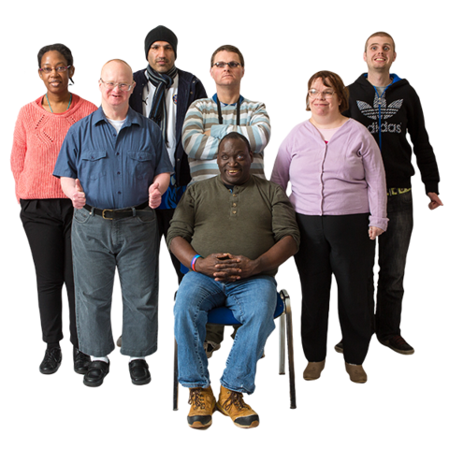
learning about being Deaf / hard of hearing in Aotearoa New Zealand
meeting other people who are Deaf / hard of hearing.

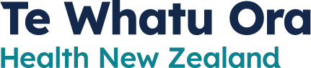
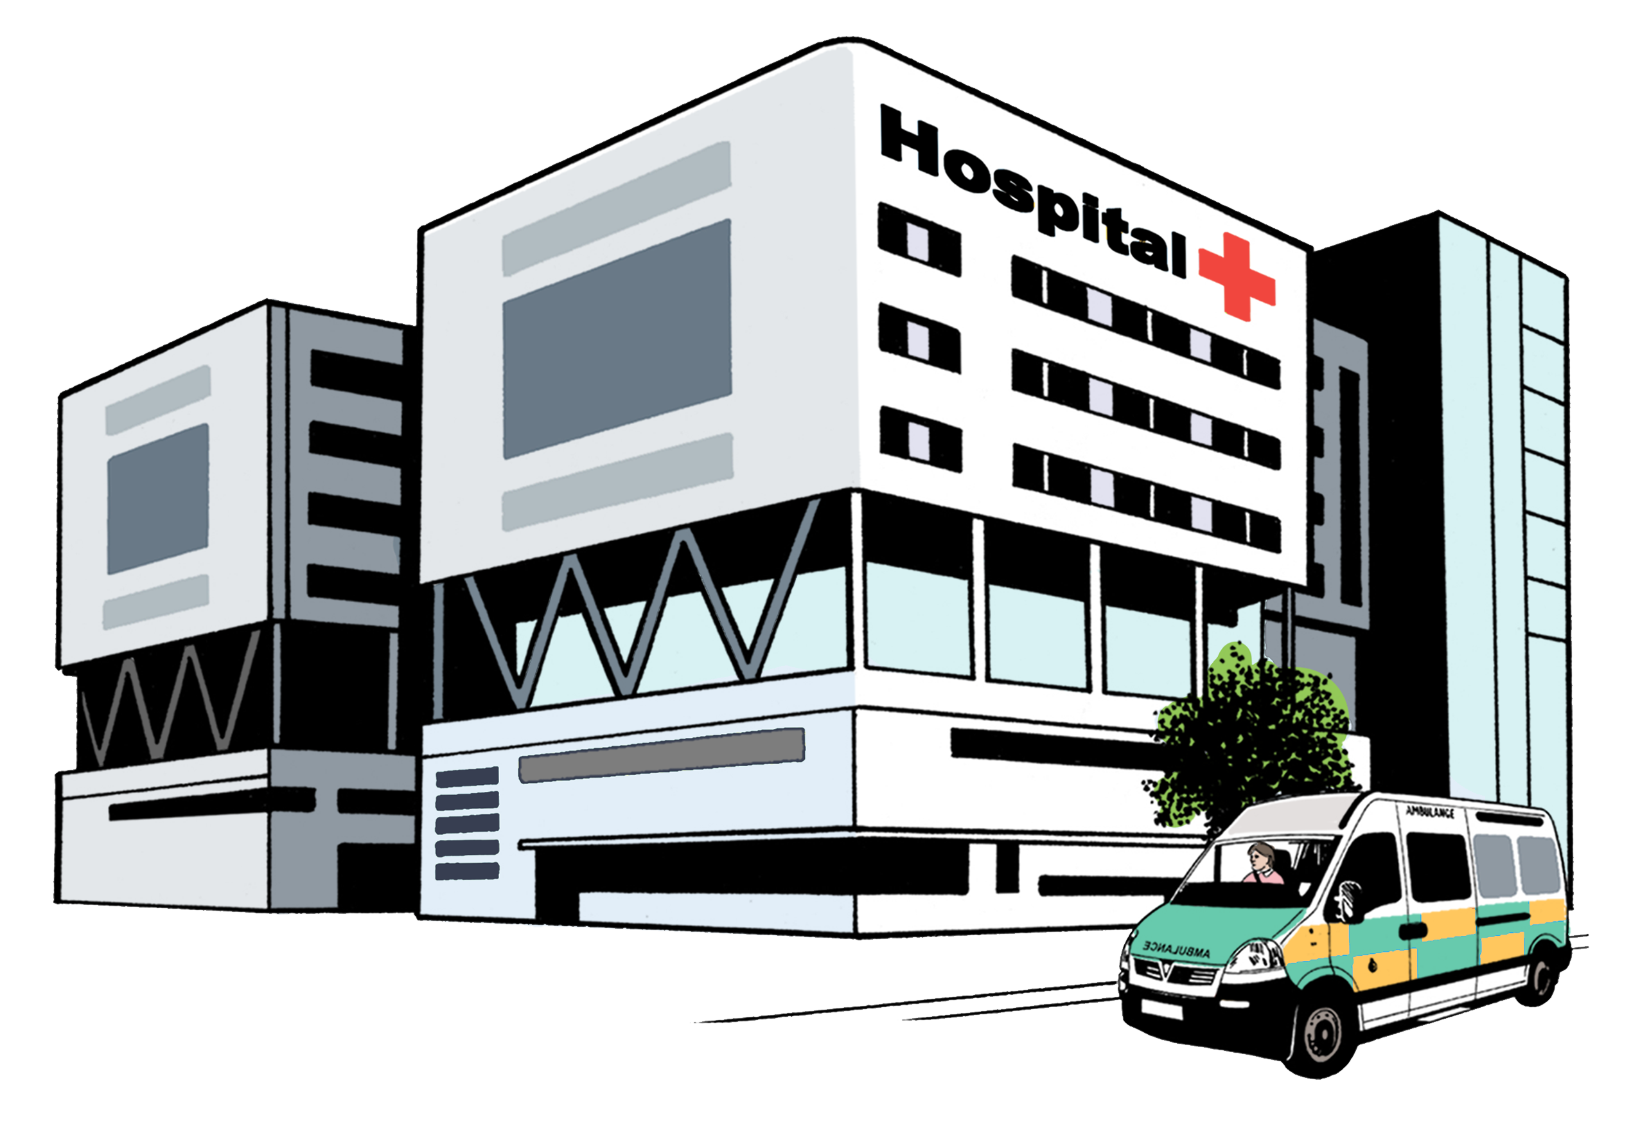
Health New Zealand | Te Whatu Ora is the part of the Government in charge of health services in
Aotearoa New Zealand.

They do things like running hospitals.

Cochlear implants are tools that support people with hearing loss to hear.


Cochlear implant programmes pay for cochlear implants for people who need them.

More information

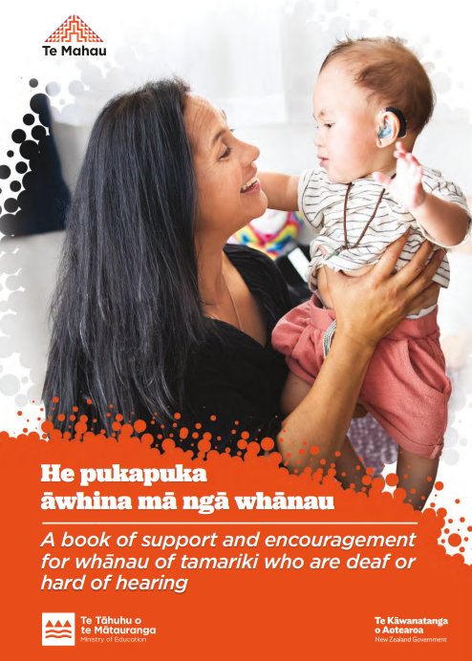
He Pukapuka Āwhina mā ngā Whānau – The Family Book is a book with information for whānau / families with a child who is Deaf / hard of hearing.

You can find the book on this website:

https://tinyurl.com/3eup47yv


You can learn NZSL for free on this website:

www.learnnzsl.nz/

You can find out more about Deaf Aotearoa on this website:

www.deaf.org.nz

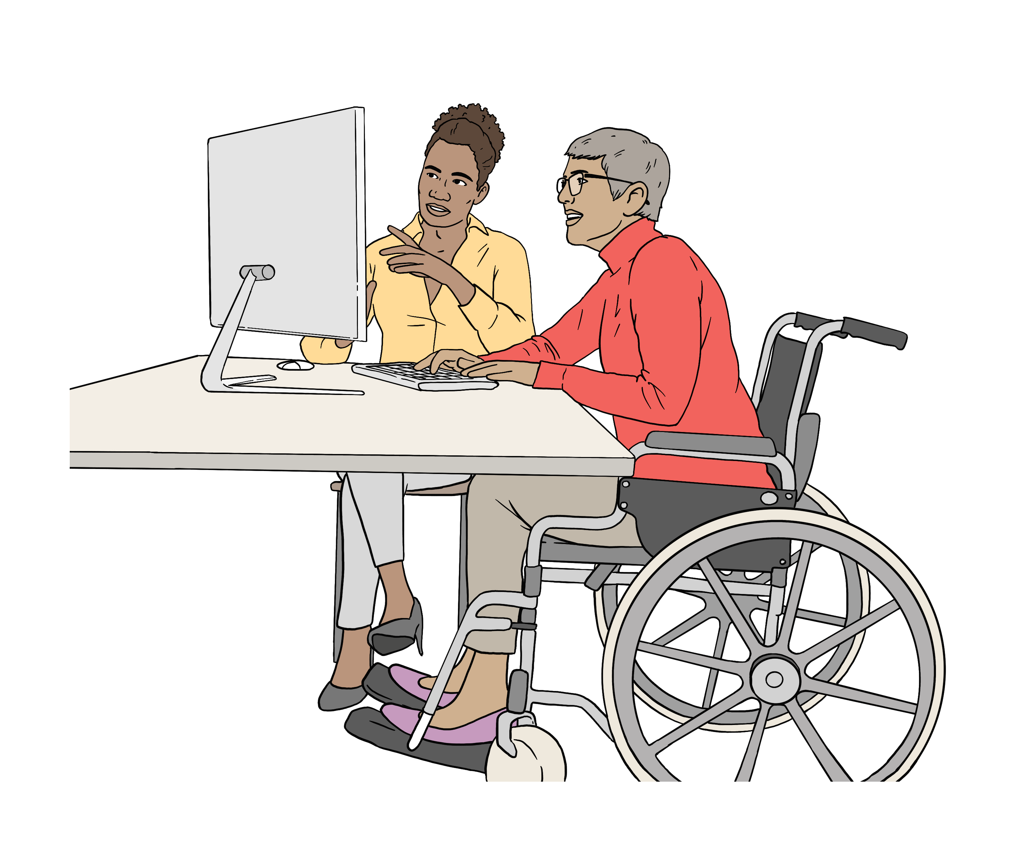
You can find out more about Deaf Aotearoa First Signs on this website:

https://firstsigns.co.nz
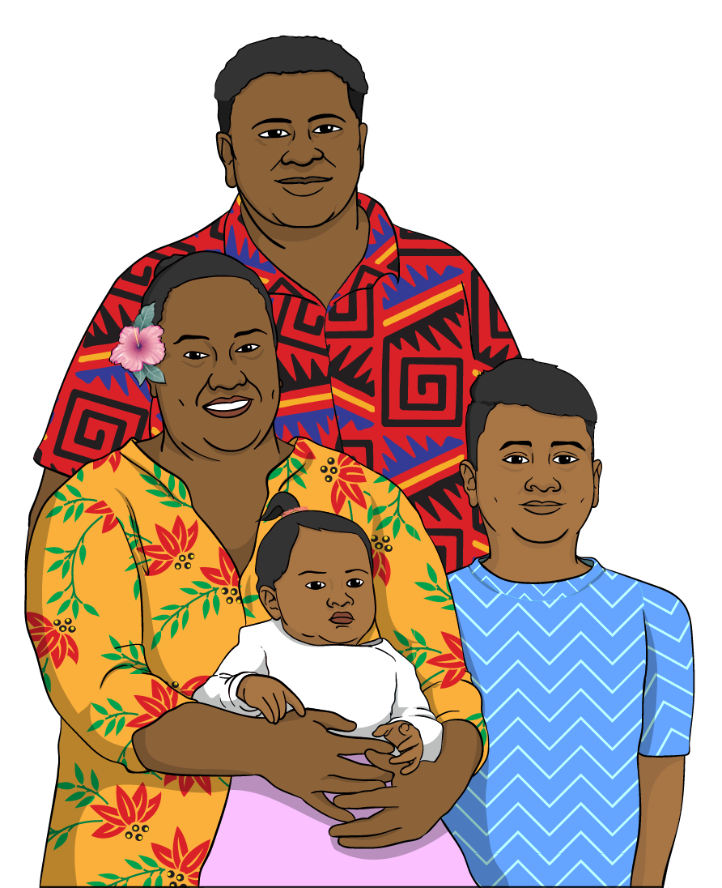

Deaf Children New Zealand supports whānau / families of children who are Deaf / hard of hearing.

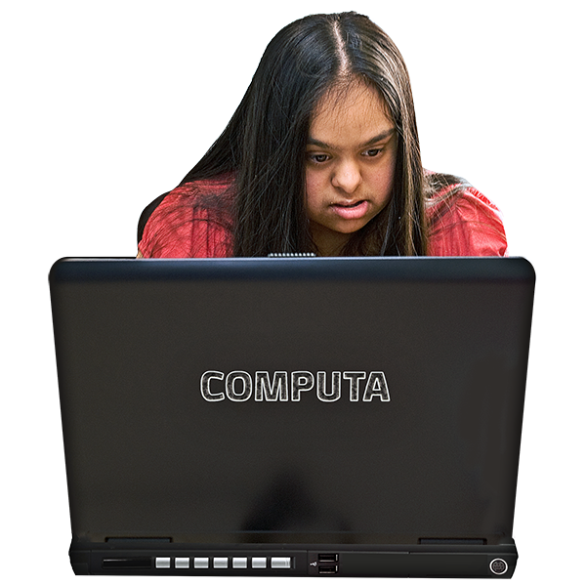
You can find out more on their website:

https://deafchildren.org.nz

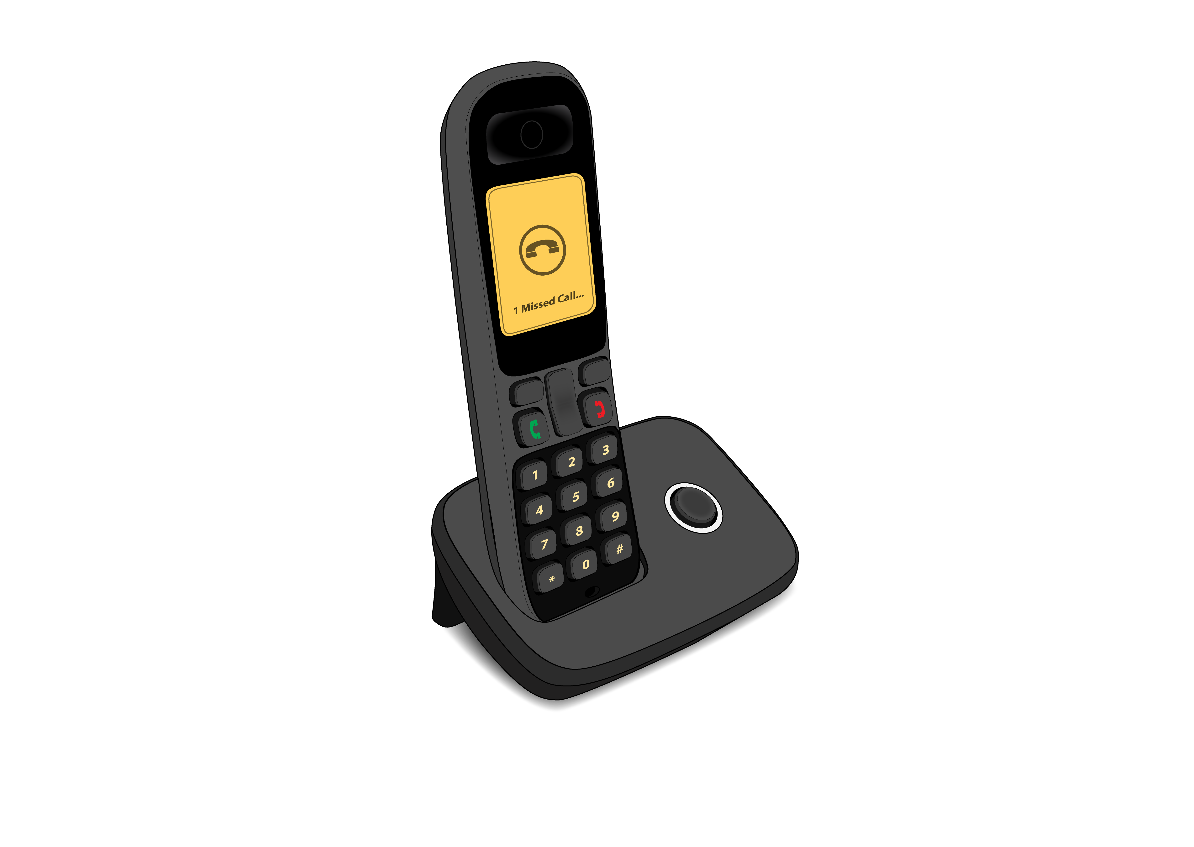
To get support from the Ministry of Education:

phone your regional office
email your regional office.

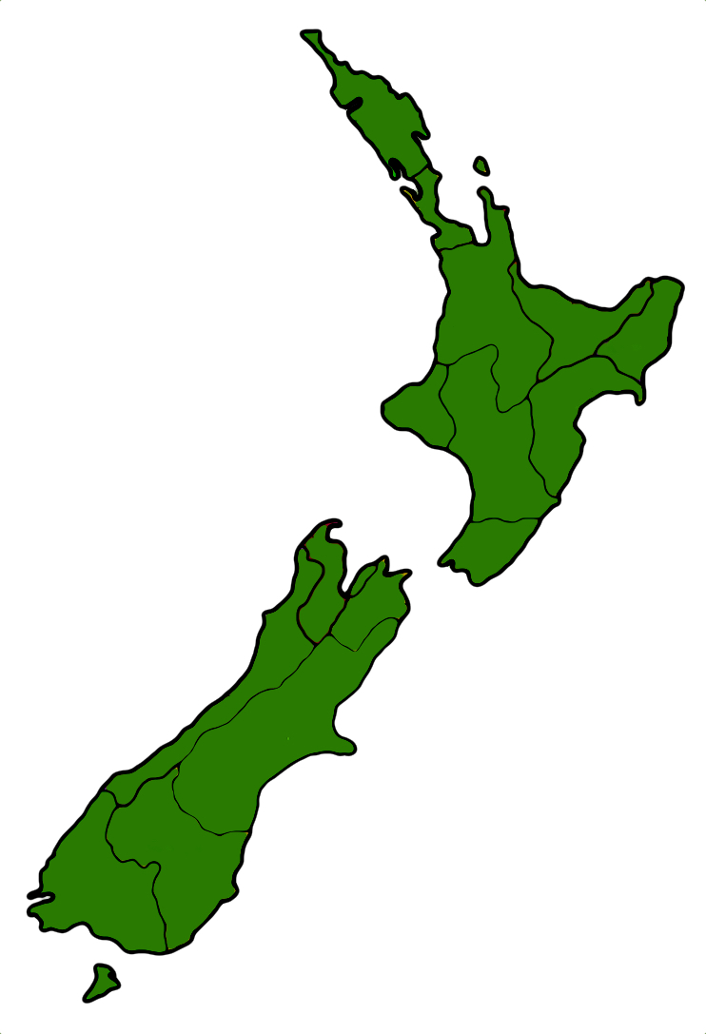
Your regional office is the part of
the Ministry of Education in charge
of the place in Aotearoa New Zealand where you live.

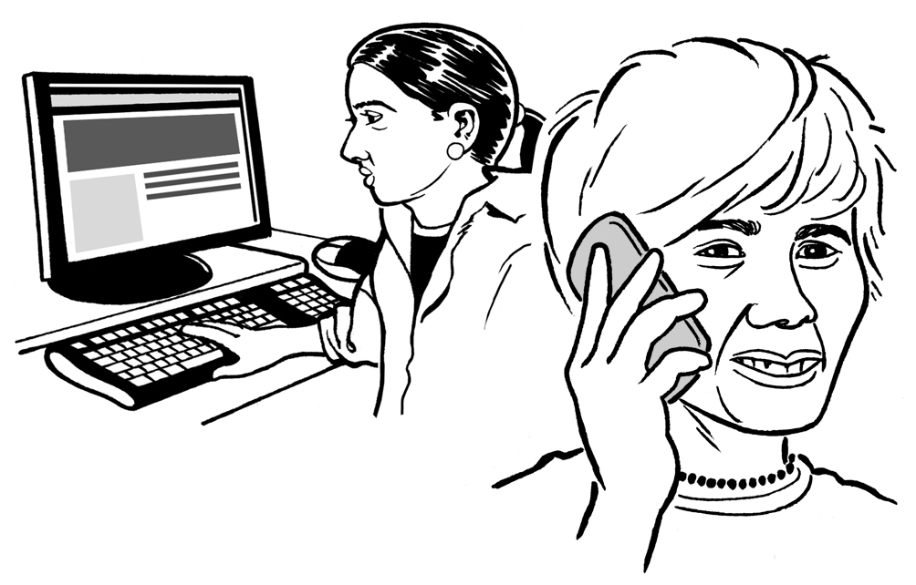
You can find out how to phone / email your regional office on this website:

https://tinyurl.com/2rtynfur

The websites in this section are not in Easy Read.

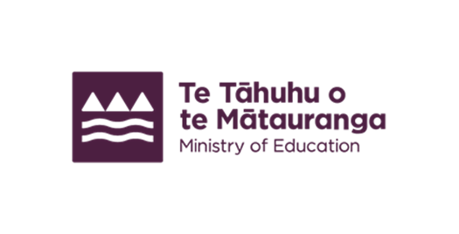
This information has been written by the Ministry of Education.

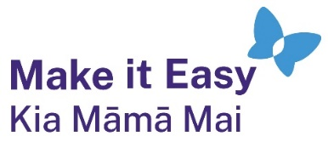
It has been translated into Easy Read by the Make it Easy Kia Māmā Mai service of People First New Zealand Ngā Tāngata Tuatahi.
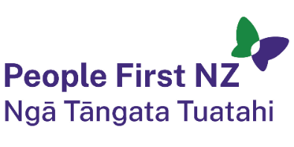
The ideas in this document are not the ideas of People First New Zealand Ngā Tāngata Tuatahi.

All images used in this Easy Read document are subject to copyright rules and cannot be used without permission.

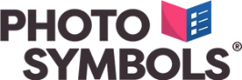
Make it Easy uses images from:

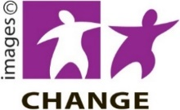
- Photosymbols

- Change Images

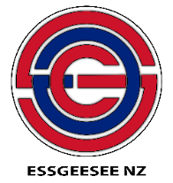
- Huriana Kopeke-Te Aho
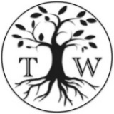
- SGC Image Works

- T Wood

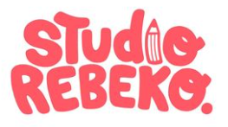
- Studio Rebeko

- Inga Kramer.

