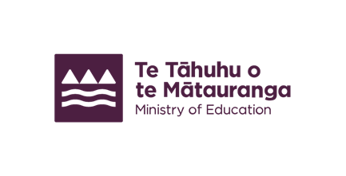


Interpreters for Deaf parents
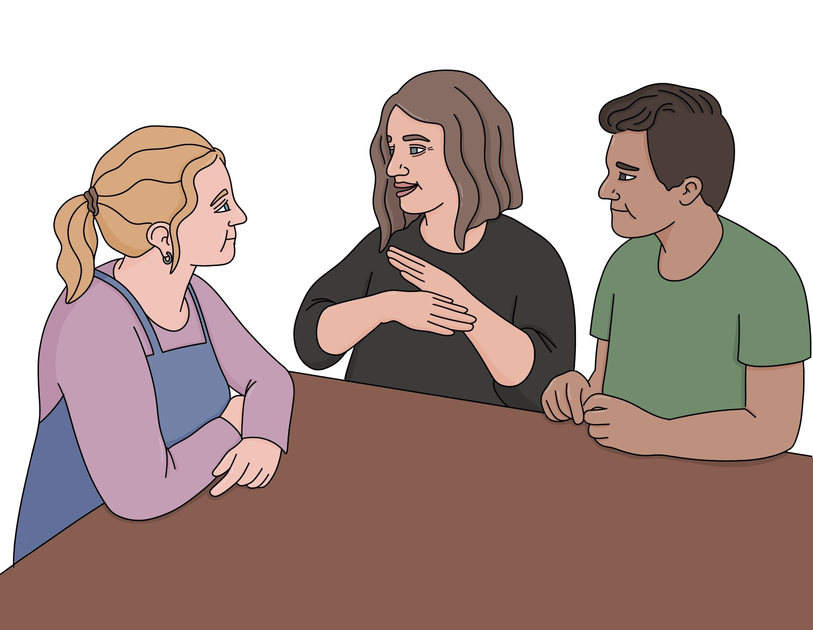

Published: September 2025

About this Easy Read


This Easy Read tells you how you can get a New Zealand Sign Language interpreter if you need one to talk to the school your child goes to.

New Zealand Sign Language interpreters support people who use:

a spoken language to talk to people who use New Zealand Sign Language
New Zealand Sign Language to talk to people who use a spoken language.

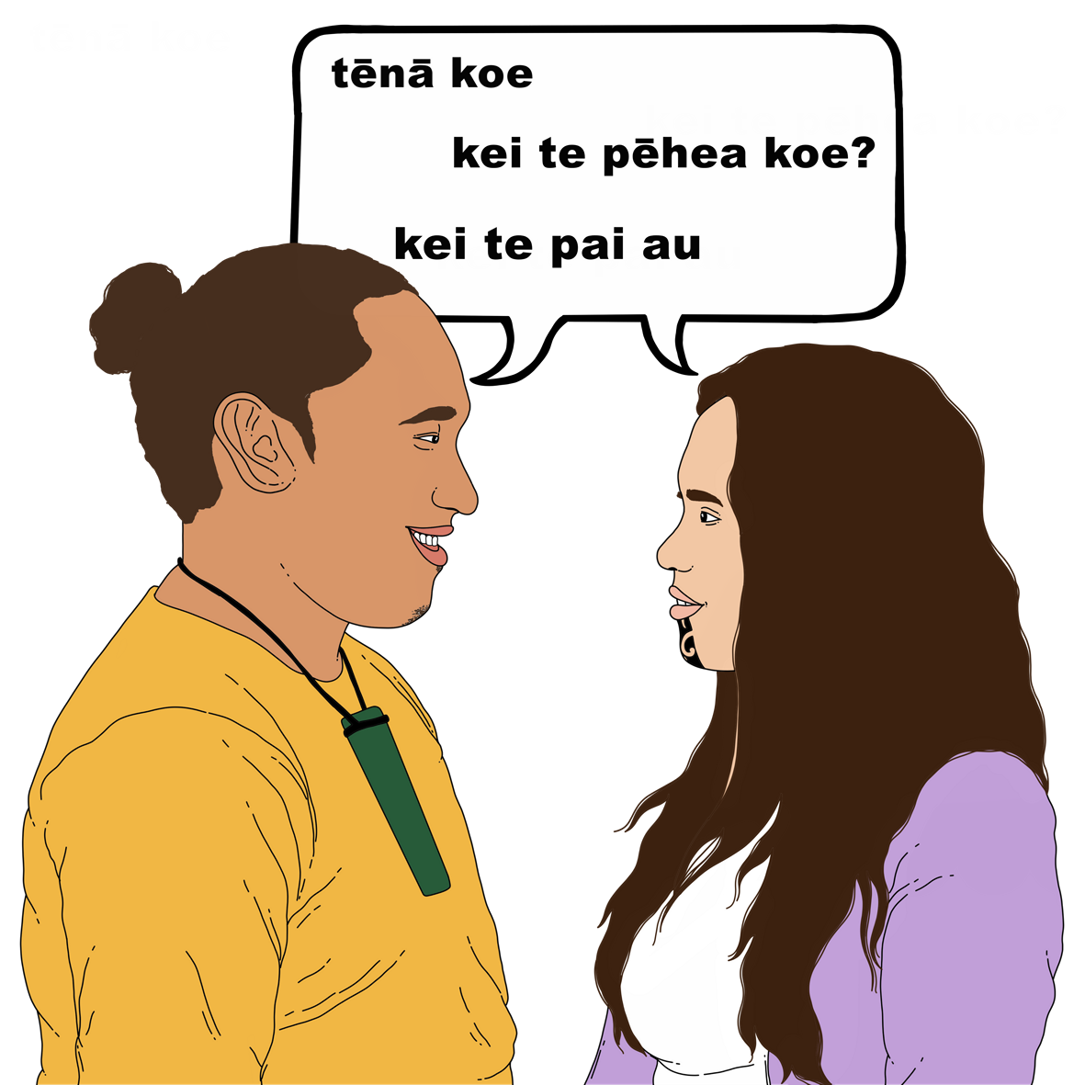
Here a spoken language means:
English
te reo Māori.

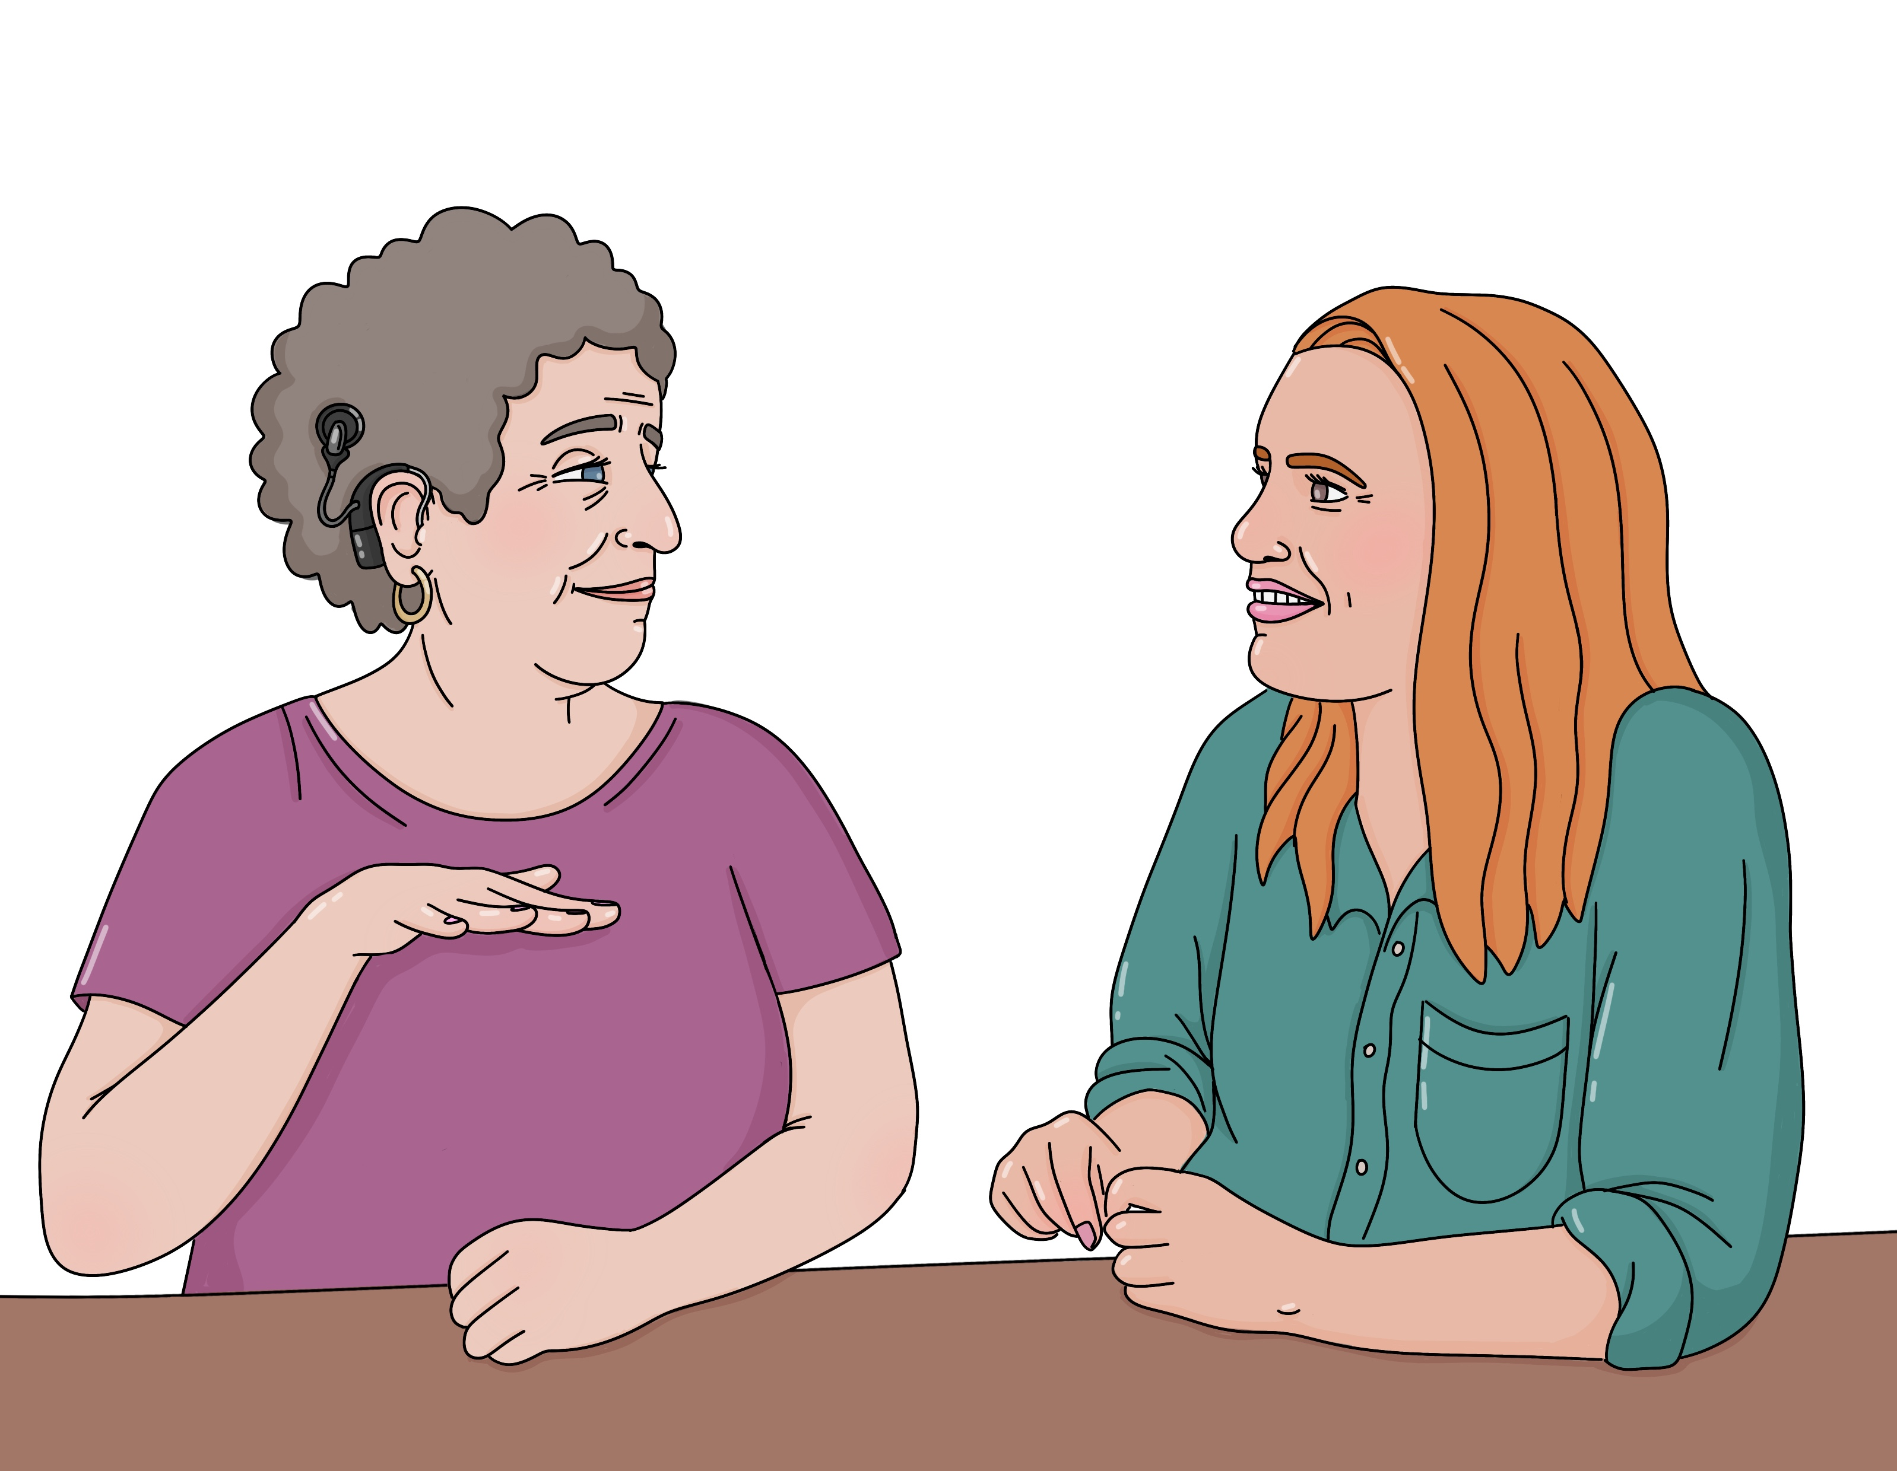
In this Easy Read we call New Zealand Sign Language NZSL for short.


The Ministry of Education pays for NZSL interpreters so you can:
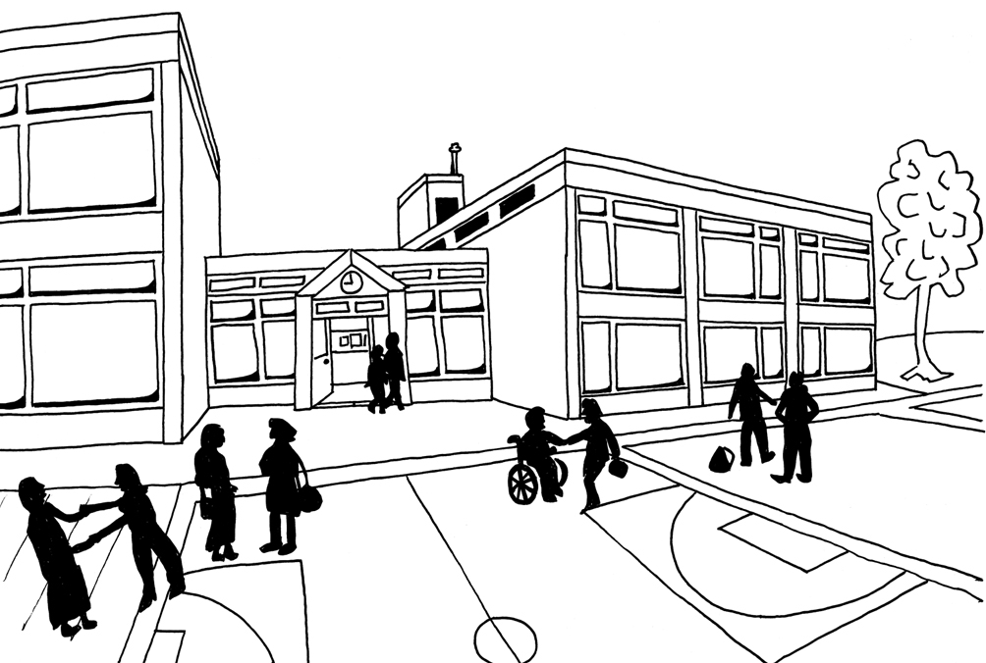
know what is happening for your child at school
be part of the school community.


The Ministry of Education is the part of the Government in charge of schools in Aotearoa New Zealand.

The Ministry of Education does
things like:

deciding what schools should teach
supporting children who need extra support with their learning
building new classrooms.


The school community is all the people who are part of a school like:

students
teachers
whānau / families.

What support can you get?


The Ministry of Education will pay for NZSL interpreters if your child goes to a:

state school / kura
state-integrated school / kura.

A state school / kura is a school that:
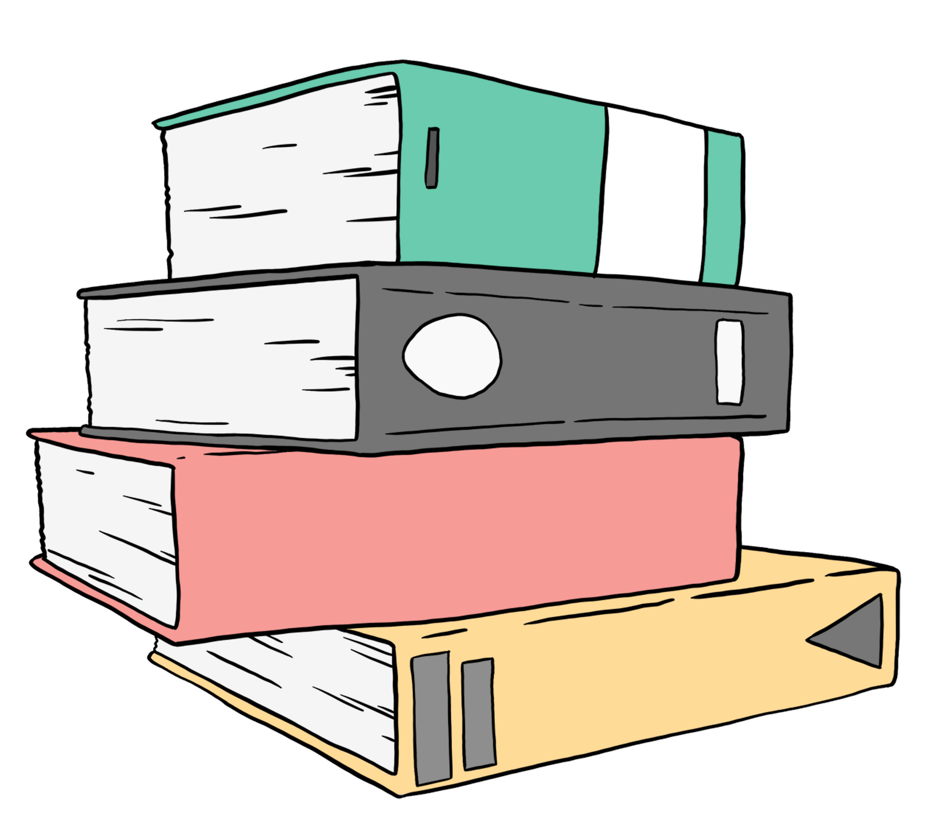
the Ministry of Education pays for
teaches the things the Ministry
of Education says it must teach.


A state-integrated school / kura is
a school that:

the Ministry of Education mostly pays for
has a special character like
being Catholic
can teach things to do with its special character as well as the things the Ministry of Education says it must teach.


You can have an NZSL interpreter at:
school enrolment meetings

formal parent–teacher meetings
support plan meetings
prizegivings / special assemblies

any other meetings with school staff where you talk about what school is like for your child.
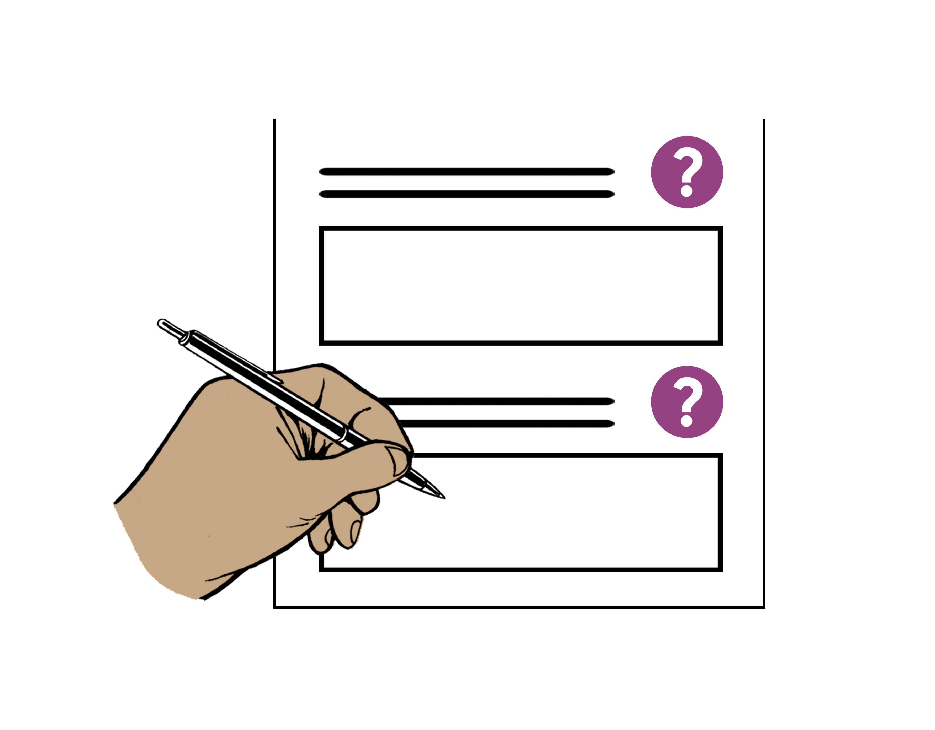

Enrolment is when you sign your child up to go to school.


A formal parent–teacher meeting is when you set up a time to talk to the teacher.

A parent–teacher interview is a
formal parent–teacher meeting.

Talking to the teacher when you drop your child off at school is not a
formal parent–teacher meeting.


A support plan meeting is a meeting where you talk about extra support your child needs with their learning.


Prizegivings / special assemblies are when the school community gets together to:
give out awards
celebrate things the students have done.


You do not have to pay for the NZSL interpreter.

The school does not have to pay for the NZSL interpreter.

How do you get support?

The Ministry of Education pays WordsWorth Interpreting to provide NZSL interpreters.

WordsWorth Interpreting is a company that makes sure people have an NZSL interpreter when they need one.


You can book an NZSL interpreter on the WordsWorth Interpreting website:

www.wordsworth.nz/booking


This website is not in Easy Read.

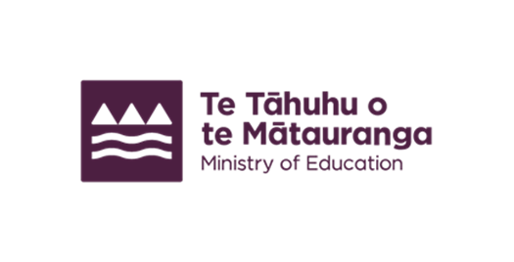
This information has been written by the Ministry of Education.

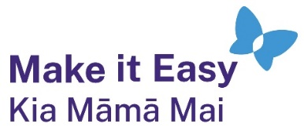
It has been translated into Easy Read by the Make it Easy Kia Māmā Mai service of People First New Zealand Ngā Tāngata Tuatahi.

The ideas in this document are not the ideas of People First New Zealand Ngā Tāngata Tuatahi.

All images used in this Easy Read document are subject to copyright rules and cannot be used without permission.


Make it Easy uses images from:

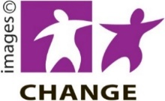
- Photosymbols

- Change Images


- Huriana Kopeke-Te Aho

- SGC Image Works

- T Wood


- Studio Rebeko

- Inga Kramer.

