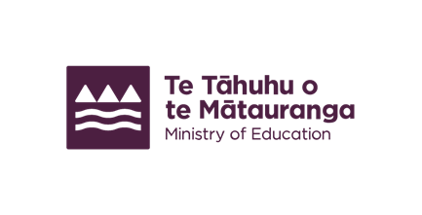
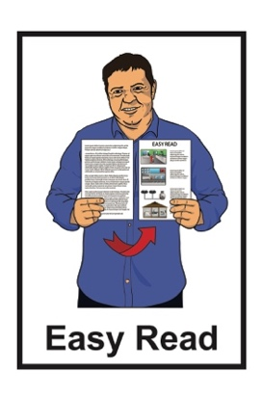

Development map for New Zealand Sign Language in education
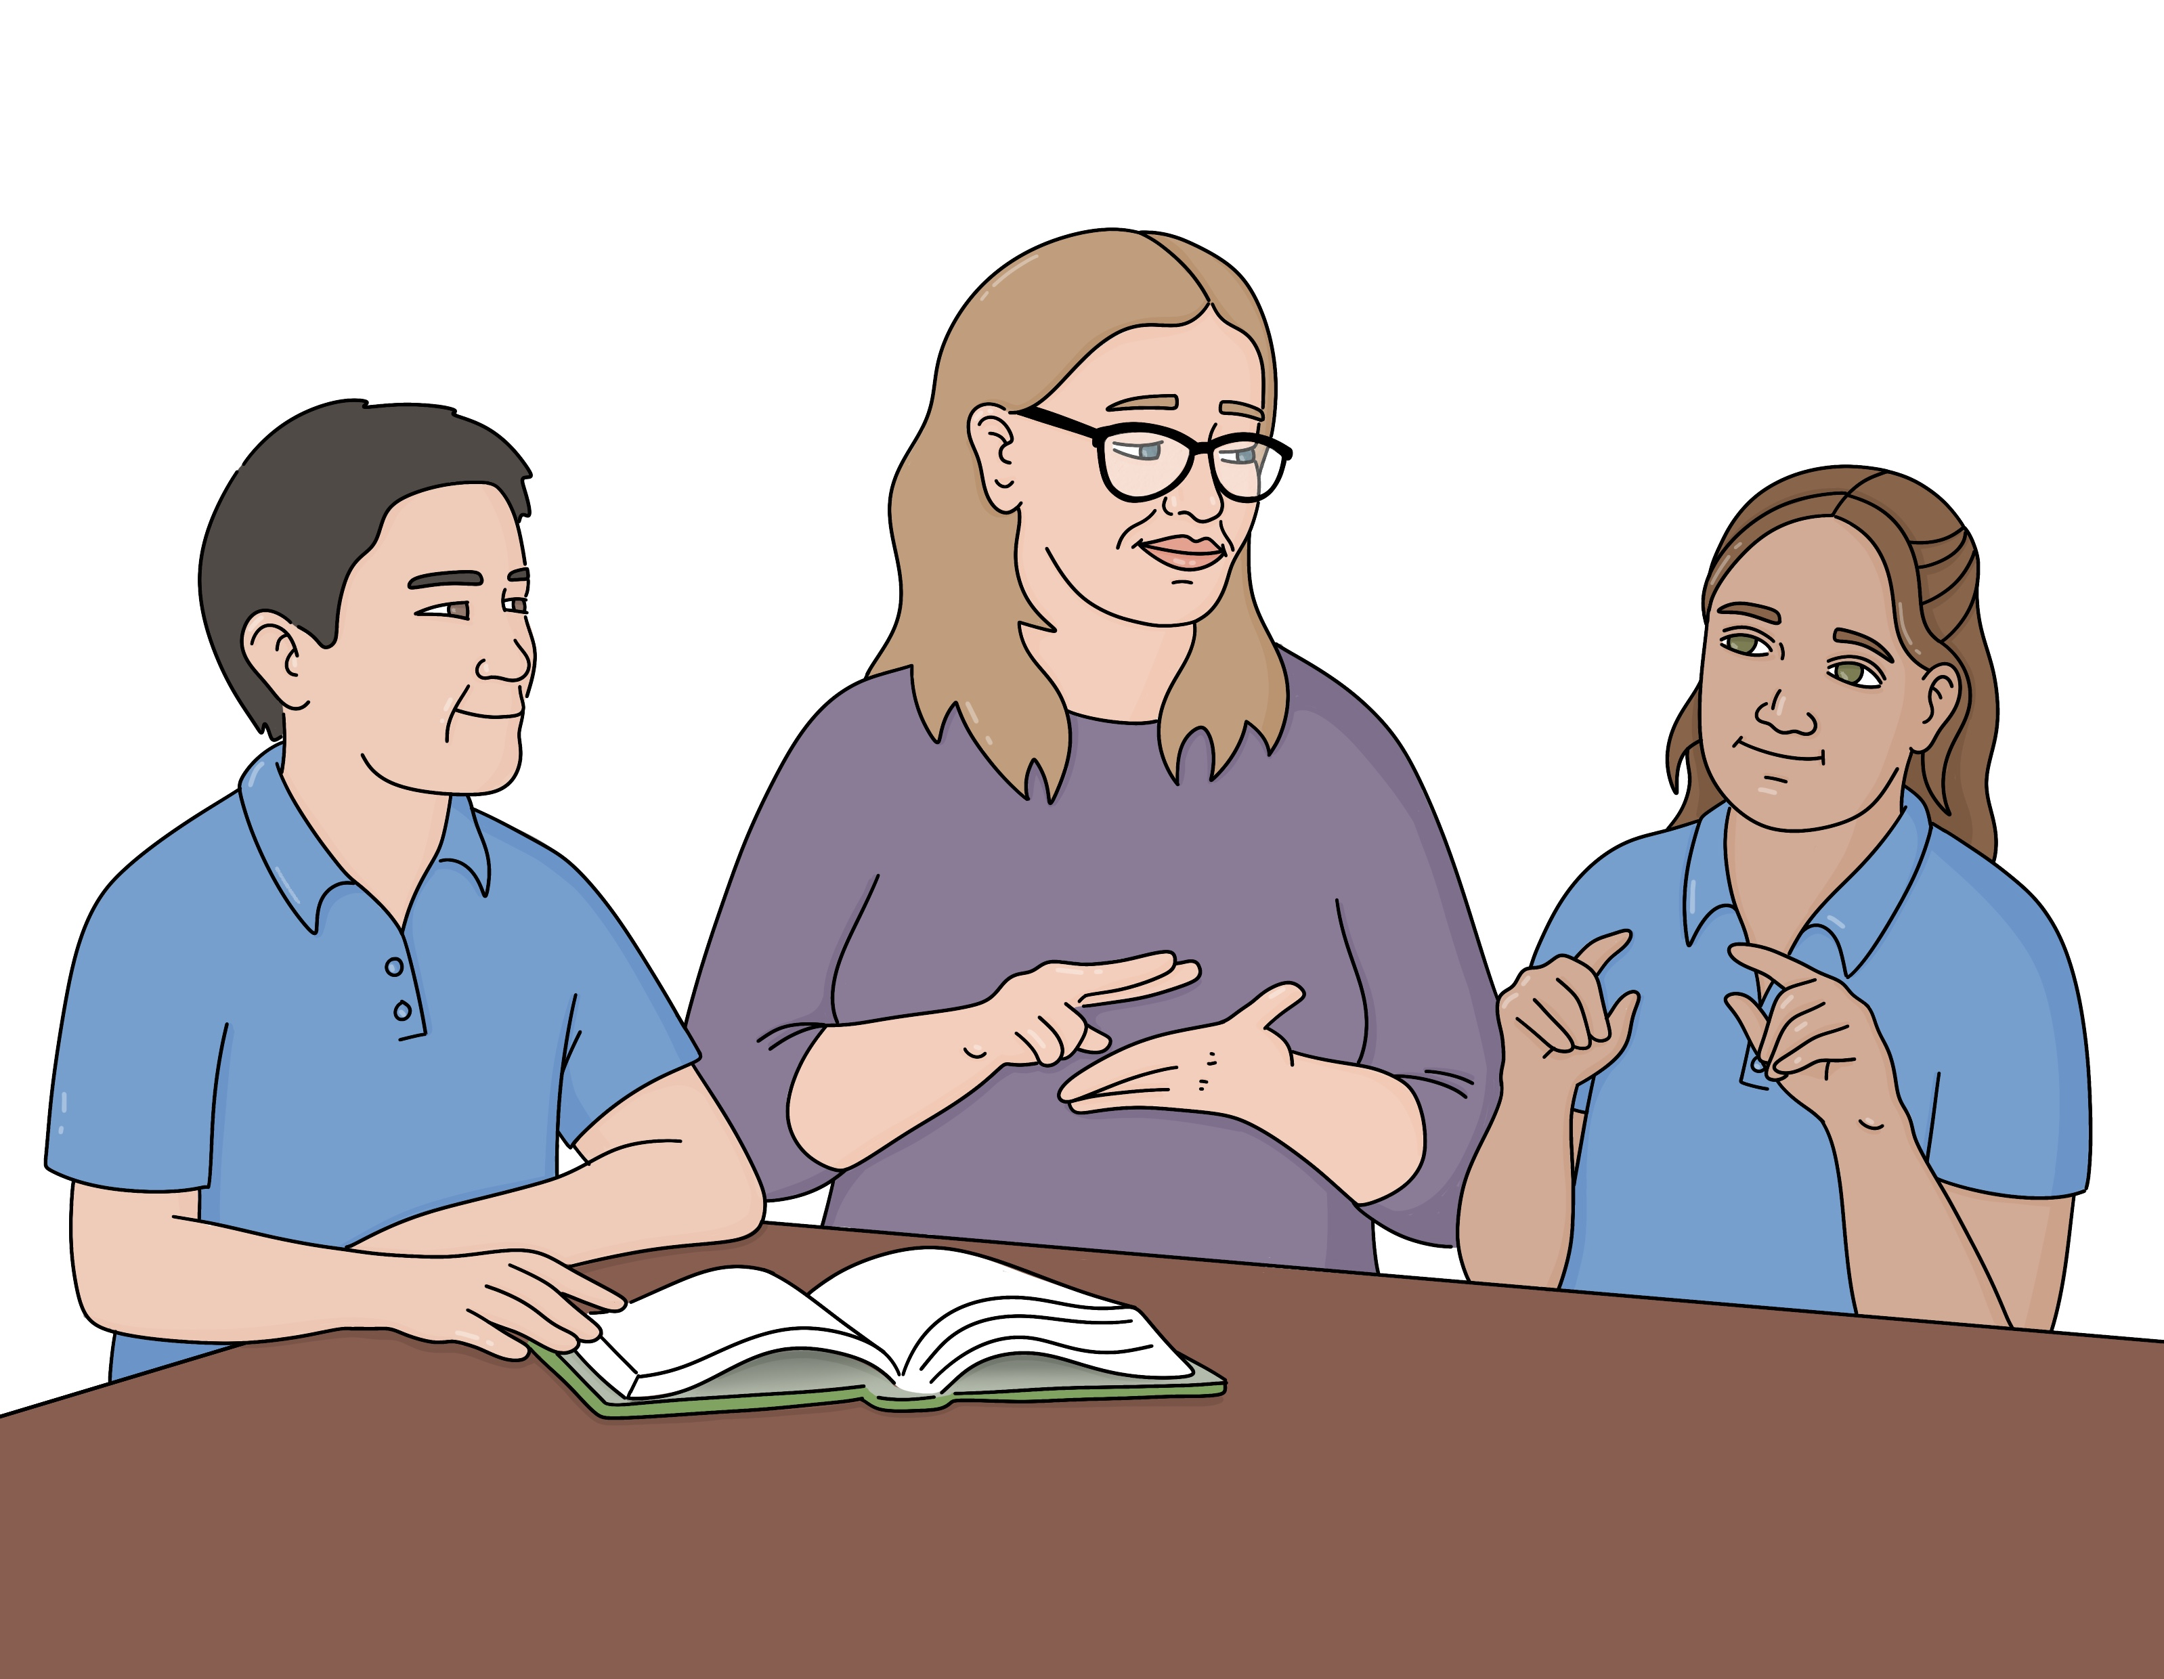

Published: September 2025

About this Easy Read

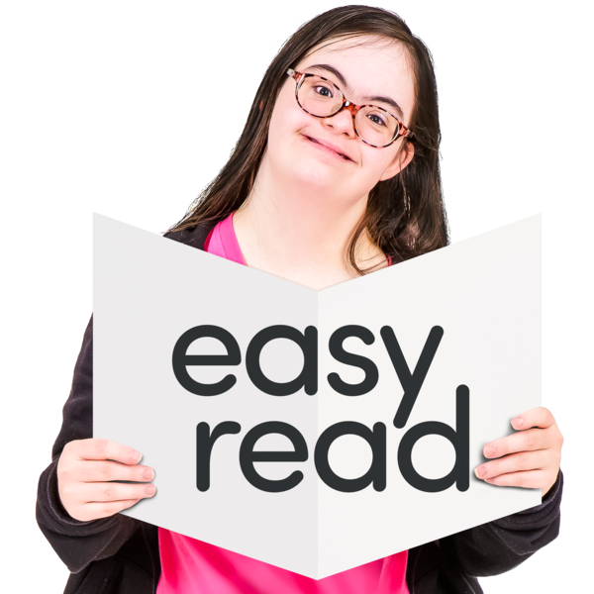
This Easy Read is about the development map for New Zealand Sign Language in education.

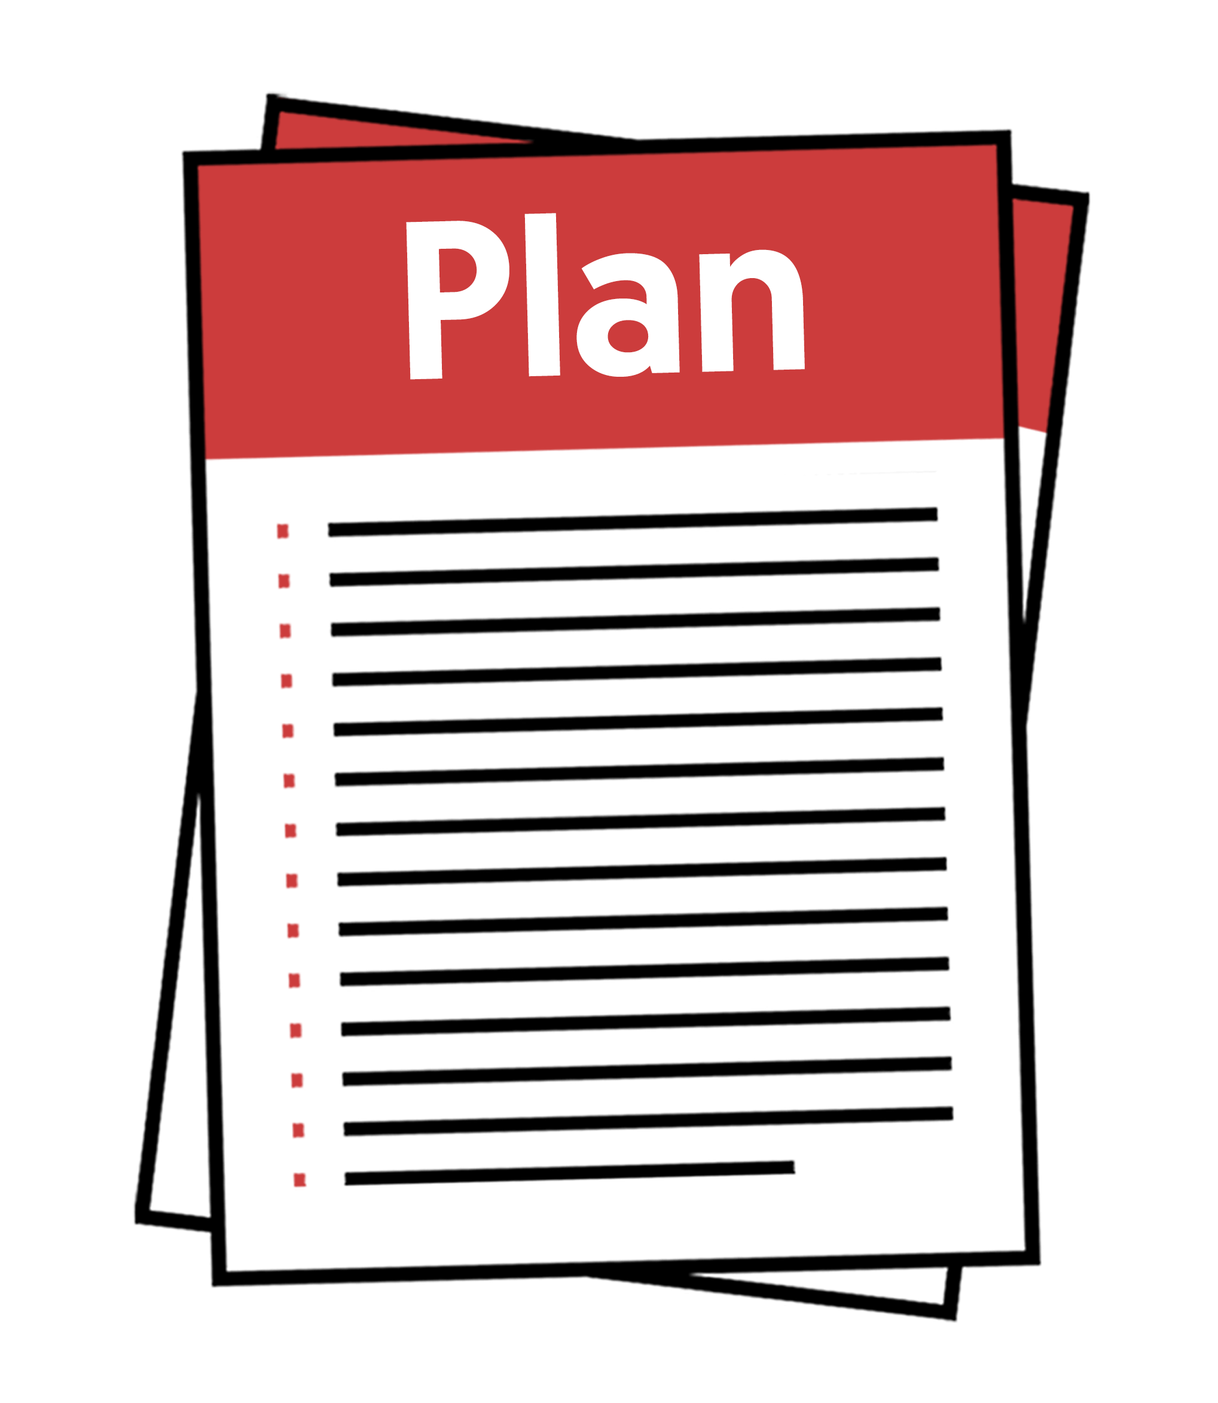
The development map for New Zealand Sign Language in education is a plan from the Ministry of Education.

It tells the Ministry of Education what to do to make sure that children and young people who use New Zealand Sign Language can do well at school.

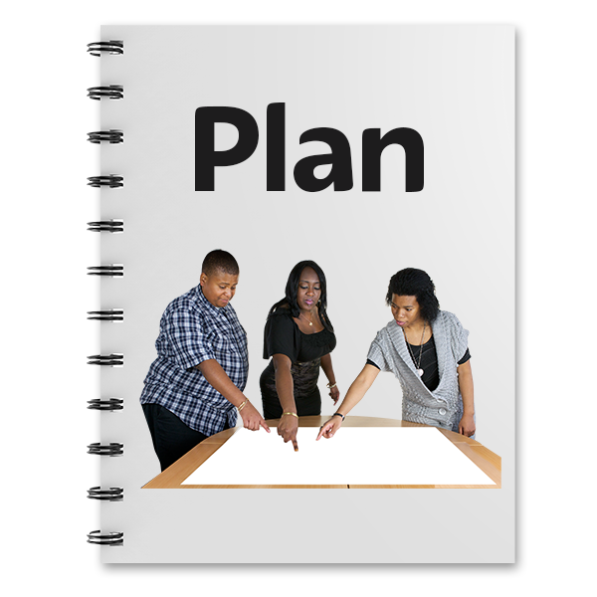
In this Easy Read we will call the development map for New Zealand Sign Language in education the development map for short.

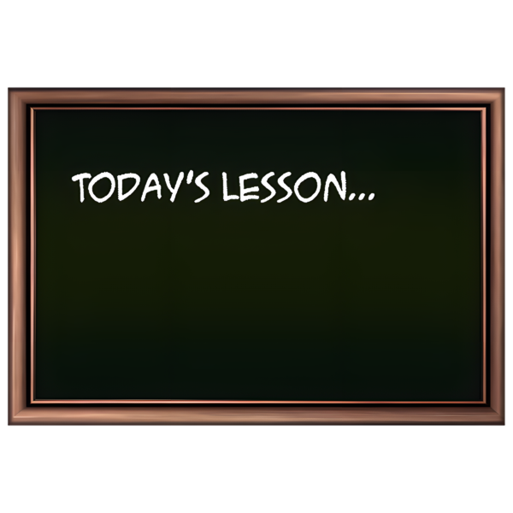
The Ministry of Education is the part of the Government in charge of schools in Aotearoa New Zealand.

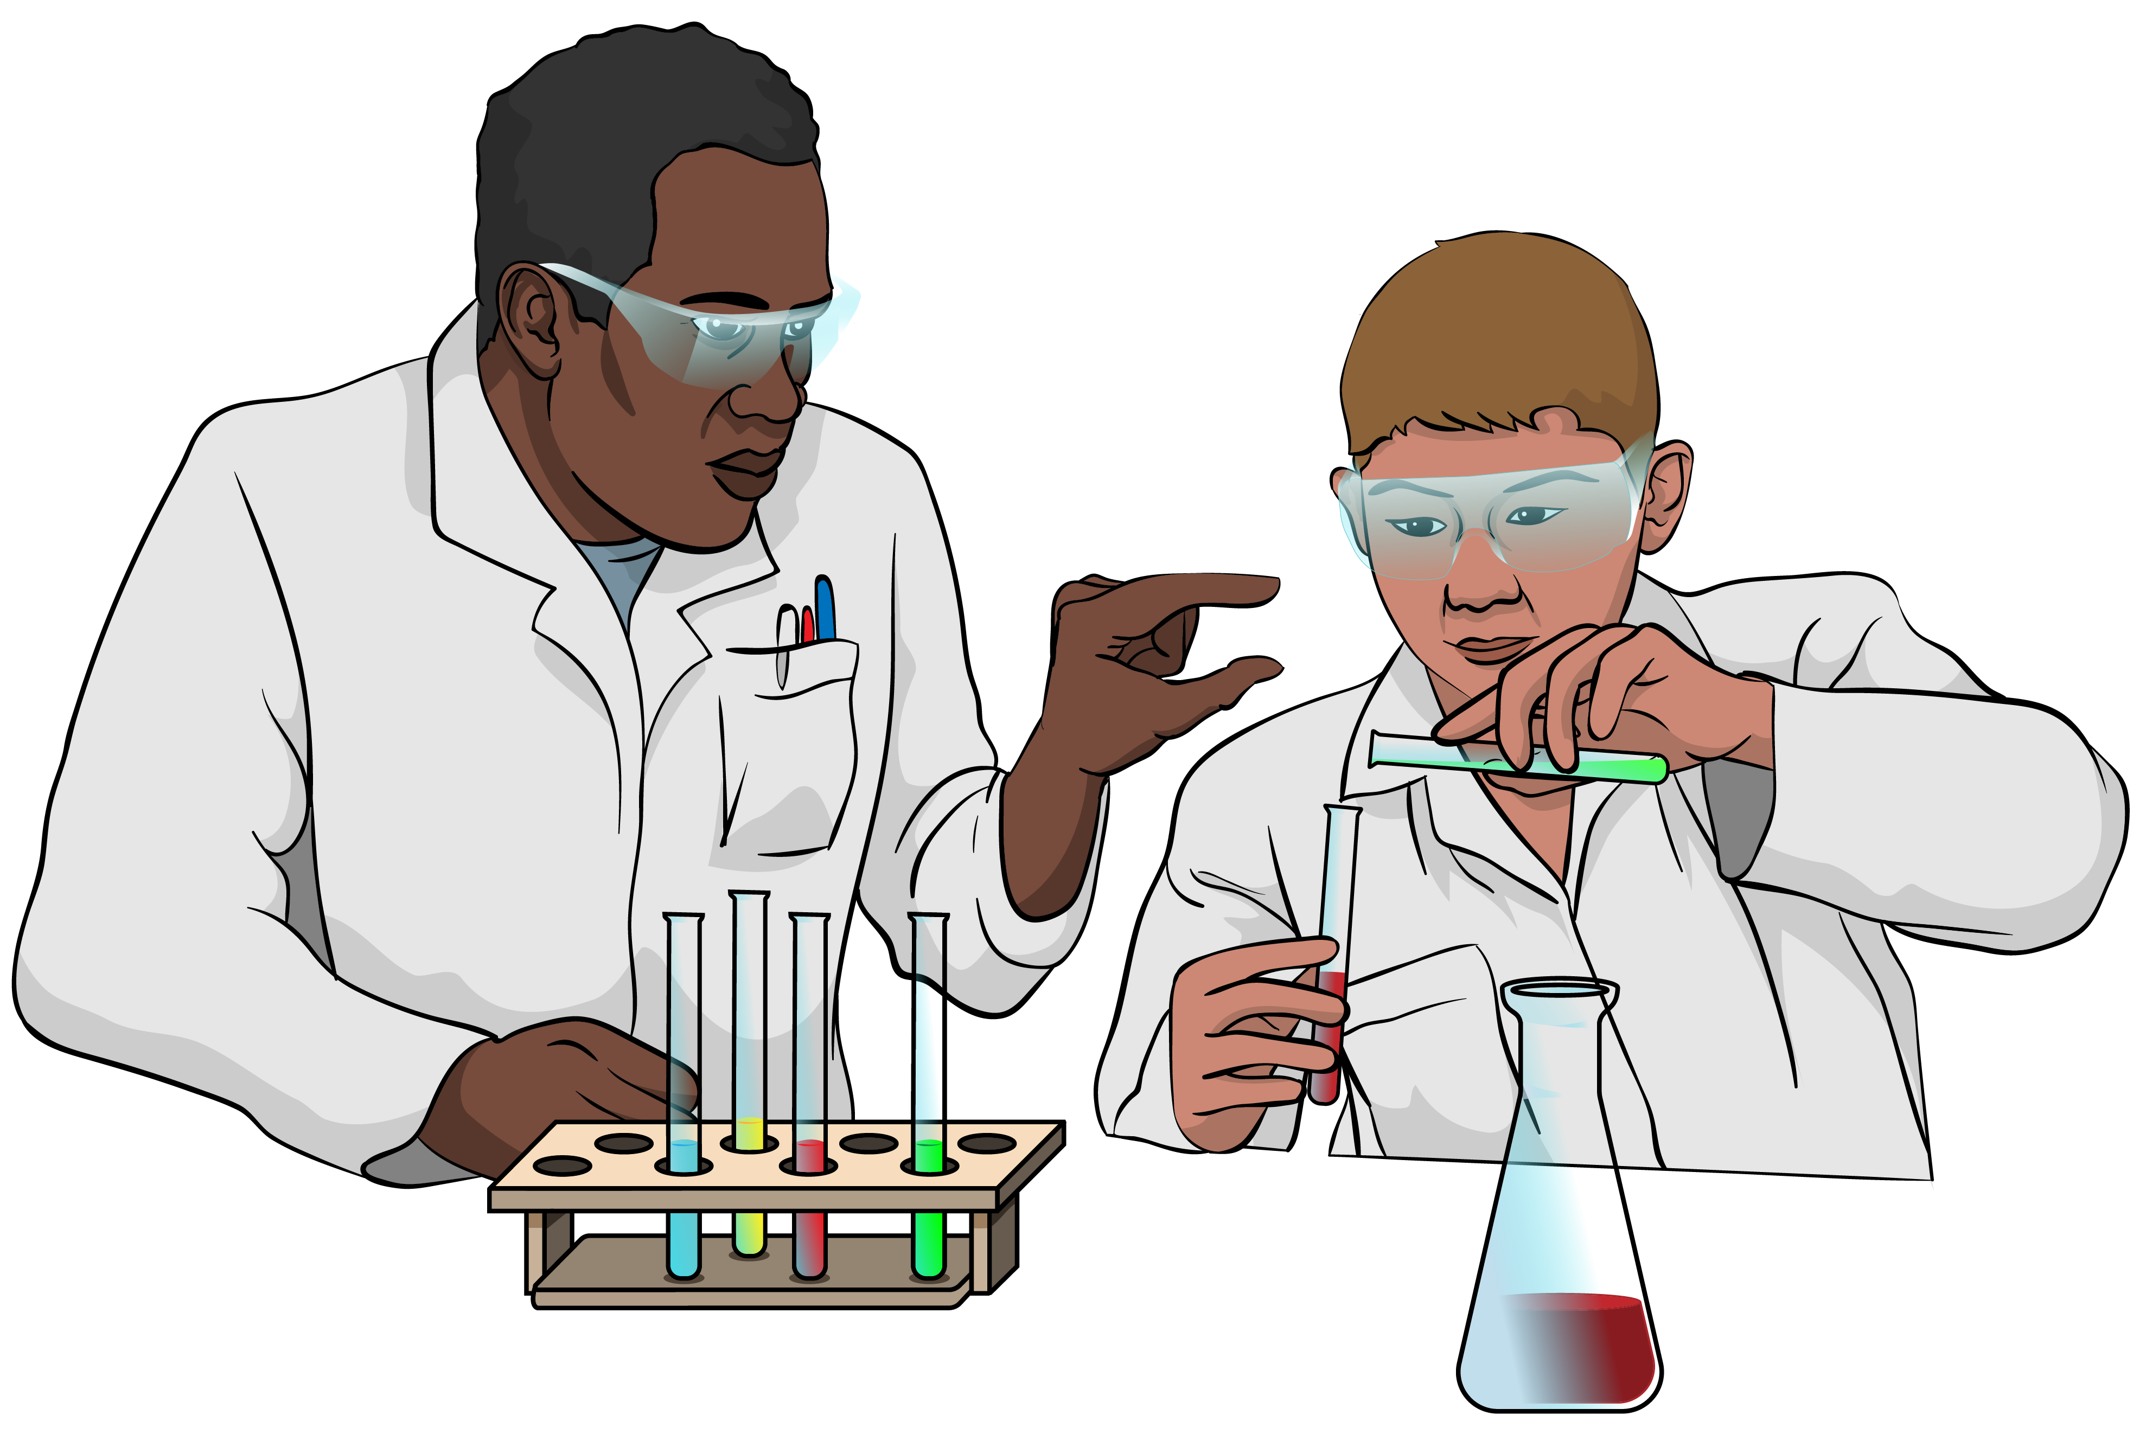
The Ministry of Education does
things like:
deciding what schools should teach
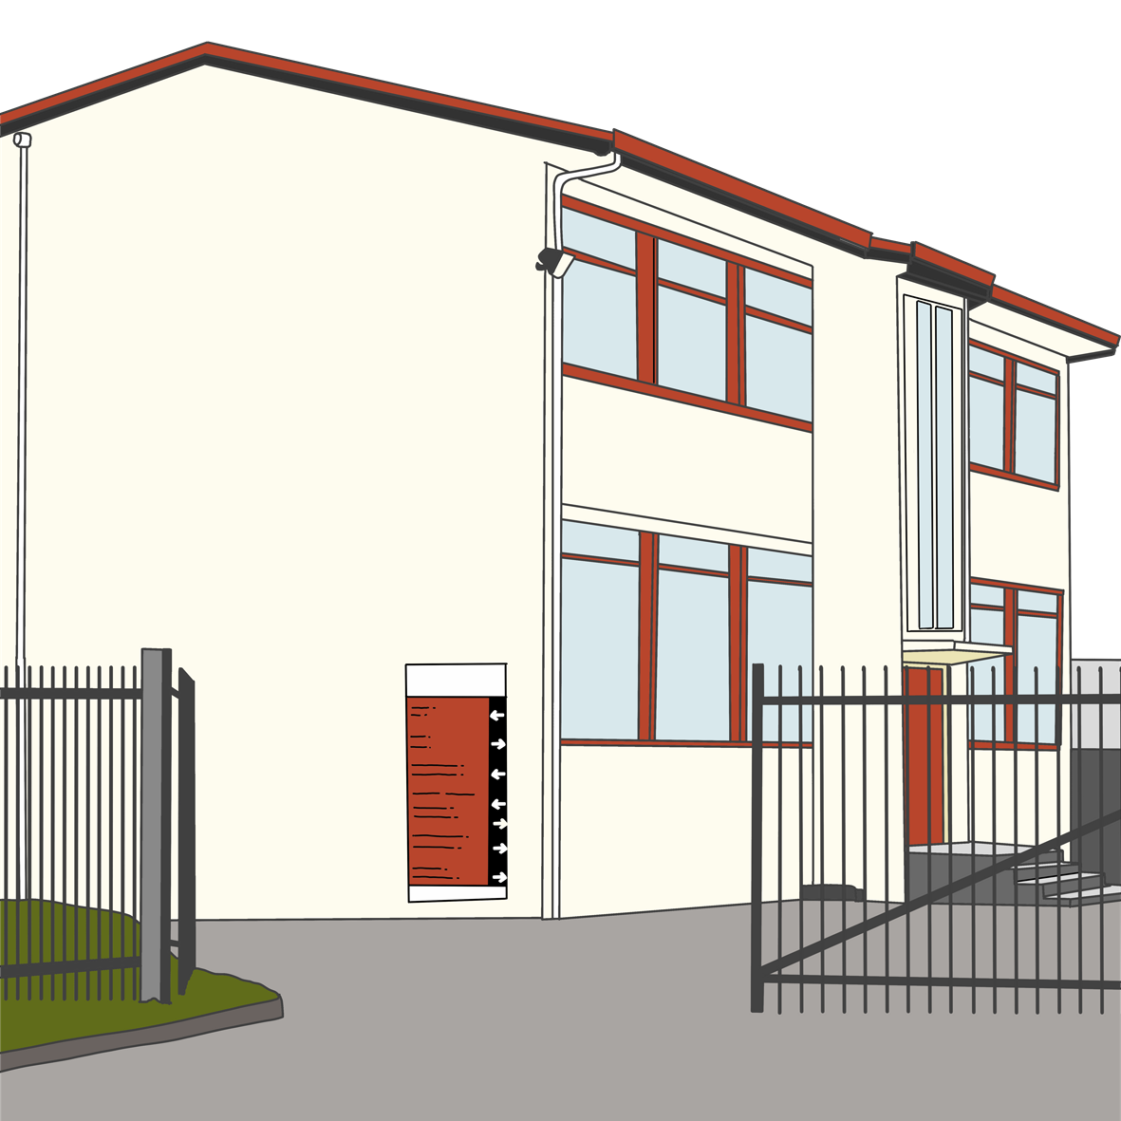
supporting children who need extra support with their learning
building new classrooms.

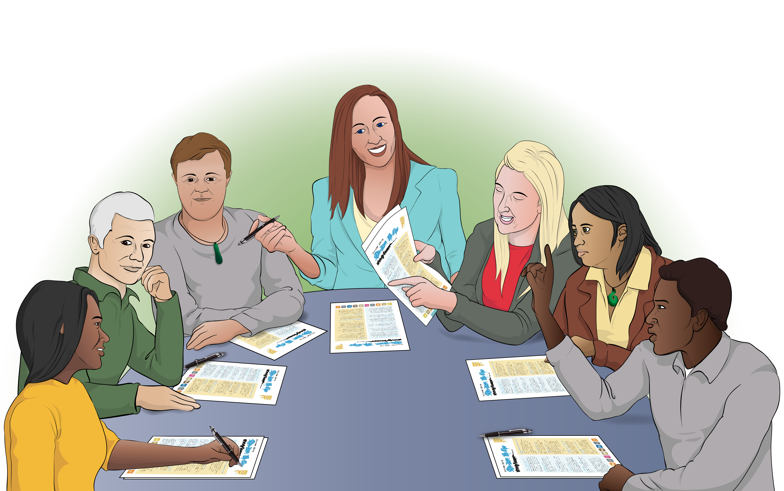
The New Zealand Sign Language Board has a plan to make sure people can use New Zealand Sign Language in all parts of their life in Aotearoa New Zealand.


The New Zealand Sign Language Board is a group of people who:
use New Zealand Sign
Language
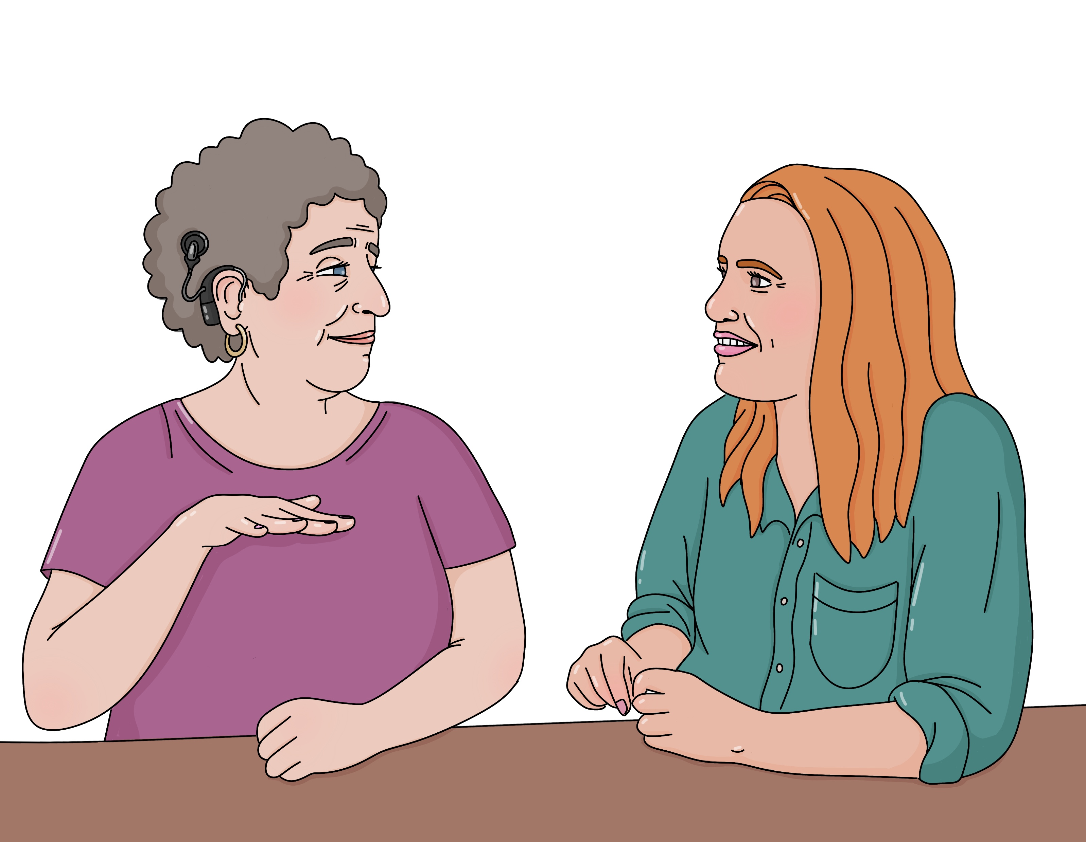
know a lot about New Zealand Sign Language
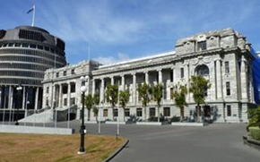
give advice about New Zealand Sign Language to the:
- Government
- community.

The development map supports the plan from the New Zealand Sign Language Board.

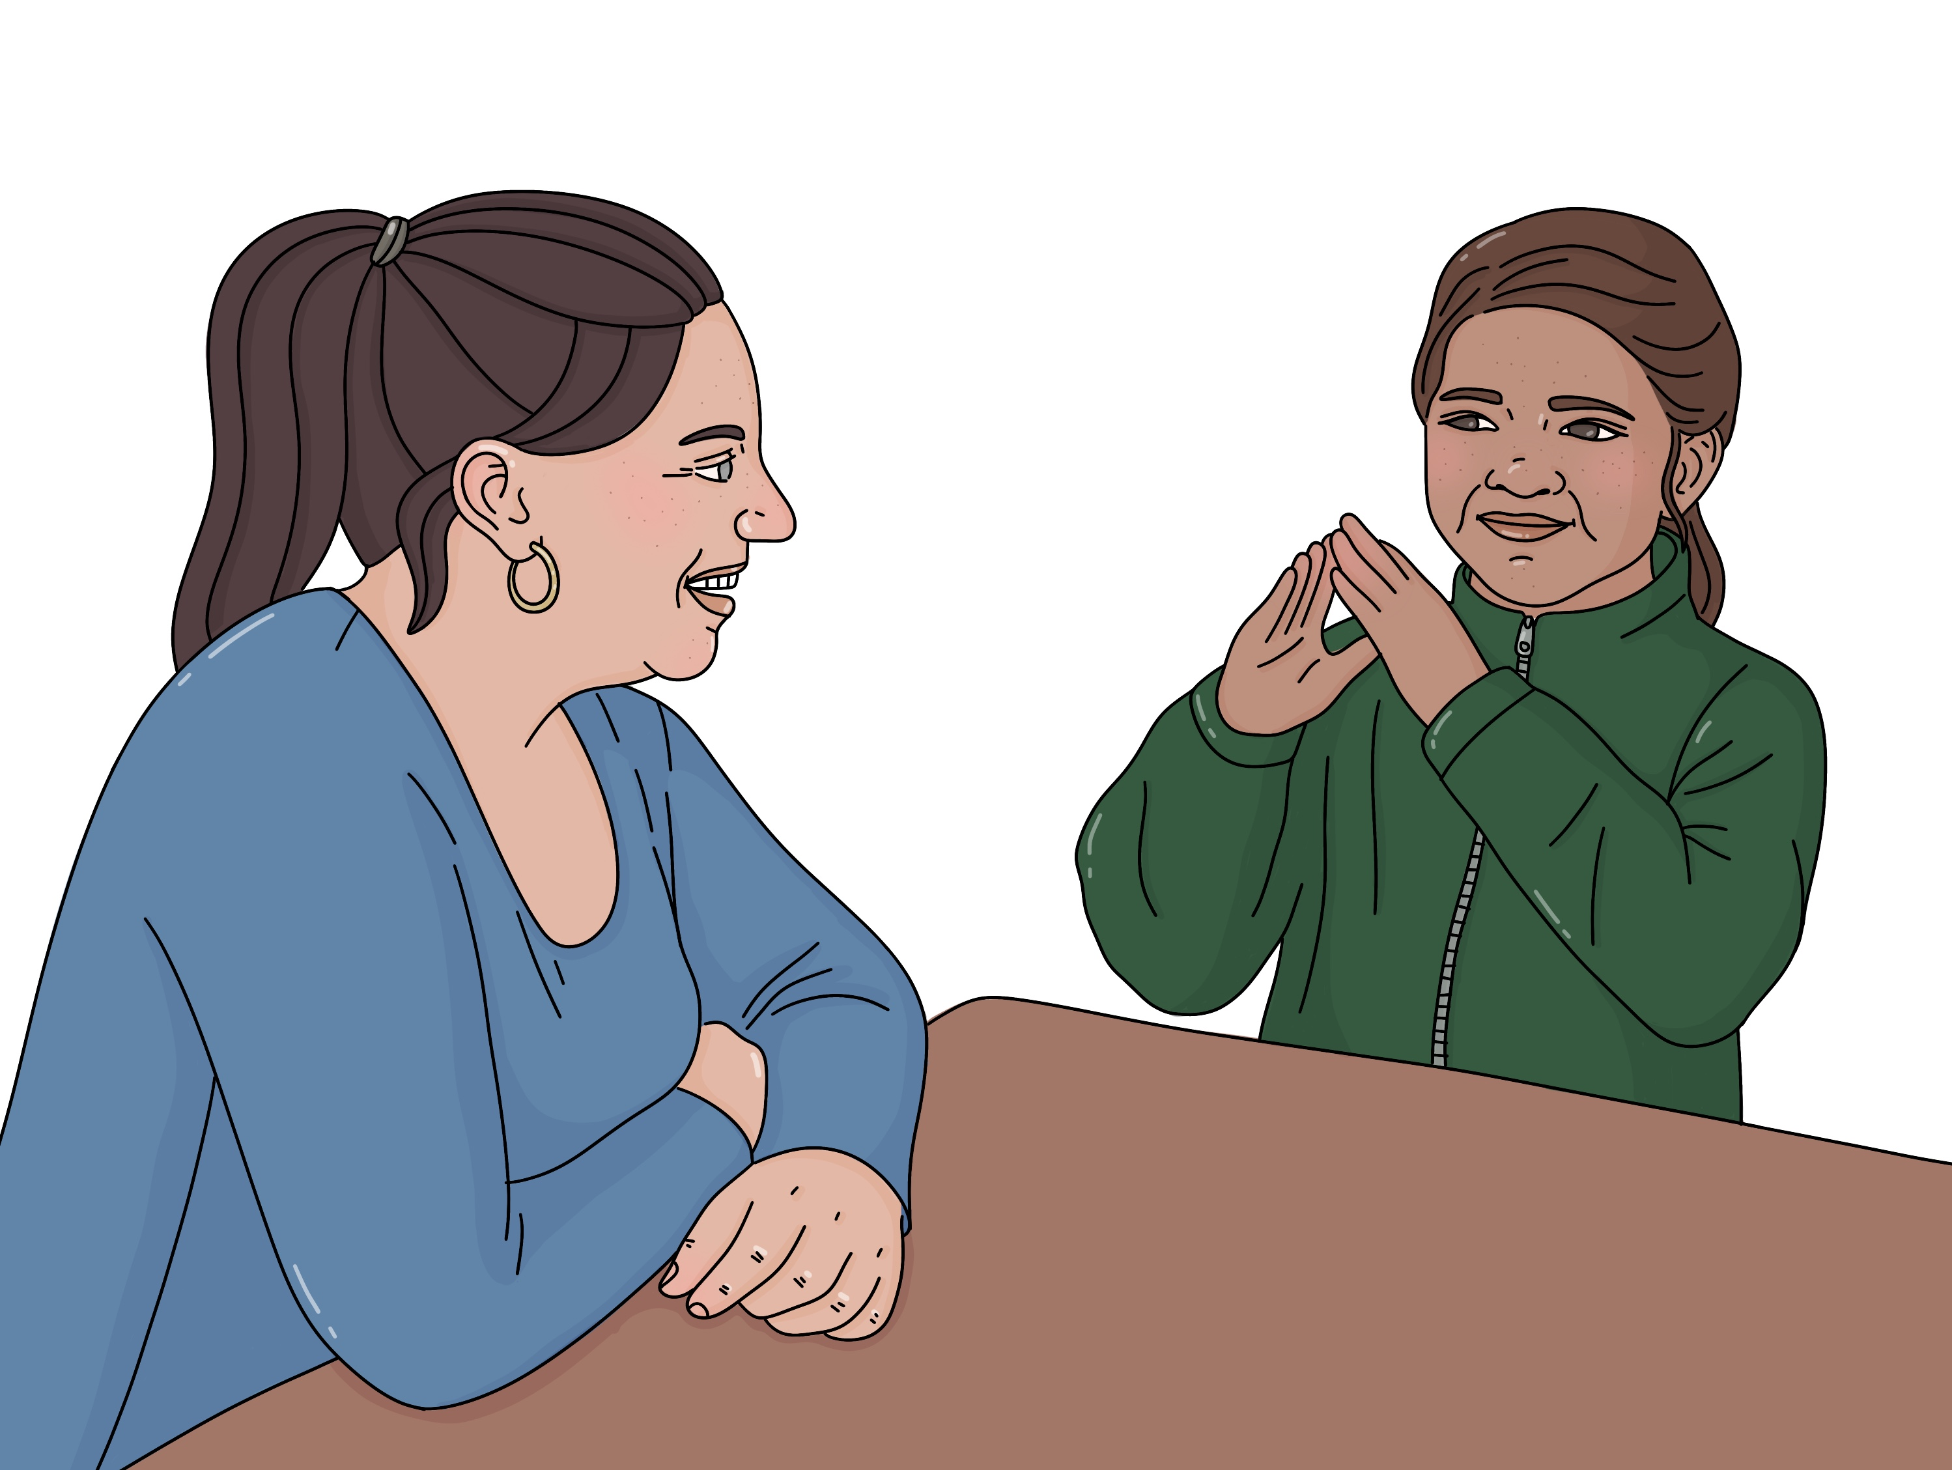
In the rest of this Easy Read we will call New Zealand Sign Language NZSL for short.

Recommendations from the Chief Ombudsman

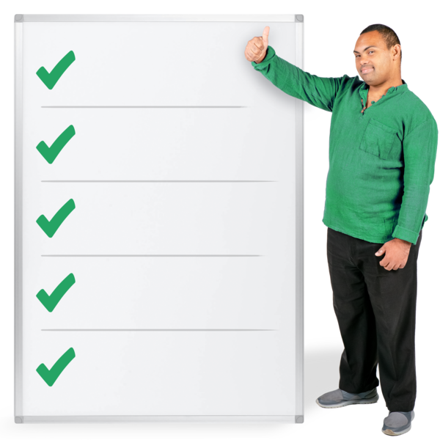
The Chief Ombudsman gave the Ministry of Education some recommendations about the development map.

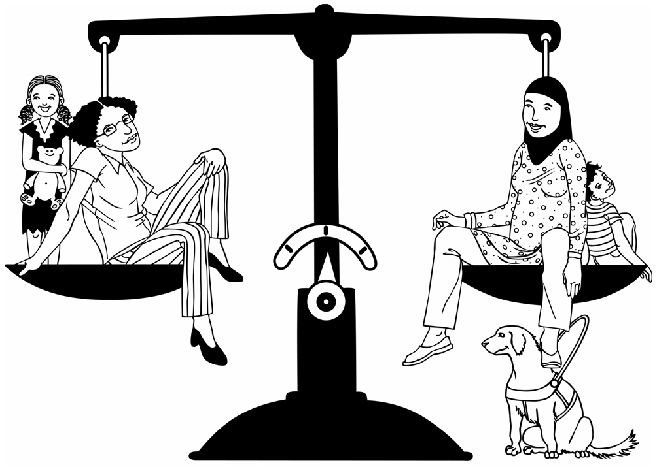
The Chief Ombudsman makes sure the Government works fairly for all New Zealanders.

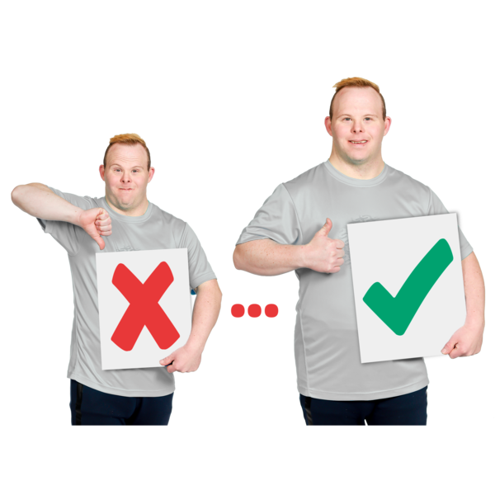
Here recommendations are things the Chief Ombudsman thinks the Ministry of Education needs to do to make the development map better.

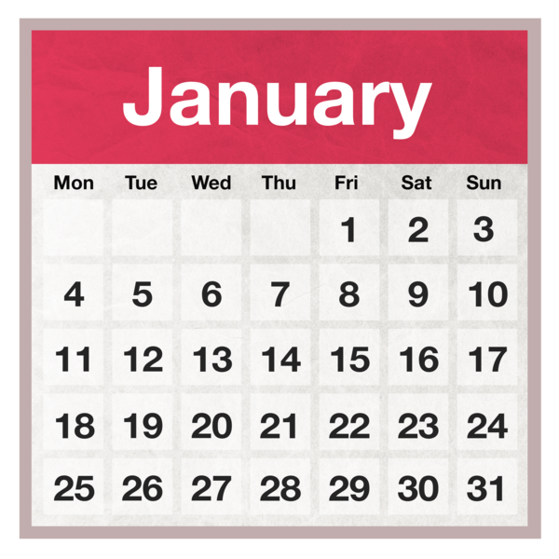
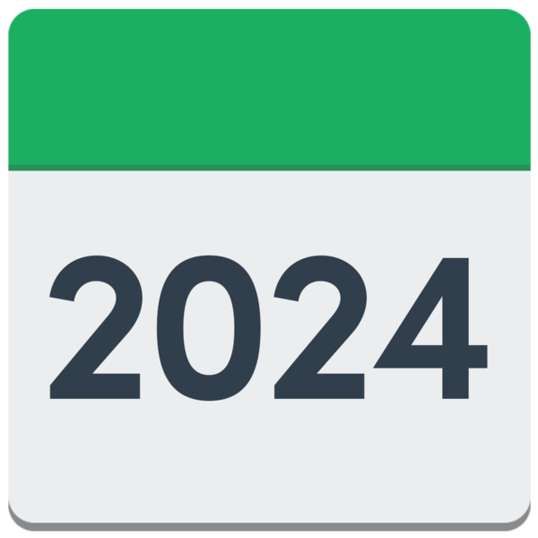
In January 2024 the Ministry of Education said they would do all the things the Chief Ombudsman recommended.

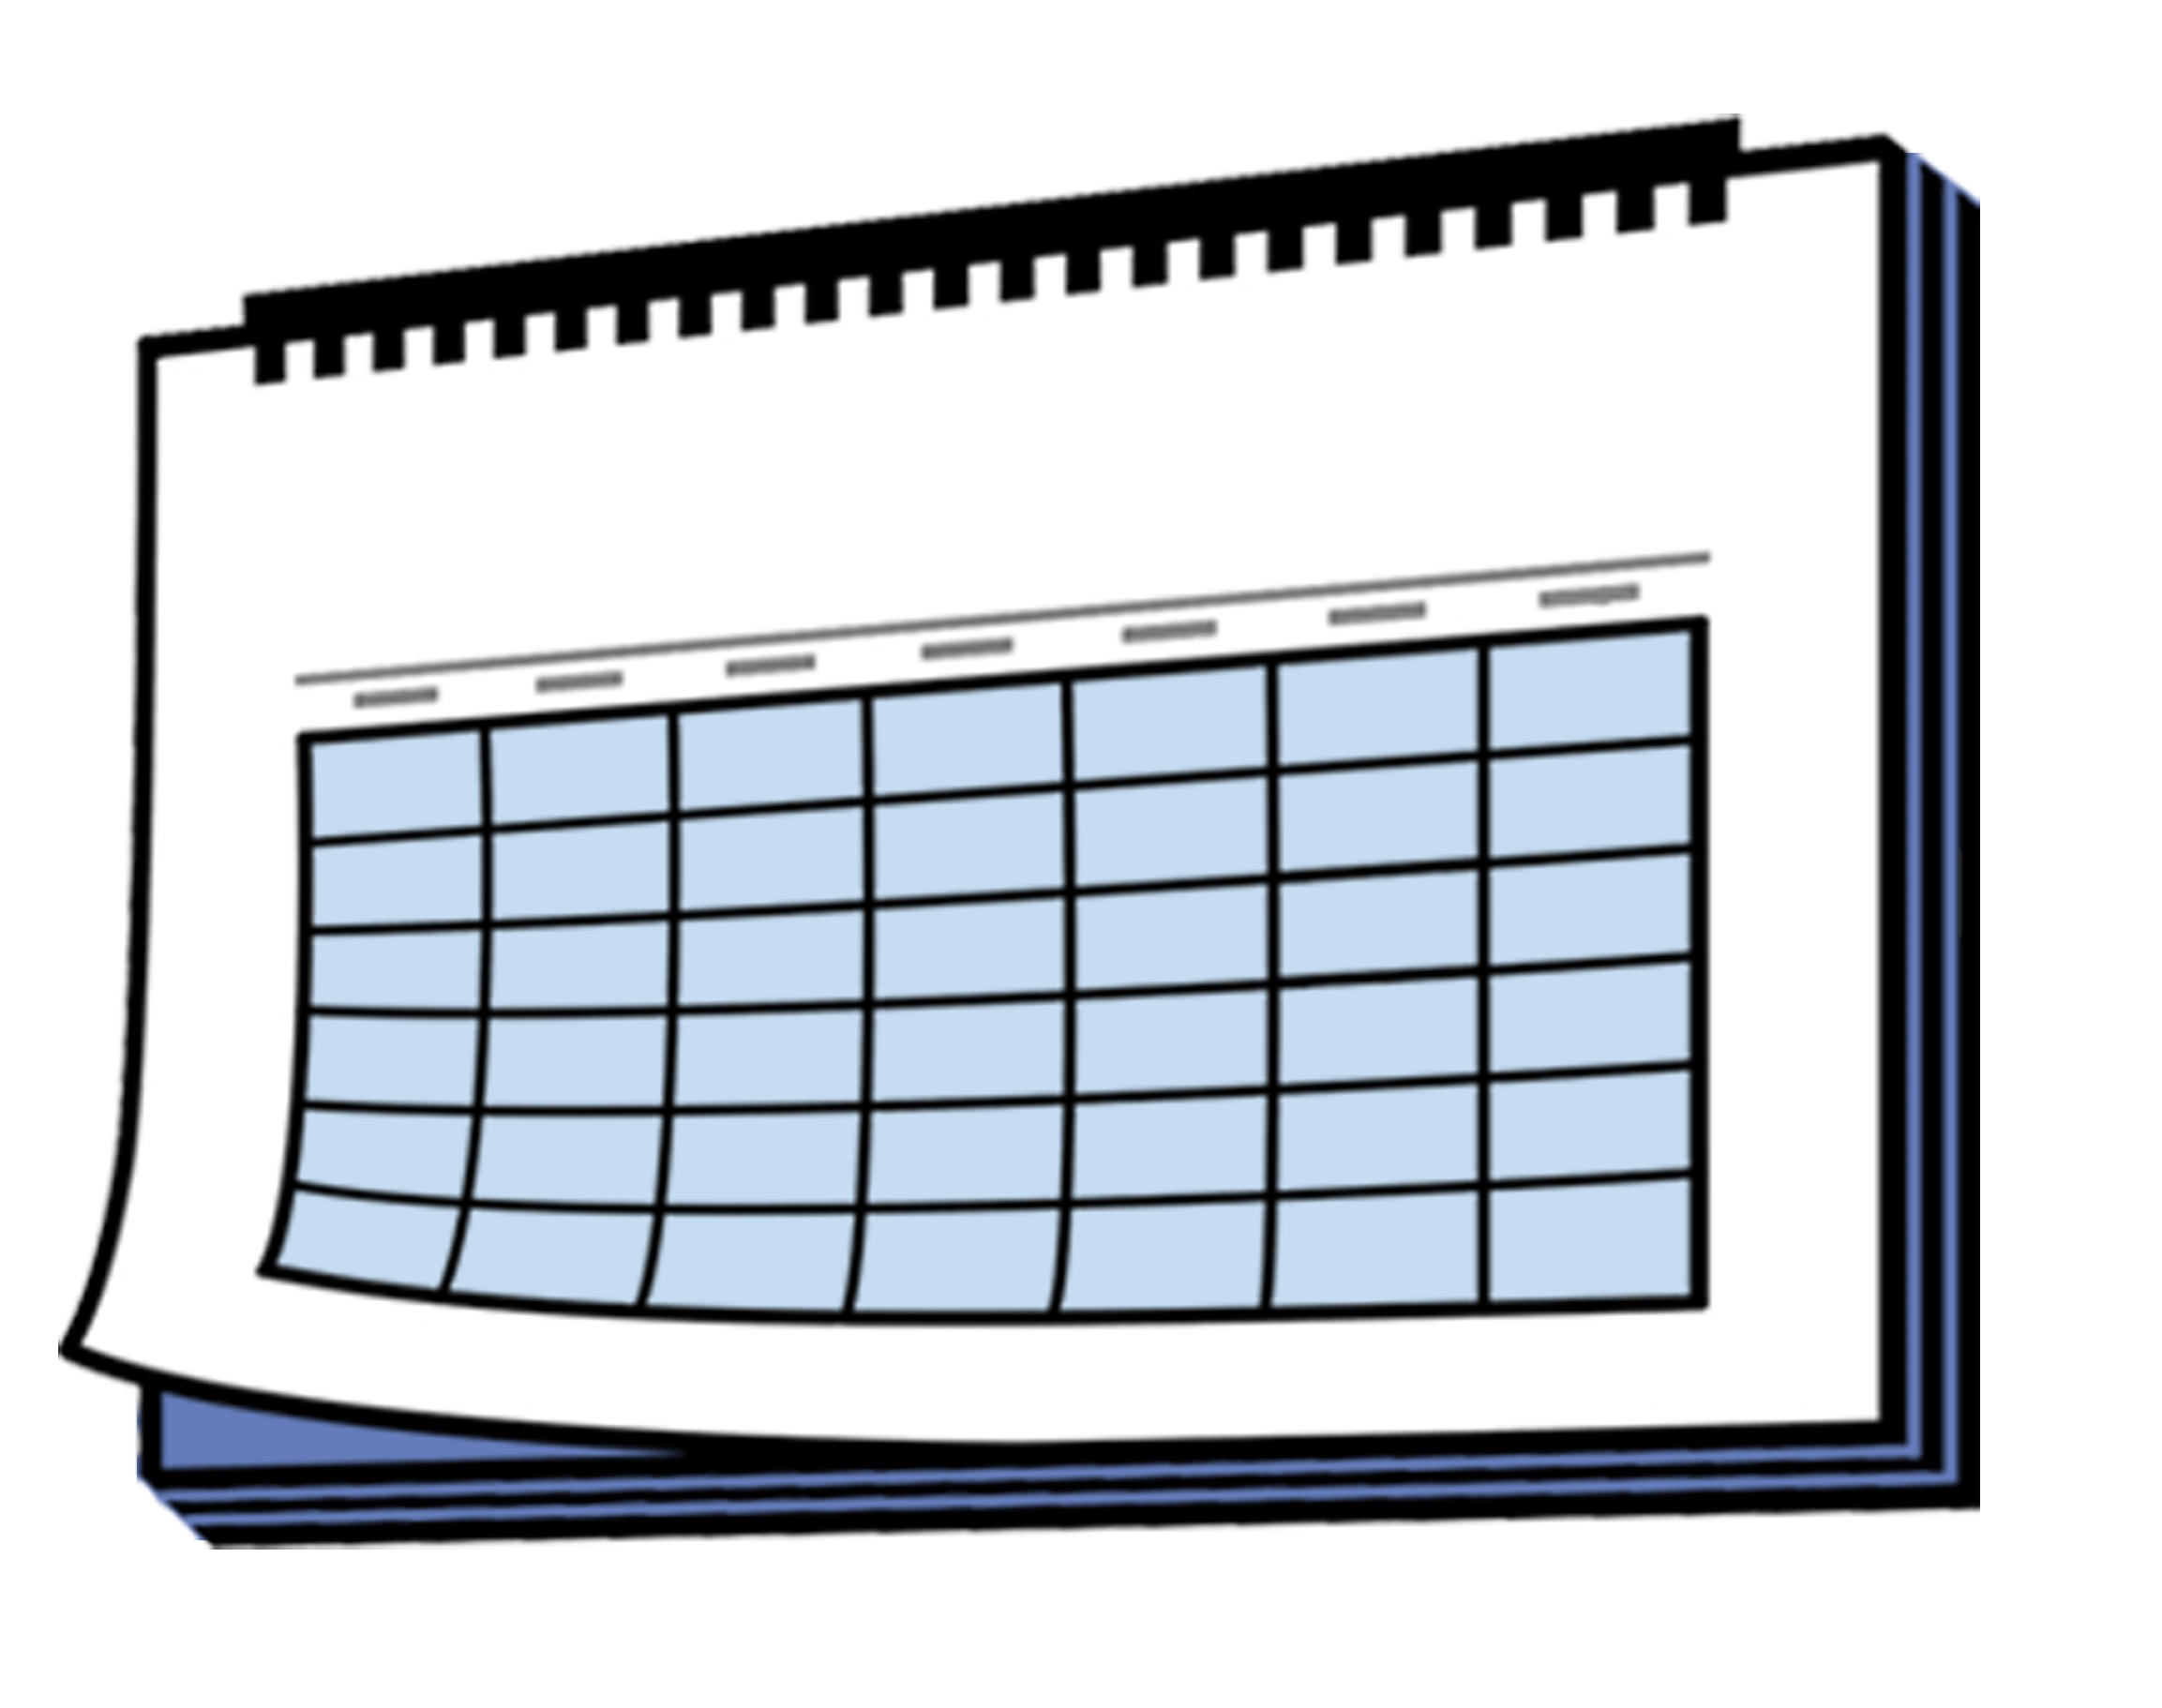
The Chief Ombudsman said the Ministry of Education should update the development map within 1 year.

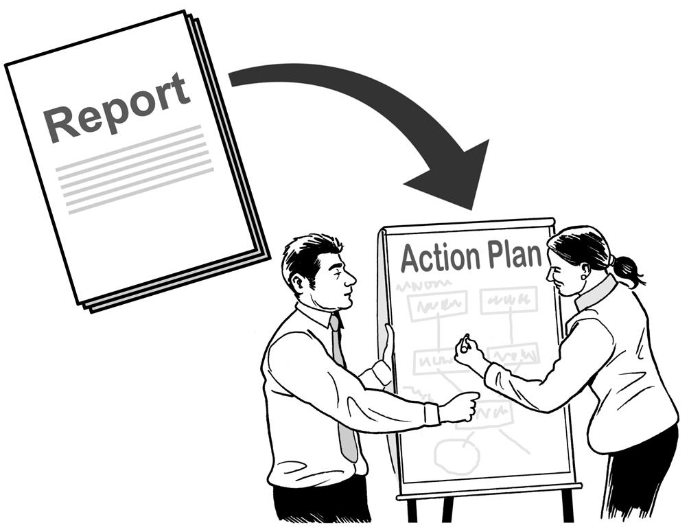
The Chief Ombudsman said the Ministry of Education should:
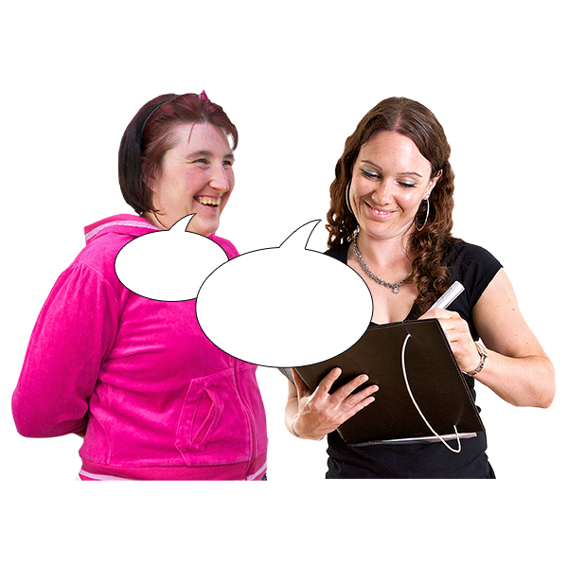
say how they would reach each goal in the development map
talk to key stakeholders about how to reach the goals in the development map.


Here a goal is something the
Ministry of Education is working to make happen.

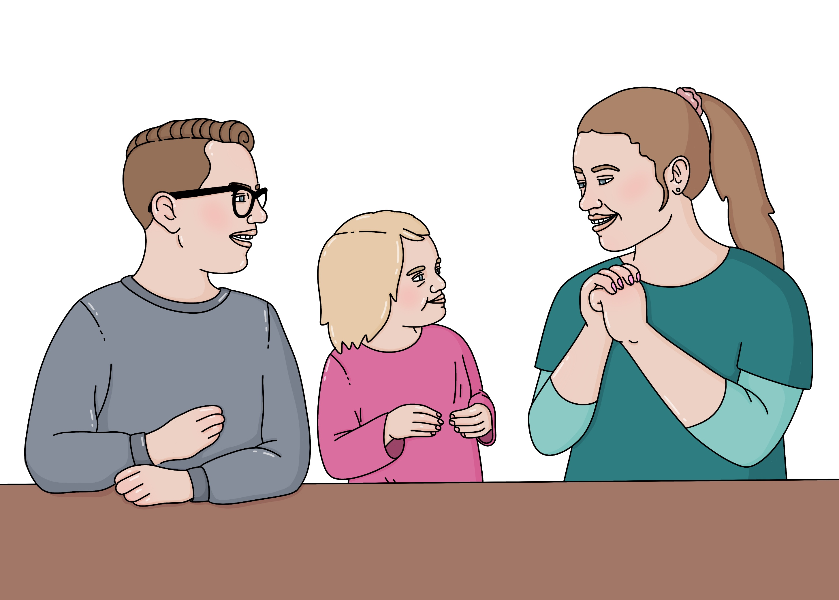
The goals in the development map are about supporting children and young people who use NZSL to do well at school.

Here key stakeholders are people who:
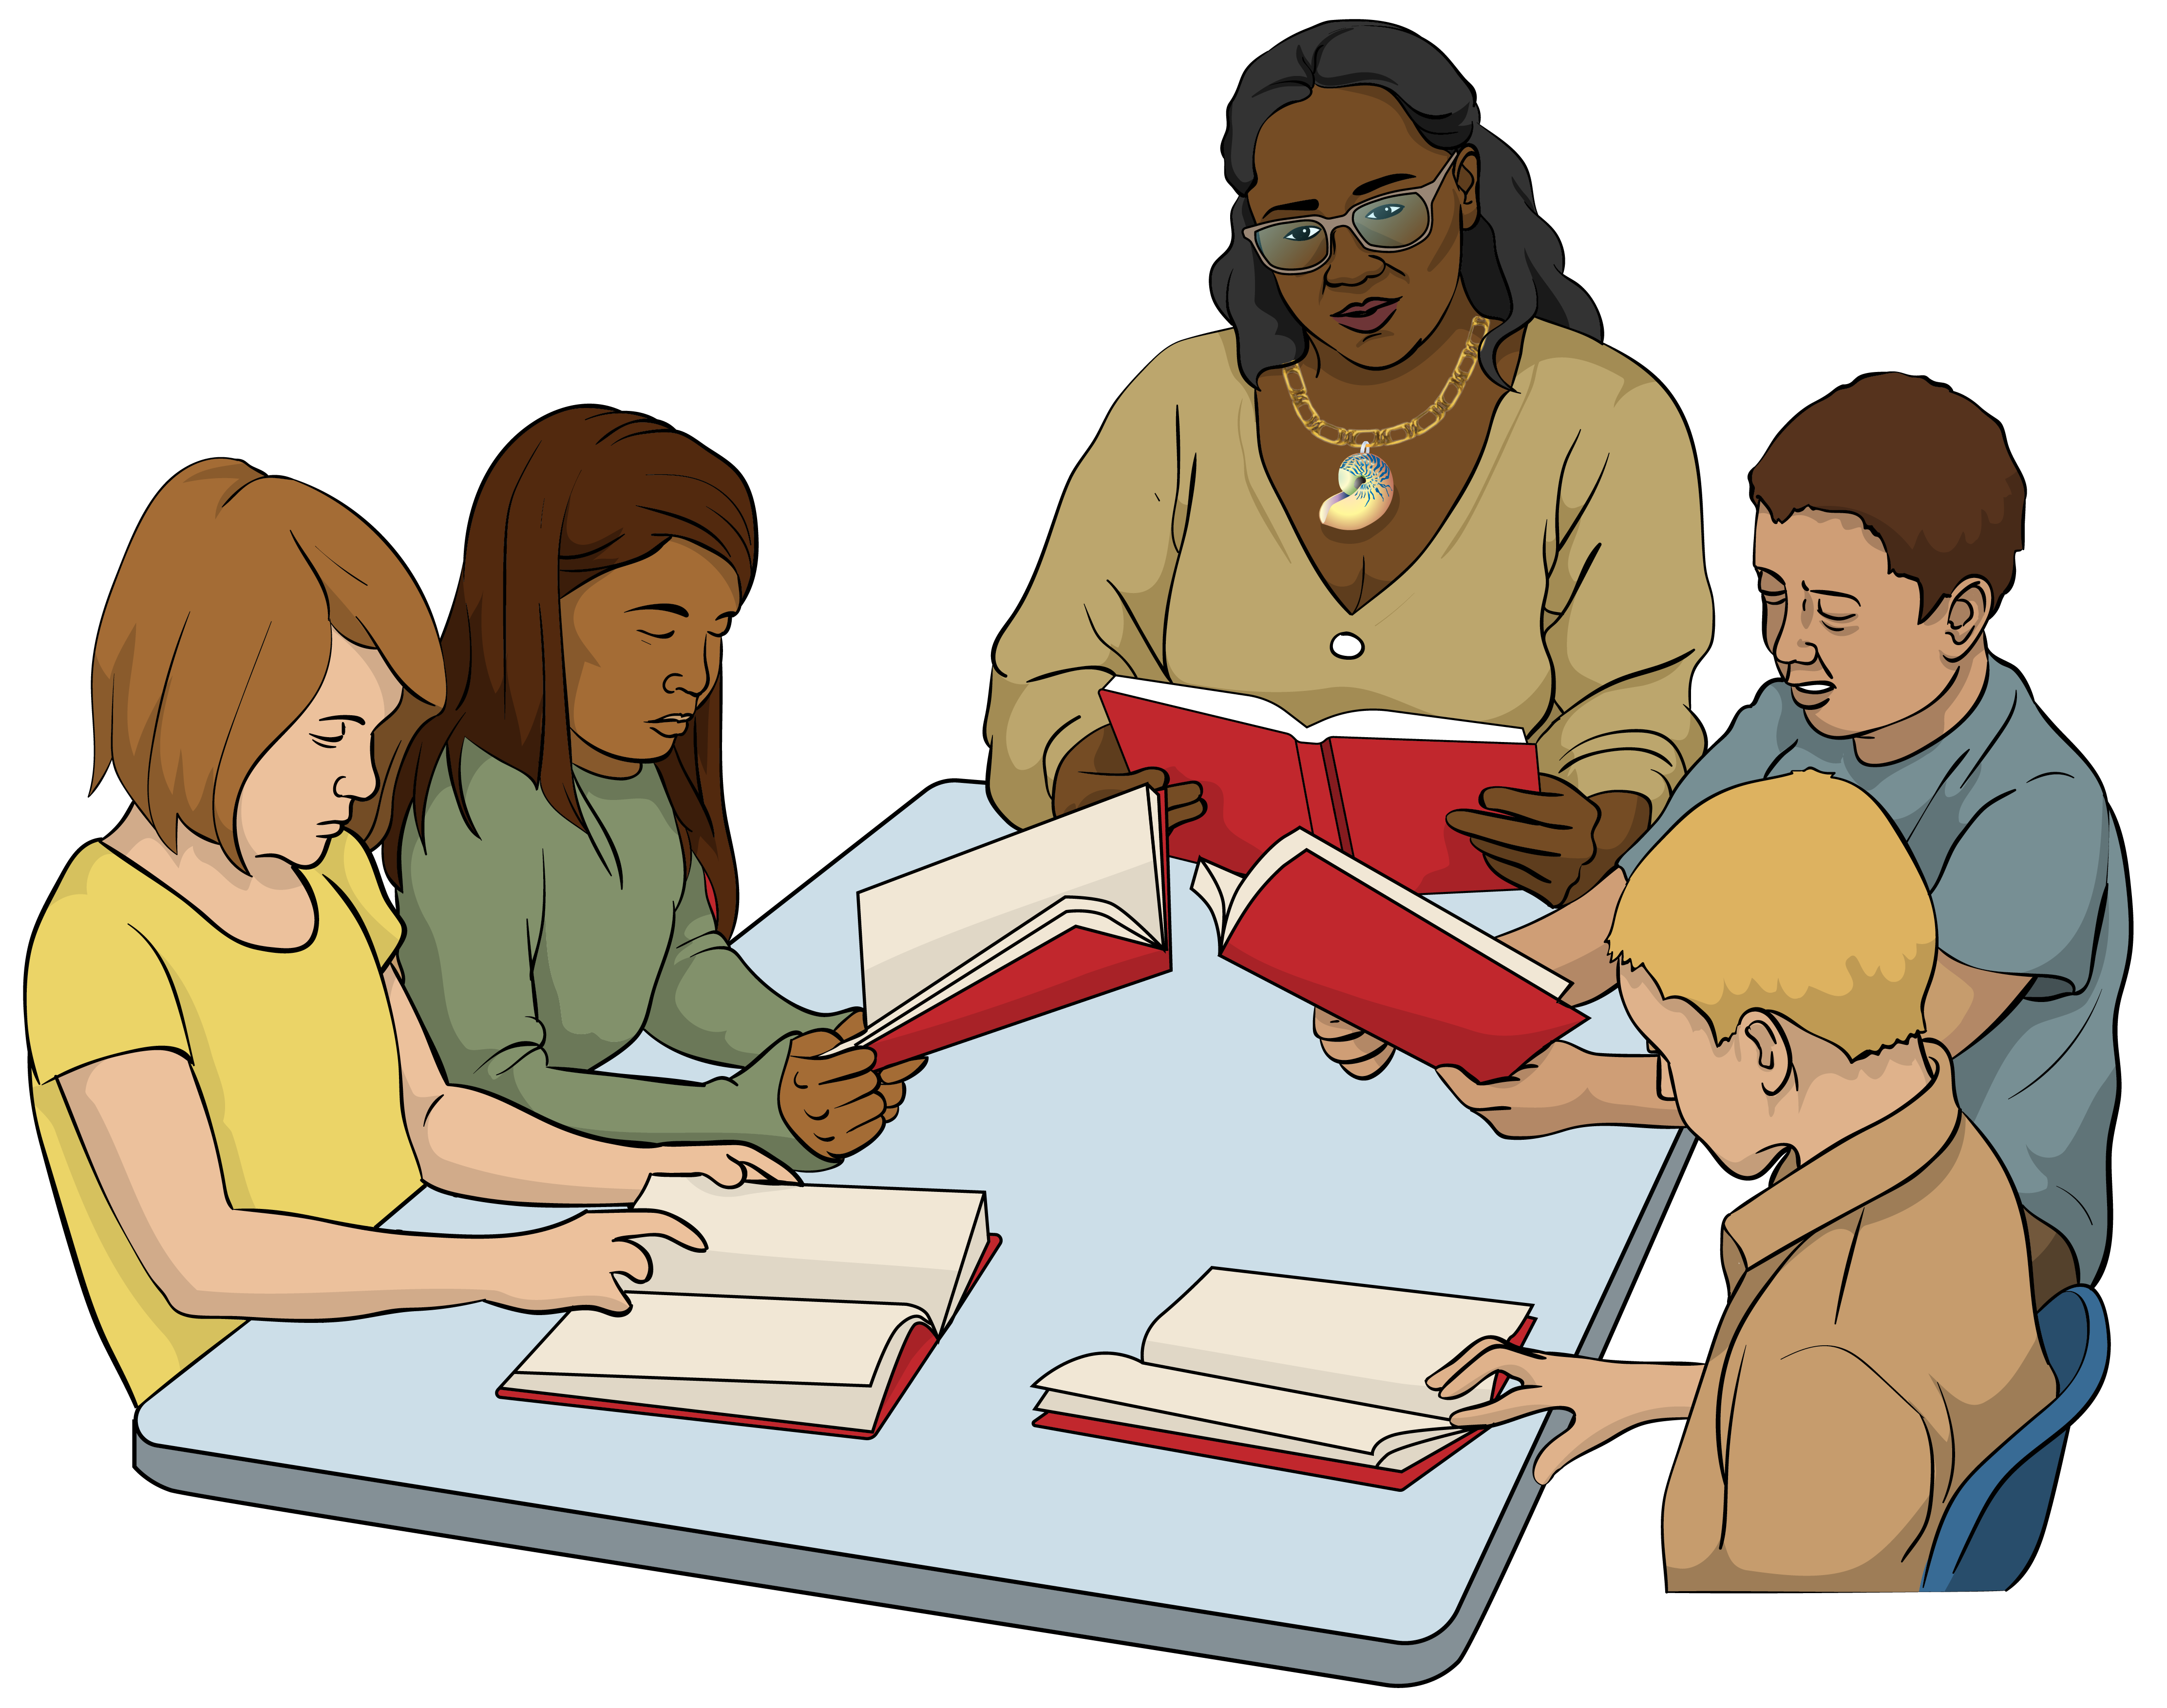
know a lot about what it is like to use NZSL at school
care about making sure children and young people who use
NZSL can do well at school.

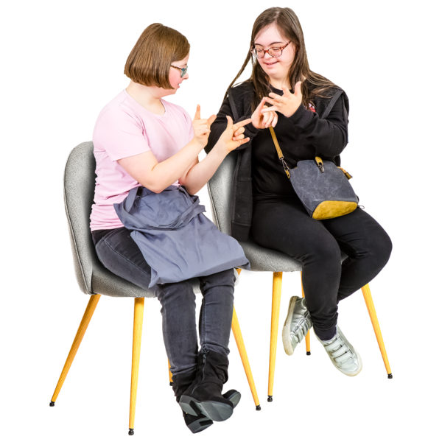
Some examples of key stakeholders are:
children and young people who use NZSL
their whānau / families
teachers.

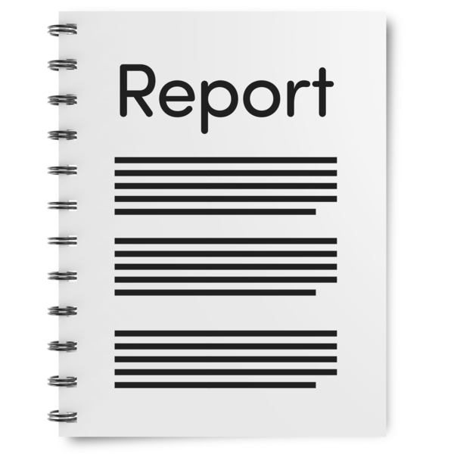
The Chief Ombudsman also said the Ministry of Education should give him a quarterly progress report.

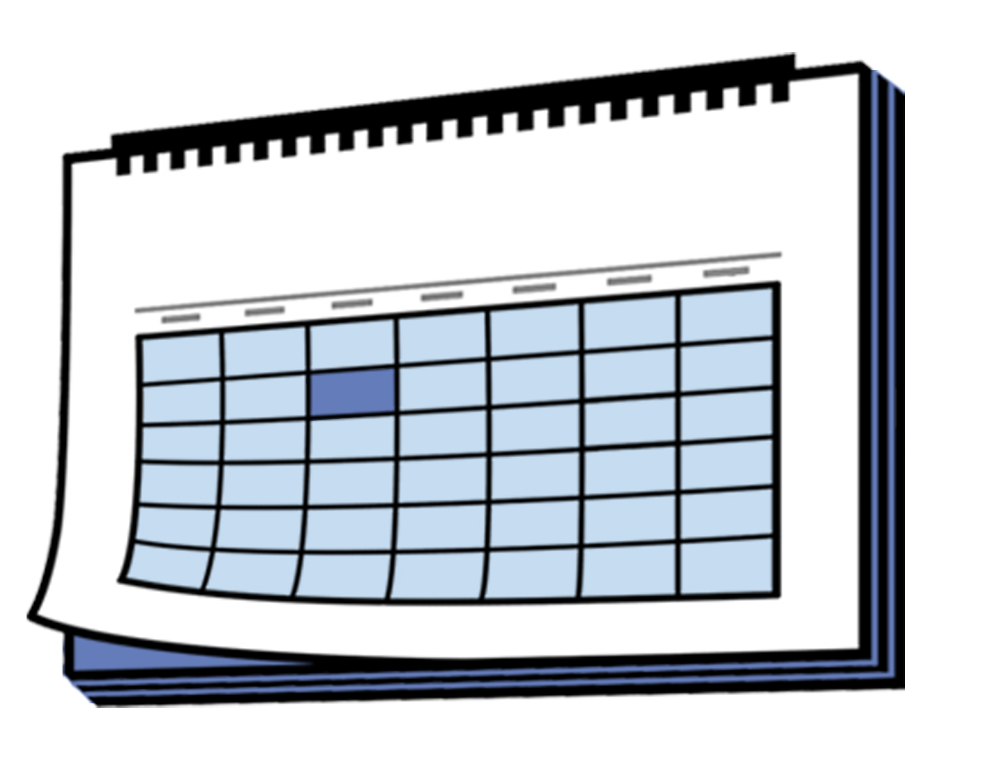
A quarterly progress report:
is written every 3 months
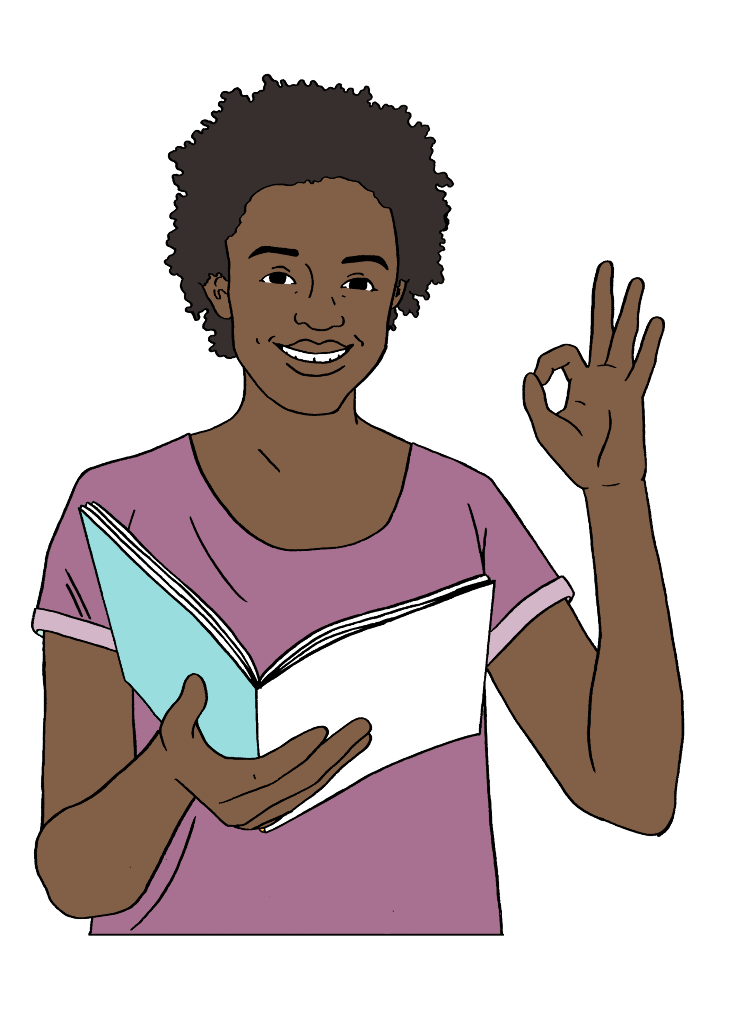
tells the Chief Ombudsman what the Ministry of Education is doing about his recommendations.

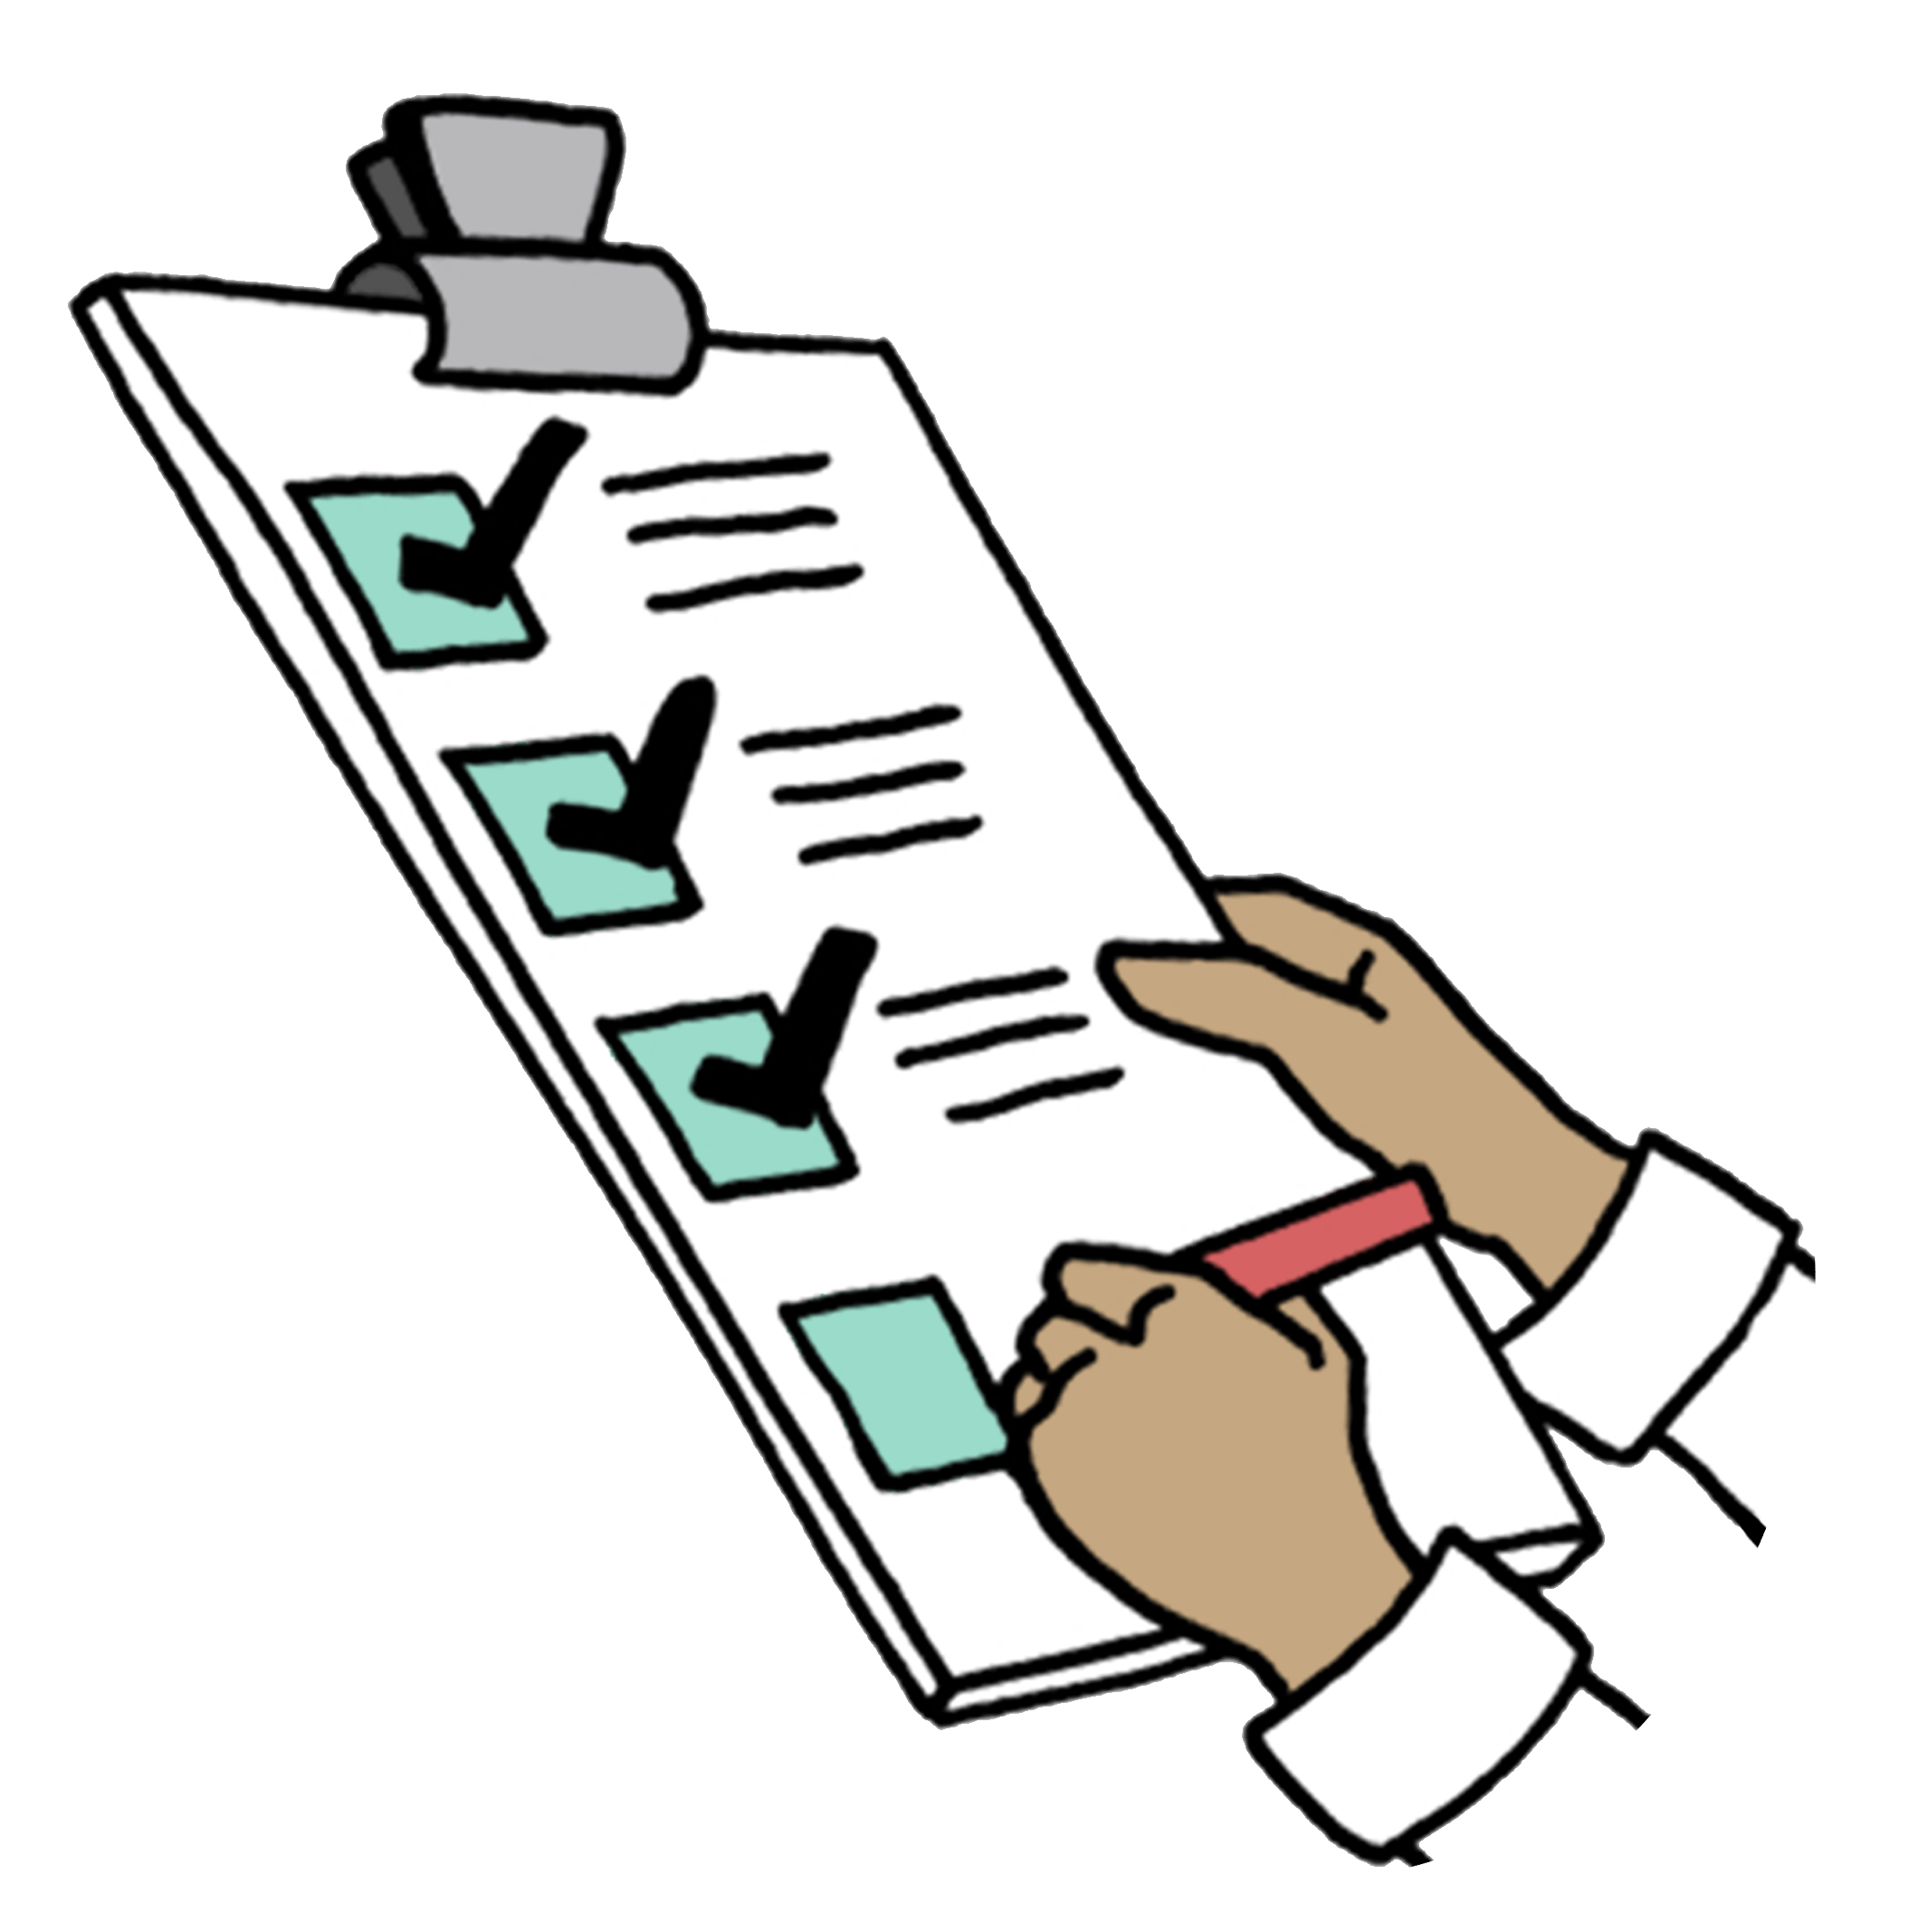
The Chief Ombudsman said the quarterly progress reports should say:
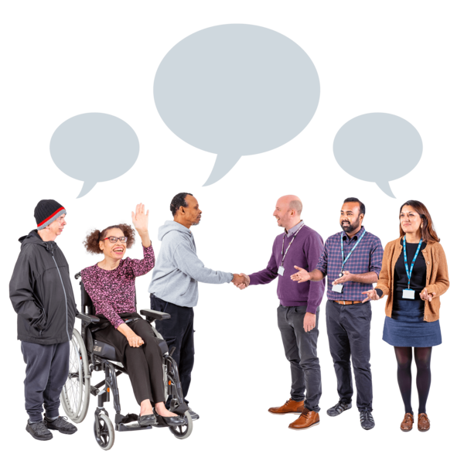
what the Ministry of Education has done to update the development map
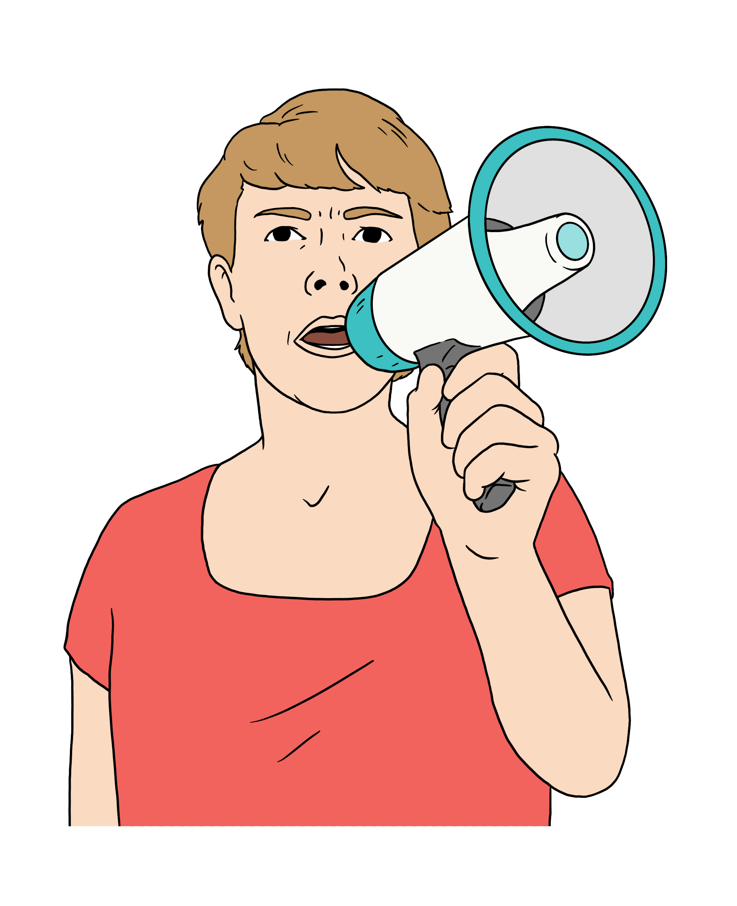
how they have talked to key stakeholders about updating the development map
how they plan to:

- tell people about the updated development map
- check if school is getting better for children and young people who use NZSL.

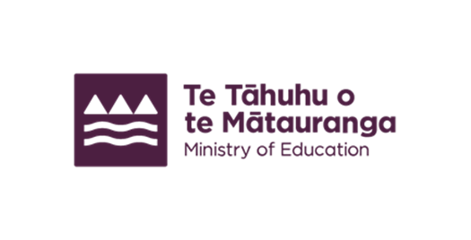
This information has been written by the Ministry of Education.

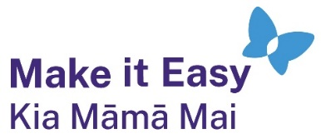
It has been translated into Easy Read by the Make it Easy Kia Māmā Mai service of People First New Zealand Ngā Tāngata Tuatahi.
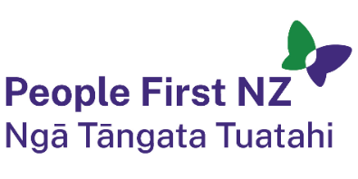
The ideas in this document are not the ideas of People First New Zealand Ngā Tāngata Tuatahi.

All images used in this Easy Read document are subject to copyright rules and cannot be used without permission.


Make it Easy uses images from:

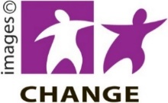
- Photosymbols

- Change Images

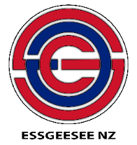
- Huriana Kopeke-Te Aho
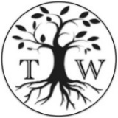
- SGC Image Works

- T Wood

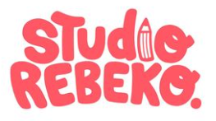
- Studio Rebeko

- Inga Kramer.

