# Rapid payments for sensitive claimants who attended Waimokoia/Mt Wellington Residential School

Our optional rapid payment process means we can make settlement offers very quickly to people who attended Waimokoia Residential School (also known as Mount Wellington). The process will be extended to McKenzie and Campbell Park schools as soon as possible. Almost half of the claims we have received relate to one of these three schools.

If you attended Waimokoia Residential School, you have the choice of whether to have your claim processed under the rapid payment or the full assessment process.

|  |  |  |
| --- | --- | --- |
|  | **Rapid payment** | **Full Assessment** |
| Interview with assessor | Not available | You can choose to meet with an assessor, but you don’t have to |
| Assessment of allegations | Allegations are not collected or assessed, though you are welcome to provide us with a list of allegations | Allegations are collected and considered by an assessor |
| Wellbeing support | The same wellbeing supports are available for all claimants, regardless of which process you choose | |
| Payment amounts | Payments are designed to reflect average payments under full assessment, but payments to individual claimants could be lower in cases of severe abuse by a convicted offender | Payments are based on assessor findings, calculated with reference to similar resolved claims to maintain consistency |
| Legal fees | We will reimburse your actual and reasonable legal fees, including Legal Aid | |
| Redress options | Financial payment and apology | Flexible – most people want a financial payment and apology, but we will discuss this with you and can be flexible |
| Apology | Apology from the Secretary for Education acknowledging what happened during the decade you attended | Apology from the Secretary for Education acknowledging your allegations |
| Records | You can access your personal records under the Privacy Act 2020 | |

**Flow chart showing the rapid payment process**

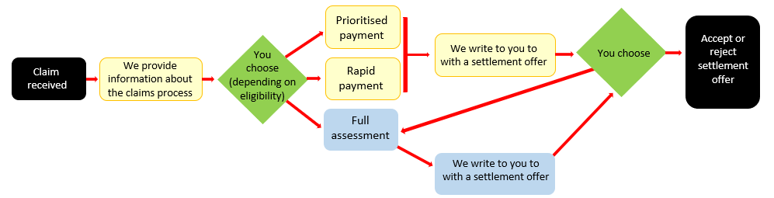

**Who is eligible?**

If you believe you were abused (physical, sexual, psychological), neglected or mistreated when you attended **Waimokoia** **Residential School** and **this experience has harmed you** in some way you will meet the criteria for the rapid payment process.

You can still access a rapid payment if your claim is about Waimokoia school and another school/s. The Waimokoia part of your claim can be processed as a rapid payment, while the rest of your claim will be assessed under our regular process, and under usual timeframes.

**Settlement offered**

The settlement offered under the rapid payment process is a financial payment, payment of any actual and reasonable legal fees and an apology from the Secretary for Education.

Under the full assessment process we collect your allegations and respond to them. We won’t do this under the rapid payment process. You will be offered an apology for what happened during the time you attended the school, but it won’t talk about your allegations.

We have made standard findings for settlement purposes about what happened at Waimokoia and will offer you a payment based on when you attended. We based settlement payments on the standard findings. You can read the standard findings on our website.

**Payments ­– explained**

Rapid payment offers are set payments for each decade that Waimokoia was open. These payments are based on ‘standard findings’ and are designed to reflect average payments under the full assessment process, which are around $15,000 to $18,000. Payments we have made under the full process have ranged from $0 to $45,000 (for extremely serious abuse by a convicted offender).

You will be offered a payment for settlement purposes depending on the decade you attended Waimokoia. Note that if you attended Waimokoia over two decades, you will not receive payments for both decades – if one of the decades you attended has a higher payment associated with it, you will be offered the higher of the two payments.

|  |
| --- |
| For example, if you attended Waimokoia in:   * 1963 and 1964 you will be offered $5,000. This is the payment level for students who attended in the 1960s. * 1969 and 1970 you will be offered $10,000. This is the payment for students who attended in the 1970s. |

During decades where we have found information that shows some staff may have abused children during a certain time period, an extra payment will be made to reflect this.

|  |
| --- |
| For example, if you were living at Waimokoia between November 1960 and January 1961 you will be eligible for a payment of $15,000. This is made up of:   * A standard payment of $5,000 for all students attending Waimokoia in the 1960’s. Our research found there were some supervision issues during the 1960s that meant sexual and/or physical abuse could have occurred between students. * A specific payment of $10,000 if you lived at the school between November 1960 and January 1961. Our research found that a staff member working at the school during this time may have sexually abused some students. |

You can find the standard findings we have made for settlement purposes and payments on our website. You can also read a report about Waimokoia on our website.

**Processing requirements and times**

If you would like to request a rapid payment please get in touch with us to discuss your needs. If you haven’t provided it already, you will need to provide information to verify your identity and we will need to confirm your claim is eligible for our claims process.

We are usually able to make a rapid payment offer within 4 weeks of receiving your claim.

**The rapid payment process is optional**

***You do not have to choose a rapid payment offer***.

Full assessments take longer than rapid payment offers. You can read about how we assess claims under our full assessment process [on our website](https://www.education.govt.nz/our-work/our-role-and-our-people/contact-us/historic-claims-for-abuse-or-neglect-at-a-residential-special-school/)­.

You can talk to a lawyer at any time to get advice on the Ministry’s claims process, including on the rapid payment process. Regardless of which option you choose, we can reimburse actual and reasonable legal costs.

**Collecting information about possible offenders**

If you request a rapid payment, we will ask you whether you can name or describe any possible offenders, so that we can make sure they are not working with children today. This is a very important step to keep tamariki and rangitahi safe.

You do not have to talk to us about this or provide any names or descriptions of abusers to

receive a rapid payment.

**Rapid payment processes will be expanded to McKenzie and Campbell Park**

We are planning to extend the rapid payment process to McKenzie and Campbell Park schools as soon as we can. To do this, we need to finish our research into these schools.

**Wellbeing support available**

If you accept the rapid payment offer you can still receive the same wellbeing support that is available to all claimants.

Help and support is available while you are going through the rapid payment and full claims processes. This includes six counselling sessions which we can pay for. You can also access our wellbeing support service, for more comprehensive and practical support.

**Contact us**

If you have any questions or would like to talk about the support available to claimants contact our sensitive claims team by:

* calling 0800 663 252
* emailing [Sensitive.Claims@education.govt.nz](mailto:Sensitive.Claims@education.govt.nz)

You can also write to us at:

Sensitive Claims

Te Pae Aronui, Ministry of Education

PO Box 166

Wellington 6140