Te Kamo High School

New Enrolment Scheme

Overview – what is changing?

The Ministry of Education regularly monitors enrolment patterns, population growth and anticipated school roll changes across the Te Kamo area. As part of this monitoring and regular review, we now consider an enrolment scheme is necessary for Te Kamo High School. This is due to growth of the school roll and because we need to ensure the Board has a fair and transparent mechanism to manage the roll. It also means we can ensure we are making best use of educational facilities across the wider Te Kamo High School area.

The new enrolment scheme will have a home zone, like other schools with enrolment schemes in the area. Students that live within this area will have entitlement to enrol at Te Kamo High School. The home zone area is shown on the map below and described here:

**TE KAMO HIGH SCHOOL (#13)**

**Proposed Draft Enrolment Scheme**

Commencement date: 1 January 2026

The guidelines for development and operation of enrolment schemes are issued under Schedule 20, Clause 3 (3) of the Education and Training Act 2020 for the purpose of describing the basis on which the Secretary’s powers in relation to enrolment schemes will be exercised.

**Home Zone**

**All students who live within the home zone described below shall be eligible to enrol at the school.**

*All residential addresses on both sides of boundary roads and all no exit roads off included sides of boundary roads are included in the zone unless otherwise stated.*

The southern boundary of the zone begins at the intersection of Kamo Road and Whau Valley Road. The zone travels north up Kamo Road, turns east into Walker Crescent and continues through Rupert Clark Road onto Te Rauponga (SH1). The zone travels north on Te Rauponga, including addresses on the western side of the highway only. From Puna Rere Drive, the zone covers both sides of the highway. At Station Road, the zone travels east and turns into Colenso Street, Ridgeway Drive, Pebble Beach Boulevard, Royal St Annes Drive, and Balmacewan Drive. The zone turns north onto Corks Road and follows it into Gillingham Road, including all Gillingham Road addresses. The zone turns west onto Eden Terrace and follows it back to Station Road. The zone travels west on Station Road to return to Te Rauponga/State Highway 1.

Continuing to travel north on State Highway 1, the zone detours onto Saleyards Road to include all addresses, then returns to State Highway 1. Mower Road, Marua Road, Mains Road, Lookout Road, Piano Hill Road and all attached no-exit roads are included in-zone. At Hikurangi, the zone travels northeast along George Street, Valley Road, Marua Road, and Whananaki South Road (Matapouri Road addresses from 2060 up included, travelling overland to the coast between McAuslin Road (excluded) and Edge Road (included). The zone follows the coast north past Whananaki, Helena Bay, and Oakura to the northern end of Ohawini Road (included in-zone). From here, it travels west overland to join Russell Road at He Puna Ruku Matauranga o Whangaruru. It travels south down Russell Road, west on Peach Orchard Road and Teatree Flat Road, north on Puhipuhi Road, south on Mine Road, and south down Puhipuhi Road back to State Highway 1.

The zone travels west on State Highway 1 towards Hukerenui, turning north into Waiotu Block Road and then south on Tapuhi Road. It turns west onto State Highway 1 then south into Crows Nest Road. It turns west into Riponui Road and follows it around the corner to the south (5 Marlow Road included in-zone). The zone continues south down Otakairangi Road to the Lovell Road intersection; 411 Lovell Road and below included in-zone. The zone then continues south down Matarau Road to Pipiwai Road and travels west along Pipiwai Road to include addresses up to the intersection with Lovell Road (remaining Lovell Road addresses excluded).

The zone travels back down Pipiwai Road and turns southwest onto Knight Road to include addresses 232 Knight Road and below. It then travels back up Knight Road, turns south onto Attwood Road, then north into Kokopu Road (Roydon Drive and Kokopu Road addresses north of the Mangere River included in-zone). The zone turns east onto Pipiwai Road then southeast into Three Mile Bush Road. Following Three Mile Bush Road to the east, it turns south into Te Puia Street and northeast into Fairway Drive, following the road around and south to Whau Valley Road (all Whau Valley Road addresses included). It travels east down Whau Valley Road back to the intersection with Kamo Road (Kamo Road addresses south of the intersection excluded).

**Section 75 of the Education and Training Act 2020** states that

“the Secretary may authorise an enrolment scheme to permit a student to enrol at the school as if the student lived in the home zone of the school if, -

(b) in the case of a new enrolment scheme, the student,

1. lives outside of the home zone of the new enrolment scheme; and

2. has a sibling who is enrolled at the school at the time that the new enrolment scheme is implemented.”

**Special Programmes**

This priority category is not applicable at this school because the school does not run a Special programme approved by the Secretary.

**Out of Zone Enrolments**

Each year the Board of Trustees will determine the number of places which are likely to be available in the following year for the enrolment of students who live outside the home zone. The Board will publish this information by public notice in a medium appropriate to the area served by the school. The notice will indicate how applications are to be made and will specify a date by which all applications must be received.

Applications for enrolments will be processed in the following order of priority:

First Priority

This priority is not applicable at this school because the school does not run a special programme approved by the Secretary for Education.

Second Priority

will be given to applicants who are siblings of current students.

Third Priority

will be given to applicants who are siblings of former students.

Fourth Priority

will be given to any applicant who is a child of a former student of the school.

Fifth Priority

will be given to any applicant who is either a child of an employee of the board of the school or a child of a member of the board of the school.

Sixth Priority

will be given to all other applicants.

If there are more applicants in the second, third, fourth, fifth or sixth priority groups than there are places available, selection within the priority group will be by ballot conducted in accordance with instructions by the Secretary, under Schedule 20, Clause 3 (1) of the Education and Training Act 2020. Parents will be informed of the date of any ballot by public notice in a medium appropriate to the area served by the school.

Applicants seeking second or third priority status may be required to give proof of a sibling relationship.

Figure 1 Te Kamo High School draft enrolment scheme

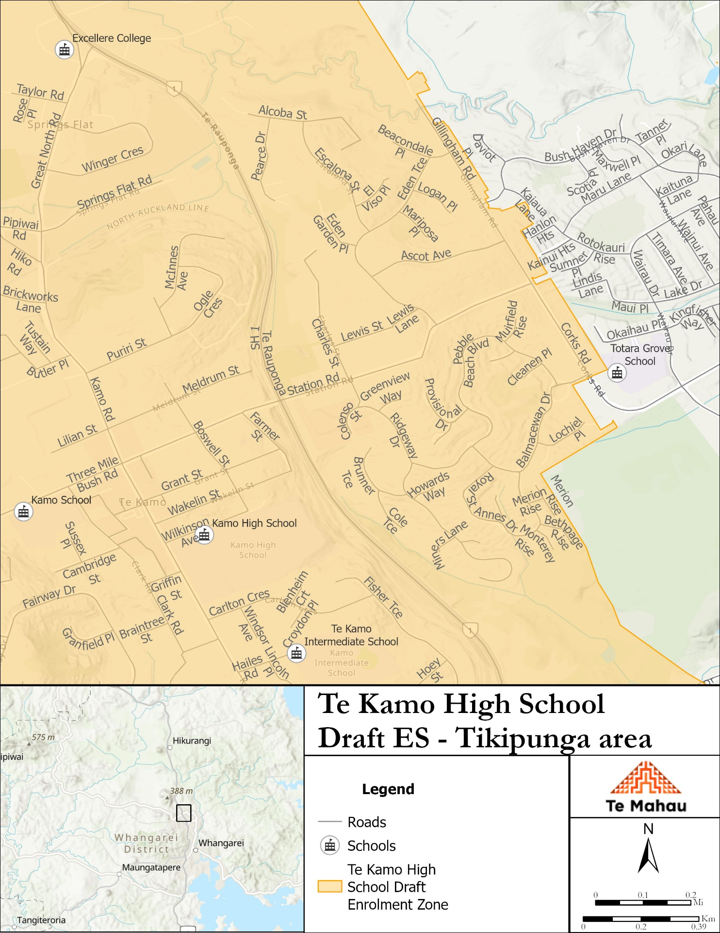

Figure 2 Te Kamo High School draft enrolment scheme – Tikipunga area

Figure 3 Te Kamo High School draft enrolment scheme - Whau Valley area

**What does this mean for my family?**

Any student currently enrolled at Te Kamo High School will not be impacted by the new enrolment scheme. All students enrolled (and attending school) will be entitled to continue attending Te Kamo High School, irrespective of where they currently live.

The establishment of the enrolment scheme and home zone will affect all enrolments starting Term 1 2026. This includes current families who have a younger sibling looking to enrol at Te Kamo High School starting on 1 January 2026 (the commencement date) or later. The flowchart below will help you assess your indicative eligibility to enrol after the commencement date.

Does your child (enrolling in 2026 or later) live within the enrolment scheme home zone? (check map for reference)

**In zone enrolment**

YES

NO

**Out of zone enrolment**

**(if places available)**

YES

Does your child (enrolling in 2026 or later) live outside of the zone?

Consultation process and timeline

The Ministry of Education is currently undertaking consultation about the proposed changes and new enrolment schemes. You can have your say by:

Completing the survey at [Have your say - Ministry of Education](https://www.education.govt.nz/have-your-say) on the Te Kamo High School consultation page.

* This site also has further information about the proposed scheme.
* Emailing [taitokerau.enrolmentschemes@education.govt.nz](mailto:taitokerau.enrolmentschemes@education.govt.nz) if you have further questions or comments.

Consultation will run 11th August 2025 to 21st September 2025. The Ministry will consider all feedback and liaise with the Te Kamo High School Board before making a final decision. We expect the school community to be updated about progress made 18 October 2025. The new scheme and changes will come into effect for enrolments after the commencement date