Mangawhai Beach School

Amendment to Enrolment Scheme

Overview – what is changing?

The Ministry of Education regularly monitors enrolment patterns, population growth and anticipated school roll changes across the Kaipara district. As part of this monitoring and regular review, we now consider an amendment for the enrolment scheme is necessary for Mangawhai Beach School. This is due to growth of the school roll and because we need to ensure the Board has a fair and transparent mechanism to manage the roll. It also means we can ensure we are making best use of educational facilities across the wider Mangawhai Beach School area.

The new enrolment scheme will have a home zone, like other schools with enrolment schemes in the area. Children that live within this area will have entitlement to enrol at Mangawhai Beach School. The home zone area is shown on the map below and described here:

**MANGAWHAI BEACH SCHOOL (#1038)**

**Proposed Enrolment Scheme**

Commencement date: 1 January 2026

The guidelines for development and operation of enrolment schemes are issued under Schedule 20, Clause 3 (3) of the Education and Training Act 2020 for the purpose of describing the basis on which the Secretary’s powers in relation to enrolment schemes will be exercised.

**Home Zone**

**All students who live within the home zone described below shall be eligible to enrol at the school.**

*The Home Zone includes addresses on both sides of the boundary roads mentioned in the description, and all no-exit roads off the boundary roads are included in the zone unless otherwise stated.*

**To the North:**

* Starting at the intersection of Pebblebrook and Tara Roads, the boundary moves south-east along Tara Road including both sides.
* It turns north-east along Cove Road and travels to the Kaipara District/ Whangarei District boundary. The zone boundary turns onto Tuaraki Road to include all addresses, then travels directly east until it hits the foreshore.

**To the East:**

* Following the line of the foreshore, the boundary continues southward to Te Arai Point Road, ending at the southern end of Te Arai Regional Park. The boundary travels west inland, joining Ocean View Road at the intersection with Western Boundary Road (816 Ocean View Road included).

**To the South:**

* The boundary travels west on Ocean View Road, Lake Road, and Te Arai Point Road. The boundary turns west into Mangawhai Road then onto Cames Road; only addresses and no-exit roads on the northern side of the road are in-zone. As Cames Road turns to the north, only addresses and no-exit roads on the eastern side of the road are in-zone.

**To the West:**

* The boundary travels north into Lawrence Road; only addresses and no-exit roads on the eastern side of the road are in-zone.
* The boundary turns into Kaiwaka-Mangawhai Road, only including addresses on the northern side of the road, then into Hilltop Road, including addresses on both sides of the road.
* From the end of Hilltop Road, the boundary travels north overland back to the intersection of Pebblebrook and Tara Roads.

**Special Programmes**

This priority category is not applicable at this school because the school does not run a Special programme approved by the Secretary.

**Out of Zone Enrolments**

Each year the Board of Trustees will determine the number of places which are likely to be available in the following year for the enrolment of students who live outside the home zone. The Board will publish this information by public notice in a medium appropriate to the area served by the school. The notice will indicate how applications are to be made and will specify a date by which all applications must be received.

Applications for enrolments will be processed in the following order of priority:

First Priority

This priority is not applicable at this school because the school does not run a special programme approved by the Secretary for Education.

Second Priority

will be given to applicants who are siblings of current students.

Third Priority

will be given to applicants who are siblings of former students.

Fourth Priority

will be given to any applicant who is a child of a former student of the school.

Fifth Priority

will be given to any applicant who is either a child of an employee of the board of the school or a child of a member of the board of the school.

Sixth Priority

will be given to all other applicants.

If there are more applicants in the second, third, fourth, fifth or sixth priority groups than there are places available, selection within the priority group will be by ballot conducted in accordance with instructions by the Secretary, under Schedule 20, Clause 3 (1) of the Education and Training Act 2020. Parents will be informed of the date of any ballot by public notice in a medium appropriate to the area served by the school.

Applicants seeking second or third priority status may be required to give proof of a sibling relationship.

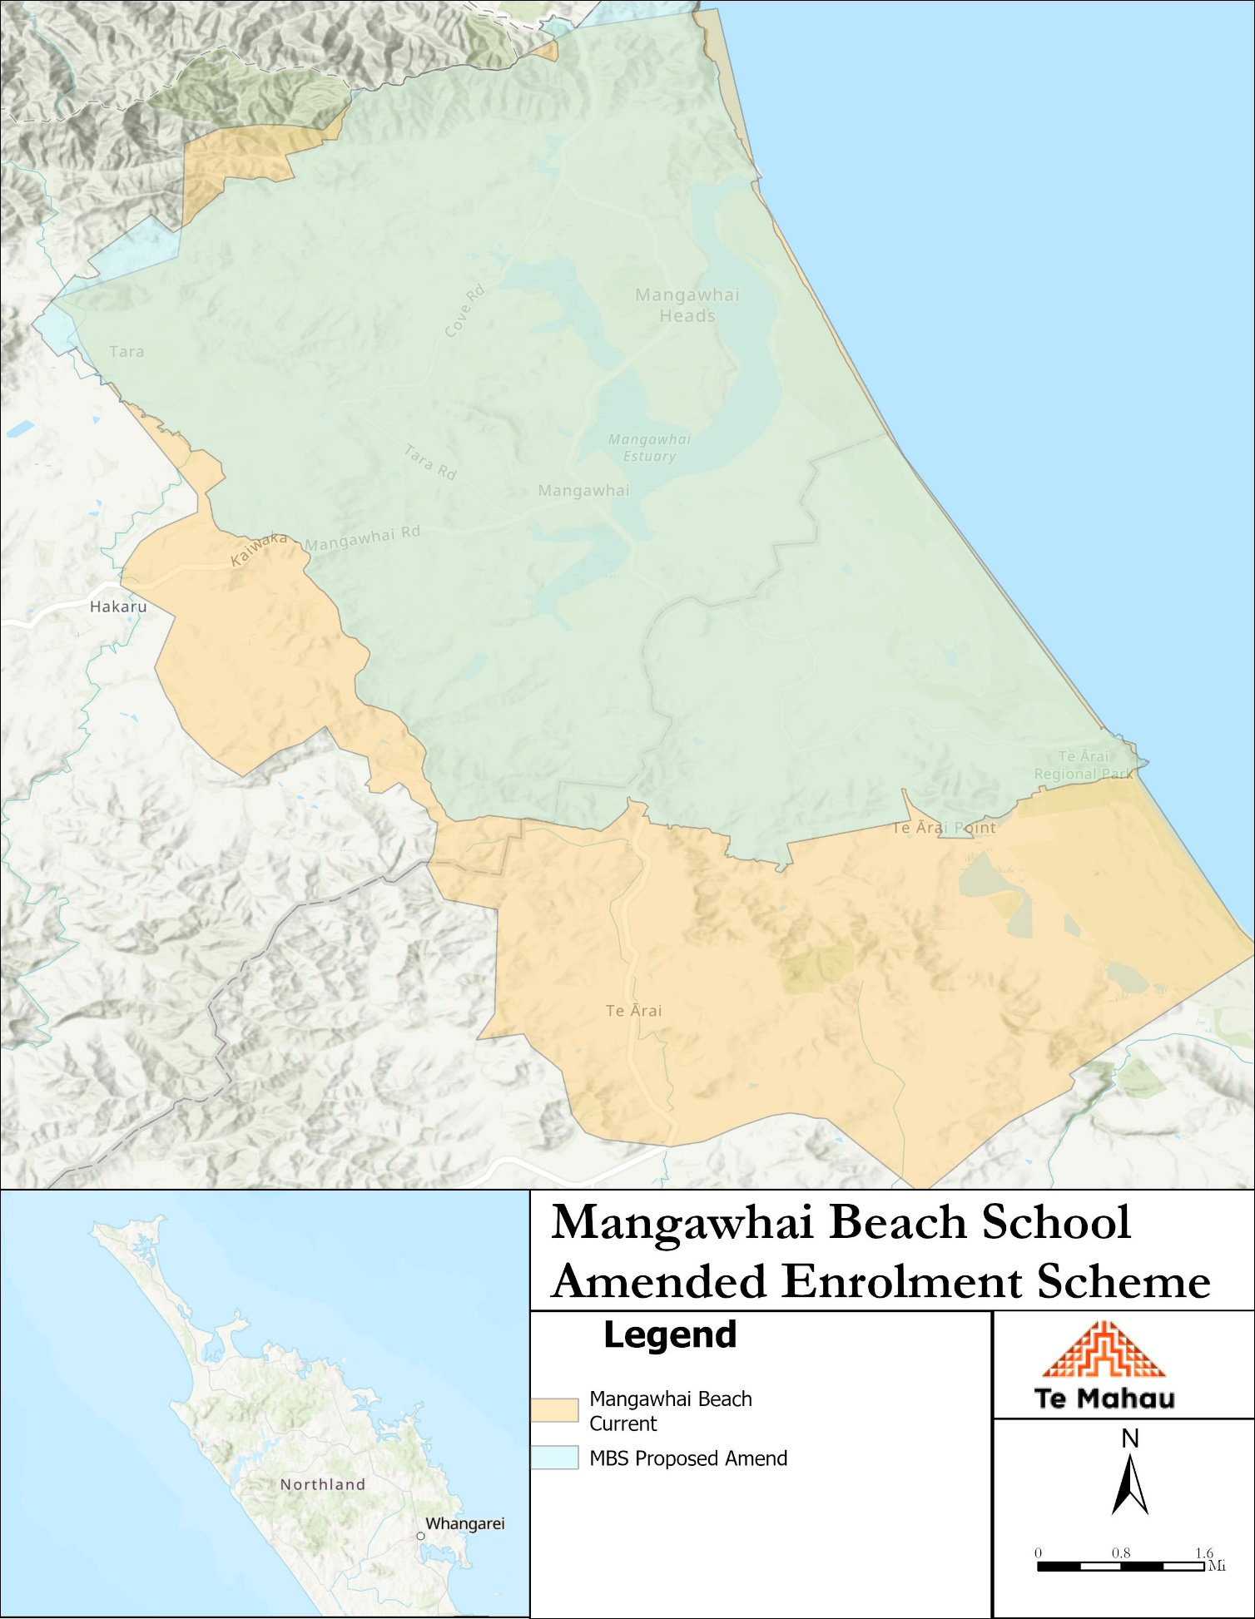

**What does this mean for my family?**

Any student currently enrolled at Mangawhai Beach School will not be impacted by the new enrolment scheme. All students enrolled (and attending school) will be entitled to continue attending Mangawhai Beach School, irrespective of where they currently live.

The establishment of the enrolment scheme and home zone will affect all enrolments starting at the beginning of Term 1 2026. This includes current families who have a younger sibling looking to enrol at Mangawhai Beach School starting on 1 January 2026 (the commencement date) or later. The flowchart below will help you assess your indicative eligibility to enrol after the commencement date.

Does your child (enrolling in 2026 or later) live within the enrolment scheme home zone? (check map for reference)

**In zone enrolment**

YES

NO

**Out of zone enrolment**

**(if places available)**

YES

Does your child (enrolling in 2026 or later) live outside of the zone?

Consultation process and timeline

The Ministry of Education is currently undertaking consultation about the proposed changes and new enrolment schemes. You can have your say by:

Completing the survey at ADD LINK on the Mangawhai Beach School Consultation page.

* This site also has further information about the proposed scheme.
* Emailing [taitokerau.enrolmentschemes@education.govt.nz](mailto:taitokerau.enrolmentschemes@education.govt.nz) if you have further questions or comments.

Consultation will run 4th August 2025 to 13th September 2025. The Ministry will consider all feedback and liaise with the Mangawhai Beach School Board before making a final decision. We expect the school community to be updated about progress made 20 October 2025. The new scheme and changes will come into effect for enrolments after the commencement date