


Learning Support
2025 Budget Factsheet


Published: July 2025

What this Easy Read is about


This Easy Read is from
Te Tāhuhu o te Mātauranga Ministry of Education.


Te Tāhuhu o te Mātauranga Ministry of Education is the part of the Government in charge of:
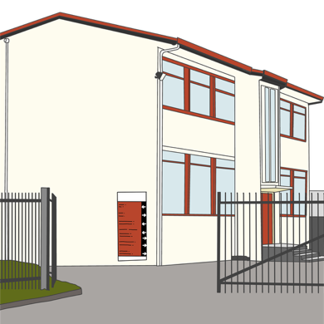
schools
preschools
tertiary education like polytechnics.


This Easy Read has information about new funding for learning support in schools from the
2025 budget.
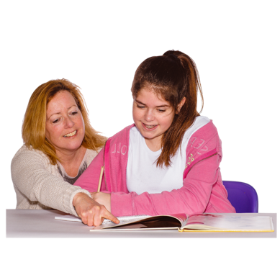
Learning support is support for students who:

find it hard to learn at school
need to learn in different ways from most other students.

Here the budget is when the Government says:
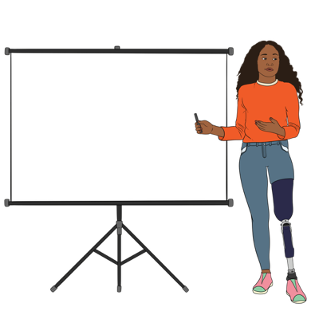

how much money it will spend in the coming year
what it will spend the money on.


This Easy Read is a summary of the full report.


A summary is:
shorter than the full report
tells you the main ideas.


You can find the full report on this website:

https://tinyurl.com/ytk34jt2


The full report is not in Easy Read.

New funding for learning support

For learning support the budget has:
over 6 hundred million dollars of operating funding
around 1 hundred million dollars of capital funding.


Operating funding is money schools can use to pay for everyday costs like:

staff who are not teachers
things students use like books.

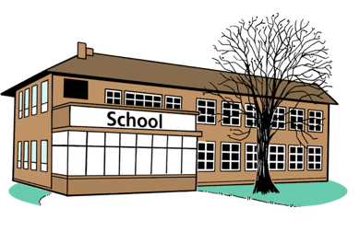
Capital funding is money schools can use to build things like new classrooms.


This funding will support schools to:
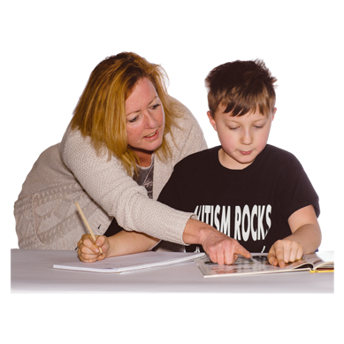
find out what learning support students need
give students the right learning support.


With the right learning support students will:
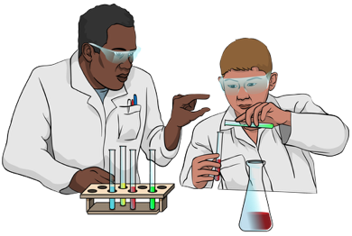
want to go to school more often
do better at school.

What the funding will be spent on

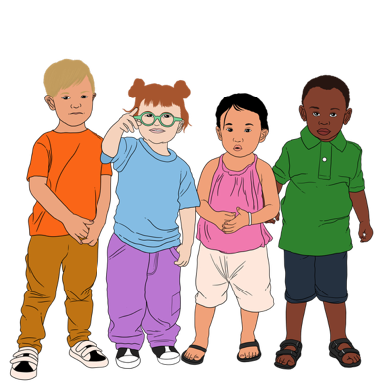
Early Intervention Service

The Early Intervention Service gives support for children who:
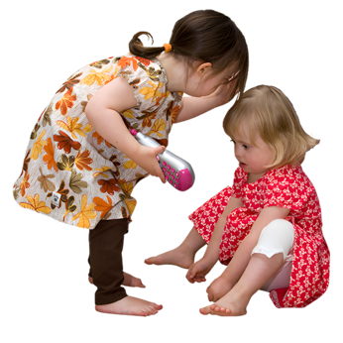
are disabled
have trouble with:
- learning
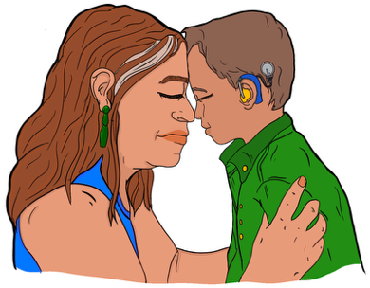
- behaviour
- communication.
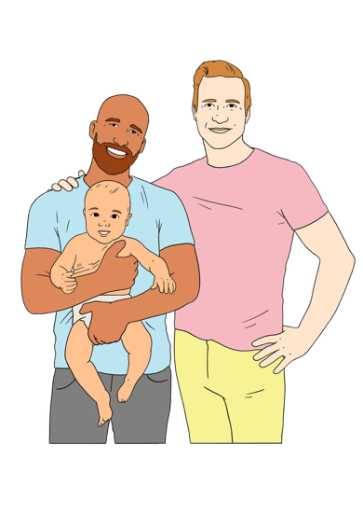

It is for:
children from birth to starting school
their whānau / families.

Here communication is things like:
talking
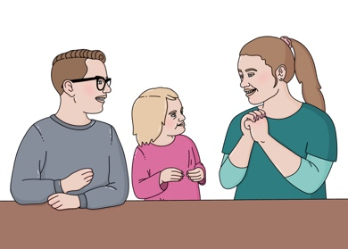
using sign language
understanding other people.



The Early Intervention Service used to stop when children started school.

75 million dollars will be used so that children can use the Early Intervention Service in their first year at school.

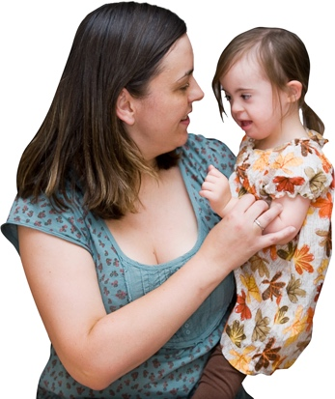
Almost 1 hundred and 30 million dollars will be used so children do not need to wait as long to get early intervention.


40 million dollars will pay for more teacher aides to support children using the Early Intervention Service.


Teacher aides work in schools to support students with their learning.

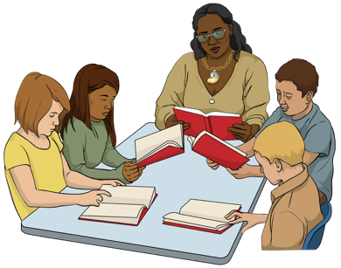
They may work with:
1 student
lots of students.


23 million dollars will be used to pay for:
people to give early intervention services
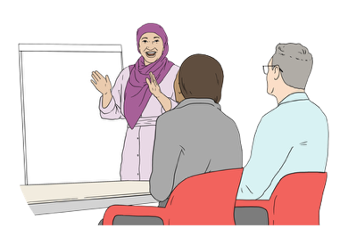
training more early intervention specialists.

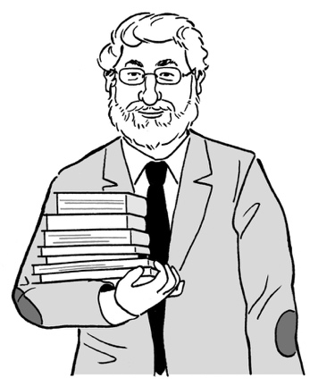
A specialist is someone who knows a lot about 1 thing.

Teacher aides

There is funding for an extra 2 million hours of work for teacher aides.

The funding will pay for 1 million more hours of teacher aides working in the Ongoing Resourcing Scheme.

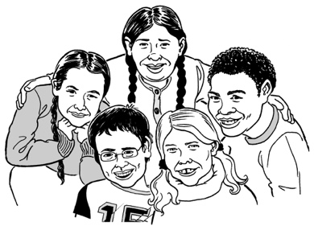
The Ongoing Resourcing Scheme is funding for students who will have high support needs for a long time in:
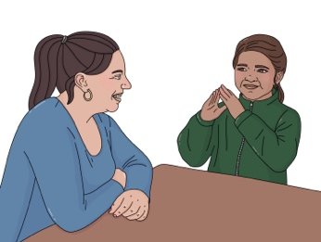
learning
hearing

vision / seeing
mobility / moving / walking
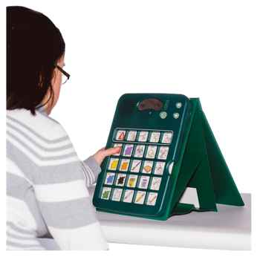
communicating
working with other people.

It is called ORS for short.

The funding will pay for
9 hundred thousand hours of teacher aides working to support children in their first few years at school.


The funding will pay for almost
1 hundred and 60 thousand hours of teacher aides working to support students with:
behaviour
communication.

There is also 3 million dollars of funding to pay for training for teacher aides so they can better support the students they work with.

Funding for other services

Almost 2 million dollars of funding will pay for Learning Support Coordinators.

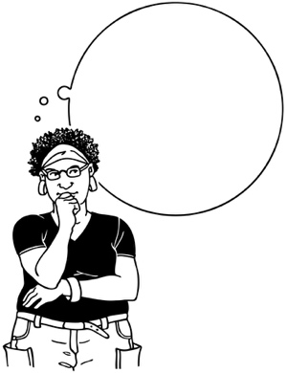
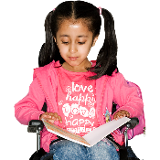
Learning Support Coordinators work in a school to:
find out which students need learning support
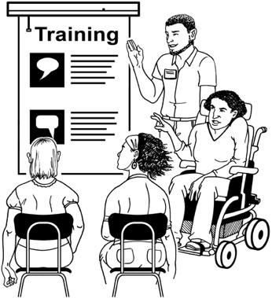
find the right learning support for students
support teachers to learn more about learning support.


There will be a Learning Support Coordinator in every school with children in Year 1 to Year 8 that is a:
state school
state integrated school.

A state school:
is owned by the Government
gets funding from the Government.

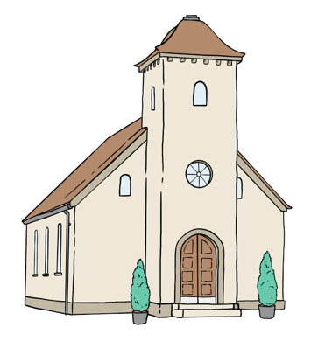
A state integrated school:
is owned by an organisation like a church
gets funding from the Government.

There will be over 1 hundred and 20 million dollars of funding for ORS.

The way that ORS works will change so that students with ORS funding will get the support they need.

There will be around 40 million dollars of funding for Behaviour and Communications Service.

This funding will be used to pay for more:
teacher aide hours
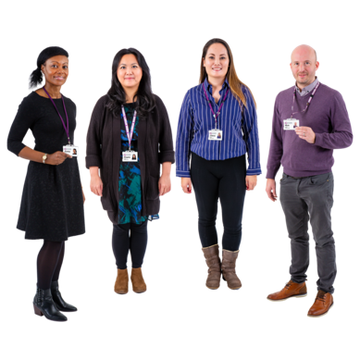
speech language therapists
psychologists.

Speech language therapists:
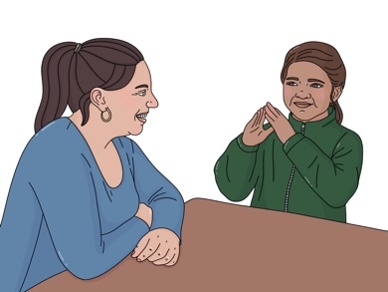
support people who find it hard to communicate
teach people about communication that works for them.

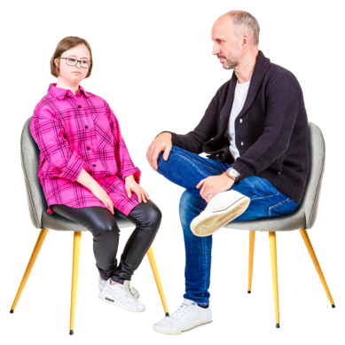
Psychologists support people to deal with:
their feelings
things that are happening in their lives
things that make learning harder.

About 7 million dollars of funding will pay for more children to use the Intensive Wraparound Service.

The Intensive Wraparound Service is for children who need a lot of support with:

learning
behaviour
feelings / emotions.


It gives support to the whole
whānau / family:

at home
at school
in their community.

Around 4 million dollars of funding will pay for more intern educational psychologists.


An intern is someone who is working at a job while they learn how to do it.

An educational psychologist is a psychologist who supports people with:
learning
behaviour
managing being at school.


Having more interns means there will be enough educational psychologists in the coming years.

Around 1 hundred million dollars of funding will pay for:
making schools more accessible
new satellite classrooms.
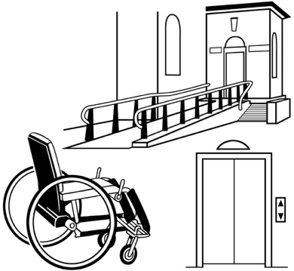

Accessible means something has been built so it works well for disabled people.


A satellite classroom is a class just for students who have high needs inside a mainstream school.

A mainstream school has:
students who are not disabled
and
disabled students.


This information has been written by Te Tāhuhu o te Mātauranga Ministry of Education.

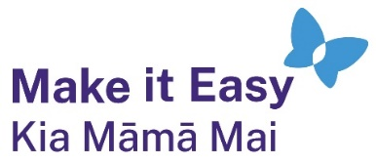
It has been translated into Easy Read by the Make it Easy Kia Māmā Mai service of People First New Zealand Ngā Tāngata Tuatahi.

The ideas in this document are not the ideas of People First New Zealand Ngā Tāngata Tuatahi.

All images used in this Easy Read document are subject to copyright rules and cannot be used without permission.


Make it Easy uses images from:

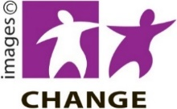
- Photosymbols

- Change Images


- Huriana Kopeke-Te Aho

- SGC Image Works

- T Wood


- Studio Rebeko

- Inga Kramer.

