

STEO User GUIDe

Ministry of Education &
Tertiary Education Commission
Thursday, 30 November 2023

Version 4.0.4

Contents
1 Contents 2
2 Figures 6
3 Document Overview 10
3.1 Background 10
3.2 Contacts 10
3.3 Revision History 11
4 Site Map 12
5 Glossary 13
6 Getting Started with STEO 15
6.1 Recommended Internet Browser 15
6.2 Home Page Link 15
6.3 Main Menu Navigation 15
6.4 Wildcard Searching 16
6.5 Lookup Windows 16
6.6 Sorting Search Results 18
6.7 Navigating through Result Pages 18
6.8 Mandatory Inputs 19
6.9 Validation of Input 19
6.10 Discarding Unsaved Changes 20
6.11 Maximum File Size when Uploading 21
7 Logging in to STEO 22
7.1 Education Sector Logon (ESL) 22
7.2 Log in to STEO 22
7.3 Log out from STEO 24
8 Contacts 25
8.1 Contacts 26
8.2 Edit Contact 26
8.3 Add Contact 28
8.4 Delete Contact 30
8.5 Contact Fields and Descriptions 31
9 Delivery Sites 35
9.1 Delivery Sites 35
9.2 View / Edit / Delete Delivery Site Details 36
9.3 Add Delivery Site 38
9.4 Delivery Site Fields and Descriptions 40
9.5 Error Messages in Delivery Sites 41
10 Qualifications 42
10.1 Search Qualifications 43
10.1.1 View Qualification Details 44
10.1.2 View Courses under Qualification 46
10.1.3 Edit Qualification 47
10.1.4 Close Qualification 49
10.2 Add New Qualification 50
10.3 Qualification Change Requests 52
10.3.1 Search Qualification CRs 53
10.3.2 View / Edit Qualification CR 54
10.4 Concurrent Studies 57
10.4.1 Search Concurrent Studies 57
10.4.2 View / Edit Concurrent Qualification 58
10.4.3 Add New Concurrent Qualification 60
10.5 Qualification Fields and Descriptions 62
10.5.1 Qualification and Qualification CRs 63
10.5.2 Concurrent Studies 69
10.6 Error Messages in Qualifications 71
11 Courses 72
11.1 Courses 72
11.1.1 View Course 74
11.1.2 Edit Course 75
11.2 Add Course 77
11.3 Course Change Requests 79
11.3.1 Search Course CRs 79
11.3.2 View / Edit Course CR 80
11.4 Courses Fields and Descriptions 83
11.5 Error Messages in Courses 87
12 SDR Processing 88
12.2 SDR Validation Summary 89
12.3 Validate New SDR 90
12.3.1 Select SDR Run Kind, Year and Month 90
12.3.2 Upload SDR Files 92
12.3.3 Submit for Processing 92
12.3.4 Validating Other File Types 93
12.3.5 SDR Processing and Results 96
12.4 Summary Reports 100
12.4.1 SDR Broad Summary Report 102
12.4.2 SDR Summary Report Detail 104
12.4.3 Course Completion Summary Report 107
12.4.4 Qualification Completion Summary Report 110
12.5 Validation Error Report 113
12.5.1 View All Errors / View All Warnings 114
12.5.2 Validation Error Details 115
12.6 EFTS Forecast Update / View 118
12.6.1 Add EFTS Forecast Entry 121
12.6.2 Edit EFTS Forecast Entry 122
12.6.3 Set Forecast Growth 124
12.6.4 EFTS Forecast Import 125
12.6.5 Zero EFTS Forecast 126
12.7 Course Difference Submit / View 128
12.8 Downloads 132
12.8.1 Course Completion Summary 132
12.8.2 EFTS by Course 133
12.9 SDR Submission 135
12.9.1 Forecast Validation 139
12.9.2 Check if Course Differences Exist 139
12.9.3 Check if Course Pending Change Requests Exist 139
12.9.4 Check if Workforce Questionnaire Submitted 139
13 Indicative (SDR) Data Collection 141
13.1 IND Validation Summary 141
13.2 Validate New IND 142
13.2.1 Select Return Year, Upload IND ZIP file and Notification Contacts 143
13.2.2 IND Submission and Results 144
13.3 Validation Error Report 145
13.3.1 View All Errors 146
13.3.2 Validation Error Details 147
14 Workforce Questionnaires (WFQ) 149
14.1 Workforce Questionnaires 150
14.2 Download WFQ Template 151
14.3 WFQ Upload 152
14.4 View WFQ Details 154
14.5 WFQ Error Report 155
15 Non SDR Provider 156
15.1 RS20 156
15.1.1 RS20 History 157
15.1.2 Download RS20 Template 158
15.1.3 RS20 Error Report 159

Figures
Figure 1 – Home Page Link 15
Figure 2 – Main Menu Navigation 16
Figure 3 – Wild Card Search Example 16
Figure 4 – Lookup Field 17
Figure 5 – Funding Category Lookup Window 17
Figure 6 – Populated Lookup Field 17
Figure 7 – Default Sorting of Search Results 18
Figure 8 – Sorting of Search Results by Qualification Title 18
Figure 9 – Result Page Example 18
Figure 10 – Mandatory Fields Example 19
Figure 11 – Validation Error 20
Figure 12 – Validation Error Box with Rectified Issues 20
Figure 13 – Unsaved Changes Warning 21
Figure 14 – Maximum File Size Exceeded Error Page 21
Figure 15 – ESL Log In Page 23
Figure 16 – ESL Context Page 23
Figure 17 – STEO Authenticated User Home Page 24
Figure 20 – Contacts Tab 25
Figure 21 – Contacts List 26
Figure 22 – Accessing Contact Details 26
Figure 23 – Edit Contact 27
Figure 24 – CEO Contact Details Page 27
Figure 25 – Save Contact Confirmation 28
Figure 27 – Add Contact Page 29
Figure 28 – Add Contact Confirmation 30
Figure 29 – Accessing Delete Contact 30
Figure 30 – Delete Contact Page 30
Figure 31 – Delete Contact Confirmation 31
Figure 32 – Delivery Sites Tab 35
Figure 33 – Delivery Sites Page 36
Figure 34 – Accessing Delivery Site Details 36
Figure 35 – View / Edit Delivery Site Details 37
Figure 36 – Roaming Checked on View / Edit Delivery Sites 37
Figure 37 – Delivery Site Save Confirmation 38
Figure 38 – Delivery Site Delete Confirmation Prompt 38
Figure 39 – Delivery Site Delete Confirmation 38
Figure 40 – Add Delivery Site 39
Figure 41 – Roaming Checked on Add Delivery Site 39
Figure 42 – Delivery Site Add Confirmation 40
Figure 43 – Qualifications Tab 42
Figure 44 – Accessing Search Qualifications 43
Figure 45 – Qualifications Search Page 43
Figure 46 – Qualifications Search Results Page 44
Figure 47 – Accessing Qualification Details from Qualification Search 44
Figure 48 - View Qualification Details 45
Figure 49 – View Qualification Details with collapsed sections 45
Figure 50 – Accessing Courses under Qualification 46
Figure 51 – No Courses under Qualification found notification 47
Figure 52 – Courses under Qualification 47
Figure 53 – Accessing Edit Qualification 48
Figure 54 – Edit Qualification Page 48
Figure 55 – Edit Qualification Confirmation Message 49
Figure 56 – Accessing Close Qualification 50
Figure 58 – Close Qualification Confirmation Message 50
Figure 59 – Accessing Add New Qualification 51
Figure 61 – Notification Message when Adding New Qualification 52
Figure 62 – Add New Qualification Confirmation Message 52
Figure 63 – Accessing Pending Qualification CRs 53
Figure 64 – Qualification CR Search 53
Figure 65 – Qualification CR Search Results 54
Figure 69 - Qualification CR Highlighted Field 56
Figure 71 – View Qualification CR Page 57
Figure 72 - Accessing Concurrent Studies 57
Figure 73 – Search Concurrent Studies 58
Figure 74 – Concurrent Studies Search Results 58
Figure 75 – View Concurrent Qualification 59
Figure 76 – Edit Concurrent Studies 59
Figure 77 – Confirmation Message when Saving Concurrent Qualification 60
Figure 78 – Accessing Add New Concurrent Qualification 61
Figure 79 – Add New Concurrent Qualification 61
Figure 80 – Qualification and Provider Code Lookups Behaviour 62
Figure 81 – Warning when Adding Duplicate Concurrent Qualification 62
Figure 82 – Add Concurrent Qualification Confirmation Message 62
Figure 83 – Courses Tab 72
Figure 84 – Default Courses Page 73
Figure 85 – Course Search Results 73
Figure 86 – Accessing View Course 74
Figure 87 – View Course 74
Figure 88 – Accessing Edit Course 75
Figure 89 – Edit Course 75
Figure 90 – Warning Message when altering Start Year of Existing Course 76
Figure 91 – Edit Course Confirmation Message 76
Figure 92 – Newly Created Course Change Request 76
Figure 93 – Add Course 77
Figure 94 – Add Course page 77
Figure 95 – Add New Course Confirmation Message 78
Figure 96 – Newly Created Course Change Request 78
Figure 97 – Course Change Requests 79
Figure 98 – Course Change Requests page 79
Figure 99 – Course CR Search Results 80
Figure 100 – Accessing Course CR Details 81
Figure 101 – Edit Course CR 81
Figure 102 – Edit Course CR Confirmation Message 82
Figure 103 – View Course CR 82
Figure 104 – Course CR Highlighted Field 83
Figure 105 – Accessing SDR Validation 89
Figure 106 – SDR Validation Summary 89
Figure 107 – Accessing SDR Validation 90
Figure 108 – Selecting SDR Full as Run Kind 90
Figure 109 – Data Return Contacts 91
Figure 110 – Upload SDR Files 92
Figure 111 – Submit SDR Validation confirmation 93
Figure 112 - SDR Validation Request Success Message 93
Figure 113 – Upload SDR FIles (Other File Types) 94
Figure 114 – Return Month (Other File Types) 95
Figure 115 – SDR Processing Queue 96
Figure 116 – SDR Validation Processing in Progress 96
Figure 117 – SDR Processed Successfully during SDR Round 97
Figure 118 – SDR Processed during SDR Round but round period is expired 97
Figure 119 – SDR Processed and Rejected 98
Figure 120 – SDR File Not Processed due to Unknown Error 98
Figure 121 – SDR Processed but Too Late for SDR 99
Figure 122 – Qualification Completion Processed Successfully 99
Figure 123 – Course Completion Processed Successfully 99
Figure 124 – Course Register Processed Successfully 100
Figure 125 – Accessing Summary Reports 100
Figure 126 – Summary Report Links for Successfully Validated SDR 101
Figure 127 – Summary Report Links for SDR Validation with Errors 101
Figure 128 – Accessing SDR Broad Summary Report 102
Figure 129 – SDR Broad Summary Report 103
Figure 130 – Accessing SDR Summary Report Detail 104
Figure 131 – SDR Detailed Summary Report – Student Enrolment 105
Figure 132 – SDR Detailed Summary Report – EFTS Consumed 105
Figure 133 – SDR Detailed Summary Report – Actual and Forecasted EFTS 106
Figure 134 – Accessing Course Completion Summary Report 108
Figure 135 – Course Completion Summary Report – Course Count for Each Year 108
Figure 136 – Course Completion Summary Report – Course Count for SDR Round 109
Figure 137 – Course Completion Summary Report – Course Count for PBRF Courses 109
Figure 138 – Course Completion Summary Report – Course Count for Historical Years 109
Figure 139 – Course Completion Summary Report – Future Completed Course Count 110
Figure 140 – Course Completion Summary Report – Future Completed PBRF Course Count 110
Figure 141 – Accessing Qualification Completion Summary Report 111
Figure 142 – Qualification Completion Summary Report – Qualification Count for 4 Years for Current SDR 111
Figure 143 – Qualification Completion Summary Report – Qualification Count for 4 Years not part of Current SDR 112
Figure 144 – Qualification Completion Summary Report – Qualification Count for Current SDR Year 112
Figure 145 – Accessing Validation Error Report 113
Figure 146 – SDR Validation Errors 114
Figure 147 – Accessing View All Errors / View All Warnings 114
Figure 148 – View All Errors or View All Warnings 115
Figure 149 – Accessing Validation Error Details 116
Figure 150 – Validation Error Details 117
Figure 151 – Accessing EFTS Forecast Update / View 118
Figure 152 – EFTS Forecast View 118
Figure 153 – EFTS Forecast Data Export 119
Figure 154 – EFTS Forecast Update 120
Figure 155 – Accessing Add EFTS Forecast 121
Figure 156 – Add EFTS Forecast 121
Figure 157 – Add EFTS Forecast Save Confirmation Message 122
Figure 158 – Accessing Edit EFTS Forecast 122
Figure 159 – Edit EFTS Forecast 123
Figure 160 – Edit EFTS Forecast Save Confirmation Message 123
Figure 161 – Accessing Set Forecast Growth 124
Figure 162 – Set Forecast Growth 124
Figure 163 – Set Forecast Growth Save Confirmation Message 125
Figure 164 – Importing EFTS Forecast 125
Figure 165 – EFTS Forecast Upload Error Message 126
Figure 166 – EFTS Forecast Upload Error Message with Line Numbers 126
Figure 167 – EFTS Forecast (Original) 126
Figure 168 – EFTS Forecast (After Zero) 127
Figure 169 – EFTS Forecast (Original) 127
Figure 170 – EFTS Forecast (After Zero) 128
Figure 171 – Accessing Course Difference View 129
Figure 172 – Accessing Course Difference Submit 129
Figure 173 – Course Difference View 130
Figure 174 – Course Difference Export 130
Figure 175 – Course Difference Submit 131
Figure 176 – Accessing Course Completion Summary 132
Figure 177 – Accessing EFTS by Course 133
Figure 178 – EFTS by Course 134
Figure 179 – Submitting SDR Full 135
Figure 180 – Submitting SDR Full with Extension 135
Figure 181 – SDR Submission Confirmation Prompt 136
Figure 182 – SDR Full Submission 136
Figure 183 – SDR Full Submission with Extension Granted 137
Figure 184 – SDR Full Submitted 137
Figure 185 – SDR Full Submitted with Extension Granted 138
Figure 186 – SDR Full Submission Failed 138
Figure 187 – Forecast Validation Failed Error Message 139
Figure 188 – Course Difference Check Failed Error Message 139
Figure 189 – Course Pending Change Request Check Failed from Edit Courses 139
Figure 190 – Workforce Questionnaire Check Failed 140
Figure 191 – Accessing Indicative Validation 141
Figure 192 – IND Validation Summary 142
Figure 193 – Accessing Validate New IND 142
Figure 194 – Step 1 of IND Validation 143
Figure 195 – Data Return Contacts 143
Figure 196 – IND Processing In Progress 144
Figure 197 – IND Data Submitted Successfully 144
Figure 198 – IND Files Rejected 145
Figure 199 – Accessing IND Validation Error Report 145
Figure 200 – IND Validation Error Report 146
Figure 201 – Accessing View All Errors 146
Figure 202 – IND Validation View All Errors 146
Figure 203 – IND Validation Error Export 147
Figure 204 – Accessing IND Validation Error Details 148
Figure 205 – IND Validation Error Details 148
Figure 206 – Accessing Workforce Questionnaires 149
Figure 207 – Workforce Questionnaires Page 150
Figure 208 – Downloading the Workforce Questionnaire Template 151
Figure 209 – Workforce Questionnaire Template 151
Figure 210 – Using the WFQ Upload Functionality 152
Figure 211 – WFQ Upload Incorrect File Type Error Message 152
Figure 212 – WFQ Upload Invalid Provider Type Template 152
Figure 213 – WFQ Successfully Uploaded 152
Figure 214 – WFQ Uploaded and Processed without Errors 153
Figure 215 – WFQ Uploaded and Rejected with Errors 153
Figure 216 – Historical WFQ Uploaded and Processed with Errors 153
Figure 217 – Accessing WFQ Details 154
Figure 218 – WFQ Details 154
Figure 219 – Accessing WFQ Error Report 155
Figure 220 – WFQ Error Report 155
Figure 221 – Non SDR Provider Main Menu 156
Figure 222 – Accessing RS20 156
Figure 223 – RS20 Overview 156
Figure 224 – RS20 Download/Upload section 157
Figure 225 – RS20 File Not Valid Excel Spreadsheet Error Message 157
Figure 226 – Accessing the RS20 Return Template 158
Figure 227 – RS20 Return Template 158
Figure 228 – Accessing RS20 Error Report 159
Figure 229 – RS20 Validation Errors 159

Document Overview

Background
This document is primarily designed to address STEO functions available to Provider users.
The STEO website is used by Tertiary Education Organisations (TEOs, or Providers) to submit the singe data return (SDR) files three times a year, which is core business for Providers in reporting to TEC and MoE about the students and courses taken as well as the outcomes of the study.
Based on the permissions granted, Provider users can upload and process Workforce Questionnaire (WFQ) and RS20 (return of staff and students for unfunded private training establishments) Excel files. Provider users are also able to maintain their Qualifications, Courses, Delivery sites and Contacts via STEO. The STEO functions available to Providers are discussed in this document to provide guidance and instructions to Providers when interacting with the STEO website.
The STEO application can be found at the following address: https://web.dxp.tec.govt.nz/.

Contacts
If you have any further queries about the STEO website, please contact the TEC customer contact group:

Tertiary Education Commission Customer Contact Group
Phone: 0800 601 301 or +64 4 462 5201 (for international callers)
Email: CustomerService@tec.govt.nz
Post: The Tertiary Education Commission
Te Amorangi Mātauranga Matua
PO Box 27048
Wellington 6141
New Zealand

Revision History
Version | Date | Author | Changes
0.0.0 | 09/03/2016 | Gabriel Loh | - Initial internal draft
0.1.0 | 20/04/2016 | Gabriel Loh | - Substantive changes following review by Lydia J and Gregory Y.
1.0.0 | 12/05/2016 | Lydia Jesudas | - Versioned for release
1.0.1 | 29/06/2016 | Lydia Jesudas | - Updates after review by Sarah W and Nick O  - Minor updates from Gregory
2.0.0 | 03/08/2016 | Lydia Jesudas | - Final release
2.0.1 | 11/12/2018 | Chirag Patel | - Rewrite – Updated screenshots and content to match latest STEO changes
3.0.0 | 07/01/2019 | Gregory Yanovsky | - Review, updates from GY and versioned for release
3.0.0 | 30/01/2019 | Gregory Yanovsky | - Minor changes following Jan Sheppard review (no version change)
3.0.1 | 16/07/2019 | Chirag Patel | - EEL Summary Report and Menu changes and version for release
3.0.2 | 03/09/2020 | John Maria Antony | - Removed EEL summary report
3.0.3 | 18/11/2020 | Chirag Patel | - Removed Provider Code 6003 and replaced it with 1111. Minor changes to the text
4.0.0 | 12/04/2022 | Jayme Natoli | - Update for the transition of STEO application to TEC Data Exchange Platform (DXP)
4.0.1 | 02/05/2022 | Jamie Webster | - Reviewed and made updates
4.0.2 | 01/11/2022 | Vinay Karepalli | - Summary reports  - Workforce Questionnaire

Site Map
The STEO website is organised into the following tabs as shown below:
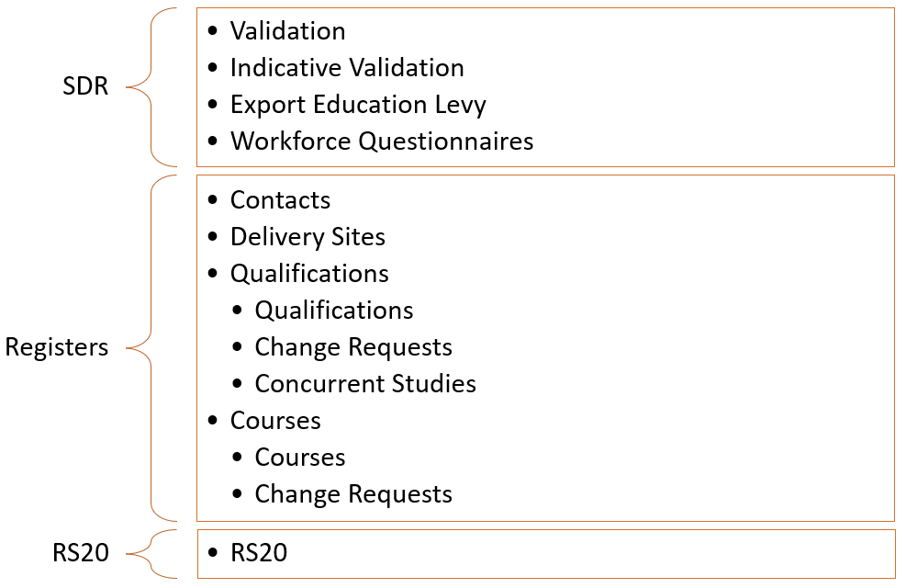

Glossary
This glossary may be helpful in defining some commonly encountered terms in this document:
Term | Description
EEL | Export Education Levy. The Export Education Levy (EEL) is collected from all TEOs that enrol international fee-paying students. The levy funds export education industry development, promotion, quality assurance and research. TEOs may recover the cost of the EEL through the tuition fee charged to international students.
EFTS | Equivalent Full Time Student. This is a rating indicating how much of a full-time course of study a particular course or paper is expected to require.
ESL | Education Sector Login. This is an education sector log on that permits access secure education sector related services such as the NSI, with a single sign-on.
IND | Indicative Single Data Return (SDR). A set of data files given to the Ministry of Education to give early indicators of demand shifts and trends that may impact vote management and tertiary education policy.
ISCED | International Standard Classification of Education. ISCED is a statistical framework for organising information on education developed and maintained by UNESCO.
MoE | Ministry of Education.
NSI | National Student Index. This is the New Zealand education sector's core database of student identity data and the way in which the National Student Number (NSN) is allocated to individual students.
NZCQF Level | This refers to the qualification level on the NZ Qualification and Credentials Framework.
NZSCED | New Zealand Standard Classification of Education. This is a subject-based classification system for courses and qualifications in New Zealand.
PBRF | Performance-Based Research Fund. It is a performance-based funding system to encourage and reward excellent research in New Zealand’s degree-granting organisations (apart from PTEs).
PTE | Private Training Establishment
SDR | Single Data Return. A set of data files that are specifically required by the Ministry of Education and the Tertiary Education Commission (TEC) for funding, monitoring performance against Investment Plans, publishing performance information, as well as statistical reporting and policy development purposes.
SDR Window | The time interval between 2 consecutive SDR data collection start dates. The SDR Year is divided into 3 SDR Rounds – April, August and December.
SDR Round | The time period within the SDR Window where providers should process SDR files. The processing consists of 2 stages – SDR Validation and SDR Submission. Outside of this time period (but within SDR Window), SDR Validation is allowed, but SDR Submission is not permitted unless granted by TEC.
SMS | A SMS (Student Management System) is a system which can process and store digital information relating to students’ personal and study details. SMS also supply data (such as the SDR files) that are required by the Government.
STEO | Services for Tertiary Education Organisations both a website and the name of a secure application where SDRs are securely submitted.
TEC | Tertiary Education Commission
TEI | Tertiary Education Institution
TEO | Tertiary Education Organisation
WFQ | Workforce Questionnaire. An annual aggregated return of staff employed at TEOs.

Getting Started with STEO
The STEO application has some interactive elements that you may need to know about in order to use it better.

Recommended Internet Browser
The following browsers are recommended for browsing STEO:
- Google Chrome (latest version)
- Edge (2 most recent major versions)
- Firefox (latest version)
- Safari for MacOS (2 most recent major versions)

Home Page Link
The “STEO” option in the banner at the top of the application is a link to the STEO home page:
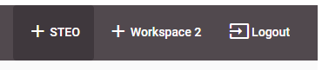
Figure 1 – Home Page Link
Clicking on it at any time will redirect you to the home page of STEO. You will remain logged in until you log out.

Main Menu Navigation
The Main Menu groups the various pages in STEO into headings that are organised by function. You can navigate between the pages by clicking on the desired heading:
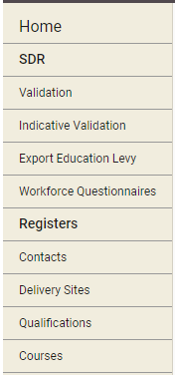
Figure 2 – Main Menu Navigation

Wildcard Searching
Some search fields you encounter in the STEO website allow wildcard searching. This means that it will perform a search that matches all or some of the search string you enter.
For example:
We are trying to search for a course which has a Course Title “Painting, Theory, Aesthetics”.
In the Course Search page (see the Course section), we will enter “pain” into Course Title as shown below:
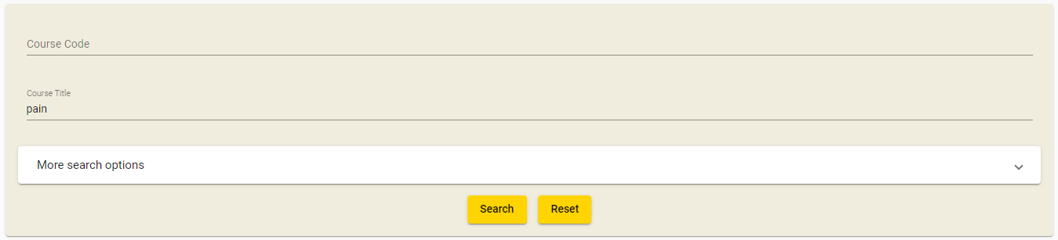
Figure 3 – Wild Card Search Example
This search yields 81 courses that have a Course Title with the letters “pain” in it, with the third course being the desired result.

Lookup Windows
Some input fields and search fields in STEO provide lookup functionality. This allows you to search for data that may be difficult to remember, such as Qualification Codes or NZSCED Codes. These are represented by the button, as shown below:
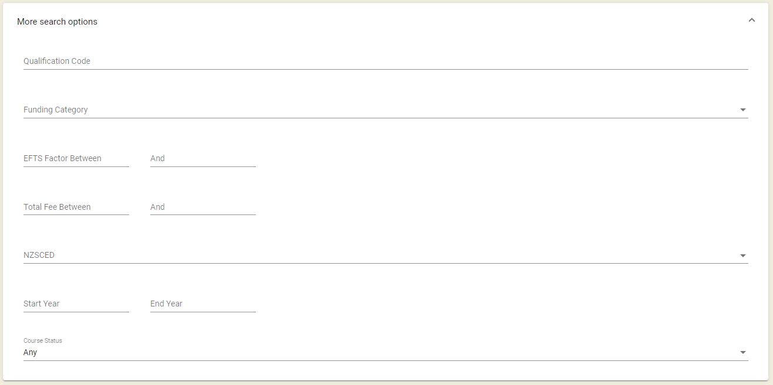
Figure 4 – Lookup Field
Once you click the button, a dropdown list will be opened containing all the data that is relevant to the field. You can select one of these entries by clicking on it, which will close the window and automatically populate the field.
In this example, if you cannot remember the funding category, you can click the button next to the Funding Category field, which will open the corresponding dropdown list:
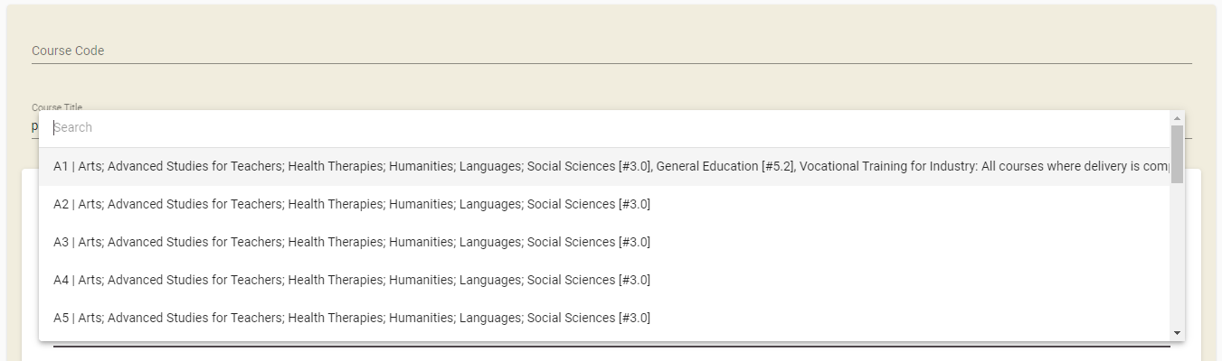
Figure 5 – Funding Category Lookup Window
If you click on one of the funding categories (for example A1 – Arts [#3.0], General [#5.2]) it will be populated into the Funding Category field, as shown below:
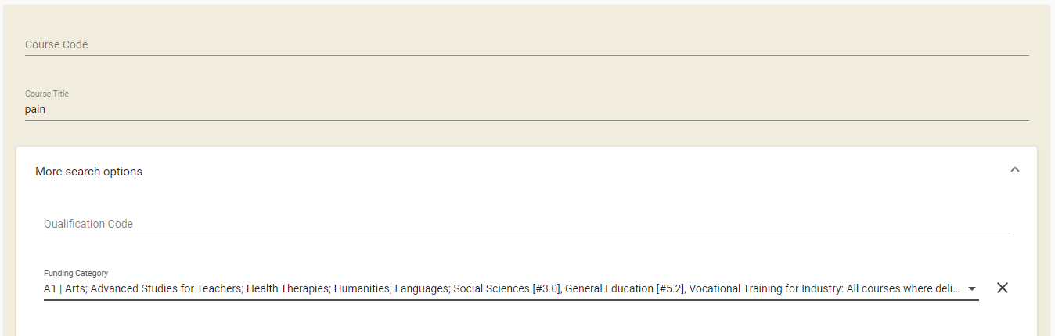
Figure 6 – Populated Lookup Field
Alternatively, you can click outside of the dropdown list if you wish to close the list. The field will not be overwritten if you do so.
You can open the dropdown list more than once to change the value.

Sorting Search Results
When you perform a search, STEO will display the search results to you sorted in a default order. You can change this sort order by clicking on the column header you wish to sort by which will be identified with a :
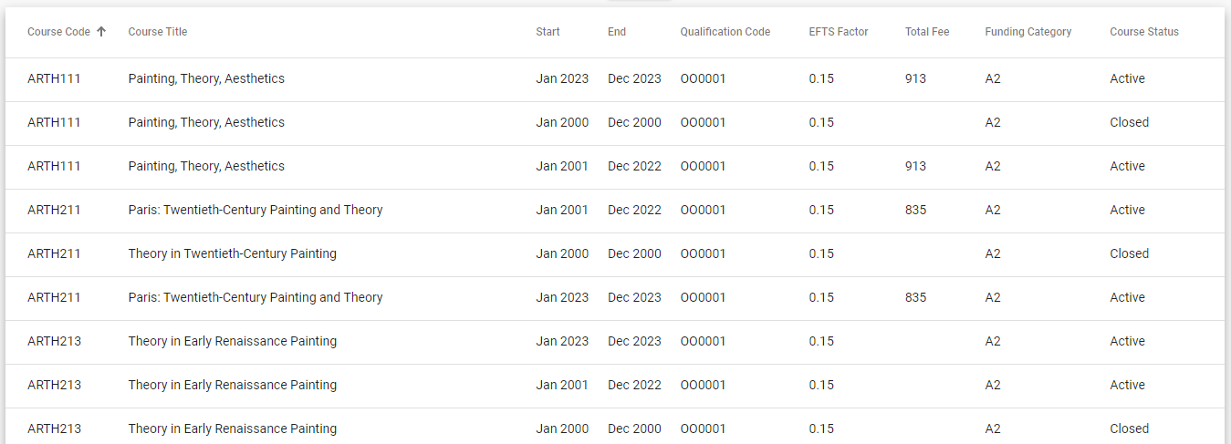
Figure 7 – Default Sorting of Search Results

In this example, when we click on the column header “Course Title”, the results resort themselves by Course Title in ascending order:
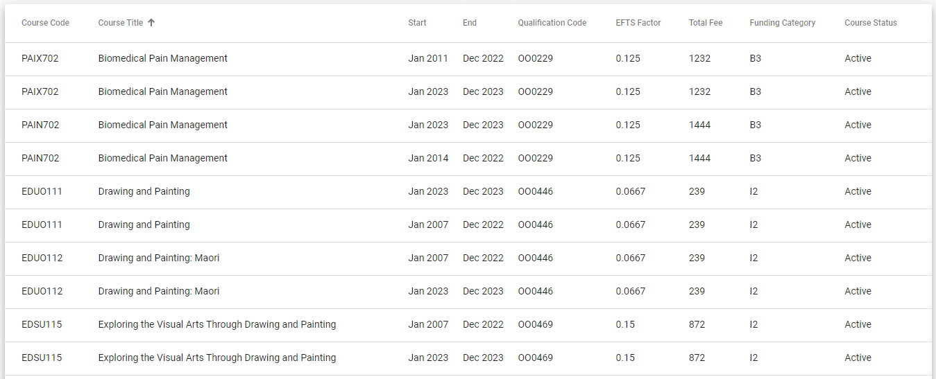
Figure 8 – Sorting of Search Results by Qualification Title
Clicking on Course Title again will resort the results by Course Title in descending order.

Navigating through Result Pages
Some pages in STEO, such as the lookup pages and the search result pages may contain more results than are shown in one page. In this situation, the bar will usually denote how many results are shown of the possible total:
Figure 9 – Result Page Example
The figure above indicates that there are 81 qualification results found, but only the first 20 results are currently shown. You can navigate through the pages by clicking on the navigation buttons
The navigation buttons perform the following actions:
Clicking  will take you to the very first page of results.
Clicking will take you to the previous page of results.
Clicking  will take you to the next page of results.
Clicking will take you to the very last page of results.

Mandatory Inputs
Some input fields in STEO are required to proceed with data entry or searching (these are called mandatory fields). This means that you will be unable to proceed with the action you’re attempting, e.g. creating a new qualification, without filling in all mandatory input fields.
Mandatory input fields are denoted by a black asterisk (*), as shown in the example below:
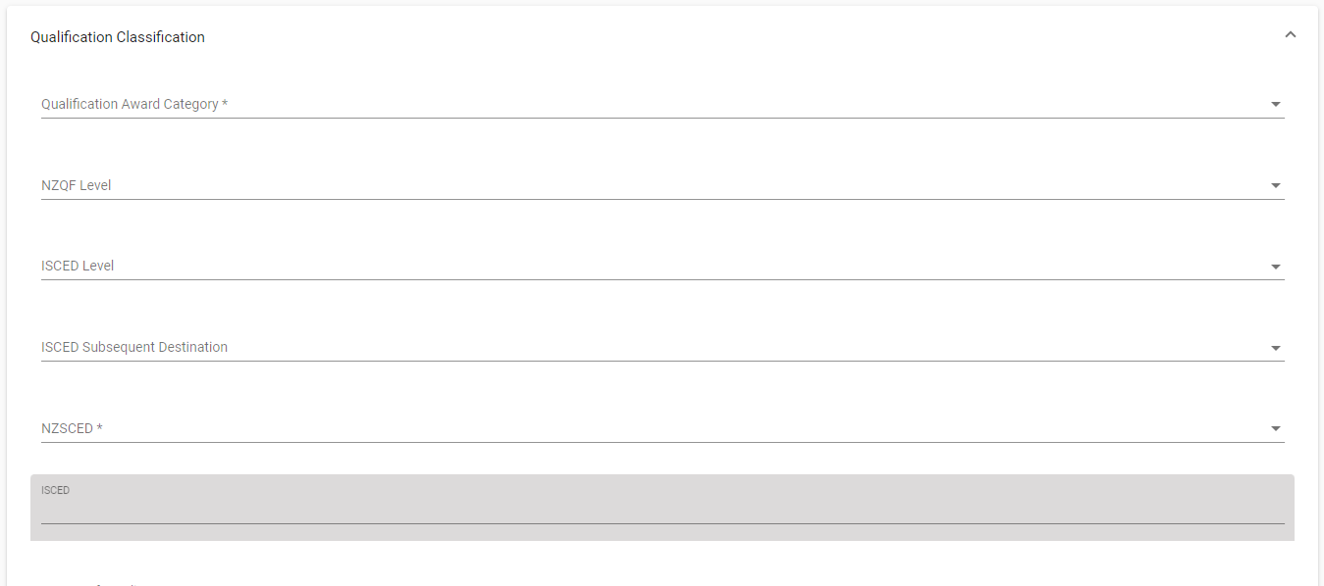
Figure 10 – Mandatory Fields Example
In the figure above, Qualification Award Category and NZSCED are required and must be filled in.

Validation of Input
The STEO website will validate the values you enter in input fields as well as some search fields.
If there are any issues with the values that are being entered, these will be displayed on the screen in red, as shown below:
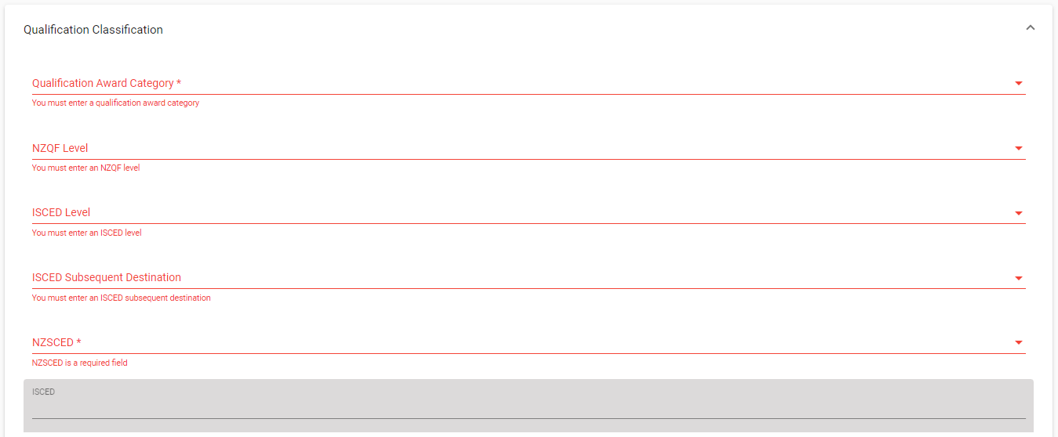
Figure 11 – Validation Error
The red text will display after you move away from a field.

You can edit these fields to rectify the issues. The errors will disappear from the input fields as these issues are rectified, as shown below:
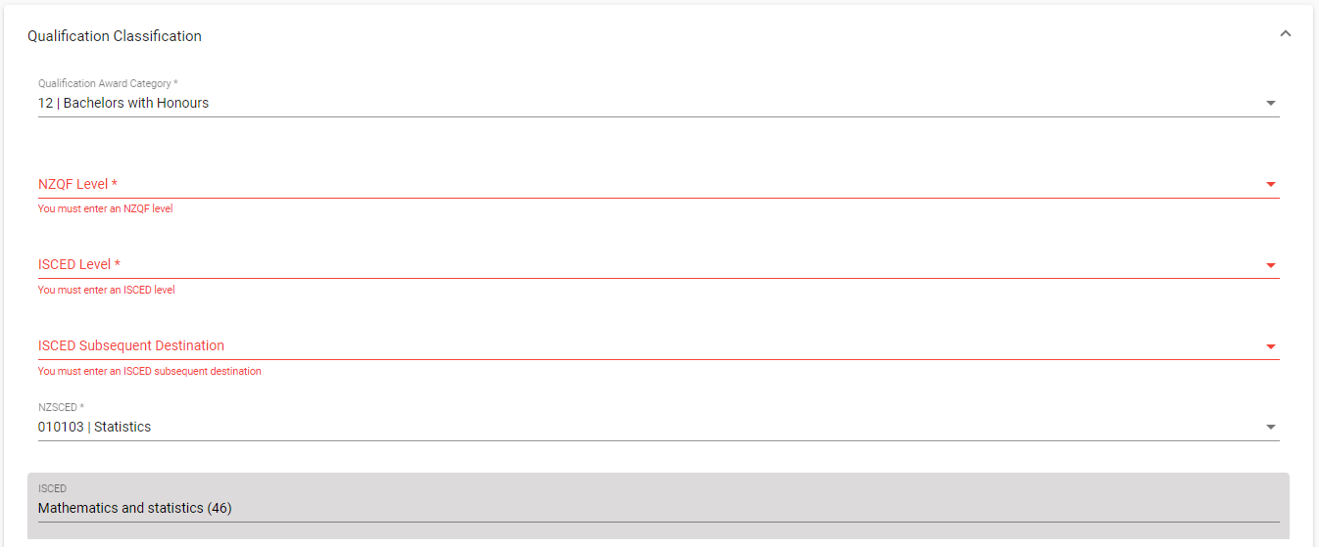
Figure 12 – Validation Error Box with Rectified Issues

Discarding Unsaved Changes
Some pages in STEO require you to input some data which is saved (like editing a course). Should you wish to abandon making any changes, you can navigate away from the page. However, the website will prompt you with a warning reminding you that there are unsaved changes, as shown below:
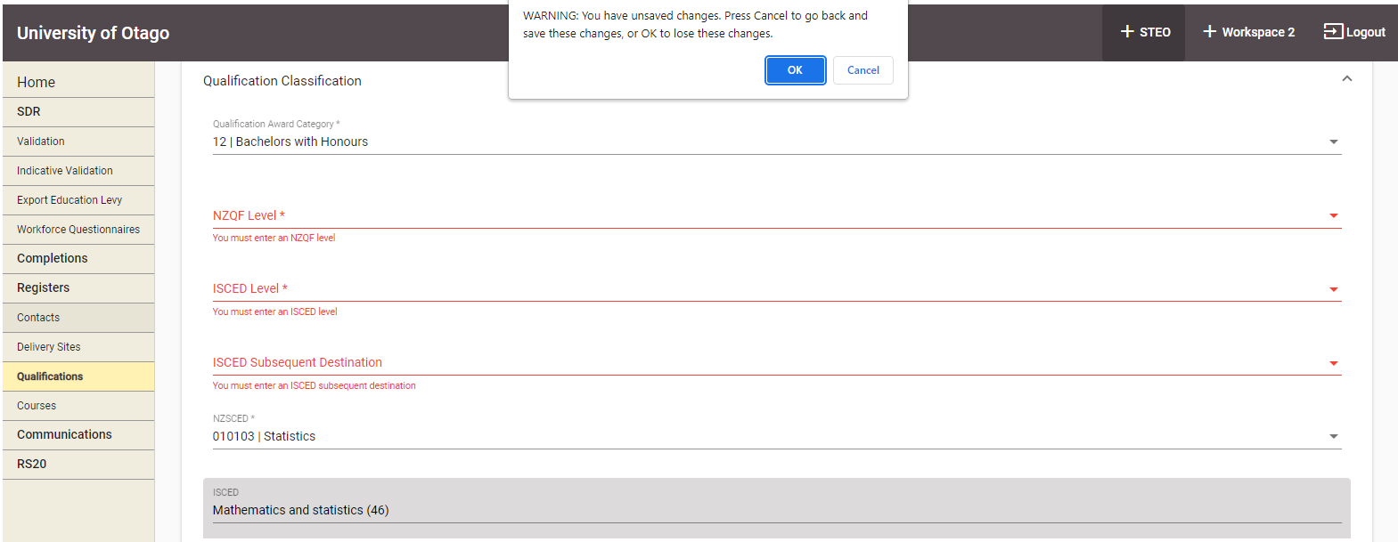
Figure 13 – Unsaved Changes Warning
This warning message may look different depending on the browser you are using.
Clicking “OK” will discard the unsaved changes and navigate you away from the page.
If you click “Cancel”, you will remain on this page, and are free to continue editing the form.

Maximum File Size when Uploading
The maximum file size when uploading any file to STEO is 20 megabytes (MB). If you upload a file greater than 20MB, you will be shown the following message:
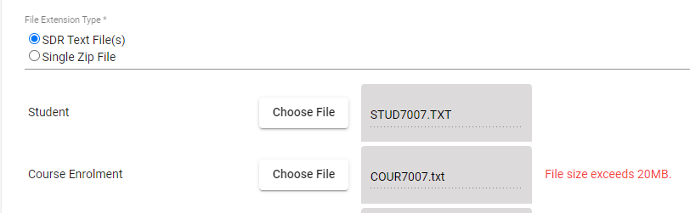
Figure 14 – Maximum File Size Exceeded Error Page
Please note that if you are uploading a .zip file where the contents are greater than 20MB, this is permitted as long as the uploaded .zip file is less than 20MB.

Logging in to STEO

Education Sector Logon (ESL)
STEO uses the Education Sector Logon (ESL) system for security and access. ESL is used by the Ministry of Education and other government Tertiary Education agencies to simplify the log in service as a Single Sign On (SSO) service. You need to have an ESL Username and Password, and be associated with a valid TEO to log in to STEO.

Log in to STEO
To log on using an ESL Username and Password, go to https://web.dxp.tec.govt.nz/ then select ‘Login using ESL’ to be directed to the Education Sector Logon (ESL) log in page.

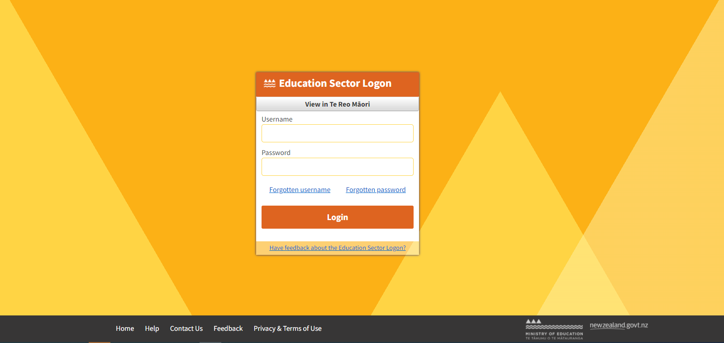
Figure 15 – ESL Log In Page
Enter your Username and Password.
Then click Login button to log in and begin your validation process.

If you are associated with more than one organisation, you will be asked to select a context before proceeding to STEO website:

Figure 16 – ESL Context Page
If you have access to Workspace 2 and the STEO application, then you will be shown the Workspace 2 home page first.
Select STEO in the top-right corner to navigate to the STEO home page.

Figure 17 – STEO Authenticated User Home Page
You are now successfully logged in to the STEO website.

Log out from STEO
Once you are logged in to STEO, there will be new links at the top of the page.

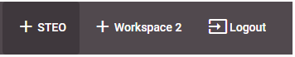
Figure 18 – STEO, Workspace 2, and Logout
To log out from STEO, you can click the Logout button at the top of the page. Once logged out, you will be directed to the DXP Log In page:

Figure 19 – Login Page

Contacts
Contacts are used to define and nominate contacts that will be notified during various processes that you may perform in STEO (like SDR Validation). The Contacts tab contains all contacts affiliated with your organisation. You can use this tab to view and alter information relating to these contacts, and you can also add or delete contacts.
The Contacts tab allows you to access the following pages and associated functionalities:
- Contacts
- Edit Contact
- Add Contact
- Delete Contact
You can navigate to this section by clicking on Contacts in the main menu.
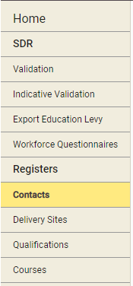
Figure 180 – Contacts Tab

Contacts

The Contacts page is the default page that you will land on when you navigate to the Contacts tab.
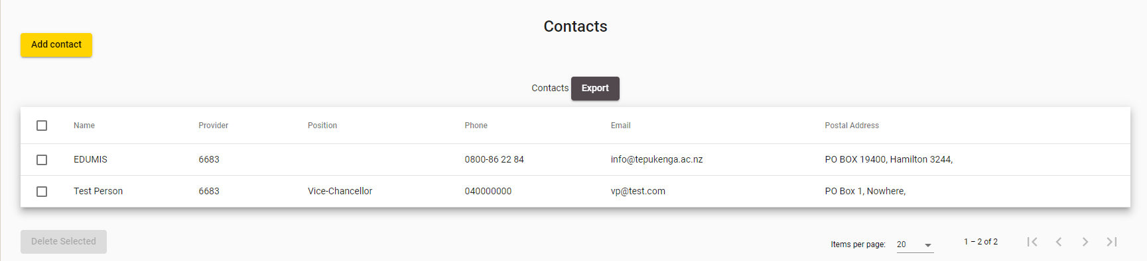
Figure 191 – Contacts List
You can sort the contacts list by clicking on the column header titles as previously described in the Sorting Search Results section.
If there is more than one page of contacts, you can browse through the other pages using the navigation buttons as described in Navigating through Result Pages.
You may navigate to a Contact by clicking on the Name of the contact, which will allow you to Edit Contact.
Clicking  will allow you to add a contact, as described in the Add Contact section.
If you select one or more contacts using the checkboxes in the Delete column and click 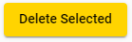, it will allow you to delete contacts, as described in the Delete Contact section.

Edit Contact
The Contact Details page contains more information for a given contact. You can access the Contact Details page by clicking anywhere on a contact’s row on the contacts page, as shown below:
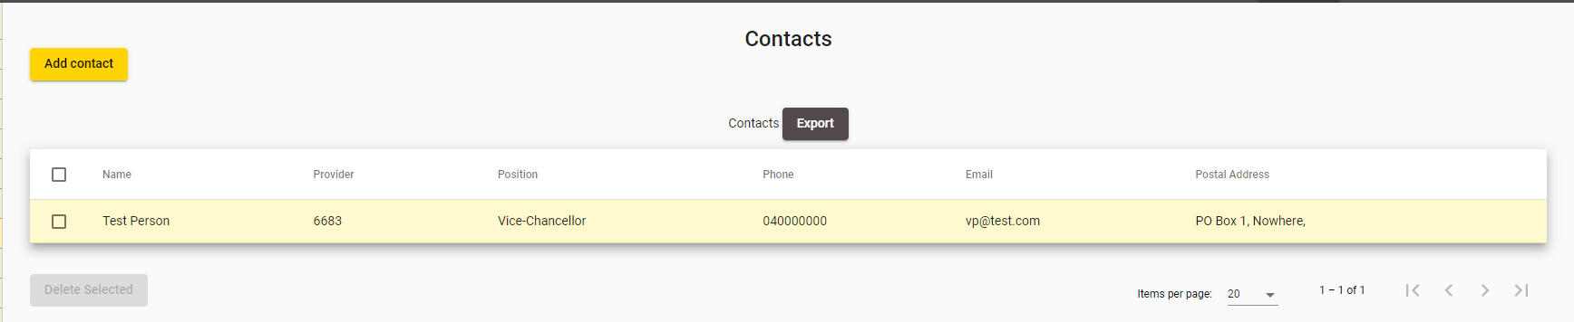
Figure 202 – Accessing Contact Details

The following page will be shown when you access Contact Details:
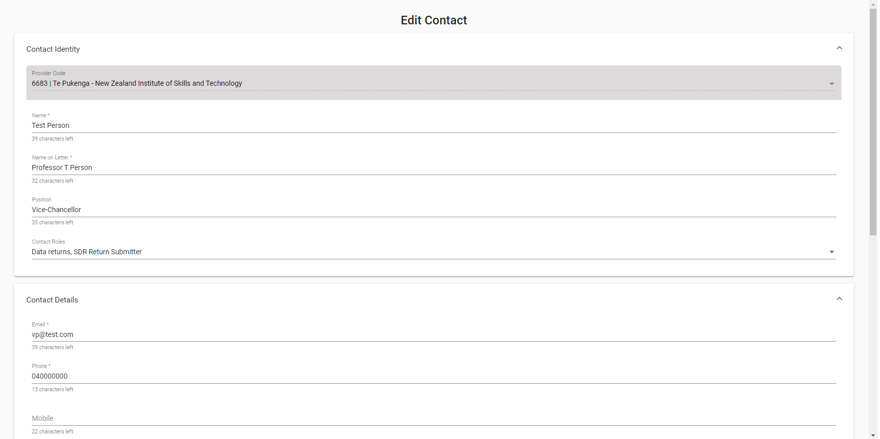
Figure 213 – Edit Contact
The Roles assigned to this Contact are shown in the 5th field of the Edit Contact form.
If the Contact has the CEO Contact Role then additional fields will be displayed, as shown below:
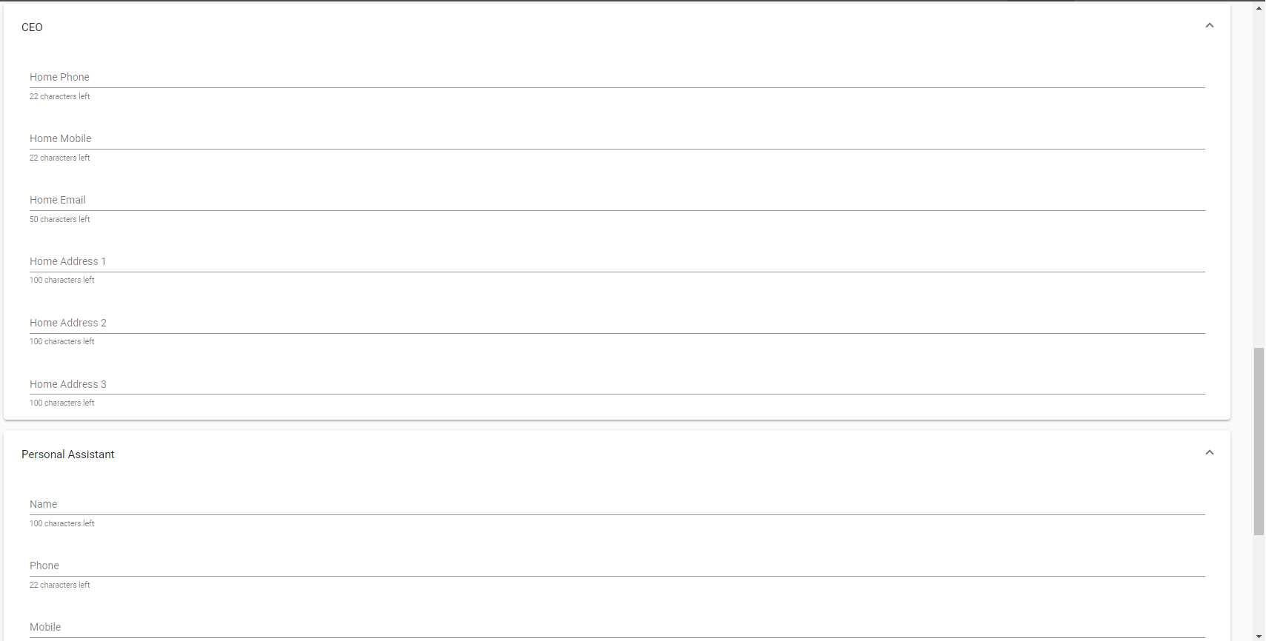
Figure 224 – CEO Contact Details Page
You can enter values as needed into the editable fields. Mandatory (required) fields are denoted by the asterisks (*), as described in the Mandatory Inputs section.
You can also assign and un-assign contact roles to the contact by selecting or unselecting the Contact Roles checkboxes in the dropdown list of the Contact Roles field.
Please note that if you are viewing an EDUMIS contact, you will be unable to edit any field on the page.
You can abandon updating the contact details at any time by clicking the  button. A warning message will be shown if you have unsaved changes as described in the Discarding Unsaved Changes section.
Clicking will return you to the Contacts page.
When you are finished with updating the contact details, you can click the  button. If there are any errors with data entered into the fields, you will be able to view and rectify the error as described in the Validation of Input section.
You may refer to Contact Fields and Descriptions for a more detailed explanation on what values are expected for each field.
Upon successfully updating the contact details, you will remain on the same page and you will be shown the following confirmation message:
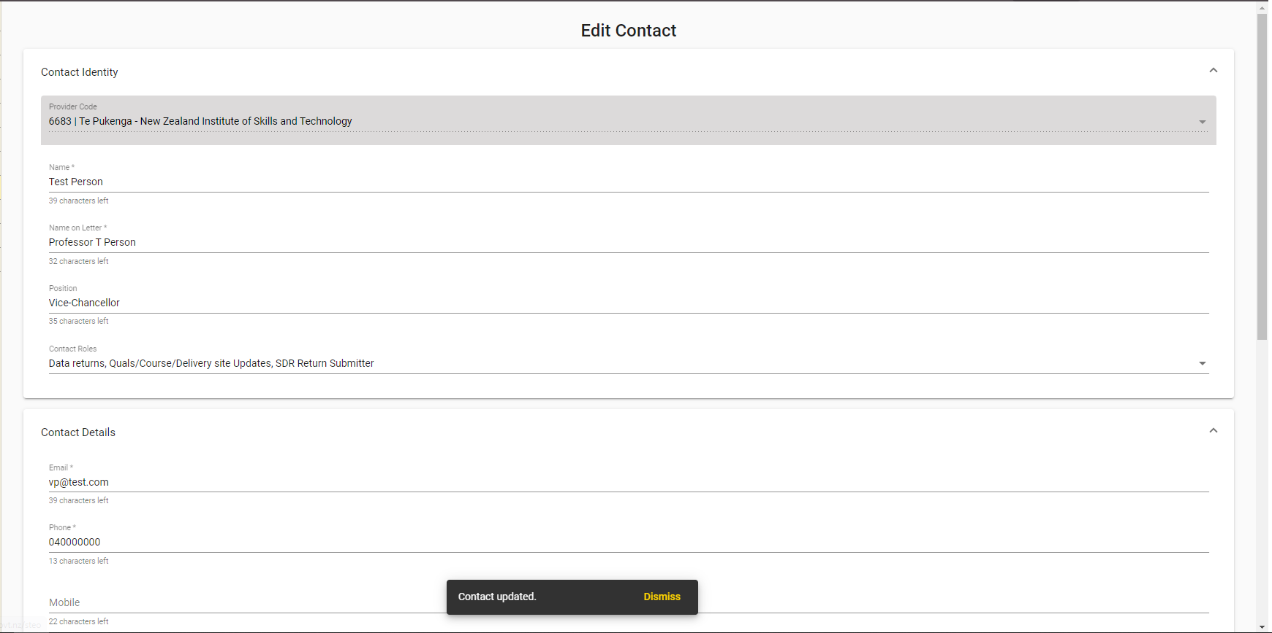
Figure 235 – Save Contact Confirmation

Add Contact
The Add Contact page allows you to add a new contact to your list of Contacts in STEO. You can access the Add Contact page by clicking on the  button from the Contacts page.
The following page is shown when you navigate to the Add Contact page:
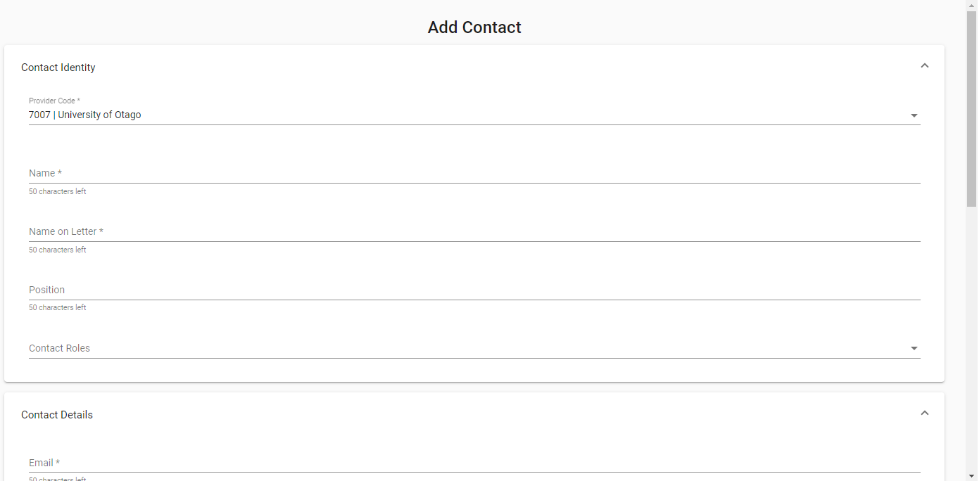
Figure 24 – Add Contact Page
All fields will be left blank, and all Contact Role dropdown list checkboxes will be left unticked.
You can enter values as needed into the editable fields. Mandatory (required) fields are denoted by the asterisks (*), as described in the Mandatory Inputs section.
You can also assign and un-assign contact roles to the contact by checking or unchecking the Contact Roles checkboxes.
You can abandon updating the contact details at any time by clicking the button. A warning message will be shown if you have unsaved changes as described in the Discarding Unsaved Changes section.
Clicking will return you to the Contacts page.
When you are finished with adding the new contact details, you can click the button. If there are any errors with data entry into the fields, you will be able to view and rectify the error as described in the Validation of Input section.
You may refer to Contact Fields and Descriptions for a more detailed explanation on what values are expected for each field.
Upon successfully adding the contact, you will be returned to the Contacts page, and you will be shown the following confirmation message:
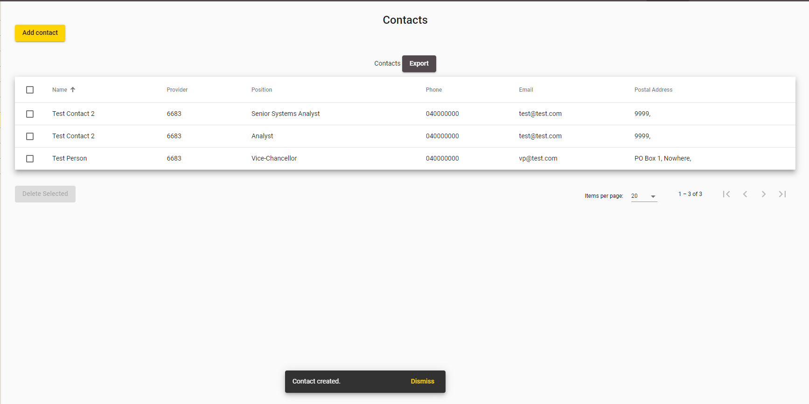
Figure 25 – Add Contact Confirmation

Delete Contact
The Delete Contact pop-up is a confirmation dialog that you will see when you attempt to delete one or more contacts. You can access the Delete Contact confirmation dialog by selecting at least one contact using the checkboxes, and clicking 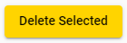 from the Contacts page, as shown below:
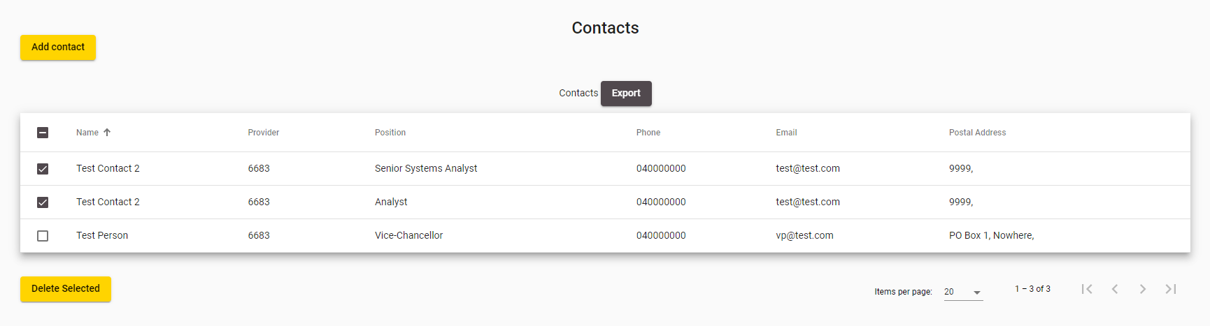
Figure 26 – Accessing Delete Contact
The following confirmation dialog box is shown when you attempt to delete a contact:
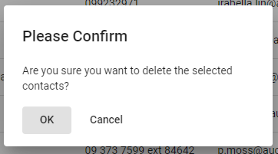
Figure 27 – Delete Contact Page
Clicking  will return you to the Contacts page.
Clicking  will proceed with deleting the contact(s). After the contact(s) have been deleted, you will return to the updated Contacts page (the contact(s) you deleted will not show up). You will also be shown the following confirmation message:
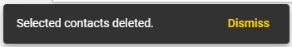
Figure 28 – Delete Contact Confirmation

Contact Fields and Descriptions
When you are filling in the forms to add or edit provider contacts you will encounter the following fields. This table may assist in providing some guidance as to how to fill in the fields correctly to avoid erroneous entries.
Field | Value
Contact Identity
Name  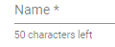 | Enter the name of the contact.  This is a mandatory field, which accepts a maximum of 50 characters.
Name on Letter   | Enter the name of the contact that should appear on any official letters.  This is a mandatory field, which accepts a maximum of 50 characters.
Position   | Enter the position of the contact within your organisation.  This is not a mandatory field, and accepts a maximum of 50 characters.
Contact Roles  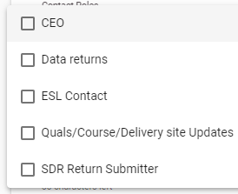 | Select at least one contact role for the contact.  The following active contact roles are available for selection:  - CEO – The Chief Executive Officer for the organisation  - Data returns – This is the preferred contact for SDR Submission emails  - ESL Contact - This is the contact who can sign off the ESL request form for the organisation  - Quals/Course/Delivery site Updates – This is the contact role that TEC will correspond with for any Course changes  - SDR Return Submitter – This is the contact who submits the SDR files
Contact Details
Email Address  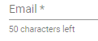 | Enter the email address that the contact can be reached by.  This is a mandatory field, which accepts a maximum of 50 characters, and it should be in an email format
Phone  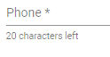 | Enter the phone number of the contact  This is a mandatory field and accepts a maximum of 20 characters.
Mobile  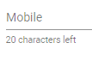 | Enter the mobile number of the contact  This is not a mandatory field and accepts a maximum of 20 characters.
Web Site   | Enter the web site for the contact.  This is not a mandatory field and accepts a maximum of 100 characters. It should also be in a typical web site link format.
Address  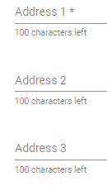 | Enter the address of the contact  This is a mandatory field.  There are three separate field lines, each field line accepts a maximum of 100 characters.
Postal Address  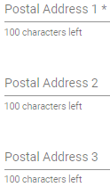 | Enter the postal address of the contact  This is a mandatory field.  There are three separate field lines, each field line accepts a maximum of 100 characters.
Postal Code  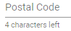 | Enter the postal code for the contact  This is not a mandatory field, which accepts up to 4 digits.
CEO
CEO Home Phone  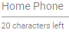 | Enter the CEO’s home phone number  This is a not mandatory field and accepts a maximum of 20 characters.  This field is only visible if the CEO Contact Role checkbox is ticked.
CEO Home Mobile  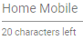 | Enter the CEO’s home mobile number  This is not a mandatory field and accepts a maximum of 20 characters.  This field is only visible if the CEO Contact Role checkbox is ticked.
CEO Home Email   | Enter the CEO’s home email address that they can be reached by.  This is a not mandatory field and accepts a maximum of 50 characters, and it should be in an email format  This field is only visible if the CEO Contact Role checkbox is ticked.
CEO Home Address  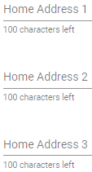 | Enter the home address of the CEO  There are three separate field lines, each field line accepts a maximum of 100 characters.  This field is only visible if the CEO Contact Role checkbox is ticked.
Personal Assistant
PA Name  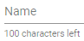 | Enter the name of the CEO’s personal assistant.  This is not a mandatory field. This field accepts a maximum of 100 characters.  This field is only visible if the CEO Contact Role checkbox is ticked.
PA Phone  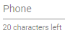 | Enter the phone number of the CEO’s personal assistant.  This is not a mandatory field. This field accepts a maximum of 20 characters.  This field is only visible if the CEO Contact Role checkbox is ticked.
PA Mobile   | Enter the mobile number of the CEO’s personal assistant  This is not a mandatory field. This field accepts a maximum of 20 characters.  This field is only visible if the CEO Contact Role checkbox is ticked.
PA Email   | Enter the email address of the CEO’s personal assistant.  This is not a mandatory field. This field accepts a maximum of 50 characters.  This field is only visible if the CEO Contact Role checkbox is ticked.
PA Address  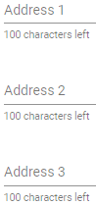 | Enter the address of the CEO’s personal assistant.  This is not a mandatory field. There are three separate field lines, each field line accepts a maximum of 100 characters.  This field is only visible if the CEO Contact Role checkbox is ticked.

Delivery Sites
Delivery sites are locations or campuses where the majority of the teaching, instruction or learning occurs for a course or module of a formal programme. The campus or site must be a recognised centre of learning by the provider that is geographically separate from other sites or campuses. The Delivery Site is used by the Ministry of Education for tertiary sector reporting and policy purposes.
The Delivery Sites tab contains all delivery sites affiliated with your organisation. You can use this tab to view and alter information relating to these delivery sites, and you can also add delivery sites.
The Delivery Sites tab allows you to access the following pages and associated functionalities:
- Delivery Site
- View / Edit / Delete Delivery Site Details
- Add Delivery Site
You can navigate to this section by clicking on Delivery Sites in the main menu.
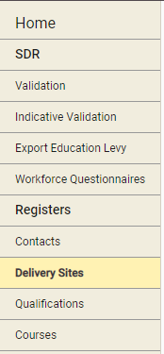
Figure 29 – Delivery Sites Tab

Delivery Sites
The Delivery Sites page is the default page that you will land on when you navigate to the Delivery Sites tab.
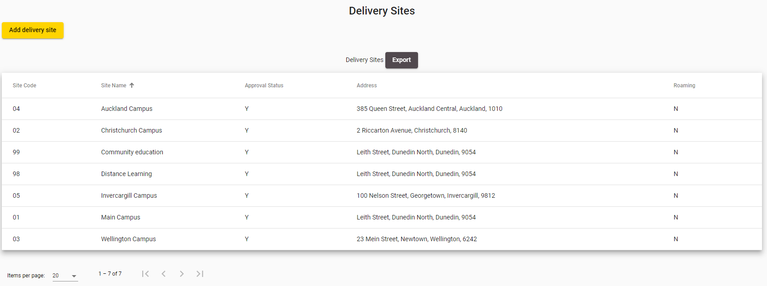
Figure 30 – Delivery Sites Page
All Delivery Sites affiliated with your organisation will be shown here.
You can sort the delivery sites list by clicking on the column header titles as previously described in the Sorting Search Results section.
If there is more than one page of delivery sites, you can browse through the other pages using the navigation buttons as described in Navigating through Result Pages.
You may navigate to a Delivery Site by clicking on the row of the delivery site, which will allow you to View / Edit / Delete Delivery Site Details.
Clicking  will allow you to add a delivery site, as described in the Add Delivery Site section.

View / Edit / Delete Delivery Site Details
The Delivery Site Details page contains more information for a given delivery site which you can edit. You can access the Delivery Sites Details page by clicking on a delivery site’s row from the Delivery Site page as shown below:
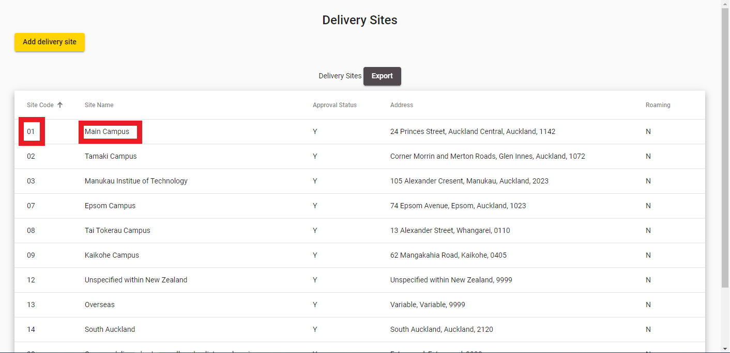
Figure 31 – Accessing Delivery Site Details
The following page will be shown when you access Delivery Site Details:
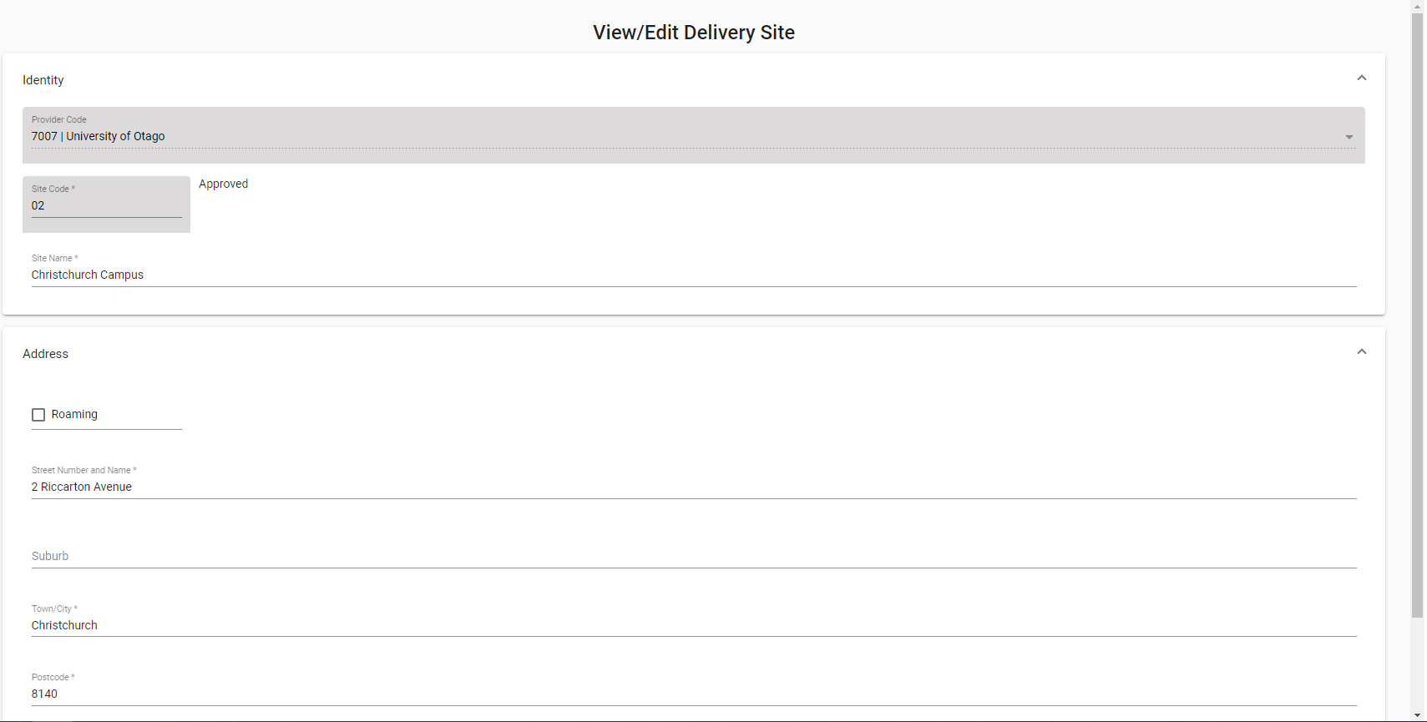
Figure 32 – View / Edit Delivery Site Details
Clicking on the “Find your postcode” link will take you to NZ Post’s Post Code Finder Tool (https://www.nzpost.co.nz/tools/address-postcode-finder) where you can find the correct postcode. Please note that this is a view-only website, and you will still have to manually enter the postcode into the Delivery Site Details page after you located the required postcode on the NZ Post website.
You can enter values as needed into the editable fields. Mandatory (required) fields are denoted by the asterisks (*), as described in the Mandatory Inputs section. If you tick the Roaming checkbox field, all Address fields will no longer be mandatory, as shown below:
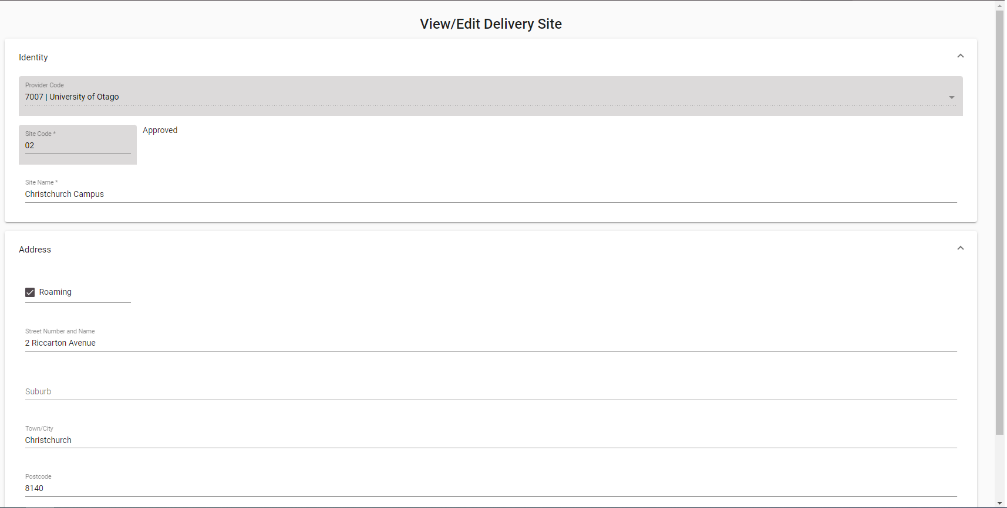
Figure 33 – Roaming Checked on View / Edit Delivery Sites
You can abandon updating the delivery site details at any time by clicking the button. A warning message will be shown if you have unsaved changes as described in the Discarding Unsaved Changes section.
Clicking will return you to the Delivery Site page.
When you are finished with updating the delivery site details, you can click the  button. If there are any errors with data entered into the fields, you will be able to view and rectify the error as described in the Validation of Input section.
You may refer to Delivery Site Fields and Descriptions for a more detailed explanation on what values are expected for each field. Additionally, if you encounter further issues, the section Error Messages in Delivery Sites explains commonly encountered problems.
Upon successfully updating the delivery site details, you will be returned to the Delivery Site page, with the following confirmation message shown:
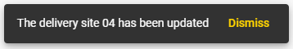
Figure 34 – Delivery Site Save Confirmation
You can also delete the delivery site by clicking the 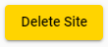 button, and confirming on the warning message. This will prompt you to confirm deletion as shown below:
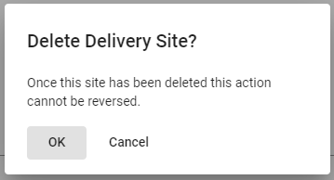
Figure 35 – Delivery Site Delete Confirmation Prompt
Upon successfully deleting the delivery site, you will be returned to the Delivery Site page with the following confirmation message shown:

Figure 36 – Delivery Site Delete Confirmation

Add Delivery Site
You can add a new delivery site using the Add Delivery Site page. You can access the Add Delivery Sites page by clicking on the button from the Delivery Site page. The following page will be shown when you access the Add Delivery Site page:
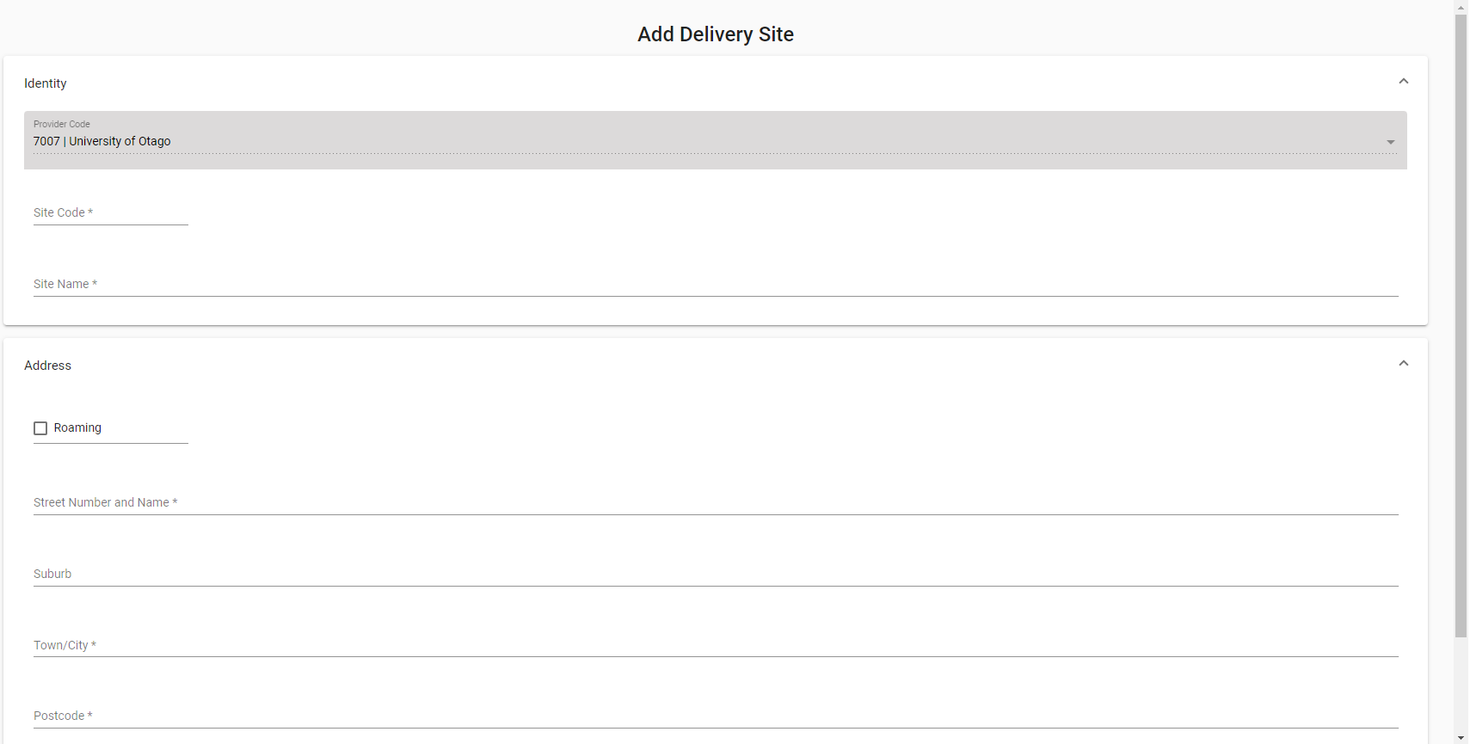
Figure 37 – Add Delivery Site
Clicking on the “Find your postcode” link will take you to NZ Post’s Post Code Finder Tool (https://www.nzpost.co.nz/tools/address-postcode-finder) where you can find the correct postcode. Please note that this is a view-only website, and you will still have to manually enter the postcode into the Add Delivery Site page.
You can enter values as needed into the editable fields. Mandatory (required) fields are denoted by the asterisks (*), as described in the Mandatory Inputs section. If you tick the Roaming checkbox field, all Address fields will no longer be mandatory, as shown below:
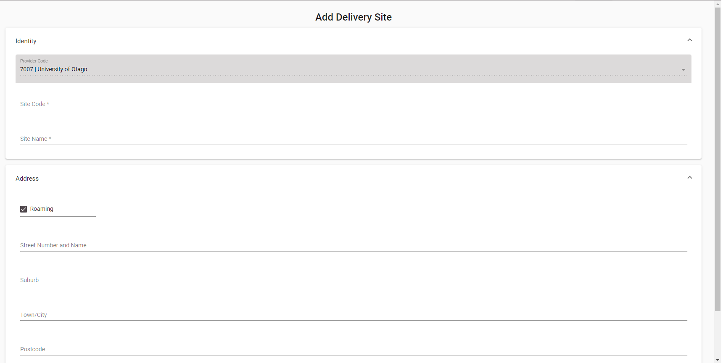
Figure 38 – Roaming Checked on Add Delivery Site

You can abandon adding the delivery site at any time by clicking the button. A warning message will be shown if you have unsaved changes as described in the Discarding Unsaved Changes section.
Clicking will return you to the Delivery Site page.
When you are finished with entering the new delivery site details, you can click the button. If there are any errors with data entered into the fields, you will be able to view and rectify the error as described in the Validation of Input section.
You may refer to Delivery Site Fields and Descriptions for a more detailed explanation on what values are expected for each field. Additionally, if you encounter further issues, the section Error Messages in Delivery Sites explains commonly encountered problems.
Upon successfully adding the delivery site, you will be returned to the Delivery Site page, with the following confirmation message shown:

Figure 392 – Delivery Site Add Confirmation

Delivery Site Fields and Descriptions
When you are filling in the forms to add or edit delivery sites you will encounter the following fields. This table may assist in providing some guidance as to how to fill in the fields correctly to avoid erroneous entries.
Field | Value
Identity
Site Code | Enter in a unique Site Code.  The site code needs to be two-digit code in accordance with the CRS_SITE field in the SDR manual.  This field has a maximum of 2 alphanumeric characters.
Site Name | Enter in the name of the delivery site.  This field accepts has a maximum of 200 characters
Address
Roaming   | Tick this field if the delivery site is a roaming site.  If Roaming is ticked, there are no mandatory address fields.
Street Number and Name   | Enter in the Physical Address of the delivery site.  This field accepts a maximum of 50 alpha-numeric characters.
Suburb   | Enter in the suburb the delivery site is located in.  Please not this is not a mandatory field, and has a maximum of 25 alpha characters.
Town/City | Enter the Town/City the delivery site is located in.  This field has a maximum of 25 alpha characters.
Postcode   | This is the postcode of the delivery site.  Valid post codes should be used. The field has a maximum of 4 numeric characters.  A link for users to find their post code (Find your post code) is provided, which redirects users to an external page located at https://www.nzpost.co.nz/tools/address-postcode-finder. This does not result in any data being transmitted back to the original page.

Error Messages in Delivery Sites
Most errors can be avoided by following the guidelines outlined in Delivery Site Fields and Descriptions. However, in some cases you may encounter additional error messages:
Error Message | Description
Enrolments exist for this combination of Provider Code and Location Code (<Provider Code>, <Delivery Site Code>). Deletion is not possible.  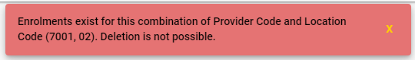 | The SDR Submission process creates enrolment records for courses being taught at delivery sites.  You will not be able to delete the delivery site if any students were ever enrolled in courses that are taught at the delivery site you are attempting to delete.  You must first ensure that there was/is no study enrolments at the delivery site before you proceed with deletion.
Site Code already exists for provider  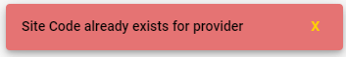 | The Site Code must be unique before you can create it. You may not create a Delivery Site that shares a duplicated Site Code.  Please use a different Site Code if you are trying to add a new Delivery Site, or edit the existing Delivery Site instead.

Qualifications
The Qualifications tab and underlying functionality gives you access to your organisation’s offered qualifications (current and prior qualifications), including any change requests (to add/update the qualifications) that have been lodged against these qualifications. You can use this tab to view and alter the qualification details and their lodged change requests. This tab also allows you to search for and edit Concurrent Studies.
Some fields in this section may also be used to provide data for the Key Information Set (KIS) for this qualification published to support students' enrolment decisions. See here for more information about the Key Information Set.
KIS data is provided by the TEC data service for all active TEC funded qualifications. The KIS data for each qualification is published on the TEO website and also on the TEC website. Use the close process to ensure a KIS is not published for any qualifications no longer delivered.
The Qualifications tab allows you to access the following pages and functions:
- Search Qualifications
- View Qualification Details
- View Courses under Qualification
- Edit Qualification
- Close Qualification
- Add New Qualification
- Search Qualification CRs
- View / Edit Qualification CR
- Search Concurrent Studies
- View / Edit Concurrent
- Add New Concurrent
You can navigate to this section by clicking on Qualifications in the main menu.
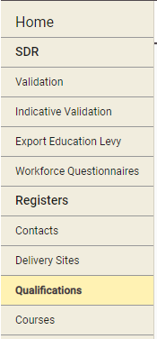
Figure 40 – Qualifications Tab

Search Qualifications
The Qualifications Search page allows you to search for qualifications that your organisation offers (both Active and Closed) as defined in the Qualifications Register. You can access on the Qualification Home Page.
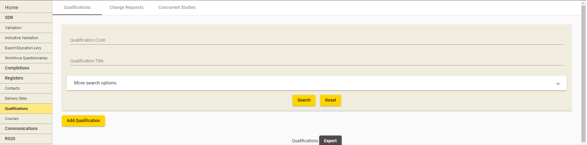
Figure 414 – Accessing Search Qualifications
The following form is shown when you click on the More Search Options dropdown:
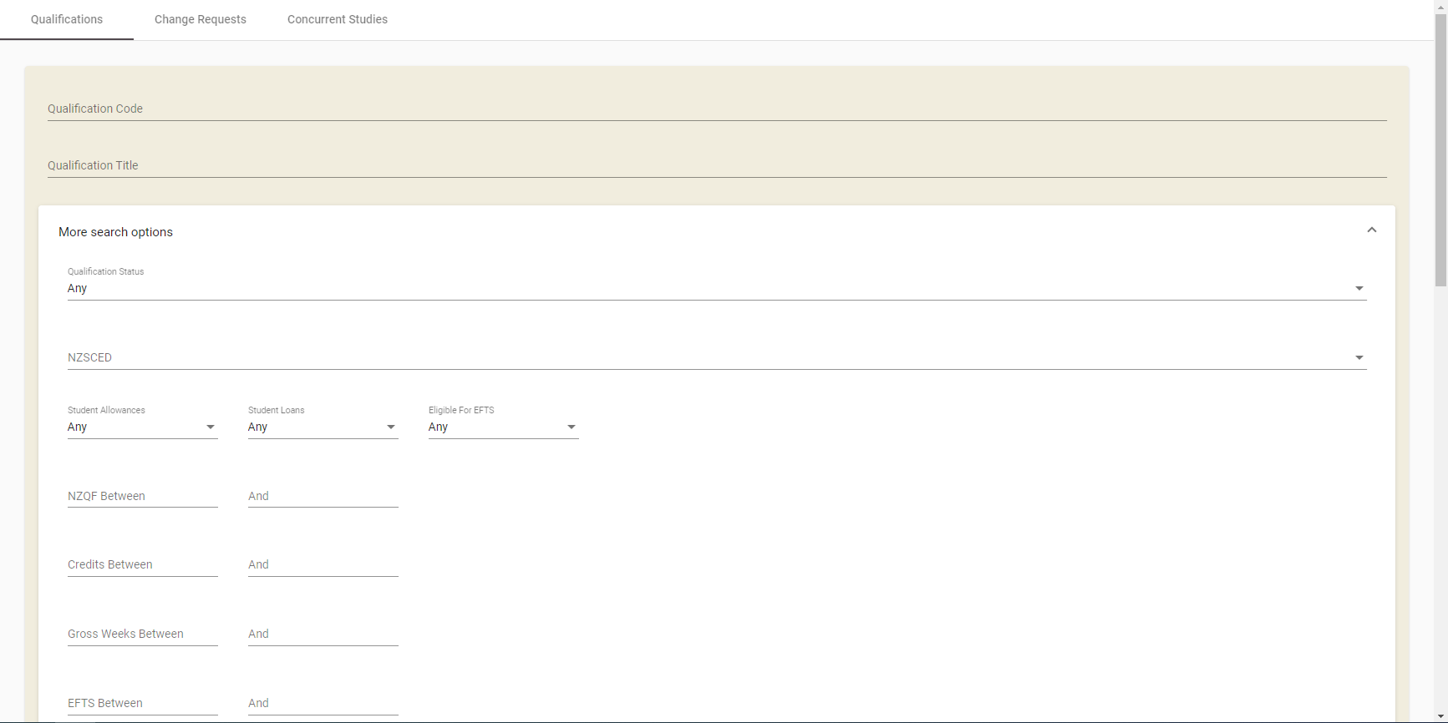
Figure 425 – Qualifications Search Page
You can search for all existing qualifications against your organisation by optionally entering search criteria into any of the fields shown in the search box and clicking . The Qualification Code, Qualification Title, and NZSCED fields will allow for wildcard searching which match partial characters entered into the field as described in the Wildcard Searching section. The NZSCED field also allows you to look up existing entries by clicking on the button. This will drop down a list of NZSCED options to pick from as described in the Lookup Windows section.
If there are any errors with data entry into the search fields, you will be able to view the error as described in the Validation of Input section.
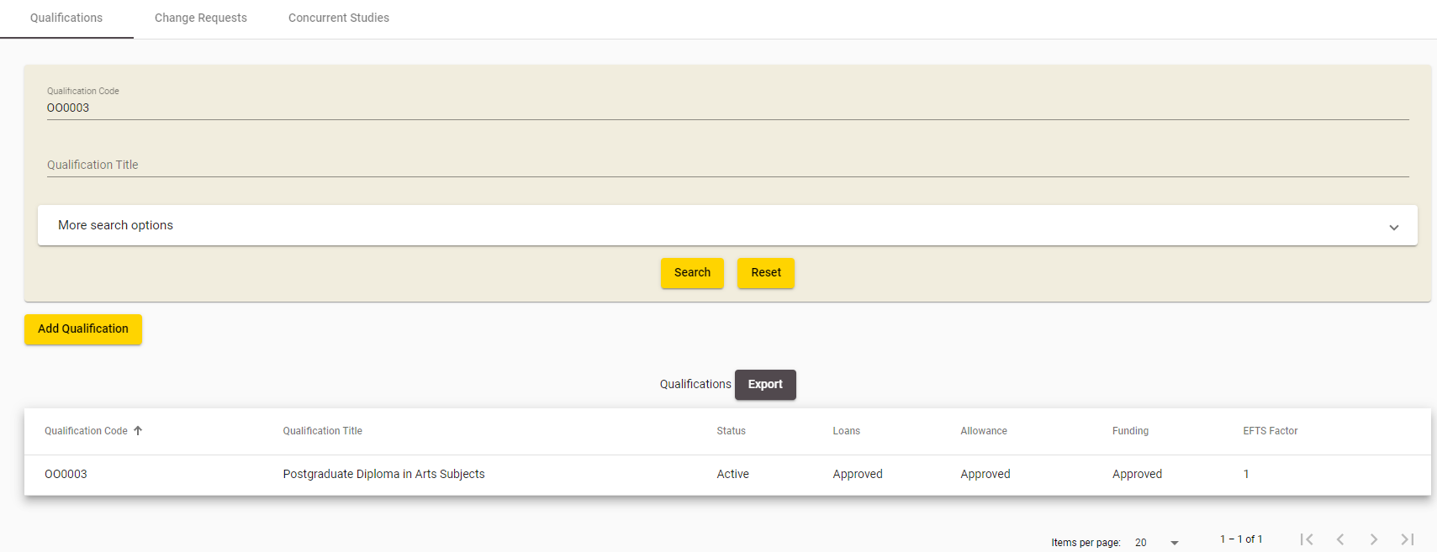
Figure 436 – Qualifications Search Results Page
The search results based on the criteria entered will be shown as per Figure 436, with 20 qualifications shown per page.
You can sort the results by clicking on the column header titles as previously described in the Sorting Search Results section.
If there is more than one page of qualifications, you can browse through the other pages using the navigation buttons as described in Navigating through Result Pages.
You may View Qualification Details of a Qualification by clicking on the qualification’s row.
Clicking  will clear the search results page and return the search fields back to their defaults so you can start a fresh search.

View Qualification Details
The Qualification Details page contains information related to a given qualification. You can access the Qualification Details page by clicking on a qualification’s row from the Search Qualifications page, as shown in the figures below:
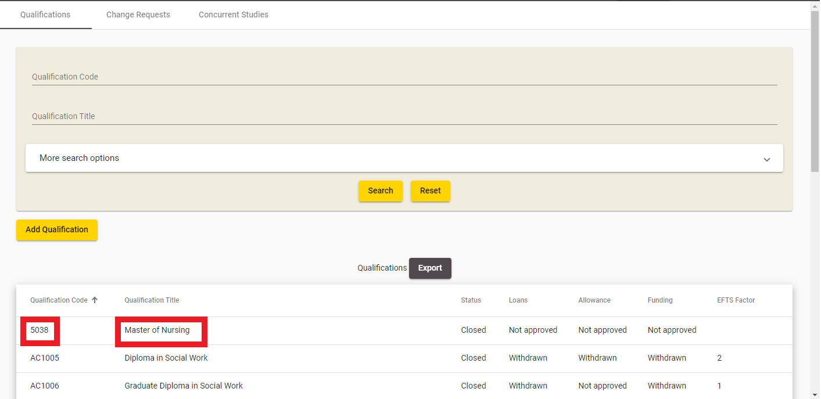
Figure 447 – Accessing Qualification Details from Qualification Search
When you access the Qualification Details page, the following page will be shown:
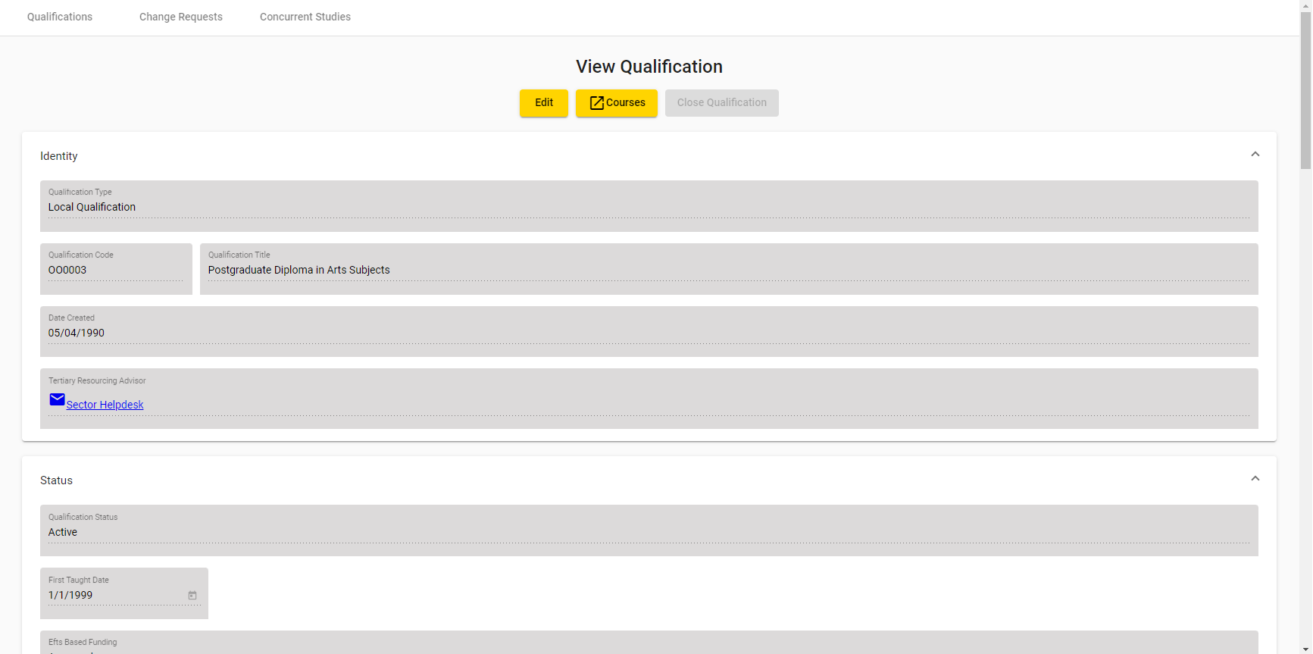
Figure 458 - View Qualification Details

You can collapse or expand the sections on this page by clicking on the headers (e.g. Status, or Duration). The expandable and collapsible sections will have chevrons or to the right of the header title as shown below:
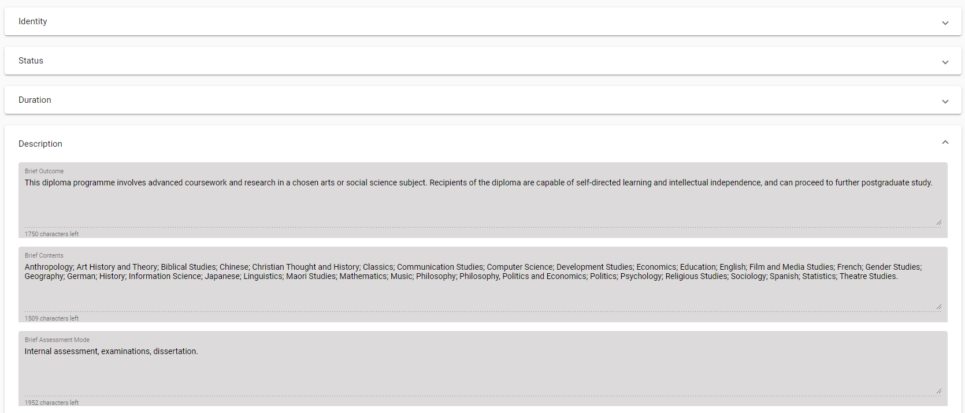
Figure 4946 – View Qualification Details with collapsed sections
Clicking on the name of the Tertiary Resourcing Advisor will open your email client application with a new email addressed to the email of the contact.
Some buttons are conditionally visible.
The  button is shown if the Qualification Status is Active and the EFTS Based Funding, Student Allowances and Student Loans are not currently Approved. Clicking on it will allow you to close the qualification, as described in Close Qualification.
The  button is shown when the Qualification Status is Active, and there are no pending qualification change requests lodged against the qualification. Clicking on it will allow you to Edit Qualification.
Clicking on  will take you to the View Courses under Qualification page.
Clicking on Qualifications in the header  will return you to the Search Qualifications page.

View Courses under Qualification
The View Courses under Qualification page contains all the latest courses (both Active and Inactive) that are associated with a particular qualification. It can be accessed by clicking  from the View Qualification Details or the Edit Qualification pages, as shown below:
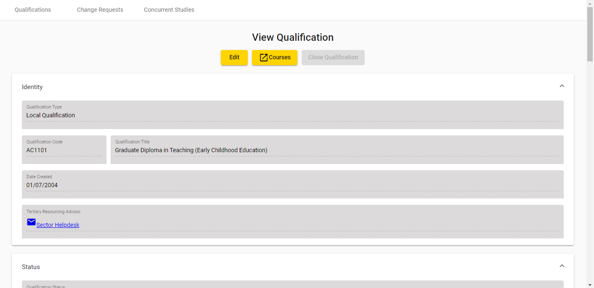
Figure 470 – Accessing Courses under Qualification
It is possible that there may be no courses associated with the qualification. In this scenario, you will be shown the following message when you click on :
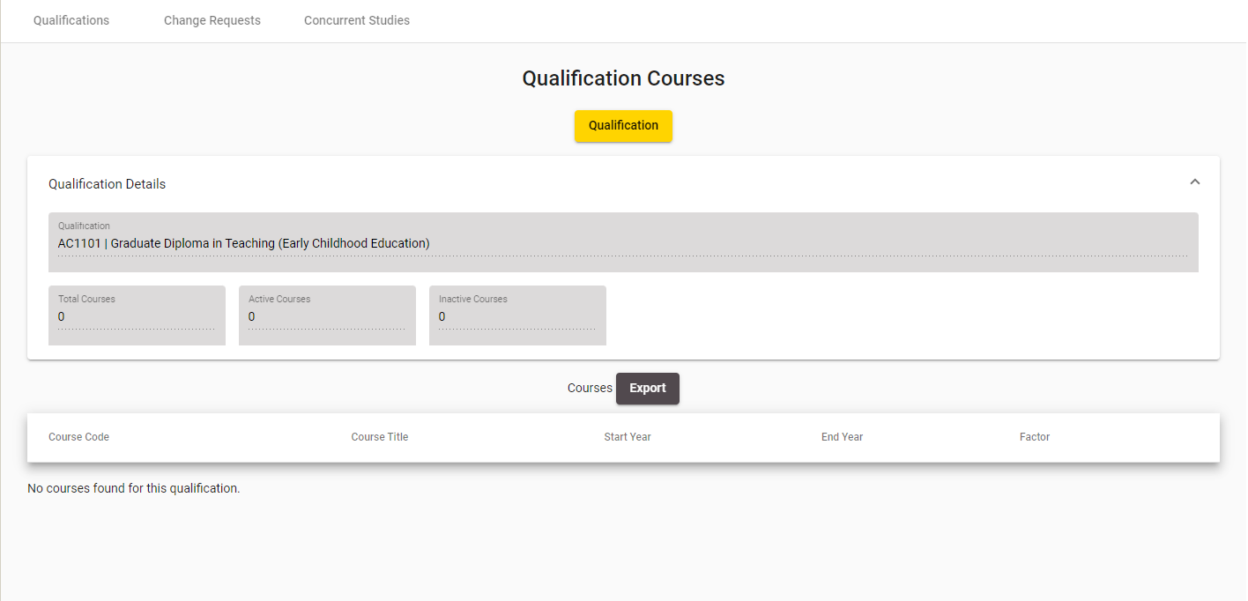
Figure 481 – No Courses under Qualification found notification
Otherwise, if there are courses associated with the qualification, the following page will be opened in a new tab or window in your internet browser:
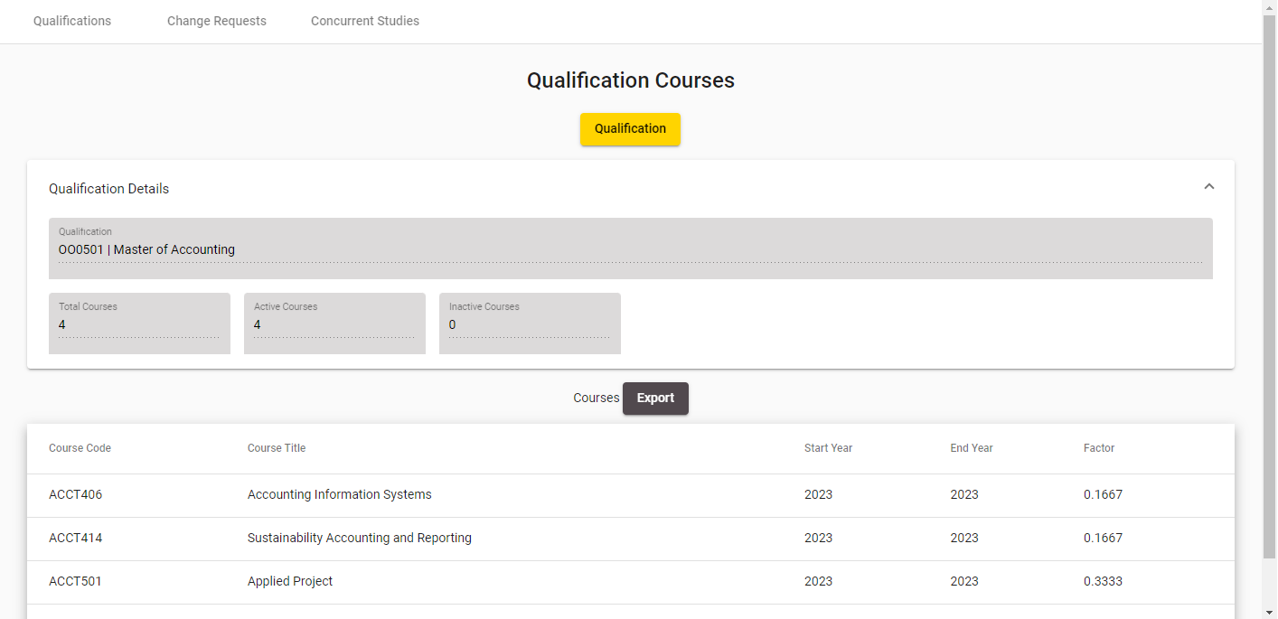
Figure 492 – Courses under Qualification
Only the most recent course instances will be shown in this page (if there are multiple courses with the same Course Code, only the most recent one is shown). The Courses will be shown sorted by Course Code in ascending order.
Please note that Inactive Courses are shown in grey text, whereas Active Courses are shown with black text.
Should you wish to return to View Qualification Details or Edit Qualification, you can close this tab.

Edit Qualification
The Edit Qualification page, allows you to edit the details of an existing active qualification. You can access it by clicking the  button from the View Qualification Details page:
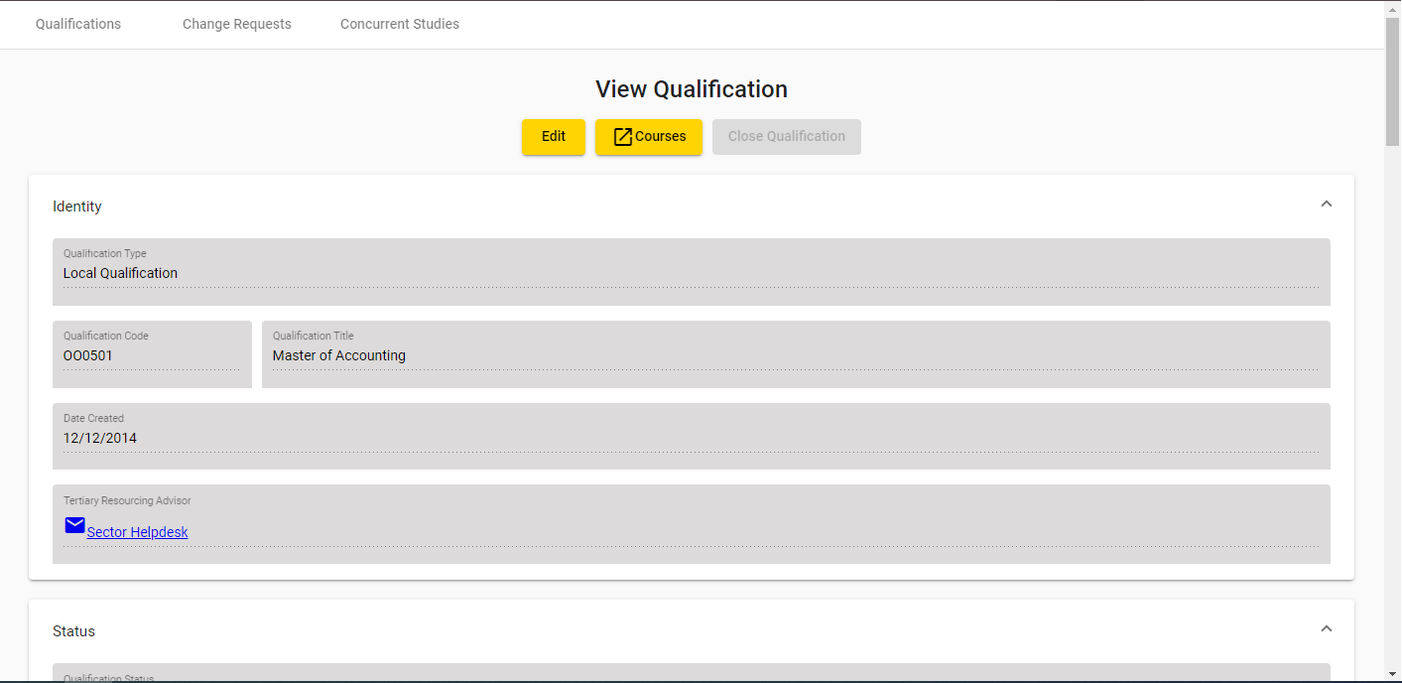
Figure 503 – Accessing Edit Qualification
Please note that if the Qualification has a pending Change Request, the button will not be shown, and instead a  button will be shown, as described in View / Edit Qualification CR.
The following page will be shown when you access the Edit Qualification page:
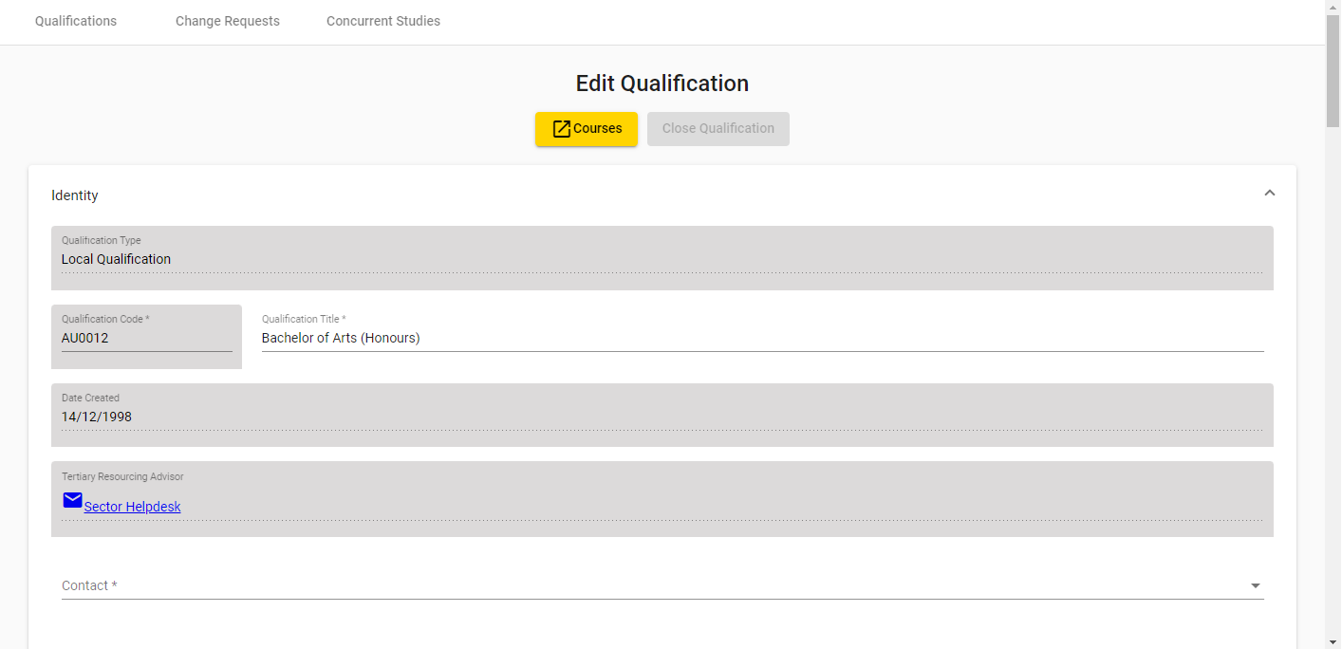
Figure 514 – Edit Qualification Page
The following sections will be visible for you to edit:
- Identity
- Status
- Duration
- Description
- Qualification Classification
Please note that the Qualification Type, Qualification Code, Date Created, Tertiary Resourcing Advisor, Qualification Status, First Taught Date and ISCED fields are disabled when editing a local qualification, the Qualification Title field is also disabled when editing a national qualification.
Clicking on the name of the Tertiary Resourcing Advisor will open your email client with a new email addressed to the email of the contact.
You can enter values as needed into the editable fields. Mandatory (required) fields are denoted by the asterisks (*), as described in the Mandatory Inputs section.
The Qualification Award Category, NZSCED, Source of Funding, and Certifying Authority fields allow you to look up existing entries by clicking on the button. This is described in further detail in the Lookup Windows section.
You can abandon updating the qualification details at any time by clicking the  button. A warning message will be shown if you have unsaved changes as described in the Discarding Unsaved Changes section. Clicking will return you to the View Qualification Details page.
When you are finished with updating the qualification details, you can click the  button. If there are any errors with data entry into the fields, you will be able to view and rectify the error as described in the Validation of Input section.
You may refer to Qualification Fields and Descriptions for a more detailed explanation on what values are expected for each field. Additionally, if you encounter further issues, the section Error Messages in Qualifications explains commonly encountered problems.
Upon successfully updating the qualification details, a new qualification change request will be created and you will be taken to the View / Edit Qualification CR page, with the following confirmation message shown:
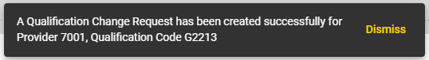
Figure 525 – Edit Qualification Confirmation Message
Alternatively, if you only make changes to fields that will be automatically approved, a Qualification Change Request that is automatically approved will be created. These fields are:
- Brief Outcome
- Brief Contents
- Brief Assessment Mode
- Brief Entry Requirements
- Certifying Authority
No further review and approval needs to be performed by the Agency. The Change Request will have a Request Status of No Action Required.
You may continue to edit the qualification should you wish to do so.

Close Qualification
The Close Qualification function allows you to close a qualification. To do so, the qualification must have a Qualification Status of Active, and the EFTS Based Funding, Student Allowance and Student Loans must not be Approved (either Withdrawn, Not Approved, or Not Sought). In addition, there must be no pending Qualification Change Requests lodged against the Qualification. If these conditions are met, the  button will be visible.
You can close the qualification by clicking the button on the View Qualification Details page, as shown below:
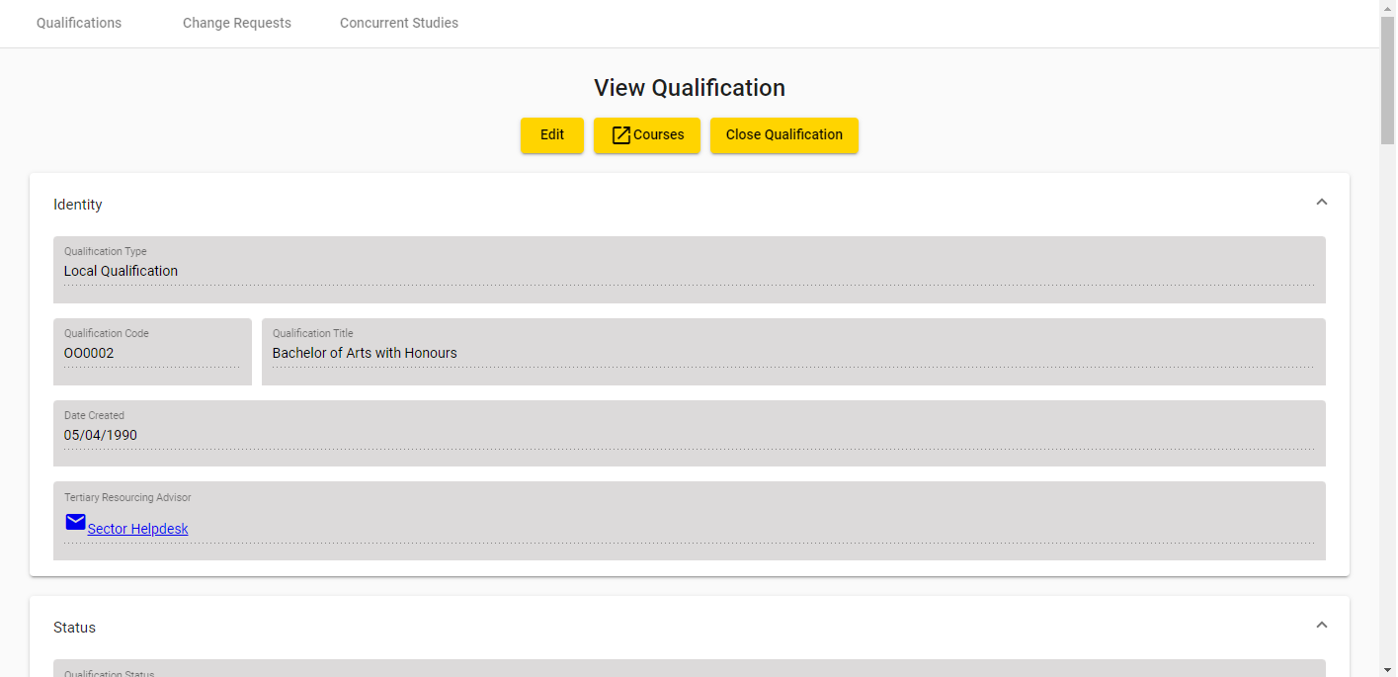
Figure 553 – Accessing Close Qualification
You will be shown a warning message asking you to confirm:
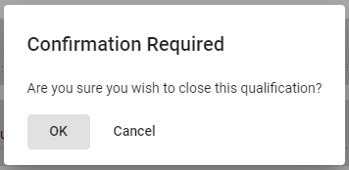
Figure 57 – Close Qualification Confirmation Prompt
If you proceed with closing the qualification, you will remain on the View Qualification Details page and the following confirmation message will be shown:

Figure 5854 – Close Qualification Confirmation Message

Add New Qualification
The Add New Qualification page allows you to add new qualifications. You can access it by clicking Add Qualification from the Qualifications tab:
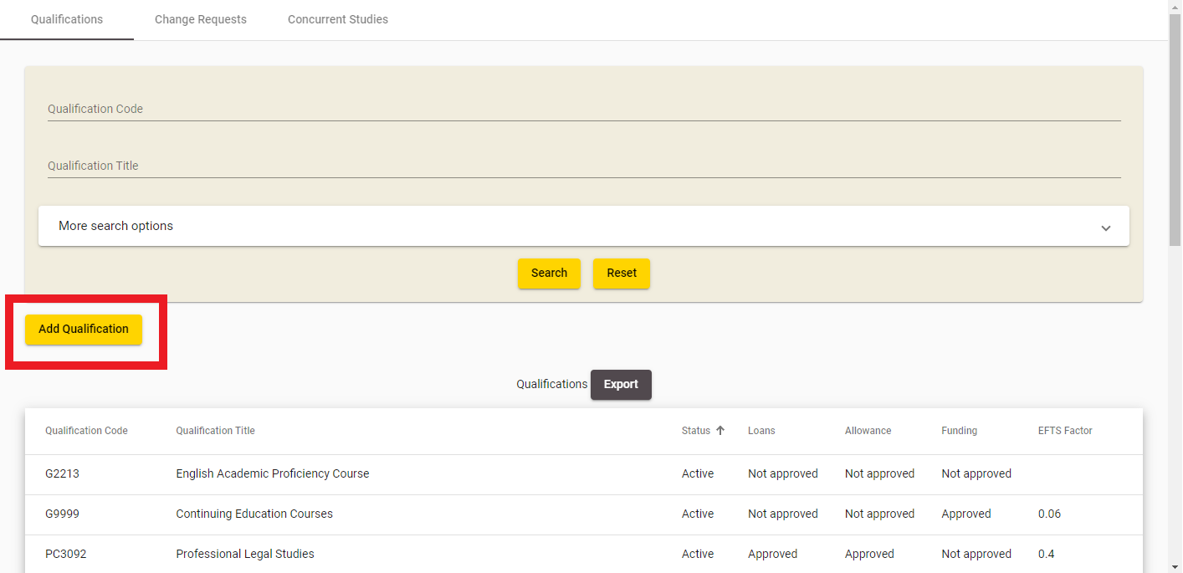
Figure 5955 – Accessing Add New Qualification
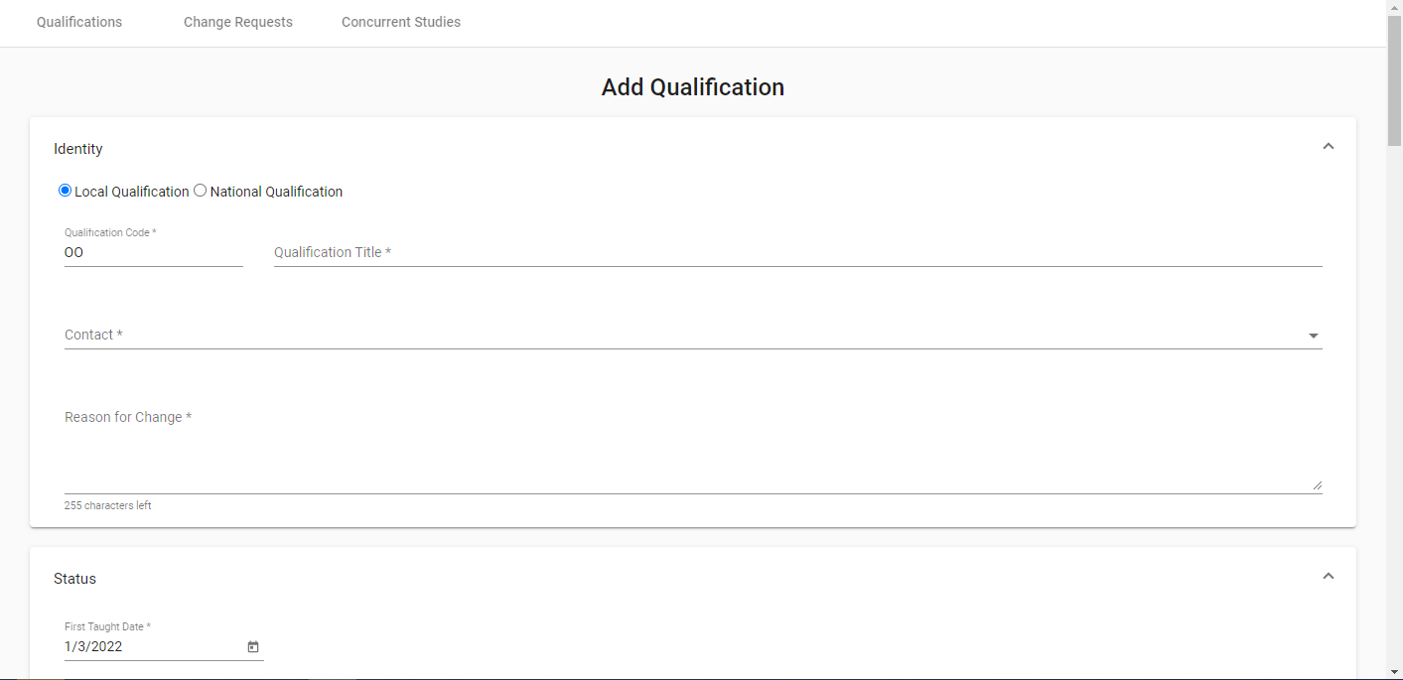
Figure 60 – Add New Qualification Page
The following sections will be visible:
- Identity
- Status
- Duration
- Description
- Qualification Classification
Please note that the Qualification Code may be partially pre-populated if the code prefix is recorded for your organisation by MoE or TEC.
You can enter values as needed into the editable fields. Mandatory (required) fields are denoted by the asterisks (*), as described in the Mandatory Inputs section.
The Contact, Qualification Approval Body, Teacher Registration Board Approval, Qualification Award Category, NZQCF Level, ISCED Level, NZSCED, ISCED Subsequent Destination, Source of Funding, Distance Learning Available and Certifying Authority fields allow you to look up existing entries by clicking on the button. This is described in further detail in the Lookup Windows section.
You can abandon updating the qualification details at any time by clicking the button. A warning message will be shown if you have unsaved changes as described in the Discarding Unsaved Changes section.
Clicking will return you to the View Qualification Details page.
When you are finished with updating the qualification details, you can click the  button. If there are any errors with data entry into the fields, you will be able to view and rectify the error as described in the Validation of Input section.
You may refer to Qualification Fields and Descriptions for a more detailed explanation on what values are expected for each field. Additionally, if you encounter further issues, the section Error Messages in Qualifications explains commonly encountered problems.
If there are no data entry errors, you will be shown the following notification message:
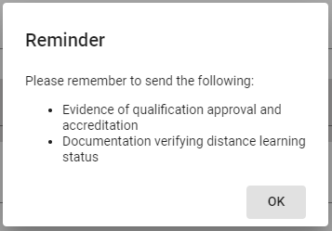
Figure 561 – Notification Message when Adding New Qualification
Upon successfully updating the qualification details, a new qualification change request will be created and you will be taken to the View / Edit Qualification CR page, with the following confirmation message shown:
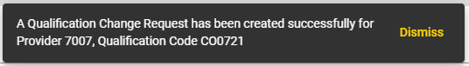
Figure 572 – Add New Qualification Confirmation Message

Qualification Change Requests
Qualification Change Requests (CR) are created whenever you create a new qualification or modify an existing qualification. Pending change requests have to be reviewed and approved by TEC Advisors.
The Change Requests tab allows you to search for Qualification change requests, and view or edit change requests. You can access it by clicking on Change Requests as shown below:

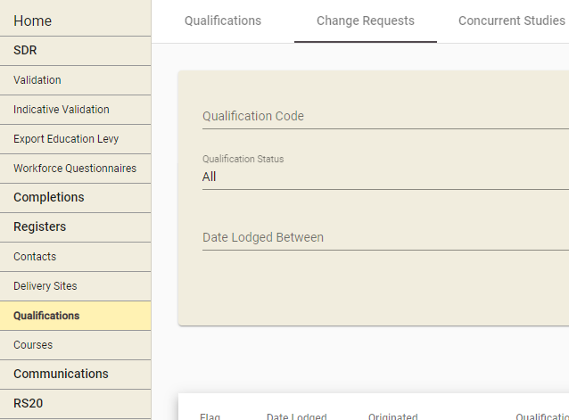
Figure 583 – Accessing Pending Qualification CRs

Search Qualification CRs
The Qualification Change Request Search page is the default page shown when you navigate to the Change Requests tab.
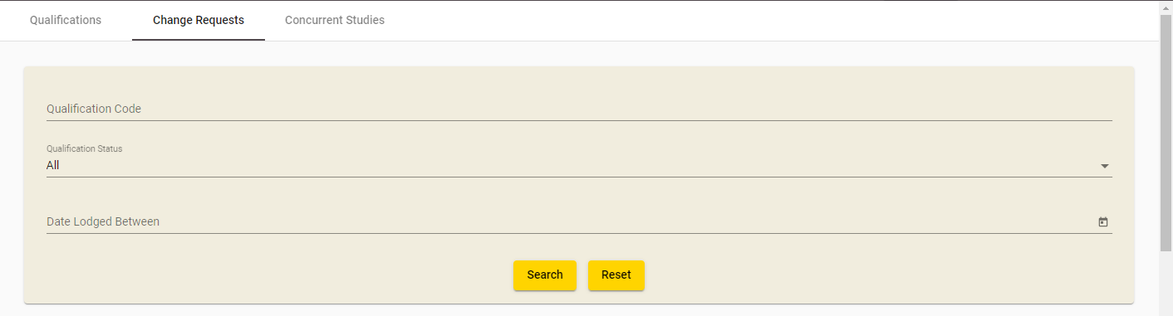
Figure 594 – Qualification CR Search
You can search for all recorded qualification change requests (whether pending or finalised) against your organisation by optionally entering search criteria into any of the fields shown in the search box and clicking . The Qualification Code field will allow for wildcard searching which match partial characters entered into the field as described in Wildcard Searching section.
If there are any errors with data entry into the search fields, you will be able to view the error as described in the Validation of Input section.

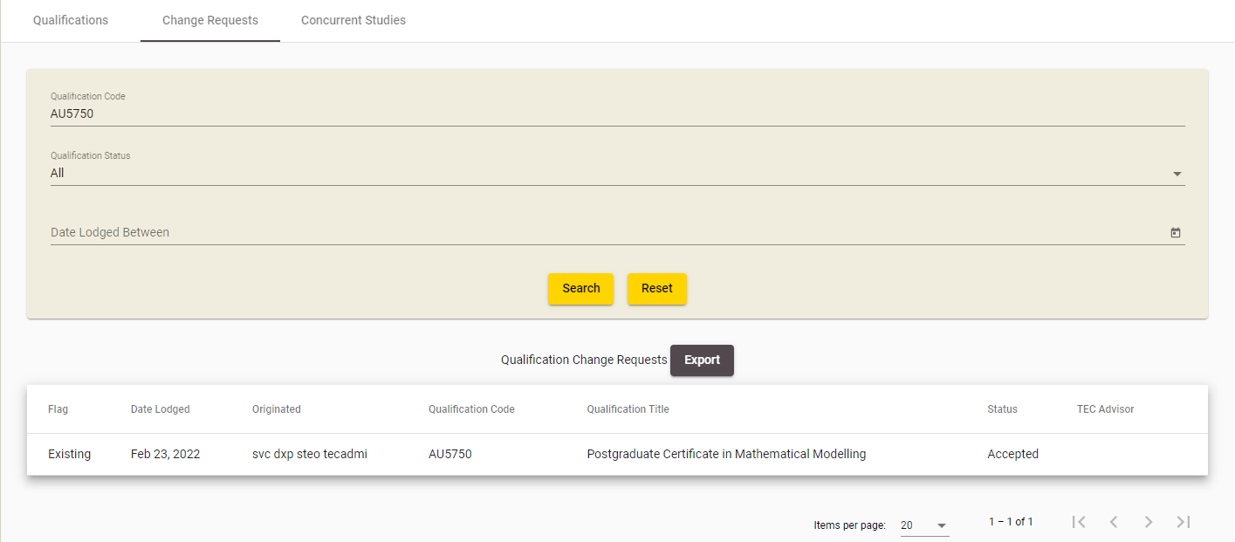
Figure 605 – Qualification CR Search Results
Clicking  will clear the search results page and return the search fields back to their defaults so you can start a fresh search.

View / Edit Qualification CR
The Qualification Change Request View or Edit page contains the details of a particular qualification CR. You can access this page by clicking on the Qualification CR’s row on the Change Requests page, or by clicking on the button for a Qualification that has a Pending Change Request in the View Qualification Details page.
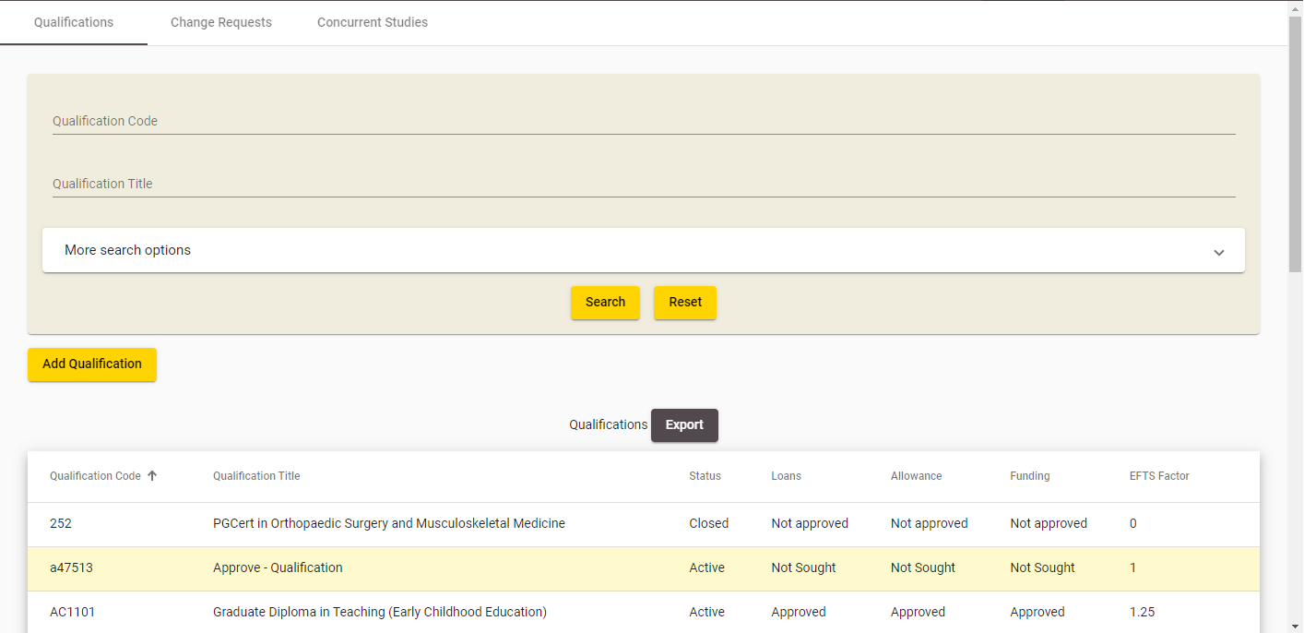
Figure 66 – Accessing View / Edit Qualification CR from Search Qualification CRs
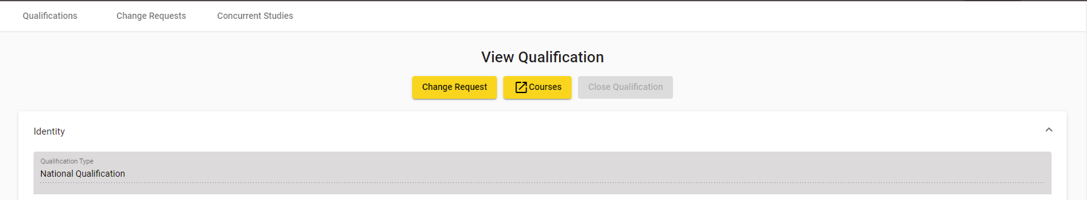
Figure 67 – Accessing View / Edit Qualification CR from View Qualification Details
If the Qualification CR you’re accessing has a status of “Submitted” or “Provider Action Required”, you will be directed to the Edit Qualification Change Request page.
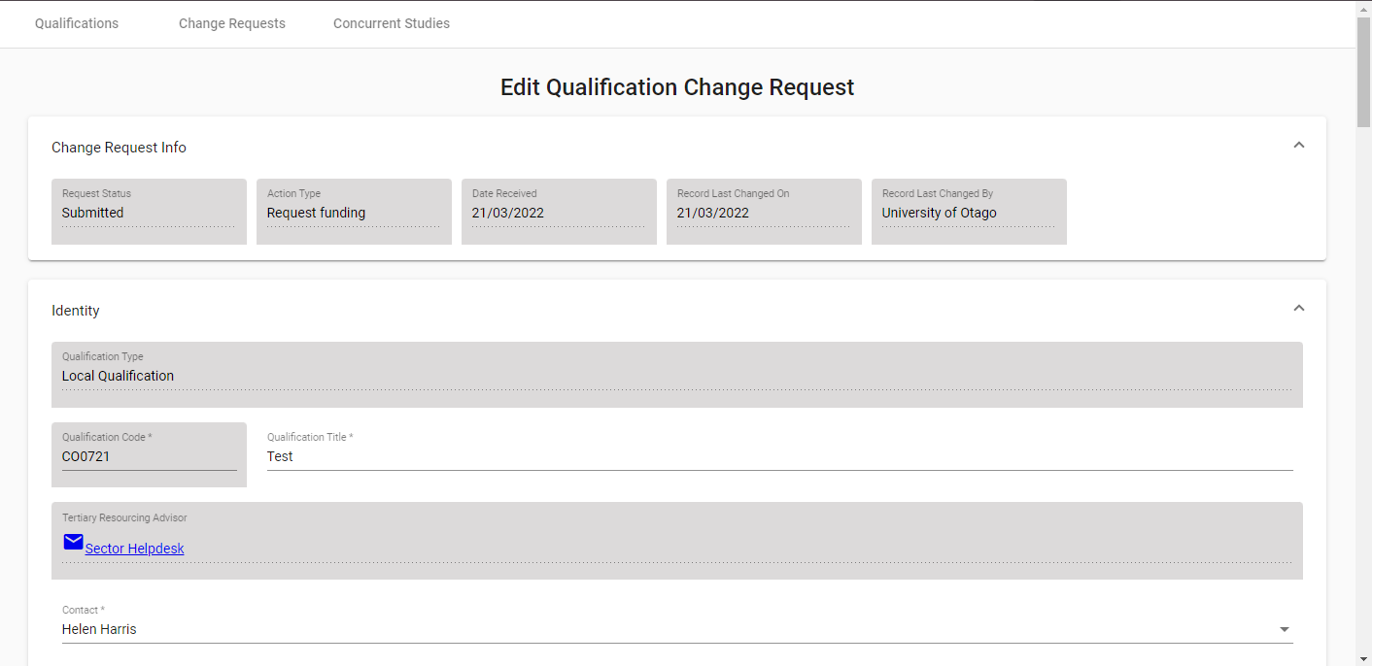
Figure 68 – Edit Qualification CR Page
You will be able to edit the fields with white backgrounds in the Edit Qualification Change Request page.
The values in the left-hand Requested section denote the qualification values that you entered (whether for updating an existing qualification or creating a new qualification), and the values in the right-hand Existing column denote the qualification values that are currently recorded for this qualification in the Qualification Register.
If the Qualification Change Request is for a newly created qualification, there will be no existing values.
Differences between the existing qualification field (if it exists) and the requested change will be highlighted by a border around the changed field as shown in Figure 696169.
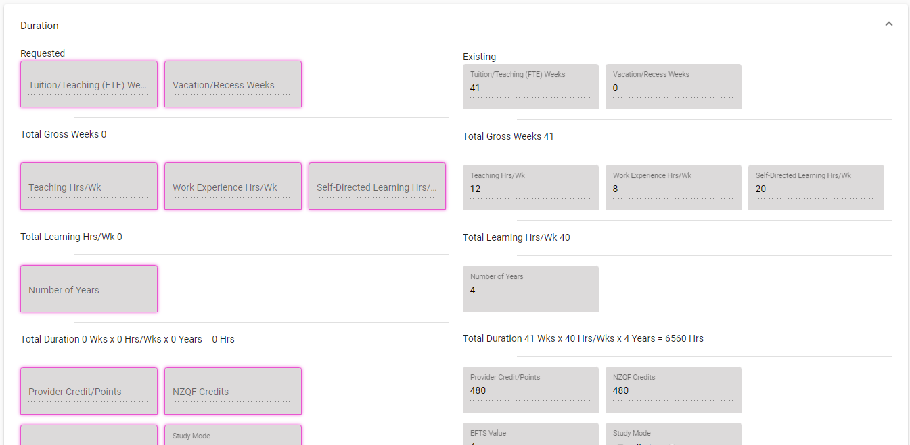
Figure 6961 - Qualification CR Highlighted Field
You can enter values as needed into the editable fields. Mandatory (required) fields are denoted by the asterisks (*), as described in the Mandatory Inputs section.
A number of fields allow you to look up existing entries by clicking on the button. This is described in further detail in the Lookup Windows section.
You can abandon updating the qualification CR details at any time by clicking the button. A warning message will be shown if you have unsaved changes as described in the Discarding Unsaved Changes section.
Clicking will return you to the Search Qualification CRs Requests or the Qualifications page, depending on how you accessed the Change Request.
When you are finished with updating the qualification CR details, you can click the  button. If there are any errors with data entry into the fields, you will be able to view and rectify the error as described in the Validation of Input section.
You may refer to Qualification Fields and Descriptions for a more detailed explanation on what values are expected for each field. Additionally, if you encounter further issues, the Error Messages in Qualifications explains commonly encountered problems.
Upon successfully updating the qualification CR details, you will remain on the same View / Edit Qualification CR page for the newly updated qualification change request, with the following confirmation message shown:
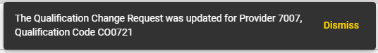
Figure 70 – Edit Qualification CR Confirmation Message
You may make further updates to the Qualification CR if you wish.
Please note that if the TEC Advisors set the status of the Qualification CR to Provider Action Required to request further updates from you, an email will be sent to the Provider’s contact assigned to the Qualification CR.
Alternatively, if the Qualification CR you’re accessing has any of the final statuses (“Accepted”, “Declined”, “Open”, or “No Action Required”), you will be directed to the View Qualification Change Request page.
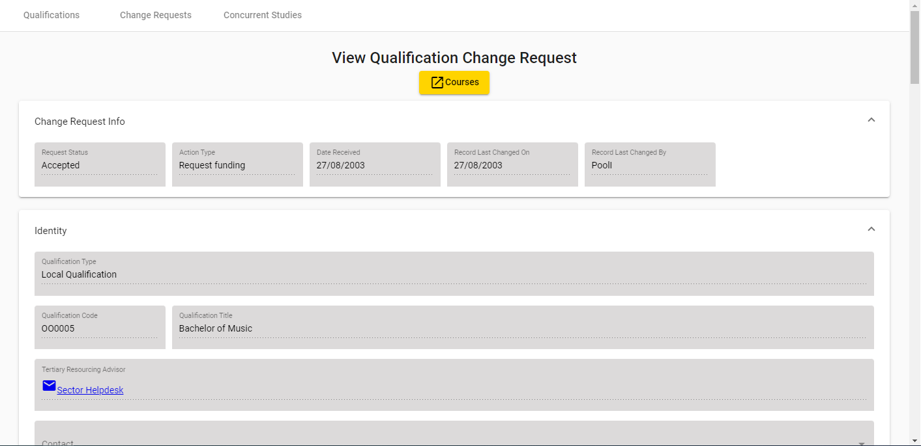
Figure 621 – View Qualification CR Page
You will be unable to edit any fields in the View Qualification Change Request page.

Concurrent Studies
Frequently, a student is enrolled in more than one qualification. On occasion, these qualifications may be undertaken at different TEOs (with the approval of the TEO academic staff and student administration). A concurrent (or conjoint) qualification is defined as a single entity comprised of qualifications (up to a maximum of three) associated with one or more providers.
The primary purpose of the Concurrent Studies function on STEO is to allow a TEO the ability to join previously approved qualifications together. By convention, all Concurrent Studies codes start with ‘CO’ to be easily identified. Please note that you cannot search for Concurrent Studies from the Search Qualifications page.
The Concurrent Studies tab allows you to search for Concurrent Studies that your organisation offers (either solely or jointly with other organisations), and add, view or edit some details of the conjoint qualifications. You can access it by clicking on Concurrent Studies under Qualifications as shown below:

Figure 632 - Accessing Concurrent Studies

Search Concurrent Studies
The Search Concurrent Studies page is the default page that you will land on when you navigate to the Concurrent Studies tab.
By default, Any (Approved, Rejected and Pending) status will be selected.
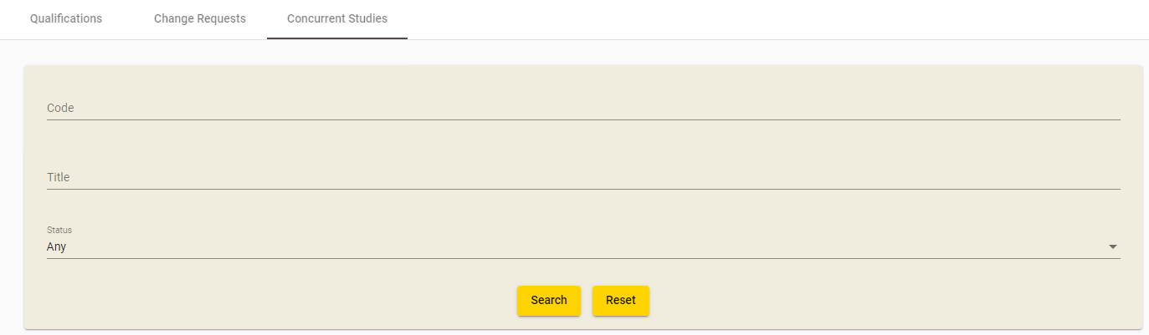
Figure 643 – Search Concurrent Studies
You can search for Approved or Pending or Rejected Concurrent Studies by clicking on the Status dropdown list, selecting your preference and clicking .
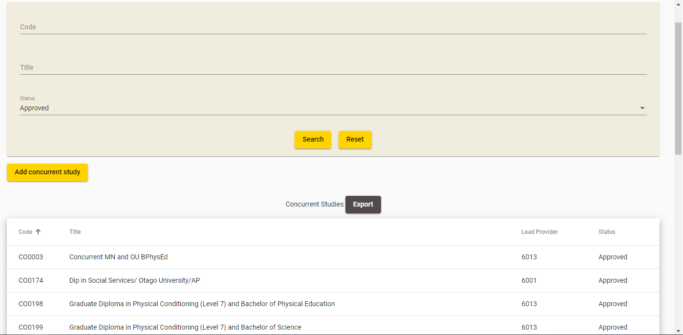
Figure 654 – Concurrent Studies Search Results

Clicking  will clear the search results page and return the search fields back to their defaults so you can start a fresh search.
You may navigate to the View / Edit Concurrent page of a Concurrent Qualification by clicking on the Concurrent Qualification’s row.
Clicking  will allow you to add a Concurrent Qualification, as described in the Add New Concurrent section.

View / Edit Concurrent Qualification
The View / Edit Concurrent Qualification page contains the details of a particular Concurrent Qualification. You can access this page by clicking on the on the row for a Concurrent Qualification from the Concurrent Studies page.

If the Concurrent Qualification you’re accessing does not have your organisation listed as the lead provider (denoted by the Lead Provider field Figure 756675) you will instead be directed to the View Concurrent Qualification page. Hence, you will be unable to edit any fields.
The example below is the View Concurrent Qualification for when the user that is logged in belongs to the organisation with a code that is not 7008.
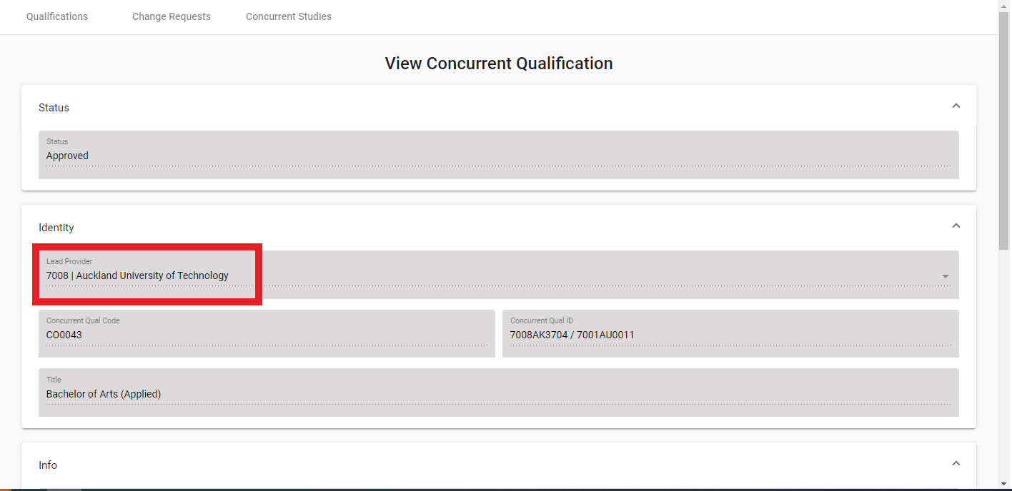
Figure 7566 – View Concurrent Qualification

Clicking will return you to the Concurrent Studies page.
Alternatively, if you access a Concurrent Qualification for which you are the lead provider, you will be directed to the Edit Concurrent Qualification page, as shown in Error! Reference source not found.76 below:
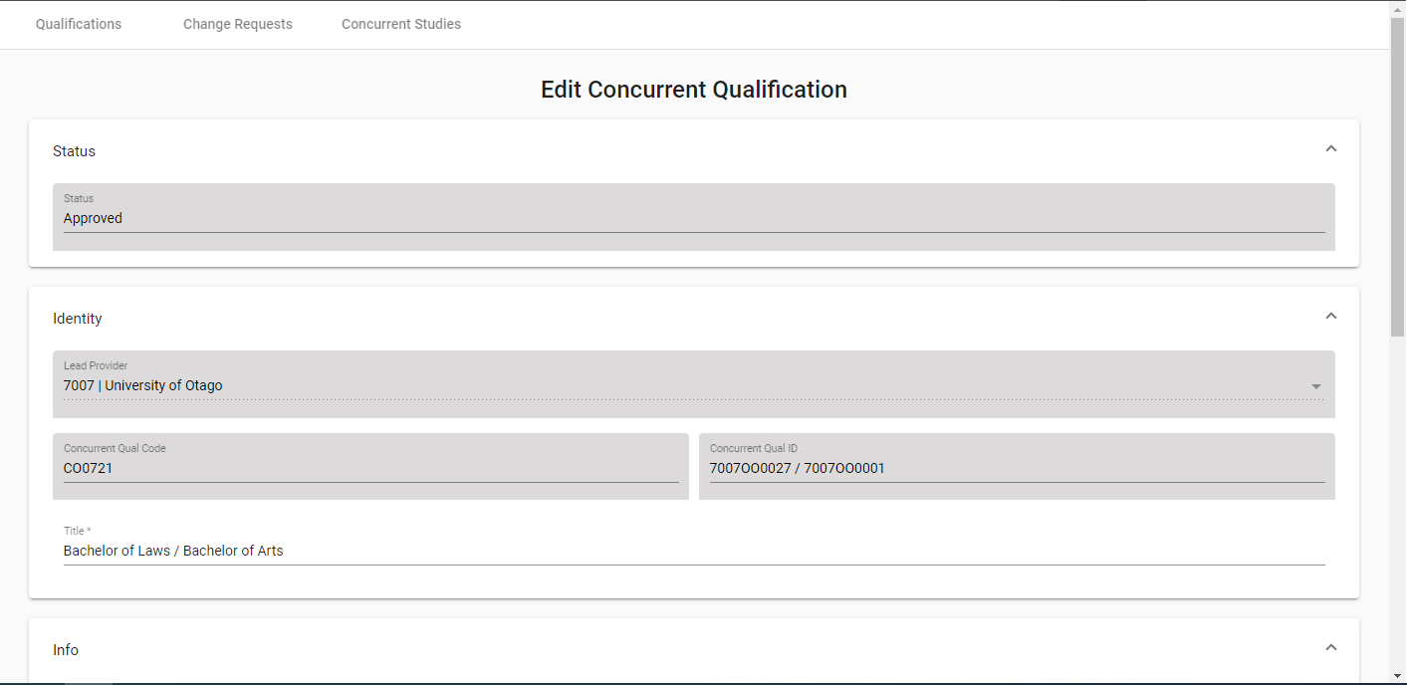
Figure 7667 – Edit Concurrent Studies
You will be able to edit the fields with white background in the Edit Concurrent Qualification page. Please note that you will be unable to edit the Qualification Components.
You can enter values as needed into the editable fields. Mandatory (required) fields are denoted by the asterisks (*), as described in the Mandatory Inputs section.
You can abandon updating the Concurrent Studies details at any time by clicking the button. A warning message will be shown if you have unsaved changes as described in the Discarding Unsaved Changes section.
Clicking will return you to the Concurrent Studies page.
When you are finished with updating the Concurrent Qualification details, you can click the  button. If there are any errors with data entry into the fields, you will be able to view and rectify the error as described in the Validation of Input section.
You may refer to Qualification Fields and Descriptions for a more detailed explanation on what values are expected for each field.
Please note that if you update a previously Approved or Rejected Concurrent Qualification, it will be set to Pending after it has been successfully edited, and must be reviewed and approved by the TEC.
Upon successfully updating the Concurrent Qualification details, you will remain on the page for the newly updated Concurrent Qualification, with the following confirmation message shown:
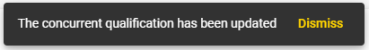
Figure 7768 – Confirmation Message when Saving Concurrent Qualification
You may continue to make further changes to the newly Pending Concurrent Qualification.

Add New Concurrent Qualification
The Concurrent Studies page allows you to add a new concurrent qualification for which you will be the lead provider. You can access this page by clicking on the  button from the Concurrent Studies page.
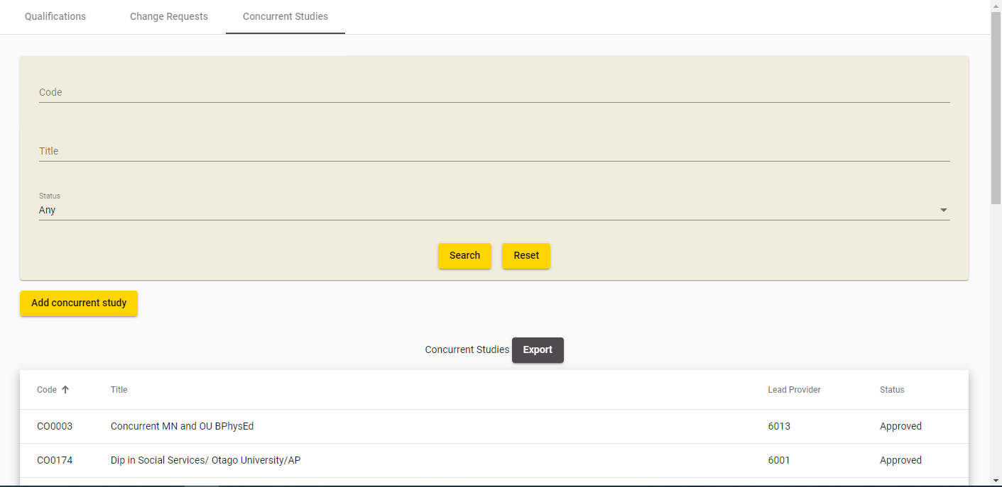
Figure 7869 – Accessing Add New Concurrent Qualification
You will be shown the following page when you navigate to the Add Concurrent Qualification page:
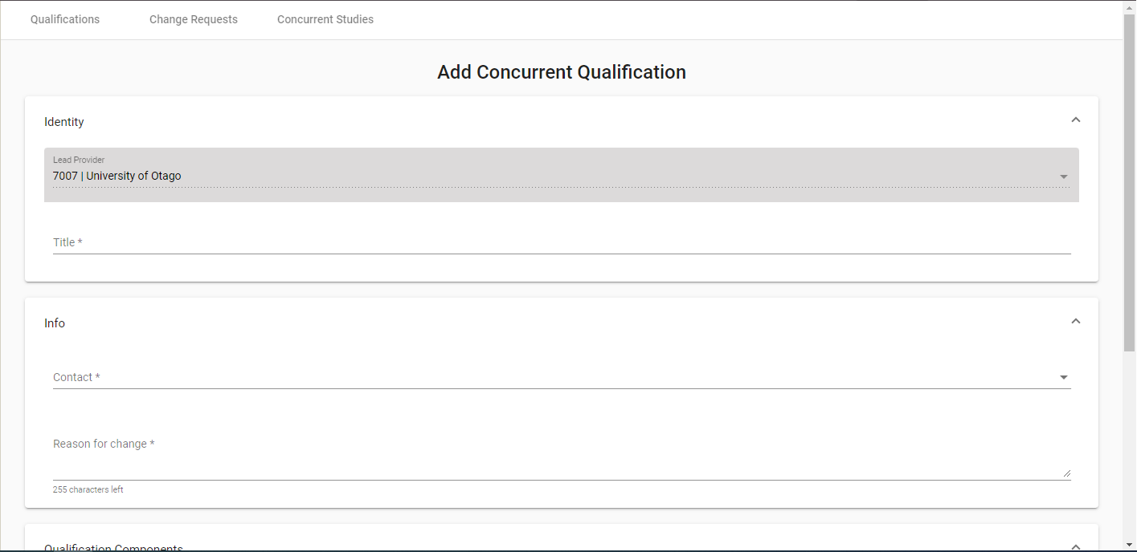
Figure 7970 – Add New Concurrent Qualification
You will be able to edit the fields with a white background in the Add Concurrent Qualification page.
You can enter values as needed into the editable fields. Mandatory (required) fields are denoted by the asterisks (*), as described in the Mandatory Inputs section.
Some fields also allow you to look up existing entries by clicking on the button. This is described in further detail in the Lookup Windows section. Please note that for the second and third Provider Code and Qualification Code fields (as shown in Error! Reference source not found.80), will only be displayed after you have entered a Qualification Code in the previous row.
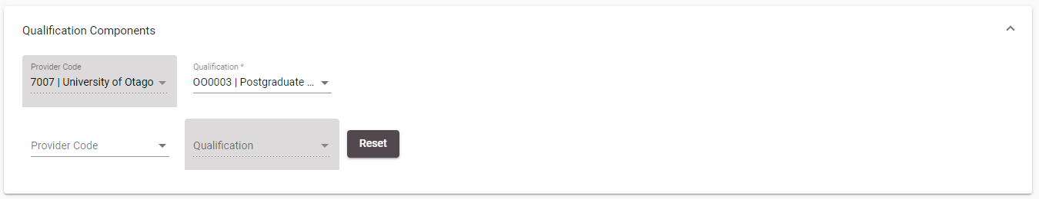
Figure 8071 – Qualification and Provider Code Lookups Behaviour
You can abandon adding the Concurrent Studies at any time by clicking the button. A warning message will be shown if you have unsaved changes as described in the Discarding Unsaved Changes section.
Clicking will return you to the Concurrent Studies page.
When you are finished with adding the new Concurrent Studies details, you can click the  button. If there are any errors with data entry into the fields, you will be able to view and rectify the error as described in the Validation of Input section.
You may refer to Qualification Fields and Descriptions for a more detailed explanation on what values are expected for each field.
Please note that if you create a Concurrent Qualification that has the same Qualification Components as an Approved Concurrent Qualification, you will be warned if you wish to proceed, as shown below:
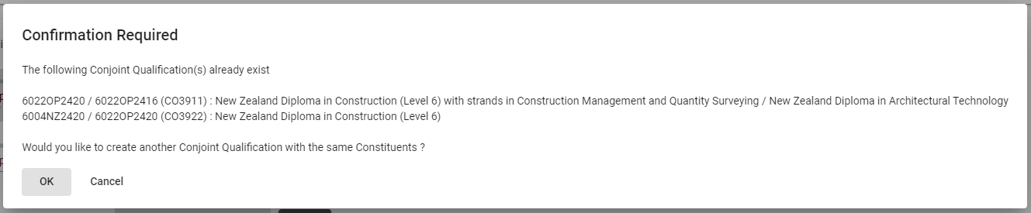
Figure 8172 – Warning when Adding Duplicate Concurrent Qualification
Please note that if you add a Concurrent Qualification, it will be set to Pending after it has been successfully added, and must be reviewed by the TEC before it is approved or rejected.
Upon successfully adding the Concurrent Qualification, you will remain on the page for the newly added Concurrent Qualification, with the following confirmation message shown:
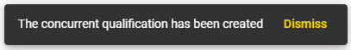
Figure 8273 – Add Concurrent Qualification Confirmation Message

Qualification Fields and Descriptions
When you are filling in the forms to add or edit qualifications, or alter a pending qualification change request, you will encounter the following fields. This table may assist in providing some guidance as to how to fill in the fields correctly to avoid erroneous entries.

Qualification and Qualification CRs
Section 1: Identity
Field | Value
Qualification Code  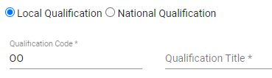   | Select 1 of the 2 radio buttons.  If National Qualification is selected, click on to be taken to list of valid National and/or New Zealand Qualification codes.  National and/or New Zealand qualifications must use the qualification code assigned by the New Zealand Qualification Authority (NZQA) which can be selected from the list of valid National Qualification codes.  If Local Qualification is selected, you can either leave the qualification code blank and the system will allocate a qualification code to the new qualification for you, or you can enter a six lettered qualification code of your choice.  The convention AANNNN where A = alpha and N = numeric is usually followed, for example AB1234. However, if you wish, you can enter a fully numeric, six-digit qualification code.  This field is mandatory. The qualification code cannot be edited after saving the qualification.
Qualification Title   | This field has different requirements depending on what you selected in the radio button for Qualification Code  - If Local Qualification is selected, Title must be supplied and must not be left blank.  - If National Qualification is selected, this field is not editable and is instead auto populated when you select a NCND code which is selected from lookup for Qualification Code  A maximum of 255 characters is allowed.  This field is mandatory.
Contact   | This is the nominated contact person from your organisation, as defined by the list of contacts in your organisation.  This field is mandatory.
Reason for Change  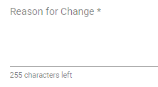 | Enter the reason for change or reason for request.  A maximum of 255 characters is allowed.  This field is mandatory.

Section 2: Status
Field | Value
Qualification Status  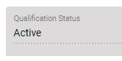 | Displays the Qualification Status – Active or Closed.  (The status will not be displayed if you are adding a new qualification).
First Taught Date   | The date the qualification will first be taught. A calendar is displayed when you click on the First Taught Date calendar icon.  You can only enter a date when you are creating a new qualification. This field is mandatory, and only future dates are allowed.
EFTS Based Funding, Student Allowances, Student Loans  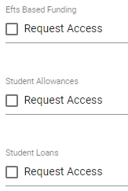 | The type of funding that the qualification is eligible for.  When adding a qualification, remember to tick the left hand tick boxes for what funding you will be applying for. Note that if the qualification you are opening will be used exclusively for Youth Guarantee, then please do not tick the Student Loans box.  Please note that if you are editing an existing qualification you cannot request both Funding Access and Funding Withdrawal in the same qualification change request.
Qualification Approval Body   | This field is mandatory.  Click on the dropdown arrow to select the relevant Approval Body. In general Youth Guarantee providers should choose NZQA.  NZQA  CUAP  ITPQ  CEAC  Academic Board  SkillNZ  Maritime Safety Authority  Other  Awaiting Confirmation
Teaching Council of Aotearoa New Zealand Approval   | Select the appropriate option regarding Teaching Council of Aotearoa New Zealand Approval.

Section 3: Duration
Field | Value
Tuition/Teaching (FTE) Weeks   | The overall number of full time equivalent weeks during which students studying for a particular qualification are being taught, including study breaks, from the first tuition date until after the last assessment or examination, but excluding holidays.  This field must be numeric with no decimals, and must be between 1-104 inclusive.  This field will be used to provide duration data for the Key Information Set (KIS) for this qualification. This field is mandatory.
Vacation/Recess Weeks   | This field must be numeric with no decimals, and must be between 0-104 inclusive.  Note that any qualifications with vacation or recess of more than 3 weeks will not be eligible for student allowances.  This field will be used to provide duration data for the Key Information Set (KIS) for this qualification. This field is mandatory.
Total Gross Weeks | This field will be automatically populated with the sum of the values entered in the Tuition/Teaching (FTE) Weeks and the Vacation/Recess Weeks fields.
Teaching Hrs/Wk   | The total number of teaching hours per week.  This field must be numeric and must be between 0-99.99 inclusive. This field is mandatory.
Work Experience Hrs/Wk:   | Number of work experience hours per week required for the qualification.  This field must be numeric and must be between 0-99.99 inclusive. This field is mandatory.
Self-Directed Learning Hrs/Wk:   | This includes the time an average student is expected to spend in unsupervised and independent study such as research, study groups, preparation and homework per week.  This field must be numeric and must be between 0-99.99 inclusive. This field is mandatory.
Total Learning Hrs/Wk  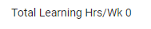 | This field will automatically populate with the sum of the values entered in the Teaching Hrs/Wk, Work Experience Hrs/Wk and Self-Directed Learning Hrs/Wk fields.
Total Length (or Total Learning Hours per Year)  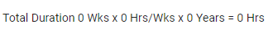 | This field will automatically populate with the total number of hours for the qualification when Adding or Editing a qualification. If you are viewing or editing a Qualification Change request, this is instead automatically populated with the Total Number of Hours per year.  It is calculated by the following formulae:  Qualifications  Total Length (Hours) = Tuition/Teaching (FTE) Weeks * Total Learning Hrs/Wk * Number of Years  OR  Qualification Change Requests  Total Learning Hours per Year = Total Teaching Weeks * Total Learning Hrs/Wk
Provider Credit/Points   | Credit/Points are the number of credits or points that indicate the amount of learning required, on average, to complete the qualification. This field requires you to enter credit/points allocated to a qualification that is not encompassed by NQZF Credit points.  This field has a maximum of 4 digits and no decimals are allowed. Numbers must be between 0-1200 inclusive. This field is mandatory.
NZQCF Credits   | Refers to qualification made up of unit standards and is encompassed within the NZQCF.  In most cases, the NZQCF system equates 120 credits with 1 full-time year of study and 1.0 EFTS unit.  This field has a maximum of 4 digits, has no decimals and must be between 0-1200 inclusive.
EFTS Value   | The EFTS value is expressed in numbers of EFTS units and is established by the Tertiary Education Commission (TEC). Calculations are based on full-time student workload.  This value is calculated on the basis of credits, and/or full time teaching weeks, but the calculation based on credit values takes precedence.  This field has a maximum of 6 characters, must be numeric and between 0.0001-9.9999 inclusive. This field is mandatory.  This field will be used to provide data for the Key Information Set (KIS) for this qualification.
Full/Part Time  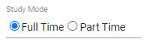 | You can select either of the radio buttons to denote whether the qualification is delivered full time or part time. This field is mandatory.  Note: If the qualification is delivered both full time and part time, please make sure you select Full Time.

Section 4: Description
Field | Value
Brief Outcome  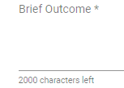 | Enter details of any minimum or preferred entry requirements for this qualification.  Information should be clear and concise and contain no more than 2000 characters for KIS quality purposes.  This field will be used to provide data for the Key Information Set (KIS) published on your website for this qualification. Any additional entry requirements can be presented via the Additional requirements link in the KIS.  Please note this field is mandatory for publication of the KIS.
Brief Contents  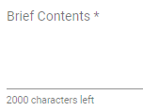 | Enter in contents of the qualification. This field is mandatory.  Information should be clear and concise and allows a maximum of 2000 characters.  Changing only this field in Edit Qualification will result in an auto approved qualification change request. These changes will be automatically saved to the Qualification Register with no need for TEC approval.
Brief Assessment Mode  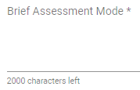 | Enter in details of assessments. This field is mandatory.  Information should be clear and concise and allows a maximum of 2000 characters.  Changing only this field in Edit Qualification will result in an auto approved qualification change request. These changes will be automatically saved to the Qualification Register with no need for TEC approval.
Brief Entry Requirements  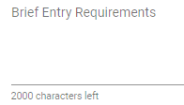 | Enter details of any minimum or preferred entry requirements for this qualification.  Information should be clear and concise and allows a maximum of 2000 characters.  Changing only this field in Edit Qualification will result in an auto approved qualification change request. These changes will be automatically saved to the Qualification Register with no need for TEC approval.  This field will be used to provide data for the Key Information Set (KIS) published on your website for this qualification. Any additional entry requirements can be presented via the additional requirements link in the KIS.

Section 5: Qualification Classification
Field | Value
Qualification Award Category   | Click on to view list of valid Qualification Award Categories. This field is mandatory.  For Youth Guarantee qualifications, please choose 41 or 46.  Note: If Qualification Award Category is any of 90, 97 or 99, and the qualification will NOT be used under Sources of Funding (SoF) 01, 11 and 37, then Qualification can be submitted with NZQCF Level, ISCED Level and ISCED Subsequent Destination as blank.
NZQCF Level  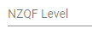 | The valid NZQCF value depends on the Qualification Award Category selected and the valid values will be available for selection in the dropdown list once a Qualification Award Category is selected/entered.
ISCED Level   | International Standard Classification of Education (ISCED) is a classification of level of education ranging from 0-9.  The valid ISCED value depends on the Qualification Award Category selected and the valid values will be available for selection in the dropdown list once a Qualification Award Category is selected/entered.
ISCED Subsequent Destination   | The valid ISCED Subsequent Destination values will be populated in the dropdown for selection once an ISCED Level is selected and mapping is defined.  If mapping is available, a value must be selected and cannot be left blank; alternatively ISCED Subsequent Destination will be blank.
NZSCED   | Click on to select a valid NZSCED that relates to the qualification. This field is mandatory.  The NZ Standard Classification of Education is a subject based classification system for TEOs. This system was developed by the Ministry of Education (MoE) with the aim of improving the quality and consistency of statistics collected by agencies regarding tertiary education.  This field will be used to provide data for the Key Information Set (KIS) for this qualification. The NZSCED provides the field of study to match the employment outcomes of tertiary education data to the qualification.
Source of Funding   | Click on to select a valid Source of Funding.  This field is not mandatory.  If a Youth Guarantee provider has received NZQA approval for the qualification, choose ‘M | Ministry Funded’ from the list.
Distance Learning Available   | Select ‘Yes’ or ‘No’ if distance learning is available.  This field is not mandatory.
Certifying Authority   | Click on to select a certifying authority for the qualification.  This field is not mandatory.  Changing only this field in Edit Qualification will result in an auto approved qualification change request. These changes will be automatically saved to the Qualification Register with no need for Agency approval.

Concurrent Studies
Section 1: Concurrent Study Details
Field | Value
Lead Provider  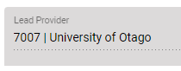 | This field denotes who the lead provider is.  When you add a Concurrent Qualification, it will always be populated with your provider code.
Concurrent Qual Code  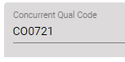 | This field is automatically populated after you create a Concurrent Qualification.  It will always start with the letters “CO” and is immediately followed by a 4 digit number.
Concurrent Qual ID  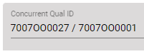 | This field is automatically populated after you create a Concurrent Qualification.  It is generated by joining all the provider code and qualification codes of the Qualification Components.  E.g. if I create a Concurrent Qualification with the following components:  1111 – BP3410  1111 – AGRI1007  7001 – AC1053  The resulting Concurrent Qual ID will be  1111BP3410 / 1111AGRI1007 / 7001AC1053
Title   | Enter the title of the Concurrent Qualification.  Please note that this is a mandatory field and has a maximum of 200 characters.
Contact   | Contacts that belong to your organisation will be populated in this dropdown.  You must select a contact, this field is mandatory.
Reason for change  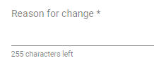 | Enter the reason for creating or editing the Concurrent Qualification.  This field is mandatory, and accepts a maximum of 255 characters.
First Date   | The date the Concurrent Qualification will first be taught. A calendar is displayed when you click on the First Taught Date calendar icon.  When you add a Concurrent Qualification, this field will default to the 1st January of the current year.  This field is mandatory.
Gross week of study   | The total number of teaching and vacation weeks the Concurrent Qualification will take.  This field is mandatory, and only accepts numeric whole numbers up to 3 digits between 1-999 inclusive.

Section 2: Qualification Components
Field | Value
Provider (1)  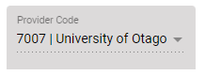 | This field denotes who the lead provider is. This field is not editable.  When you add a Concurrent Qualification, it will always be populated with your provider code.
Qualification Code (1)   | Please click on to be taken to a list of valid Qualification codes for your provider.  This field is mandatory.
Provider (2)   | Please click on to be taken to a list of valid Provider Codes.  This field is not mandatory.  It will be displayed after Qualification Code (1) has been populated.
Qualification Code (2)   | This field is not mandatory if you did not define a provider in Provider (2).  Please click on to be taken to a list of valid Qualification codes for the chosen provider in Provider (2).  It will be displayed after Qualification Code (1) has been populated.
Provider (3)   | Please click on to be taken to a list of valid Provider Codes.  This field is not mandatory.  It will be displayed after Qualification Code (2) has been populated.
Qualification Code (3)   | This field is not mandatory if you did not define a provider in Provider (3).  Please click on to be taken to a list of valid Qualification codes for the chosen provider in Provider (3).  It will be displayed after Qualification Code (2) has been populated.

Error Messages in Qualifications
Most errors can be avoided by following the guidelines outlined in Qualification Fields and Descriptions. However, in some cases you may encounter additional error messages:
Error Message | Description
The changes you have made are not sufficient to create a Qualification Change Request.  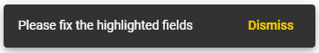 | When you are creating a qualification, you must update more than the Contact and Reason for Change fields for a change request to be created.
Cannot make changes to Qualification that is already closed  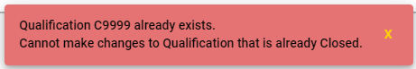 | If you are trying to create a new Qualification where the Qualification Code already exists, but the existing qualification is Closed, you will be unable to proceed.  Please create a new qualification that does not have the same code as the closed qualification.
Qualification <Qualification Code> already exists.  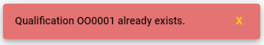 | You cannot create a qualification that has the same qualification code as an existing Active Qualification.  Please create a new qualification that does not share the same code.
Pending Request for this Qualification already exists.  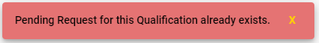 | You cannot create a qualification if there is a pending change request that exists for the proposed qualification code.  This error may occur if you’ve already created a new qualification and are trying to repeat the process.

Courses
The Courses tab contains all the information about your organisation’s courses (current and prior courses), including any change requests that have been lodged against these courses. You can use this tab to view and alter information relating to courses and their lodged change requests.
Some fields in this section may also be used to provide data for the Key Information Set (KIS) for the qualifications published to support students' enrolment decisions. Click here for more information about the Key Information Set.
KIS data is provided by the TEC data service for all active TEC funded qualifications. The KIS data for each qualification is published on the TEO website and also on the TEC website. Use the close process to ensure a KIS is not published for any qualifications no longer delivered.
The Courses tab allows you to access the following pages and functionality:
- Course
- View Course
- Edit Course
- Add Course
- Search Course CRs
- View / Edit Course CR
You can navigate to this section by clicking on Courses in the main menu.
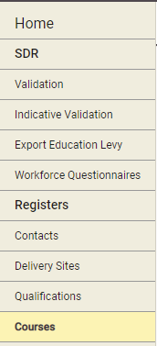
Figure 8374 – Courses Tab

Courses
The Courses page allows you to search for courses that your organisation offers, both Active and Closed as defined in the Course Register. The Courses page is the page that you will land on when you navigate to the Courses tab.
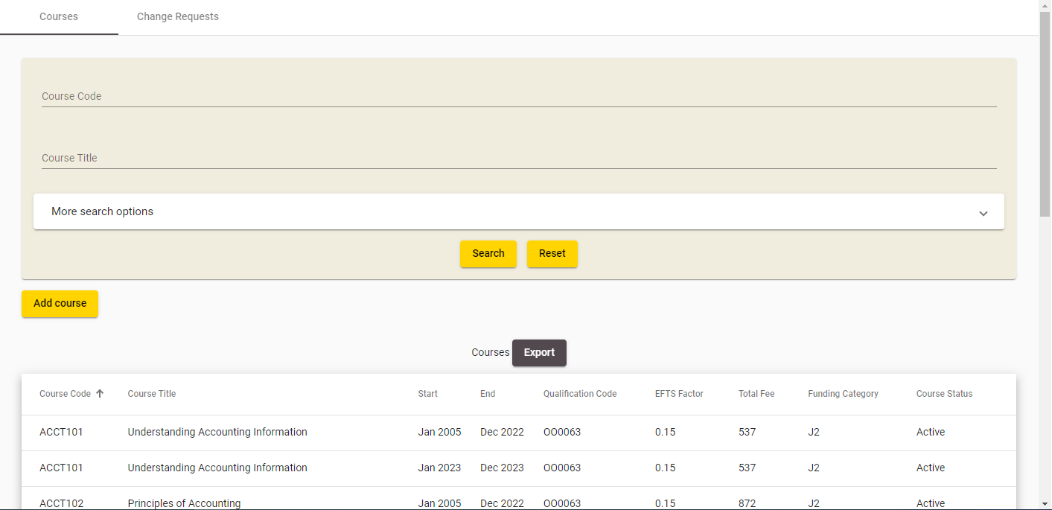
Figure 8475 – Default Courses Page
You can search for all existing courses against your organisation by optionally entering search criteria into any of the fields shown in the search box and clicking .
The Course Code, Course Title, and Qualification Code, fields will allow for wildcard searching which match partial characters entered into the field as described in the Wildcard Searching section. The Funding Category, NZSCED and Course Status fields also allow you to look up existing entries by clicking on the button. This will direct you to the relevant lookup as described in the Lookup Windows section. The EFTS Factor Between, Total Fee Between and Start Year - End Year fields will allow you to narrow your search between certain ranges.
If there are any errors with data entry into the search fields, you will be able to view the error as described in the Validation of Input section.
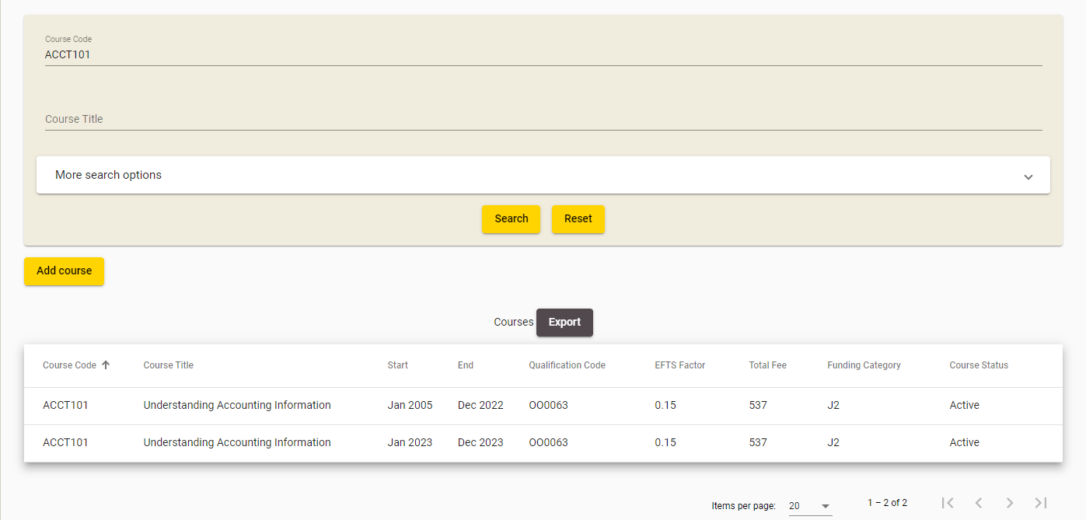
Figure 8576 – Course Search Results
The search results based on the criteria entered will be shown as per Error! Reference source not found.85, with 20 courses shown per page.
You can sort the results by clicking on the column header titles as previously described in the Sorting Search Results section.
If there is more than one page of courses, you can browse through the other pages using the navigation buttons as described in Navigating through Result Pages.
You may navigate to a Course by clicking on the Course’s row.
Clicking  will clear the search results page and return the search fields back to their defaults so you can start a fresh search.

View Course
The View Course page contains a more detailed view of a particular course. You can access the Course Details page by clicking on a Course row from the Courses page, as shown below:
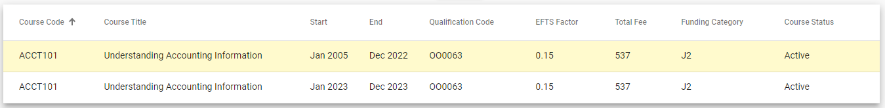
Figure 8677 – Accessing View Course

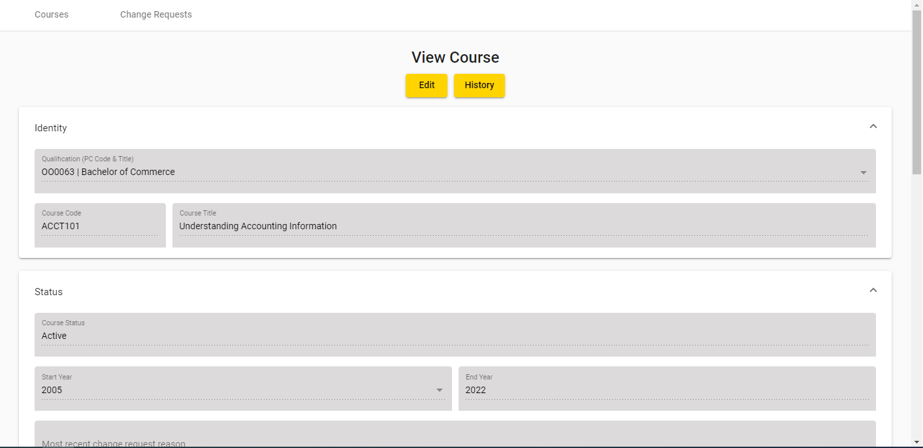
Figure 8778 – View Course

You can click  to Edit Course.
You can also click  to return to the Courses page.

Edit Course
The Edit Course page allows you to update the details of a specific course version. You can access the Edit Course page by clicking on the Edit button from the View Course page.
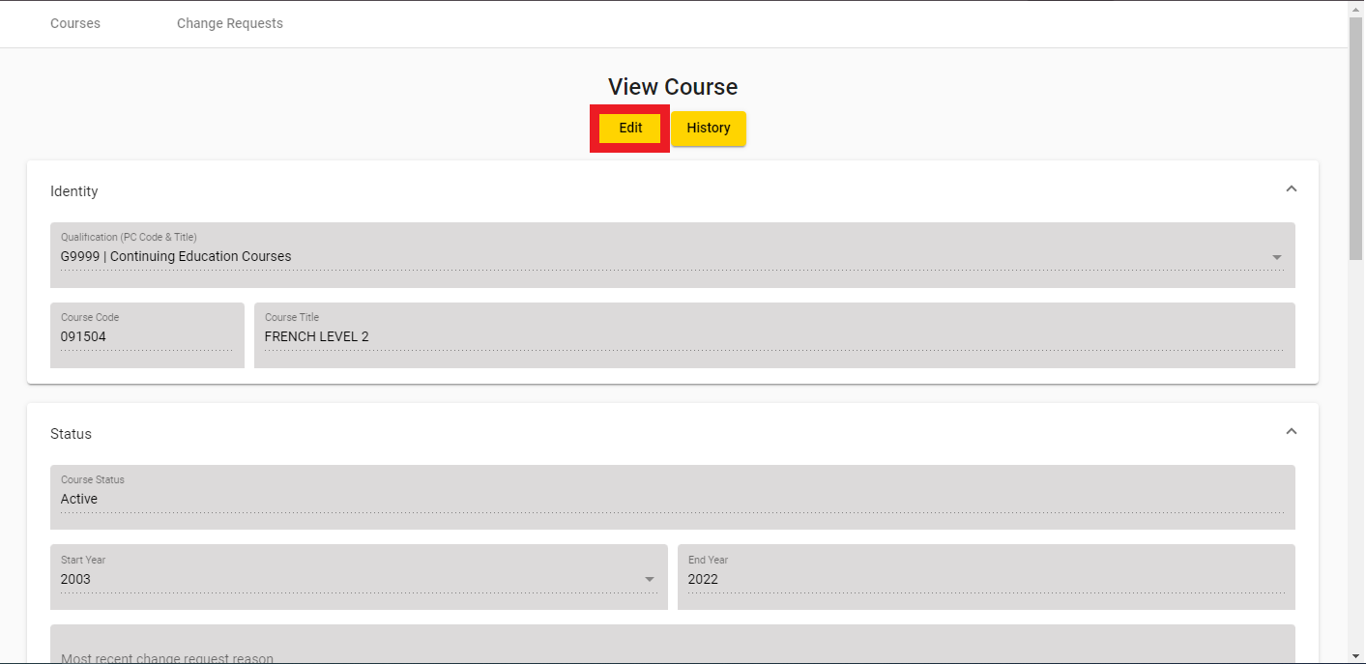
Figure 8879 – Accessing Edit Course

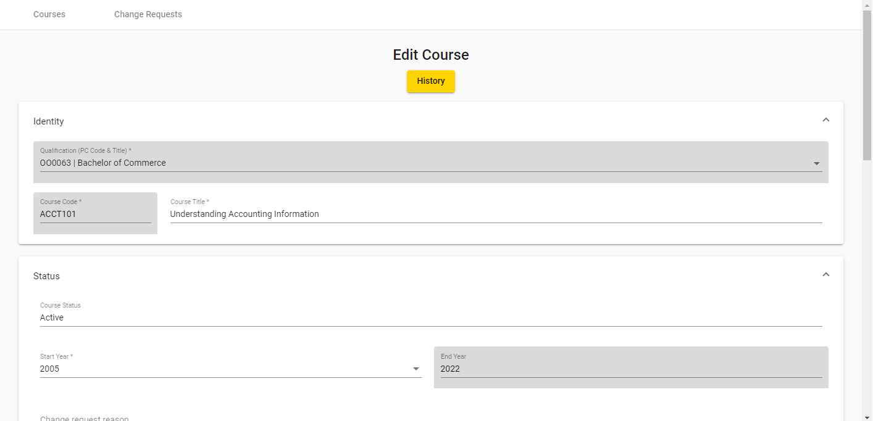
Figure 8980 – Edit Course

You can enter values as needed into the editable fields. Mandatory (required) fields are denoted by the asterisks (*), as described in the Mandatory Inputs section.
The Qualification (PC Code), Funding Category, Course Classification, and NZSCED fields also allow you to look up existing entries by clicking on the button. This is described in further detail in the Lookup Windows section.
You can abandon updating the course details at any time by clicking the button. A warning message will be shown if you have unsaved changes as described in the Discarding Unsaved Changes section.
Clicking will return you to the View Course page.
When you are finished with updating the course details, you can click the  button. If there are any errors with data entry into the fields, you will be able to view and rectify the error as described in the Validation of Input section. You may refer to Courses Fields and Descriptions for a more detailed explanation on what values are expected for each field. Additionally, if you encounter further issues, the section Error Messages in Courses will explain commonly encountered problems.
Please note that if you modify the Start Year field of the course, you will create a new course version. If you select a Start Year that already has a course version you will be shown the following message:
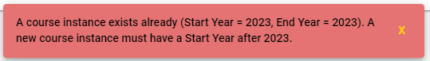
Figure 9081 – Warning Message when altering Start Year of Existing Course
Upon successfully updating the course details, a course change request will be created and you will be taken to the View / Edit Course CR page, with the following confirmation message shown:
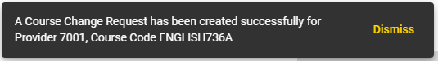
Figure 9182 – Edit Course Confirmation Message

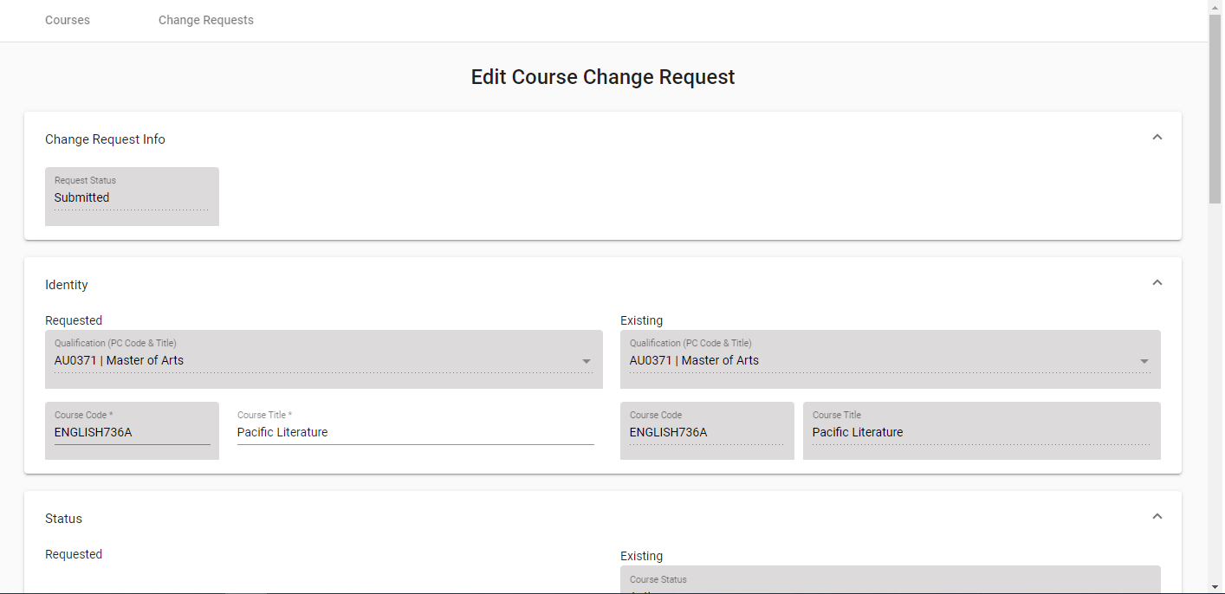
Figure 9283 – Newly Created Course Change Request

Add Course
The Add Course page allows you to add a course for your organisation. You can access the Add Course page by clicking the “Add course” button under Courses:
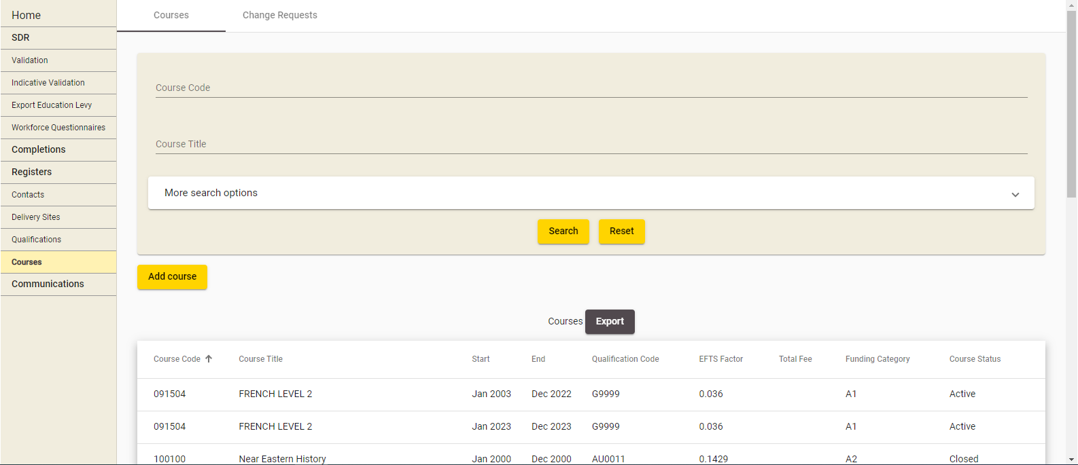
Figure 9384 – Add Course

The following page will be shown when you click the Add course button:
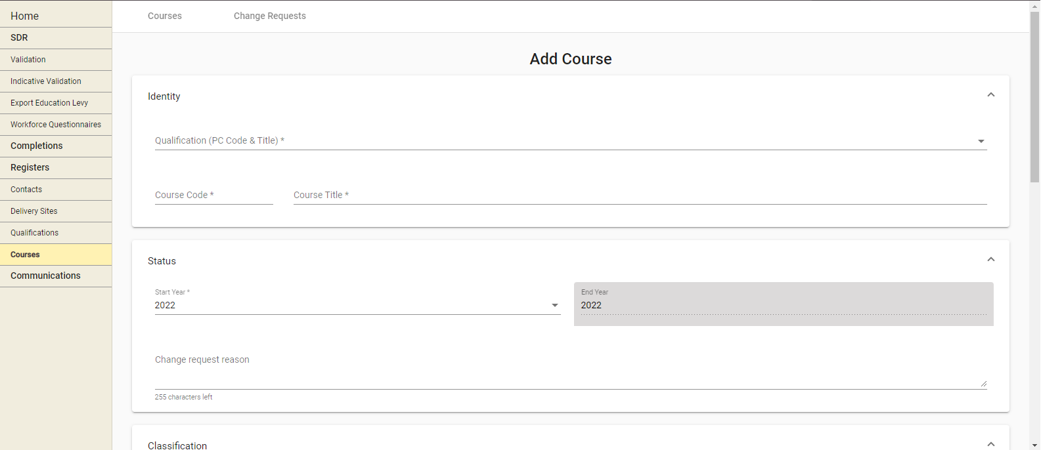
Figure 9485 – Add Course page
The current year is populated into the Start Year field. The End Year will automatically update to match the Start Year.
You can enter values as needed into the editable fields. Mandatory (required) fields are denoted by the asterisks (*), as described in the Mandatory Inputs section.
The Qualification (PC Code & Title), Start Year, NZSCED, Course Classification, Funding Category, NZQCF Level, Mandatory Course, PBRF, Stage, Literacy Numeracy Indicator and Internet fields also allow you to look up existing entries by clicking on the button. This is described in further detail in the Lookup Windows section.
You can abandon updating the course details at any time by clicking the button. A warning message will be shown if you have unsaved changes as described in the Discarding Unsaved Changes section.
Clicking will return you to the last page you were on before navigating to the Add Course page.
When you are finished with entering the new course details, you can click the  button. If there are any errors with data entry into the fields, you will be able to view and rectify the error as described in the Validation of Input section. You may refer to Courses Fields and Descriptions for a more detailed explanation on what values are expected for each field. Additionally, if you encounter further issues, the section Error Messages in Courses will explain commonly encountered problems.
If you add a course with the sae code as an existing course at your organisation then you must add as a new course version by selecting a Start Year that is greater than the existing course.
If you select a Start Year that already has a course version you will be shown the following message:
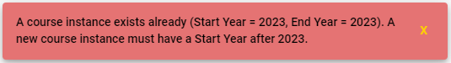
Upon successfully saving the new course details, a new course change request will be created and you will be taken to the View / Edit Course CR page, with the following confirmation message shown:
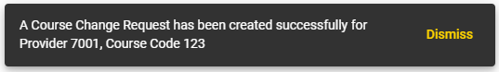
Figure 9586 – Add New Course Confirmation Message

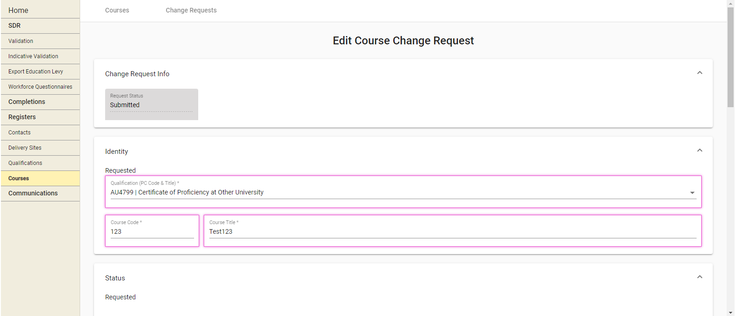
Figure 9687 – Newly Created Course Change Request
Please note that this course must be approved by the TEC before it will be active.

Course Change Requests
Course Change Requests (CRs) are created whenever you add a new course, modify an existing course, or submit course changes using the Course Register files (as described in Validate New SDR). Pending change requests have to be reviewed and approved by TEC Advisors.
The Change Requests tab allows you to search for Course CRs, and view or edit Course CRs. You can access it by clicking on Change Requests under Courses as shown below:
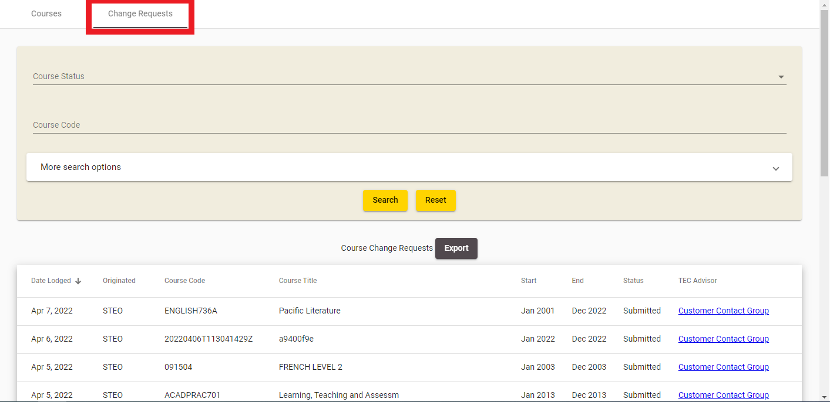
Figure 9788 – Course Change Requests

Search Course CRs
The Change Requests page is the default page shown when you navigate to the Change Requests tab.
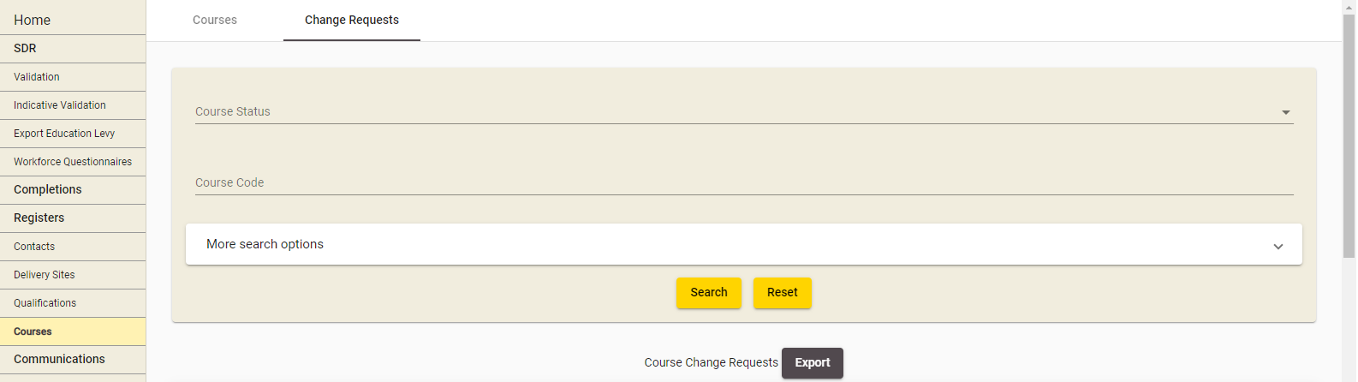
Figure 9889 – Course Change Requests page
You can search for all recorded course change requests (whether pending or finalised) against your organisation by optionally entering search criteria into any of the fields shown in the search box and clicking .
The Course Code field allows for wildcard searching which match partial characters entered into the field as described in Wildcard Searching section.
If there are any errors with data entry into the search fields, you will be able to view the error as described in the Validation of Input section.
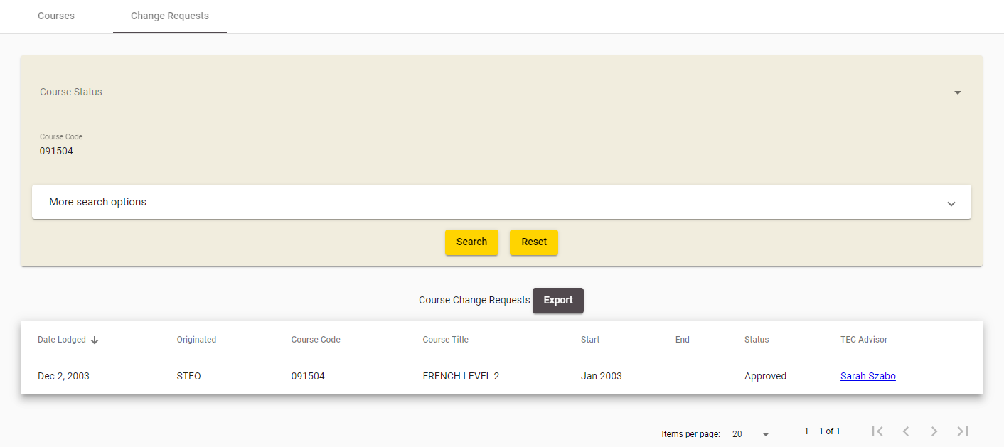
Figure 9990 – Course CR Search Results
The search results based on the criteria entered will be shown as per Error! Reference source not found., with 20 change requests shown per page.
You can sort the results by clicking on the column header titles as previously described in the Sorting Search Results section.
If there is more than one page of course change requests, you can browse through the other pages using the navigation buttons as described in Navigating through Result Pages.
You may navigate to View / Edit Course CR by clicking on the row of a Change Request.
You may also email the TEC Advisor responsible for reviewing the Course Change Request by clicking on the TEC Advisor name. This will open a blank email addressed to the TEC Advisor in your default email client application (e.g. Microsoft Outlook).
Clicking  will clear the search results page and return the search fields back to their defaults so you can start a fresh search.

View / Edit Course CR
The Course Change Request View page contains the details of a particular course CR. You can access this page by clicking on the row in the Search Course CRs page.
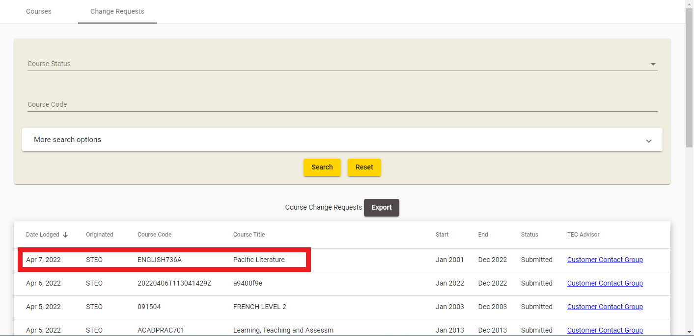
Figure 10091 – Accessing Course CR Details
If the Course CR you’re accessing has a status of “Submitted” or “Provider Action Required”, you will be directed to the Edit Course Change Request page.
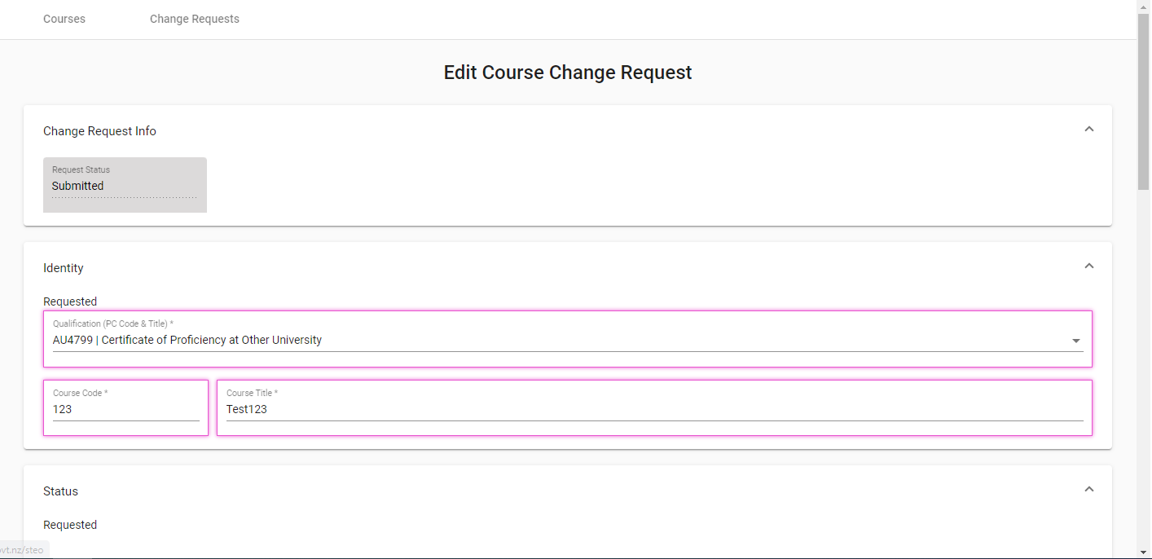
Figure 10192 – Edit Course CR
You will be able to edit the fields with a white background in the Edit Course Change Request page.
The values in the Requested column on the left denote the course values that were entered by you (whether for updating an existing course or creating a new course), and the values in the Existing column on the right denote the course values that are currently recorded for this course in the Course Register.
If the Course Change Request is for a newly created course, there will be no existing values.
Differences between the existing course field (if it exists) and the requested change will be highlighted by a border around the changed field as shown in Error! Reference source not found..
You can enter values as needed into the editable fields. Mandatory (required) fields are denoted by the asterisks (*). The Qualification (PC Code & Title), NZSCED, Course Classification, Funding Category, NZQCF Level, Mandatory Course, PBRF, State, Literacy Numeracy Indicator and Internet fields also allow you to look up existing entries by clicking on the  button. This is described in further detail in the Lookup Windows section.
You can abandon updating the course CR details at any time by clicking the button. A warning message will be shown if you have unsaved changes as described in the Discarding Unsaved Changes section.
Clicking will return you to the Search Course CRs page.
When you are finished with updating the course CR details, you can click the  button. If there are any errors with data entry into the fields, you will be able to view and rectify the error as described in the Validation of Input section. You may refer to Courses Fields and Descriptions for a more detailed explanation on what values are expected for each field. Additionally, if you encounter further issues, the section Error Messages in Courses will explain commonly encountered problems.
Upon successfully updating the course CR details, you will remain on the same View / Edit Course CR page for the newly updated course change request, with the following confirmation message shown:
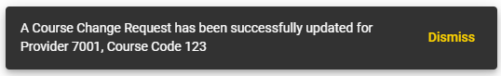
Figure 10293 – Edit Course CR Confirmation Message
You may continue make further updates to the Course CR if you wish.
Please note that if the TEC Advisors set the status of the Course CR to Provider Action Required to request further updates from you, an email will be send to Provider’s contacts that have been assigned the Contact Role “Quals/Course/Delivery site updates”.
Alternatively, if the Course CR you’re accessing has any of the final statuses (“Approved”, “Approved with Change”, “Open”, or “No Action Required”), you will be directed to the View Course Change Request page.
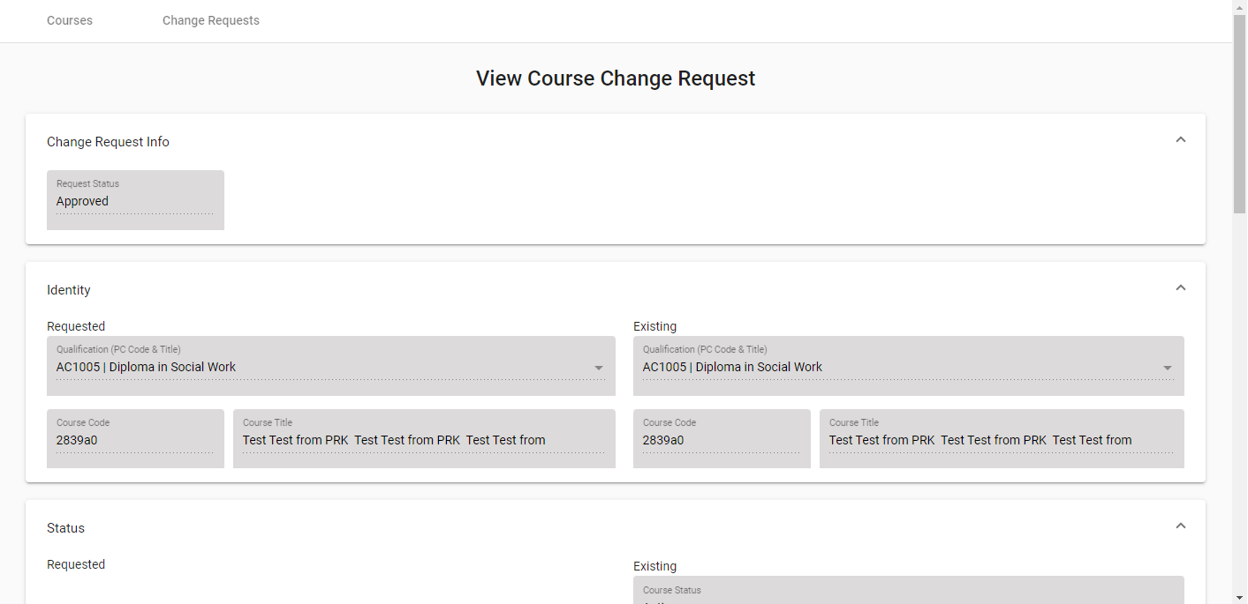
Figure 10394 – View Course CR
You will be unable to edit any fields in the View Course Change Request page.
The values in the Provider Requested column on the left denote the course values that were entered by you (whether for updating an existing course or creating a new course), and the values in the Existing column on the right denote the course values that are currently recorded for this course in the Course Register.
If the Course Change Request is for a newly created course, there will be no existing values.
Differences between the existing course field (if it exists) and the requested change will be highlighted by a border around the changed field as shown in Error! Reference source not found.:
Figure 10495 – Course CR Highlighted Field

Courses Fields and Descriptions
When you are filling in the forms to add or edit courses, or alter a pending course change request, you will encounter the following fields. This table may assist in providing some guidance as to how to fill in the fields correctly to avoid erroneous entries.
Field | Value
Identity
 | Clicking on the will give you a list of all active qualifications available on your qualification register.  This qualification is the ‘home’ qualification nominated for this course. The course may be delivered under a number of qualifications without requiring multiple entries in the course register, but the ‘home’ qualification is the qualification under which the course is recognised for quality assurance purposes.  This is a mandatory field with a maximum of 6 characters.
 | A unique code for this course/subject/unit that is assigned by you. The code should remain the same for the course regardless of delivery context, time or location.  It is a mandatory field, has a maximum of 20 characters and must be a unique course code.  Note: Once approved the course code cannot be edited.
 | The course title should give a fair representation of the subject matter of the course.  It is a mandatory field, and has a maximum of 75 characters.
Status
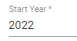 | This is the year from which enrolments under this course code will be counted in the SDR under the parameters described in this entry in the course register.  This field will be default to the current year. It is a mandatory field.
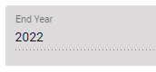 | This will be set to match the Start Year.  All course versions must now be year bound so that data can be managed against each yearly version and the course register file process can be used to update and create new yearly course versions.
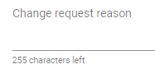 | This field allows you to briefly explain why the course is being added or changed.  This field accepts a maximum of 255 characters.
Classification
 | Clicking on the will give you a list of all the valid NZSCED codes.  This is a mandatory field with a maximum of 6 digits.
 | Clicking on the will give you a list of all the valid course classifications.  Course classification indicates the subject matter covered by the majority of the course in question. TEC providers guidance on course classifications in the Delivery Classification Guide. Use the Delivery Classification Guide https://www.tec.govt.nz/funding/funding-and-performance/reporting/delivery-classification-guide/ to find the most appropriate course classification for the course.  This classification must be valid, and must also have a valid funding category. This is a mandatory field.
 | Clicking on the will give you a list of all the valid funding categories for the selected Course Classification.  The funding category field denotes the funding rate that enrolments in the course will generate. The Delivery Classification Guide https://www.tec.govt.nz/funding/funding-and-performance/reporting/delivery-classification-guide/ providers guidance on which funding category to apply.  The funding category you enter must be valid for the course classification it falls into. This is a mandatory field.
 | Clicking on the will give you a list of all the valid NZQCF levels.  NZQCF (register level) was formerly (and commonly) referred to as the NQZF level. It indicates the level/complexity of the learning undertaken in the course. The entry must be between 0-9.  - NZQCF Level must be 0 when PBRF value is C or D  - NZQCF Level must be 8 or 9 when PBRF value is L or M  The NZQCF Level must be between 1 and 5 if the Literacy/Numeracy indicator is set to Y.
 | Clicking on the will give you an option of Yes or No.  This field indicates whether the course in question is mandatory for the successful completion of the ‘home’ qualification, or if the course is an elective/optional course.
 | Clicking on the will give you a list of all the valid codes available for use.  This field is used to indicate whether the course is eligible for Performance Based Research Fund (PBRF). There are 5 codes available for use:  - M Masters (greater than 0.75 EFTS)  - D Doctorate (greater than 0.75 EFTS)  - L Part-time Masters  - C Part-time Doctorate  - X Not PBRF Eligible  Please note this field is not mandatory.
 | Clicking on the will give you a list of 1-6.  This field denotes the year of study that a course falls into, and is included specifically for pre-service teacher education courses.  Please note this is not a mandatory field.
 | Clicking on the will give you an option of Yes or No to indicate if the course includes embedded literacy and/or numeracy.  Specifically, a course that embeds literacy and numeracy will deliver deliberate teaching of literacy and numeracy that is contextualised to the relevant curriculum and in response to the diagnosed learner needs.
 | This field records the learning hours involved in the course.  This field has a maximum of 7 numeric characters, up to 2 decimal places, and must be between 0-2400.99 inclusive.
 | The Volume of Research Factor (VRF) is associated with the PBRF eligibility flag and is a multiplier that gives a measure of the research content of a course. Allows a maximum of 6 numeric characters with 4 decimal places.  The valid PBRF/VRF range for PBRF eligible courses is defined as follows:  - if PBRF is set to ‘C’ or ‘D’ the valid VRF value is blank or 0.0 to 3.0 inclusive  - if PBRF is set to ‘L’ or ‘M’ the valid VRF range is blank or 0.75 to 1.0 inclusive  - if PBRF is set to ‘X’ then VRF value must be blank  - if PBRF is set (‘C’, ‘D’, ‘L’ or ‘M’), VRF value can be set to blank.  Note – this field is not applicable to Youth Guarantee
 | This field refers to either the NZQCF credits the course involves, or, for non-NZQCF courses, the points or credits as defined by your organisation.  The credit value cannot exceed 240. This field also has a maximum of 3 numeric characters.
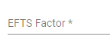 | This is the EFTS factor that you believe the courses study requirements represents.  TEC sets the course EFTS factor, but you must propose a factor based on the proportion of the requirements for the attainments of the qualification that the course represents.  This field accepts a maximum of 6 numeric characters, with up to 4 decimal places, and must be a value between 0.0001 – 2.0000 inclusive.  Note: Please check the EFTS factor calculation on TEC website: http://www.tec.govt.nz/Funding/Fund-finder/SAC3/Funding-and-payments/
 | This field contains the standard fee that domestic students normally pay for tuition and costs associated with enrolment in a course. It is GST inclusive.  This is a mandatory field has a maximum of 5 digits and must have an integer value between 0 and 99999 inclusive.  Note: if the course is to be exclusively used for Youth Guarantee, the provider must enter the Fee as Zero (0).  This field will be used to provide data for the Key Information Set (KIS) for relevant qualifications.
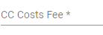 | The Compulsory Course (CC) Costs Fee includes such costs as compulsory administration charges, examination fees, other charges associated with a course or program of study, material charges, costs of field trips and any compulsory purchase of equipment or books through the TEO. It is GST inclusive.  This is a mandatory field has a maximum of 5 digits and must have an integer value between 0 and 99999 inclusive.  Note: if the course is to be exclusively used for Youth Guarantee, the provider must enter the Compulsory Course Costs Fee as 0 (zero).  This field will be used to provide data for the Key Information Set (KIS) for relevant qualifications.
 | Clicking on the will give you a list of all the valid internet codes available for use.  This field is used to indicate whether teaching and learning in the course is currently available in part or as a whole via the internet. There are 4 codes you can use:  - No Access  - Web-Supported  - Web-Enhanced  - Web-Based  Please note this field is not mandatory.
 | This field is required for Export Education Levy (EEL) purposes.  The foreign fee must always exceed the fee for domestic students.  This fee covers all domestic tuition fees, as well as the costs of sale such as agent’s fees and marketing costs, as well as recovering the cost of EEL.  Please note this is not a mandatory field and allows 5 digits and can have an integer value between 0 and 99999 inclusive.

Error Messages in Courses
Most errors can be avoided by following the guidelines outlined in Courses Fields and Descriptions. However, in some cases you may encounter additional error messages:
Error Message | Description
A course instance already exists (Start Year = yyyy, End Year = yyyy).  New course instance must have a Start Year after yyyy. | When you are creating a new course (either by adding a course or altering the Start Year of an existing course) that has the same course code as another existing course, the year entered in the Start Year field must be after the start year of the latest instance of the course.  E.g. if you are creating a new course with Course Code AGRI2007, and there is an existing course AGRI2007 with a start year of 2022, the new course you are creating must have an “Applicable From Start Of“ value of 2023 or later.
Another pending course change request already exists for this course.  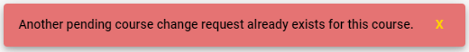 | Editing or adding a new course creates a course change request that must be approved by the Agency.  If there is an existing pending course change request that is awaiting approval for a course that has the same Course Code and Start Year, you cannot add a new course until the pending change request has been reviewed and approved.  E.g. if you are creating a new course with Course Code AGRI2009 and Start Year 2023, and there is a pending Course Change Request for AGRI2009 2023, you will not be able to create this course change request..

SDR Processing
The Single Data Return (SDR) is a set of data items that are specifically required by the Ministry of Education (MoE) and the Tertiary Education Commission (TEC) for funding, monitoring performance against Investment Plans, publishing performance information, as well as statistical reporting purposes.
All TEOs that receive the Student Achievement Component and/or have students with Student Loans or Allowances are required to complete an SDR.
The main benefit of the SDR is that it provides one central point for the collection, processing and delivery of information from TEOs to education agencies.
TEOs extract data from their Student Management Systems (SMSs), creating data files in the format specified in the SDR manual. The Single Data Return (SDR) is comprised of five data files as described:
            - Student (STUD)
            - Enrolment (COUR)
            - Course Register (CREG)
            - Course Completion (COMP)
            - Qualification Completion (QUAL)
A copy of the latest SDR Manual and Appendices can be found at http://www.steo.govt.nz/sdr/sdr-manuals/.
The SDR Validation tab allows you to access the following pages and functionalities:
- SDR Validation Summary
- Validate New SDR
- Summary Reports
  - SDR Broad Summary Report
  - SDR Summary Report
  - Course Completion Summary Report
  - Qualification Completion Summary Report
- Validation Error Report
- EFTS Forecast Update / View
- Course Difference Submit / View
- Course Completion Summary
- EFTS by Course
- SDR Submission

You can navigate to this section by clicking on Validation under SDR in the main menu.
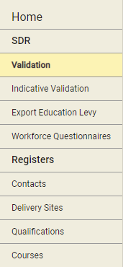
Figure 10596 – Accessing SDR Validation

SDR Validation Summary
The SDR Validation Summary is the default page when you navigate to the SDR Validation tab. By default, the SDR Validation Summary of the current Return Month is displayed, which is a visual representation of SDR Round. Each SDR Year is divided into 3 consecutive SDR Rounds, referred to as the April, August and December SDR Rounds.
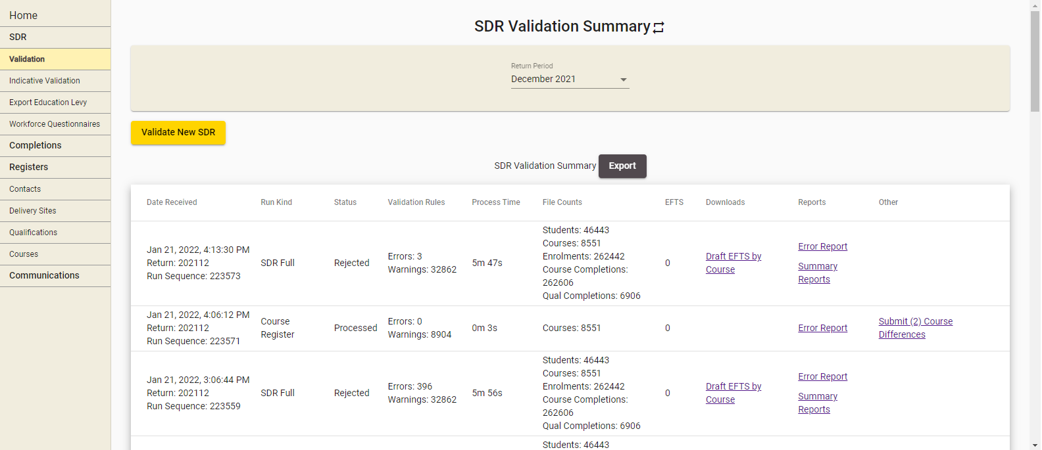
Figure 10697 – SDR Validation Summary
You can sort the results by clicking on the column header titles as previously described in the Sorting Search Results section.
You can view returns from other Round periods by selecting a different month from the Return Period dropdown.

Validate New SDR
You can access the SDR Validation page by clicking on the Validate New SDR button, as shown below:
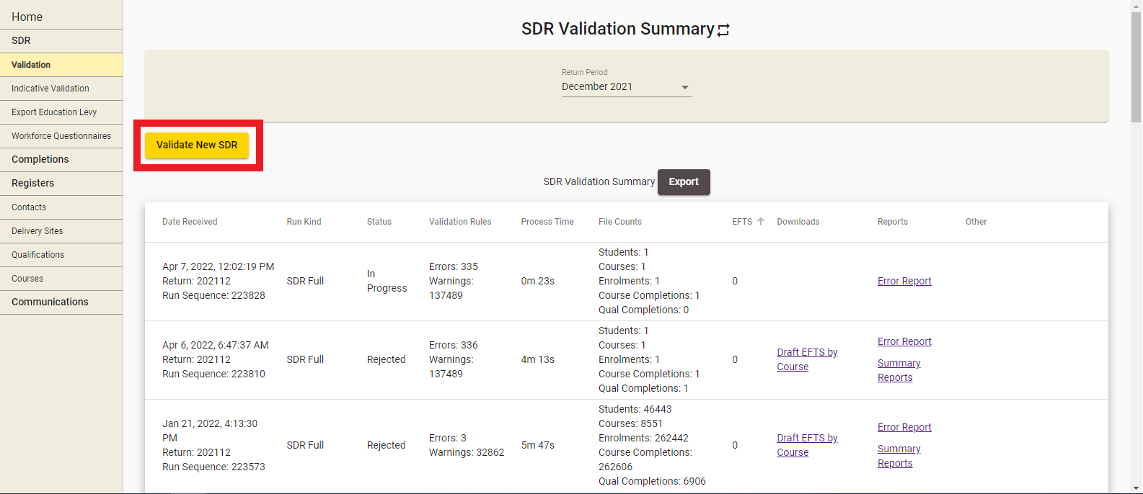
Figure 10798 – Accessing SDR Validation
The SDR Validation process has the following steps:
- Select SDR
- Upload SDR Files
- Submit for Processing

Select SDR Run Kind, Year and Month
The first step of the SDR Validation process is shown below:
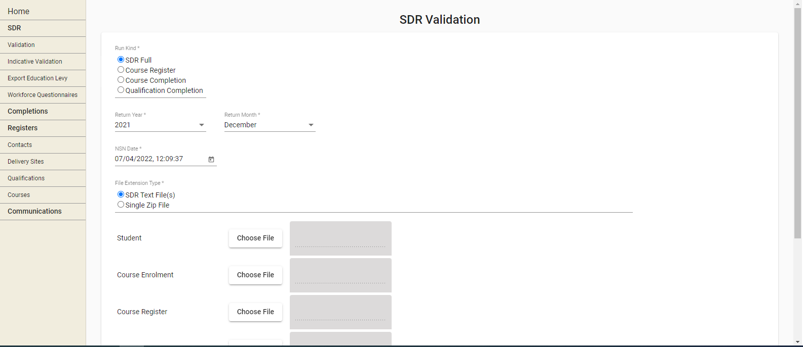
Figure 10899 – Selecting SDR Full as Run Kind

You must select a Run Kind to proceed. You can select from one of four Run Kinds:
- SDR Full – comprised of STUD, COUR, CREG, COMP and QUAL files
- Course Register – CREG file only
- Course Completion – COMP file only
- Qualification Completion – QUAL file only
Please refer to the Validating Other File Types section for SDR Processing of the CREG, COMP or QUAL files.
The Return Year will default to the year of the selected Return Month in the SDR Validation Summary page.
When “SDR Full” is selected as the Run Kind, the Return Month will default to the current Return Month of the selected year in the SDR Validation Summary page. For historical years, it will default to the December return of the selected year.
For SDR Full returns, the NSN Date will default to the current date and time.
You may optionally select one or more email notification contacts to specify to receive email notifications of the progress of your SDR processing. The contacts are populated from the list of contacts in your organisation in the Contacts who have the Data Returns role.
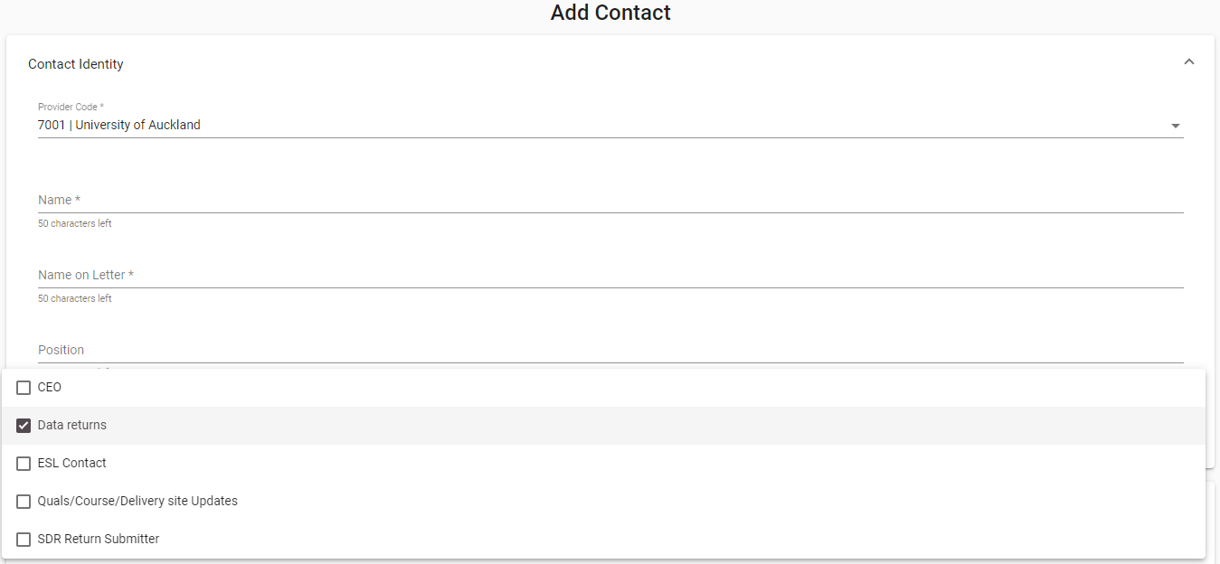
Figure 109100 – Data Return Contacts

Selecting a Run Kind will update the page to display the Upload SDR Files fields.

Upload SDR Files
The Upload SDR Files fields are shown below:
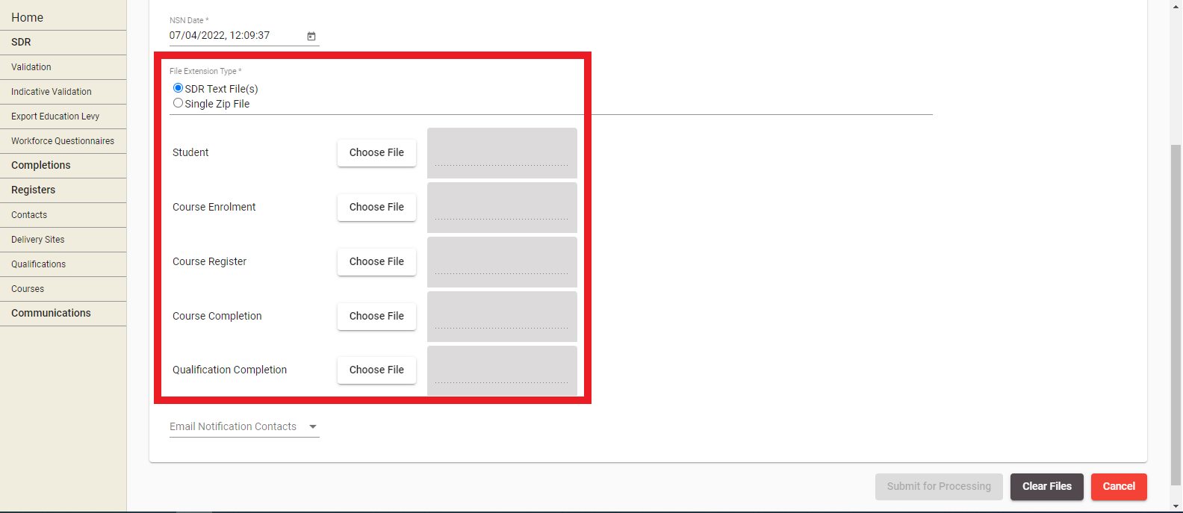
Figure 110101 – Upload SDR Files
It is assumed at this stage that you will have created the required files, either manually or from your SMS. In addition, all qualifications and courses recorded in the files must already be created and approved in STEO (that is, they exist in Qualification Register and Course Register).
Click Choose File and select the relevant files to upload.
Please note that if any of the files are larger than 20 megabytes (MB), you will have to compress them into a single .zip under 20 MB. Further details can be found in Maximum File Size when Uploading.
If a single zip file is selected, please ensure that the files in the .zip file are named correctly, e.g. for the provider code 1111 the following files are expected for SDR Full:
- STUD1111.txt
- COUR1111.txt
- CREG1111.txt
- COMP1111.txt
- QUAL1111.txt
Clicking on  will remove all uploaded files. You will remain on the same page.
Clicking on will return you to the SDR Validation Summary page.

Submit for Processing
This is the final step of the SDR Validation Process.
Clicking on  will take you to a confirmation message.

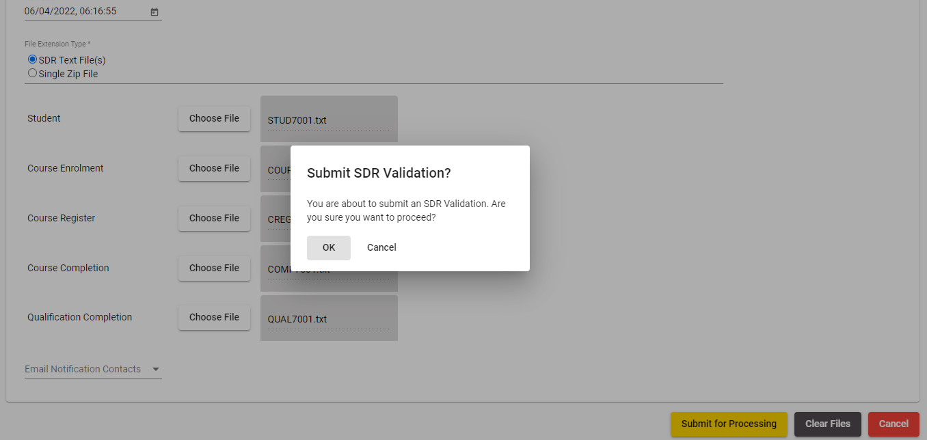
Figure 111102 – Submit SDR Validation confirmation
Clicking on Cancel will take you to the SDR Validation page for further changes.
Clicking OK will add the uploaded SDR files to the queue for processing. See SDR Processing and Results for more information.
You will be directed back to the SDR Validation Summary page with the following pop-up message:
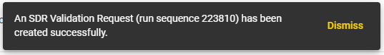
Figure 112103 - SDR Validation Request Success Message

Validating Other File Types
The pages shown will be slightly different if you elect to upload a file that is not a SDR Full type. These are:
- Course Register – CREG file only
- Course Completion – COMP file only
- Qualification Completion – QUAL file only
Please note: Some File Types may require you to have submitted a SDR Full for the current round (e.g. Course Completion and Qualification Completion).
The following restrictions apply to some of the File Types:
- CREG – A CREG file can be processed on its own at any time of the year and there is no requirement to process a SDR Full file first. New courses that do not exist in the Course Register can be added as part of CREG only processing, as well as new values for a different year bound version of an existing course. This creates course differences that can be submitted for approval as shown in Course Difference Submit / View
- COMP – A COMP file can be processed on its own if the SDR Full is submitted for the latest year and return
- QUAL – A QUAL file can be processed on its own if the SDR Full is submitted for the selected latest year and return
If you select Course Completion (COMP) or Qualification Completion (QUAL) as the File Type, please note that you cannot process a COMP or QUAL for a given Return Year if a SDR Full return has been successfully submitted for a later year.
Selecting any of the other File Type options such as Course Register, Completion, or Qualification Completion will only display one file for upload, as shown in Error! Reference source not found. below:
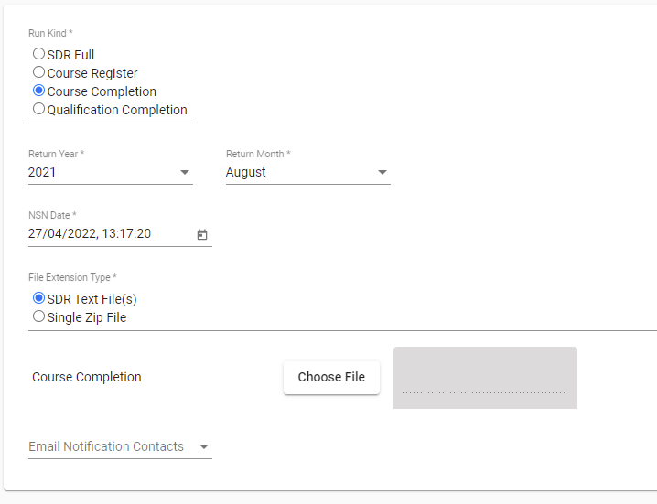
Figure 113104 – Upload SDR FIles (Other File Types)
Selecting any of the other File Type options such as Course Register, Completion, or Qualification Completion will only display the available Return Month as shown in Error! Reference source not found. below:
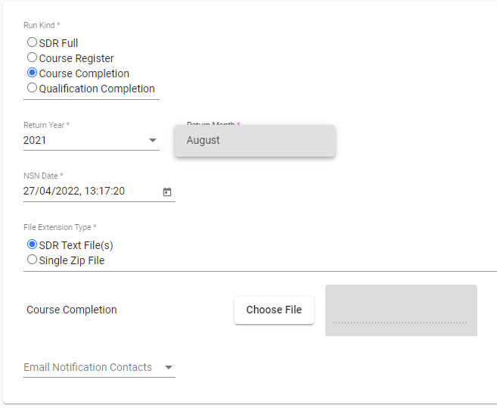
Figure 114105 – Return Month (Other File Types)
Please note for Course Completion (COMP) or Qualification Completion (QUAL) file types, you must first process and submit SDR Full files for the given Return Month. If you have not submitted the SDR Full, the Return Month will be not be available.

SDR Processing and Results
After you click in the final step of the SDR Validation process, the uploaded files will be added to the queue for processing, as shown below:
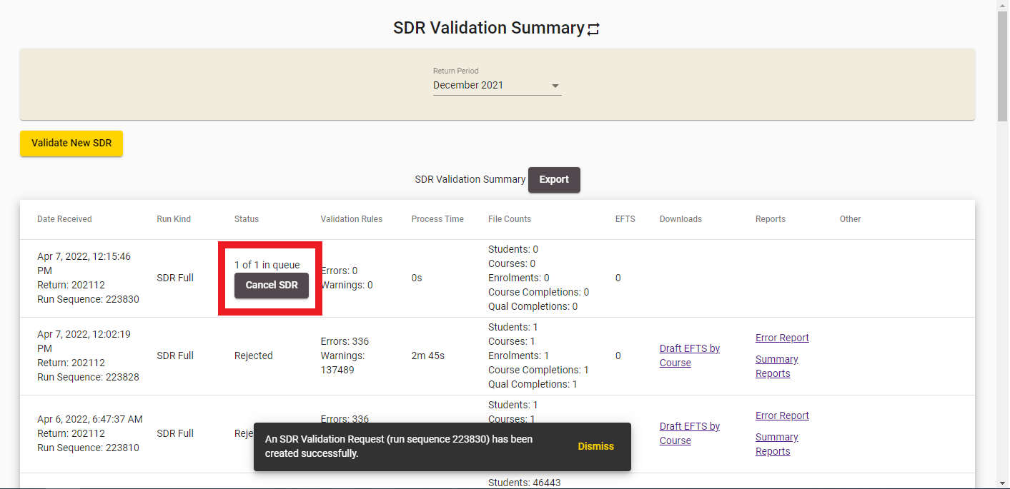
Figure 115106 – SDR Processing Queue
Clicking on Cancel SDR will allow you to cancel the SDR Validation before it starts processing. Once the SDR Processing has begun, the status will switch to “In Progress” as shown below:
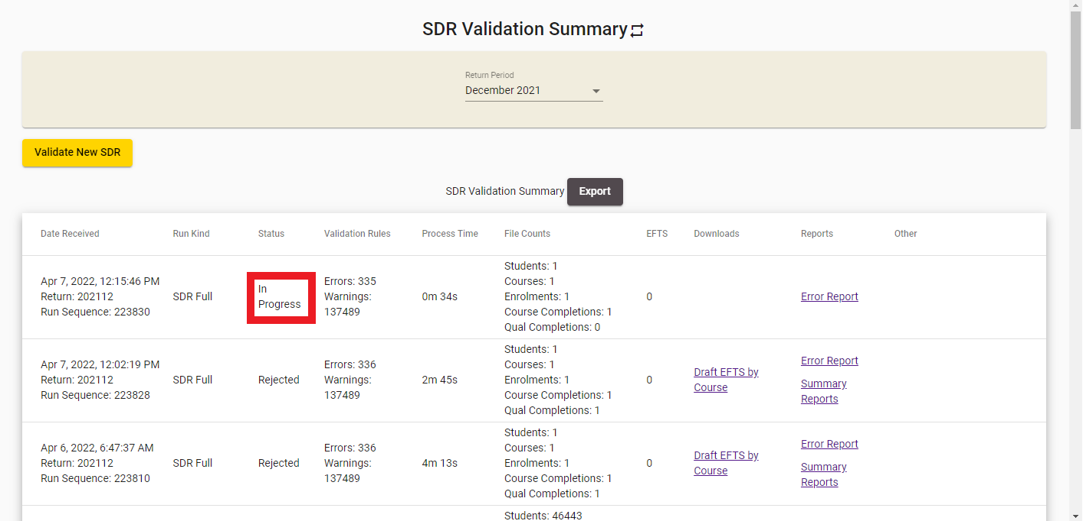
Figure 116107 – SDR Validation Processing in Progress
You will be unable to cancel SDR Validation once it is “In Progress”. Clicking or your browser’s refresh button while SDR Validation is in progress will refresh the page. When the processing of the SDR Validation has been completed, the results of validation will be shown in the Status field.
If the SDR Validation is successfully processed with no errors (warnings are fine), and the file was processed within the SDR Round period, the following status will be shown as per Error! Reference source not found..
If any warnings were present the link Error Report will be shown, which will take you to the Validation Error Report.
Clicking on Submit will allow you to perform SDR Submission.
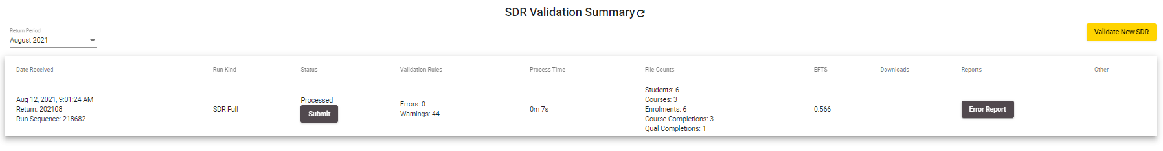
Figure 117108 – SDR Processed Successfully during SDR Round
If you processed an SDR Full return successfully within the SDR Round period, but did not submit by the due date for each round, you will not see a Submit SDR Full Link.
Please note that you can contact the Customer Contact Group to arrange for an extension to be granted so you can submit the SDR (as long as the SDR Round window is not over, which coincides with the beginning of the next SDR Round).
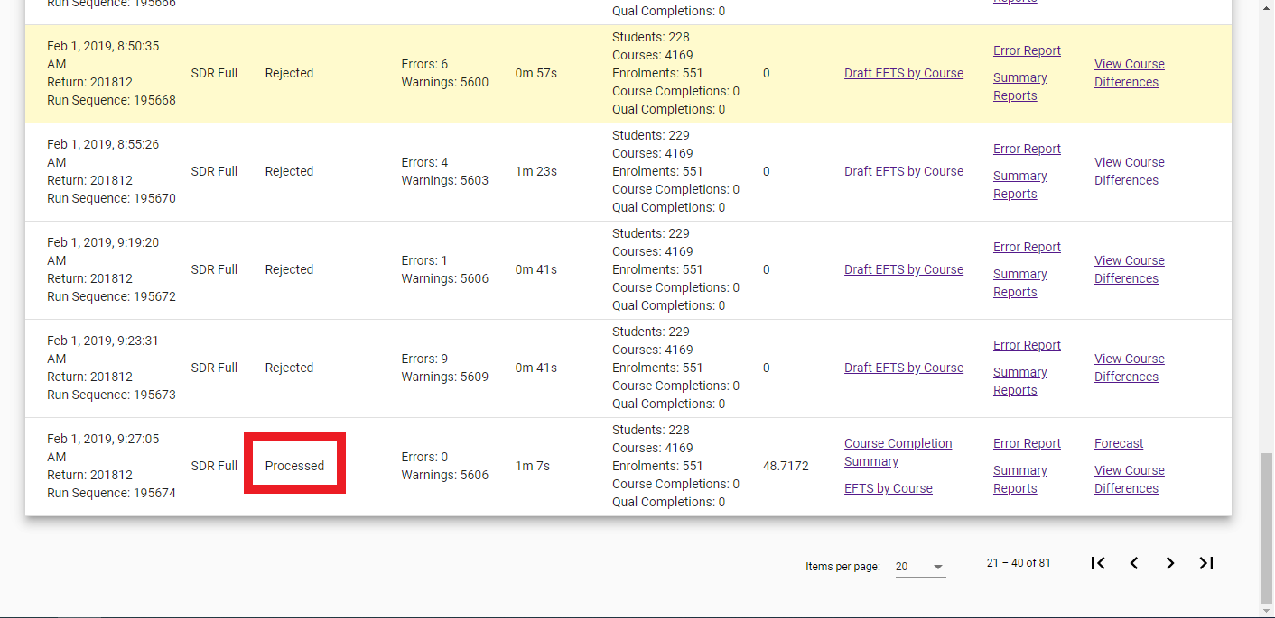
Figure 118109 – SDR Processed during SDR Round but round period is expired
If the files were processed, but errors were present during validation, the status will read Rejected (as per Error! Reference source not found..
Clicking on the link Error Report will take you to the Validation Error Report.
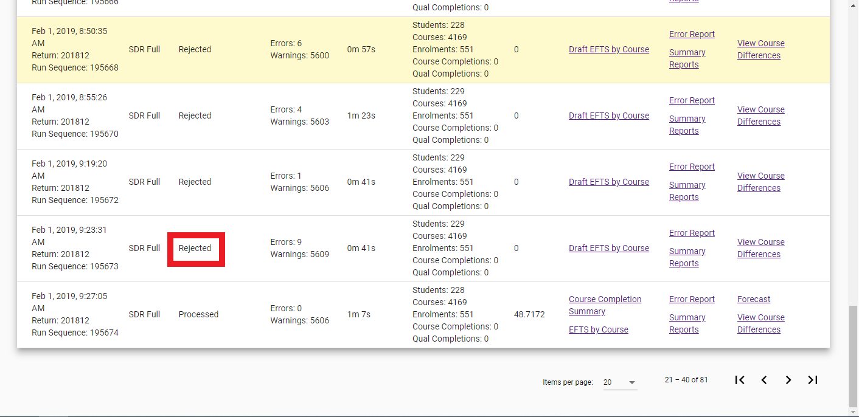
Figure 119110 – SDR Processed and Rejected
If the files have some unexpected data issues that could not be handled during processing and validation, the processing will be aborted, and the status will read Unknown Error as shown in Error! Reference source not found.. Please contact the Customer Contact Group for assistance in this situation.
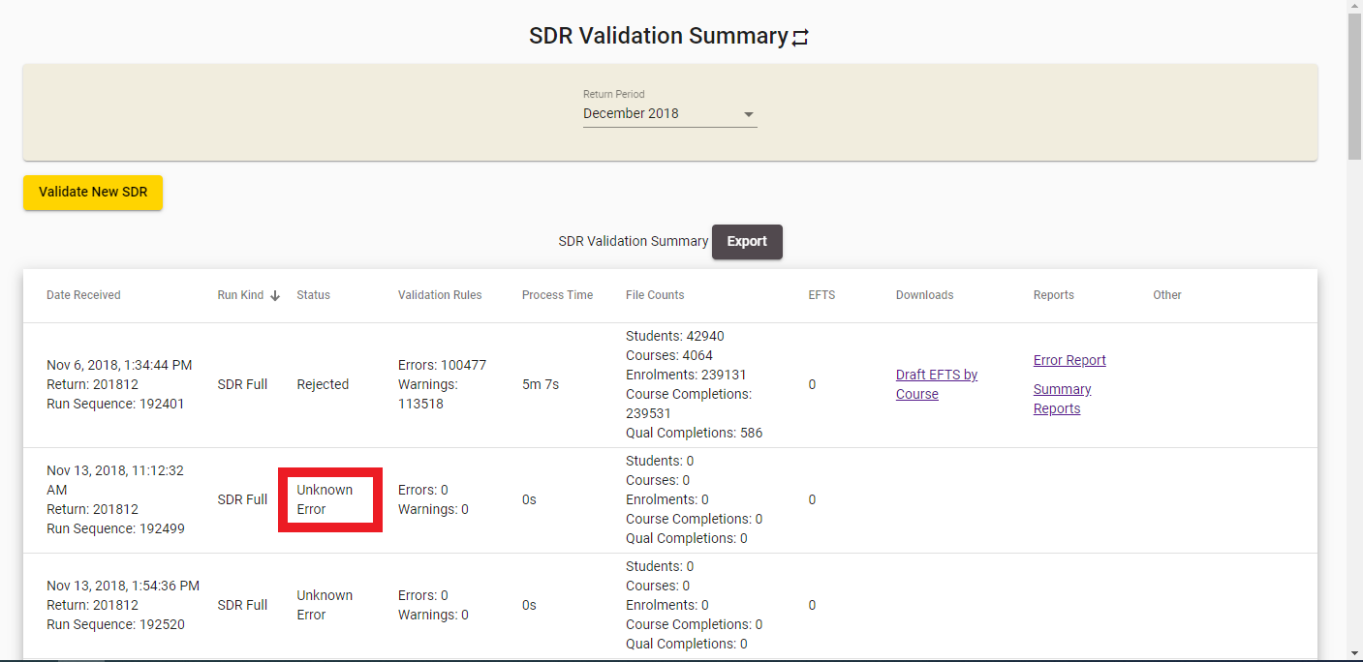
Figure 120111 – SDR File Not Processed due to Unknown Error
If your files were processed successfully without errors, but you have missed SDR Submission for the SDR Round window, you will see the “Too late for SDR” message below the Processed Status, as shown in Error! Reference source not found.:
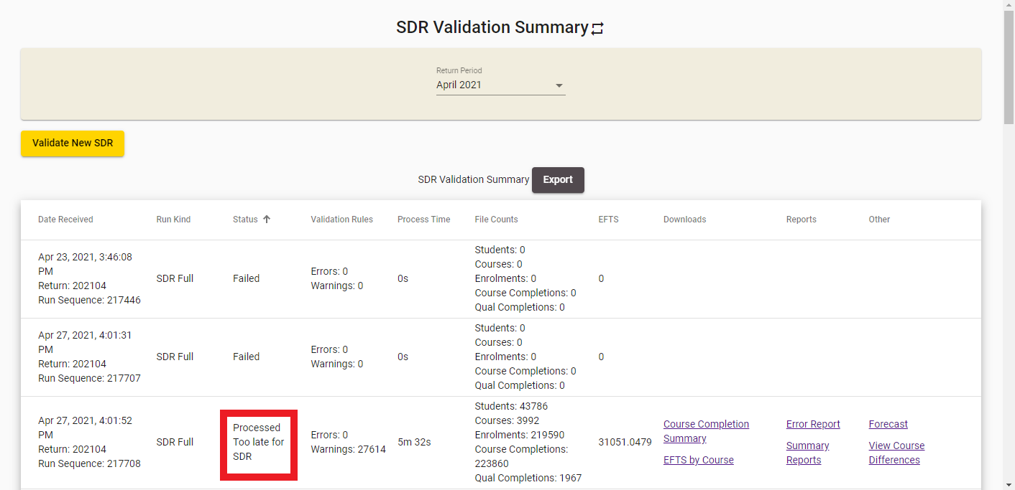
Figure 121112 – SDR Processed but Too Late for SDR
If your files were processed successfully without errors, but you have processed them before the SDR Round window, you will see the “Too early for SDR” message below the Processed Status.
If you submitted a single Qualification Completion file for your return, and it was processed successfully, you will see a Submit button under the processed status:
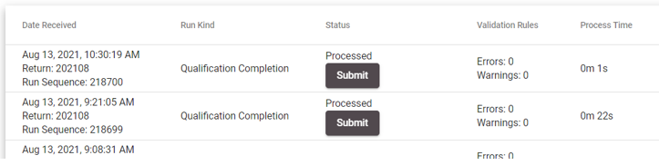
Figure 122113 – Qualification Completion Processed Successfully
If you submitted a single Course Completion file for your return, and it was processed successfully, you will see a Submit button under the processed status:
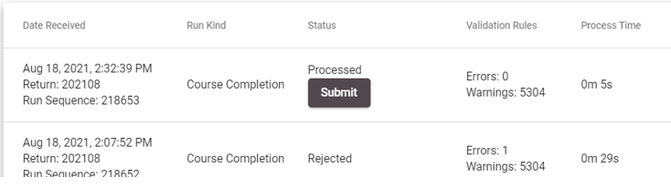
Figure 123114 – Course Completion Processed Successfully
Please note that QUAL and COMP files Submission does not require extension to be granted. That is only applicable to SDR Full.
If you submitted a single Course Register file for validation, and it was processed successfully, it will be shown as “Processed” as shown in Error! Reference source not found.. Please note that CREG files do not require submission as Course Differences are used to submit any changes.
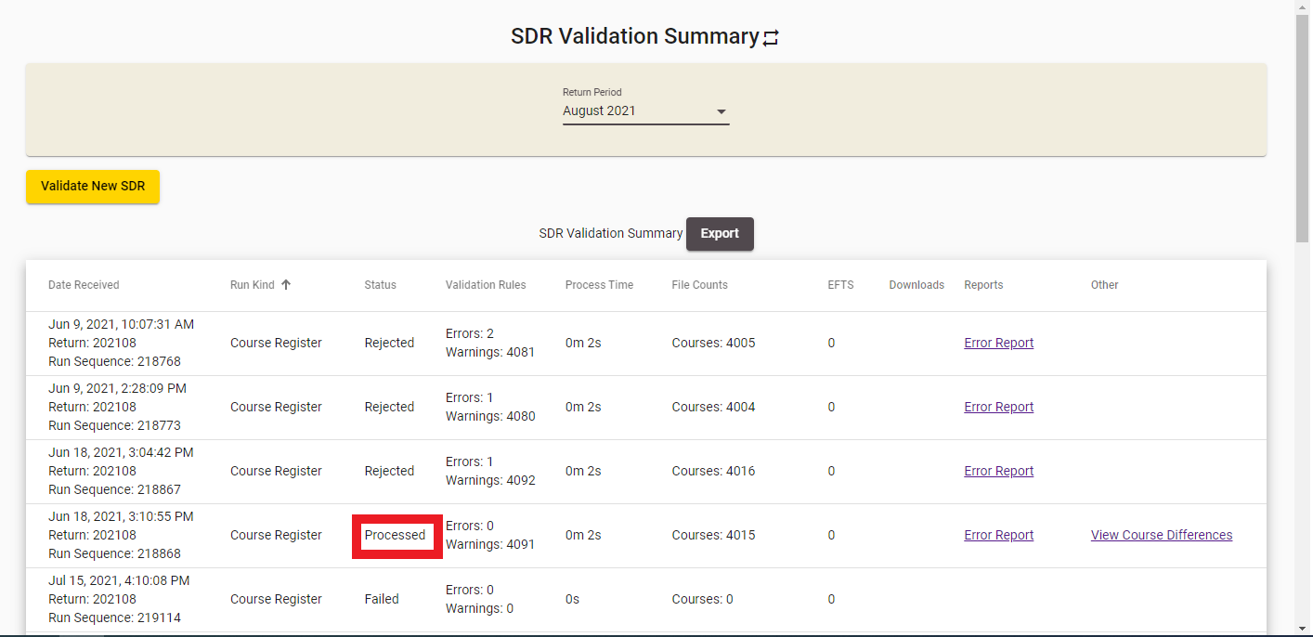
Figure 124115 – Course Register Processed Successfully

Summary Reports
The Summary Report Links pop-up provides access to several reports that you can view after your SDR Validation has been completed. You can access it by clicking on the Summary Reports link shown below:
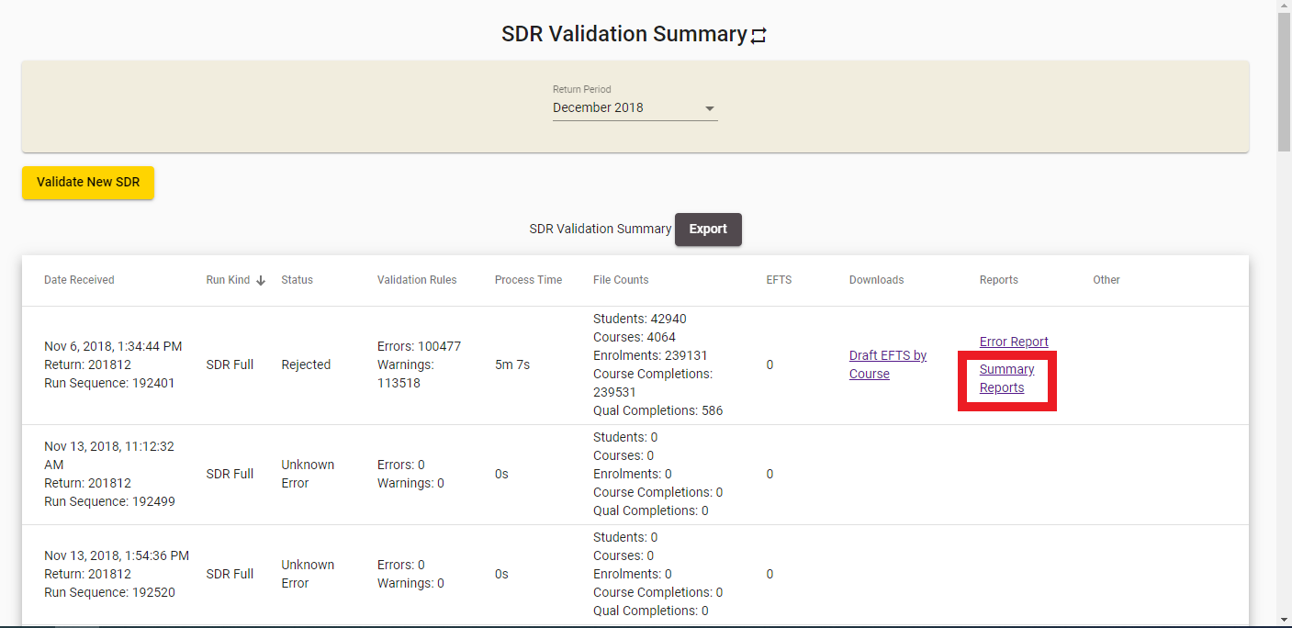
Figure 125116 – Accessing Summary Reports
The Summary Report Links pop-up will be shown to you as per the figure below:

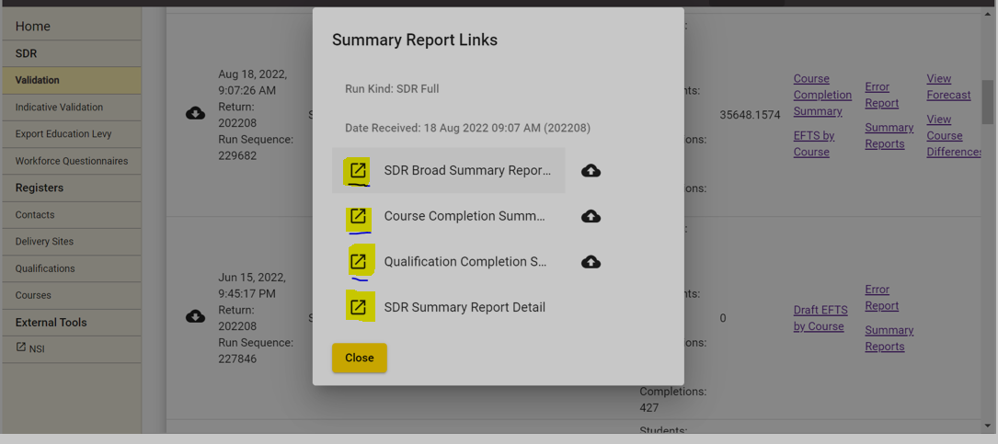
Figure 126117 – Summary Report Links for Successfully Validated SDR
Please note that if the SDR Validation was completed with errors, each of the following reports will be preceded with the word Draft as shown in Error! Reference source not found..
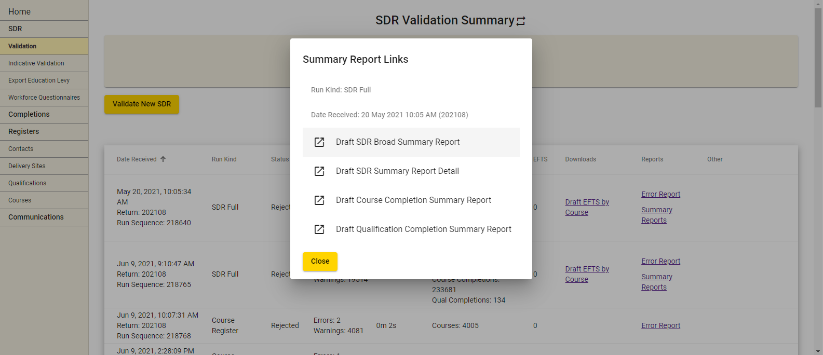
Figure 127118 – Summary Report Links for SDR Validation with Errors
The following reports can be accessed, printed and signed by clicking on the respective links:
- SDR Broad Summary Report and Sign Off
- Course Completion Summary Report
- Qualification Completion Summary Report
- SDR Summary Report
Clicking on  will allow you to upload the signed summary page back to STEO for TEC (CCG) to review.
Clicking on 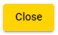 will return you to the SDR Validation Summary page.

SDR Broad Summary Report
When you use the validation program a broad summary report is generated. The broad summary is provided so that you can check student numbers and thus ensure that there are no obvious inconsistencies. The broad summary is also used to certify that your data files are accurate and that they have been validated in accordance with the Ministry and TEC’s standards.
You can access the SDR Broad Summary Report by clicking on the SDR Broad Summary Report and Sign Off or the Draft SDR Broad Summary Report link from the Summary Report pop-up.
From August 2016 onwards, the Summary Sign-off page must be signed by your Chief Executive or Vice Chancellor for April and August SDR.
From December 2016 onwards, each organisation’s summary report for the December SDR submission must be signed by either the Chief Executive or, where the organisation has one, the Chair of the Council or Board.
Only the sign-off page is required to be uploaded back to STEO. You can upload this using the upload button next to the SDR Broad Summary Report link from the Summary Report pop-up as shown in the Figure 128119.Note: There will not be any Sign Off page for the Draft SDR Broad Summary Report.

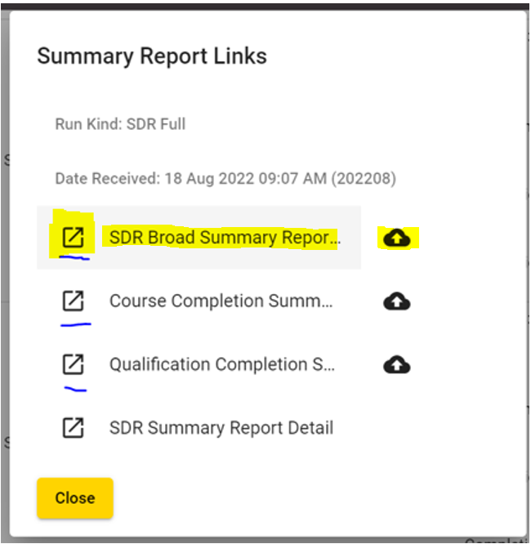
Figure 128120 – Accessing SDR Broad Summary Report
When you access the SDR Broad Summary Report, it will be opened in a new tab or window of your web browser. You will be able to print it off as needed.

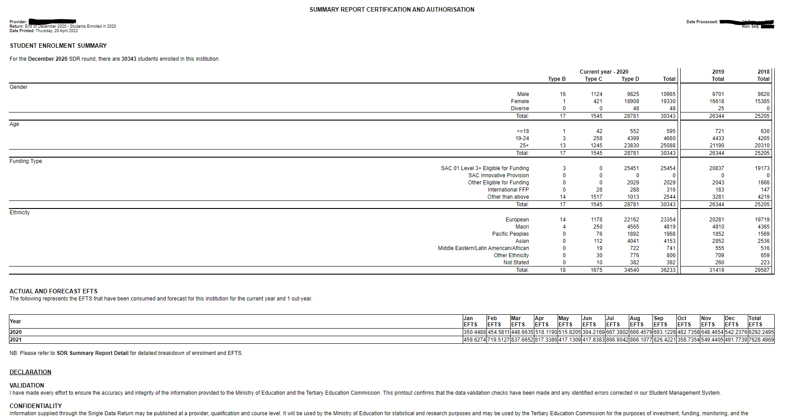
Figure 129121 – SDR Broad Summary Report
The Funding Type section in the SDR Broad Summary Report is classified for different Source of Funding as below:
Funding Type | Source of Funding (SoF)
SAC 01 Level 3+ Eligible for Funding | 01
Other Eligible for Funding | 22, 23, 24, 25, 26, 27, 28, 29, 30, 32, 33, 35, 36, 37
International FFP | 02
SAC Innovative Provision | 34
Other than above | Other SoF which is not listed above

SDR Summary Report Detail
The SDR Summary Report Detail contains a more detailed breakdown of enrolments and EFTS than what is contained in the SDR Broad Summary Report.
You can access the SDR Summary Report Detail by clicking on the SDR Summary Report Detail or the Draft SDR Summary Report Detail link from the Summary Report pop-up.

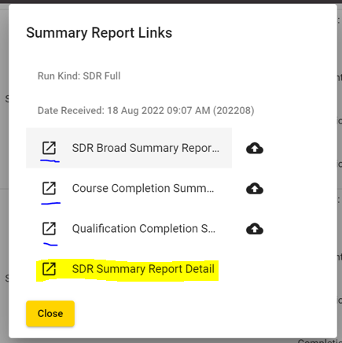
Figure 130122 – Accessing SDR Summary Report Detail
When you access the SDR Summary Report Detail, it will be opened in a new tab or window of your web browser. You will be able to print it off as needed.

The following sections are shown in the SDR Detailed Summary Report:
- Student Enrolment Summary
This section shows the count of students for each student type and their total count under each listed category. It also shows the total count for two previous years.

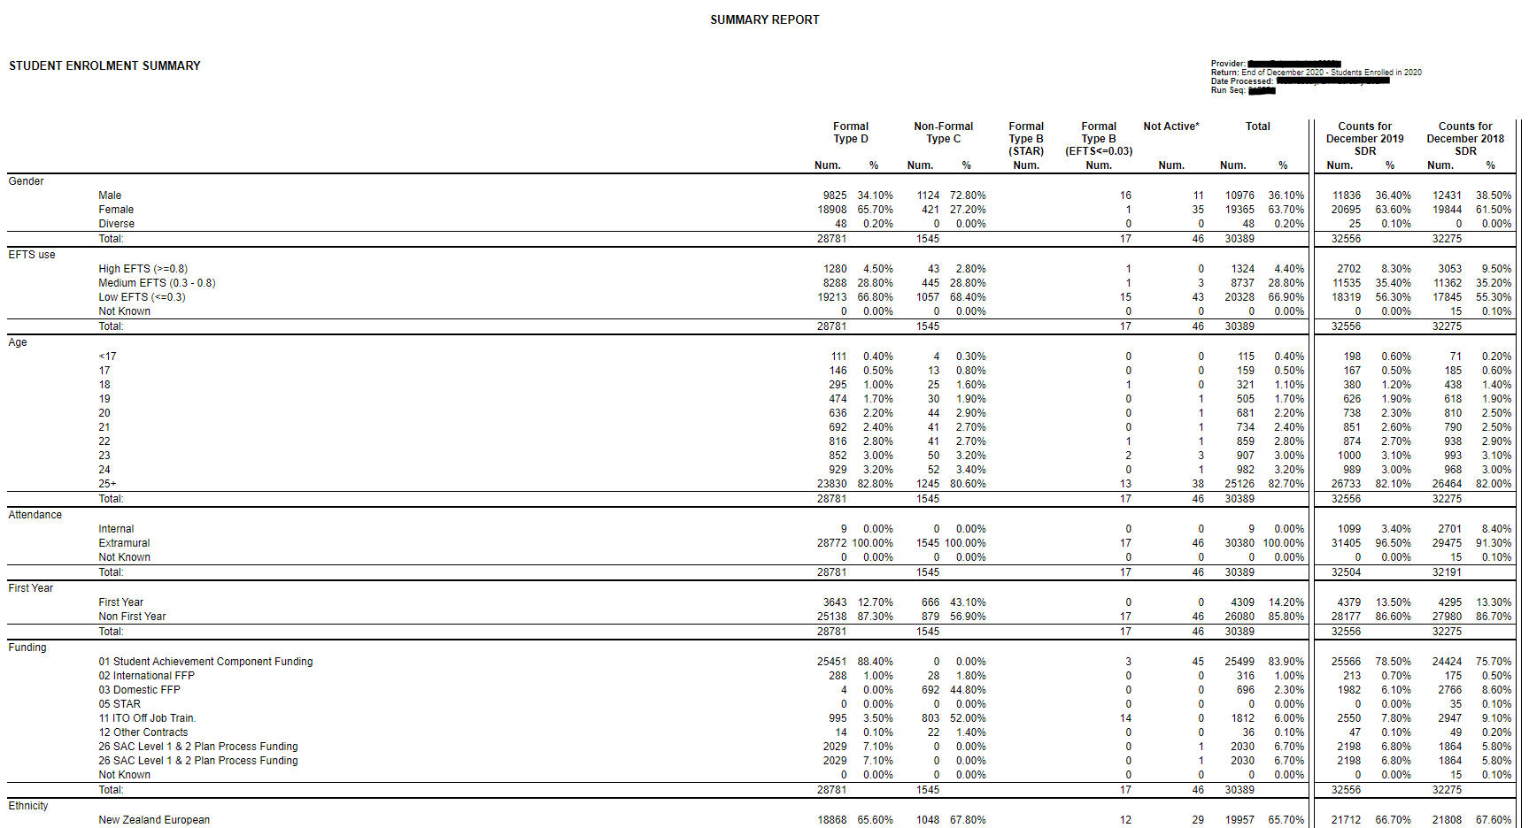
Figure 131123 – SDR Detailed Summary Report – Student Enrolment
- EFTS Consumed by Source of Funding
This section shows the monthly EFTS and Total EFTS grouping by the funding source given in the enrolment file.
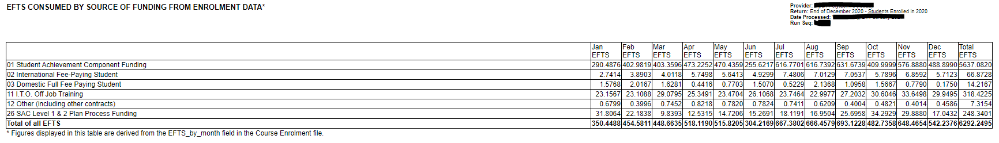
Figure 132124 – SDR Detailed Summary Report – EFTS Consumed
- Actual and Forecast EFTS by Course Classification
This section shows the monthly EFTS and Total EFTS based on the course classification and funding category given in the enrolment file.
Note: The forecast data which are manually updated via the EFTS Forecast Update / View page will be reflected here.
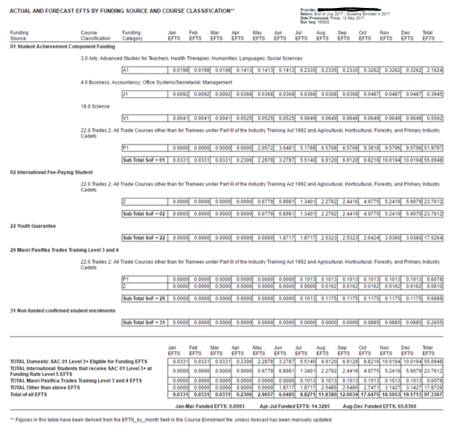
Figure 133125 – SDR Detailed Summary Report – Actual and Forecasted EFTS
Note: Any enrolment with Source of Funding different from 01, 29 or 34 will be counted towards Funding Category Z (regardless of which Funding Category was used in the enrolment). Where Source of Funding is 01, 29 or 34 the actual funding category submitted with the enrolment is used and the Course Classification/Funding Category EFTS breakdown is displayed.

- Forecast EFTS
This section shows the Forecast EFTS (monthly and Total) for the funded and non-funded source of funding the student is enrolled for the course for the SDR processed year and four out years.
Note: The forecast data which are manually updated via the EFTS Forecast Update / View page will be reflected here.
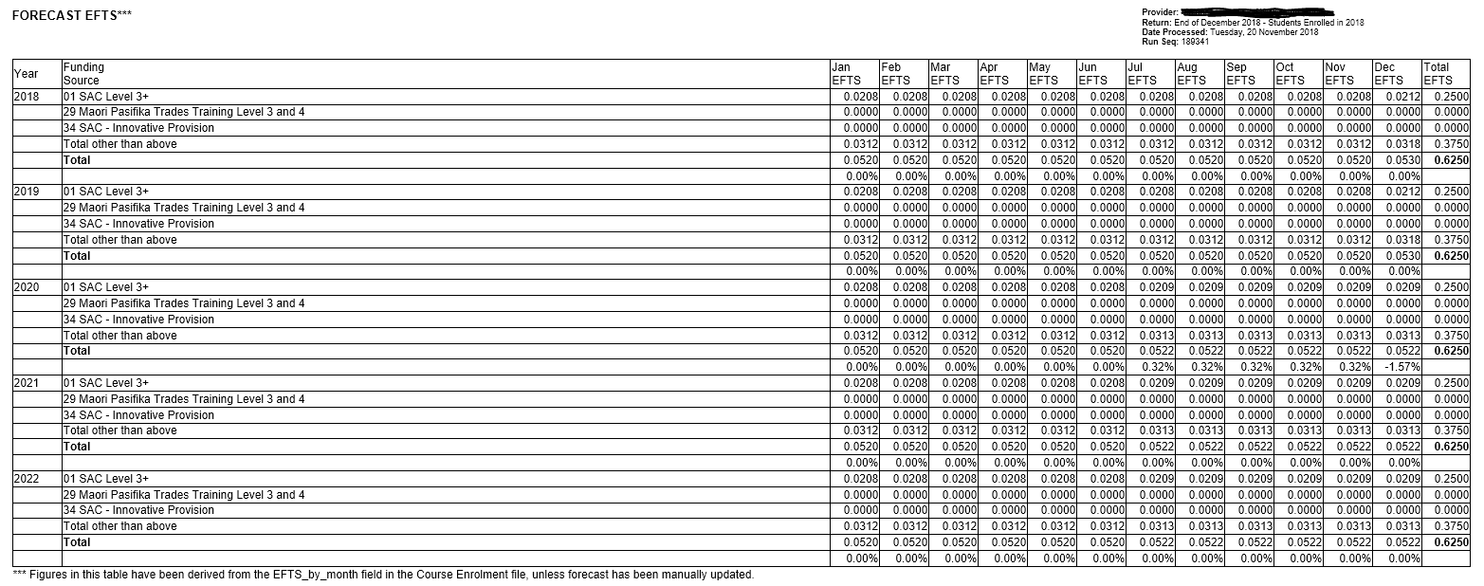
SDR Detailed Summary Report – Monthly and Total Forecasted EFTS

Course Completion Summary Report
You can access the Course Completion Summary Report by clicking on the Course Completion Summary Report or the Draft Course Completion Summary Report link from the Summary Report pop-up.
From August 2016 onwards, the Summary Sign-off page must be signed by your Chief Executive or Vice Chancellor for April and August SDR. From December 2016 onwards, each organisation’s summary report for the December SDR submission must be signed by either the Chief Executive or, where the organisation has one, the Chair of the Council or Board.
Only the sign-off page is required to be uploaded back to STEO. You can upload this using the upload button next to the Course Completion Summary Report link from the Summary Report pop-up as shown in the Figure 134126.
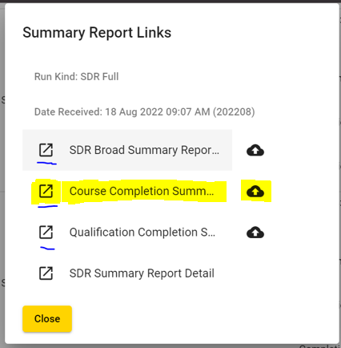
Figure 134127 – Accessing Course Completion Summary Report
When you access the Course Completion Summary Report, it will be opened in a new tab or window of your web browser. You will be able to print it off as needed.
The following sections are shown in the Course Completion Summary Report:
- Course Count for Each Year
The first section shown in Error! Reference source not found.135 displays the courses count against each completion code for each year reported in the Course Completion file.

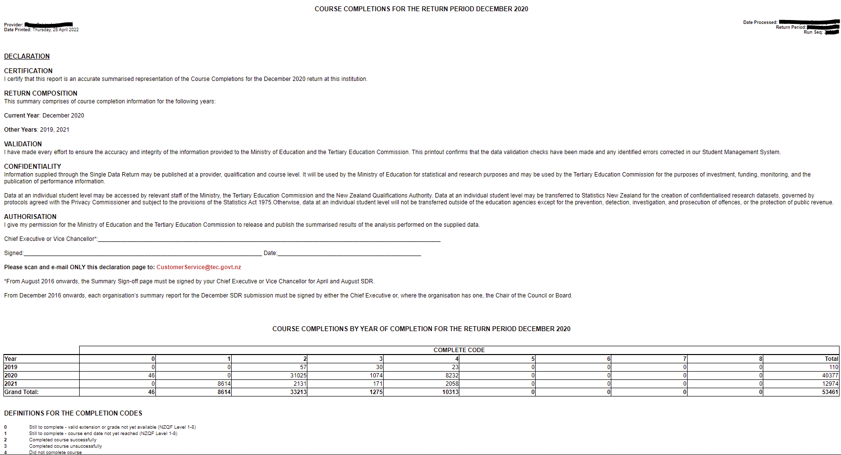
Figure 135128 – Course Completion Summary Report – Course Count for Each Year
- Course Count for the SDR Round
The second section shown below displays the courses count against each completion code for the SDR processed round and for all the courses reported in the Course Completion file.
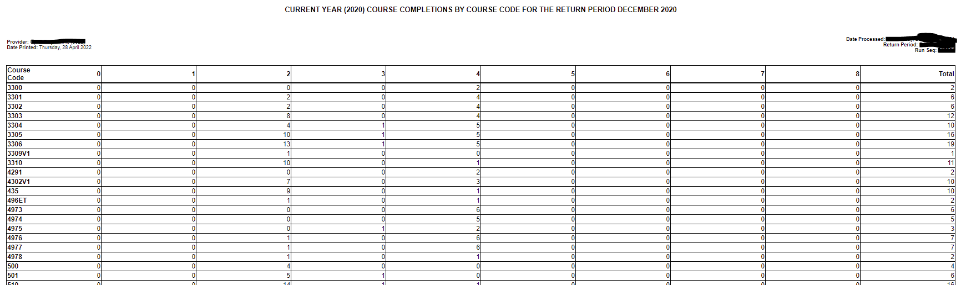
Figure 136129 – Course Completion Summary Report – Course Count for SDR Round
- Course Count for PBRF Courses
The third section is displayed only if PBRF courses (i.e. courses that have PBRF flags in either M, D, L or C in Course Register) are entered in the Course Completion file. The section shown below displays the courses count for PBRF courses against each completion code for the SDR processed round and for each PBRF course reported in the Course Completion file.
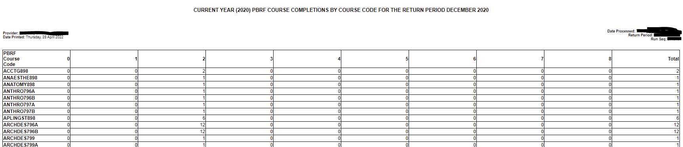
Figure 137130 – Course Completion Summary Report – Course Count for PBRF Courses
- Historical Course Count
The additional sections will be displayed for each historical year depending on the historical course completion years if any are reported in the Course Completion file starting from lowest to highest. An example is shown below:
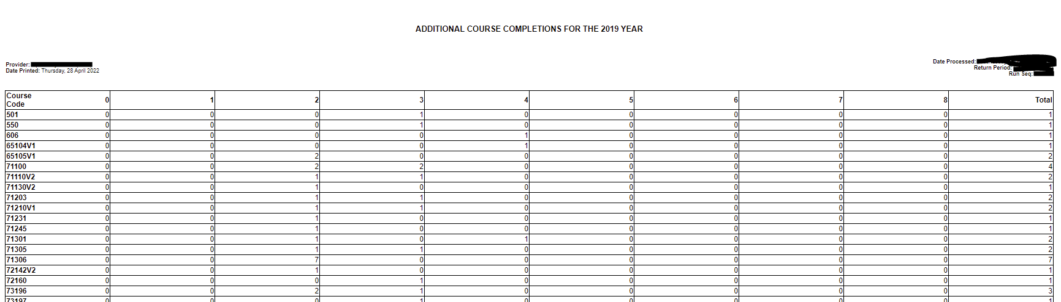
Figure 138131 – Course Completion Summary Report – Course Count for Historical Years
- Future Completed Course Count
The last section shows the courses count that will be completed in the next year (SDR processed year + 1) if any are reported in the Course Completion file as below.
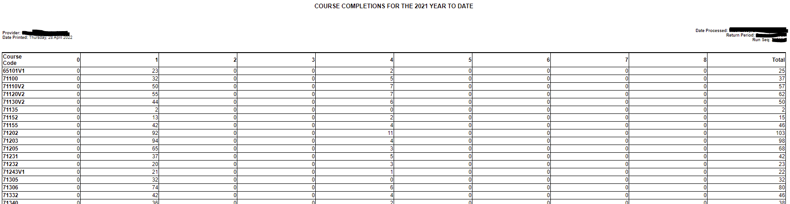
Figure 139132 – Course Completion Summary Report – Future Completed Course Count
Please note that if the Course Completion file has any PBRF courses that are completing in the next year (SDR processed year + 1) reported then an additional section will be displayed:
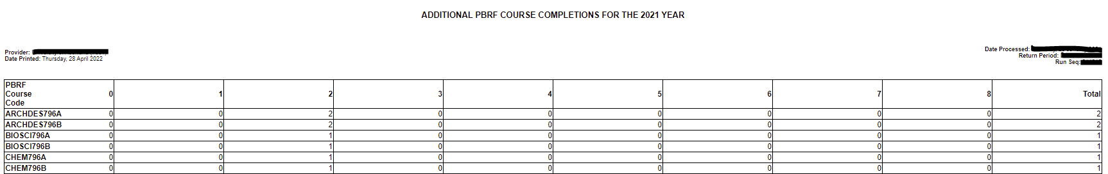
Figure 140133 – Course Completion Summary Report – Future Completed PBRF Course Count

Qualification Completion Summary Report
You can access the Qualification Completion Summary Report by clicking on the Qualification Completion Summary Report or the Draft Qualification Completion Summary Report link from the Summary Report pop-up.
From August 2016 onwards, the Summary Sign-off page must be signed by your Chief Executive or Vice Chancellor for April and August SDR. From December 2016 onwards, each organisation’s summary report for the December SDR submission must be signed by either the Chief Executive or, where the organisation has one, the Chair of the Council or Board.
Only the sign-off page is required to be uploaded back to STEO. You can upload this using the upload button next to the Qualification Summary Report link from the Summary Report pop-up as shown in the Figure 141134.

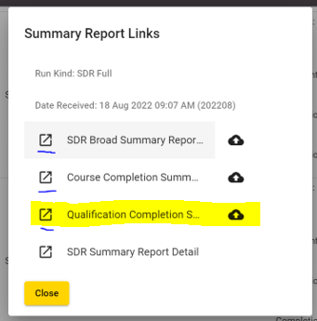
Figure 141135 – Accessing Qualification Completion Summary Report
When you access the Qualification Completion Summary Report, it will be opened in a new tab or window of your web browser. You will be able to print it off as needed.
The following sections are shown in the Qualification Completion Summary Report:
- The first section displays the qualifications count for 4 completion years (from SDR processed year to three previous years) for each Qualification Award Category (QAC) reported in the Qualification Completion file shown in Error! Reference source not found.

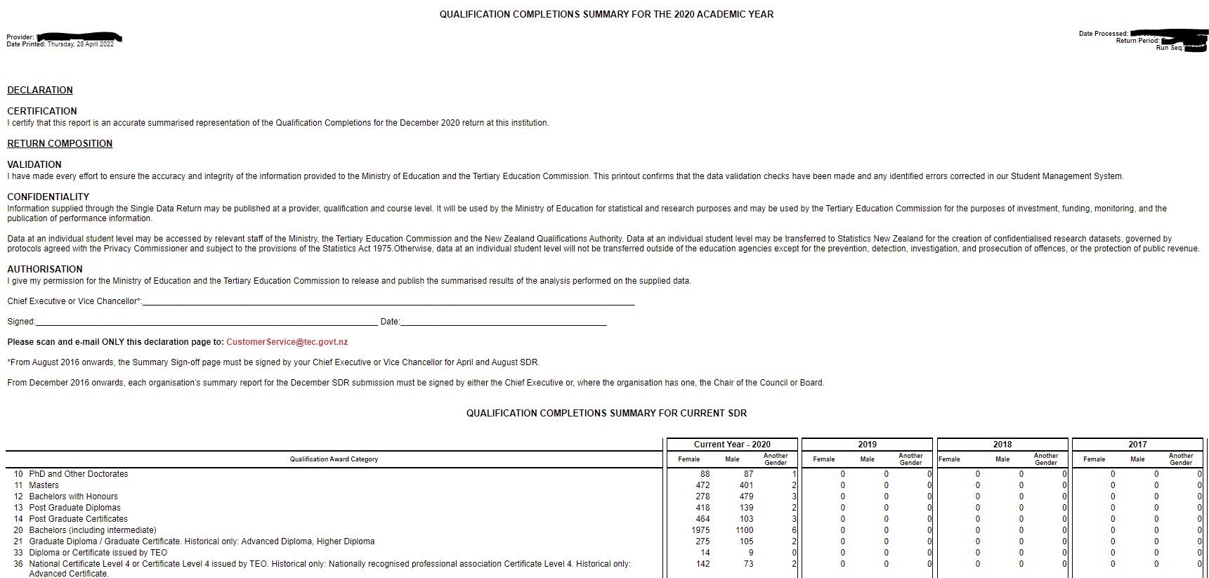
Figure 142136 – Qualification Completion Summary Report – Qualification Count for 4 Years for Current SDR

- The next section displays the qualifications count for 4 completion years (from SDR processed year to three previous years) for each Qualification Award Category reported in the Qualification Completion file that are not part of the currently processed SDR but from the latest submitted Qualification Completion data.
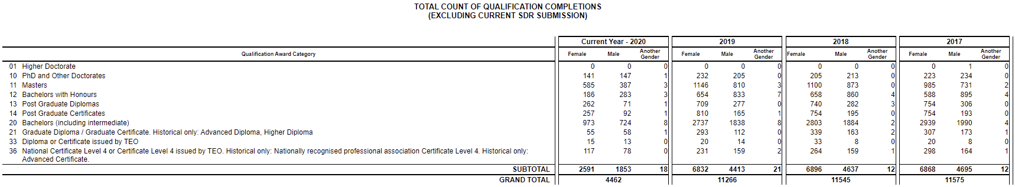
Figure 143137 – Qualification Completion Summary Report – Qualification Count for 4 Years not part of Current SDR

- The next section shows the breakdown of qualifications count based on the QAC and Qualification code reported in the Qualification Completion file for the SDR processed year.
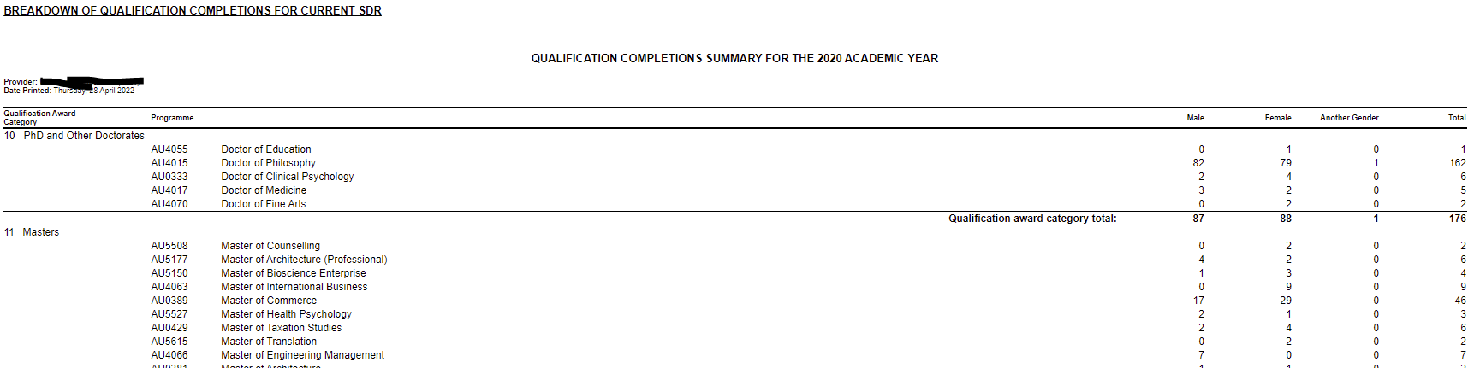
Figure 144138 – Qualification Completion Summary Report – Qualification Count for Current SDR Year

- The additional sections that show the breakdown of qualifications will be displayed for each historical year depending on the historical qualification completion years if any are reported in the Qualification Completion file starting from lowest to highest.

Note:

- TEC reviews and accepts signed summary reports only after all the three summary reports are uploaded by Providers.

- Once TEC reviews and accepts the signed summary reports, the upload icon disappears as shown below,
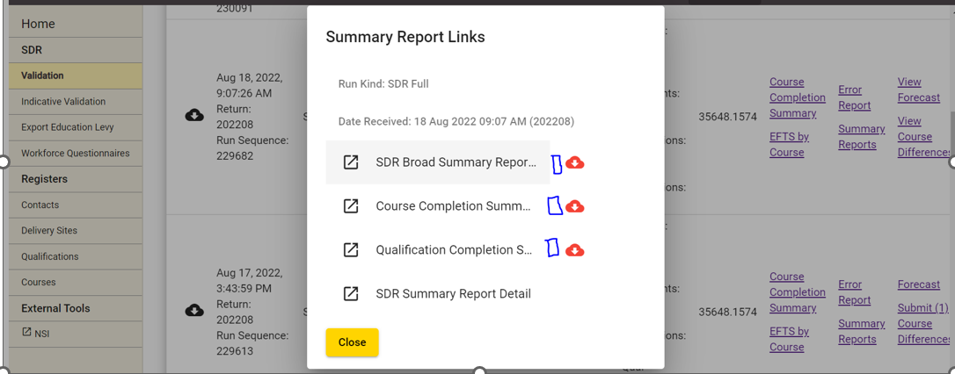

- Providers can download their signed reports for their reference anytime subsequent to submitting by clicking on icon next to each report.

Note: The download icon appears after report/s are uploaded. To download, close the pop-up screen and re-open as shown below,
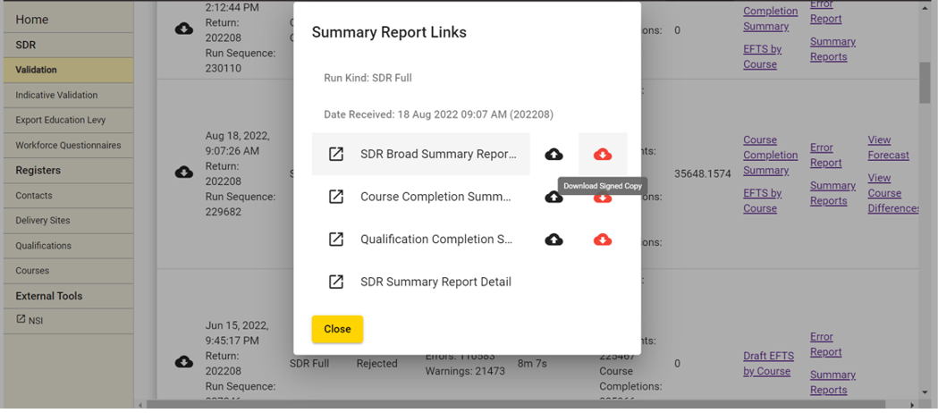

Validation Error Report
If your SDR files were rejected (or successfully validated but with warnings), you can access detailed information about the errors that need to be fixed, and warnings by clicking on the Error Report link in the SDR Validation Summary page.
Note: The list of SDR validation errors and warnings can be found in the latest SDR Manual and Appendices available at http://services.education.govt.nz/steo/sdr/sdr-manuals/.
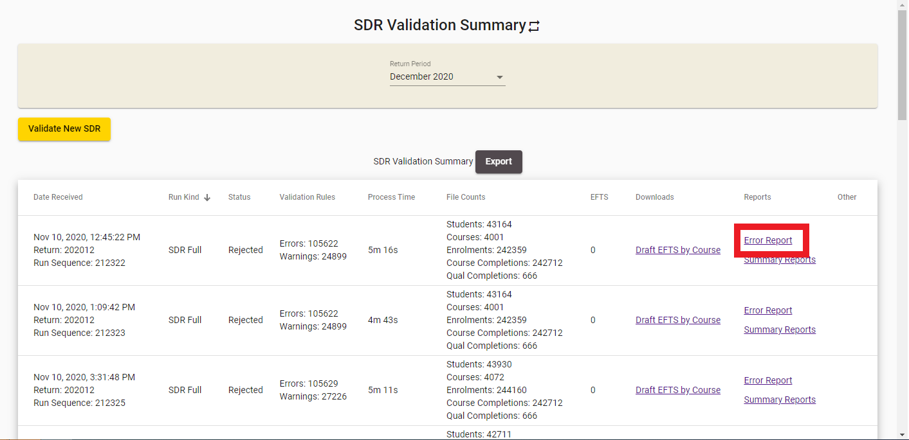
Figure 145139 – Accessing Validation Error Report
The following page will be shown to you. You will be able to see all the errors and warnings that occurred during processing and the number of times each occurred.
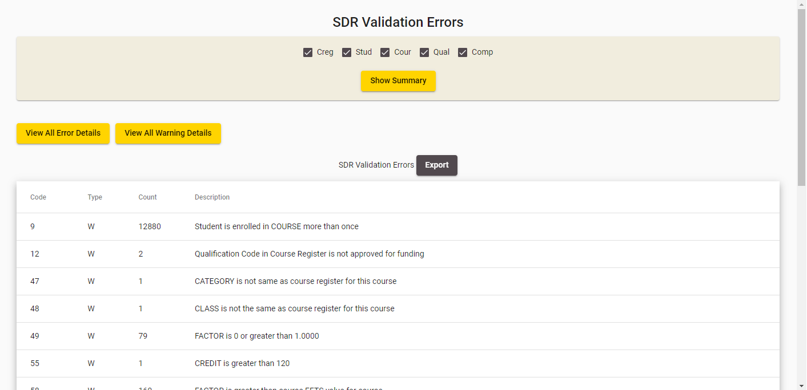
Figure 146140 – SDR Validation Errors
You can filter the error and warning list to only display from particular return files by checking the checkboxes (Creg, Stud, Cour, Grad, and Comp) and clicking 
If you click View All Errors or View All Warnings, you be shown a detailed view of all the errors or warnings that occurred during processing in the View All Errors / View All Warnings page.
To view details of a particular error, click on the row of the error to access the Validation Error Details.

View All Errors / View All Warnings
The View All Errors or View All Warnings page shows all errors or warnings that have occurred while processing the files. You can access it by clicking on View All Warning Details or View All Error Details while you are on the Validation Error Report page:
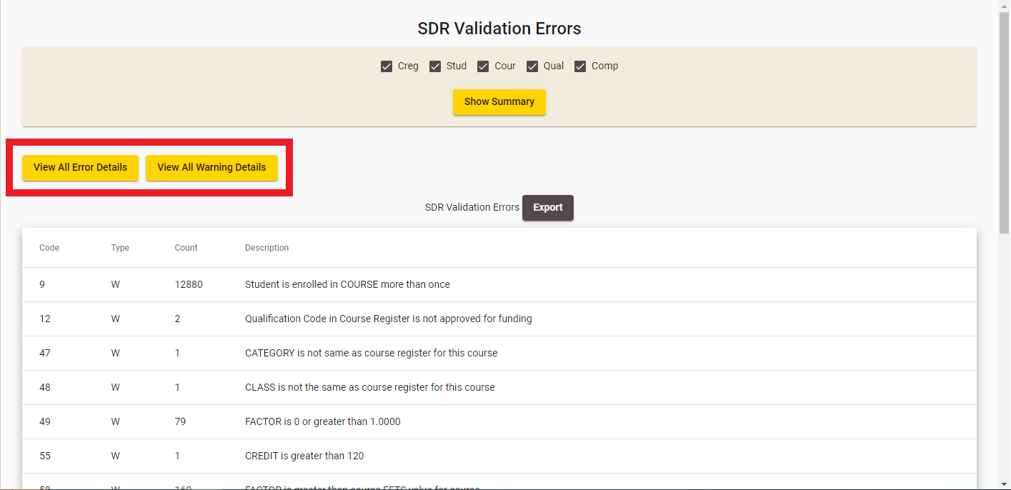
Figure 147141 – Accessing View All Errors / View All Warnings
The following page will be shown:
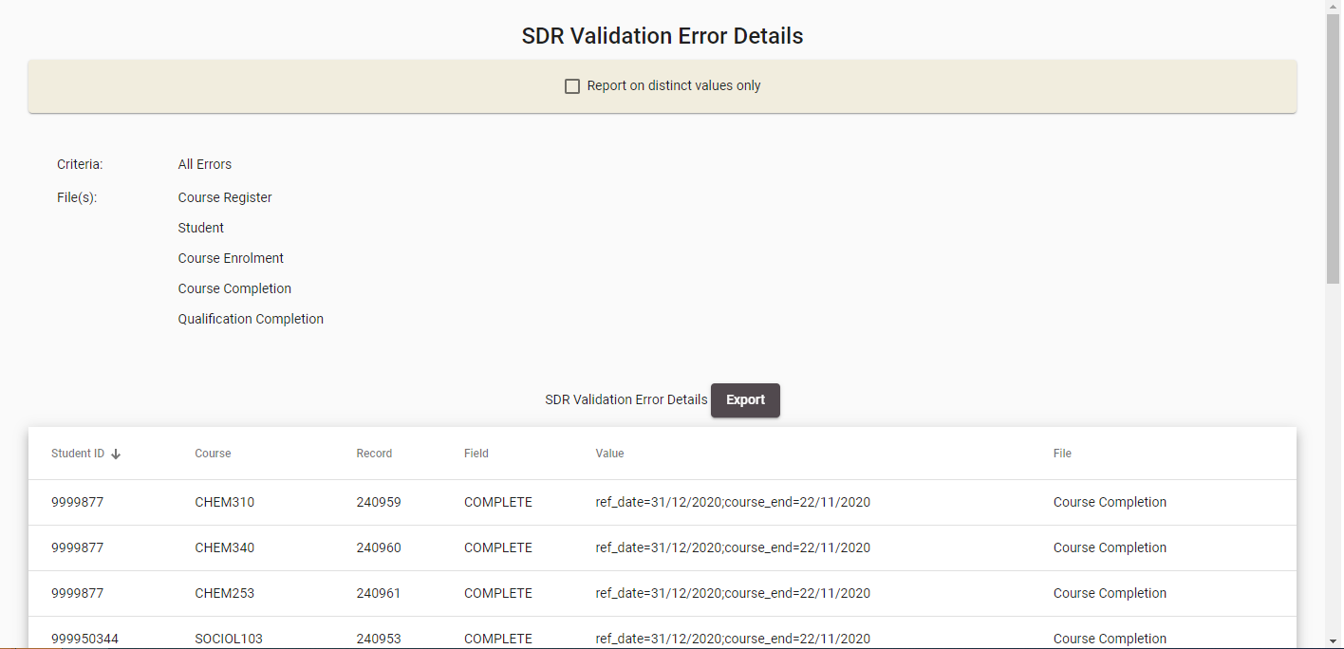
Figure 148142 – View All Errors or View All Warnings
You can sort the results by clicking on the column header titles as previously described in the Sorting Search Results section.
You may wish to show only distinct records based on the following columns: Field, Value and File. You may do so by ticking the Report on distinct values only checkbox at the top of the screen.
Some NSN Student errors will provide a link to the student’s NSN record. You can navigate to it by clicking on View NSN Record. Please note that this will open the NSI website (https://nsi.education.govt.nz) in a different window with the Single sign on from ESL if you have access to NSI page.
Clicking on  will generate a .csv file that contains all the errors or warnings.

Validation Error Details
The Validation Error Details page shows all instances of a particular error or warning that have occurred while processing SDR files.
You can access this page by clicking on the row for a given warning or error in the Validation Error Report:
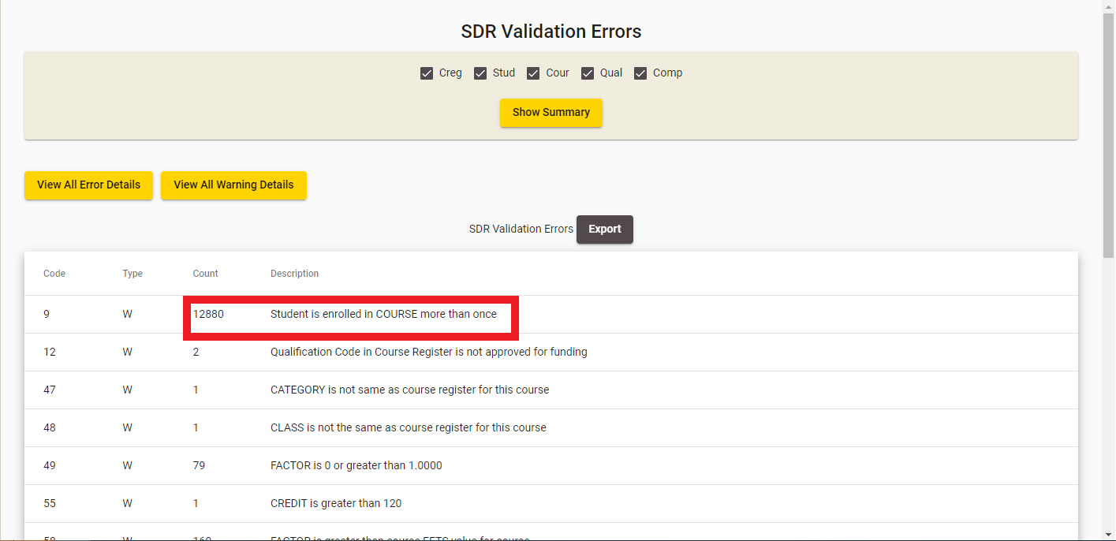
Figure 149143 – Accessing Validation Error Details

The following page will be shown:
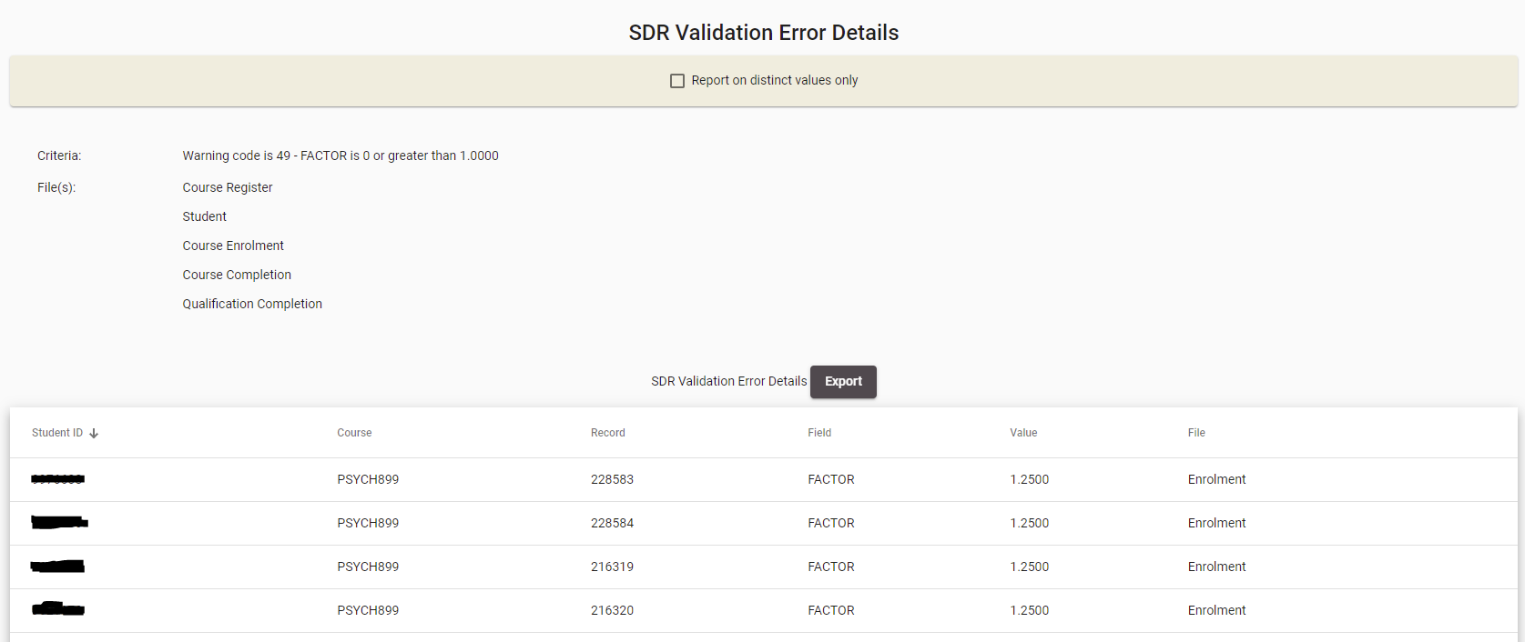
Figure 150144 – Validation Error Details
You can sort the results by clicking on the column header titles as previously described in the Sorting Search Results section.
You may wish to show only distinct records based on the following columns: Value and File. You may do so by ticking the Report on distinct values only checkbox.
Some NSN Student errors will provide a link to the student’s NSN record. You can navigate to it by clicking on View NSN Record. Please note that this will open the NSI website (https://nsi.education.govt.nz) in a new window using your Single Sign On credentials from ESL if you have access to the NSI page.
Clicking on  will generate a .csv file that contains all the errors or warnings.

EFTS Forecast Update / View
As part of the SDR submission process you need to provide EFTS forecast data for SAC 01 funding only. The information uploaded in your SDR files will produce an auto-generated forecast for the forthcoming periods, calculated for the current year and 4-out years. The current year and the first out year are broken down by month, and the other out years are in six months’ periods.
You can access the EFTS Forecast Update by clicking on the Forecast link, or the EFTS Forecast View by clicking on the View Forecast link from the SDR Validation Summary page.
Please note that the EFTS Forecast Update is only available for SDR Full returns that have been Processed with no errors. If the SDR Full return has been Submitted successfully, you will only be able to go to the EFTS Forecast View.
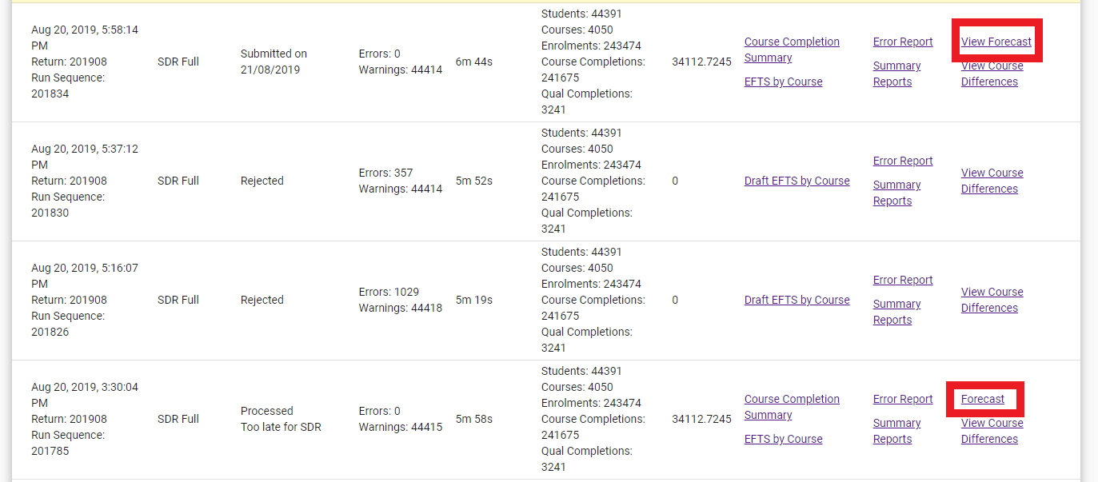
Figure 151145 – Accessing EFTS Forecast Update / View
If you click on the View Forecast link, you will only be shown read-only data of the EFTS Forecast for the return:
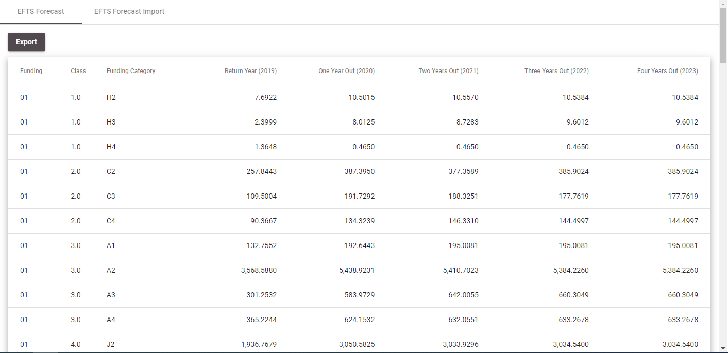
Figure 152146 – EFTS Forecast View
Note: Any enrolment with Source of Funding different from 01, 29 or 34 will be counted towards Funding Category Z (regardless of which Funding Category was used in the enrolment). Where Source of Funding is 01, 29 or 34 the actual funding category submitted with the enrolment is used and the Course Classification/Funding Category EFTS breakdown is displayed.
You can click on the  button to export the EFTS Forecast data as a .csv file.
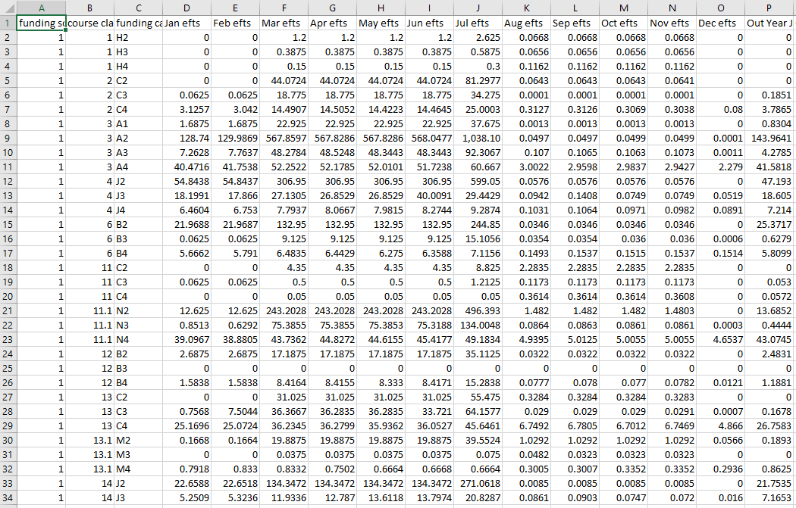
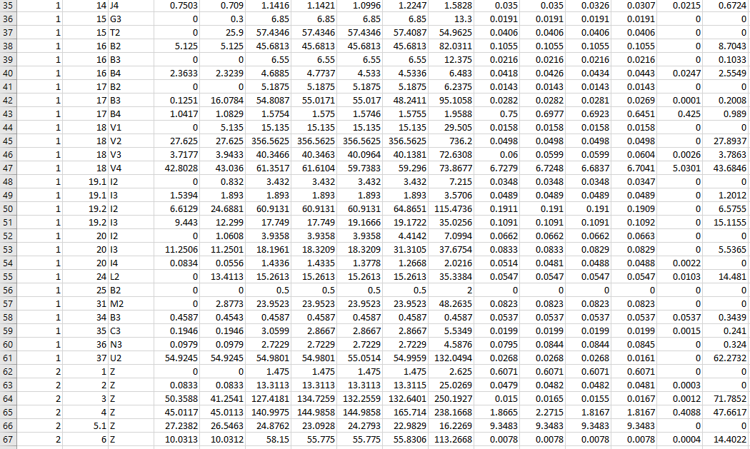
Figure 153147 – EFTS Forecast Data Export

If you click on the Forecast link, you will be shown data of the EFTS Forecast for the return which you can update:
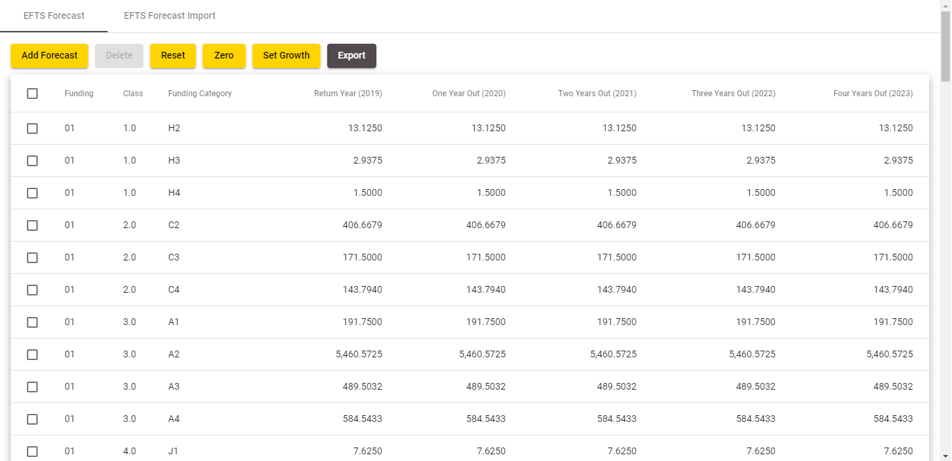
Figure 154148 – EFTS Forecast Update

You can click on the  button to export the EFTS Forecast data as a .csv file. It will produce a .csv that looks like the one referenced in Error! Reference source not found..
You can select a .csv forecast file to import by clicking 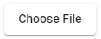in the EFTS Forecast Import tab to add new forecast entries or update the existing values for the Funding Category and Course Class combination as mentioned in
EFTS Forecast Import.
Clicking on an EFTS Forecast row will take you to the Edit EFTS Forecast Entry page.
Clicking on  will return all EFTS forecast entries to their initial values. All deleted forecast entries will be restored, and all newly added forecast entries will be removed.
Clicking on 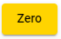 will set the values on the One Year Out, Two Years Out, Three Years Out, and Four Years Out fields for all EFTS forecast entries to 0.0000. In addition, this will also set the EFTS Forecast entries for the current year to 0.0000 for forecasted months (ignoring months with actual EFTS data). Refer to Zero EFTS Forecast for more information.
Clicking on  will take you to the
Set Forecast Growth page.
Clicking on  will take you to the Add EFTS Forecast Entry page.
If you select one or more EFTS Forecast rows using the checkboxes and click, you will delete the selected EFTS Forecast entries.

Add EFTS Forecast Entry
The Add EFTS Forecast Entry page allows you to add a new EFTS Forecast entry to the EFTS Forecast of a return.
You can access this page by clicking on from the EFTS Forecast Update / View page when you are in the Update mode.
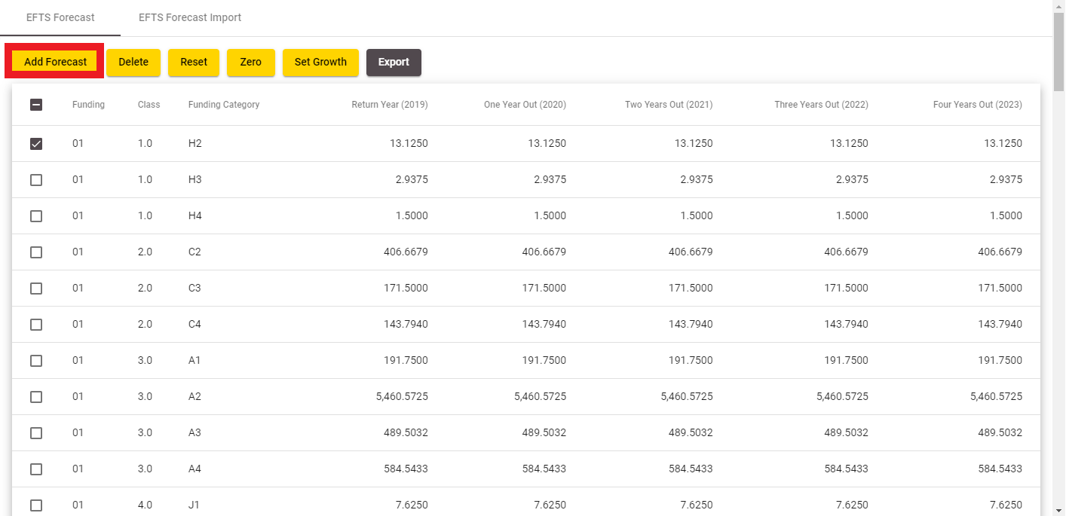
Figure 155149 – Accessing Add EFTS Forecast
The following page will be shown:
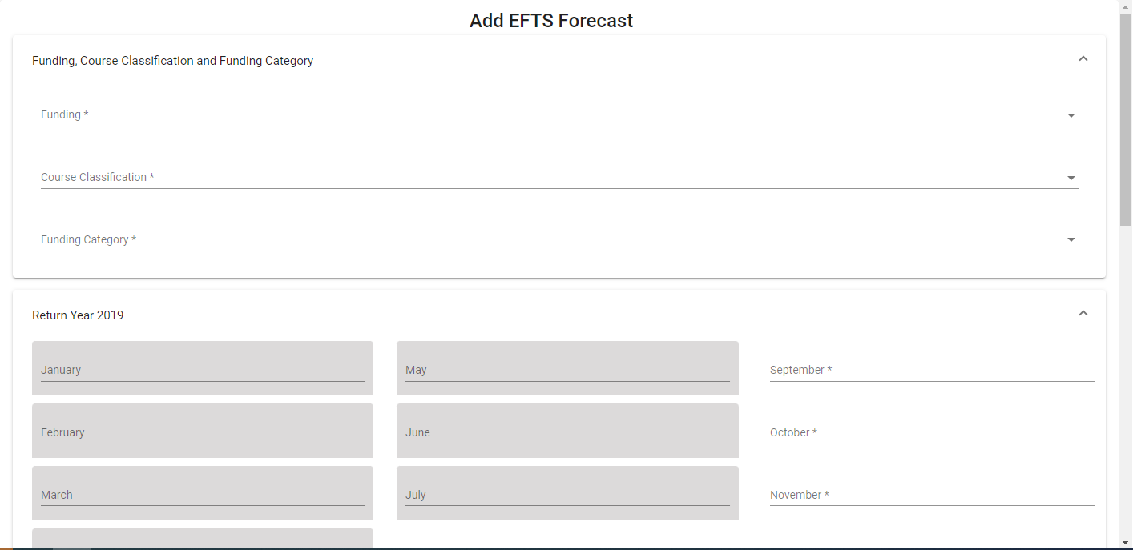
Figure 156150 – Add EFTS Forecast
The Funding dropdown allows you to select one of Source of Funding (currently 01, 29 or 34 only) for which the Forecast entry can be created on the page.
The Course Classification and Funding Category fields allow you to look up existing entries by clicking on the button. This is described in further detail in the Lookup Windows section.
Depending on SDR Round (April, August or December) the EFTS Forecast is associated with, some months’ fields for the current return year will not be editable as they represent the actual figures that you are not allowed to update. For example, if the SDR Forecast is related to the August return, then all months prior to August for the return year are greyed out as not editable (as per Error! Reference source not found.).
Clicking on when you are on the Add EFTS Forecast Entry page will return you to the EFTS Forecast Update / View page.
Clicking on  will save all your changes on the Add EFTS Forecast Entry page. If there are no errors, you will be shown a confirmation message:
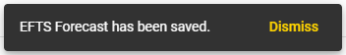
Figure 157151 – Add EFTS Forecast Save Confirmation Message

Edit EFTS Forecast Entry
You can access the EFTS Forecast Entry page by clicking on an EFTS Forecast row in the EFTS Forecast Update / View page:
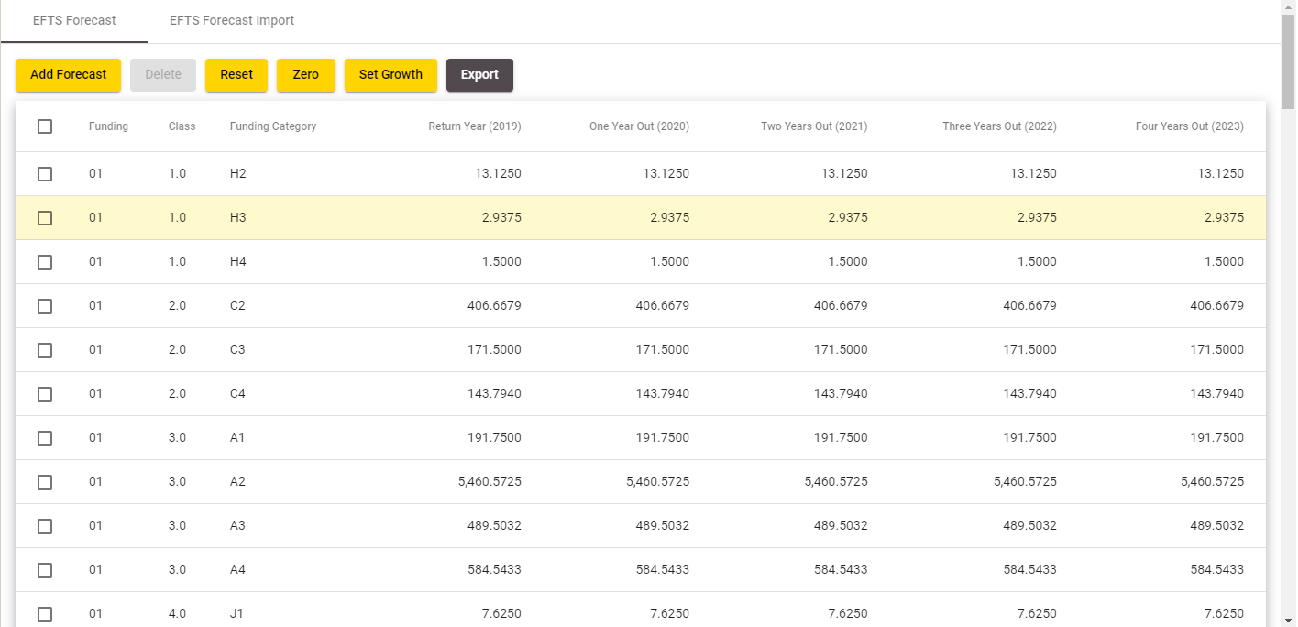
Figure 158152 – Accessing Edit EFTS Forecast

The Edit EFTS Forecast page will be displayed to you as below:
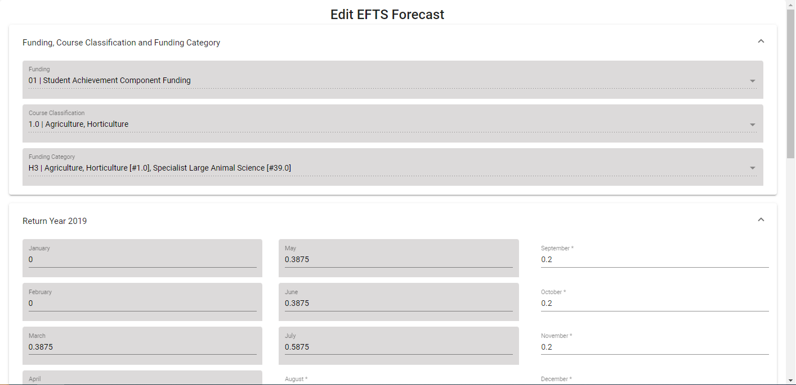
Figure 159153 – Edit EFTS Forecast
You will be unable to change the Funding, Course Classification and Funding Category fields.
Depending on the SDR Round (April, August or December) the EFTS Forecast is associated with, some months’ fields for the current return year will not be editable as they represent the actual figures that you are not allowed to update. For example, if an SDR Forecast is related to the December return, then all months for return year are greyed out as not editable.
Clicking on when you are on the Edit EFTS Forecast Entry page will return you to the EFTS Forecast Update / View page.
Clicking on will save all your changes on the Edit EFTS Forecast Entry page. If there are no errors, you will be shown a confirmation message:
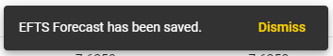
Figure 160154 – Edit EFTS Forecast Save Confirmation Message

Set Forecast Growth
This page allows you to set the forecast growth using either percentage values or EFTS values.
You can access this page by clicking on  in the EFTS Forecast Update / View page:
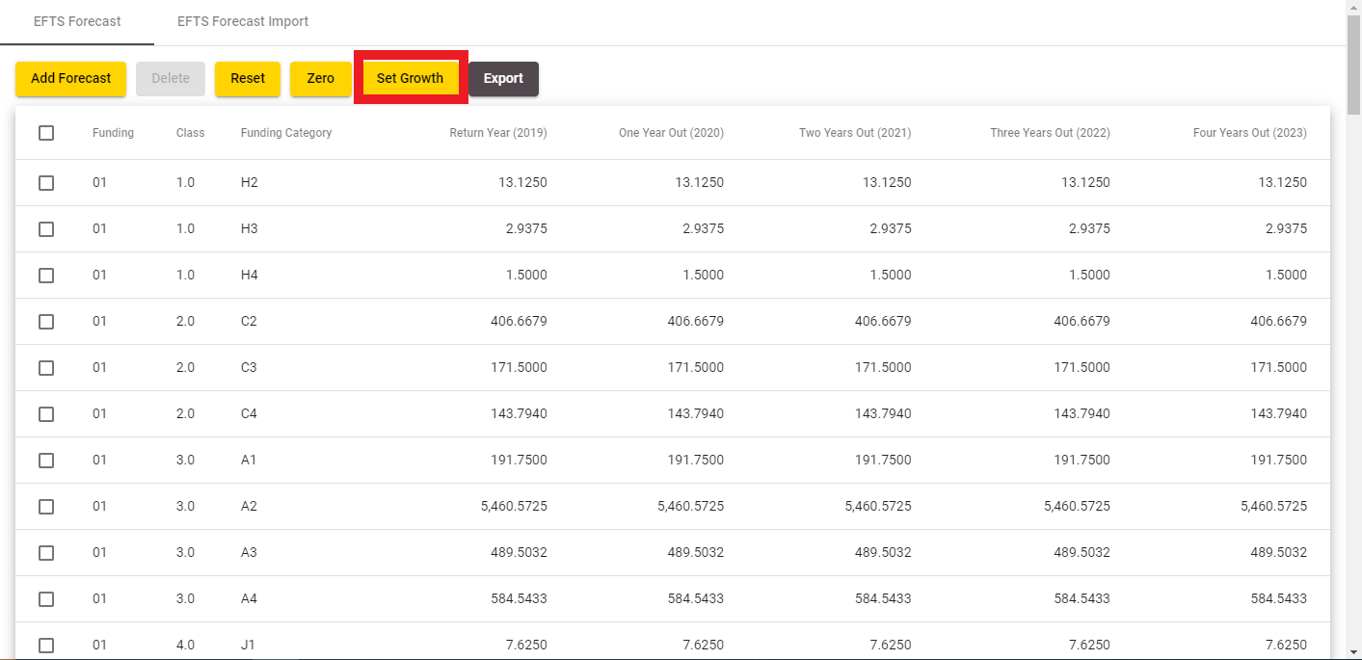
Figure 161155 – Accessing Set Forecast Growth
The following page will be shown when you access the Set Forecast Growth page. Please note that the  button is disabled until you enter inputs.
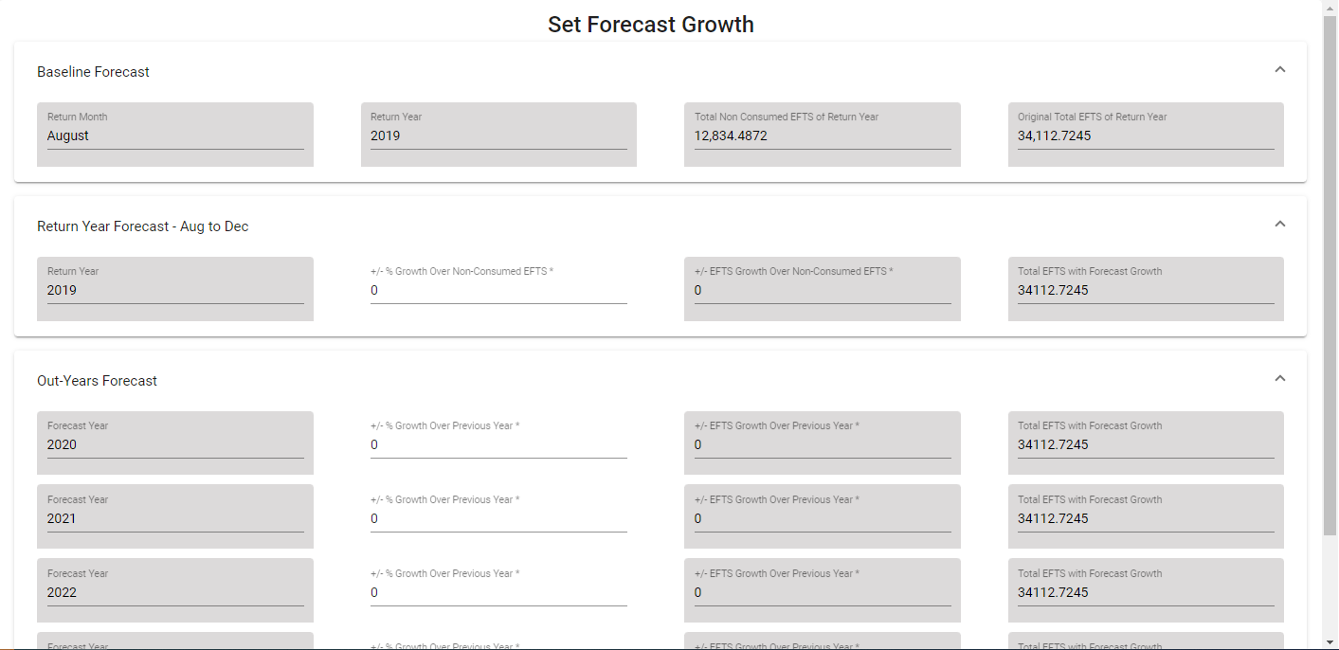
Figure 162156 – Set Forecast Growth
Clicking on will return you to the EFTS Forecast Update / View page.
Clicking on  will return all forecast growth entries to their initial values. The button will be disabled.
Clicking on  will toggle between using EFTS or a percentage value for calculating EFTS growth. The relevant columns (‘+/- % Growth’ or ‘+/- EFTS Growth’) will become editable as you click on the button.
The new forecasted values will be calculated as you enter inputs. The button is disabled until you enter inputs.
Clicking on will save all your changes. If there are no errors, you will be shown a confirmation message:
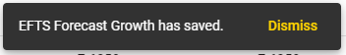
Figure 163157 – Set Forecast Growth Save Confirmation Message

EFTS Forecast Import
You can select a .csv forecast file to import by clicking in the EFTS Forecast Import tab to add new forecast entries or update the existing values for the Funding Category and Course Classification combination. Clicking the “Import” button will initiate the import process, as shown in the following figure:
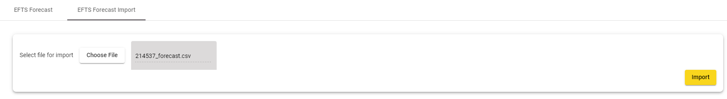
Figure 164158 – Importing EFTS Forecast
Please note that you will have to upload a .csv file that is less than 20 megabytes (MB). Further details can be found in Maximum File Size when Uploading.
The uploaded file is subject to the following requirements. Failing any of these requirements will cause the forecast import process to fail, with no new forecast rows being added:
- The file must have the header lines for each column (see Error! Reference source not found.)
- There must be at least one forecast record in the file
- There must be 33 values in each line. These are:
  - Source of Funding
  - Course Classification
  - Funding Category
  - 12 EFTS Values (One for each month)
  - 12 Out Year EFTS Values (One for each month)
  - 2 Half Out 2-Year EFTS Values
  - 2 Half Out 3-Year EFTS Values
  - 2 Half Out 4-Year EFTS Values
- The Source of Funding values are mandatory and valid
- The Course Classification values are mandatory, and valid
- The Funding Category values are mandatory, valid, and have length of 2 characters or less
- EFTS forecast value must be positive and numeric
- The Course Classification and Funding Category combination must be valid for the given year
- There must be no duplicate combinations of Course Classification and Funding Category
- Funding Category should be Z if Source of Funding is not 01, 29 or 34
If any of these validations are not passed, processing will not occur, and no new forecast rows are added. You will see an error message as shown in Error! Reference source not found. and Error! Reference source not found.. Some error messages will contain the erroneous line numbers as shown in Error! Reference source not found..
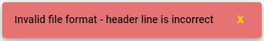
Figure 165159 – EFTS Forecast Upload Error Message

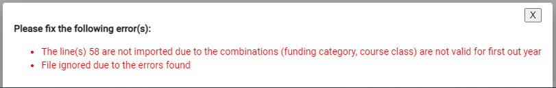
Figure 166160 – EFTS Forecast Upload Error Message with Line Numbers

Zero EFTS Forecast
Clicking on  from the EFTS Forecast Update / View page in Update mode will set the values on the One Year Out, Two Years Out, Three Years Out, and Four Years Out fields for all EFTS forecast entries to 0.0000.
In addition, this will also set the EFTS Forecast entries for the current year to 0.0000 for forecasted months (ignoring months with actual EFTS data as described in Edit EFTS Forecast Entry). As such, it is possible that the EFTS figure for the Return Year will not be set to 0.0000.
This will change the values of the data as shown in Error! Reference source not found. to that as shown in Error! Reference source not found.:
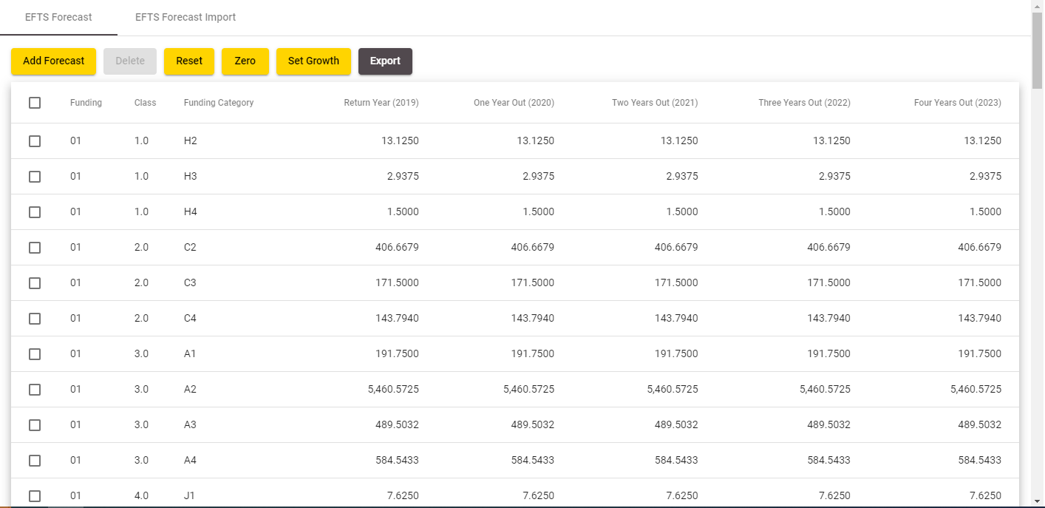
Figure 167161 – EFTS Forecast (Original)

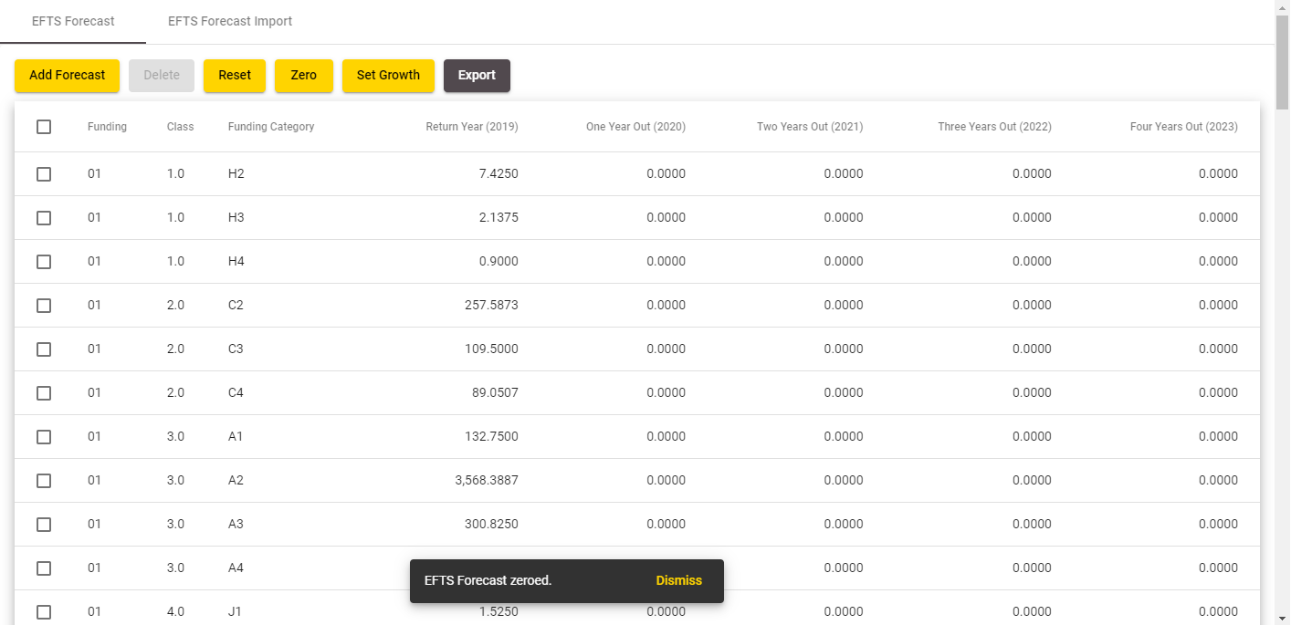
Figure 168162 – EFTS Forecast (After Zero)
Please note that the EFTS forecast values for individual months will also be set to 0. The months that will be set to 0 will be the months that are editable as described in Edit EFTS Forecast Entry as shown in Error! Reference source not found. and Error! Reference source not found.:
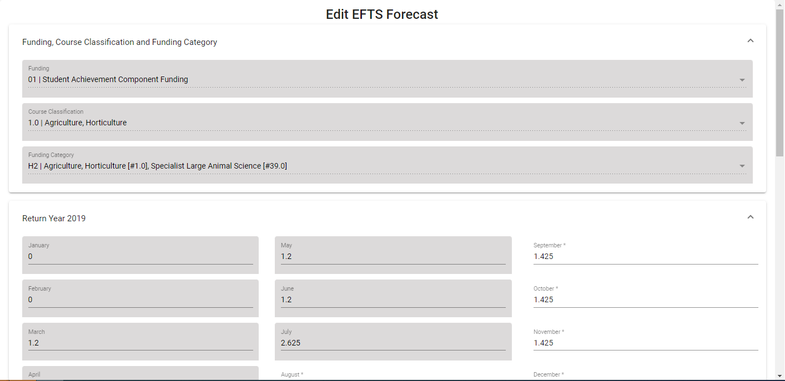
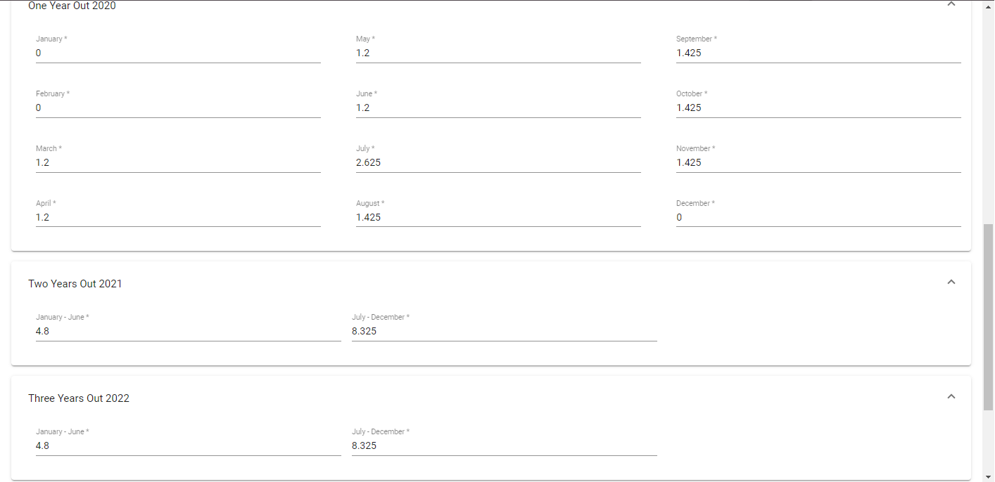
Figure 169163 – EFTS Forecast (Original)
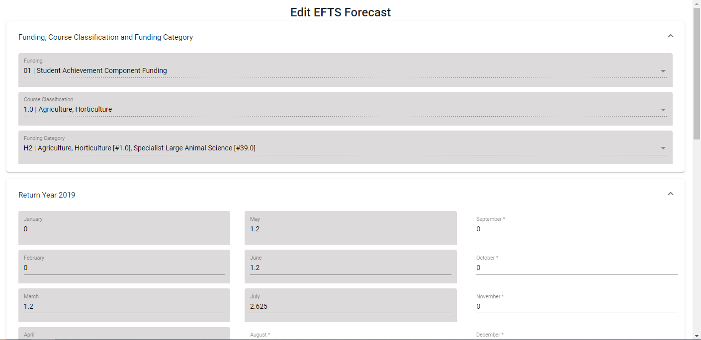
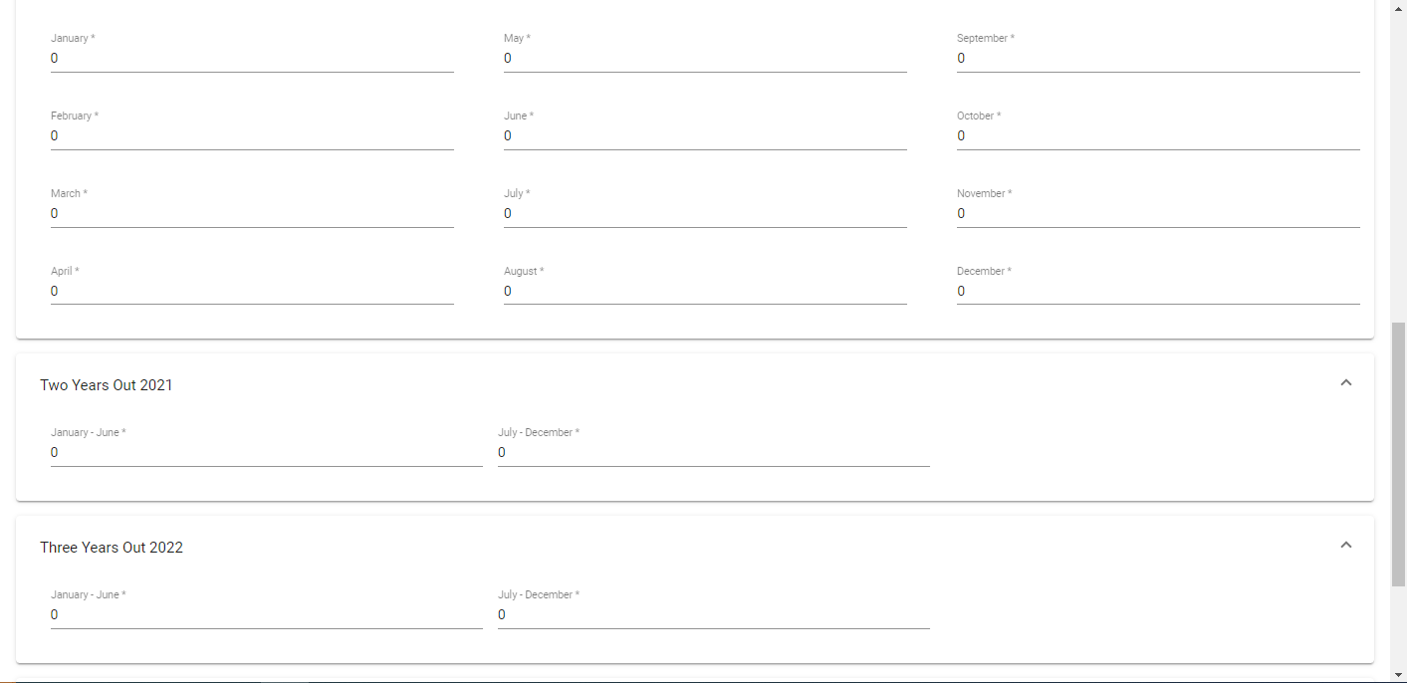
Figure 170164 – EFTS Forecast (After Zero)

Course Difference Submit / View
When you process your files, in some instances it is permitted for some differences to exist between the values you have submitted in your Course Register (CREG) file and what has been already approved and held in the TEC Course Register. When this happens it will generate ‘course differences’ that can be seen in the course differences screen. Note that you will only see the course differences link when you have processed an error free SDR Full or a Course Register file.
You can access the Course Difference Submit or Course Difference View page by clicking on the Submit Course Differences or View Course Differences links from the SDR Validation Summary page.
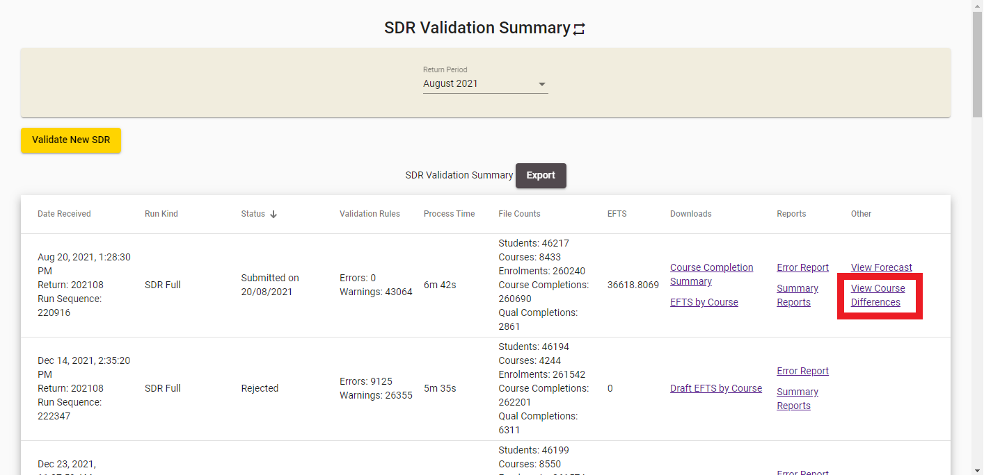
Figure 171165 – Accessing Course Difference View

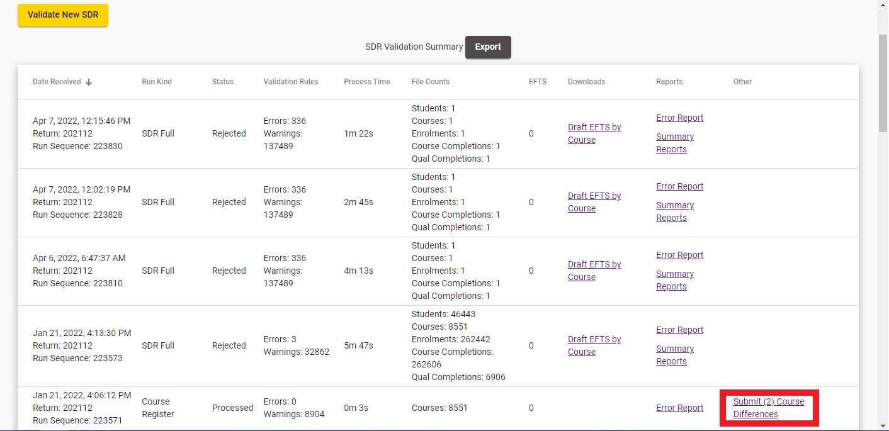
Figure 172166 – Accessing Course Difference Submit

If you access the Course Difference View page, you will see the following page:
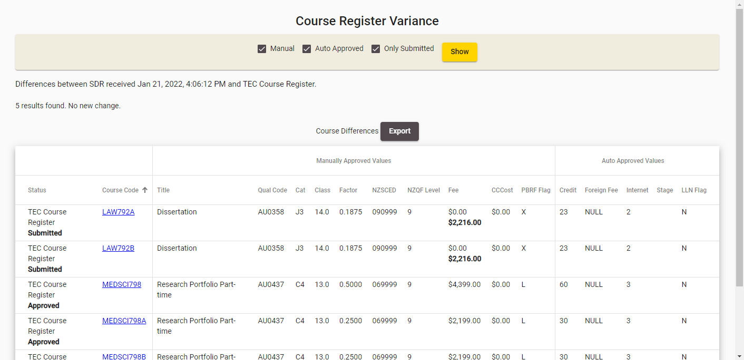
Figure 173167 – Course Difference View
You will be shown 20 course differences per page. The values that are displayed in bold are the values that have been changed.
Clicking on the Course Code will take you to the View Course page.
You can filter to selectively show Manual, Auto-Approved and Only Submitted course changes by using the checkboxes and clicking 
You can also export the course differences by clicking . This will generate a .csv file that contains the course differences as shown below:
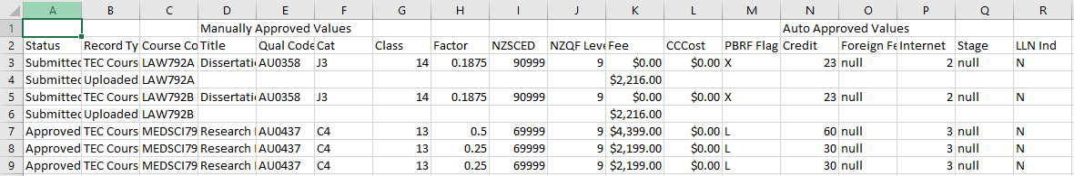
Figure 174168 – Course Difference Export

If you access the Course Difference Submit page, you will see the following page:
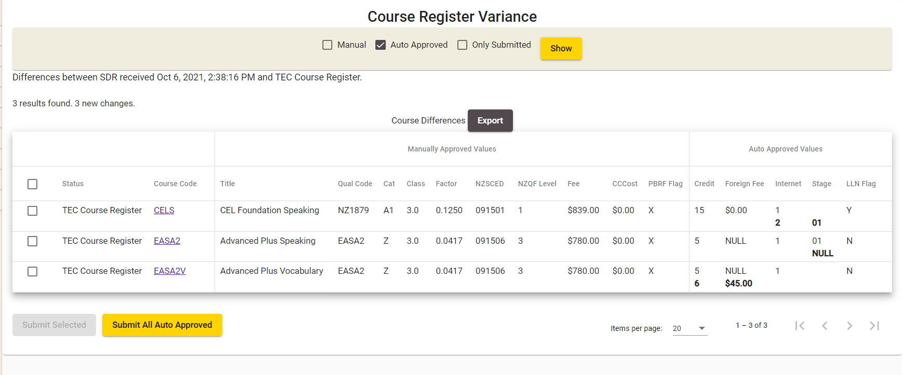
Figure 175169 – Course Difference Submit
You will be shown 20 course differences per page. The values that are displayed in bold are the values that have been changed. For a new course (that is processed by CREG file) the TEC Course Register values will be displayed blank.
Clicking on the Course Code will take you to the View Course page.
You can filter to selectively show Manual, Auto-Approved and Only Submitted course changes by using the checkboxes and clicking .
You can export the course differences by clicking . This will generate a .csv file that contains the course differences.
Clicking on the Submit Selected button will submit all the selected course differences as course change requests. You will be able to view these Course Change Requests in the Course Change Requests section.
Note: If the changes are available for Auto Approved values, upon clicking the Submit Selected button, those changes will be auto approved to the Course Register and no pending Course Change Requests will be created. The changes to Manually Approved values will go through the normal pending course change request process discussed in Course Change Requests.
All pending course change requests should be resolved (either approved or rejected for a change by Advisors) before you can proceed with SDR Submission.

Downloads
You can access up to two downloadable files in the Downloads column for every submitted return.
The files you can download are:
- Course Completion Summary
- EFTS by Course
Both files are generated as CSV files and can be viewed as a spreadsheet via MS Excel.

Course Completion Summary
You can access the Course Completion Summary by clicking on the Course Completion Summary link for the particular file return.
Please note that the Course Completion Summary is not available if the return has a status of Rejected.
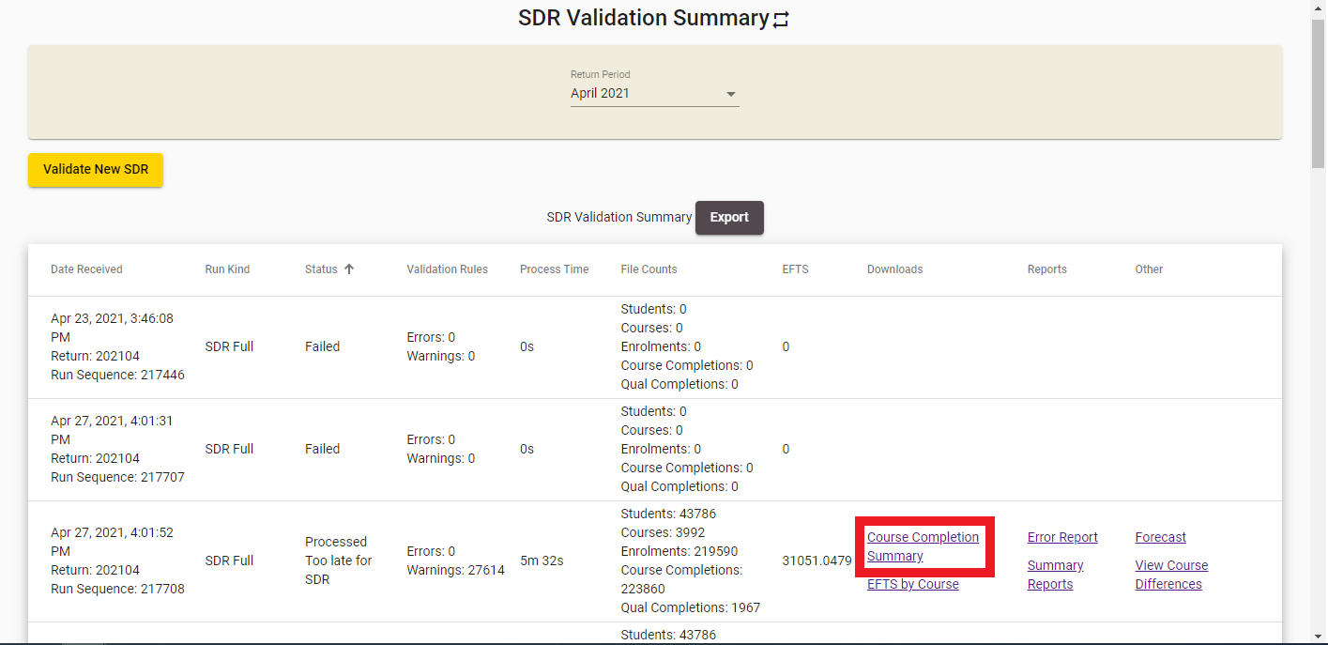
Figure 176170 – Accessing Course Completion Summary
You will be prompted to download and open or save the course completion summary spreadsheet. It will be formatted as shown below:
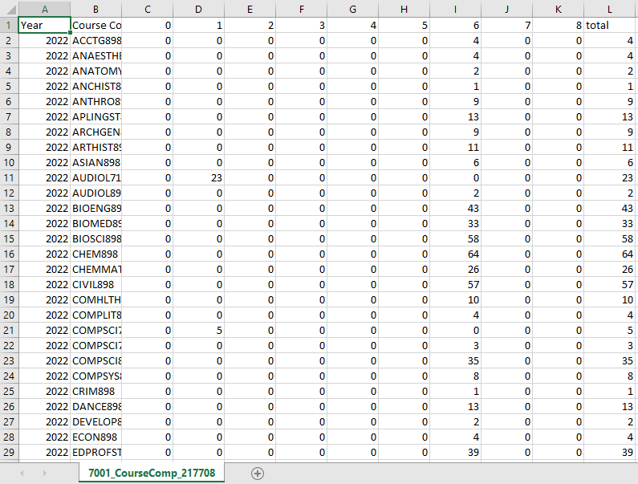
Course Completion Summary

EFTS by Course
You can access the EFTS by Course file by clicking on the EFTS by Course link for the particular file return.
Please note that the file will be called Draft EFTS by Course if the return has a status of Rejected.
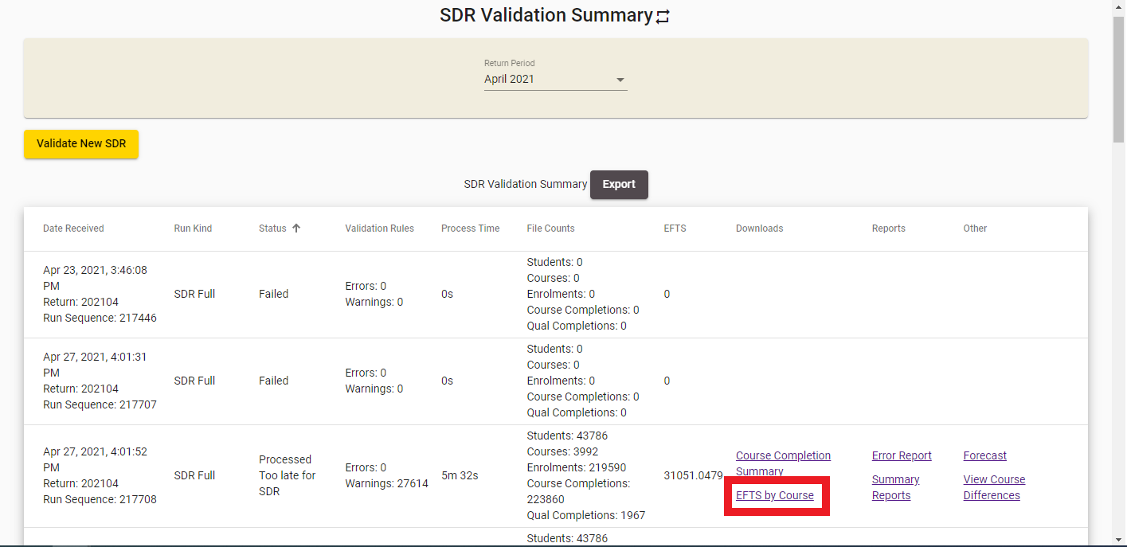
Figure 177171 – Accessing EFTS by Course

You will be prompted to download and open or save the EFTS by Course spreadsheet. It will be formatted as shown below:
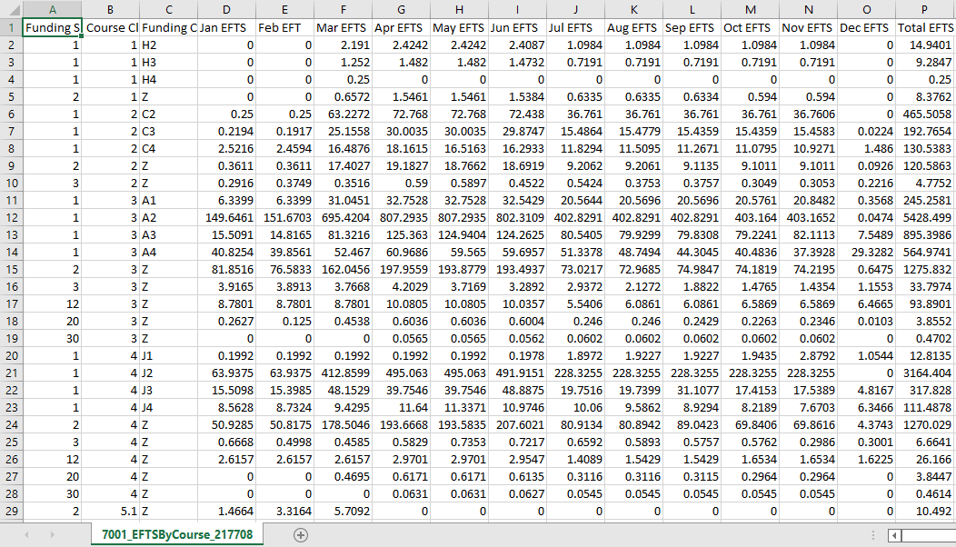
Figure 178172 – EFTS by Course

SDR Submission
The last step in the SDR processing is SDR Submission. You will need to submit your SDR data validated successfully by clicking the Submit button in the SDR Validation Summary page.
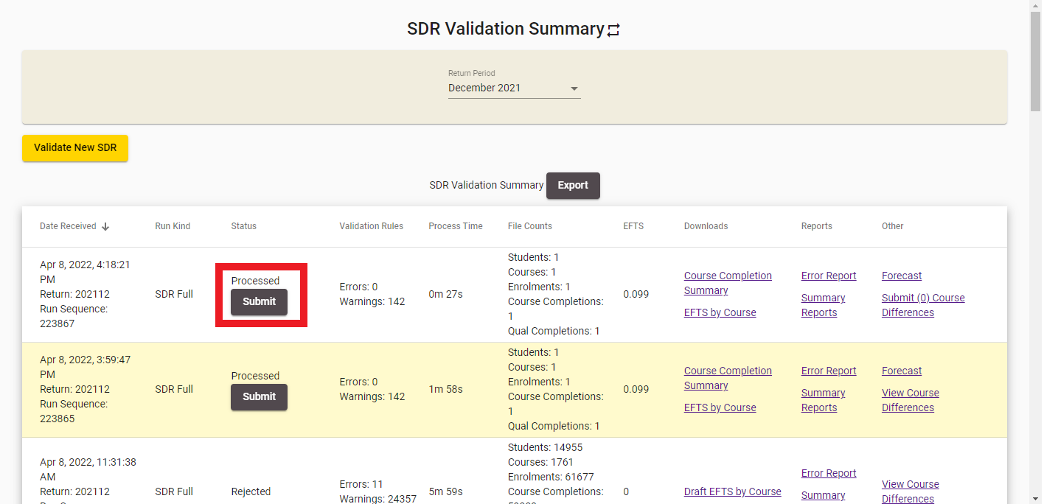
Figure 179173 – Submitting SDR Full
If you’ve arranged for an extension within the current SDR window, you will see the details of the extension as shown below:
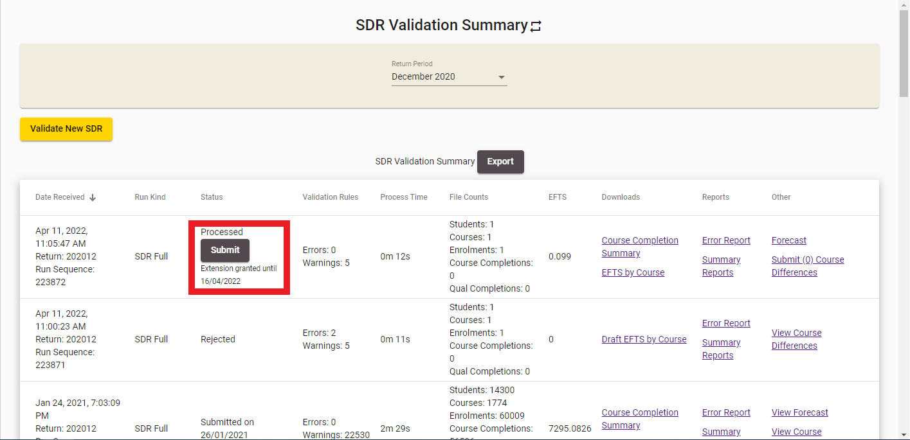
Figure 180174 – Submitting SDR Full with Extension
If the extension period has lapsed, you will be unable to submit the SDR and will require another extension to be granted.
On clicking the Submit button, the following prompt will be shown for you to confirm submission:
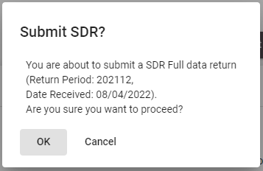
Figure 181175 – SDR Submission Confirmation Prompt
Clicking  will proceed with the submission process.
Clicking  will cancel the submission process and return you to the SDR Validation Summary page.
The STEO site will perform some pre-submission validations before proceeding with the submission process. These are:
- Forecast Validation
- Check if Course Differences Exist
- Check if Course Pending Change Requests Exist
- Check if Workforce Questionnaire Submitted
If any of these pre-submission validations are not passed, the submission process will be stopped. You will be able to address these issues and try again.
Otherwise, if all pre-submission validations are passed, the submission process will proceed, as shown below:
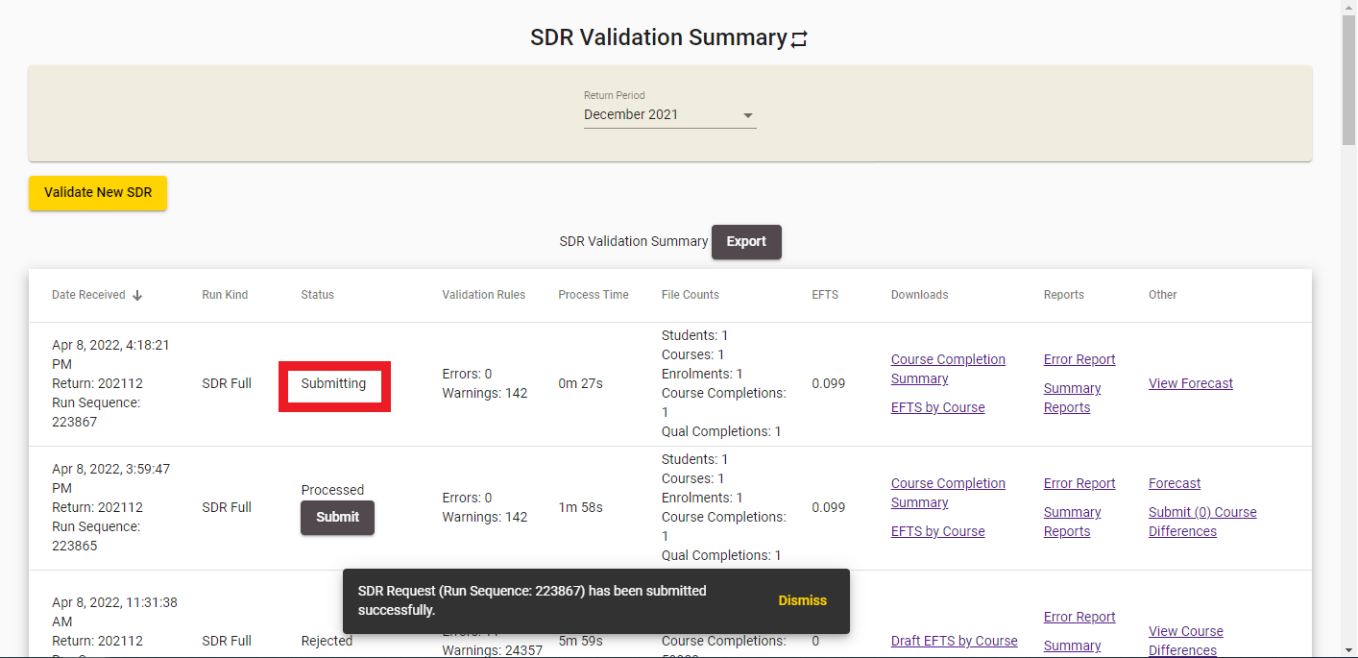
Figure 182176 – SDR Full Submission
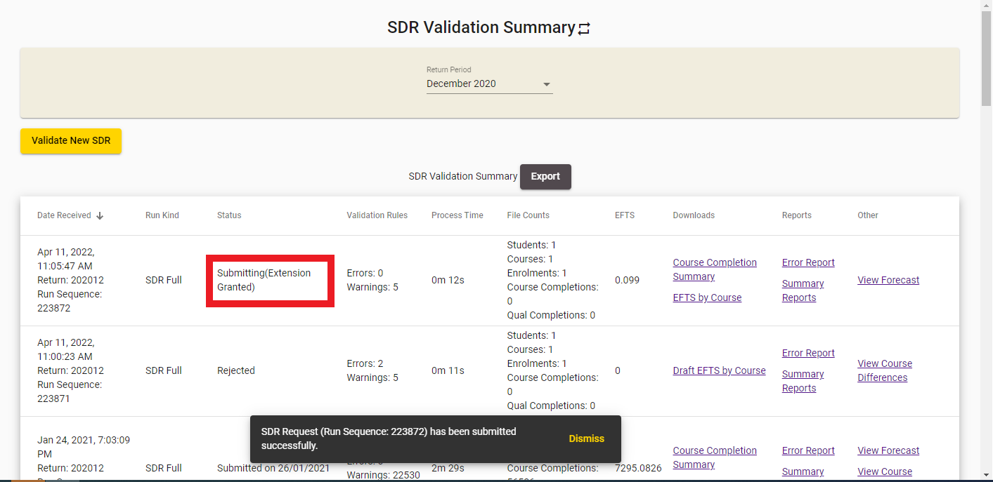
Figure 183177 – SDR Full Submission with Extension Granted
If the submission process has completed successfully, the Status will be updated to say Submitted, as shown below:
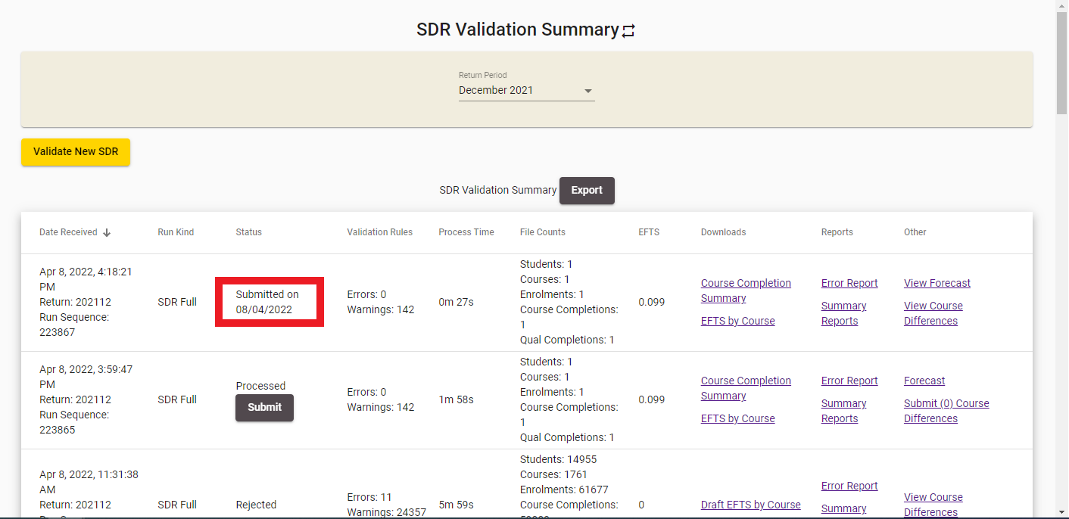
Figure 184178 – SDR Full Submitted

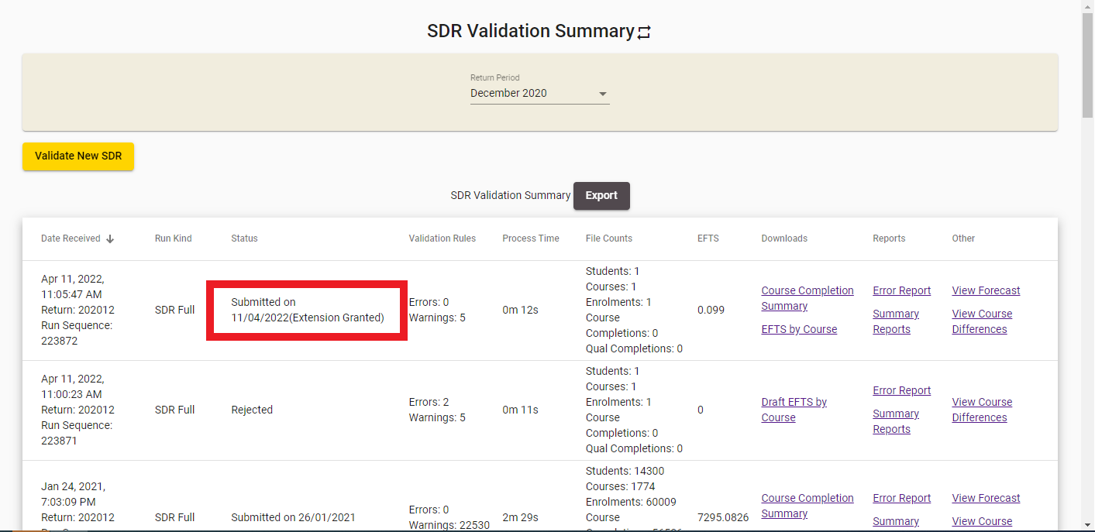
Figure 185179 – SDR Full Submitted with Extension Granted
Sometimes the SDR process will pass the pre-submission validations but may rarely encounter some other issues. In this scenario, SDR submission will fail and the Status field will read Failed, as shown in Error! Reference source not found. below.
Please contact the Customer Contact Group for assistance with investigating and resolving this issue.
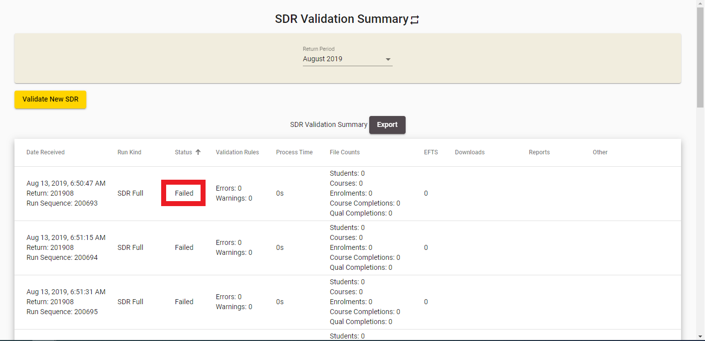
Figure 186180 – SDR Full Submission Failed

Forecast Validation
The forecast validation checks that funding category and course classification combinations in Forecast data for a given SDR (created during SDR Validation) are valid for the Year of SDR return and the following year.
If this validation does not pass, you will see the following error message with the invalid Funding Category/Course Class combinations listed:
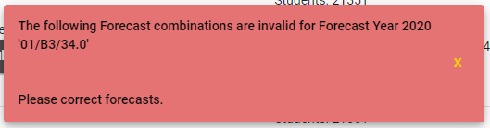
Figure 187181 – Forecast Validation Failed Error Message
Clicking on  will take you back to the SDR Validation Summary page.

Check if Course Differences Exist
The course difference checks validate that there are no differences between the submitted course register (CREG) file and the existing Course Register. This check does not apply if you are only submitting a single Qualification Completion or a single Course Completion file.
If this validation does not pass, you will see the following error message:
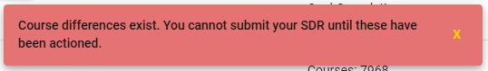
Figure 188182 – Course Difference Check Failed Error Message

Check if Course Pending Change Requests Exist
The Course Pending Change Request Check validates that there are no current pending course change requests for your organisation. This check does not apply if you are only submitting a single Qualification Completion or a single Course Completion file.
If this validation does not pass because there are pending change requests that would result (or have resulted) from the processing of your SDR files or from using the Edit Course functionality, you will see the following error message:
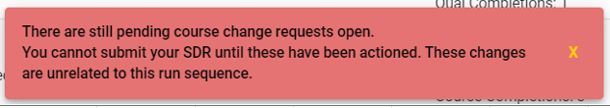
Figure 189183 – Course Pending Change Request Check Failed from Edit Courses

Check if Workforce Questionnaire Submitted
The Workforce Questionnaire check ensures that you have submitted a Workforce Questionnaire (WFQ) for the current year prior to submitting the SDR return. Currently December SDR is the set SDR Round for checking that a WFQ has been submitted. This check does not apply if you are only submitting a single Qualification Completion or a single Course Completion file.
You can find out more about WFQs in the Workforce Questionnaires (WFQ) section.
If a WFQ has not been submitted for the year you are trying to perform the SDR Submission, you will see the following error message:
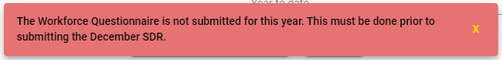
Figure 190184 – Workforce Questionnaire Check Failed

Indicative (SDR) Data Collection
The Indicative (SDR) Data Collection (IND) is a set of three SDR data files that are specifically required by the Ministry of Education to give early indicators of demand shifts and trends that may impact vote management and affect future policy developments. This indicative SDR is low compliance as it has fewer validations than a full (five file) SDR.
The purpose of the IND is to provide early information on tertiary demand to inform policy development or changes, and allow responsiveness to sudden changes in economic conditions. The collection shows trends over time – establishing statistical models that facilitate prediction of full-year outcomes
The latest copy of the IND User Guide can be found here at https://applications.education.govt.nz/services-tertiary-education-organisations-steo/how-use-steo/indicative-data-collection-user-guide.
The IND Data Collection tab allows you to access the following pages and functionalities:
- IND Validation Summary
- Validate New IND
- Validation Error Report
You can navigate to this section by clicking on Indicative Validation under SDR in the main menu.
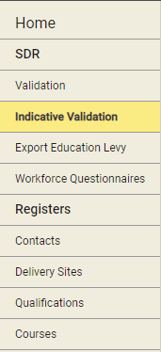
Figure 191185 – Accessing Indicative Validation

IND Validation Summary
The IND Validation Summary is the default page when you navigate to the IND Data Collection tab.
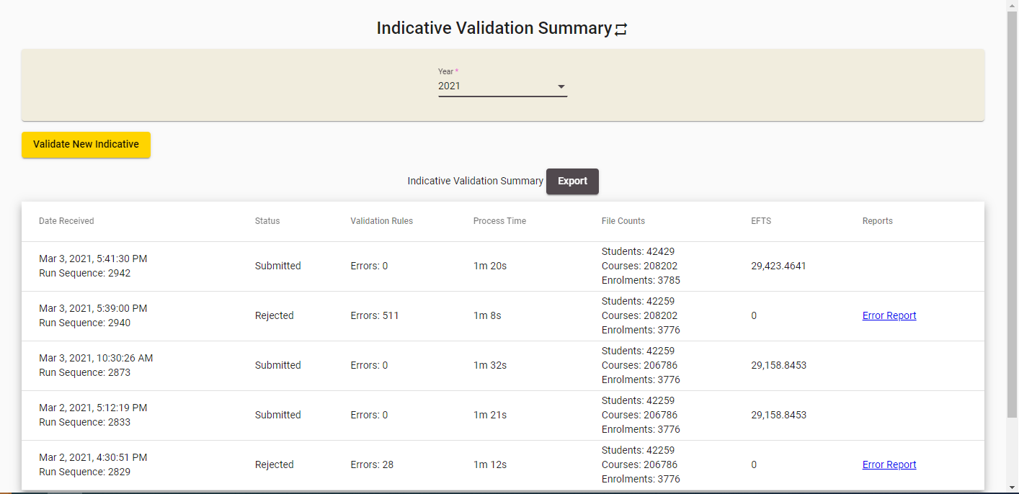
Figure 192186 – IND Validation Summary
You can sort the results by clicking on the column header titles as previously described in the Sorting Search Results section. The Year is defaulted to the current calendar year.
You can view IND submissions from other years by selecting a different year from the Year dropdown.

Validate New IND
You can access the Validate New IND page by clicking on the Validate New Indicative button, as shown below:
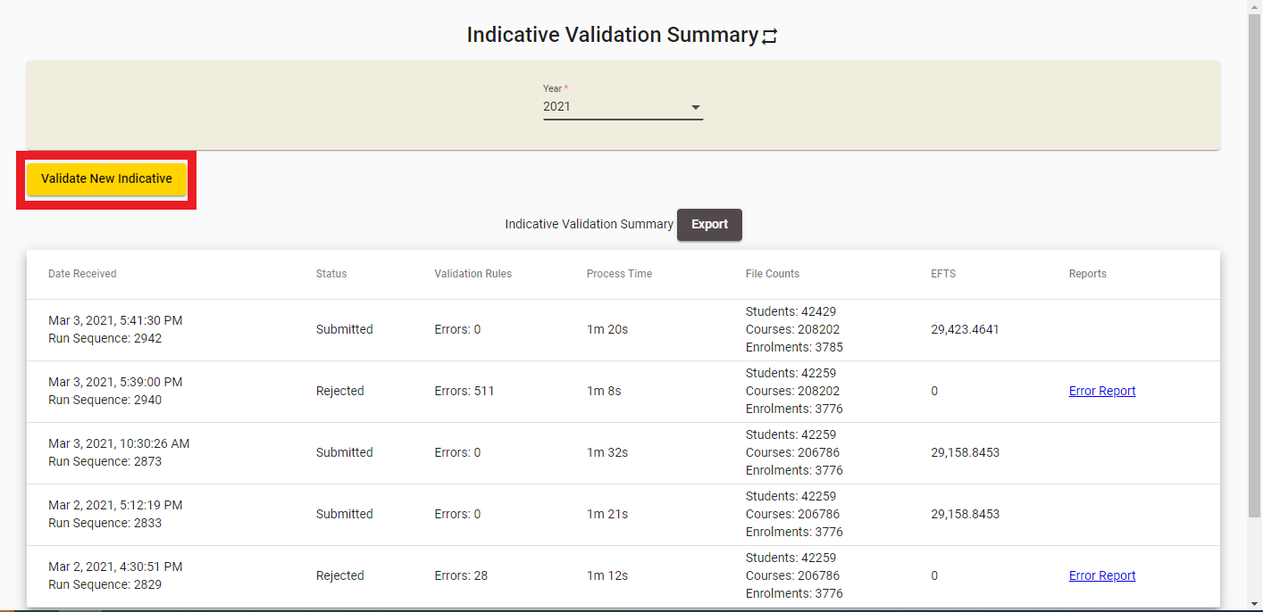
Figure 193187 – Accessing Validate New IND
The IND Validation process is a multi-step process, with the following steps:
- Select Return Year, Upload IND ZIP file and Notification Contacts
- Error! Reference source not found.
- Error! Reference source not found.

Select Return Year, Upload IND ZIP file and Notification Contacts
The IND Validation steps are shown below:

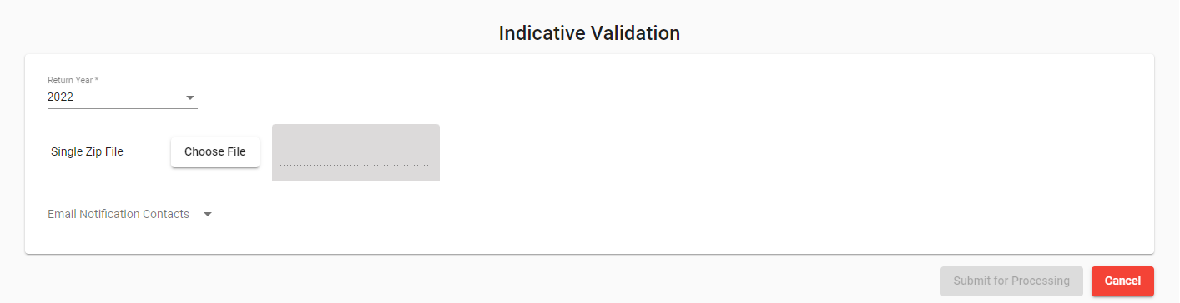
Figure 194188 – Step 1 of IND Validation
The Return Year will default to the current year.
Click Browse and select the relevant .zip file to upload. The student file, enrolment file and course register file are expected to be uploaded in a single .zip file. Please ensure that the files in the .zip file are named correctly, e.g. for the provider code 1111 the following files are expected:
- INDSTUD1111.txt
- INDCOUR1111.txt
- INDCREG1111.txt
Please note that if the compressed zip file is larger than 20 megabytes (MB), you will not be able to process the IND Data collection. Further details can be found in Maximum File Size when Uploading.
You may optionally select one or more contacts to specify who receives email notifications about the processing progress. The contacts are populated from the list of contacts in your organisation in the
Contacts who are not EDUMIS contacts.
Figure 195189 – Data Return Contacts

Clicking on  will add the uploaded IND data files to the queue for processing. See IND Submission and Results for more information.
Clicking on will take you to the default page as per Figure 192.

IND Submission and Results
After you click in the final step of the IND Validation process (Error! Reference source not found.), the uploaded files will be added to the queue for processing.
Once the IND Processing has begun, the status will switch to “In Progress” as shown below:

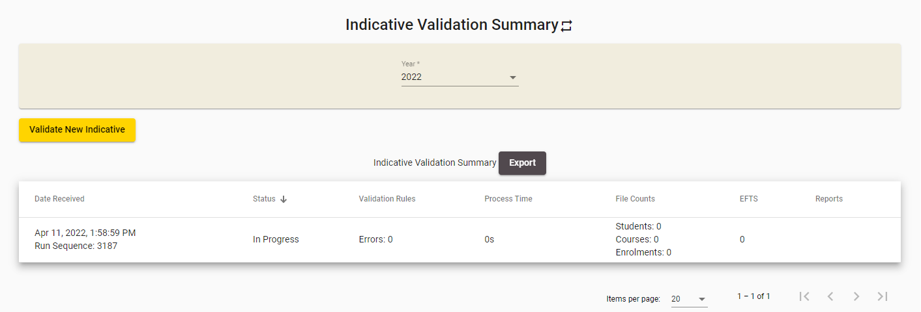
Figure 196190 – IND Processing In Progress
When the processing of the IND Validation has been completed, the results of validation will be shown in the Status field.
The status will read “Submitted” as per Error! Reference source not found. if the IND Validation is successfully processed with no errors.
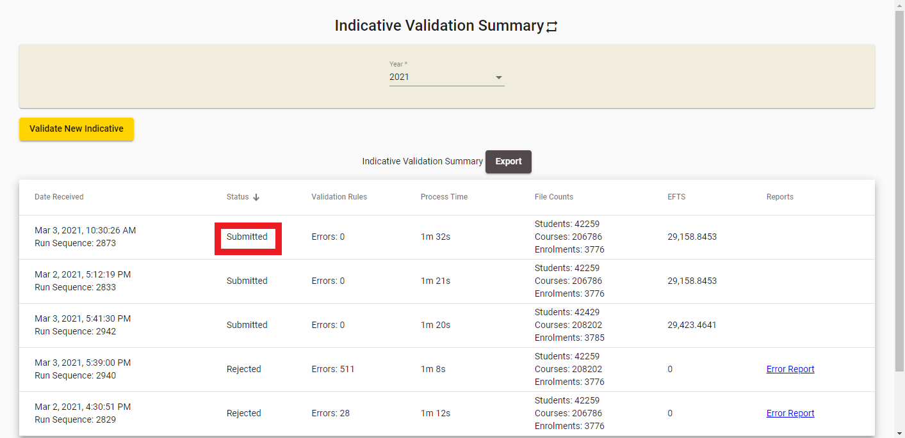
Figure 197191 – IND Data Submitted Successfully
If the files were processed, but errors were present during validation, the status will read Rejected (as per Figure 198).
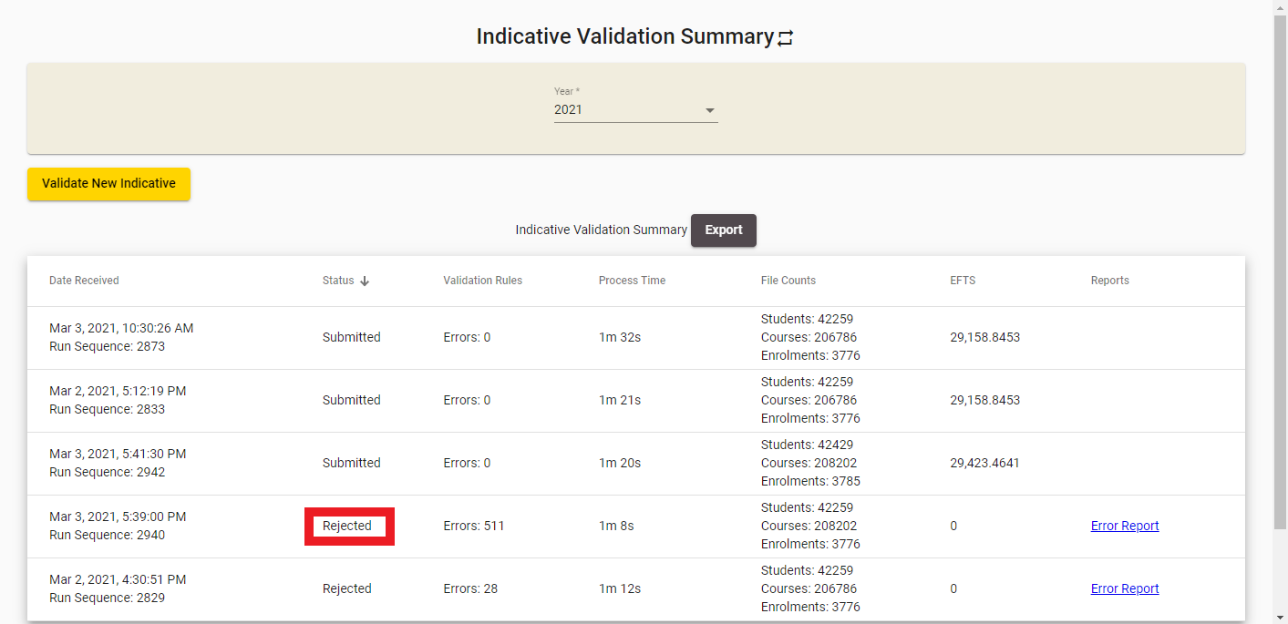
Figure 198192 – IND Files Rejected

Validation Error Report
If your IND files were rejected, you can access detailed information about the errors that need to be fixed by clicking on the Error Report link in the IND Validation Summary page:
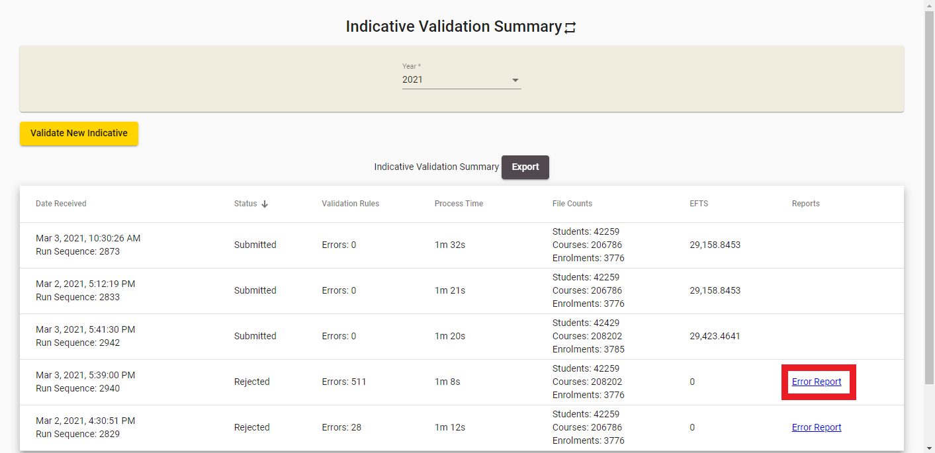
Figure 199193 – Accessing IND Validation Error Report

The following page will be shown when you access the IND Validation Error Report:
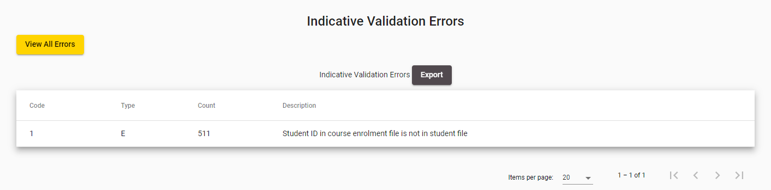
Figure 200194 – IND Validation Error Report
If you click View All Errors, you be shown a detailed view of all the errors that occurred during processing in the View All Errors page.

To view details of a particular error, click on the Description of the error or the Count to access the Validation Error Details page.

View All Errors
The View All Errors page shows all errors that have occurred while processing the files. You can access it by clicking View All Errors while you are on the Validation Error Report page:
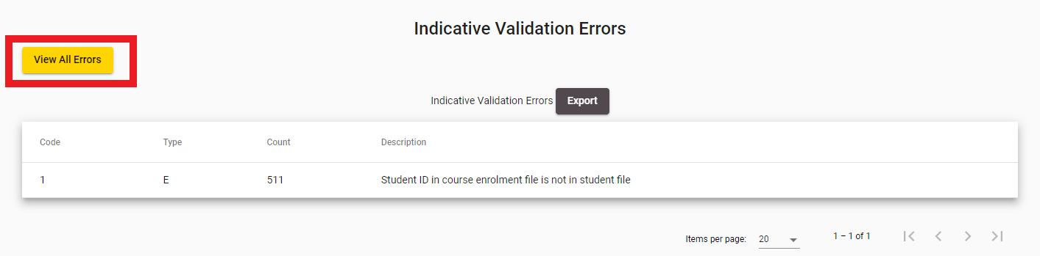
Figure 201195 – Accessing View All Errors
The following page will be shown:
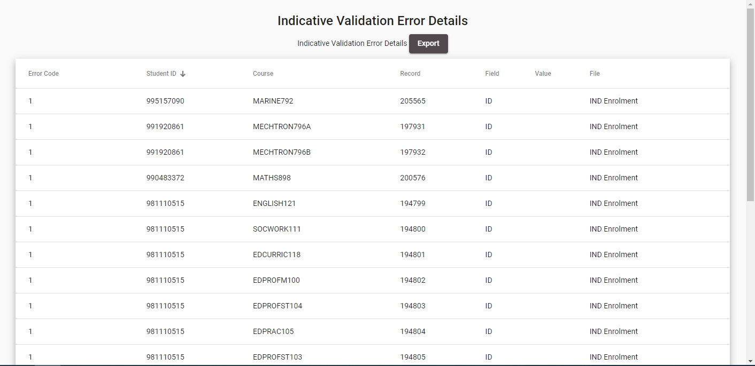
Figure 202196 – IND Validation View All Errors

You can sort the results by clicking on the column header titles as previously described in the Sorting Search Results section.
Clicking on  will generate a .csv file that contains all the errors, as shown in Error! Reference source not found..
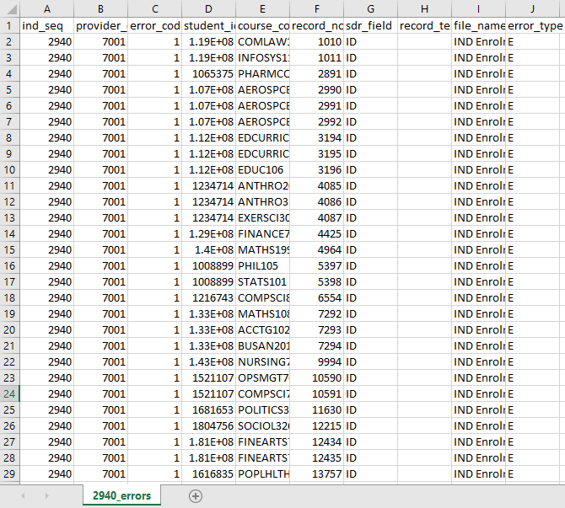
Figure 203197 – IND Validation Error Export

Validation Error Details
The Validation Error Details page shows all instances of a particular error that have occurred while processing the file.
You can access this page by clicking on the Count or Description link for a given error in the Validation Error Report:
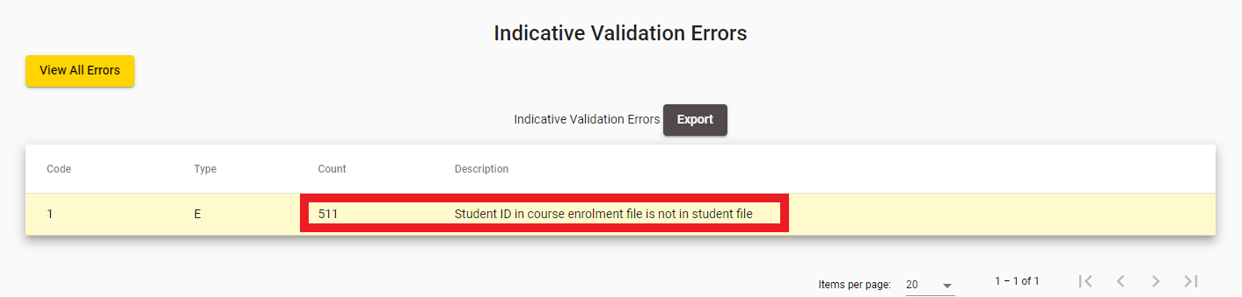
Figure 204198 – Accessing IND Validation Error Details
The following page will be shown:
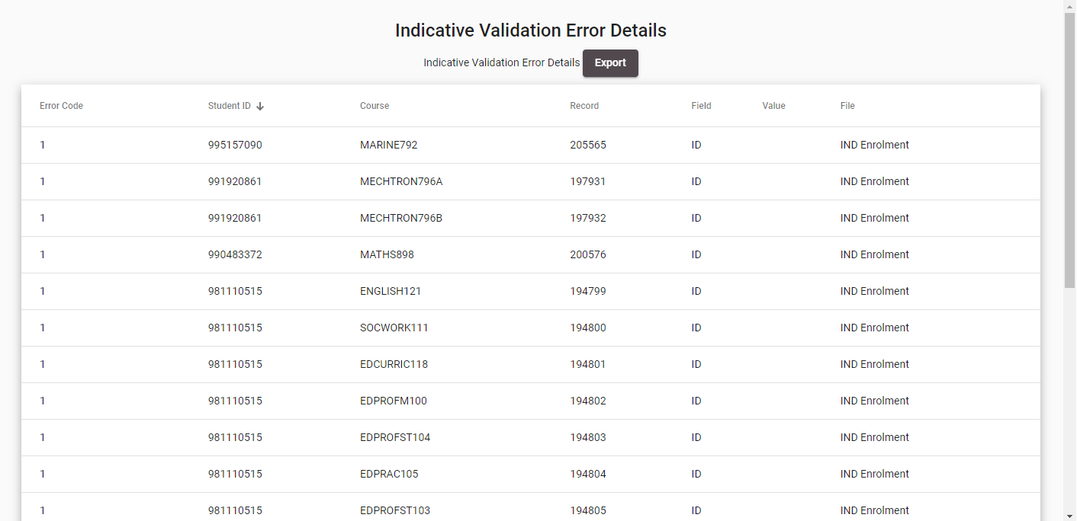
Figure 205199 – IND Validation Error Details
You can sort the results by clicking on the column header titles as previously described in the Sorting Search Results section.

Workforce Questionnaires (WFQ)
The Workforce Questionnaire collects data on staff employed in tertiary education providers that complete an SDR. The Workforce Questionnaire now captures workforce data for the complete year and must be returned to the Ministry prior to Submission of the December SDRs (current arrangement as discussed in SDR Submission) using the SDR system.
For TEIs, the return will report numbers of staff and full-time equivalents by designation, ethnicity, age group and gender.
For PTEs, the return will report numbers of staff and full-time equivalents for teaching, executive and support staff by ethnicity, age group and gender.
The Workforce Questionnaires (WFQ) tab allows you to access details for previously uploaded WFQs, download the WFQ template, and upload new WFQs.
The Workforce Questionnaires tab allows you to access the following pages and functionality:
- Error! Reference source not found.
- Download WFQ Template

- You can download a WFQ template by clicking on the Download Workforce Questionnaire button.
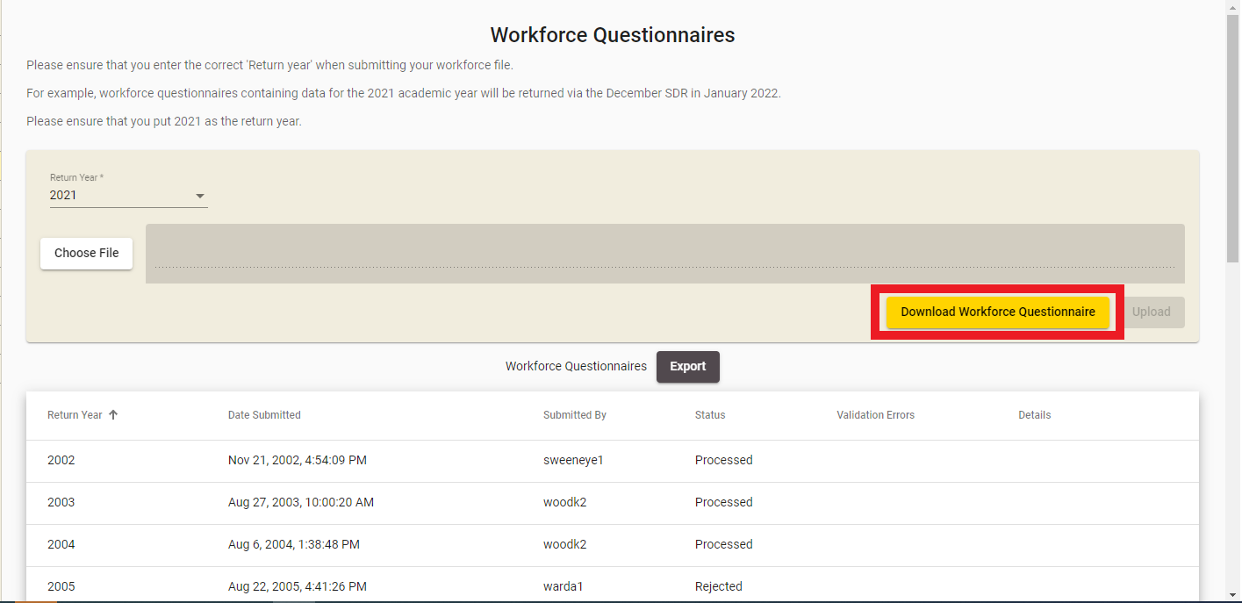
Figure 208202 – Downloading the Workforce Questionnaire Template
Clicking it will prompt you to save the Excel (.xlsx) file to your local computer. The template will be different depending on your organisation type (e.g. polytechnic, university, PTE and so on).

Figure 209203 – Workforce Questionnaire Template

- View WFQ Details
- WFQ Error Report
You can navigate to this section by clicking on Workforce Questionnaires under SDR in the main menu.
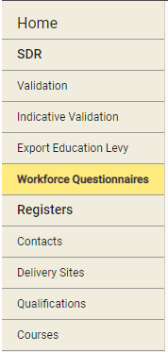
Figure 206200 – Accessing Workforce Questionnaires

Workforce Questionnaires
The Workforce Questionnaires page is the default page that is shown when you navigate to the workforce questionnaires tab.
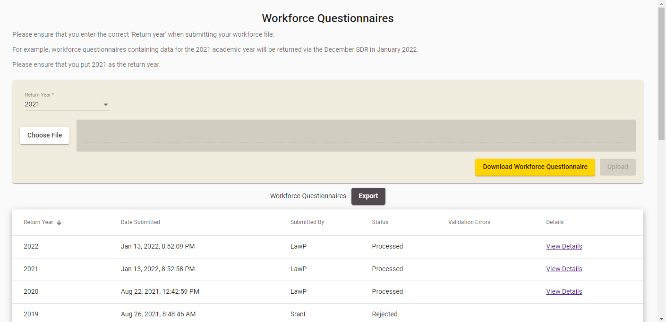
Figure 207201 – Workforce Questionnaires Page
Return Year selection is defaulted to the year for which data is being reported in the current SDR.
You can view all previously uploaded WFQs in the Upload History section. Only one Processed WFQ Return per year (the latest uploaded) is preserved for your organisation by the system. Remembering that from 2016 the templates are for a complete year of data (not a snapshot).
If you click on , select a file and click , you will perform a WQF Upload.
Please do not upload blank or partially completed questionnaires. Ensure that you have saved the final version of your completed questionnaire before uploading.
Clicking on the Download Workforce Questionnaire link will Download WFQ Template that you can use. There are a few templates supported by the system each designed for a specific TEO type.
Clicking on View Details of a previously uploaded WFQ will allow you to View WFQ Details.
Please note that WFQ Details are available for Returns submitted since year 2012 when the current WFQ templates were introduced.

Download WFQ Template
You can download a WFQ template by clicking on the Download Workforce Questionnaire button.
Figure 208202 – Downloading the Workforce Questionnaire Template
Clicking it will prompt you to save the Excel (.xlsx) file to your local computer. The template will be different depending on your organisation type (e.g. polytechnic, university, PTE and so on).
Figure 209203 – Workforce Questionnaire Template

WFQ Upload
The Upload Spreadsheet section of the page allows you to upload a new WFQ file. It is accessible when you navigate to the Workforce Questionnaires page.
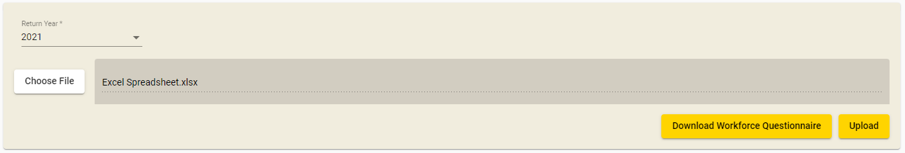
Figure 210204 – Using the WFQ Upload Functionality
Clicking on will allow you to select a completed workforce questionnaire on your computer. Ensure that you have saved the final version of your questionnaire before doing this.
After you select a file and the return year that it is for, click the button to perform the upload. Please note that the uploaded file size must not exceed 20 megabytes (MB). Further details can be found in Maximum File Size when Uploading.
Please ensure that the uploaded WFQ file is of the file type .xls or .xlsx. If you upload a file that is not of the type .xls or .xlsx, the following error as shown in Error! Reference source not found. will be displayed and the WFQ processing will not proceed.
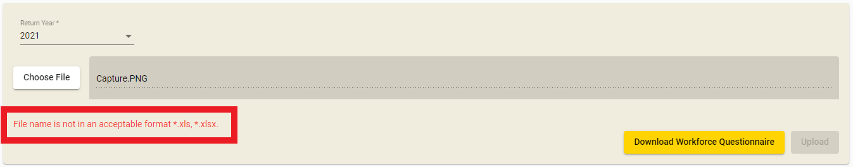
Figure 211205 – WFQ Upload Incorrect File Type Error Message
You may also be shown the following error message if you upload a template for a provider type that does not match your organisation type:
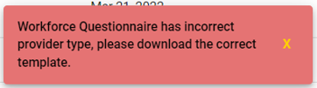
Figure 212206 – WFQ Upload Invalid Provider Type Template
If your file upload was successfully uploaded, you will see a success message as shown below:
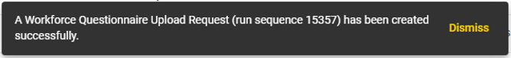
Figure 213207 – WFQ Successfully Uploaded
If the file was successfully uploaded and processed without errors, the View Details link will be visible. Clicking on it will take you to the View WFQ Details page.
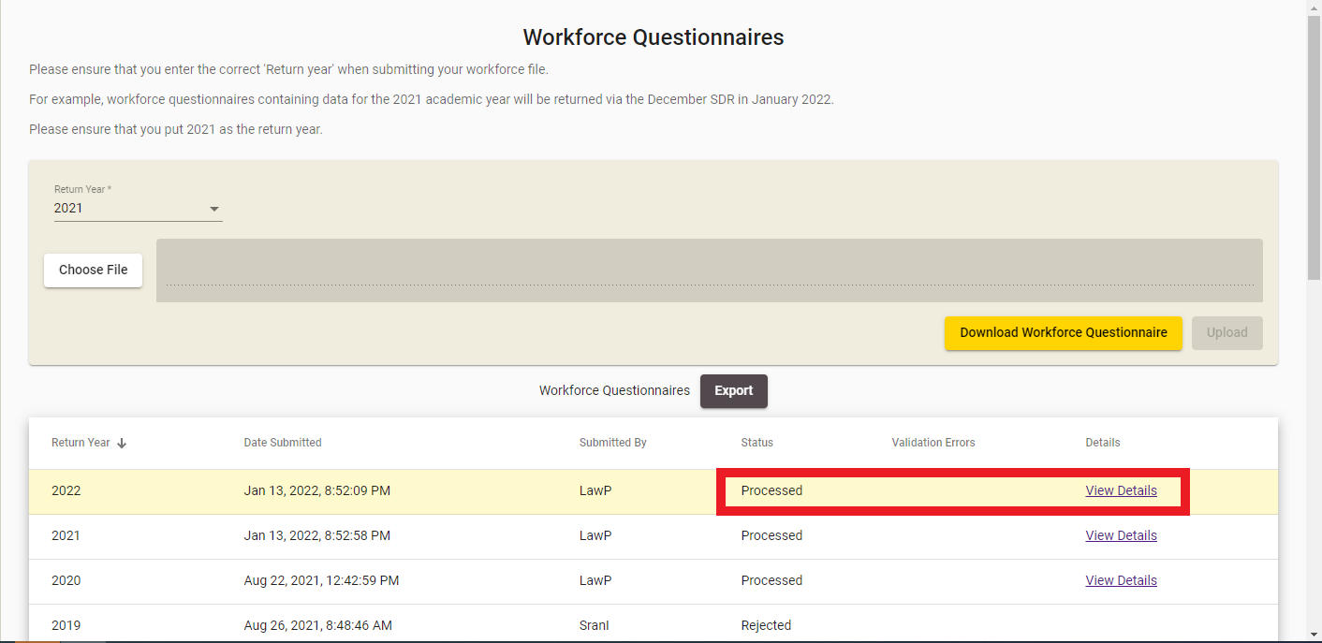
Figure 214208 – WFQ Uploaded and Processed without Errors
If your upload was not successful (e.g. with invalid data or template does not match expected new format or invalid provider type), and your WFQ upload could not be processed, it will be shown as Rejected and Error Report link will be displayed if any data validation errors were found. Clicking on it will take you to the WFQ Error Report page
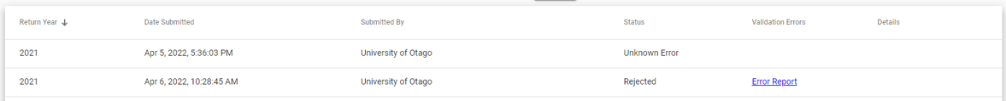
Figure 215209 – WFQ Uploaded and Rejected with Errors
Note: Rejected WFQ is displayed only if the latest uploaded one is Rejected for the given year. If any successful WFQ upload is done after, then only the latest Processed will be displayed for the year.
For any historical WFQ processed prior to 2012, no View Details link will be visible. If there are any errors, you can view them by clicking the Error Report link that will take you to the WFQ Error Report page.
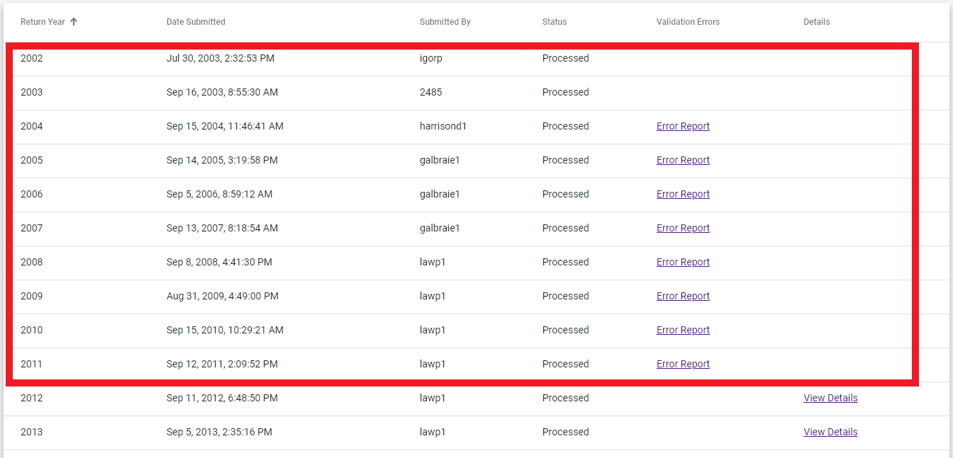
Figure 216210 – Historical WFQ Uploaded and Processed with Errors

View WFQ Details
Clicking on the View Details link in the Error! Reference source not found. section allows you to inspect the details of a recently uploaded WFQ that was successfully processed.
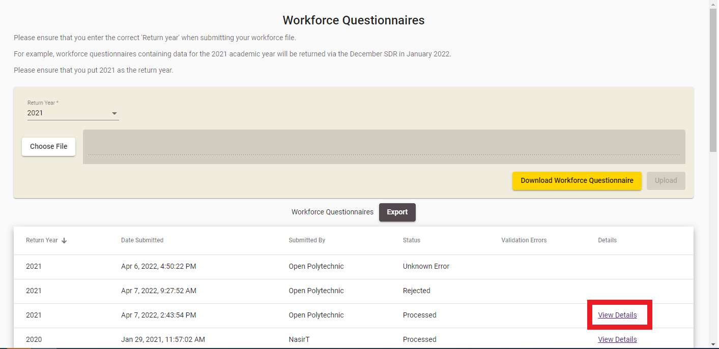
Figure 217211 – Accessing WFQ Details
You will be shown the following page when you access the WFQ Details:
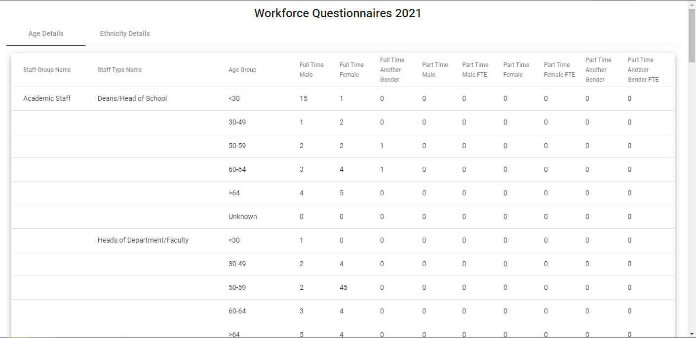
Figure 218212 – WFQ Details
The WFQ Details page has two pages – Age Details, and Ethnicity Details.

WFQ Error Report
If your WFQ Upload was processed with errors, you will be able to access the error report. You can do so by clicking on the Error Report link.
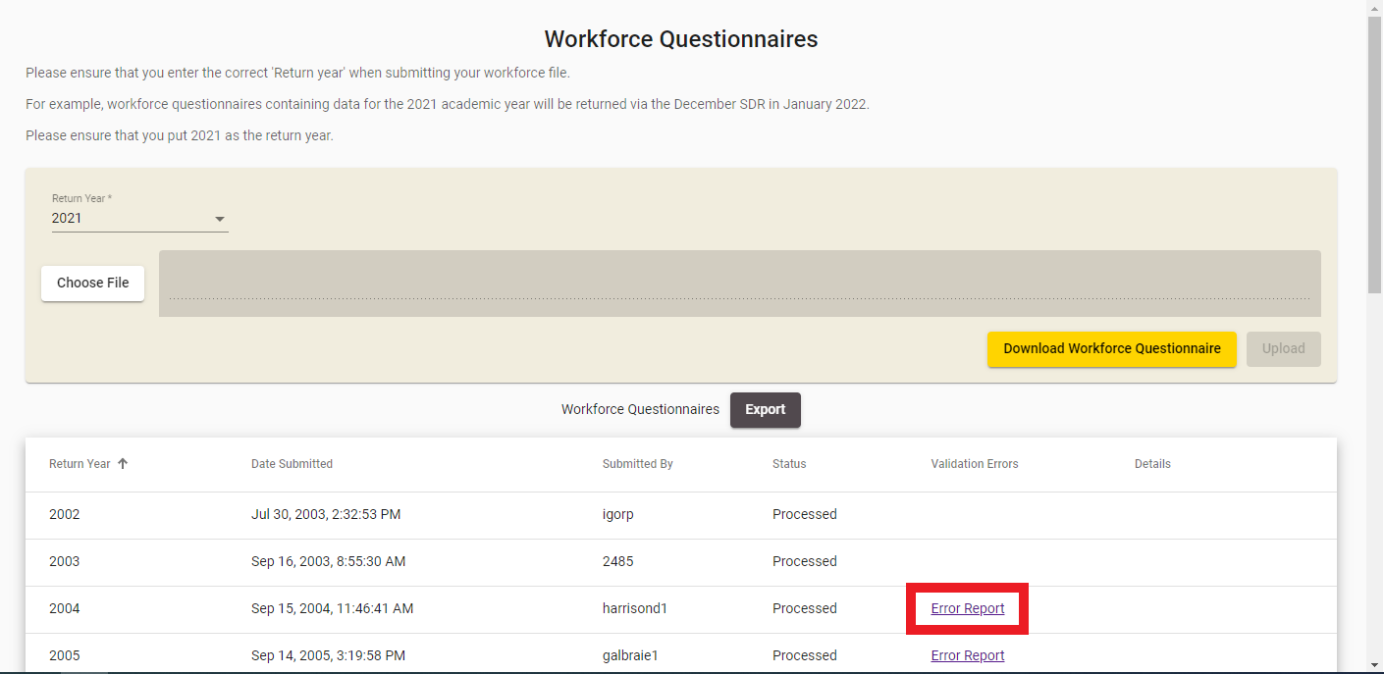
Figure 219213 – Accessing WFQ Error Report
The WFQ Error Report will be shown as per the figure below:
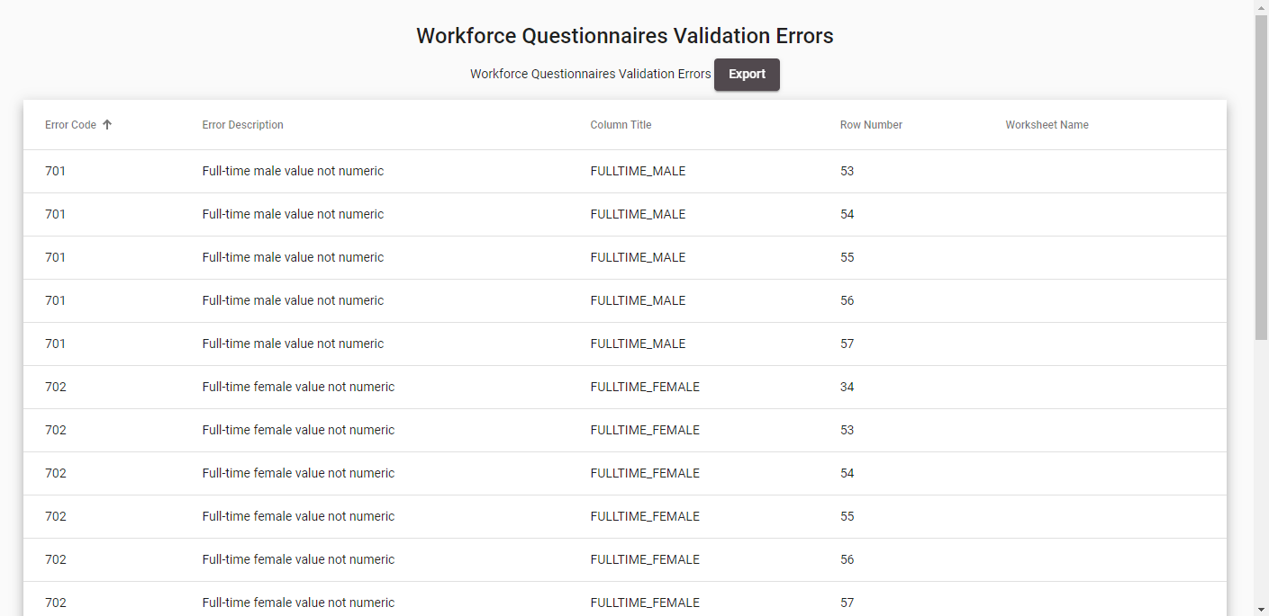
Figure 220214 – WFQ Error Report
You can click on any of the column headers to resort them, as described in Sorting Search Results.
If there is more than one page of errors, you can navigate through them as described in Navigating through Result Pages.

Non SDR Provider
If you are a Non SDR Provider that are signatories to the Code of Practice (that is have international students) you must return a Unfunded International Provider (UIP) data return (see the relevant section of the https://services.education.govt.nz website). If you are a Non SDR Provider and do not have international students, you will have to perform the RS20 statistical return through a different set of pages as shown below:
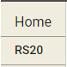
Figure 221215 – Non SDR Provider Main Menu
Non SDR providers will have access to the RS20 main menu tab.

RS20
The RS20 is a census collected annually containing data on the students and staff at private training establishments. If your organisation is not one that returns a Single Data Return, you will be required to complete a RS20 statistical return.
You can navigate to the RS20 section by clicking on RS20 from the Main Menu:
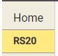
Figure 222216 – Accessing RS20
You will be automatically directed to the overview page:
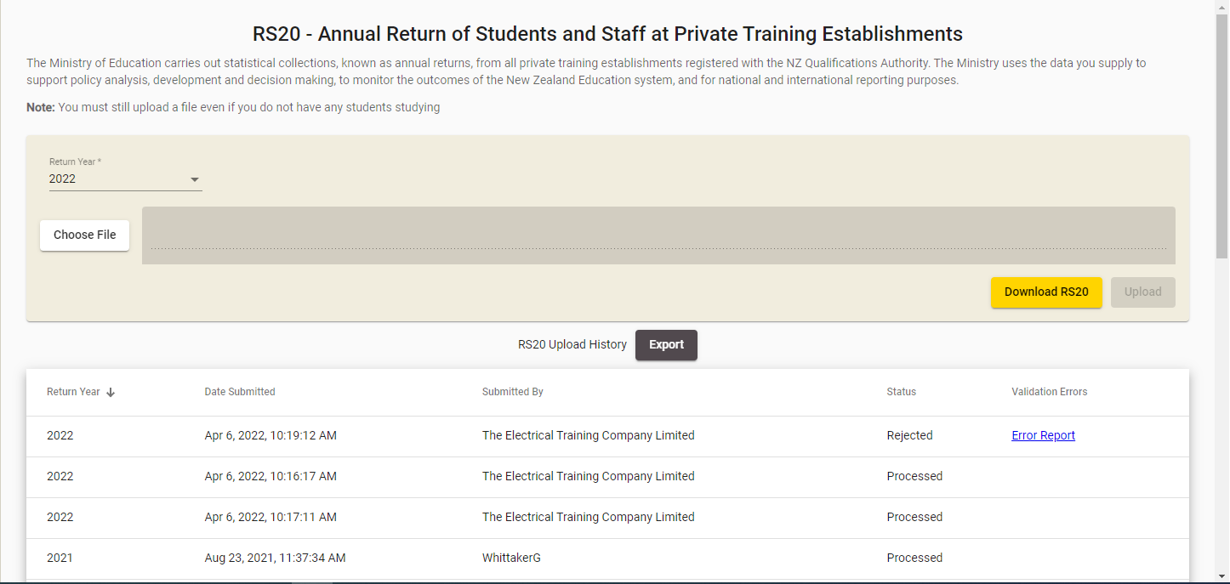
Figure 223217 – RS20 Overview

RS20 History
The RS20 Download/Upload section is shown below, with the Return Year defaulted to the current year:
Figure 224218 – RS20 Download/Upload section
If you click on , select a file and click , you will perform a Error! Reference source not found..
Please ensure that the uploaded RS20 return file is of the file type .xls or .xlsx. If you upload an invalid file type (not .xls or .xlsx), you will see the error message as shown in Error! Reference source not found.:
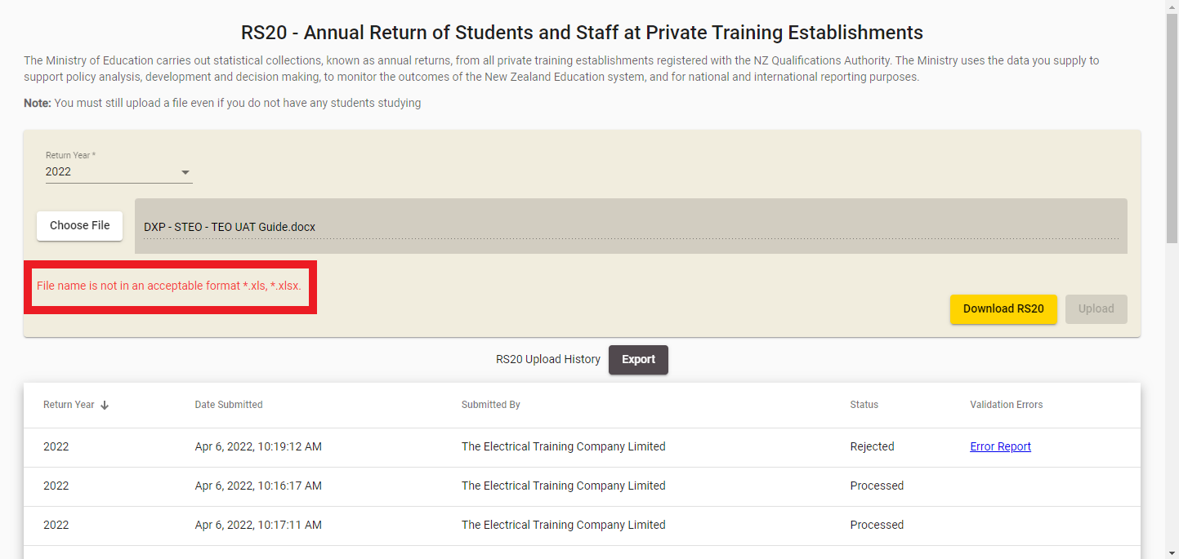
Figure 225219 – RS20 File Not Valid Excel Spreadsheet Error Message
Please note that the uploaded file must be less than 20 megabytes (MB). You may refer to Maximum File Size when Uploading for more information.
After you select a file and the return year that it is for, click the button to perform the upload.

Download RS20 Template
You can download a RS20 template by clicking on the Download RS20 button.
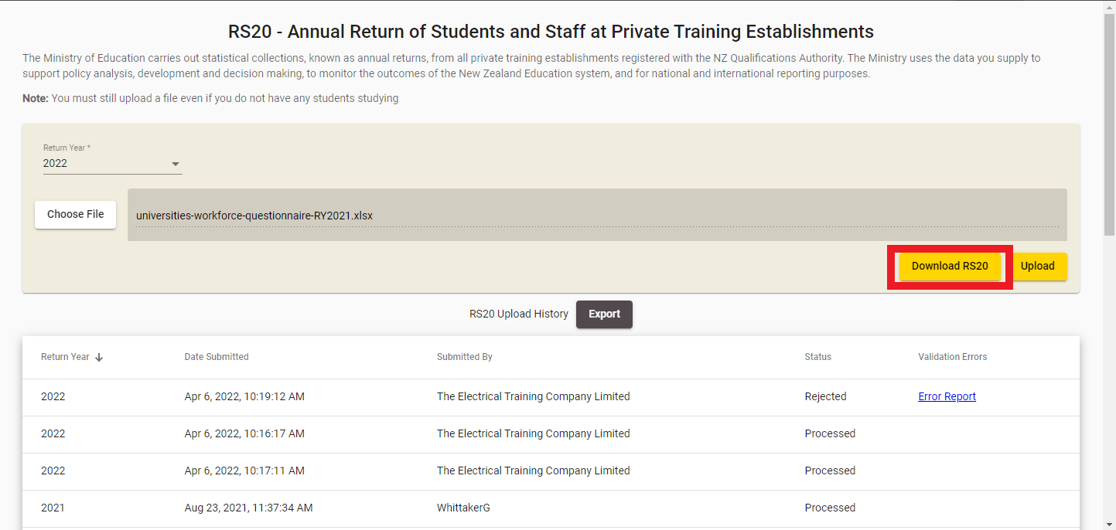
Figure 226220 – Accessing the RS20 Return Template
Clicking it will prompt you to save the Excel (.xlsx) file to your local computer. The Return Template is shown below:
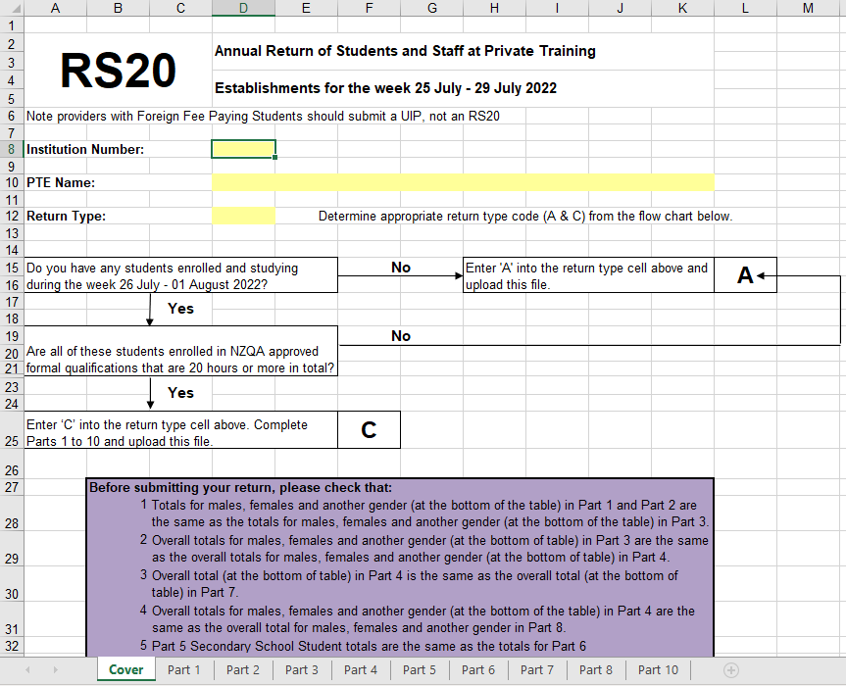
Figure 227221 – RS20 Return Template

RS20 Error Report
If your RS20 Return was processed with errors, you will be able to access the error report. You can do so by clicking on the Error Report link.
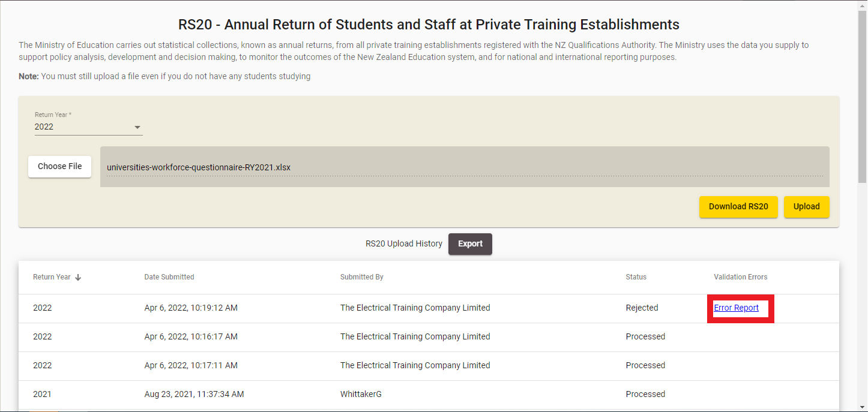
Figure 228222 – Accessing RS20 Error Report
The RS20 Error Report will be shown as per the figure below:
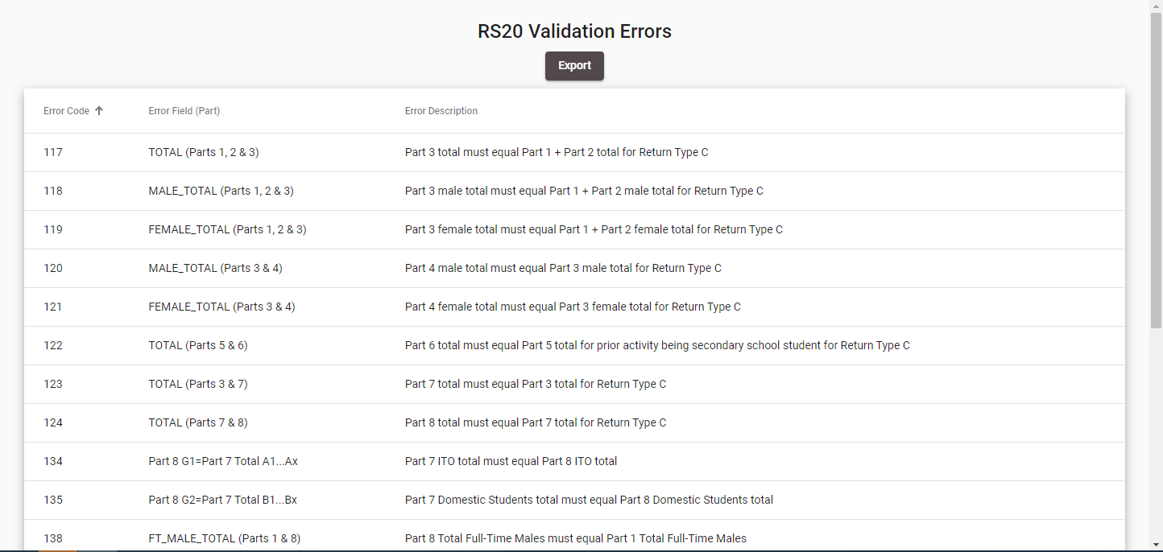
Figure 229223 – RS20 Validation Errors

You can click on any of the column headers to resort them, as described in Sorting Search Results.
If there is more than one page of errors, you can navigate through them as described in Navigating through Result Pages.

