Waipu School

New Enrolment Scheme

Overview – what is changing?
The Ministry of Education regularly monitors enrolment patterns, population growth and anticipated school roll changes across the Whangārei District. As part of this monitoring and regular review, we now consider an enrolment scheme is necessary for Waipu School. This is due to growth of the school roll and because we need to ensure the Board has a fair and transparent mechanism to manage the roll. It also means we can ensure we are making best use of educational facilities across the wider Ruakaka area.
The new enrolment scheme will have a home zone, like other schools with enrolment schemes in the area. Children that live within this area will have entitlement to enrol at Waipu School. The home zone area is shown on the map below and described here:
WAIPU SCHOOL (1125)
Proposed Draft Enrolment Scheme
Commencement date: 1 January 2026

The guidelines for development and operation of enrolment schemes are issued under Schedule 20, Clause 3 (3) of the Education and Training Act 2020 for the purpose of describing the basis on which the Secretary’s powers in relation to enrolment schemes will be exercised.
Home Zone
All students who live within the home zone described below shall be eligible to enrol at the school.
The Home Zone includes addresses on both sides of the boundary roads mentioned in the description, and all no-exit roads off the boundary roads are included in the zone unless otherwise stated.
Beginning on Cove Road north of the intersection with Tuaraki Road (not included), the zone travels north through Langs Beach and Waipu Cove townships. The zone turns left onto McClean Road, left onto South Road, then right onto Glenmohr Road. The zone then turns left onto State Highway 1 and continues south to the intersection with Artillery Road/the southern end of Brynderwyn Scenic Reserve. From here, the zone travels west overland to the intersection of Waipu Gorge Road and Gorge Road at the southern end of the Waipu Gorge Forest Scenic Reserve (Gorge Road addresses are not included).
The zone travels north along Waipu Gorge Road, turns left onto State Highway 1, left onto Brooks Road, then left onto Finlayson Brook Road. After 884 Finlayson Brook Road the zone travels north overland to connect with Millbrook Road at 1332 Millbrook Road/the north-western corner of Mareretu Forest Conservation Area. The zone travels east on Millbrook Road, turns left onto Helmsdale Road, left onto Shoemaker Road, then left onto Waipu Caves Road. The zone continues on Waipu Caves Road to the intersection with Mangapai Caves Road (not included), then turns right into Springfield Road and continues up to the intersection with Ormiston Road (924 and 917 Springfield Road are included in zone).
The zone turns east down Ormiston Road, including addresses 315-412 Kukunui Road (up to the northern end of the McKenzies of Limestone Hill Park Scenic Reserve). The zone continues on Ormiston Road and follows it east and south until it becomes Waipu Caves Road and then turns left onto Mountfield Road. The zone continues up until 465 Mountfield Road, then travels south-east overland to the intersection of McLeod Road and Rosyth Road. All Mcleod Road addresses and addresses up to 256 Rosyth Road are in-zone. The zone travels south on Rosyth Road, turns left onto State Highway 1, and continues north until the Waipu Golf Course/3251 State Highway 1. From here the road turns east overland towards the coast and follows the coast back down to the starting point on Cove Road.

Section 75 of the Education and Training Act 2020 states that

“the Secretary may authorise an enrolment scheme to permit a student to enrol at the school as if the student lived in the home zone of the school if, -

(b) in the case of a new enrolment scheme, the student,

1. lives outside of the home zone of the new enrolment scheme; and
2. has a sibling who is enrolled at the school at the time that the new enrolment scheme is implemented.”

Special Programmes
This priority category is not applicable at this school because the school does not run a Special programme approved by the Secretary.
Out of Zone Enrolments
Each year the Board of Trustees will determine the number of places which are likely to be available in the following year for the enrolment of students who live outside the home zone. The Board will publish this information by public notice in a medium appropriate to the area served by the school. The notice will indicate how applications are to be made and will specify a date by which all applications must be received.
Applications for enrolments will be processed in the following order of priority:
First Priority
This priority is not applicable at this school because the school does not run a special programme approved by the Secretary for Education.
Second Priority
will be given to applicants who are siblings of current students.
Third Priority
will be given to applicants who are siblings of former students.
Fourth Priority
will be given to any applicant who is a child of a former student of the school.
Fifth Priority
will be given to any applicant who is either a child of an employee of the board of the school or a child of a member of the board of the school.
Sixth Priority
will be given to all other applicants.

If there are more applicants in the second, third, fourth, fifth or sixth priority groups than there are places available, selection within the priority group will be by ballot conducted in accordance with instructions by the Secretary, under Schedule 20, Clause 3 (1) of the Education and Training Act 2020. Parents will be informed of the date of any ballot by public notice in a medium appropriate to the area served by the school.
Applicants seeking second or third priority status may be required to give proof of a sibling relationship.

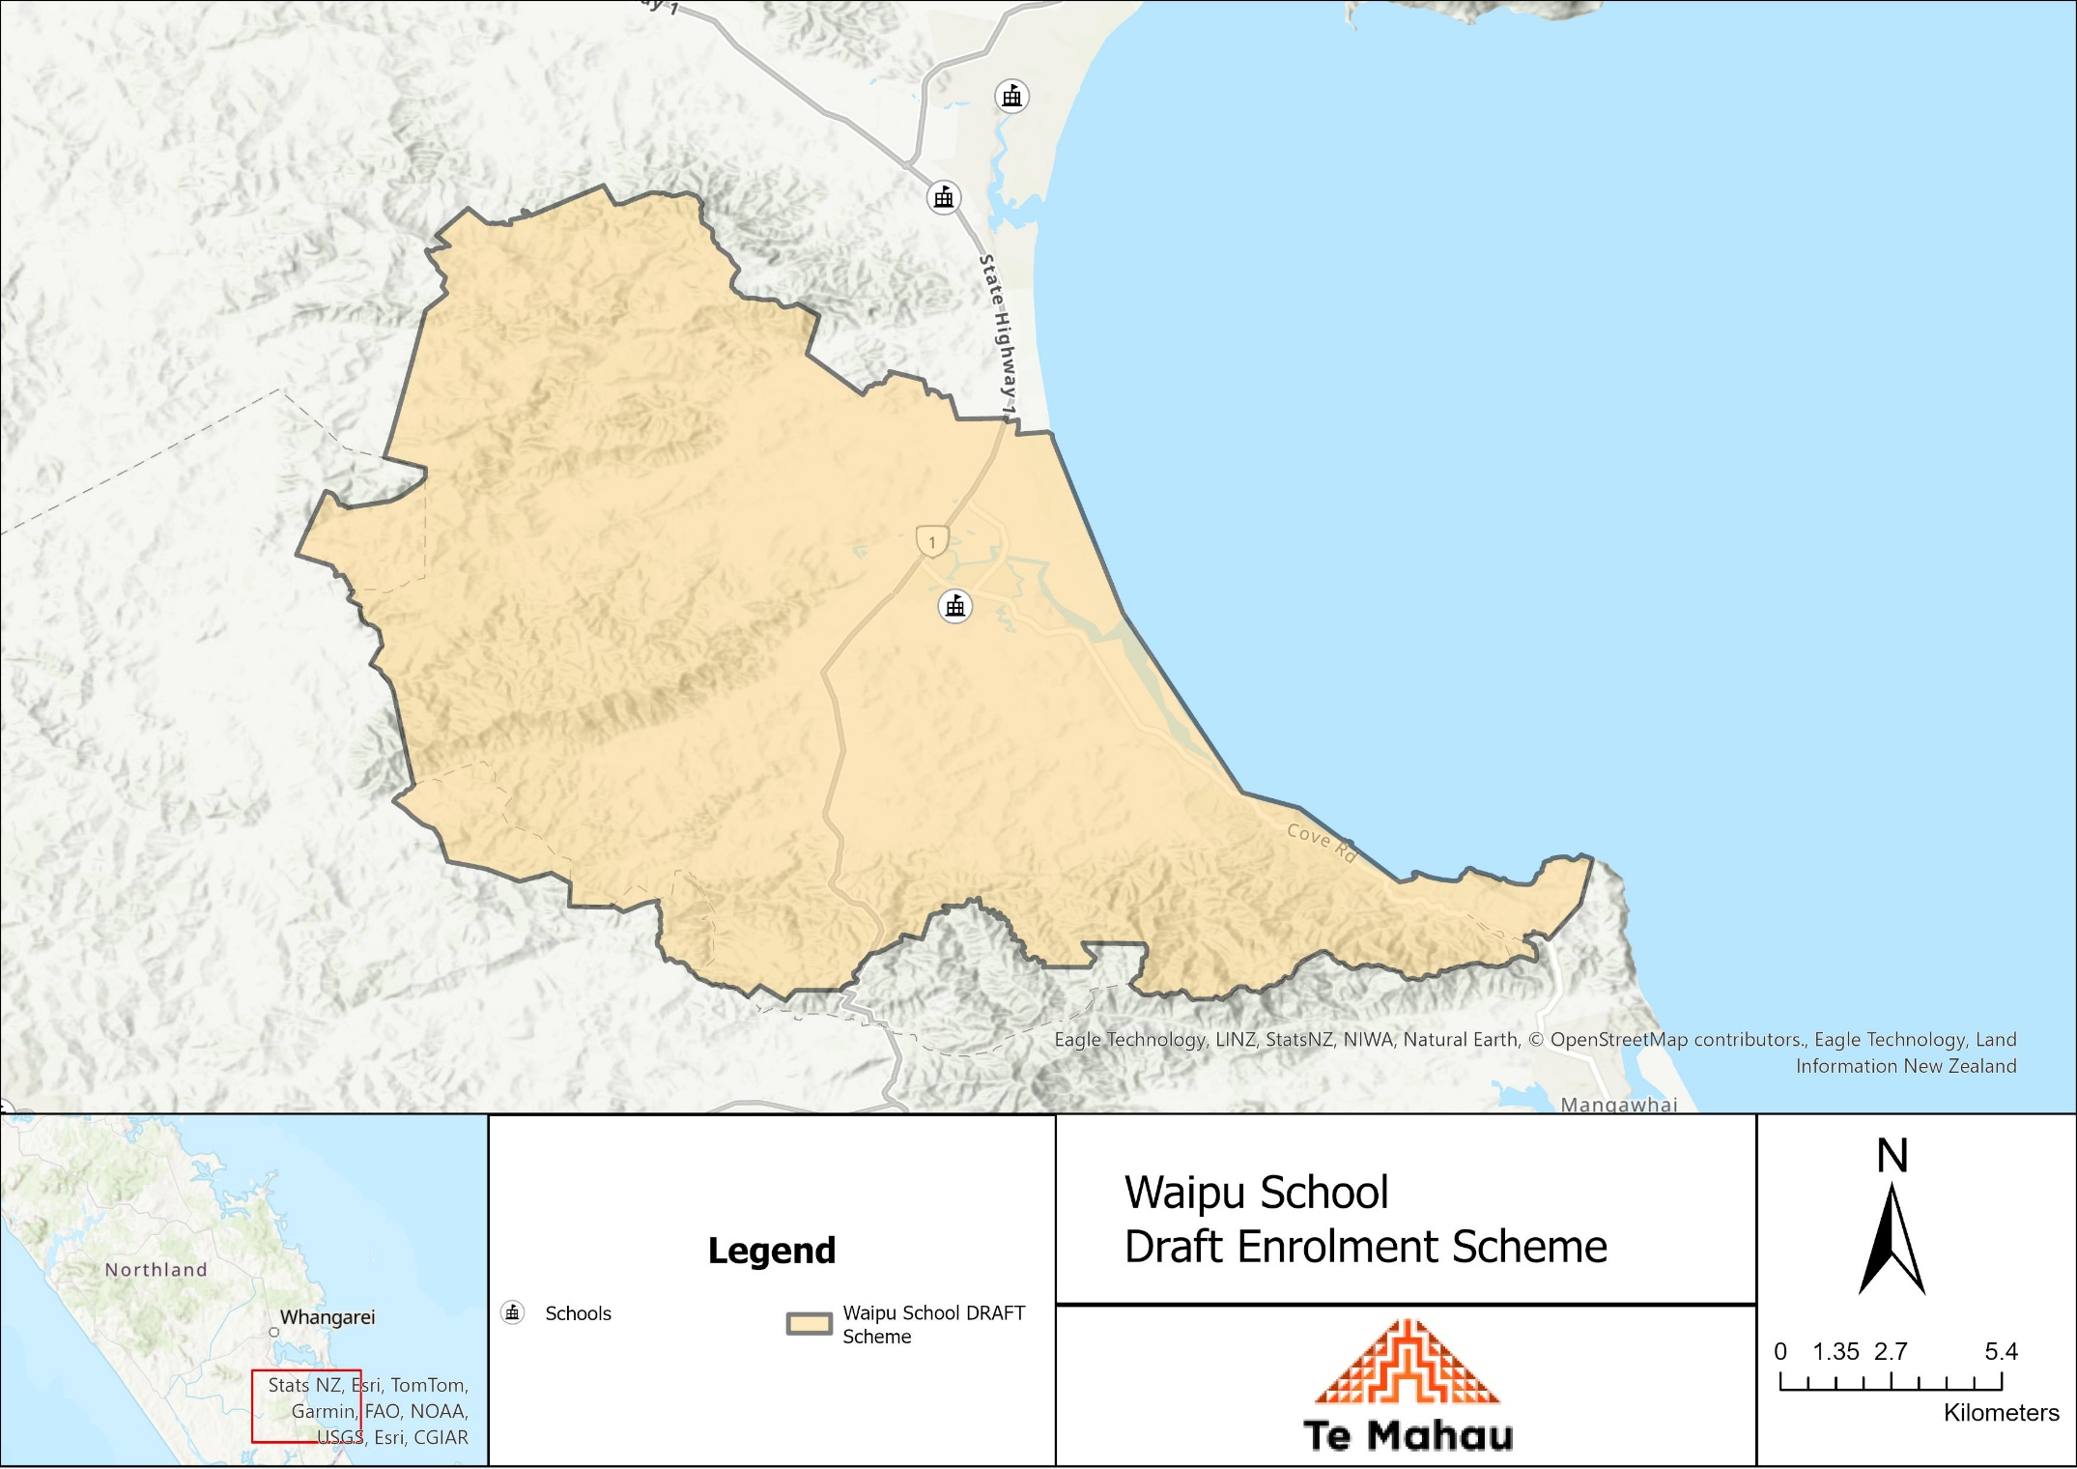

What does this mean for my family?
Any student currently enrolled at Waipu Primary School will not be impacted by the new enrolment scheme. All students enrolled (and attending school) will be entitled to continue attending Waipu Primary School, irrespective of where they currently live.
The establishment of the enrolment scheme and home zone will affect all enrolments starting at the beginning of Term 1 2026. This includes current families who have a younger sibling looking to enrol at Waipu Primary School starting on 1 January 2026 (the commencement date) or later. The flowchart below will help you assess your indicative eligibility to enrol after the commencement date.

Does your child (enrolling in 2026 or later) live within the enrolment scheme home zone? (check map for reference)
In zone enrolment
YES

NO
Out of zone enrolment
(if places available)

YES
Does your child (enrolling in 2026 or later) live outside of the zone?

Consultation process and timeline
The Ministry of Education is currently undertaking consultation about the proposed changes and new enrolment schemes. You can have your say by:
Completing the survey at: Have your say - Ministry of Education on the Waipu School consultation page.

- This site also has further information about the proposed scheme.
- Emailing taitokerau.enrolmentschemes@education.govt.nz if you have further questions or comments.
Consultation will run 26th May 2025 to 6th July 2025. The Ministry will consider all feedback and liaise with the Waipu Primary School Board before making a final decision. We expect the school community to be updated about progress made 28.^{th} July 2025. The new scheme and changes will come into effect for enrolments after the commencement date.

